Committee on Standards in Public Life

Room G07,
1 Horse Guards Road
London
SW1A 2HQ

Rt Hon Simon Clarke MP
Secretary of State for Levelling Up,
Housing and Communities

(By email)

4 October 2022

Dear Secretary of State,

I am writing in light of the government’s response of March this year to the Committee on Standards in Public Life 2019 report on Local Government Ethical Standards.

While we note the government’s commitment to further work to support local government, the Committee is very disappointed that many of its careful recommendations have not been accepted. We aimed in that report to produce a balanced, considered package of recommendations to strengthen the arrangements in place whilst respecting the benefits of a localised approach.

It was clear from our evidence that the sector backed our call to strengthen the arrangements in place to support high ethical standards. There is clear frustration within local authorities at the limited powers within the local government standards regime to address poor behaviour by a minority of individuals.

We would urge you to reconsider our recommendations and would welcome a conversation with you to understand how you are taking forward the government’s stated aim to work with local authorities and their representative organisations to ensure that local government is supported in reinforcing its reputation for ethical local standards.

Across all tiers of local government, decisions are taken about a wide range of local services using public funds, so it is important that there are robust governance arrangements that command public confidence.

Yours sincerely.
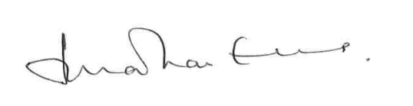

Lord Evans of Weardale KCMG DL
Chair, Committee on Standards in Public Life

