Application Decision
Site visit made on 10 August 2022
by Heidi Cruickshank BSc MSc MIPROW
Appointed by the Secretary of State for Environment, Food and Rural Affairs
Decision date: 20 September 2022

Application Ref: COM/3288901
Land at Teneriffe, Cornwall
Register Unit No: CL 489 (original common land register number)
Commons Registration Authority: Cornwall Council
- The application, dated 15 December 2020, is made under paragraph 4 of Schedule 2 of the Commons Act 2006.
- The application is made by Mr T Hannis, Landman LLP, on behalf of the Open Spaces Society.
- The application is to register waste land of a manor in the Register of Common Land.

Decision
- The application made on behalf of the Open Spaces Society (the OSS) is approved. The land outlined in red on the plan attached to this decision shall be added to the Register of Common Land.

Procedural Matters
- No one requested to be heard in relation to this application. The application was dealt with by way of the written representations procedure and an unaccompanied site inspection.

The application land
- The application relates to two pieces of land situated adjacent to the south-eastern side of Predannack Road, as it runs north-east of Teneriffe Farm. There is a strip of land situated near Teneriffe Farm and a smaller triangle of land to the north-east. Both land areas are open to the road, with a variety of overgrowth encroaching from the hedges to the fields lying to south-east.

Main Issues
- The application has been made in accordance with the provisions of paragraph 4 of Schedule 2 to the Commons Act 2006 (CA 2006). Cornwall Council, the Commons Registration Authority (the CRA) have confirmed that the application has been processed in accordance with the relevant regulations.
- The main issue is whether the land is waste land of a manor, at the date of the current application, and whether before 1 October 2008:

a) the land was provisionally registered as common land under section 4 of the Commons Act 1965;

b) an objection was made in relation to the provisional registration; and

c) the provisional registration was cancelled in the circumstances specified in sub-paragraphs (3), (4) or (5) of paragraph 4 of Schedule 2 to CA 2006.
- Sub-paragraph (5), on which the OSS relies, requires that the person on whose application the provisional registration was made requested or agreed to its cancellation (whether before or after its referral to a Commons Commissioner).

Reasons

The requirements of paragraph 4 of Schedule 2
- The land was provisionally registered as unit CL 489 as a result of application number 1575, made on 17 May 1969 by the then owners and/or occupiers of Teneriffe Farm, Mullion. Objection No. X193A was made to the registration by Cornwall County Council on 21 July 1972, on the basis that the land was not common land at the date of registration.
- On 12 September 1980 the representative for the applicant wrote to the Commons Commissioner requesting withdrawal of the 1969 application. There was subsequently a hearing by a Commons Commissioner on 7 October 1980 and the Commissioner refused to confirm the registration. The decision reference for this is 206/D/861-862.
- The provisional registration was cancelled on 21 July 1981 such that the land was not registered. The circumstances meet those specified in paragraph 4 of Schedule 2 to CA 2006, see paragraphs 5 and 6 above.

Whether at the time of the current application the land was waste land of a manor
- The land was shown to have formerly been in the manor of Predannack Wartha. It appears to have been left as part of the roadside waste following the inclosure of Predannack Wartha common.
- The definition of waste land of a manor arising from the case of Attorney-General v Hanmer [1858] 27 LJ Ch 837 is “the open, uncultivated and unoccupied lands parcel of the manor other than the demesne lands of the manor”. Demesne land that owned and occupied by the lord of the manor for his own purposes.
- The smaller area to the north-east was entirely overgrown and inaccessible at the time of the site visit, with the undated photographs attached to the application showing a similar situation. Google streetview images from June 2009 and August 2016 suggest little has changed over the last thirteen years. The land is open to the road, clearly uncultivated and unoccupied.
- In relation to the north-eastern end of the larger strip of land the situation is very similar with most of it overgrown and inaccessible as shown in the photographs and during the site visit. There is a track to a field gate which is obviously used for farm access but there is nothing to prevent anyone else from accessing that area and so the use could not be said to be exclusive. Registration of common land would not disturb any existing private rights of access.
- The current occupier of Teneriffe Farm indicated in objection that he had used the land for over 10 years, this area being regularly used as an extension to the farming activities. The photographs show that the area closest to Teneriffe Farm has generally been grass cover and weeds, with less shrubby overgrowth than the land further from the farm. At the time of the site visit there were a couple of pieces of farm machinery situated in that area, adjacent to an unmade track leading generally south-east from Predannack Road. The lack of dense overgrowth in this area suggests more active use of the land, keeping the growth at bay, although none of the earlier photographs show any such use. The land is open to the road and uncultivated.
- The objector suggested the land had been a part of the farm for as long as the farm had been there; it is noted that it was former occupiers of the farm who originally applied for it to be recorded as common land, although later withdrawing that application. Whilst suggesting that the farm may have a right to the land, it is neither owned nor tenanted by the objector. The evidence presented does not indicate more than irregular, informal use. The registration of common land does not alter ownership and in this case the CRA were unable to identify a landowner. The land remains accessible to anyone who wishes to use it and could not be said to be exclusively occupied by the farm.
- Taking account of the evidence as a whole the land in question can be said to be open, uncultivated and unoccupied. As a result, I am satisfied that the application land should be registered as common land.

Conclusions
- Having regard to these and all other matters raised in the written representations, I conclude that the criteria for the registration of the application land as common land under paragraph 2(4) of the Schedule 2 to the 2006 Act has been met. The application should be approved.

Heidi Cruickshank
Inspector

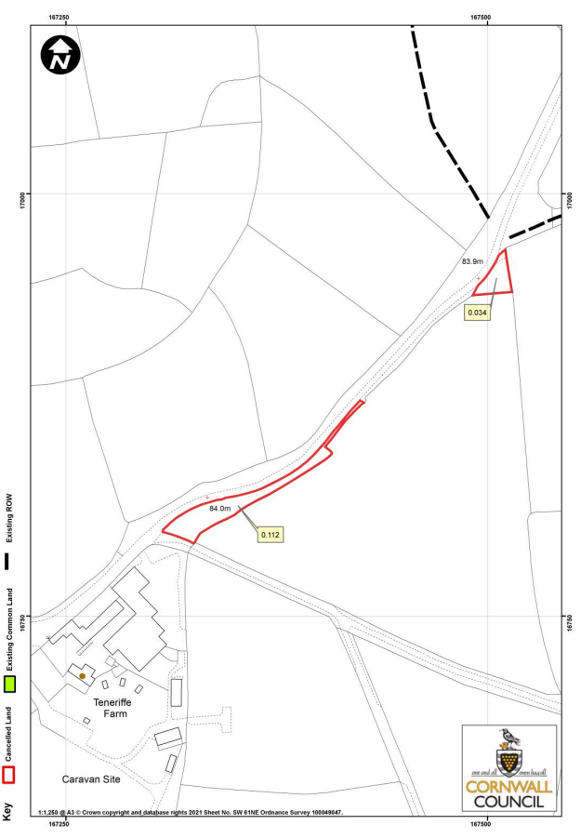
PLAN NOT TO ORIGINAL SCALE

