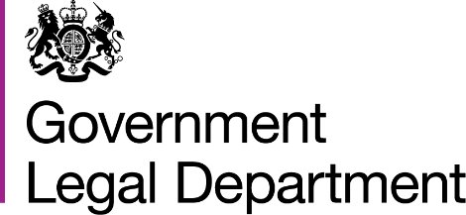

ATTORNEY GENERAL’S PANELS OF CIVIL COUNSEL
‘WIDENING THE POOL’ EVENT

Tuesday 13 September 2022 at 5pm

ST PHILIPS CHAMBERS
55 Temple Row
Birmingham
B2 5LS

This is an event aimed at those who are thinking about applying in the next Regional panel competition opening on Thursday 8 September 2022 or who just want the chance to find out more.

The Attorney-General has civil Panels of Counsel based on the circuits in the Regions. These panels are approved to undertake government work.

Lee John–Charles (Head of Home Office and Immigration Division in the Government Legal Department) will provide information about the work of the panels and the appointments process.

A current Regional Panel member will discuss their own experiences of panel work, in particular the types of cases they have undertaken during their time on the Panels and their experience of the application process.

For further information and to reserve a place please
Contact Elaine Browning on
020 7210 1353 or email
PanelCounsel@governmentlegal.gov.uk
by Friday 9 September 2022

