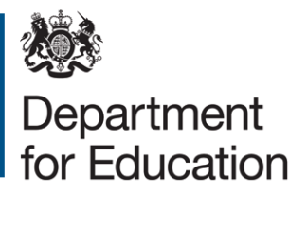

Application form for free early education for two-year-olds from families with no recourse to public funds (NRPF)
Please complete this application form if you are a family with NRPF and would like to apply for 15 hours a week of free early education for two-year-olds.
To complete this form, applicants should complete all sections.
When completed, please ensure the declaration at the end of the application is also signed.

Child’s details
Surname of child
First name(s) of child
Date of birth of child (dd/mm/yy)
Nationality of child
Address of child

Parent/carer’s details
Surname of parent/carer
First name(s) of parent/carer
Relationship to child
Nationality of parent/carer
Address of parent/carer

- Do you have no recourse to public funds? Please answer Yes or No.

(If yes you are not eligible for a place via this route).
- Does your partner have recourse to public funds? Yes/No or Not Applicable.
- (If yes you are not eligible for a place via this route).
Evidence of status provided:

Evidence of income
To be eligible for free early education for two-year-olds place, your families’ annual household income must be no higher than the following:
- £26,500 for families outside of London with one child
- £30,600 for families outside of London with two or more children
- £34,500 for families within London with one child
- £38,600 for families within London with two or more children
This includes any wider income or support you may or your partner (if you have one) may be receiving in addition to any earnings from employment. Where possible, please also provide a document to show this for you and your partner – this could be a bank statement, a pay slip or an employment contract in you or your partner’s name.
Are you employed?
If you have a partner, are they employed?
Is your annual household income, including earnings from employment and any wider support you may be receiving, less than the maximum income thresholds listed above?

Declaration of applicant
I (Name) ..........................................................................................................
of (Address) .................................. .........................................................................................
confirm that the information I have provided above is accurate and true.
I agree that the information I have provided can be shared with the Department for Education for the purposes of assessing eligibility for a free early education for two-year-olds.

Parent/Carer/Guardian with legal responsibility for care of the child
- Signed
- Print name
- Date

© Crown copyright 2022

