Committee on Standards in Public Life

Committee on Standards in Public Life
Room G07
1 Horse Guards Road
London
SW1A 2HQ
public@public-standards.gov.uk

Rt Hon Elizabeth Truss MP
Secretary of State for Foreign, Commonwealth and
Development Affairs

Sent by email

29 July 2022
Dear Foreign Secretary,

I am writing as Chair of the Committee on Standards in Public Life, the independent body that advises the Prime Minister on arrangements for upholding standards in public life, and which is responsible for promoting the Seven Principles of Public Life, the Nolan Principles - Honesty, Objectivity, Openness, Selflessness, Integrity, Accountability, Leadership.

We would like to draw your attention to our report Upholding Standards in Public Life, published last year, which recommends greater independence, stronger rules and a more formal compliance culture in central government.

High standards help set the framework within which politics and policy is conducted in our country, and the Committee would greatly welcome your commitment to taking forward our recommendations.

We see this moment as an opportunity to re-engage with some of these long standing issues and to reassure the public that the Nolan Principles remain at the heart of public life in the UK.

I am sending the same letter to Rt Hon Rishi Sunak MP.

We will publish this letter on the Committee’s website.

Yours sincerely,
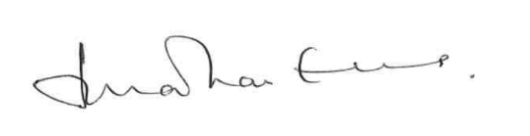

Lord Evans of Weardale KCB DL
Chair, Committee on Standards in Public Life

