Order Decision
Site visit made on 8 June 2022
by Wendy McKay LLB Solicitor (Non-practising)
an Inspector appointed by the Secretary of State for Environment, Food and Rural Affairs
Decision date: 15 July 2022

Order Ref: ROW/3280120
- This Order is made under Section 53(2)(b) of the Wildlife and Countryside Act 1981 (the 1981 Act) and is known as the Kent County Council (Bridleway EE226A at Woodnesborough and Sandwich) Definitive Map Modification Order 2020.
- The Order is dated 1 October 2020 and proposes to modify the Definitive Map and Statement for the area by upgrading a section of Public Footpath to a Bridleway as shown in the Order plan and described in Part I and Part II of the Order Schedule.
- There was one objection outstanding when Kent County Council submitted the Order to the Secretary of State for Environment, Food and Rural Affairs for confirmation.
Summary of Decision: The Order is confirmed.

Procedural Matters
- I made an unaccompanied site inspection on 8 June 2022 when I was able to view the whole of the Order route. I was also able to view the footpath EE225 between point D on the Order route and Church Street which had been suggested as a proposed modification to the Order route during the initial consultation process.
- The Application was made on behalf of the British Horse Society (BHS).
- The Order has been made by the Kent County Council, the Order Making Authority (OMA). The OMA supports the Order and has requested that it be confirmed.
- Following the making of the Order on 1 October 2020, it was advertised as required and one objection was received from one of the affected landowners. As indicated above, this objection is maintained. However, during the initial consultation period an objection to the application was received from Elgars on behalf of the other affected landowner. This objection was not re-stated during the formal Order advertisement stage. Nonetheless, I have had regard to the points raised by them in reaching my decision, albeit in the context of an objection that was made only at the pre-Order consultation stage.
- This decision refers to the points marked on the Order plan. For ease of reference, I have therefore attached a copy of the Order plan to this decision.

The Main Issue
- Section 53(3)(c)(ii) of the Act requires me to consider whether, on the balance of probabilities, the evidence discovered, when considered with all other evidence that is available, shows that a right of way that is shown on the Definitive Map and Statement (‘DMS’) as a highway of a particular description ought to be there shown as a highway of a different description. In this instance, the question is whether the footpath between points A-B-C-D-E on the map attached to the Order should instead be shown on the DMS as having the status of a bridleway.

Reasons

The Walton Estate Map (1622)
- The applicant has provided an extract from the Thomas Sackley estate map of Walton. This shows the Order route between points A and D as an enclosed track between fields. At D, the track turns north and is annotated ‘Bucksland Gate’. I note that Buckland Farm was then in different ownership to the Walton estate, and any continuation of the Order route beyond D towards E would not have been shown as part of the estate. However, the estate plan provides good evidence of the physical existence of the Order route between A and D at that time. Although no continuation of the way is shown beyond D, I consider that the reference to ‘Bucklands Gate’ strongly suggests that there was indeed provision for access to the east.

The Manor of Grove Map (1635)
- This map shows a way leading south-west from Sandwich along the line of the present bridleway ES8 which continues along the Order route between E and a point about halfway between E and D. It is also labelled ‘from Eastry Stone to Sandwich’. I concur with the applicant that this suggests the existence of a public road leading from one settlement to another.
- Although these two early estate maps do not unquestionably identify the status of the Order route, I consider that the inclusion of the ‘from/to’ annotation on the 1635 Manor of Grove map is strongly indicative that the route was a public thoroughfare. That view is reinforced by the evidence of the Hasted’s map to which I shall now turn.

The Barlow-Hasted Map of Kent (1799)
- The Hasted’s Map shows the Order route between points A and E as a defined way which continued north-east towards St Bartholomew’s Hospital, Sandwich. The route from D north-northwest to Church Street is also shown. The applicant acknowledges that not all routes shown on the map are inevitably public highways, but suggests that where a throughway is shown between two acknowledged highways, it becomes more likely that the throughway is also public. In my view, the Hasted’s map provides good evidence of the existence of a defined way along the whole of the Order route.

The Castle Estate Map of Walton (1821)
- This estate map shows the Order route east from A, staggered via B and C, as far as the eastern boundary of parcel 20 between C and D. At A the track is shown open to the junction with the public road at Foxborough Hill. Although it is described in the table of measured areas as a ‘road’, rather than a bridleway, I find the applicant’s explanation for this to be reasonable, particularly in the light of the ‘bridle-way to Sandwich’ annotation on the map at that eastern boundary. I consider that this map provides strong support for the status of the Order route as a bridleway, as acknowledged by the landowner at that time.

The Tithe Maps (1841)
- The Eastry Tithe Map shows the Order route east from A, staggered via B and C as far as the parish boundary between Eastry and Woodnesborough at D. The Order route is annotated ‘Bridle Road’ between C and D. The Woodnesborough Tithe Map does not show a defined path or track along the Order route with the exception of a short section of about 85m which is recorded as parcel 251a.
- I recognise that it was not the purpose of the Tithe Maps to distinguish between public and private rights of way. Nevertheless, I consider that the annotation on the Eastry Tithe Map provides substantial evidence that the western section of the Order route was considered to have the status of a bridleway at that time.
- Whilst the status of the eastern end of the Order route was not positively supported by the Woodnesborough Tithe Map, I consider that the applicant has provided a reasonable and likely explanation as to why it would not have been necessary for the route to have been shown on that map and why the record of parcel 251a as a ‘road’ in private occupation is consistent with the Order route as a bridle-road where the grazing in the parcel is assigned to the owner of the land. In my view, no adverse conclusions can be drawn from the Woodnesborough Tithe Map in that respect.

The deposited Great Kent (atmospheric) railway plan (1845)
- The applicant has provided plan extracts relating to the proposed railway which show the proposed railway branches to Sandwich and Deal and reveal the anticipated relationship between the line and the Order route. The Order route between B and C is labelled with parcel number ‘3s’ and between D and E it is labelled ‘8a’. The submission includes extracts from the Book of Reference for the Parish of Eastry which refers to parcel number 3s as ‘Occupation-road and footpath’, and the Book of Reference for the parish of Woodnesborough which refers to parcel 8a as ‘Footpath and bridleroad’.
- The Order route is therefore shown in a contradictory manner in that the description of its status between B and C is in conflict with the status shown on the Walton estate map, and the Eastry tithe map which was prepared only a few years earlier. Likewise, that status is hard to reconcile with the recorded status of the route between D and E as a ‘Footpath and bridleroad’.
- The applicant’s position is that given the legislative background and what can be gleaned from the plans, the conclusion can be reached that a crossing on the level was proposed. I find no reason to disagree with that stance. In those circumstances, it would not have mattered greatly whether the Order route between B and C was recorded as an occupation road, bridleway, or footpath as the railway company would, in any event, have intended to provide a crossing on the level with gates. It therefore seems likely that the surveyor of the railway company simply identified the track between B and C as an ‘Occupation road and footpath’ focusing on its use as a private (vehicular) occupation road with the intention of subsuming public bridleway rights within that classification.
- In my opinion, the deposited plan, and Book of Reference for the Great Kent (atmospheric) railway provide strong support for the Order route between D and E having the status of a public bridleway. Furthermore, I consider that the applicant has provided a credible and likely explanation for the approach of the railway company, and hence the discrepancies which have been identified in relation to the description of the Order route between B and C.

The Ordnance Survey boundary records
- The OS Boundary sketch maps date from 1869. The Woodnesborough boundary sketch map records the boundaries of the parishes of Woodnesborough and Eastry as crossing the Order route at D, and this is annotated as ‘Footpath’. On the Eastry field sketch map, the Order route is noted as a physical feature in the form of a track between A and D. It is identified by double-pecked lines, but without annotation. The applicant points out other inconsistencies with contemporary documents, and suggests that the annotation of the Order route as a footpath was mistaken.
- I recognise that the ‘Footpath’ annotation provides contrary evidence to be weighed against the confirmation of the Order in the overall balance of considerations. However, given that these were basically topographical surveys which were not concerned with land ownership or distinguishing between public and private rights I do not place undue reliance upon them.

The 1904 Eastry Rural District Council (RDC) minutes
- The 18 January 1904 Council meeting minute records: “The Clerk was directed to write to Mr F M Pepper requesting him to reinstate a bridle path which he had ploughed up, leading from St Bartholomews to Eastry and Woodnesborough Roads and being by the side of a ditch between lands occupied by Mr Deverson and himself.” The minute of the Council meeting of 15 February 1904 and the Eastry RDC surveyor’s report to the Council dated 29 February 1904, also make reference to this matter.
- The question has been raised as to whether the reference in the 18 January 1904 minutes actually refers to the Order route rather than to the Dover Road between Eastry and Sandwich such that the path identified was ES/ES8a from Sandwich to E, and then what is now footpath EE226 terminating at Biller’s Bush. However, I am unable to reconcile the description in the minute with a route to Biller’s Bush which has no connection with a road leading to Woodnesborough. I consider that it is far more likely that what was meant by the ‘Eastry and Woodnesborough Roads’ is the road leading between those two places. I am satisfied that the description of the path in the minutes refers to the Order route. The report and minutes positively identify that route as a bridlepath which reflects the reputation of the Order route as known to the district surveyor and the Council. Furthermore, the evidence does not indicate that the landowners disputed the status of the path as a bridleway at that time.

The deposited East Kent light railway plan 1911
- The applicant has submitted extracts from the deposited plan and the Book of Reference for the East Kent light railway. The original main line 1 was authorised in 1911 and crossed the Order route between D and E at X. The Order route is noted as parcel number ‘4’ on the deposited plan. The Book of Reference describes this parcel as ‘Arable, occupation road and public footpath’. Likewise, a subsequent proposal known as line 17 documents the Order route as an occupation road or public footpath. This therefore weighs against the status of the Order route as a bridleway. However, I shall consider the implications of this in the context of all the available evidence including the Eastry RDC records.

The Eastry RDC records
- The surveyor’s report to the Eastry RDC dated 5 August 1913 makes reference to the light railway having been erected “…across Bridle road leading from Foxborough Hill to Sandwich station.” The subsequent report to the meeting on 19 August 1913 refers to the erection of “…gates on Bridle Rd leading from Foxboro hill Woodnesborough to Sandwich Station.” This is recorded in the 1913 Eastry RDC minutes of the same date. The records of the meeting therefore confirm the view of the assistant surveyor to the Council that the Order route was then a bridleway, and the railway company was required to erect gates across it at X. This also provides sound evidence to support the opinion that the deposited plan and Book of Reference for the East Kent light railway referred to above were inaccurate in that respect.

The Electricity Supply Acts 1882 to 1933
- The Electricity Supply Acts notice of 23 October 1923 refers to “the road leading from Foxborough Hill, Woodnesborough to Sandwich”. It has been proposed that this description might refer to the road from Woodnesborough village to Sandwich. However, that would disregard the fact that notice was required to be given of the undertaker’s intention to lay its apparatus in certain streets not repairable by local authorities. Whilst the Order route would fit that description, it is not suggested that the other potential routes would have fallen within the scope of the notice on the basis that they were not publicly maintainable. The applicant submits that the ways identified as streets not repairable by local authorities are likely to be those which were regarded at the time as of either bridle or vehicular road status, being described as ‘roads’. However, I am unable to reach a similar conclusion from this evidence alone. Although the notice confirms the existence of the route as a public throughway of some kind, it provides little assistance as to the status of the Order route.

The HM Land Registry index map
- The extract from the HM Land Registry register of title index map and the two title plans indicate that the Order route from A to D is excluded from the registered titles. The title for the first part of the land between D and E extends to both sides of the Order route and the second part is unregistered. The applicant submits that the absence of any registered title to the Order route from A to D is good evidence that it is a highway in origin and likely to be of at least bridleway status. However, I do not believe that such an inference can safely be drawn as to the status of the route, and this is a factor to which I give little weight.

The Ordnance Survey Maps
- The OMA refers to the First Edition OS Map (1872) which shows the majority of the Order route as a double-pecked trackway braced to adjacent fields with the exception of the last 500 metres or so which is partly not depicted and partly shown as a field edge path. The Second Edition OS Map (1898) shows the whole of the Order route either as a double-pecked trackway or as a field edge path. It is annotated ‘F.P.’ throughout its length. The Third Edition OS Map (1907) shows the Order route in the same manner as the Second Edition OS Map.
- The objector at the initial pre-Order consultation stage referred to a number of OS Plans which show the Order route. It is acknowledged that OS mapping does not usually give any indication of public rights of way. However, the point is made that they do usually record the use at the time of the survey. They submit that the fact that the surveyors have for over 100 years recorded the use of the way from point A to point G, as ‘F.P.’ supports the view that there was no use of the route on horseback, only on foot. Whilst I recognise that the evidence derived from the OS Maps tends to point towards the Order route as a footpath this will be considered in the light of the purpose of the OS mapping process, along with the other conflicting evidence which has been submitted in support of the application in reaching my overall conclusion.

The Parish Map (1950), the Draft Map (1952) and the Definitive Map
- The 1950 Parish Map and survey would have been prepared in order to form the basis for the first definitive map. The Parish Map for Woodnesborough shows the Order route as a footpath. The route description indicates that it was generally in good order with gates either side of the railway line. The Parish Map for Sandwich shows Bridleway ES8A and part of the easternmost end of the Order route as ‘CRB 8’. The statement describes the route as a ‘Cart Road Bridleway to Woodnesborough’. The condition of the way is noted as a ‘rough cart track badly overgrown about 8 feet wide in poor condition, is well defined and deeply rutted in places’.
- As the OMA points out, it would appear that there were differing views as to the status of the route as a whole at the time of the Parish survey in 1950. The applicant submits that the identification of the route as a public footpath by Woodnesborough Parish Council when the remainder is identified as a bridleway in the neighbouring borough consistent with the historic mapping raises potential questions as to the accuracy of the Woodnesborough Parish Map. Whatever the reasons for the inclusion of the Order route on the Woodnesborough Parish Map as a public footpath, that status was recorded on the original 1952 Definitive Map and has continued to be shown in that manner thereafter.
- The Draft Map was subsequently prepared in 1952 by the County Council from the information contained in the Parish Map. The Draft Map for Woodnesborough shows the Order route as a public footpath with field gates depicted on either side of the railway. The Draft Map for Sandwich shows ES8A as CRB8, but does not include the Order route.
- The original Definitive Map for Kent County, and all subsequent revisions, show the entirety of the Order route as having public footpath status.

Physical evidence
- Whilst I note that the Objector refers to a locked gate at the Foxborough Hill road entrance, this was open at the time of my site visit. I was able to walk the whole of the Order route without obstruction. It appeared to me to be usable as a bridleway at present without any physical features that would be difficult or dangerous to negotiate. Although the route does narrow at the eastern end compared to the broader track to the west, I consider that it could easily be negotiated by horseback in its current condition. Indeed, I observed evidence of relatively recent user by a horse on the eastern section of the route. I also walked the modification to the route north from point D via the present course of the footpath EE225 and Church Street. This again could be negotiated without obstruction.

Overall conclusions on the evidence
- The test to be applied is whether the route ‘ought’ to be shown at a different status. The application falls to be considered on the basis of the historic evidence before me and not the desirability or otherwise of the route being recorded as having bridleway status. Furthermore, the legal principle of ‘once a highway, always a highway’ (Dawes v Hawkins 1860 141 ER 1399) means that rights do not become ‘lost’ over time merely though disuse or a change in the reputation of the route.
- The 1622 Walton Estate Map and the 1635 Manor of Grove Map confirm the Order route’s existence as a physical feature since that time. The Hasted Map of 1799 confirms the existence of the Order route as a single physical ‘through route’.
- Whilst latterly the route has more often been regarded as a public footpath, the strength of the earlier historic evidence is undeniable. There are specific references to ‘Bridle-way to Sandwich’ on the 1821 estate map, and ‘Bridleway’ on the 1841 Eastry Tithe Map in relation to the western end of the Order route. In addition, the reference to ‘from Eastry Stone to Sandwich’ on the 1635 estate map in respect of the eastern end of the Order route is pertinent and provides strong support for the Order route having historically been a through route between Foxborough Hill and Sandwich.
- The deposited railway plan prepared in relation to the 1845 Great Kent (atmospheric) Railway describes the eastern section of the Order route as ‘Footpath and Bridleroad’. Taking the evidence as a whole, I consider that the deposited plans and Book of Reference for the proposed atmospheric railway provide strong support for the status of the Order route between D and E as a public bridleway. Furthermore, I consider that the discrepancy in the description of the route between B and C, as revealed by this evidence, has been satisfactorily explained.
- The 1904 and 1913 Eastry RDC minutes provide robust evidence that the route was regarded locally as more than a public footpath. I concur with the OMA that the designation of the Sandwich section of the wider route between Foxborough Hill and Sandwich as a bridleway during the 1950 Parish Survey is consistent with this approach.
- The objection raised by the other affected landowner during the initial consultation period suggests that historically the Order route could alternatively have turned north at D and follow the present course of footpath EE225 and Church Street. However, in the light of all the evidence taken together, I do not find this to be a plausible suggestion. As the applicant points out, such a bridleway would have had no discernible purpose, since it would cover more than double the distance by road between point A and Woodnesborough Church. I do not therefore consider that the Order route should be modified as suggested by that other landowner.
- It seems to me that the balance of the evidence confirms the existence of a ‘through route’ with bridleway status between points A and E. The evidence to the contrary including that derived from the OS Maps does not dissuade me from that view. I conclude, on the balance of probabilities, that the evidence taken as a whole indicates that the Order route between points A and E ‘ought’ to be shown on the Definitive Map as having bridleway status.

The width of the route
- The 1950 Parish Survey describes the section east of the light railway to the parish boundary as having a width of 8 feet. No width is given in respect of the remainder of the path. The applicant therefore proposes that a width of 8 feet (about 2 metres) should be retained for the section to the east of the light railway and seeks a width of 3 metres for the remainder of the route being the minimum width which can accommodate two horses passing. The OMA agrees with that position, and this is reflected in the description of the path to be modified set out in the Part I of the Schedule to the Order.
- Given the limited historic information in relation to route width, and the absence of any identified width on the earliest mapping, I consider that it is reasonable for a width of 3 metres to be recorded in respect of the section to the west of the light railway (A to X), and a width of 8 feet for the section to the east (X to E). The Order description of the path to be modified does not therefore require any modification in respect of the stated width.

Other matters
- The Objector indicates that the track is used on a regular basis by external articulated lorries; by their own large tractors, trailers and other farm machinery and large balers and loaders operated by outside contractors. They raise concerns in relation to the safety of their staff, external staff, contract staff and members of the public walking the footpath on the grounds that horses could be frightened by the large vehicles and heavy machinery used in connection with the farming operations and behave unpredictably. They also raise potential security issues in connection with the locking of the Foxborough Hill road entrance gate.
- Whilst I recognise the genuine and practical nature of these concerns, the legal basis on which I must reach my decision does not encompass consideration of such matters relating to safety, security, and desirability. These are factors which I am therefore unable to take into account in reaching my decision.

Conclusions
- Having regard to these and all other matters raised in the written representations, I conclude that the Order should be confirmed.

Formal Decision
- I confirm the Order.

Wendy McKay

Inspector

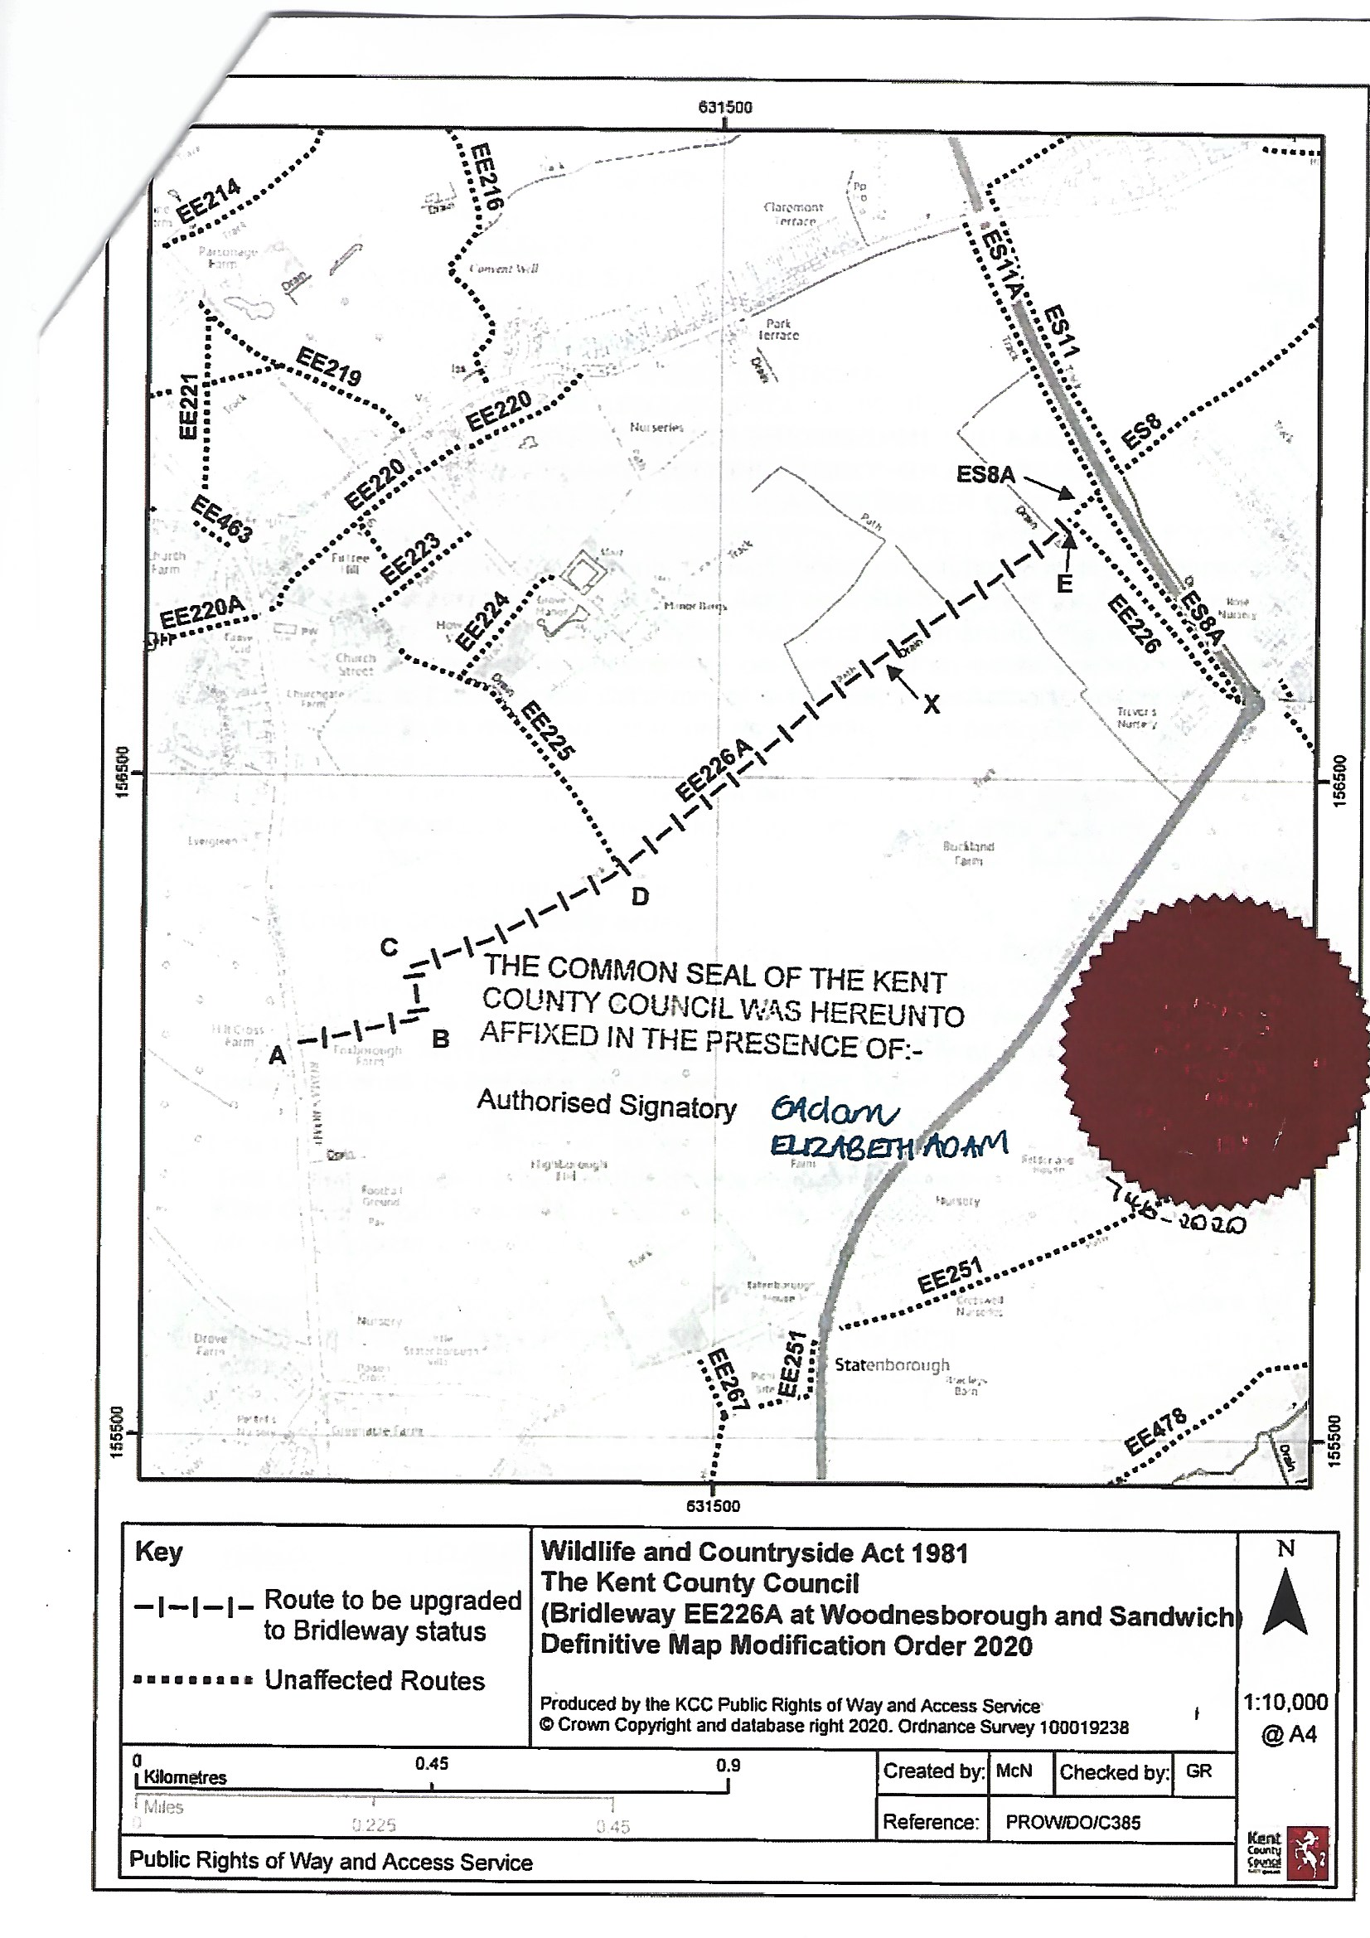

COPY – MAP NOT TO ORIGINAL SCALE

