Order Decision
Hearing Held on 17 May 2022
Site visit made on 16 May 2022
by D M Young JP BSc (Hons) MPlan MRTPI MIHE
an Inspector appointed by the Secretary of State for Environment, Food and Rural Affairs
Decision date: 22 June 2022

Order Ref: ROW/3267099
- This Order is made under Section 257 of the Town and Country Planning Act 1990 (the Act) and is known as the Dorset Council Public Footpath 24 (Part), 160, 161 (Part), 162 and Public Bridleway 21 (Part), Weymouth Public Path Diversion Order 2020.
- The Order is dated 26 June 2020 and proposes to divert the public rights of way shown on the Order plan and described in the Order Schedule.
- There were 5 objections outstanding when Dorset Council submitted the Order to the Secretary of State for Environment, Food and Rural Affairs for confirmation.
Summary of Decision: The Order is Confirmed

Procedural Matters
- I undertook an unaccompanied site visit on the evening of 16 May 2022. With the agreement of the main parties, a second site visit was not deemed necessary.
- The objectors did not attend the Hearing. Ian Beech, who had requested to be heard, subsequently contacted the Case Officer to explain that he had got the wrong date. In view of that, I afforded Mr Beech the opportunity to submit his evidence in writing after the close of the Hearing. Despite that, no evidence was submitted.

Application for costs
- At the Hearing an application for costs was made by Dorset Council against the Objectors. This application is the subject of a separate decision.

The Main Issues
- The Order was made because it appeared to the Council that it was necessary to divert the footpaths and bridleway to enable the erection of 114 dwellings on the land in accordance with application WP/17/00832/FUL (the planning permission).
- Section 257 of the Act requires that, prior to confirming the Order, I must be satisfied that it is necessary to divert the footpaths/bridleway to allow the development to be carried out in accordance with a valid planning permission which has not expired by the passage of time or is invalid on some other ground.
- My consideration of this Order under section 257 does not allow the merits of the planning application to be revisited. However, it should not be assumed that because planning permission has been granted that confirmation of an Order will automatically follow.
- I have a degree of discretion to consider the merits and disadvantages of the proposed diversions in relation to the facts that pertain and, in reaching a decision, I am entitled to take into account the effect the Order would have on those whose rights would be extinguished by it.
- In short, these legal tests have been described by the Courts as ‘the necessity test’ and ‘the merits test’. Confirmation of the Order requires both to be satisfied.

Reasons

Whether it is necessary to divert the footpath to enable the development to be carried out
- The approved layout means that it would not be possible to keep footpaths 24, 160, 161, 162 and bridleway 21 on their current legal alignments due to the layout of the development. I therefore agree that the diversions are reasonably necessary to enable the development to be carried out.
- On the basis of the land registry plans, I am satisfied that the proposed alignments would be over land controlled by the Applicant.

Whether the development is substantially complete
- When I visited the site, I saw that work to implement the planning permission is at an advanced stage. Crucially however, works have not commenced on those plots that are sited on the existing legal alignments of the routes. The Applicant has submitted a legal opinion which concludes “beyond doubt the development is not substantially complete”. None of those opposing the Order have challenged the legal opinion. On that basis, I am satisfied that the development is not substantially complete insofar as it relates to the Order routes.

The effect the Order would have on those whose rights would be extinguished by it
- In reaching a conclusion on this Order, I am required to weigh the advantages to be conferred by it against any disadvantages or loss likely to arise, either to members of the public generally or to persons whose properties adjoin or are near the existing path. Other than the newly constructed dwellings, there are no existing properties immediately adjoining the relevant sections of the Order routes. Nonetheless, as is clear from the objections, the routes are well used by local people looking to access the countryside to the south of the site.
- The Applicant’s evidence demonstrates that the length of the diversions would be fairly modest in their extent and would not significantly inconvenience existing users. One of the objectors argues that the proposed diversions would result in a 50% increase in the length of the routes. However, in the absence of cogent evidence to support that claim, the Applicant’s figures are to be preferred.
- Clearly there would be a marked change in the character of the routes as a result of them passing through or adjacent to a modern housing estate. However, that change of character would have been known to the Local Planning Authority when it granted planning permission. Given that section 257 of the Act does not allow me to revisit the merits of the original planning permission, the change in the character of the routes is not a consideration to which I can ascribe any degree of weight.
- I accept that the DEFRA Circular 1/09 advises, wherever possible, against diverting footpaths onto estate roads with preference being given to the use of paths through landscaped or open space areas. While some sections of the routes are proposed to run along footways, when considered as a whole, I consider the length of these sections to be limited and unavoidable given the size of the site and the number of routes that cross it. I therefore consider that the Order adheres to the aforementioned advice.
- Footpath 24 currently bisects the site in a north-south direction between Louviers Road and point F. The initial section of the path would be diverted onto the footway of the main access road before traversing the area of open space to the south of the estate. The overall change in the alignment of the route would be minor and would not inconvenience users.
- The changes to the alignment of footpath 160 would be more significant. Between points X and A, it would run along the same alignment as Bridleway 21. At point A, a new route would be created across the area of open space to point F. Despite that, there would be no change to the termination points and although there would be some increase to the length of the route, I do not consider this would be significant.
- Footpath 161 currently loops across the site between points H, G, F, L, K, J and I. The proposed diversion would follow a similar circular route with a new connection to Louviers Road at point V. Other than the section between points Q and N, which would run alongside the main estate road, the proposed route would traverse areas of open space within the development.
- Footpath 162 would be diverted onto the footway of one of the main estate roads. The termination points (Point A and E) would not change and any increase in distance would be minor. Bridleway 21 would be accommodated very close to its existing alignment within a landscaped corridor running through the development. As such, there would be no obvious disadvantage to this diversion.
- Overall, I am satisfied that the routes have been diverted as far as possible onto paths through landscaped or open space areas as advised by Circular 1/09. Although some sections of the Order routes would be diverted onto footways within the residential estate, care has been taken with the layout to minimise this. As vehicular speeds and volumes are likely to be very low along the estate roads, I am satisfied that there would be no significant disadvantage to the public.

Other Matters
- Those opposing the Order have raised various concerns many of which relate to the principle of having paths routed through a residential development. While it will be a disappointment to some, my determination of the Order must be based upon the criteria contained in section 257 of the Act and therefore I do not intend to stray into areas pertaining to the merits of the planning permission.
- Although there has been some suggestion that the routes could have been diverted differently, or that the proposed alignments might result in varying types of anti-social behaviour, no credible evidence has been submitted to support these concerns.

Conclusions
- Having regard to these and all other matters raised in the written representations, I conclude that it is expedient to confirm the Order.

Formal Decision
- The Order is confirmed.

D. M. Young
Inspector

APPEARANCES

For Dorset Council

Philip Crowther Solicitor

Paul Hopkins Countryside Access Management Ltd

For Persimmon Homes Ltd

Carol Ramsden Birketts LLP

Gregg Allison Persimmon Homes Ltd

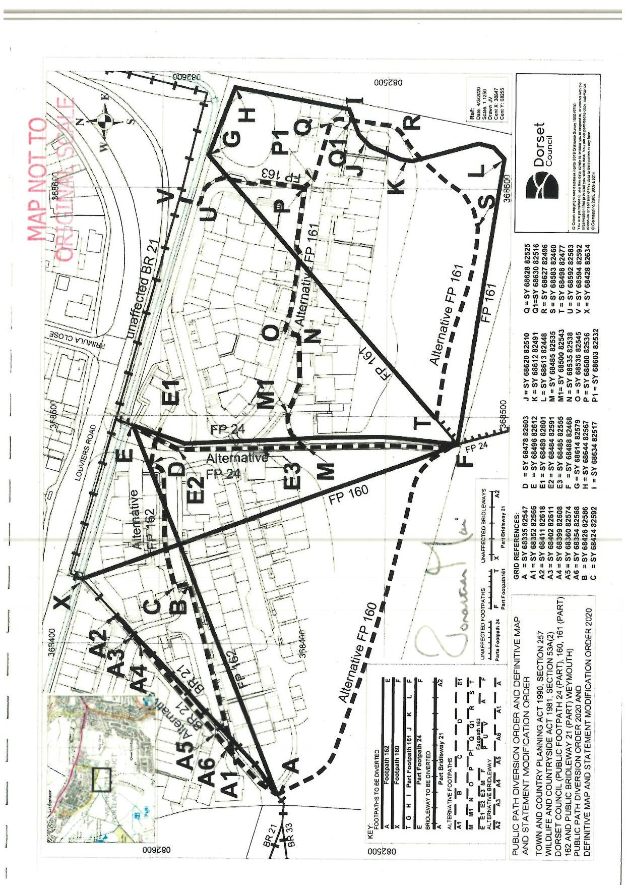

The objectors are Ian Beech, Tasha Pancherz, Ann (surname unknown), Hayley Dandy and Mrs Stanier.
Dwg No. LP08 Rev D see Appendix 14 of the Council’s Statement of Case
The Council confirmed that the development is approximately 80% complete

