Order Decision
Site visit made on 6 June 2022
by D M Young JP BSc (Hons) MPlan MRTPI MIHE
an Inspector appointed by the Secretary of State for Environment, Food and Rural Affairs
Decision date: 1 July 2022

Order Ref: ROW/3259830
- This Order is made under Section 257 of the Town and Country Planning Act 1990 and is known as the Northampton Borough Council Public Footpath HW44 (Part) Dallington Grange in the Borough of Northampton Public Path Diversion Order 2019.
- The Order is dated 18 June 2019 and proposes to divert the public right of way shown on the Order plan and described in the Order Schedule.
- There were five objections outstanding when Northampton Borough Council submitted the Order to the Secretary of State for Environment, Food and Rural Affairs for confirmation.
Summary of Decision: The Order is Confirmed subject to the Modifications set out below in the Formal Decision.

Procedural Matters
- I undertook an unaccompanied site visit on 6 June 2022 at which I was able to see and walk both the existing and proposed routes, save for the section A-F which was fenced off.
- The Order seeks to divert a section of footpath HW44 away from the existing level crossing between points A and B on the Order plan. Between points E-H-G-F the proposed route would be diverted onto an existing but unrecorded field path which loosely follows an unnamed watercourse. At point F the proposed route would pass under the railway bridge before turning north-west and running adjacent to the railway line to point A.

The Main Issues
- The Order was made because it appeared to the Council that it was necessary to divert the footpath to enable the development of a Sustainable Urban Extension comprising, amongst other things, the erection of up to 3,000 dwellings and 7.2 hectares of employment land in accordance with planning permission N/2014/1429 (the planning permission).
- Section 257 of the Act requires that, prior to confirming the Order, I must be satisfied that it is necessary to divert the footpath to allow the development to be carried out in accordance with a valid planning permission which has not expired by the passage of time or invalid on some other ground.
- Although the merits of the development are not at issue, it should not be assumed that because planning permission has been granted necessitating a path closure that confirmation of a diversion Order will automatically follow. I have a degree of discretion to consider the merits and disadvantages of the proposed closure in relation to the facts that pertain and, in reaching a decision, I am entitled to take into account the effect the Order would have on those whose rights would be extinguished by it.

Reasons

Whether it is necessary to divert the footpath to enable the development to be carried out
- In this unusual case, the footpath to be diverted falls outside the red line boundary of the planning permission. As a result, it is not the case that the diversion is necessary to allow the development to be carried out in a physical sense i.e. there are no buildings proposed on the legal alignment of HW44.
- The Council considers the diversion, or more specifically the closure of the level crossing between points A and B is necessary to ensure compliance with condition 54 of the planning permission which states:

No occupation of any part of the development shall take place until the footpath diversion on drawing no. P.1053_30 has been made, confirmed and brought into effect.

Reason: In the interests of public safety and to ensure a safe and secure development due to the proximity of the development to a level crossing in accordance with the aims of Policy S10 of the West Northamptonshire Joint Core Strategy
- There is no dispute that the planning permission cannot be implemented until condition 54 is discharged. Accordingly, it remains a ‘legal obstacle’ to the implementation of the planning permission.
- Section 257 of the 1990 Act is titled “Footpaths [bridleways and restricted byways] affected by development: orders by other authorities.” The inclusion of the words “affected by development” indicates that the scope of section 257 is limited to those situations where a development would make some material difference to a footpath. It is not however framed solely in terms of physical differences or affects. In this case, the approved development would clearly ‘affect’ HW44 through an intensification of its use through the construction of up to 3,000 houses nearby. In my view, a change in the user profile of a route can legitimately be considered an ‘affect’. Accordingly, I am satisfied that the proposed Order falls within the scope of section 257.
- As I understand it, condition 54 was imposed at the behest of Network Rail (NR) following concerns about the potential increase in footfall across the level crossing arising from the development. NR’s Statement of Case contains a significant amount of evidence which underpins the public safety case for closing the crossing. While it is not necessary for me to repeat all of that evidence here, it is important to note that it has not been challenged by those opposing the Order.
- I note that the Planning Practice Guidance (PPG) makes clear that conditions requiring compliance with other statutory regimes should not be imposed on planning permissions. While on the face of it there would appear to be some conflict with the PPG, NR has helpfully drawn my attention to a similar case where an Order under section 257 was used to close a level crossing pursuant to a condition imposed on a grant of planning permission.
- The Grampian condition in that case, which was not dissimilar to condition 54, was considered in some detail by Holgate J and Lindblom LJ in the High and Appeal Courts respectively and was not found to be unlawful. Moreover, it was held that the existence of a legal obstacle such as a planning condition could satisfy the necessity test for making an Order under section 257 of the 1990 Act.
- In light of the foregoing, I am satisfied that there is a clear public safety benefit in closing the level crossing. The planning permission is incapable of being implemented until the condition is discharged and that cannot happen unless the proposed Order is confirmed. I am therefore satisfied that it is necessary to divert the footpath to enable the development to be carried out.

Whether the development is substantially complete
- As I saw when I conducted my site visit, the development is not substantially complete.

The effect the Order would have on those whose rights would be extinguished by it
- In reaching a conclusion on this Order, I am required to weigh the advantages to be conferred by it against any disadvantages or loss likely to arise, either to members of the public generally or to persons whose properties adjoin or are near the existing path. Although there are no existing properties immediately adjoining the relevant sections of the Order route, as is clear from the objections, it is well used by local people.
- As set out above the most significant benefit of the Order is that it would enable the delivery of the planning permission. Given the quantum of new homes and employment land to be delivered, that must be seen as a significant benefit.
- The main argument against the Order is the additional distance that would be incurred. The existing length of the route between points A-B-C-D-E is approximately 195m. The distance of the new route would be some 625m which equates to an increase of 430m. By any measure that is a significant increase which would undoubtedly affect those existing users who use HW44 to access destinations to the west such as Harlestone Firs.
- I accept the point that there are likely to be a number of future paths intersecting with the Order route between points A-F which could potentially reduce the distance to these destinations. However, as I have no details of what these might be, I attribute very little weight to such arguments.
- Whilst the additional distance weighs against the Order, I am mindful that many walkers use HW44 in connection with other routes in the area for recreational purposes rather than commuting. In that context and given the myriad of available routes to the north of the railway line, I do not consider the additional 430 metres would be so significant as to discourage the public’s use of HW44. I accept that for those unknown number of people who use HW44 as a commuting route, the additional distance would be a disadvantage.
- In terms of accessibility and convenience I am mindful that the existing wicket gates at points A and B, the sharp gradients either side thereof and the railway crossing deck are all significant limitations which are likely to discourage use of HW44, particularly by the less mobile.
- While the objectors are right to raise concerns about the suitability of the proposed route with a focus on the footbridge at points H-G and the underpass at point F, it is incumbent on me to consider any proposed enhancement works set out in the Order. In this case, the section between points A-F would be metalled with links to the wider area of public open space and future development to the south of the railway line. The Order route would have a width of 2.5m with no steps or other limitations.
- The section under the railway bridge at point F is known to flood during periods of heavy rainfall. To address this, it is proposed to raise the path with a compacted surface as well as installing drainage where necessary. At points H-G the existing narrow footbridge would be removed and replaced with a more suitable and accessible structure, details of which would be agreed with the Council. Whilst sections of the Order route would undoubtedly be prone to flooding events, that is the case with the existing route. Accordingly, I do not see this as a disadvantage.
- There would be no obvious disadvantage to the Order route in terms of the quality of the walking experience. As I saw on my site visit, section E-H-G-F is a field path which enjoys pleasant views across the surrounding landscape. Although the section A-F would be adjacent to the railway line, it would be at a lower level and therefore users are unlikely to be unduly affected by passing trains. While there would be views of the new development that would also be the case from the existing route south of railway line.
- Cognisant of the works set out above, the Order route would be a significantly safer and more accessible route than the existing alignment. It would also enable the planning permission to be delivered which must be seen as significant public benefit in its own right. In my view, these advantages are sufficient to outweigh the disadvantages arising primarily from an increase in distance. Accordingly, the ‘merits test’ is passed.

Other Matters
- Those opposing the Order have raised various concerns many of which relate to the merits of the original planning application. However, my determination of the Order must be based upon the limited criteria contained in section 257 of the Act. I do not therefore intend to stray into such areas.
- Two modifications to the Order have been requested by the Council. The first is to insert additional words into paragraph 4(a) to make it clear that the width of the path is likely to be less than 2.5m over the replacement footbridge between points H-G. The second, is to clarify that a gap would be created in the existing fencing at point A. In both cases, the modifications are minor and do not affect new land. Accordingly, I am satisfied they do not require advertisement.

Conclusions
- Having regard to these and all other matters raised in the written representations, I conclude that it is expedient to confirm the Order.

Formal Decision
- The Order is confirmed subject to the following modifications:

Part 4 of the Order shall be amended as follows:

The following works shall be carried out in relation to the highway described in Part 2 of the Schedule:

(a) The path shall be a minimum of 2.5 metres wide throughout with the exception of that part of the route between Points H and G where the route crosses a watercourse, at which point the width shall be no less than 0.9 metres wide, the actual width to be agreed with the Highway Authority;

(b) A gap shall be created in the existing fence where the alternative route enters the field at Point A;

(c) The path shall be constructed to the specification agreed with the Highway Authority.

D. M. Young
Inspector

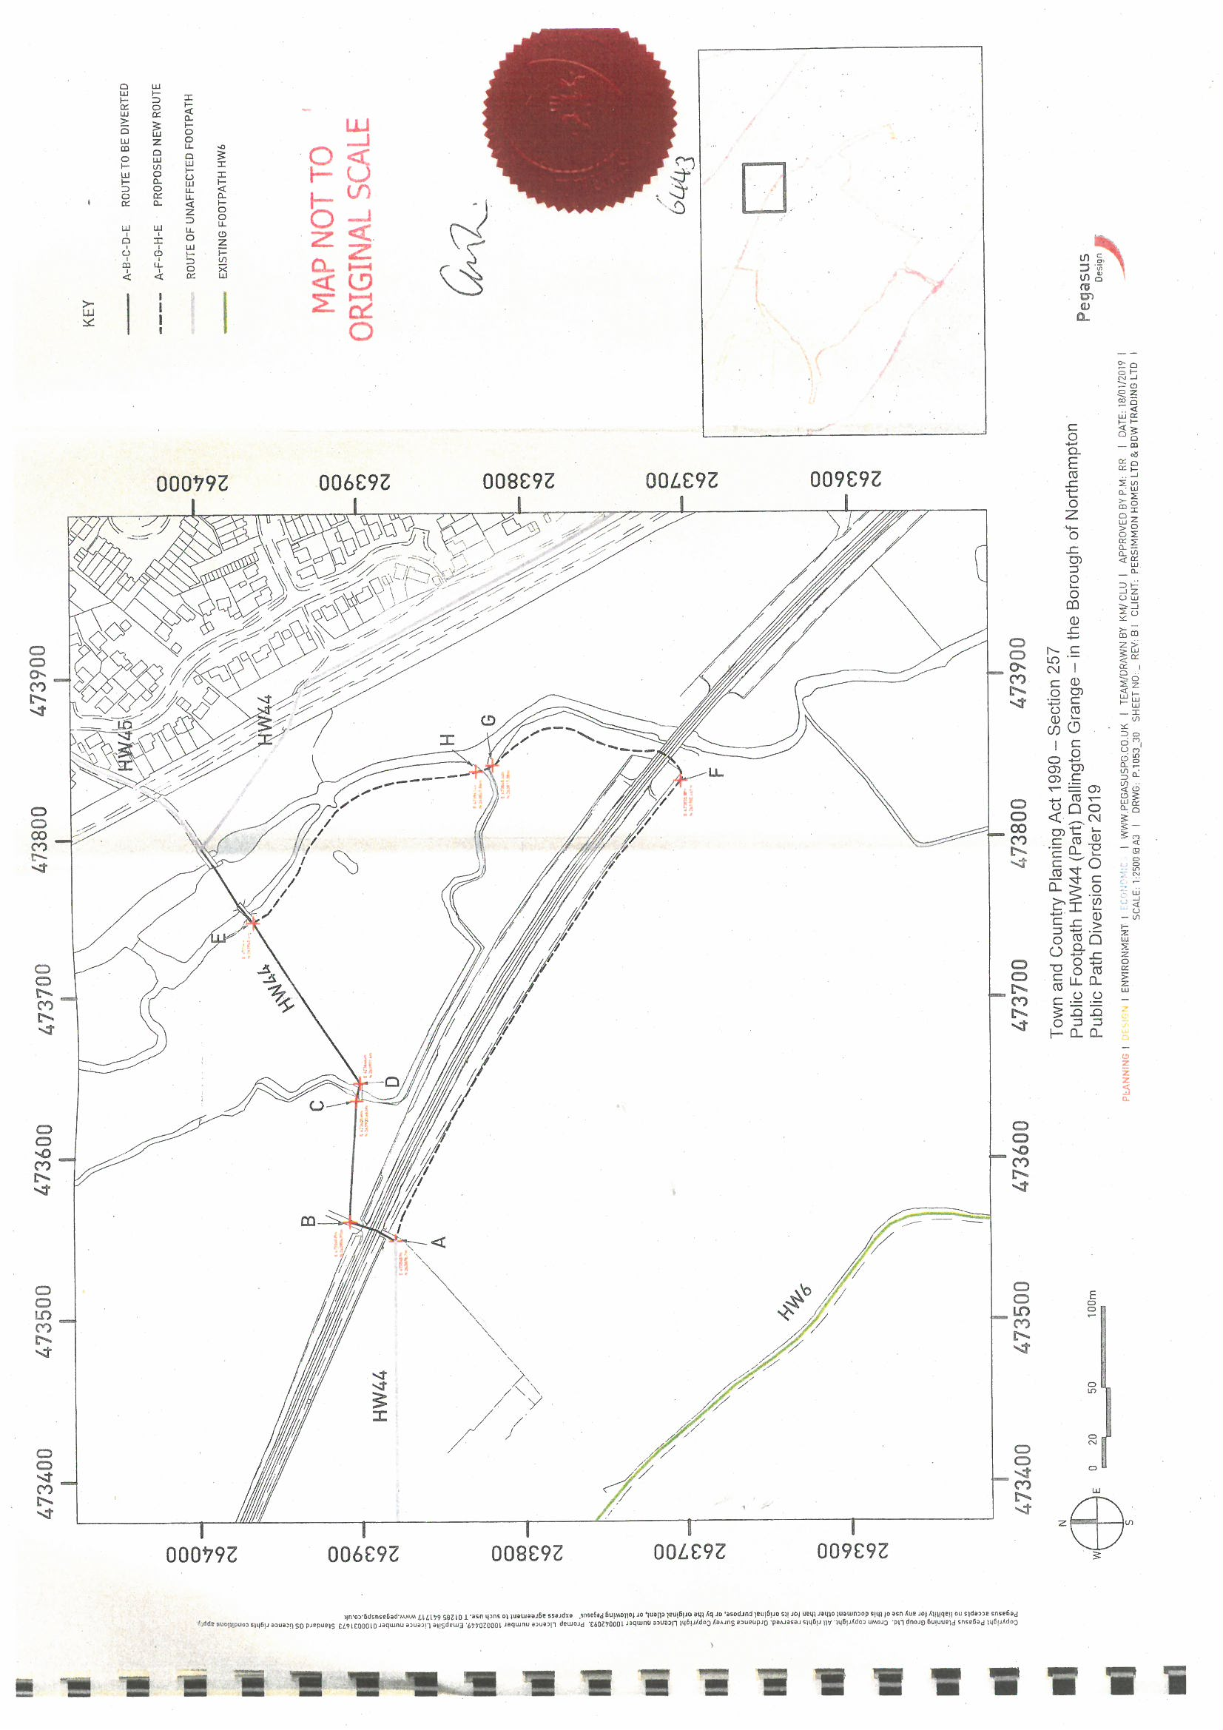

Paragraph 21a-005-20190723
The Dairy House Farm Stopping Up Order (No 1) 2015 (Footpath 303028) PINS Ref: FPS/H0928/5/1R

