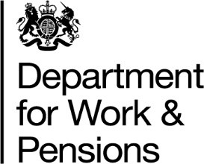
Pensions Dashboards: Further Consultation

Name of respondent/s / organisation (please provide):

Respondent Types - Please tick all that apply:

Pension Scheme type |  | Pension scheme size (Large; Medium or Small/Micro)
Master Trust |  | Large Scheme (1000 members+)
Money purchase (used for Automatic Enrolment) |  | Medium Scheme (100 -999 members)
Money purchase (other) |  | Small Scheme (<100 members)
Non money purchase (excluding Public Service Pension Scheme)
Public Service Pension Scheme
Hybrid
Administrator
Software provider
Consumer organisation
Dashboard provider
Other (please state)

Responses to consultation questions are optional. We ask that you provide your reasoning for your answers to the consultation questions that you respond to.
Question 1: Do you agree that 90 days is a reasonable period between the DAP formally being announced, and the DAP itself?

Question 2: Do you have any comments on the proposed powers to disclose information?

