Order Decision
Inquiry Held on 6-7 April 2022
Site visit made on 5 and 6 April 2022
by D M Young JP BSc (Hons) MPlan MRTPI MIHE
an Inspector appointed by the Secretary of State for Environment, Food and Rural Affairs
Decision date: 24 May 2022

Order Ref: ROW/3273792
- This Order is made under Section 53 (2) (b) of the Wildlife and Countryside Act 1981 (the 1981 Act) and is known as Kent County Council (Footpath AB70 at Tenterden Definitive Map Modification Order 2020).
- The Order is dated 4 December 2020 and proposes to modify the Definitive Map and Statement for the area by adding a footpath as shown in the Order plan and described in the Order Schedule.
- There was one objection outstanding at the commencement of the Inquiry.
Summary of Decision: The Order is not Confirmed

Procedural Matters
- The application to add a footpath to the Definitive Map and Statement (DMS) for the area was made by a local resident (Samantha Reed) in July 2019. The application was made shortly after the landowners deposited a map and statement under section 31(6) of the Highways Act 1980 (the 1980 Act).
- As objections to the Order were received, it was submitted to the Secretary of State for Environment, Food and Rural Affairs for confirmation.
- The Order route (AB70) is a circular route running from Woodchurch Road to Appledore Road around an area of land known locally as Limes Land. The landowners are Carol Daniel and Shaoul Birshan.
- The land has been managed on behalf of the landowners since July 2013 by Wates Development Ltd who submitted a planning application for a residential development to Ashford Borough Council in April 2021. In March 2022 that application was granted planning permission on appeal.
- I held a public Inquiry into the Order on 6 and 7 April 2022 having visited the site, unaccompanied, on 5 April. At that visit I was able to walk the entirety of the claimed route. Having heard evidence for and against the Order on the first day of the Inquiry, I carried out a further unaccompanied site visit on the evening of the 6 April looking specifically at the area around the large oak tree. A further site visit after the close of the Inquiry was not deemed necessary.

The Main Issues
- The Order is made under Section 53(2)(b) of the 1981 Act, relying on the occurrence of an event specified in Section 53(3)(c)(i) of the Act. This section requires me to consider whether the evidence discovered by the OMA, when considered with all other relevant evidence, is sufficient to show, on the balance of probabilities, that the right of way described in the Order subsists and that the DMS therefore requires modification.
- The Council rely on statutory dedication of the Order route under Section 31 of the 1980 Act. This provides that where a way, other than a way of such a character that use of it could not give rise at common law to any presumption of dedication, has been actually enjoyed by the public, as of right and without interruption, for a period of twenty years, the way is deemed to have been dedicated as a highway unless there is sufficient evidence that the landowner demonstrated a lack of any intention during this period to dedicate the route. As of right is set out in R v Oxfordshire County Council, ex parte Sunningwell Parish Council (1999) as being without force, secrecy or permission. The 20-year period applies retrospectively from the date on which the right of the public to use the way was brought into question.
- The main issue is therefore whether the discovery by the OMA of evidence, when considered with all other relevant evidence, is sufficient to show that a right of way which is not shown on the DMS subsists over the land in the area to which the map relates.
- In addition to considering the user evidence with regard to the provisions of section 31 of the 1980 Act, I am also required to consider whether dedication of the claimed route has taken place at common law. The evidential test to be applied, at common law or under the statutory provisions, is the civil standard of proof; that is, the balance of probabilities.

Reasons

Documentary Evidence
- Kent County Council (the Council) carried out a review of the documentary evidence as part of its investigations. Other than aerial images of the land, which I deal with below, it is agreed that the documentary evidence does not support the public’s use of the Order route over the relevant 20-year period. Accordingly, the case in support of the Order relies upon user evidence.

User Evidence

When the right to use the route was first brought into question

It is common ground that the public’s use of the route was first called into question on the 21 June 2019 when the landowners made a deposit under section 31(6) of the 1980 Act. The relevant 20-year period is therefore 21 June 1999 to 21 June 2019.

Whether there has been use by the public for the required period of 20 years
- 10 user evidence forms (UEFs) were originally submitted with 8 of the respondents being subsequently interviewed by the Council. Claimed use of the Order route extends as far back as the 1960s with several respondents referring to widespread use of the route by local people. Whilst the UEFs provide strong support for the recreational use of Limes Land by the general public over the relevant 20-year period, I have three principal concerns with the veracity of the evidence as it relates to the Order route itself.
- Firstly, 12 is not a particularly high number of UEFs, even less so when one considers that only 6 of the witnesses can attest to use of the route over the full 20-year period. Whilst I accept there are likely to be people who used the route but for whatever reason have not submitted UEFs, I must make my determination on the evidence before me and 6 UEFs is not a particularly strong starting point.
- Second, I concur with the objector (and the Courts) that human memory is inherently fallible particularly when it concerns events which occurred many years ago. This is especially so when memory is involved in litigation, where witnesses have a stake in a particular version of events. In this case, that unreliability has been demonstrated on several occasions for example by the failure of witnesses to recall fences and/or notices which were known to subsist at various points during the 20-year period.
- Third and as the Council’s witness accepted, the weight to be attached to the UEFs must be moderated by the provision of pre-prepared plans. In my view these plans at least had the potential to prejudice the information provided by the respondents particularly so in this case where it is common ground that there are/were a ‘myriad’ of walked routes over the land. In my view, the provision of a plan reduces the weight to be attached to the UEFs.
- Turning to the route described by the witnesses, Mr Forster’s UEF states that he followed an established route “around the edges of the field for the most part”. There is no mention of the oak tree or ditch. Many of the UEF’s are simply too vague to be of any evidential value. For example, Ms Douglas simply refers to the route as “all of field for grazing”, Dr Greaves refers to “circular route around fields”, Roland Green’s description appears to refer to AB12, Andrew Meike refers to a circuit around Limes Land whereas several others refer to a route from Appledore Road to Woodchurch Road and back again. I have not identified a single UEF which contains an accurate written description that corresponds to the alignment of the Order route.
- More detailed descriptions were provided in the follow up interviews. The Applicant who has only used the route since 2006 refers to the route skirting “around Limes Close…I then walk along the back of the houses on Appledore Road…”. Given that several of the aerial photographs show a route along the back of these houses, I cannot discount the possibility that this is a slightly different route and more akin to the circular/field edge route mentioned in several of the UEFs. That route is more consistent with some of the other evidence discussed below. As the Council accepted, proof of user must be over an exactly demonstrated course, if people have crossed land in the same general direction but by varying routes, their user cannot be aggregated and attributed to a single route.
- In their interviews, John Burton and Ros Debling provide a more detailed description of the route which does refer to the large oak tree and ditch in the western portion of the site. To that extent there is some support for the use of AB70 from these two users. However, and in common with the Applicant, Mr Burton’s claimed use does not cover all of the relevant 20-year period. Ms Debling used the route between 1985 and 2020 which does cover all of the 20-year period. Moreover, some confusion was introduced during her oral evidence when it was claimed that the oak tree would have been on her right when walking in an anti-clockwise direction. That would not have been consistent with the Order route.
- Accordingly, there is some doubt as to whether Ms Debling used the Order route or one of the many alternative routes ‘criss-crossing’ the land that numerous witnesses have referred to. There appears to have been a propensity to divert onto these other routes particularly during the winter months when the boggy ground would make it difficult to walk some routes. That narrative is entirely consistent with my observations on my site visits where I observed people opting to take the north-south route near the oak tree rather than jumping what was a fairly wide ditch adjacent to the oak tree.
- In oral evidence, Mr Greaves stated that the fence being on his right when walking from the back of his property southwards. This contradicts his UEF which refers walking south towards Appledore Road upon reaching the deep-water culvert. In my view, it is also likely Mr Greaves walked a north-south route either side of the large oak tree but not the alignment of AB70. I say that because there is no mention of the oak tree, nor the wide ditch immediately adjacent to it. As two of the most distinguishable features on the eastern side of AB70 one would expect such features to be mentioned.
- Perhaps my biggest concern is that the user evidence universally omits to mention the stock fence that was erected across the order route to the west of the oak tree and ditch. The evidence is not clear as to when this was erected. Mr Greaves stated in oral evidence that it was around 1996/97 although aerial images suggest it was a few years later between 26 June 1999 when no fence can be seen and April 2001 when the fences are clearly visible. The fences are visible on subsequent images from 2003, 2006, 2007 and 2008.
- On-site photographs taken between 2001-2016 provide further corroborating evidence. In particular, figures 8 and 21 of the June 2007 Landscape and Visual Appraisal categorically disprove the notion that the fence was flimsy and pushed over by livestock almost as soon as it was put up. The topographical survey of December 2013 records a 0.8m chestnut paling fence running in a north-south direct across the Order route.
- Other photographs suggest that a section of the stock fence north-west of the oak tree fell down before June 2013, possibly as early as 2010, when a track is visible to the north of the oak tree. The same section of fallen fence is shown clearly on the March 2014 photograph and to a lesser extent the July 2016 image. It was argued that the section of fallen fence seen on those photographs would have allowed the public to walk the alignment of the Order route. However, on my second site visit I made a specific point to view the oak tree from the same approximate location as the June 2014 photograph. On the basis of my observations, I am satisfied that the alignment of AB70 would still have been obstructed in 2014 and July 2016. This is because the section of fallen fence seen on the aforementioned images is to the north of the oak tree and not on the alignment of the Order route.
- As to whether the fence was pushed over by livestock or pedestrians, the evidence is unclear. However, given that sections of the fence are still intact today over 20 years later, I am not persuaded that its demise can be solely attributed to animals. I am also not persuaded that the average pedestrian could have simply ‘hopped over’ the ditch and then the fence, something which would have required a high level of athletic ability. Climbing, stepping or vaulting over the fence would not be consistent with the peaceable use of the route “as of right” irrespective of its purpose, which is not clear in any event.
- When considered in the round, the aerial images, site photographs and topographical survey collectively provide conclusive evidence as to the existence of the stock fence across the Order route between 2001 (possibly earlier) and 2016. I do not therefore subscribe to the Council’s view that the fence was only up for a ‘very short period of time’. If local people genuinely believed the route was public, I find it strange that not one person contacted the landowner or the Council as to enquire why the route had been obstructed. For all the above reasons, I give only limited weight to the user evidence

Actions by the Landowners
- Two users confirm that notices were erected to inform the public that there was only one public footpath across the land. For example, Mr Burton states that notices were erected around 2016 which included a map advising the public that they were only permitted to walk along the line of AB12. This is consistent with the landowners’ evidence. Photographs from May 2018 and February 2019 display the words “Please stay on the only footpath”. Whilst I accept this could have been open to interpretation by the public, the landowners’ intentions were nonetheless clear.
- Given the later evidence of signs being removed or vandalised, I consider there is a strong likelihood that notices were repeatedly “put up and torn down” during the 20-year period as claimed by the landowners. Additionally, Both Carole and Rio Daniel recalled issuing verbal challenges to people they found walking away from AB12.
- The above actions were in addition to letters sent to several local residents in 2014 and 2015 including Mr Greaves, Ms Debling and Mr Poole whose properties backed onto Limes Land. The letters made it clear that the land was private property and that the only access permitted to the public was the one public footpath running through the land from Appledore Road to Woodchurch Road. It follows that any use of the Order route thereafter by these individuals would not have been “as of right”.
- Considered as a whole, I consider the evidence demonstrates that repeated and proactive attempts were made by the landowners to discourage the public’s use of AB70 as well as Limes Land more generally from 2014 onwards. In truth it is difficult to know what more the landowners could have done during that period. This leads me to the conclusion that the public’s use of AB70 was not “as of right” as notices, verbal challenges and in some cases letters, were ignored.

A possible alternative route
- When considered in the round, I find the evidence in this case points much more strongly to a circular, field edge route following the backs of houses on Appledore Road rather than the alignment past the oak tree.
- As recorded in 2013 topographical survey, a gap was known to exist in the stock fence close to the shared boundary with Rose Cottage. The aerial images from 2003, 2006, 2007, 2008, 2010 also lend support to the existence of a gap at this location with a walked path visible along the southern boundary. Moreover, none of the photographs discussed above, show the fence connecting to the southern site boundary. Several, but not all, of the aerial images also show a walked route leading north (running parallel to the field edge) re-joining the line of AB70 to the west of the oak tree. Thus, the aerial images and topographical survey support the user evidence which refers to a circular, field edge route, including the Applicant herself.
- It is notable that a deliberate gap was also provided in the fencing further north near the bomb crater. That gap broadly correspondents to the line of the Order route. This raises the possibility that a gap in the fencing was deliberately provided adjacent to Rose Cottage to also enable the movement of pedestrians onto the land. It is also possible that the fence did connect to the southern site boundary when it was first erected but was subsequently removed prior to the topographical survey being carried out or that both gaps were intended to facilitate the movement of livestock rather than people.
- This alternative alignment would go some way to explaining why no complaints were received when the fence was erected and why witnesses failed to mention the stock fence in their evidence. There are however problems with the user evidence for this alternative route alignment. Although many users referred to a ‘circular’ or ‘field edge’ walk, that has to be seen in the general context of AB70 as a whole rather than this specific location and does not greatly assist. There is also the aforementioned concern that none of the witnesses have been able to provide; their own map of the route, a detailed description matching AB70 or evidence of use over the full 20-year period.
- As discussed above, it is also clear from the landowners’ evidence that meaningful steps were taken during the 20-year period to disabuse members of the public of the notion that there were public rights of way on the land other than AB12. In light of the foregoing I am not persuaded, on the balance of probabilities, that the evidence is support of the alternative route is sufficiently strong to meet the standard for confirmation.

Overall conclusions on the evidence
- I have no doubt that local people have enjoyed access over the majority of AB70 over the 20-year period and possibly before. I also agree that witnesses have provided their evidence in good faith. However, the aerial images, topographical survey, landowner testimony and on-site photographs categorically disprove that the public could have used the order route without force, secrecy or permission in the vicinity of the oak tree and ditch for a significant proportion of the 20-year period. Accordingly, the claim to add AB70 to the DMS must fail.
- In accordance with the Trevelyan principles I have carefully considered whether there is a case to modify the Order to include an alternative alignment following the backs of the houses on Appledore Road making use of a gap in the fence that was known to exist in 2013. Whilst I consider the evidence supporting this alignment is much stronger than that for Order route, I am not persuaded that the evidence before me is strong enough to support statutory dedication. I do not therefore intend to propose a modification to the Order.

Common law Dedication
- Where a claim fails under statute fails, I am obliged to give consideration to the evidence at common law. An inference that a way has been dedicated for public use may be drawn at common law where the actions of landowners (or lack of action) indicate that they intended a way to be dedicated as a highway and where the public have accepted it.
- Given the user evidence submitted is insufficient to raise a presumption of dedication under the statutory provisions, it follows that such user evidence is also insufficient to raise an inference of dedication at common law. I therefore conclude there is insufficient evidence to support common law dedication.

Conclusions
- The burden of proof in this case lies initially with the Applicant to demonstrate that public use of the route occurred for at least 20 years prior to the use being brought into question. For the reasons given, the evidence adduced in this case does not meet the requisite standard for confirmation. I have also found there is insufficient evidence to show dedication of the route at common law.
- Having regard to these and all other matters raised at the Inquiry and in the written representations, I conclude that the Order should not be confirmed.

Formal Decision
- I do not confirm the Order.

D. M. Young
Inspector

APPEARANCES

For Kent County Council

Noemi Byrd of Counsel

She called

Maria McLaughlan Kent County Council – Rights of Way Officer

Adrian Greaves Local Resident

Rosalynd Debling Local Resident

James Forster Local Resident

Other Persons Supporting the Order

Samantha Reed Applicant

Kevin Paige Local Resident

Albert Poole Local Resident

Stephen Parsons Local Resident

Russell Parkin Local Resident

In opposition to the Order

Anjoli Foster of Counsel

She called

Christine Cox Air Photo Services

Carol Daniel Landowner

Rio Daniel Wates Development Ltd

LIST OF INQUIRY DOCUMENTS

- Statement of Case of Albert Poole – handed into the Inquiry on 6 April 2022

- Appeal Decision dated 30 March 2022 Reference APP/E2205/W/21/3284479

- Council’s Opening Statement

- Applicant’s Opening Statement

- Objector’s Opening Statement

- Objector’s Closing Statement

- Council’s Closing Statement

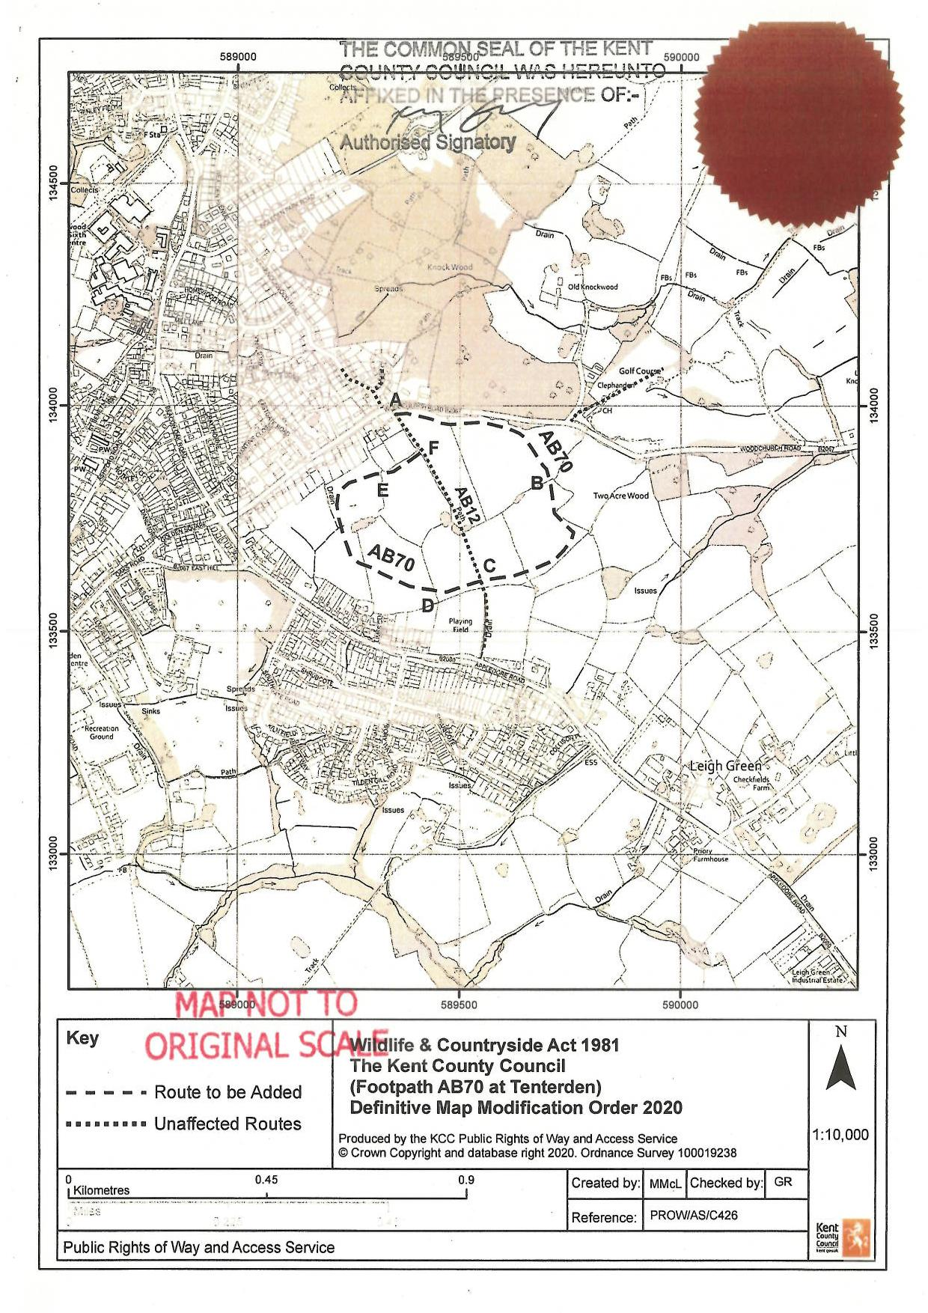

For the erection of up to 141 residential dwellings LPA Ref: 21/00790/AS
PINS Ref: APP/E2205/W/21/3284479 – See Inquiry Document 2 for Decision Letter. On 19 May 2022 Ashford Borough Council set out its intention to challenge the decision.
See pages 5-8 of the Delegated Report Appendix 20 the Council’s Evidence
As I understand it two further UEFs were submitted at a later date by the Applicant
Page 22 Council’s Statement of Case
The only UEFs to mention the oak tree and ditch are those from John Burton and Ros Debling
See paragraph 27 of the Council’s Statement of Case
Mr Parsons, Ms Debling, Ms Reed and Mr Poole Evidence in Chief
See Appendix 4 to Rio Daniels’ Proof of Evidence
See July 2010 aerial image
Mr Burton and Mr Forster
See Appendix 4 to Rio Daniels’ Proof of Evidence
On the basis of the word spacing and a clearly visible ‘y’ below the green twine
See Appendix 4 to Rio Daniels’ Proof of Evidence
See top right corner of topographical sheet 12
Image of July 2010 is good example
See Trevelyan v SSETR [2000] NPC6, (CA) [2001] EWCA Civ 266 [2002] 1 WLR 1264: “if, in the course of an inquiry, facts come to light which persuade the inspector that the definitive map should depart from the proposed order, he should modify it accordingly, subject to any consequent representations and objections leading to a further inquiry”

