Order Decision
Site visit made 15 June 2020
by Heidi Cruickshank BSc (Hons), MSc, MIPROW
an Inspector appointed by the Secretary of State for Environment, Food and Rural Affairs
Decision date: 1 June 2022

Order Ref: ROW/3220614M1
- This Order is made under Section 53(2)(b) of the Wildlife and Countryside Act 1981 and is known as The West Sussex County Council (Chichester No. 1 – Arundel (addition of a Footpath) Definitive Map Modification Order 2018.
- The Order is dated 14 November 2018 and proposes to add a footpath running between Queen Street and Fitzalan Road via Caen Stone Court to the Definitive Map and Statement. Full details are set out in the Order Map and Schedule.
- In accordance with paragraph 8(2) of Schedule 15 to the Wildlife and Countryside Act 1981 notice has been given of the proposal to confirm the Order subject to modifications.
Summary of Decision: The Order is confirmed subject to modifications originally proposed as set out in the Formal Decision.

Procedural Matters
- The Interim Order Decision (IOD), issued on 23 July 2020, was made following an unaccompanied site visit, taking account of the written representations submitted. In the IOD a modification was proposed to the alignment of the Order route.
- Following notice of the proposed modifications two objections were duly made, raising matters relevant to the proposed modification. There was no request to be heard and so the matter was dealt with by way of written representations; no further representations were received following the initial objections.

Main issues
- The main issue is whether the matters raised, taken in conjunction with the evidence as a whole, indicate that the proposed modifications should be amended or removed or additional modifications should be made or proposed, or that the Order should not be confirmed, on the balance of probabilities.

Reasons
- Objections to IOD generally revisited matters on which findings have already been made. It was said that there was insufficient evidence on which to conclude that the way had actually been enjoyed by the public as of right and without interruption for a full period of 20 years. It was indicated that further evidence would be adduced to show that there was no intention to dedicate a public right of way; no further evidence was submitted.
- In light of the arguments and being mindful of the implications arising from confirmation of this Order, the entirety of the evidence has been reviewed. I am satisfied, on the balance of probabilities, that there was sufficient evidence that the proposed route was used over the period 1985 – 2005, giving rise to a presumption of dedication. Whilst the user evidence is lower in the earliest years, it is sufficient to support the evidence and presumption.
- The concern as to undue weight being given to whether health and safety matters may not have been such a concern in years gone by is noted. The user evidence supports the proposition that there was continued use through this area during the time that it was used as a garage forecourt; no evidence was adduced to show that this was not the case or in relation to other occupation or use of the site during the relevant twenty-year period. The original assertion that users would not have been able to use the garage forecourt due to health and safety concerns is not supported by the evidence as a whole.
- The evidence points to continued use of a route in this area even after the building of Caen Stone Court, until such time as the gate was locked. Alongside that there have been continued attempts for a route to be recorded, whether through the planning process or by agreement and, ultimately through the application leading to this Order. This indicates that the public have not accepted that there was no right of way and have continued to attempt to assert their rights over the land. There have been interruptions to the alignments but, as set out in the IOD, careful analysis of the documentary evidence, alongside the user evidence, assists in identifying the alignment which was available and used, on the balance of probabilities, throughout the relevant twenty-year period.

Other matters
- It is entirely understood that the routing of a right of way through the apartment block is a matter of concern for those owning and occupying the property. However, this is not an issue which can be considered in such cases. Management of the process going forward to identify an appropriate solution sits with the OMA in their role as the highway authority for the area.

Conclusion
- Having regard to the evidence as a whole, I conclude that the Order should be confirmed, subject to modifications with regard to alignment of the route of the footpath, as set out in paragraph 49 of the IOD.

Formal Decision
- I confirm the Order subject to the following modifications:
    - Within Part I of the Schedule:
    - replace text “…501991, 106886…” with text “…501996, 106882…”;
    - add text “…north-…” to text “…north-easterly…”;
    - replace text “…32 metres then continuing along the south eastern side of Caen Stone Court for approximately 10…” with text “…46…”;
    - replace text “…502033, 106899…” with text “…502014, 106921…”;
    - replace text “…A and B…” with text “…X and Y…”;
    - add text “Width 2 metres”;
    - Within Part II of the Schedule:
    - replace text “…501991, 106886…” with text “…501996, 106882…”;
    - add text “…north-…” to text “…north-easterly…”;
    - replace text “…32 metres then continuing along the south eastern side of Caen Stone Court for approximately 10…” with text “…46…”;
    - replace text “…502033, 106899…” with text “…502014, 106921…”;
    - add text “Width 2 metres”;
  - On the Order map:
    - delete route shown A - B;
    - delete text “A” and “B”;
    - add route X - Y;
    - add text “X” and “Y”.

Heidi Cruickshank

Inspector

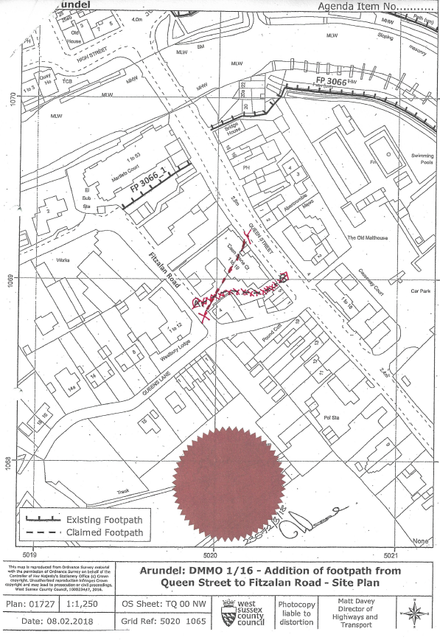
MAP NOT TO ORIGINAL SCALE

