Invitation easy read letter template. Use screening centre headed paper. This letter includes text boxes to be completed before sending.

Dear Click here to enter text.
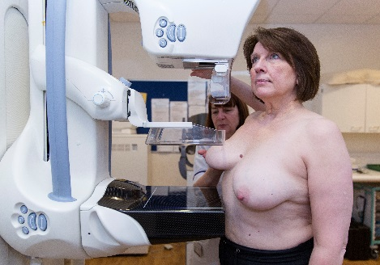

We are inviting you for a check to make sure your breasts are healthy.

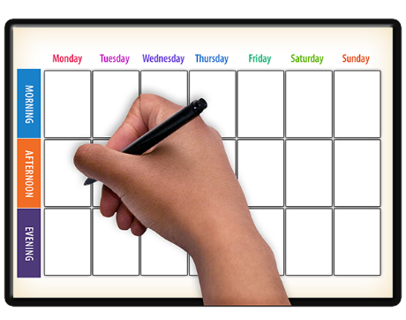

Your appointment is at
Click here to enter text.

on
Click here to enter text.
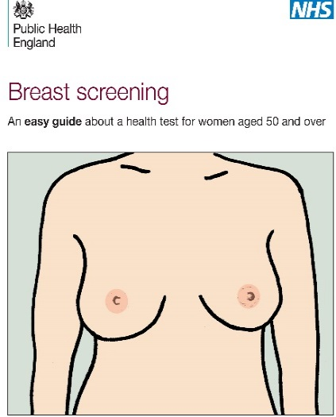 | There is a useful leaflet which looks like this.  Reading this leaflet can help you decide if you want to have your breasts checked.  Please call us on Click here to enter text. if you want us to send you this leaflet.
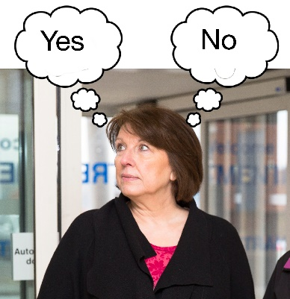 | It is your choice if you want to have your breasts checked.  Having your breasts checked is important but if you are worried or unsure please call us on Click here to enter text.
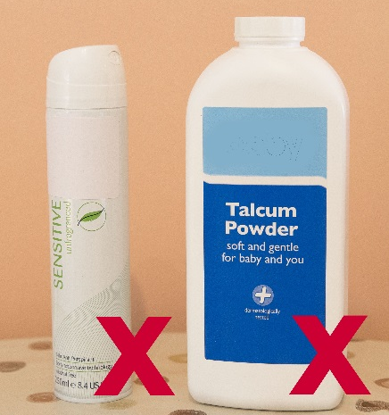 | Please do not use talcum powder or a spray underarm deodorant before your appointment.  But you can use a roll-on deodorant.
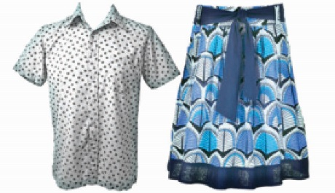 | It is a good idea to wear a top with a skirt or trousers, so you only have to take your top off for the test.
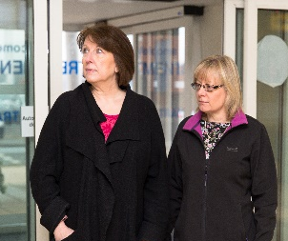 | You can bring a friend or carer with you.
If you want an appointment at a different time or place, please call us on Click here to enter text. Please also call us if you want more information.

You can ask a relative, friend or carer for help. You can also call your learning disability team on Click here to enter text.

Yours sincerely,

