NOTICE OF ORDER

Highways Act 1980 – Section 119
NOTTINGHAMSHIRE COUNTY COUNCIL
(Greasley Footpath No. 32 and No. 40) Diversion Order 2019

Notice is hereby given that the above referenced Order has been submitted to the Secretary of State for Environment, Food and Rural Affairs for determination. An Inspector will be appointed by the Secretary of State to determine the Order.

The start date for the above Order is 12 May 2022.

Consideration of the Order will take the form of a public local inquiry.

The Inquiry will be held at County Hall, Loughborough Road, West Bridgford, Nottingham, NG2 7QP on Tuesday 11 October 2022 at 10.00am.

The appointed Inspector will also open the Inquiry as a virtual event on Tuesday 11 October 2022 at 10.00am.

Anyone wishing to attend the Inquiry virtually must register that interest with the Council as soon as possible prior to the Inquiry, but no later than Friday 30 September 2022, either by email or telephone, details of which are set out in this notice.

Guidance outlining any specific requirements around social distancing and the wearing of masks etc. will be available on the Council’s website prior to the Inquiry.

The Order Making Authority will prepare bundles of case documents for the Inspector and the Council’s team. The documents will be available to others electronically on request.

The effect of the Order, if confirmed without modifications, will be to divert the public rights of way as shown on the order map and as detailed below.

Greasley Footpath No. 32

That part commencing from a point, SK 4835 4632, and proceeding for a distance of approximately 196 metres to a point, SK 4846 4646 to a line running from a point SK 4835 4632 and proceeding for a distance of approximately 191 metres to a point, SK 4846 4646.

Greasley Footpath No. 40

That part commencing from a point, SK 4838 4636, and proceeding for a distance of approximately 85 metres to a point, SK 4830 4637 to a line running from point SK 4839 4637 and proceeding for a distance of approximately 93 metres to a point SK 4830 4637.

Any queries relating to this Order should be referred to Helen Sparks at The Planning Inspectorate, Rights of Way Section, Room 3/A Eagle Wing, Temple Quay House, 2 The Square, Temple Quay, Bristol, BS1 6PN. Telephone: 0303 444 5646.
Email: helen.sparks@planninginspectorate.gov.uk Please quote reference number ROW/3262032 on all correspondence.

Any person wishing to view the statements of case and other documents relating to this Order may do so by appointment at Nottinghamshire County Council, County Hall, Loughborough Road, West Bridgford, Nottingham, NG2 7QP. The documents will be available to view online at; Rights of way news | Nottinghamshire County Council or E-mail countryside.access@nottscc.gov.uk. The contacts for the inquiry are Mr Neil Lewis, Ms Helen Swift and Mr Angus Trundle at E-mail Address: countryside.access@nottscc.gov.uk Telephone Number: 0115 977 3169.

Timetable for sending in statements of case and proofs of evidence

Within 8 weeks of the start date [by 7 July 2022]

The Order Making Authority must ensure their statement of case is received by the Secretary of State. As soon as possible after the deadline, the Secretary of State will send a copy (excluding copies of any supporting documents - these will be available to view at the Authority’s offices) to everyone who has made an objection or representation and the applicant and any other person who has written to us in respect of the Order.

Within 14 weeks of the start date [by 18 August 2022]

Everyone who has made an objection or representation and anyone who wishes to give evidence at the Inquiry must ensure their statement of case is received by the Secretary of State. As soon as possible after the deadline, the Secretary of State will send full copies to the Authority. Copies will also be sent to the applicant, every person who has made an objection or representation and any other person who has written to us in respect of the Order (excluding copies of any supporting documents - these will be available to view at the Authority’s offices).

Within the same period the applicant (if applicable) must ensure their statement of case is received by the Secretary of State. As soon as possible after the deadline, the Secretary of State will send a full copy to the Authority. Copies will also be sent to everyone who has made an objection or representation and any other person who has written to us in respect of the Order (excluding copies of any supporting documents - these will be available to view at the Authority’s offices).

4 weeks before the date of the inquiry [by 13 September 2022]

The Authority, everyone who has made an objection or representation, the applicant (if applicable) and anyone who wishes to give evidence at the Inquiry must ensure their proof of evidence (together with any summary) is received by the Secretary of State. As soon as possible after the deadline, the Secretary of State will send copies of:

- the Authority’s proof of evidence to everyone who has made an objection or representation, the applicant and anyone who has submitted a statement of case (excluding copies of any supporting documents – although none should be submitted with a proof of evidence);

- the applicant’s proof of evidence to the Authority, everyone who has made an objection or representation and anyone else who has submitted a statement of case (excluding copies of any supporting documents – although none should be submitted with a proof of evidence); and

- all other proofs of evidence to the Authority, the applicant, everyone who has made an objection or representation and anyone else who has submitted a statement of case (excluding copies of any supporting documents – although none should be submitted with a proof of evidence).

All parties must keep to the timetable set out above and ensure that statements of case and proofs of evidence are received by the Secretary of State on time. Late documents will be returned.

We cannot accept any libellous, racist or abusive comments. Any documents containing such comments will be returned.

Notice of order for inquiry

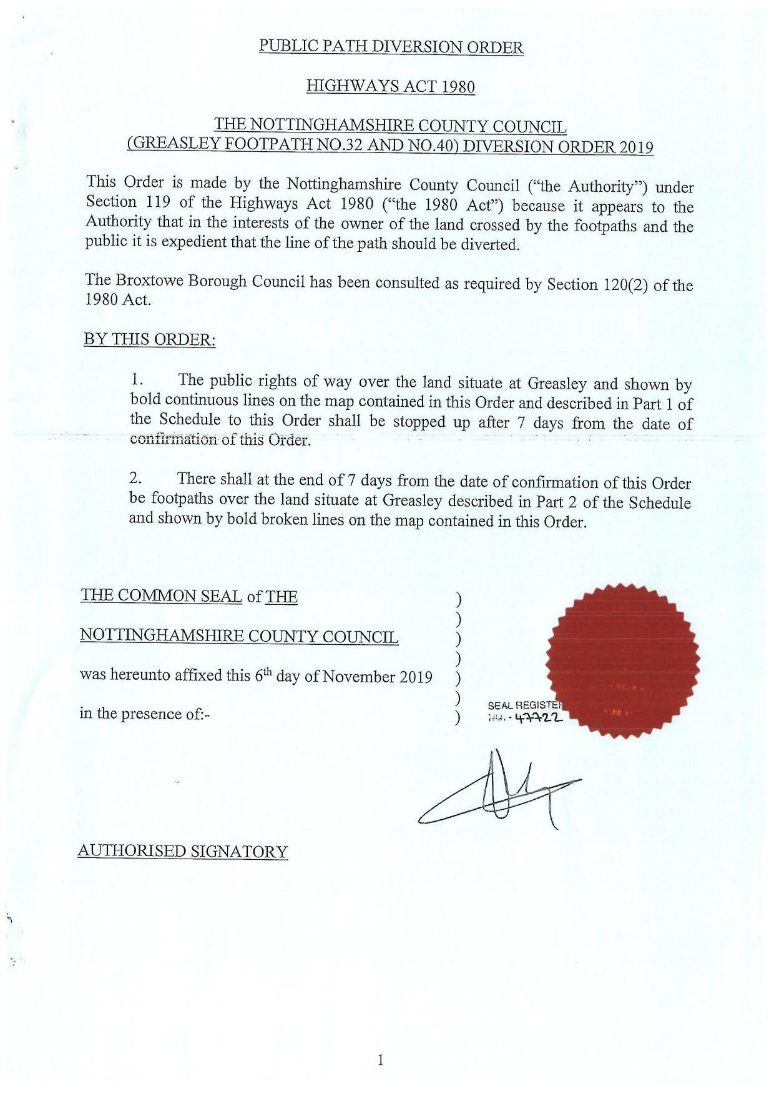

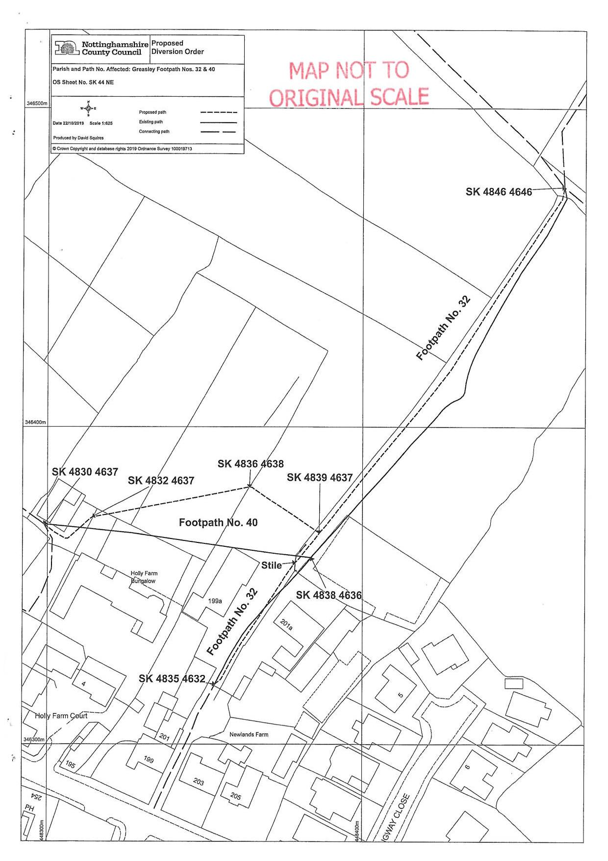

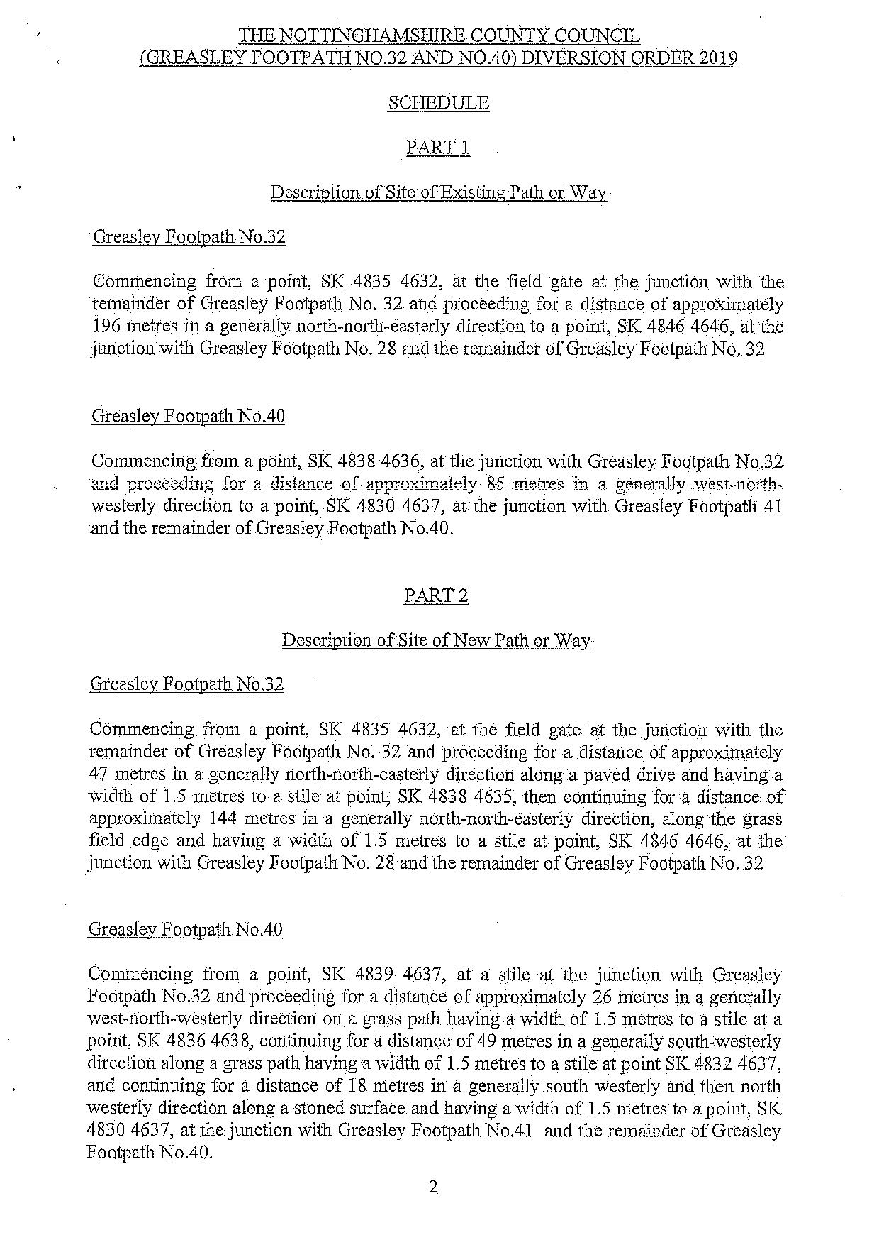

If you wish to make a legal submission, this should be submitted at the same time as your statement of case. Otherwise legal submissions will have to be submitted in writing on the day of the inquiry.

