Application Decision
Unaccompanied site visit made on 8 March 2022
by Paul Freer BA (Hons) LLM PhD MRTPI
an Inspector appointed by the Secretary of State for Environment, Food and Rural Affairs
Decision date: 4 April 2022

Application Ref: COM/3284928
Hergest Ridge and Hanter Hill
Register Unit: RCL0001
Registration Authority: Powys County Council

- The application, dated 23 September 2021, is made under Section 38 of the Commons Act 2006 (“the 2006 Act”) for consent to carry out restricted works on common land.
- The application is made by Mr William Lawrence Banks.
- The application is for fencing.

Decision
- Consent is granted for the proposed works in accordance with the application dated 23 September 2021 and the plans submitted with it subject to the condition that (1) the works shall be begin no later than 3 years from the date of this Decision and (2) the consent is limited to a period of 10 years beginning from the date of this Decision.

Main Issues
- I am required by Section 39 of the 2006 Act to have regard to the following in determining this application:

(a) the interests of persons having rights in relation to, or occupying, the land
(and in particular persons exercising rights of common over it);

(b) the interests of the neighbourhood;

(c) the public interest; and

(d) any other matter considered to be relevant.
- In considering these tests, regard should be given to the Department for Environment, Food and Rural Affairs Common Land Consents Policy of November 2015 (“the consents policy”).

The application
- The proposed boundary fencing works are required to replace some sections of the existing boundary fence (totalling 3420m in length) towards the eastern end of Hergest Ridge. Due to its age, the existing fencing is considered to be no longer fit for purpose in terms of keeping stock grazing on neighbouring properties off the common or to prevent stock grazing on the common from entering neighbouring property. The proposed fencing works are part of a Countryside Stewardship Higher-Tier agreement application that has been submitted by the Commoners Association. The applicant considers that the works will ensure that the overall stocking density on the common is maintained, which he considers to be key for the proposed management of grassland under the Higher Tier scheme.

Reasons

The interests of those occupying or having rights over the land
- There are rights over the land registered to several individuals, who collectively hold rights to graze sheep on the common and to cut bracken for litter. The purpose of the proposed fencing, and the fact that sheep were grazing on the common at time of my site visit, tend to indicate that those rights are exercised. The holders of the above rights have raised no objection to the application. In my view, for the reasons set out in the application, the fencing would assist the management of the common and to that extent would safeguard and indeed promote the rights held by those individuals. I therefore conclude that the interests of those having rights over the land in question would not be adversely affected by the proposed fencing.

The interests of the neighbourhood
- The fencing would replace sections of existing fencing and accordingly there would be no reduction in the amount of the common available to the neighbourhood for recreation. The existing public access points to the common would be unaffected by the proposals. There would also be a positive benefit arising to the neighbourhood in terms of the management of the common and safeguarding the environment enjoyed by those using the common for recreation.

The public interest
- For the same reasons set out above, there would also be a positive benefit to the public interest. In that context, no public rights of way would be affected by the proposed fencing and all existing points of access to the common would be retained. The new fencing might initially appear stark and intrusive in the landscape. However, only sections of a much longer line of fencing would be replaced, which would mitigate any such impact. In any event, the appearance of the new fencing is likely to weather and mellow over time such that, over the long term, there would be no significant harm to the landscape.
- In terms of nature conservation benefits, Natural England support the objective of renewing sections of fencing to ensure that it is stockproof. There is no evidence before me to suggest that the proposed replacement fencing would damage archaeological remains or features of historic interest.

Other relevant matters
- The Open Spaces Society (OSS) maintain that fencing on the boundary of the common is not on the common, such that in this case consent would not be required under section 38 of the 2006 Act. If, on the other hand, the proposed fencing would be located on land within the boundary of the common, then the OSS object to the proposal on the grounds that the fencing would diminish the extent and accessibility of the common albeit, it is acknowledged, to a relatively small extent.
- In response, the applicant confirms that in one particular case the fencing may be stepped in to the common from the traditional boundary but that, generally, any replacement fencing would as far as is reasonably practicable be erected on the traditional boundary. To my mind, the key wording here is “as far as reasonably practical”.
- I noted during my site visit that some sections of the existing fencing, specifically that on the south-west boundary, were positioned at the edge of a ditch. On the other side of the ditch there is, in places, a second fence. In other places, there are mature trees augmented by new tree planting along the other side of the ditch. Although I have no evidence, one possibility is that the fence/trees on the far side of the ditch when viewed from the common marks the boundary, and that the fence proposed to be replaced is on the common. I am therefore satisfied, on the balance of probability, that consent under section 38 of the 2006 Act is required for that replacement fencing.
- The situation regarding the north-east boundary is less clear cut. The existing fencing is sited part-way up a gently sloping embankment. In some places, the line of the fencing is dictated by the proximity of trees. In others, the siting appears arbitrary and does not follow any physical or natural features. However, a line of trees follows the summit of the ridge formed by the embankment upon which the existing fence is located. It is reasonable to conclude that, as a prominent and defined feature in the landscape, the ridge/line of trees could mark the boundary of the common. If that was the case, the existing fence would be sited on the common and the proposed replacement fence would require consent under section 38 of the 2006 Act.
- It remains, however, that there is no evidence to show, one way or the other, that the existing fence (and therefore the proposed new fence) is not on the common. Overarching all the above is that the proposed fencing would replace sections of an existing fence. Although there appears to be no record of consent under section 38 of the 2006 Act being granted for the existing fence, the existing fence has evidently been in situ for many years. I have not been made aware of any claims being made, by the OSS or others, that the existing fence has diminished the extent of the common or reduced accessibility to it.
- The replacement fence would not alter the position in either of those respects. The application has been made in good faith on the understanding that the fence requires consent under section 38 of the 2006 Act. The OSS has provided no evidence to substantiate its view that the proposed fence would not be on the common itself. Consequently, in the absence of any definitive evidence to the contrary, I intend to treat the application as relating to proposed works on the common and to determine the application as submitted.
- In its consultation reply dated 28 October 2021, Natural England advises that it would not normally recommend consent is given for more than 10 years for stock fencing, that being the period during which a new Agri Environment scheme is likely to be in operation. I understand the logic of that approach, and will impose a condition to that effect.

Conclusions
- I have found that those having rights over the common at Hergest Ridge and Hanter Hill would not be adversely affected by the proposed works. I have found that there would be a benefit to the neighbourhood and to the public interest as a result of the proposed fence. I have found that the proposed fencing would not harm the landscape or biodiversity value of the common. In weighing the overall balance, I find that there is no significant harm that would weight against consent being granted for the proposed fencing.
- For these reasons I conclude that consent should be granted for the fencing subject to the conditions set out paragraph 1.

Paul Freer
INSPECTOR

NOT TO SCALE
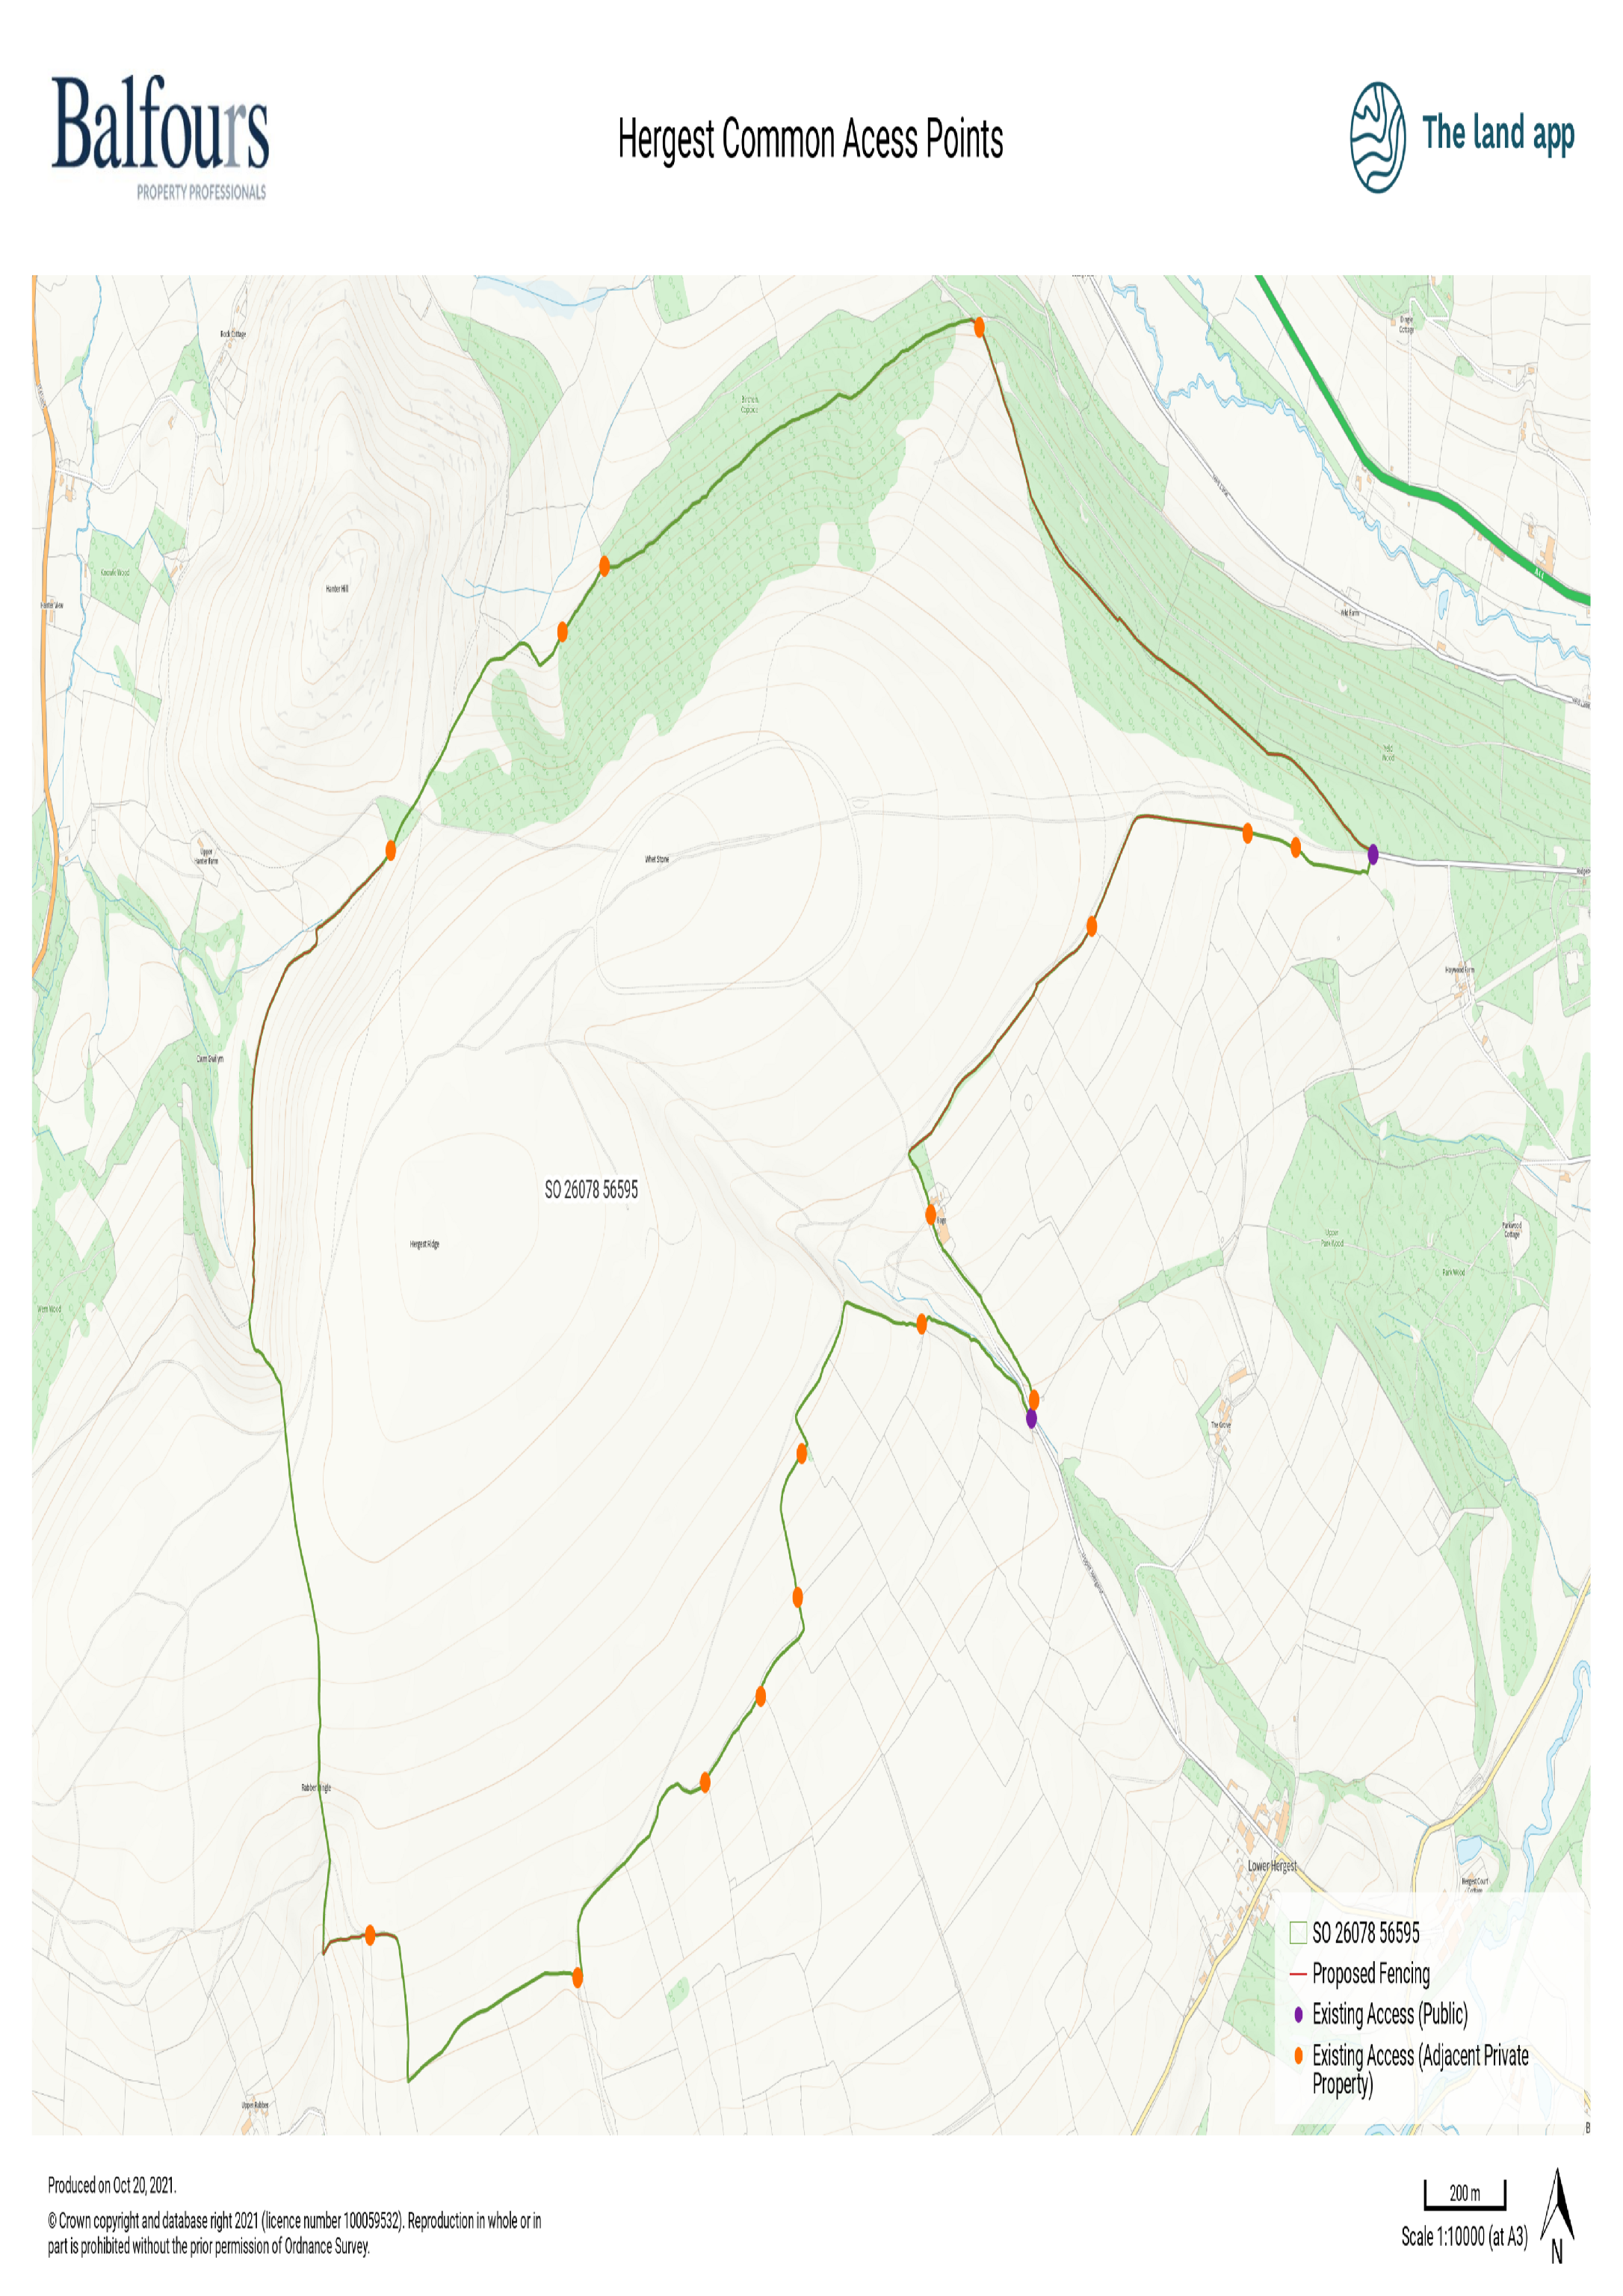

Section 39(2) of the 2006 Act provides that the public interest includes the public interest in: nature conservation; the conservation of the landscape; the protection of public rights of access to any area of land; and the protection of archaeological remains and features of historic interest.

