Order Decision
Inquiry held on 26 June 2018
Site visit made on 28 January 2020
by Susan Doran BA Hons MIPROW
an Inspector appointed by the Secretary of State for Environment, Food and Rural Affairs
Decision date: 14 March 2022

Order Ref: ROW/3187903M1
- This Order is made under Section 53(2)(b) of the Wildlife and Countryside Act 1981 and is known as The Nottinghamshire County Council (Annesley Bridleway Nos. 2, 3 and 24 and Greasley Footpath No. 10 and Bridleway Nos. 11 & 85) Modification Order 2016.
- The Order is dated 8 January 2016 and proposes to modify the Definitive Map and Statement for the area by adding a bridleway near Felley Mill, upgrading a network of footpaths to bridleway status, and consequential amendments to the Definitive Statement as detailed in the Order Map and Schedule.
- In accordance with Paragraph 8(2) of Schedule 15 to the 1981 Act notice of the proposal to confirm the Order subject to modifications has been given. One objection was received in response to the notice.
Summary of Decision: The Order is confirmed subject to some of the modifications previously proposed as set out in the Formal Decision below

Procedural Matters
- This case concerns a network of routes near Felley Mill, Annesley which it is proposed be added as, or upgraded to, bridleways in the Definitive Map and Statement (‘DMS’). This is the third decision concerning the Order, the previous interim decisions having proposed that it be modified, as described below, further to consideration of the evidence adduced and the objections and representations made.
- An Inquiry into the Order was held on 26 June 2018, following which the then appointed Inspector (since retired) proposed to confirm the Order subject to modifications in his interim decision dated 20 February 2019 (‘the first interim decision’). These were, in summary:
- Annesley Footpath No. 2 (between SK48604999 and SK 48854991); delete from the Definitive Map and Statement instead of the proposed upgrading. This is due to the discovery that the 1962 Annesley (Felley Mill) Diversion Order had no legal effect.
- Annesley Bridleway No. 2 (between SK 4861 5000 and SK 4885 4991); add to the Definitive Map and Statement on the basis of evidence discovered after the making of the Modification Order.
- Annesley Bridleway No. 2 (between SK 4885 4991 and SK 49895164); amend the particulars contained in Part 1 and Part 2 of the Modification Order.
- Annesley Footpath No. 3; amend the particulars contained in Part 2 of the Modification Order to reflect the proposed termination points being bridleways instead of footpaths.
- Annesley Bridleway No. 3; remove the proposed upgrading of Footpath 3.
- Annesley Bridleway No. 25; add to the Definitive Map and Statement on the basis of evidence discovered after the making of the Modification Order.
- Greasley Bridleway No. 11; amend the particulars in respect of the northernmost termini.
- Two objections were received following advertisement of these proposals to modify the Order. A site visit was made and the objections were considered by another appointed Inspector (again, since retired). This Inspector proposed to confirm the Order subject to some of the modifications previously proposed and to further modifications, as set out in his interim decision dated 25 February 2020 (‘the second interim decision’). These were, in summary:
- in the preamble to the Order delete the proposed modification relating to section 53(3)(c)(iii) leaving the Order unmodified in respect of the reference to this section.
- at Part I of the Schedule to the Order delete the proposed modification relating to the ‘Description of the path or way to be deleted’.
- at Parts I and II of the Schedule to the Order in respect of Annesley Bridleway No. 2 and Greasley No. 85 delete the Limitations and insert ‘None’.
- at Part II of the Schedule to the Order insert a modification to describe the unaffected section of Annesley Footpath No 2 (between SK4860 4999 and SK 4885 4991) in consequence of the effect of the 1962 diversion order.
- on the Order map, in respect of Annesley Footpath No. 2, delete the symbols depicting ‘Footpath to be upgraded to bridleway’ and insert symbols to show ‘Existing unaffected path’.
- on the insert plan (Annex 3 to the interim decision dated 20 February 2019) replace the solid line depicting ‘Footpath to be Deleted’ with a dashed line to show ‘Unaffected Footpath’ and amend the key accordingly.
- Annesley Bridleway No. 2 (between SK 4861 5000 and SK 4885 4991); add to the Definitive Map and Statement.
- Annesley Bridleway No. 2 (between SK 4885 4991 and SK 4989 5164); amend the particulars contained in Part I and Part II of the Modification Order).
- Annesley Footpath No. 3; amend the particulars contained in Part II of the Modification Order to reflect the proposed termination points being bridleways instead of footpaths.
- Annesley Bridleway No. 3; remove the proposed upgrading of Footpath 3.
- Annesley Bridleway No. 25; add to the Definitive Map and Statement on the basis of evidence discovered after the making of the Modification Order.
- Greasley Bridleway No. 11; amend the particulars in respect of the northernmost termini.
- Following advertisement of the above proposals to modify the Order an objection was made by Nottinghamshire County Council (‘the Council’). In addition, a representation was received indicating that the Inspector had addressed all the respondent’s previous concerns in the (second) interim decision. I have been appointed to consider this objection and representation.
- In addition, I accepted a late representation concerning a recent judgement, R (oao Majera) v Secretary of State for the Home Department [2021] UKSC 46 (‘Majera’) and afforded an opportunity for comments.
- The Majera judgement is provided in connection with the case made in objection to the first interim decision as cited at paragraph 4(ii) of the second interim decision, and the issue of whether or not the Annesley (Felly Mill) Public Path Diversion Order 1962 (‘the 1962 Order’), made by Basford Rural District Council (‘Basford RDC’), is void. In response to its submission, and in essence, the Council argues Majera concerns compliance with court orders rather than with administrative acts and decisions such as the 1962 Order. Accordingly, it is of limited relevance or assistance as regards determining the issue of the effect of the 1962 Order, and whether or not it was void. Having regard to the submissions, I do not place weight on the judgement in reaching my conclusions.
- My decision is reached on the basis of the papers on file.

The Main Issues
- The Council’s objection raises two issues, firstly as regards the 1962 Order and its effect on Annesley Footpath No. 2; and secondly regarding the proposed modification that no limitations be recorded in respect of Annesley Bridleway No. 2.
- Accordingly, the main issues are whether there is any evidence or argument which has a bearing on the modifications proposed in the second interim decision which might indicate that those modifications should be amended or not pursued as regards the validity (or otherwise) of the 1962 Order in respect of Annesley Footpath No. 2, and the existence (or otherwise) of limitations on Annesley Bridleway No. 2.

Reasons

The effect of the 1962 Order
- The 1962 Order was made under section 111 of the Highways Act 1959 which enabled the diversion of footpaths and bridleways. In the first interim decision (at paragraph 12), the Inspector found the 1962 Order to be void and it therefore had no effect. In the second interim decision (at paragraph 11) it was concluded the 1962 Order created an anomalous situation by diverting footpath rights to a more southerly alignment with bridleway rights remaining on the original route. Accordingly, the Inspector proposed a section of Annesley Footpath No. 2 (between grid references SK 4860 4999 and SK 4885 4991) be shown as an unaffected footpath.
- The Council concurs with the first interim decision in that the 1962 Order is void, and also with the second interim decision, but only insofar as the 1962 Order could not have diverted bridleway rights.
- The Definitive Map was published in 1961 and the extract provided to me shows the alignment of Footpath No. 2 at that time. The 1962 Order, dated 2 January, diverted part of a footpath near Felley Mill. Although it refers to an accompanying plan, none is attached. Nevertheless, it appears that the 1962 Order concerned the diversion of part of Footpath No. 2 to a more southerly alignment.
- If the 1962 Order was void, as concluded in the first interim decision, then no public rights were diverted and the route described would follow its original alignment as depicted on the Definitive Map published in 1961. However, there is nothing to suggest that the 1962 Order was incorrectly made or that Basford RDC exceeded their powers in making it. Nor indeed, that they intended to create a hybrid highway, being a bridleway with no public right of way on foot, as is suggested was its effect. I agree with the findings in the second interim decision, the 1962 Order having been subsequently confirmed by the Minister for Housing and Local Government on 27 April of that year, and there being no evidence of a challenge to this. Moreover, and as stated above, the route recorded in the DMS at the time of the 1962 Order was a footpath, and the 1962 Order diverted footpath rights. It follows, in my view, that the effect of the 1962 Order was to divert the footpath rights that were legally recorded at the time to a new more southerly alignment.
- The DMS is a record of minimum rights, and in the event that new evidence is discovered it may be modified. Since the making and confirmation of the 1962 Order evidence has come to light to support the existence of higher rights. In particular, in this regard, and further to the documentary evidence considered in the first interim decision, bridleway rights have been determined to exist over the historic (original) alignment of Footpath No. 2 (paragraph 10 of the first interim decision, further to the 1874 Annesley Estate Map and Estate documents). As a consequence, it was concluded that the present Order should be modified to add a new length of bridleway (paragraph 13 and bullet point 2 of paragraph 1 of the first interim decision - the new length of Bridleway No. 2 to be added running between grid references SK 4861 5000 and SK 4885 4991). This conclusion was upheld in the second interim decision (at paragraph 12). I have no reason to depart from these findings. Further, from my analysis of the evidence, the length of bridleway proposed to be added appears to follow the original definitive alignment of Footpath No. 2. Accordingly, evidence has been discovered that a public bridleway subsists over the former route of Footpath No. 2 and it can therefore be added to the DMS. This is the effect of the modification proposed in the first interim decision. Were the 1962 Order void and public footpath rights remained on the original alignment then the discovery of evidence of the existence of higher rights would require the upgrading of the original alignment of Footpath No. 2 to a bridleway rather than the addition of a bridleway at this location.
- As regards a potentially anomalous situation arising as a result of the 1962 Order, a hybrid way whereby bridleway rights might exist but not incorporate footpath rights, I accept, as argued by the Council, this would create difficulties as to how to manage and represent the resulting route. Also, that such a way would be inconsistent with the definition of a bridleway and does not exist in law. However, whilst this may be arguable, taking a pragmatic approach, my findings above, and given the proposed modification to add a bridleway here, it follows in my view that no anomaly arises.
- I conclude that the modifications proposed in this regard in the second interim decision should stand.

Whether limitations should be recorded for Annesley Bridleway No. 2
- No consideration had been given to limitations when the Inquiry was held in 2018, the matter not having been in dispute at that time. The proposal not to record limitations stems from findings made in the second interim decision, the issue having been raised in objections to the first interim decision.
- In the second interim decision, it was concluded that whilst some of the documentary evidence adduced indicated the presence of limitations in the form of gates or barriers at locations identified in the Order, there was nothing to indicate they were present when the routes were dedicated. The date of dedication was determined as at least from 1774, this being the date of Chapman’s Map of Nottinghamshire which confirmed the network had come into existence by then (paragraph 10 of the first interim decision). This finding was not overturned in the second interim decision. However, in the absence of evidence, the Inspector was unable to reach a conclusion that the routes were dedicated subject to the limitations identified in the Order, in or before 1774.
- An enlarged and annotated extract of the 1774 Chapman Map provided by the Council depicts two lines drawn across the route of Annesley Bridleway No. 2 which correspond with two of the limitations described in the Order, at grid references SK 4976 5018 and SK 5007 5097.
- Chapman’s Map is a small scale (1 inch to 1 mile) County Map and there is nothing in its key which identifies what such lines represent. Nevertheless, I agree that the Council’s conclusion is a reasonable one, noting that both lines appearing on the 1774 Map coincide with the location of gates recorded in the Order as made. In addition, they appear on examples of later mapping previously considered (at paragraph 16 of the second interim decision).
- Accordingly, I conclude that this modification should not be pursued and that both limitations described in the Order for Annesley Bridleway No. 2 remain as originally proposed.

Conclusions
- Having regard to these and all other matters raised in the written representations, I conclude that the Order should be confirmed subject to some of the modifications previously proposed.

Formal Decision
- The Order is confirmed subject to the following modifications as summarised below and set out in a copy of the Order, as modified, attached to this decision as Appendix A:
- Annesley Bridleway No. 2 (between SK 4861 5000 and SK 4885 4991); add to the Definitive Map and Statement
- Annesley Bridleway No. 2 (between SK 4885 4991 and SK 4989 5164); amend the particulars contained in Part I and Part II of the Modification Order)
- Annesley Footpath No. 3; amend the particulars contained in Part II of the Modification Order to reflect the proposed termination points being bridleways instead of footpaths
- Annesley Bridleway No. 3; remove the proposed upgrading of Footpath 3
- Annesley Bridleway No. 25; add to the Definitive Map and Statement on the basis of evidence discovered after the making of the Modification Order
- Greasley Bridleway No. 11; amend the particulars in respect of the northernmost termini
- in the preamble to the Order delete the proposed modification relating to section 53(3)(c)(iii) leaving the Order unmodified in respect of the reference to this section
- at Part I of the Schedule to the Order delete the proposed modification relating to the ‘Description of the path or way to be deleted’
- at Parts I and II of the Schedule to the Order in respect of Greasley Bridleway No. 85 delete the Limitations and insert ‘None’
- at Part II of the Schedule to the Order insert a modification to describe the unaffected section of Annesley Footpath No 2 (between SK4860 4999 and SK 4885 4991) in consequence of the effect of the 1962 diversion order
- on the Order map, in respect of Annesley Footpath No. 2, delete the symbols depicting ‘Footpath to be upgraded to bridleway’ and insert symbols to show ‘Existing unaffected path’
- on the insert plan (Annex 3 to the interim decision dated 20 February 2019) replace the solid line depicting ‘Footpath to be Deleted’ with a dashed line to show ‘Unaffected Footpath’ and amend the key accordingly

S Doran

Inspector

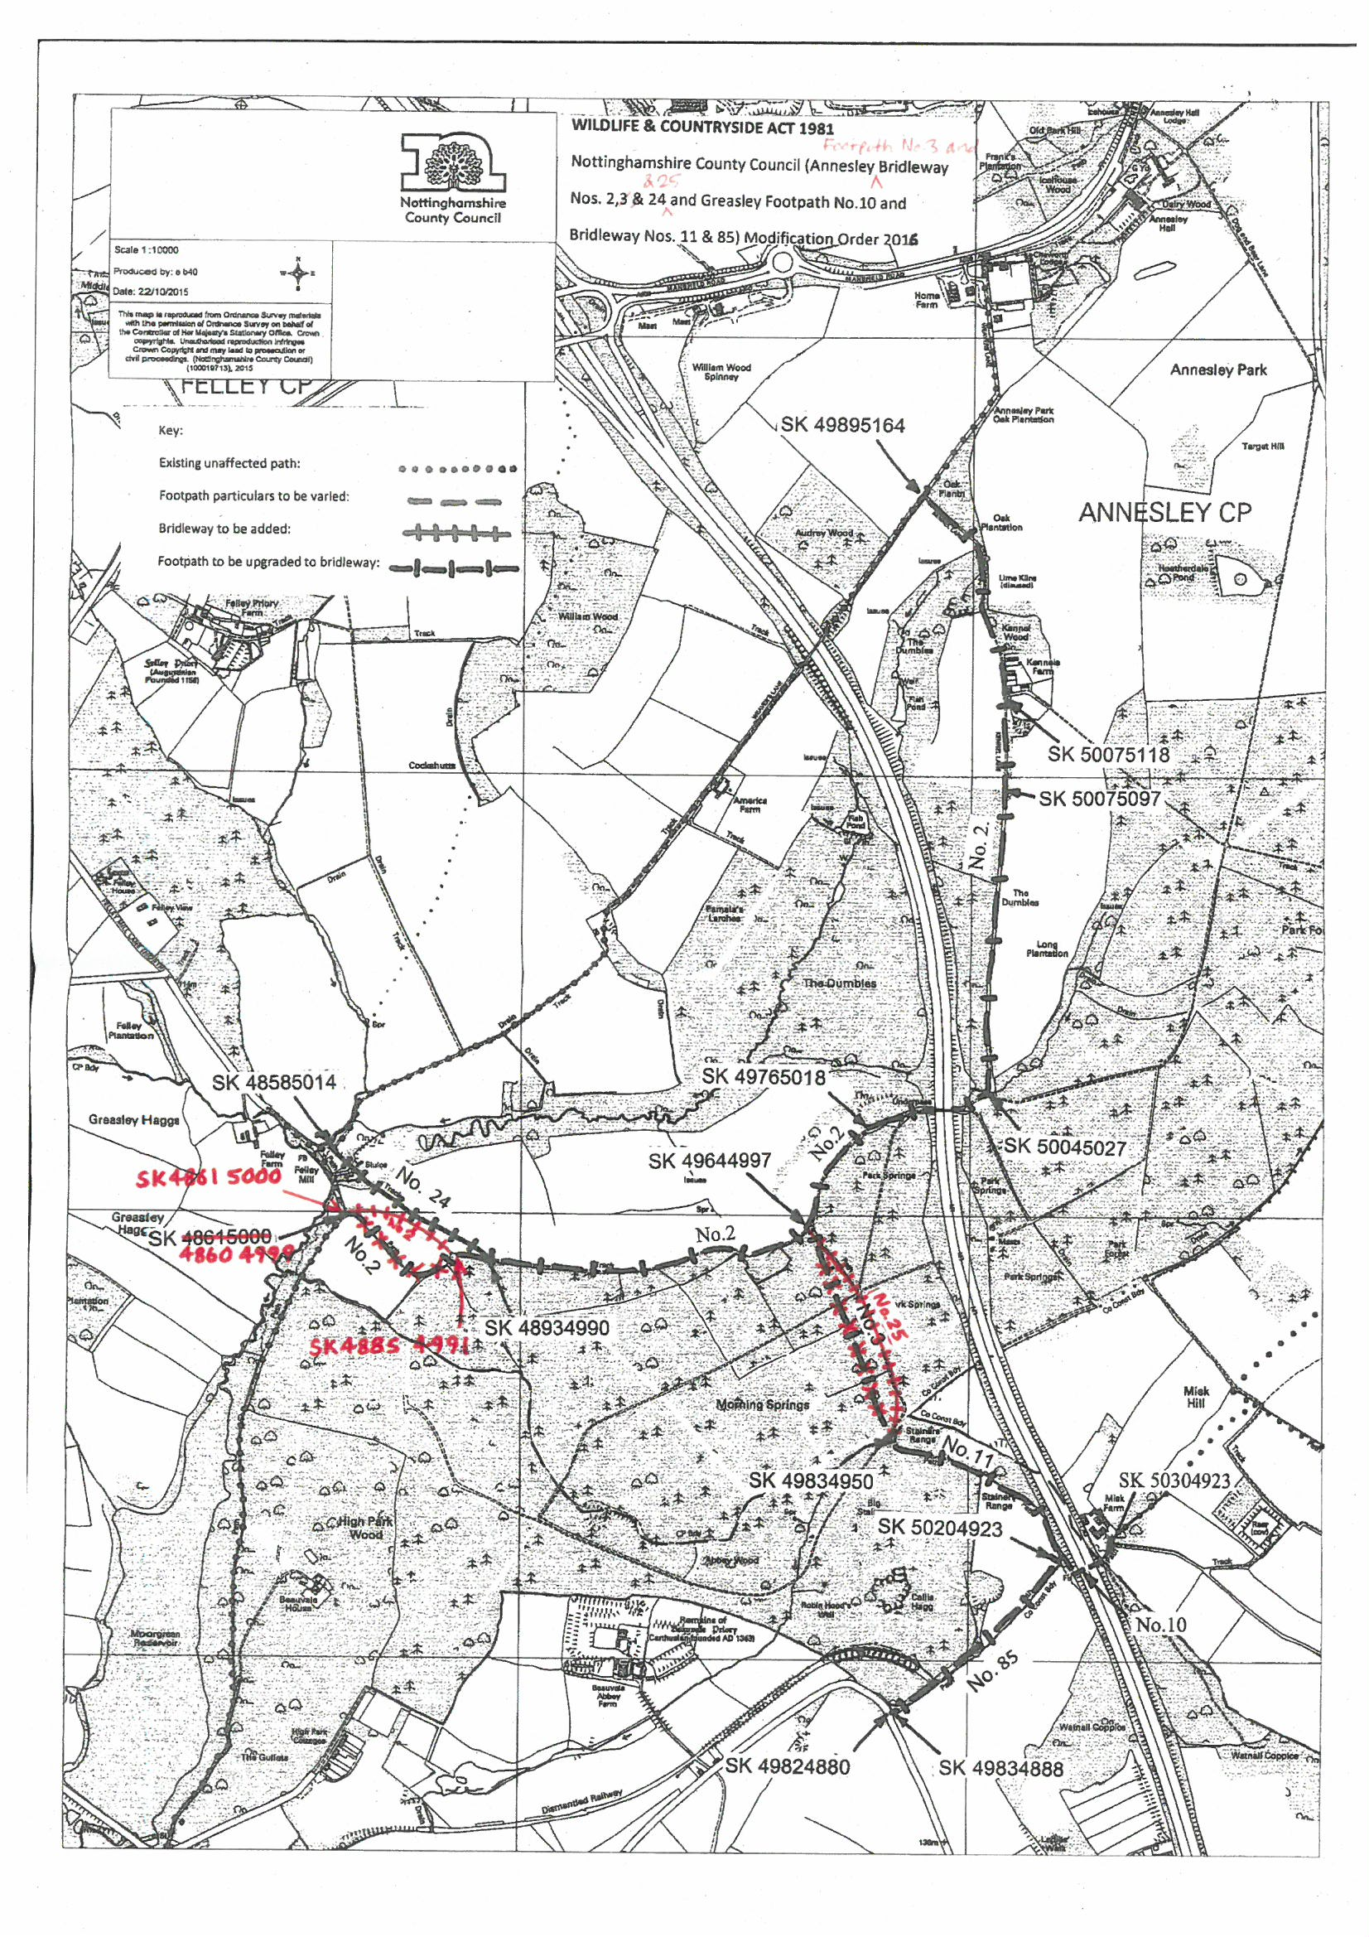
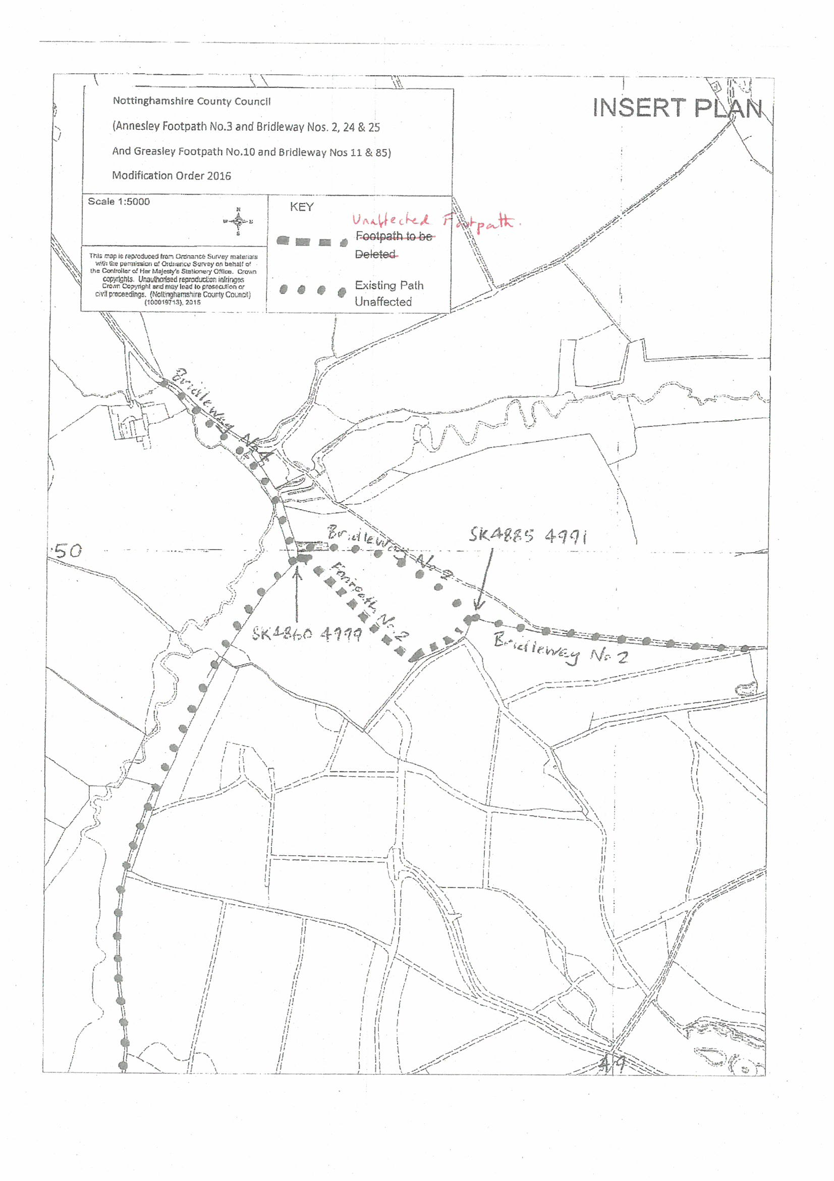
APPENDIX A
WILDLIFE AND COUNTRYSIDE ACT 1981
THE NOTTINGHAMSHIRE (ASHFIELD AREA & AREA 3) DEFINITIVE MAP AND STATEMENT
THE NOTTINGHAMSHIRE COUNTY COUNCIL (ANNESLEY FOOTPATH NO.3 and BRIDLEWAY NOS. 2, 3 & 24, & 25 AND GREASLEY FOOTPATH NO.10 AND BRIDLEWAY NOS. 11 & 85) MODIFICATION ORDER 2016

This Order is made by the Nottinghamshire County Council under Section 53(2)(b) of the Wildlife & Countryside Act 1981 (“the Act”) because it appears to that Authority that the Nottinghamshire (Ashfield Area and Area 3) Definitive Map and Statement require modification in consequence of the occurrence of an event specified in Sections 53(3)(b), 53(3)(c)(i), 53(3)(c)(ii) and 53(3)(c)(iii) of the Act, namely:
(b) the expiration, in relation to any way in the area to which the map relates, of any period such that the enjoyment by the public of the way during that period raises a presumption that the way has been dedicated as a public path or restricted byway; (c) the discovery by the authority of evidence which (when considered with all other relevant evidence available to them) shows-
(i) that a right of way which is not shown in the map and statement subsists or is reasonably alleged to subsist over land in the area to which the map relates, being a right of way such that the land over which the right subsists is a public path; (ii) that a highway shown in the map and statement as a highway of a particular description ought to be there shown as a highway of a different description; and (iii) other particulars contained in the map and statement require modification

The Authority have consulted with every Local Authority whose area includes land to which this Order relates.
The Nottinghamshire County Council hereby order that:
1. For the purposes of this Order the relevant date is 21st of October 2015
2. The Nottinghamshire (Ashfield Area and Area 3) Definitive Map and Statement shall be modified as described in Part I and Part II of the Schedule and shown on the Map attached to this Order.
3. This Order shall take effect on the date it is confirmed and may be cited as “The Nottinghamshire County Council (Annesley Bridleway Nos. 2, 3 & 24 and Greasley Footpath No.10 and Bridleway Nos. 11 & 85)

Modification Order 2016” (Annesley Footpath No.3 and Bridleway Nos. 2, 24 & 25 and Greasley Footpath No.10 and Bridleway Nos. 11 & 85) Modification Order 2016”.
SCHEDULE
PART I
Modification of Definitive Map
Description of the path or way to be added

Annesley Bridleway No. 24 From: SK 4858 5014 To: SK 4893 4990
Commencing at the junction with Annesley Bridleway No.1, and proceeding along a track in a south-easterly direction for a distance of approximately 433 metres to the junction with Annesley Bridleway No. 2.
Width: 3 metres Limitations: None

Annesley Bridleway No.2 From: SK 4861 5000 To: SK4885 4991
Commencing at the junction with Annesley Bridleway No.4 and proceeding across an agricultural field in a generally easterly then south-easterly direction for a distance of approximately 285 metres to the junction with the remainder of Annesley Bridleway No.2.
Width: 2.5 metres Limitations: None

Annesley Bridleway No.25 From: SK 4964 4997 To: SK4983 4950
Commencing at the junction with Annesley Bridleway No.2 and proceeding alongside Park Springs Wood in a generally south-south-easterly then southerly direction for a distance of approximately 527 metres to the junction with Greasley Bridleway No.11.
Width: 2.5 metres Limitations None

Description of the path or way to be upgraded
Annesley Bridleway No.2 From: SK 48615000 4885 4991 To: SK 4989 5164
Commencing at the junction with the remainder of Annesley Bridleway No.24 and running along a field edge and proceeding along a track on the north side of Morning Springs Wood in a generally south-easterly then north easterly then easterly direction for a distance of approximately 400 88 metres to a point SK 48934990 at the junction with Annesley Bridleway No. 24 then proceeding along a track on the north side of Morning Springs Wood in a generally easterly direction for a distance of approximately 740 metres to a point SK49644997 at the junction of Annesley Footpath No.3 and Annesley Bridleway No.25 and then proceeding along a track on the north west side of Park Springs Wood in a generally northerly then north-easterly then easterly direction then through the M1 underpass to a point SK50045027, then continuing along Kennel Lane in a generally northerly then north-westerly direction for a distance of approximately 1985 metres to the junction with Annesley Bridleway No.1.
Width: 2.0 2.5 metres between points SK 48615000 4885 4991 and SK 48934990 3.0 metres between points SK 4893 4990 and SK 5004 5027 2.5 metres between points SK 5004 5027 and SK 5007 5097 2.7 metres between points SK 5007 5097 and SK 5007 5118 3.4 metres between points SK 5007 5118 and SK 4989 5164
Limitations: Swing gate at SK 49765018 Farm gate at SK 50075097

Annesley Bridleway No.3 From: SK 49834950 To: SK 49644997
Commencing at the junction with Greasley Bridleway No.11 and running through Morning Springs Wood in a north-north-westerly direction for a distance of approximately 517 metres to the junction with Annesley Bridleway No.2.
Width: 2.5 metres Limitations: None

Greasley Bridleway No.85 From: SK 4982 4880 To: SK 5020 4923
Commencing at the junction with New Road at the southern corner of Callis Hagg Wood, and running along a track and then a field edge in a north-easterly direction for a distance of approximately 515 metres to the junction with Greasley Footpath No.10 and Greasley Bridleway No.11.
Width: 2.5 metres Limitations: None Farm gate near the junction with New Road at SK 49834888

Greasley Bridleway No.11 From: SK 5020 4923 To: SK 4983 4950
Commencing at the junction with Greasley Footpath No.10 and Greasley Bridleway No. 85 on the western side of the M1 motorway, and running along a field edge then through Big Stainers/Stainers Range Wood in a generally north-westerly direction for a distance of approximately 487 metres to the junction with Annesley Bridleway No.3 25 and Annesley Footpath No.3.
Width: 2.5 metres Limitations: None

PART II
Modification of Definitive Statement
Variation of particulars of path or way

The definitive statement for the Parish of Annesley shall be amended as follows:
Status and Path No: | Bridleway 24
O.S. Sheet No: | SK 44 NE / SK 45 SE
Approx. Length: | 433 metres.
Width: | 3 metres.
Starting Point: | SK 4858 5014 The junction with Annesley Bridleway  No.1.
Finishing Point: | SK 4893 4990 The junction with Annesley Bridleway  No.2.
General Description: | Proceeds along a track in a south-easterly direction.
Legal Event /  Remarks: | Limitations: None

Status and Path No: | Bridleway 2
O.S. Sheet No: | SK 44 NE / SK 45 SE / SK 55 SW
Approx. Length: | 3,125 3,098 metres
Width: | 2.0 2.5metres between points SK 48615000 4861 5000 and SK 48934990  3.0 metres between points SK 48934990 and SK 50045027  2.5 metres between points SK 50045027 and SK 50075097  2.7 metres between points SK 50075097 and SK 50075118  3.4 metres between points SK 50075118 and SK 49895164
Starting Point: | SK 4861 5000 The junction with Annesley Bridleway No.  4.
Finishing Point: | SK 4989 5164 The junction with Annesley Bridleway  No.1.
General Description: | Proceeds across an agricultural field in a generally easterly the south-easterly direction for a distance of approximately 285 metres to a point SK 4885 4991 then continuing along a field edge in a generally south easterly then north easterly then a track on the north side of Morning Springs Wood in a generally easterly direction for a distance of approximately 400 88 metres to a point SK 4893 4990 at the junction with Annesley Bridleway No. 24 then proceeding along a track on the north side of Morning Springs Wood in a generally easterly direction for a distance of approximately 740 metres to a point SK4964 4997 at the junction of Annesley Bridleway No.3 then proceeding along a track on the north west side of Park Springs Wood in a generally north-easterly direction then through the M1 underpass, then along Kennel Lane in a generally northerly then north-westerly direction for a distance of approximately 1,985 metres.
Legal Event /  Remarks: | Limitations: Swing gate at SK 4976 5018. Farm gate at  SK 5007 5097.

Status and Path No: | Footpath No.3
O.S. Sheet No: | SK 44 NE
Approx. Length: | 515 metres.
Width: | -
Starting Point: | SK 4983 4950 The junction with Greasley Bridleway  No.11 and Annesley Bridleway No.25
Finishing Point: | SK 4964 4997 The junction with Annesley Bridleway  No.2 and Annesley Bridleway No.25.
General Description: | Proceeds through woodland in a north-north-westerly  direction.
Legal Event /  Remarks: | -

Status and Path No: | Bridleway 25
O.S. Sheet No: | SK 44NE
Approx. Length: | 527 metres.
Width: | 2.5 metres.
Starting Point: | SK 4694 4997 The junction with Annesley Bridleway  No.2 and Annesley Footpath No.3.
Finishing Point: | SK 4983 4950 The junction with Greasley Bridleway  No.11 and Annesley Footpath No.3.
General Description: | Proceeds alongside Park Springs Wood in a generally  south-south-easterly then southerly direction
Legal Event /  Remarks: | Limitations: None

Status and Path No: | Bridleway 3
O.S. Sheet No: | SK 44 NE
Approx. Length: | 517 metres.
Width: | 2.5 metres.
Starting Point: | SK 4983 4950 The junction with Greasley Bridleway  No.11.
Finishing Point: | SK 4964 4997 The junction with Annesley Bridleway  No.2.
General Description: | Proceeds through Morning Springs Wood in a north-north-westerly direction
Legal Event /  Remarks: | Limitations: None.

Status and Path No: | Footpath 2
O.S. Sheet No: | SK 44 NE / SK 45 SE
Approx. Length: | 328 metres
Width: | 1.2 metres
Starting Point: | SK 4869 4999 The junction with Annesley Bridleway No. 4
Finishing Point: | SK 4885 4991 The junction with Annesley Bridleway No. 2
General Description: | Commencing at the junction with Annesley Bridleway No. 4 near Felley Ford, and running along the south-west side of a hedge in an easterly then south-easterly direction for approximately 215 metres, then along the north-west side of Morning Springs Wood in a north-easterly direction for approximately 113 metres to the junction with Annesley Bridleway No. 2
Legal Event /  Remarks: | Limitations: None

The definitive statement for the Parish of Greasley shall be amended as follows:
Status and Path No: | Bridleway 85
O.S. Sheet No: | SK 44 NE / SK 54 NW
Approx. Length: | 515 metres.
Width: | 2.5 metres.
Starting Point: | SK 4982 4880 The junction with New Road at the  southern corner of Callis Hagg Wood.
Finishing Point: | SK 5020 4923 The junction with Greasley Footpath  No.10 and Greasley Bridleway No.11.
General Description: | Proceeds along a track and then a field edge in a north-easterly direction.
Legal Event /  Remarks: | Limitations: Farm gate near the junction with New Road at  SK 49834888 None.

Status and Path No: | Bridleway 11
O.S. Sheet No: | SK 44 NE / SK 54 NW
Approx. Length: | 487 metres.
Width: | 2.5 metres.
Starting Point: | SK 5020 4923 The junction with Greasley Footpath  No.10 and Greasley Bridleway No.85 on the western side of the M1 motorway.
Finishing Point: | SK 4983 4950 The junction with Annesley Bridleway No. 25 and Annesley Footpath No.3.
General Description: | Proceeds along a field edge then through Big Stainers /  Stainers Range Wood in a generally north-westerly  direction.
Legal Event /  Remarks: | Limitations: None.

Status and Path No: | Footpath 10
O.S. Sheet No: | SK 54 NW
Approx. Length: | 131 metres
Width: | 2.0 metres.
Starting Point: | SK 5020 4923 The junction with Greasley Bridleway  No.11 and Greasley Bridleway No.85 on the western side of the M1 motorway.
Finishing Point: | SK 5030 4923 The junction with Hucknall Footpath No.  35.
General Description: | Proceeds from a field edge in a north-easterly then south-easterly then north-easterly direction along a footbridge crossing the M1 up to the parish/district boundary.
Legal Event /  Remarks: | Limitations: None.

