


Technical standard for the approved repairs, maintenance, inspection and specifications of Fire Doors and Fire Compartmentation
Technical Standard – 2022/02  (Re-issued) | ESTATE MANAGEMENT
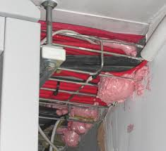  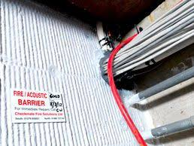  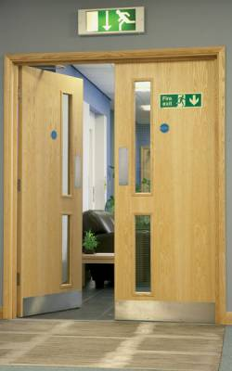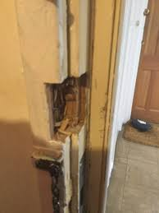 | ESTATE MANAGEMENT
Version 1.1 – Mar 2022

Document Information
DIO Sponsor: Bryan Dunn | Date of Issue: 01 March 2022
Contact if different from above Sponsor:

DIO TS Senior Fire Safety Manager,
Defence Infrastructure Organisation,
St Gorge’s House, DMS Whittington, Lichfield WS14 9PY

DIO-TSFiresafety@mod.gov.uk

MOD telephone: Mobile: 07790 960334
Email: DIO-TS firesafety@mod.gov.uk

Who should read this: 1) All TLB/EO fire safety leads. 2) All Heads of Establishment and their nominated Establishment/Building Fire Focal Points. (Or equivalent). 3) All defence personnel and Infrastructure Delivery and Maintenance Management Organisations (i.e., Industry Partners and their supply chain) involved in facility management and carrying out infrastructure works on the Defence estate. 4) All personnel carrying out fire risk assessments on the Defence Estate, including DFR HQ and their service delivery partner. 5) Establishment/Regional H&S advisors.
When it takes effect: Immediately | When it is due to expire: When Rescinded
Equality and Diversity Impact Assessment
This policy has been Equality and Diversity Impact Assessed in accordance with the Defence Equality Analysis Guidance 2018 up to:
Stage 2 Initial assessment only - no impact found; full EA not required.

Document Name: | Guidance for the approved repairs, maintenance, inspection, and specifications of Fire Doors and Fire Compartmentation.
Version No: | 1.1
Version Date: | 01 March 2022
Author: | Marc Plester
Reviewed by: | Bryan Dunn Head of TS Engineering and Construction
Review Date: | 12 months from publishing

Document History
Date Issued | Version | Author | Reason for Change
01 Feb 2022 | 1.0 | Marc Plester | No previous policy.
01 March 2022 | 1.1 | Marc Plester | Formatting corrections and point clarifications

Foreword
This Technical Standard here after known as ‘the Standard’ is published by Defence Infrastructure Organisation (DIO) in its role as infrastructural technical authority for Mandatory application across all areas of the MoD. This standard is mandated for all contracts including USVF, overseas and PFI arrangements and those where DIO is not the delivery agent.
Document Synopsis
This Technical Standard provides direction on how to ensure fire safety requirements are consistently achieved where Defence agencies or personnel hold responsibility, or are involved in the required works, when carrying out repairs to compartmentation or fire doors.
Contents

- Roles and Implementation …………………………………………………………………………………………………………………………………………………………….…….. 4
- Application of Technical Standards …………………………………………………………………………………………………………………………………………………………………… 4
- Standard Requirements …………………………………………………………………………………………………………………………………………………………………… 4
- Approved repairs to fire compartmentation breaches
…………………………………………………………………………………………………………………………………………………………………… 4
- Approved repairs, maintenance and checks to fire doors
…………………………………………………………………………………………………………………………………………………………………… 5
- Fire Dampers
…………………………………………………………………………………………………………………………………………………………………… 6
- Heritage Assets
…………………………………………………………………………………………………………………………………………………………………….6
- Fire Risk Assessment
…………………………………………………………………………………………………………………………………………………………………….7
- Records and Reviews
……………………………….…………………………………………………………………………………………………………………………………...7
- References …………………………………………………………………………………………………………………………………………………………………….7
- Glossary of Terms …………………………………………………………………………………………………………………………………………………………………….8
- Informative Annex A – General Fire Door Standards
……………………………………………………………………………………………………………………………………………….………………….A1
- Informative Annex B – DIO-TS Fire Safety, Fire Doors, Checks and FAQs
………………………………………………………………………………………………………………………………………………………….……….B1

- Roles and Implementation

    - DIO are the document owner and Technical Authority for this standard. Approval for any deviation or derogation from this standard are to be approved by the DIO Senior Fire Safety Manager prior to the commencement of any work. DIO-TSFiresafety@mod.gov.uk
    - The Defence Fire and rescue service provider upon receipt of a request, are responsible for providing general fire safety advice on the requirement for any works to be carried out on compartmentation and/or fire doors.

- Application of the Technical Standard

    - This Technical Standard applies to all works taking place to compartmentation lines and fire doors in buildings on the MOD estate. This standard is not retrospectively mandated.
    - All fire door and fire compartmentation work undertaken by installers and contractors are to ensure that these specialist items of fire safety equipment maintain continual conformance with the initial installation standard and any subsequent works continue to maintain these standards as a minimum, ensuring that the Estate remains legally and statutory compliant.

- Standard Requirements

  - Any works carried out on fire compartmentation and fire doors including repairs and installation MUST be undertaken by a competent person that holds current 3rd party accreditation (3PA) by a UKAS certification scheme, e.g., BM TRADA, Certifire, FIRAS etc.
  - All completed works must be provided with suitable certification of fire test evidence. This information must be made available to the Responsible Person in accordance with Article 17 of the Fire Safety Order and documents be provided to the MMO & DIO for inclusion in the buildings Operation & Maintenance (O&M) manual.
  - To ensure that the correct level of fire compartmentation is achieved it is essential that the Management Maintenance Organisation (MMO) (or equivalent personnel responsible for Infrastructure delivery) uses the Fire Strategy for the building (if available) or seeks advice from a competent person.
  - On completion of works to fire compartmentation or fire doors the MMO must ensure that the DIO Fire Safety Team are informed so that any works can be captured by the 2nd party assurance plan if deemed necessary. DIO-TSFiresafety@mod.gov.uk

- Approved repairs to fire compartmentation

  - Any repairs to fire compartmentation must be equal to or greater than the existing level of fire resistance.
  - Only firestopping products that are UKCA/CE marked, 3rd party certified and tested for the intended application by a UKAS accredited organisation or assessed as suitable by a competent, suitably qualified fire engineer as an ‘expert judgement,’ with evidence captured and recorded, can be used.
  - Firestopping products from different manufacturers should not be mixed in the same opening unless there is clear test evidence to substantiate their mixed use.
  - Polyurethane Foams (PU) are widely misused in industry for fire stopping. Many PU Foams are fire rated but these ratings are reaction to fire classification’s and cannot be used where fire resistance is required. PU foams are not structural materials so must not be used in areas subjected to load i.e., foot traffic etc.

The use of PU foams must be restricted to the use for which they have been designed and specifically certified as such. They are predominantly certified as a linear gap seal and NOT for fire compartmentation breaches or gap filling.

Any use of PU foam must have certified test evidence to support its use in the specific situation recorded and only be used within manufacturers guidelines (especially fire ratings and gap sizes, width & depth).

4.5 All works to fire compartmentation or where service penetrations have undergone fire stopping must be correctly labelled. This must be a permanent label next to the penetration detailing information about the penetration and the materials used to address the fire stopping with digitally recorded evidence held on a BIM (if available) in accordance with normal industry practice and be available to relevant personnel upon request.
  - All fixed ICT installations works involving cable runs and trunking/conduit installations (including Wi-Fi installations) MUST comply with this standard and with JSP 604, Leaflet 4800, Chapter 5 for correct fire standard for the cable used. They should be correctly fire stopped and be labelled and records maintained in accordance with this document.
  - Any compartmentation breaches created by plastic piping regardless of diameter must be correctly fire stopped using correct certified materials (collars or wraps). This requirement exceeds BS7671 IET Wiring Regulations 18th Edition para 527 standards to ensure Defence’s assets are suitably protected from fire/smoke spread.
  - Further information and guidance on fire compartmentation repairs can be found in industry guidance I.e., Association for Specialist Fire Protection (ASFP) coloured guides etc, for approved fire compartmentation repairs or from this office.

- Approved repairs, maintenance and checks to fire doors
The following paragraphs provide a specification for the repair of fire doors, the requirements placed on the persons carrying out the repairs and the information that should be provided once the works are complete:
5.1 Any repairs to fire doors are to be completed to ensure maintenance of certification in line with
industry recognised guides I.e., BM TRADA, British Woodworking Federation, which is a UK approved standard in industry for repairs and alterations of wood fire doors and frames.
5.2 All fire doors should carry the appropriate identification label or door leaf plug which is usually found on the top edge of the door or along the hinge side of the door on modern doors. Older fire doors may not have the appropriate labels but can usually be identified as fire doors by their thickness, FD30 = 44mm, FD60 = 54mm.
  - All fire doors are to be inspected at least every 6 months by a competent person, in accordance with BS8214 & BS9999 and more frequently (determined by way of a risk assessment, a 3 monthly check should suffice) on high use door sets by a competent person and auditable individual door records kept. For Defence purposes all cross corridor and stairwell fire doors should be checked every 3 months by the building custodian or responsible person. See user check guide in section 6.
  - There is no requirement to replace existing fire doors if they do not have visible or documented certification or do not meet current standards. If the door, frame and hardware would be expected to still perform their job, be seen as suitable by the fire safety practitioner during the FRA process, the door closes into the frame with reasonable gaps (2-6 mm) with no noted damage that would interfere with its fire resistance then they should be fit for purpose. These doors are known as nominal fire doors.
  - New fire doors can be supplied in one of two ways, as a door set or as an assembly.
- A door set is a frame, pre hung door leaf, vision panels and all essential ironmongery, all matched and pre-assembled in the factory and delivered from a single source.
- A door assembly is all the components needed to install them supplied separately from multiple sources.
It is preferable to use a certified fire door set. If using a fire door assembly, then all components must be certificated, and all certifications held in the buildings O&M records.
  - Fire doors can be trimmed during installation, but manufacturer’s instructions must be followed. This work must be carried out by a competent person in line with manufacturers guidance for that specific door leaf, as removal of an excessive amount would void the fire certification.
  - The use of any internal chain/spring ‘Perko’ type closers are not authorised for use on the Estate as they do not ensure door latching from any angle unless they are certified as fire rated for the use with a power size of at least 3.
  - It is permissible to paint fire doors as this will not affect the performance of the door. It is also acceptable, to paint over the intumescent seal, however smoke and acoustic seals must not be painted over as this will affect their fire/smoke/rated performance and potentially safety to life and render them unusable.
  - Intumescent paints and coatings are widely used to provide a fire-resistant coating to structural steels and timbers. These liquid paints must not be used as a method to give or increase the fire rating of a door or compartmentation on the Defence Estate as the application cannot be certified to give suitable fire ratings with application.

- Fire Dampers

  - The MMO should provide an inventory of fire dampers showing their location, type and size across the site. This information should also be made available to the Building Custodian.
  - All dampers should be accessible usually through an accessible inspection panel. If this is not possible it should be recorded, reported, and remedial action taken to provide appropriate access.
  - All fire dampers shall be tested at least annually. Fire dampers located in dust laden environments should be tested more frequently, at periods suited to the degree of dust generation.
  - Fire and or smoke dampers used in smoke control systems for means of escape require a weekly system check to be carried out by a competent person. Fire/smoke dampers in other smoke control systems require a 3 monthly system check by a competent person.
  - All fire dampers shall be tested and maintained in accordance with the relevant British Standard, the MoD inspection regime schedules (MIRS), Manufacturer’s Instructions or Industry Standards.

- Heritage Estate

  - Repairs and other works to the heritage estate including all designated heritage assets including listed buildings and scheduled monuments are to be completed in accordance with all the points 3.1 to 6.5 on this document.
  - Works must also be completed IAW Heritage guidance and discussion with the DIO Historic Buildings team, as consultation with, and permissions from the Local Planning Authority may be necessary IAW host nation legislation.

Heritage consultation must take place with the DIO Historic Buildings team and be
documented to ensure that Defence remains compliant.

8 Fire Risk Assessment
8.1 When carrying out repair work to fire doors or compartmentation there may be a need to review the Fire Risk Assessment. The duty holder should contact the current Defence fire service provider for advice.

9 Records and reviews
9.1 All records and Reviews are to be completed in accordance with TLB and units fire safety management system or equivalent (SHEMS).
9.2 HoE is to ensure that fire door inspections are recorded in the fire diary by the person/organisation tasked to undertake them.

- References
British Standard EN 1154 “Controlled Door Closing Devices”.
British Standard EN 12209 “Building Hardware – Mechanically operated locks and latches”.
British Standard EN “Hinges”.
BM TRADA Q-Mark Fire Door Installation Scheme
The Regulatory Reform (fire safety) Order 2005 (FSO)
MoD maintenance Task Schedules, MIRS (MOD infra requirement system)
JSP 604 Defence Networks Governance
ASFP Coloured Guides

Glossary of terms
ASFP | Association for Specialist Fire Protection
CFR | Capita Fire & Rescue
Compartmentation | A building or part of a building comprising one or more rooms, spaces or storeys that is constructed to prevent the spread of fire to or from another part of the same building.
Competent Person | A person that has the necessary training, knowledge and experience to complete a task to the correct standard.
DFR | Defence Fire & Rescue
DIFS | Defence Infrastructure Fire Standards
DIO | Defence Infrastructure Organisation
DFSR | Defence Fire Safety Regulator
FD30S | An engineered door designed and tested to withstand the passage of heat and smoke for a designated period of 30 minutes
Fire/Smoke Damper | A mechanical or intumescent device within a duct or ventilation opening that operates automatically and is designed to resist the spread of fire and/or smoke.
Fire Door set | A door or shutter which together with its frame and furniture as installed in a building, is intended (when closed) to resist the spread of fire and gaseous products of combustion and meets specified performance criteria.
Final Exit | The end of an escape route from a building that gives direct access to a street, walkway or open space of ultimate safety, and is sited to ensure that people rapidly disperse away from the building so that they are no longer in danger from fire and smoke.
FRA | Fire Risk Assessment
FSA | Fire Safety Advisor
HoE | Head of Establishment
Licensed Convertor | Certificated Fire Door Company
MoD | Ministry of Defence
Means of Escape | Structural means that provide one or more safe routes for people to go, during a fire, from any point in the building to a place of safety.
PU Foams | Polyurethane Foams
RP | Responsible person as defined by the FSO
Self-Closing Device | A device that closes a door when open at any angle, against a door frame.
TS | Technical Services
UKAS | United Kingdom Accreditation Service

Informative Annex A
General Fire Door Standards
- It is permissible to fit face fixed items to a fire door such as push plates, numbers etc if the following guidelines are observed:
- they do not exceed 30% coverage of the door leaf
- bolt through fixings is not used
- the item does not wrap around the side of the door

2 Any large apertures needed to accommodate glazing, air transfer grilles, letter plates etc must only be carried out by a Licensed Convertor. Locks should be installed at mid height provided it does not cut through the mid rail of the door in accordance with the door leaf manufacturers guidance.
- All glazing apertures must include glass appropriate to the fire resistance, a glazing gasket or glass retention system, hardwood glazing beads for FD30 and FD60’s, steel beads for FD90, FD 120’s and above. Any broken glazing should be replaced on a like for like basis. All works must be carried out by a Licensed Convertor and certification supplied.
- Fire doors are usually fitted using at least three hinges (known as a pair and a half). All hinges should be in accordance with BS EN 1935. Materials used must have a minimum melting point of 800 degrees. Screws used to secure hinges must be a minimum length of 30mm. Consideration should be given to load bearing capacity, weight and usage of the door and durability. Hinges should be fitted in accordance with test evidence and manufacturers guidance.
- Self-closing devices should be in accordance with BS EN 1154. They should be capable of closing the door from any angle, have a minimum power size of 3 and any delayed action should not exceed 25 seconds from an angle of 120 degrees. The maximum opening force at the leading edge should not be more than 30N between 0° and 30° and not more than 22.5N between 30° and 60° of the opening cycle. All controls should be concealed or only operable by using a tool. They should be fitted in accordance with test evidence and manufacturers guidance.
- All locks and latches should be in accordance with BS EN 12209. They should be fitted at mid height providing it does not cut through the mid rail of the door. Minor over sizing of the mortice can be compensated using intumescent mastic. All locking mechanisms should be single action opening. The use of glass/ceramic security bolts (redlam bolts) is not permitted on new installs unless security issues require them under JSP 440 and then it MUST be approved by way of a deviation from this Standard by the DIO TS SFSM and in consultation with DSA-DFSR.
- Fire doors should be fitted with the appropriate signage IAW BS 5499. Signs should be positioned at a height of approximately 1.5m from finished floor level on both sides of the door (unless it’s a cupboard) including those under ADBv2 Sec C12b (2020 ver) as not required.
- Final escape doors can be fitted with 1 of 2 types of door furniture. Emergency escape furniture will consist of a push pad or lever. These devices are suitable for buildings that have trained personnel and not more than 60 people. Where members of the public (or unfamiliar persons) are present, or the building is occupied by more than 60 people panic escape furniture should be used. This will be a panic bar that should cover 60 percent of the width of the door and be able to open the door when pressed anywhere along its length.
- Metal fire doors must be installed by a person/company that has been certificated under an independent installer scheme. Any ancillary fittings should be installed by a qualified person.

Informative Annex B
DIO-TS Fire Safety, Fire doors, checks & FAQs:
Introduction
Article 17 of the Regulatory Reform (Fire Safety) Order 2005 makes it a legal requirement to ensure that fire resisting doors and escape doors are correctly installed and adequately maintained for them to be fit for purpose. Therefore, suitable checks should be carried out at least once every six months by a competent person to ensure that the door remains fit for purpose but also completed on a more frequent basis (monthly for very high use doors or 3-monthly for high use doors) by an end user following a set check list and keeping records with a door locations floorplan. For defence purposes cross corridor and stairwell fire doors should be checked every 3 months. Any faults noticed must be immediately notified to the local maintenance management organisation following local procedures.
What is a fire door?
A fire door is an opening in a fire compartment that allows persons to travel through a wall opening into/through a fire compartment. A fire compartment is designed to hold a fire in a certain room/area for a pre-determined time, either to allow escape for persons and/or to protect neighbouring property/assets
What defines a fire door?
A modern fire door would be tested in stringent test facilities to ensure that it performs to the standard necessary to designate it as a 30, 60, 120- or 240-minute fire door. A lot of the existing estate have doors that meet the intent of a fire door (known as a nominal door) and were suitable when they were fitted to perform the role but do not meet the modern standards, BUT they should still perform their role if subject to a fire.
Fire doors can be made from wood or metal.
What does a modern fire door look like?
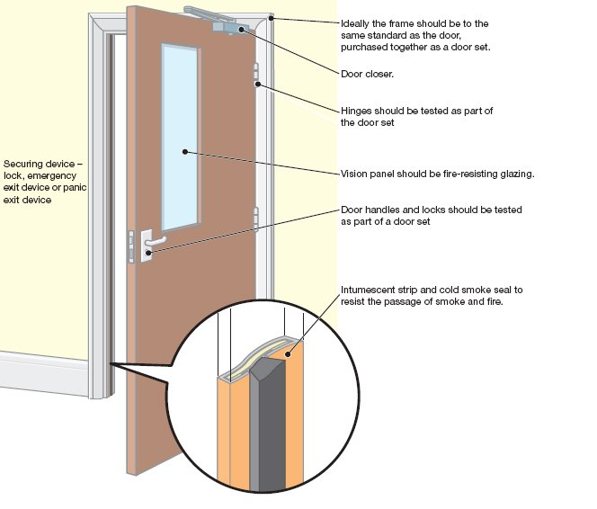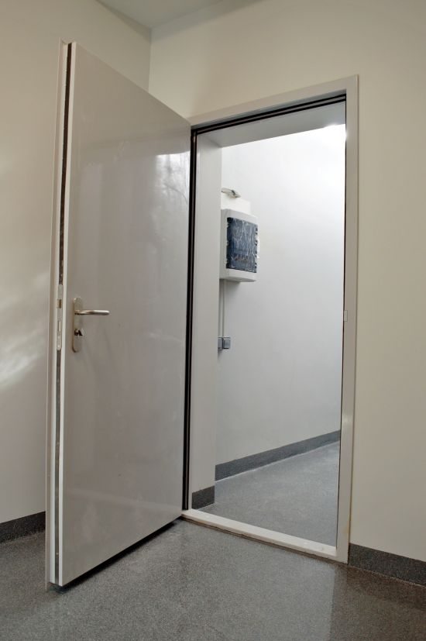
It would be at least 44mm thick (for a 30min FD, or 54mm thick for a 60min FD), be of solid construction, have 3 hinges, a self-closer, fire door keep shut/locked/closed signage, usually a latching mechanism (not usual in double swing sets), seals around the sides and top, maximum gaps of 4mm along the sides and top, 8mm at the bottom, a label on the top edge of coloured plastic plug in the hinge edge, sometimes has a vision panel of fire rated glazing with stamp and with a 12mm rebate to the frame.
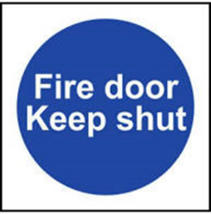
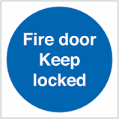
The Mandatory Blue Signage is usually 100mm², may also be round, ‘keep locked’ signage is usually found on the door to higher hazard rooms, electrical cupboards etc.

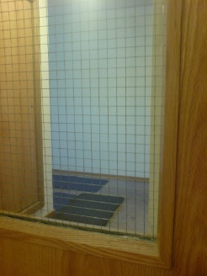
What do the (nominal) older fire doors look like?
At least 44mm thick, usually solid, but not always, should have a fire door keep shut/locked sign on each side, it may not have a self-closer, it may not have seals along sides and top, if it has a glass panel, it would usually be Georgian wired glass. These would be classed as nominal fire doors.
If my doors don’t meet the modern standards with certification do I need to replace my nominal fire doors with modern doors?
Simple answer is no, if the door, frame and hardware still perform its job and closes into the frame, with reasonable gaps, these could be slightly greater than the 3mm as long as the rebate is approximately 25mm deep. Your doors do not need retrofitting for seals or self-closers either, seals & self-closers would only need to be fitted if the doors and frames are no longer fit for purpose and need replacing, then a modern certified door/frame with hardware would be fitted.
How would I know it’s a fire door if it doesn’t have the label?
See above and also, its location, is it at the top or bottom of a stairwell on a means of escape route, is it along a corridor, is it on a high hazard room? These are the best ways to attempt to define if it’s a fire door.
What are the different types of seals?
Modern fire doors must have intumescent seals, these are rebated into the door or preferably frame and expand when heated to seal the gap between the door and frame to stop/reduce the heat/fire/smoke passing between the door and frame. Smoke seals are flexible and can be brushes, fins or wipe seals and are designed to stop cold smoke passing through the door gap allowing persons to escape safely without becoming overcome by smoke.
Can seals be painted over?
Intumescent seals can be painted over without causing issues to its performance, smoke seals cannot be painted over.
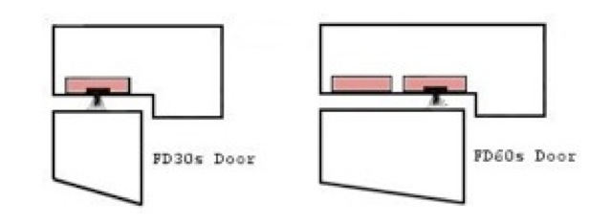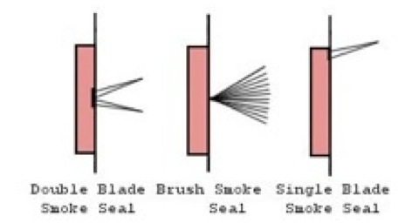

Intumescent (heat) seal Combination heat & smoke seals
Do I need to be certified/qualified to check a fire door?
No, if you follow a defined step by step checklist (one below) for each door and keep a log with your fire diary for each door then you are suitable to check a fire door for serviceability.
What would I look for?
- CERTIFICATION
Look for a label, a round plastic plug or a Christmas tree symbol on it in the top of the door or the hinge edge. You can use a mirror or mobile phone in ‘selfie’ mode to look for this.
NOTE - Don’t get too hung up on this point about labelling. The key fire doors are the ones segregating corridors, segregating stairwells from corridors or kitchenette doors and will need inspection. Does the door have a Fire/Smoke Door keep shut/closed/locked label/plate on both sides?
Typical plugs/labels for fire doors:
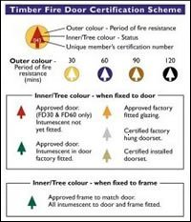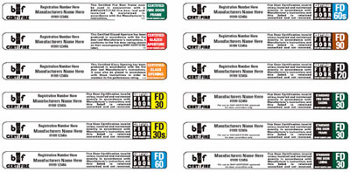
- GAPS
Check the gaps between the door and frame around the sides and top are consistently less than 4mm when the door is closed. The gap under the door can be slightly larger (up to 8mm) but you should not see light under the door, also is the door warped and does not close into the rebate along both sides and top? Double doors must close inline if both opened together and not clash.
Note – You can use a £1 coin to do this as it is a shade off 3mm thick. 3mm is considered a normal through which smoke and flame would have trouble penetrating easily. Especially if coupled with the 25mm frame rebate. If the gap is larger than 3mm record it. The door may need adjusting in the frame to centralise it. If the door is warped and does not come close to touching the rebate all around it needs attention. Record your findings and report faults.

- SEALS
Look for any intumescent seals around the door or frame. Check they are intact with no sign of damage.
Note – If the door and frame have no seals, it may not be a fire door. Old fire door standards never mandated seals. So only concern yourself at looking at what is in front of you. Has your door or frame got seals in place, are they damaged or missing (empty rebate in frame)? Intumescent seals and fitted flush to the door/frame and can be painted over, smoke seals sit proud and cannot be painted over. Record your findings and report faults.

- HINGES
Check all the hinges are firmly fixed with no missing or broken screws or bent hinges.
As a minimum a fire door will have three hinges sometimes four (nominal may only have two). Check that no excessive wear has happened to the hinges causing gap issues. Any problem with the hinges, Record your findings and report faults.
- CLOSING PROPERLY
Check the door closes firmly onto the latch without sticking on the floor or the frame.
All modern fire doors should have a door closer fitted, older doors will not. If it has a self-closer, then open the door fully and halfway and let go, If the door closer is working correctly, the door should close and latch from any open position without slamming. Door closers are found with the arms disconnected, leaking oil and in some cases removed. If the door fails to close into the frame fully (it should close in about 5-10 seconds but no longer than 25 seconds from fully open position) and latch it will need adjustment. Record your findings and report faults.
- FINAL CHECK
Check the hardware and glazing fitted to the door.
Are the glazing panels and additional hardware, handles, closers, co-ordination devices etc. fitted securely, work correctly and not damaged. Glazing panels should be held in place with intumescent seals and pinned beads. Record your findings and report faults.

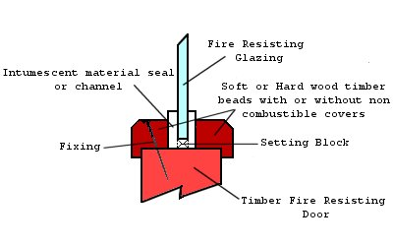
How often should I carry out these inspections?
These checks should be carried out at least once every six months
Buildings may require more frequent checks in the first year of use or where traffic is high, as they are likely to be more susceptible to damage and should be checked at least every 3 months, some TLBs may mandate more frequent checks (for example, monthly)

Why do I need to carry out these Fire Door Inspections?
Article 17 of the Regulatory Reform (Fire Safety) Order 2005 makes it a legal requirement to ensure that fire resisting doors and escape doors are correctly installed and adequately maintained in order for them to be fit for purpose, these checks should ensure that the door remains fit for purpose. This is now being picked up on fire risk assessments as these checks are not being completed and therefore not complying with the British Standard.

Can fire doors be repaired by anybody to any standard?
This Standard mandates that only 3rd party competent person (to a UKAS recognised pertinent organisation) fit and carry out repairs to fire doors IAW certain recognised standards. BM TRADA have a good set of usable approved repair methods that would maintain (the fire doors) certification (on wooden fire doors).
Can I drill through a Fire Door, or fit hardware to it?
You should not fit hardware through a fire door unless it has been approved by the door manufacturer and it is tested to perform at the same level of the door. Only qualified persons should make alterations to fire doors. For your checks just deal with what you have in front of you and not be concerned with current modifications/fittings to doors unless they have left holes through the door, then report the door as faulty needing attention.

Embedded pdf document: (double click)
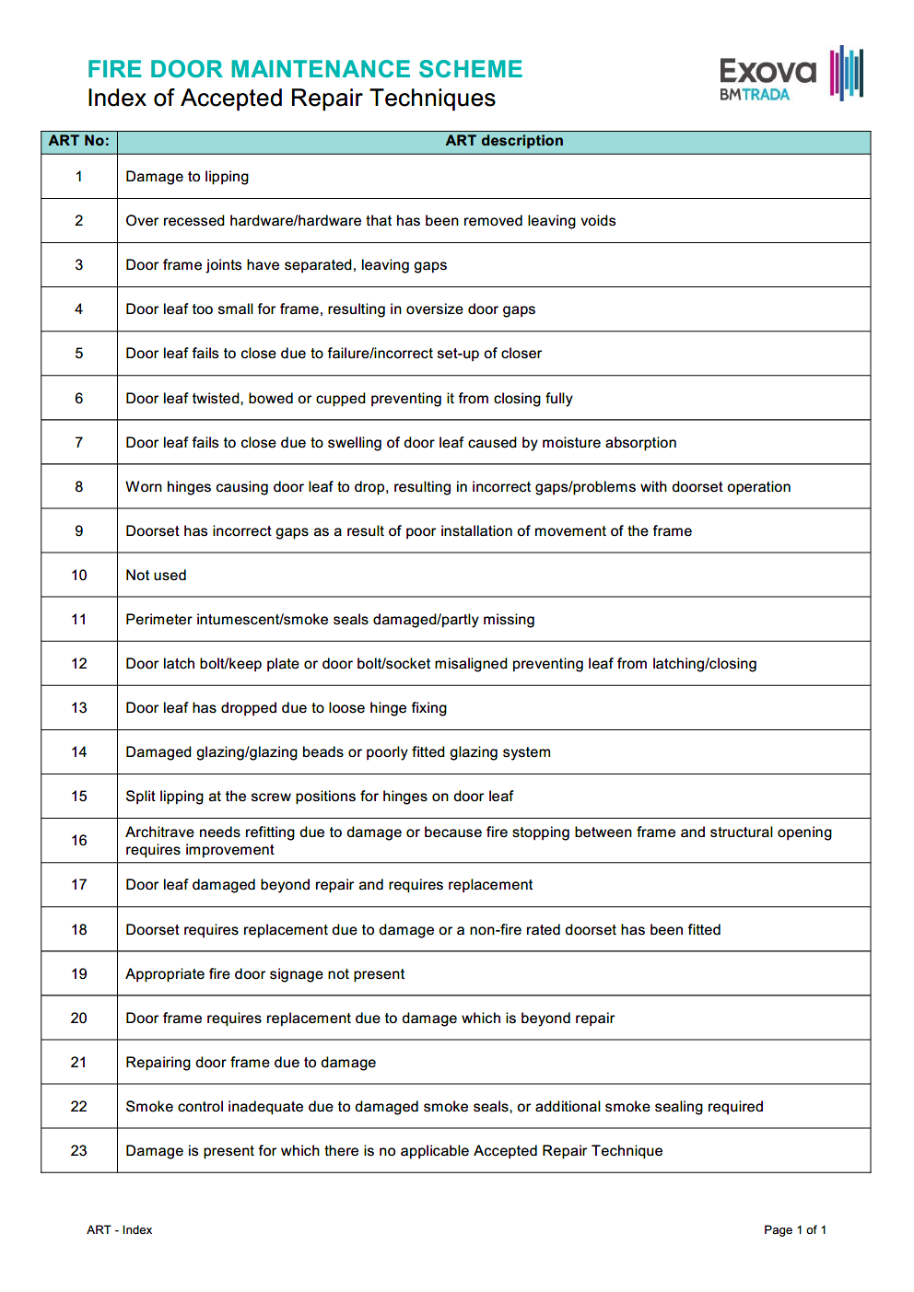

Fire Doors (No. 1-?)
‘X’ denotes an issue that needs to be addressed |  |  |  | Date of this Inspection: …../…../……….
Door Number | 1 | 2 | 3 |  | 4 | 5 | 6 | 7 | 8 | 9 | 10
Does the door have certification markings?
Are the fire door keep shut/locked labels attached?
Is the door gap 4mm or less, (top and sides)?
Does the door fit flat into its frame, without being warped?
Is the door damaged?
Is the frame secure to the wall?
Seals damaged/missing/smoke seals overpainted?
Hinges damaged/worn?
Does the door engage the latch?
Does the door close from any angle?
Is the door closer functioning correctly, not slamming and closing within 5-10 seconds if fitted?
Hold open device working (if applicable)?
(If a double door) Do the doors close in line?
Gap under the door less than 10 mm?
Sample of a door inventory list and checklist:

Sample of a door inventory list and checklist:
Door Inventory List
It is recommended that as well as referencing the doors and their location on this checklist, that you put a label with the door’s number somewhere visible on the door or its frame to help make these checks easier and more accurate.
Door No. | Door Location
1 | Ground floor, next to main entrance etc
2 | Ground floor bottom of stairwell etc
3
4
5
6
7
8
9
10
11
12

