Application Decision
by Richard Holland
Appointed by the Secretary of State for Environment, Food and Rural Affairs
Decision date: 10 February 2022
Application Ref: COM/3277758
Newlands Corner, Albury Downs, Guildford, Surrey
Register Unit No: CL344
Commons Registration Authority: Surrey County Council

- The application, dated 18 June 2021, is made under Section 38 of the Commons Act 2006 (the 2006 Act) for consent to carry out restricted works on common land.
- The application is made by Surrey County Council.
- The works comprise:
- a natural timber play area on 25m² with a 10m extension to the existing wooden post and rail fence;
- improved picnic area with 16 oak picnic tables and natural log seating and up to 10m of knee-high (600mm) timber birds mouth railing;
- relocating fenced bin store (2m high timber hit and miss fencing) on 20m²; and
- a free-standing bottle filling water fountain on 0.3m².

Decision
- Consent is granted for the works in accordance with the application dated 18 June 2021 and the plans submitted with it subject to the following conditions:
- the works shall begin no later than 3 years from the date of this decision; and
- the land shall be fully reinstated within one month from the completion of the works.
- For the purposes of identification only, the location of the proposed works is shown in red on the attached plan.
Preliminary Matters
- I have had regard to Defra’s Common Land consents policy in determining this application under section 38, which has been published for the guidance of both the Planning Inspectorate and applicants. However, every application will be considered on its merits and a determination will depart from the policy if it appears appropriate to do so. In such cases, the decision will explain why it has departed from the policy.

- The application form and application notice refer to the relocated bin store as having a 5m² footprint. However, the application form goes on to give the footprint as 5m x 4m (20m²) (to match the existing bin store area) and the applicant subsequently confirmed that 20m² is the correct footprint. I am satisfied that the application form is clear that the relocated bin store will have the same footprint as the existing store and that no person wishing to comment on the application has been prejudiced by the inaccurate measurement.
- This application has been determined solely on the basis of written evidence. I have taken account of the representations made by Natural England (NE), Historic England (HE), Surrey Hills Area of Outstanding Natural Beauty (SHAONB), Surrey County Council’s Archaeological Officer (SCCAO), Open Spaces Society (OSS) and Save Surrey Countryside (SSC). None of them object to the proposals.
- I am required by section 39 of the 2006 Act to have regard to the following in determining this application:-
- the interests of persons having rights in relation to, or occupying, the land (and in particular persons exercising rights of common over it);
- the interests of the neighbourhood;
- the public interest; and
- any other matter considered to be relevant.

Reasons

The interests of those occupying or having rights over the land
- Albury Downs is owned by the Albury Estate, which was consulted about the application but did not comment. The common land register records no rights of common. There is no evidence before me to suggest that the works are likely to harm the interests of those occupying or having rights over the land.

The interests of the neighbourhood and public rights of access
- The interests of the neighbourhood test relates to whether the works will impact on the way the common land is used by local people and is closely linked with interests of public access.

- The new natural play area will be located in the area of Albury Downs known as Newlands Corner between the existing café and toilet buildings on the site of an older play area where metal urban style play structures were previously installed. Two sides of the playground are already fenced and the additional 10m of fencing will adjoin the north section to reduce the chances of children wandering off. Whilst the style of play structures will change, public use of the site as a playground will not and I am satisfied that the proposed works are consistent with the traditional use of this part of the common.

- The proposed picnic tables will be a mix of new and existing ones and will be installed at various locations near the café building along with some natural tree stump and log seating. The knee rail is to be installed to the edge of the new picnic area to visually separate it from the play and motorbike parking areas. Whilst the tables, seats and rail will impede anyone wishing to walk through the area, I consider that this is outweighed by their benefit to those wishing to picnic on the common and, in particular, to parents supervising children in the adjacent natural play area.

- It is proposed to move the bin store from its current location opposite the toilet block to the rear of the motorbike parking area and to the east of the natural path. Whilst it is not clear how this might impact on local use of the area and public rights of access over it, the applicant says it will be hidden amongst an overgrown area, which I take to mean it will be moved to a lesser used area away from the café, toilets, picnic and play areas. No party to have made representations has suggested that the proposed new location is inappropriate and there is no reason for me to believe that this might be so.

- The proposed bottle filling water fountain will occupy a very small footprint and will be of direct benefit to those visiting the common; in particular those using the play and picnic areas.

- I conclude that the proposed works will benefit the above interests.

The public interest

Nature conservation and conservation of the landscape
- The application land is not subject to any statutory designations for nature conservation, although Newlands Corner west to White Lane has been designated as a Site of Nature Conservation Importance (SNCI). The applicant advises that the proposals include the removal of one Holly tree (Ilex aquifolium), about which NE has raised no concerns. Environmental Impact Assessment (EIA) screening found that the proposals would not give rise to significant environmental impacts.

- The applicant advises that the works have been designed to merge with and reflect the natural surroundings and will be constructed with local timber sourced from the landowner’s sustainably managed forests. The applicant proposes to plant new hedging along the west side of the motorbike parking area to act as a second visual barrier between the parking and picnic areas and some wild seeding and shrub planting is also proposed as part of the works project.

- The proposed works will not harm nature conservation interests and I note NE’s advice that the planting has the potential to improve the nature conservation value of the area in the immediate vicinity of the proposed works. The common lies within SHAONB, whose Planning Advisor has confirmed that the AONB Board has no objection to the proposed works. The Board considers the works to be well conceived and designed and should enhance the visitor experience. The Board further considers the works to accord with the current SHAONB Management Plan, which encourages the provision of such facilities. Given the materials to be used I am satisfied that the works will, by and large, be sympathetic to their surroundings and will help conserve the natural beauty of the AONB.

Archaeological remains and features of historic interest
- HE advised that it had no comments other than to suggest that SCCAO views should be sought. SCCAO advised that it has no archaeological concerns about the works as there are no Scheduled Monuments at the site and the area does not fall within an identified Area of High Archaeological Potential. I am satisfied that the above interests will not be harmed by the works.

Other matters
- SCC advised that it had no objections to the works but it was concerned about the applicant’s inadequate posting of application notices on site. The applicant subsequently took the required steps to ensure that the notice posting procedures were fully complied with and I am satisfied that they were.

Conclusion
- I conclude that the proposed works will not harm the interests set out in paragraph 6 above. Indeed, they will improve existing play and picnic facilities for local people and the wider public and will blend sympathetically with their surroundings. Consent is therefore granted for the works subject to the conditions set out in paragraph 1.

Richard Holland

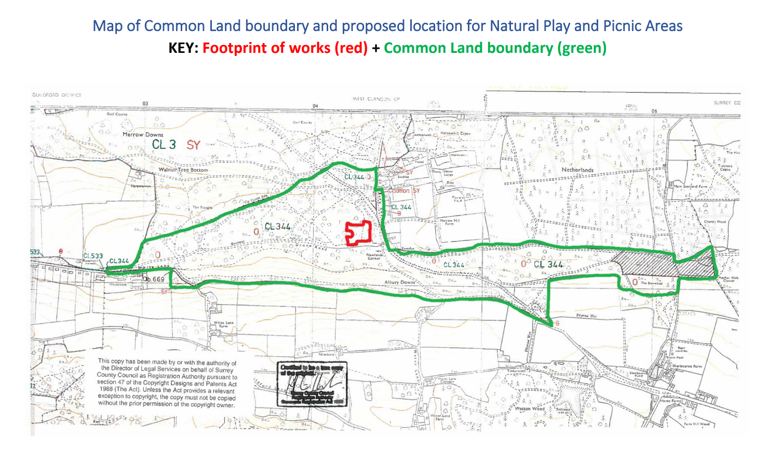

Common Land consents policy (Defra November 2015)

