Application Decision
Site visit made on 11 January 2022
by Helen O'Connor LLB MA MRTPI
an Inspector appointed by the Secretary of State for Environment, Food and Rural Affairs
Decision date: 4 February 2022

Application Ref: COM/3282031
Land adjoining The Dog Inn pub, Marsh Lane, Water Orton B46 1NW
Register Unit: VG.62
Registration Authority: Warwickshire County Council

- The application is made under Section 16 of the Commons Act 2006 (“the 2006 Act”) to deregister and exchange land registered as a village green.
- The application is made by Ms Joanne Higgins on behalf of Star Pubs & Bars Limited (owner of the release land) and Mr Brendan Bushe (owner of the replacement land).
- The release land comprises of approximately 2,144m² of land.
- The replacement land comprises of 3,035m² of a field lying to the west of Plank Lane, Water Orton.

Decision
- The application is granted.

Procedural Matters
- During the application some procedural concerns were raised as to whether the application had been publicised in accordance with Regulation 7 of The Works on Common Land, etc, (Procedure) (England) Regulation 2007 (the Regulations). Whilst this has been the subject of separate correspondence, based on the information before me, I am satisfied that the publicity requirements of the Regulations have been adequately addressed.

Main Issues
- Section 16(1) of the 2006 Act provides that the owner of any land registered as a village green may apply for the land (‘the release land’) to cease to be so registered. If the area of the release land is greater than 200m² a proposal must be made to replace it with other land to be registered as village green (‘the replacement land’).
- I am required by Section 16(6) of the 2006 Act to have regard to the following in determining this application:

(a) the interests of persons having rights in relation to, or occupying, the release land (and in particular persons exercising rights of common over it);

(b) the interests of the neighbourhood;

(c) the public interest;

(d) any other matter considered to be relevant.

The Application
- The deregistration of the land adjoining The Dog Inn pub, Marsh Lane is sought primarily to release the land for residential development.

The Release Land
- The release land amounts to approximately 2,144m² and is located within the settlement of Water Orton adjacent to the car park of The Dog Inn pub. It encompasses all the registered village green reference VG.62. The broadly rectangular site comprises grassland and scrub. There are permanent physical boundaries to the east with the adjacent residential property as well as to the railway line to the south. In addition, temporary fencing has been erected along the otherwise unencumbered northern and western boundaries. The applicant states this was done in February 2019 to deter flytipping and anti-social behaviour.
- For the purposes of identification, a copy of the application plan is attached to this decision at Appendix A. The release land is edged in red.

The Replacement Land
- The replacement land comprises a triangular parcel of land of approximately 3,035m². It forms part of a larger field used for keeping horses to the west of Plank Lane and is not presently accessible to the public. The replacement land is edged in green on the attached application plan.

Representations and Objections
- Four representations were made in response to the notice of the application, three objecting and one in support.
- Water Orton Parish Council support the application. They state that it was not until 2016/17 that they became aware that the release land had village green status. It has not been maintained by the Parish Council and there is little record to show it has ever been used as a village green. They refer to the historic use of the site as a cattle marketing yard and suggest the original standing remains under the grass surface. The replacement land would, they contend, offer more opportunity to create an enhanced area that would benefit the community. They refer to the replacement land being accessible, close to the school and adjacent to another small area of common land. Further reference is made to the replacement land being in the Green Belt and forming part of a green corridor.
- North Warwickshire Borough Council object primarily on public interest grounds. They consider that the replacement land is not in a safe or reasonably accessible location to the Water Orton community. Similarly, Natural England express some doubts as to whether the test of equal value would be met by the proposed replacement land due to its accessibility. They also question why the release land has been fenced off and allowed to become neglected as these are factors which hamper its ability to make a positive contribution towards the recreational wellbeing of the local community.
- These are matters also highlighted by the Open Spaces Society who consider that the temporary fencing erected around the release land is unlawful. They go on to state that the proposed replacement land is too remote from the village to be of use as a village green.

Assessment
- In determining the application, I have had regard to the Department for Environment, Food and Rural Affairs Common Land consents policy, November 2015 (the 2015 Guidance) published for the guidance of both the Planning Inspectorate and applicants. Paragraph 3.2 sets out overall policy objectives to protect commons and greens which includes the outcome that the stock of such land is not diminished so that any deregistration of registered land is balanced by the registration of other land of at least equal benefit.

The interests of those occupying or having rights over the land
- The information before me shows that no one occupies the release land and that there are no registered rights over it. On that basis, it follows that the proposal would not have an adverse impact on any person with an interest in the land.

The interests of the neighbourhood
- The 2015 guidance indicates that the issues to be considered in this context include whether the exchange would prevent local people from using the green in the way they are used to, and whether or not there would be an interference with the future use and enjoyment of the land as a whole.
- The information provided reveals that until relatively recently, the Parish Council were generally unaware of the village green status of the release land. It is reasonable to suppose that this lack of awareness pervades more widely in the neighbourhood. Perhaps it is not surprising in those circumstances that there has been no established neighbourhood usage of the release land as a village green. This would have been compounded by the limited maintenance of the land and erection of temporary fencing preventing access. Consequently, in this sense the neighbourhood would not experience the loss of an existing use.
- Nevertheless, the proposal would remove any potential opportunity for the future use and enjoyment by the neighbourhood of the release land. The configuration of the site is of a reasonable size and shape and it is located relatively close to facilities within the settlement. Pedestrian access is supplied by lit and generally overlooked footways, but the site is separated from much of the settlement by the railway line. Pedestrians have the option to use the more direct railway bridge but would need to navigate a considerable number of steps which would be an obstacle to those with reduced mobility or for example, pushing a pram. Otherwise, pedestrians and cyclists from the more densely populated part of the settlement to the south would need to use a busy part of Marsh Lane. Hence, despite being centrally located, these factors would detract from the attractiveness of the route for people in the neighbourhood.
- By comparison, the proposal would provide more replacement land than would be released, which weighs in its favour. However, concerns have been expressed regarding the accessibility of the site to the neighbourhood. In this regard there is some overlap with matters considered under public rights of access. As part of my site visit, I walked to the replacement land from a central part of Water Orton and noted the location and provision of other greens within the village. There was a lit footway to the replacement land in either direction from Plank Lane. The routes to the site are of a reasonable length from most of Water Orton and consequently, the distance would be unlikely to deter people in the neighbourhood from accessing the site. At my visit, I observed that Plank Lane was well used by pedestrians and joggers. Furthermore, as parts of Plank Lane have a more rural character than Marsh Lane, with generally less vehicular traffic and glimpses of the open countryside, the experience of accessing the replacement land was more pleasant.
- Although less centrally positioned than the release land, the replacement land is reasonably close to residences as well as the primary school. As such, I cannot agree that it would be remote as has been asserted in some of the representations. In addition, the more western location would allow for a reasonably even distribution of greens within the neighbourhood. For these reasons, I am satisfied that the replacement land would be conveniently situated to local people.
- Furthermore, the Parish Council indicate there is no immediate prospect of them undertaking to improve the condition or maintenance of the release land, and there is nothing before me to show that it would otherwise notably be improved. Realistically, this limits the potential opportunities for future use by the neighbourhood. In contrast, a vision for the replacement land has been outlined which has the involvement of the Parish Council whereby it would provide a village green with a more naturalistic environment and open countryside setting. It is intended to counter-balance other areas of green in the village which are mostly grass or playing pitches.
- In addition, it would provide an opportunity for the Parish Council to make better use of a small area of adjacent common land (part of registered unit CL22). In isolation, the shape and size of this parcel of common land inhibits its meaningful use or enjoyment by the neighbourhood.
- Taking these factors together, the proposed exchange would, overall, be beneficial to the interests of the neighbourhood. My view on this is considerably reinforced by the views of the Parish Council who are in a good position to reflect and articulate the interests of people in the neighbourhood.

The public interest

The protection of public rights of access
- Public access to the release land has been physically prevented by temporary fencing since February 2019. However, there is nothing before me to show that consent has been given for this obstacle and therefore, public access to the release land ought not to be prevented. Otherwise, the release land is reasonably accessible to those living nearby.
- Paragraph 5.1 of the 2015 guidance refers to evaluating a proposed exchange in terms of both quality and quantity. The area of replacement land is larger than the release land and as such, there would be a modest gain in the area available for public access.
- For similar reasons to those outlined in relation to the interests of the neighbourhood, notwithstanding the more central location of the release land, the replacement land would be conveniently accessible to the public. Having observed and compared the available routes to the release and replacement land, I am satisfied that the public would be no worse off in consequence of the exchange than without it and in many respects the access would be more pleasant. Accordingly, the proposal would protect public rights of access.

Nature conservation
- Limited information is provided in relation to biodiversity at either the release or replacement land and neither are subject to any national or local designations for wildlife interest. In broad terms, both the grassland and scrub at the release site and grazing land at the replacement site are likely to contain relatively limited biodiversity. Nevertheless, depending on the management regime employed both have the potential to enhance biodiversity.
- The applicant refers to the possible creation of a wildflower garden and tree planting at the replacement land, but no solid plans have been confirmed. I have also noted that the Parish Council states that the replacement land would help to provide a green corridor linking the village to the Park Hall nature reserve as part of the HS2 project. However, it is not shown that this is dependent upon the replacement land obtaining village green status.
- On the evidence before me, I consider that the potential for nature conservation at both sites is broadly balanced. I am satisfied that the proposed exchange would not have any adverse impact upon biodiversity or nature conservation.

Conservation of the landscape
- My observations of the release land were consistent with the descriptions given that outline a lack of maintenance and temporary fencing. Nevertheless, I observed the absence of built form, sense of spaciousness and presence of some greenery presently make a limited positive contribution to the built-up area of the settlement.
- The replacement land is situated closer to open countryside. Limited physical alterations are proposed which include the creation of a new pedestrian entrance and maintenance gate from Plank Lane, signage and timber and rail fencing along the north western and south eastern boundaries to differentiate the replacement land from the remainder of the field. These modest measures would be unlikely to result in a significant alteration to the rural landscape. Limited and localised landscape benefits could be derived from the likely upgrading of the adjacent small area of common land.
- Overall, I am satisfied that the impact on the landscape character of the area would be generally neutral.

Archaeological remains and features of historic interest
- No archaeological remains or features of historic interest have been brought to my attention and no comments have been made with respect to those matters. Consequently, I have no reason to find that any adverse effects would arise on this basis.

Other relevant matters
- The applicant refers to the poor condition of the release land and states that it is a nuisance site prone to fly tipping and antisocial behaviour. However, this has had little bearing on my determination as other measures might be reasonably employed to address such problems that stop short of deregistration.
- The replacement land is in the Green Belt and reference is made to potential future reviews of the Green Belt that could find the land favourable for development. Be that as it may, development plan decisions including those concerning the extent of the Green Belt, must be made with reference to the relevant procedures in force that take account of many complex factors. Accordingly, I have not attributed weight to the possible future content of the development plan in this regard.

Conclusions
- Having had regard to the statutory criteria and 2015 guidance, the proposal would increase the stock of village green land. Furthermore, for the reasons outlined above, I am satisfied that the replacement land would be of at least equal benefit to the release land. I do not find that there are any relevant matters which indicate that the application should be refused.
- Therefore, having regard to all matters raised in the application and written representations, I find that consent for an exchange of land should be granted and an Order of Exchange given in respect of the application.

Helen O’Connor

Inspector

Order

On behalf of the Secretary of State for Environment, Food and Rural Affairs and pursuant to section 17(1) and (2) of the Commons Act 2006, I HEREBY ORDER Warwickshire County Council, as commons and village greens registration authority for the area in which the release land and the replacement land are situated:
- to remove the release land from its register of town and village greens, by amending register unit VG.62 to exclude the release land;
- to register the replacement land as village green, by amending register unit VG.62 to include the replacement land.

First Schedule – the release land

Colour On Plan  (Appendix A) | Description | Extent
Edged in red | Land adjoining The Dog Inn pub, Marsh Lane, Water Orton B46 1NW | 2,144²

Second Schedule – the replacement land

Colour On Plan  (Appendix A) | Description | Extent
Edged in green | Part of field lying to the west of Plank Lane, Water Orton. | 3,035m²

Helen O’Connor

Inspector

Appendix A

Not to scale

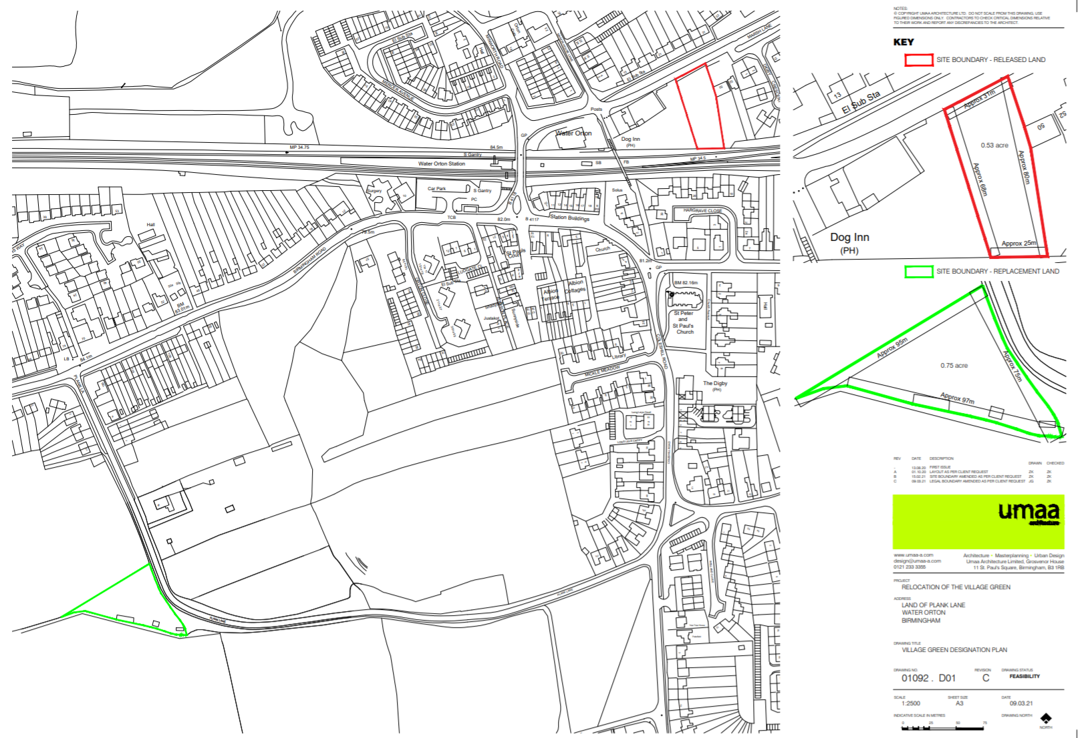

Section 16(8) of the 2006 Act provides that the public interest includes the public interest in: nature conservation; the conservation of the landscape; the protection of public rights of access to any area of land; and the protection of archaeological remains and features of historic interest.

