Order Decision
Site visit 28 September 2021
by Grahame Kean B.A. (Hons) Solicitor HCA
an Inspector appointed by the Secretary of State for Environment, Food and Rural Affairs
Decision date: 07 January 2022

Order Ref: ROW/3249317
- The Order is made under Section 53(2)(b) of the Wildlife and Countryside Act 1981 (‘the 1981 Act’) and is known as The City of Salford (Haddon Road Area, Worsley) (Definitive Map and Statement Modification) Order (No 1) 2019
- The Order is dated 22 March 2019 and proposes to proposes to modify the Definitive Map and Statement for the area by adding a public footpath as shown in the Order plan and described in the Order Schedule.
- There was one objection outstanding when Salford City Council (the Council) submitted the Order to the Secretary of State for Environment, Food and Rural Affairs for confirmation.

Summary of Decision: The Order is confirmed.

_________________________________________________________________

Preliminary matters
- The Order is promoted by the Council which is also the Order Making Authority (‘OMA’). I made an accompanied site visit with the Council officer and supporters of the Order. The objector was invited to attend but did not do so.

Main issue and legal framework
- The Order is made under section 53(2)(b) of the 1981 Act in consequence of an event specified in section 53(3)(c)(i). The main issue is whether the discovery by the authority of evidence, when considered with all other relevant evidence, is sufficient to show that a right of way which is not shown in the map and statement subsists over the land in the area to which the map relates. The test to be applied to the evidence is on the balance of probabilities.
- By s32 Highways Act 1980 (the 1980 Act) I have to take account of any “map, plan or history of the locality or other relevant document” offered in evidence and give such weight to it as is justified by the circumstances, including its antiquity, the status of the person by whom and the purpose for which it was made or compiled, and the custody in which it has been kept and from which it is produced.
- Section 31 of the 1980 Act sets out a statutory presumption of dedication: if public use of a way for twenty years or more is shown, the way is deemed to have been dedicated as a highway of that description unless there is “sufficient evidence” from which it can be concluded there was no such intention during that period to dedicate it.
- The twenty-year period must be calculated retrospectively from the date when the public’s right to use the way as claimed is brought into question. Further, at common law it may be inferred that a way was dedicated and accepted for public use for periods less than 20 years.

Reasons
- The objector is the owner of the land on which the alleged route runs. He registered his freehold interest at HM Land Registry on 28 October 2016 and around December 2016 erected fencing and then signs, at each end of the Order route that disavowed the existence of any public right of way.
- The Council made the Order on the application, dated 20 June 2017, of the Broad Oak Park Residents’ Association (the applicant) and supports confirmation of the Order. The application was supported by user evidence forms (UEFs) claiming uninterrupted public use of the Order route for over twenty years, historical map evidence and other documents. It was responded to by the owner who denied the existence of public rights over the Order route, asserting that due to (i) signage on the land by the previous owner; and (ii) a conveyance of the land, the previous owners had no intention to dedicate the Order route as a public right of way.
- The Council considered relevant documents discovered after its investigation. Firstly, Ordnance Survey (OS) maps, the earliest dating to 1848 provide evidence of the physical existence of a path along the alignment of Public Footpaths 41 and 44. From this evidence the Council infers that they, together with the Order route formed a single continuous route, which was generally retained when Haddon Road and Chatsworth Road were developed.
- Secondly, the 1910 Finance Act index map shows that the Order route was excluded from valuation. The Council considers this is “good evidence” that the Order route was considered to be a public highway of some status at the time.
- The Council primarily relies on s31 of the 1980 Act but also considers that under common law principles the historic documentary and the user evidence together are sufficient evidence from which to infer a dedication and acceptance of a public footpath over the Order route.

When was the way called into question?
- Post and wire fencing was erected in December 2016 across both ends of the Order route and was removed shortly afterwards but at the same time green signs were erected in the vicinity of the Order route with white writing on them stating: Private Land – No Public Access or Right of Way. So a possible date on which the existence of the Order route was brought into question is December 2016, the relevant 20 year period being December 1996 – December 2016.
- However another possible date, 26 April 2004, is suggested as relevant, ie when the then landowners applied for planning permission to erect a wall that would have enclosed the land and prevented use of the Order route. That application and another similar one were withdrawn around June 2004, and the wall was not built.
- The effect of s31 of the 1980 Act is that the evidence that a landowner did not intend to dedicate a path to public use requires overt acts from which users would reasonably understand the landowner’s intention. A planning permission does not permit development that would be in breach of other restrictions on the use of the land, including interference with public rights of way, so a planning application alone might not be sufficient to bring to the attention of the public that their right to use the way was brought into question. The rights would continue to be enjoyed unless or until the way is stopped up or diverted.
- Here, site notices would have notified users that a development was proposed that might ultimately prevent future use of the path, but that would not necessarily call into question its use as a public right of way; indeed it might be the owner’s intention to divert or stop it up. The issue is fact specific. The Council points to the completed planning application which stated “No” to the question whether it was intended to close or divert the way, but it is still tenuous evidence that its status was thereby called into question. The circumstances of the planning applications do not amount to sufficient evidence that called into question the alleged public right of way.
- It is also said that the use of the route was brought into question by signs installed by previous owners at some time between 2000 and 2004. However I agree with the Council that these signs were not, on the photographic and other evidence, including my own observations on site, directed toward the use of the path rather than the triangular piece of land in front. They would be difficult to see from the path and the relevant 20 year period should not be applied from the date they were first erected.
- I find on this matter that the public use of the path was first brought into question in December 2016 and the relevant 20 year period is from December 1996 to December 2016.

Evidence
- Some thirty UEFs were submitted and all user witnesses were interviewed individually by Rights of Way Officers. A graph summarising the period of use by each witness is submitted. It indicates the Order route was used during the period 1930 to 2017 with over 20 witnesses claiming use throughout the full twenty‐year period 1996 to 2016.
- The UEFs show that the Order route was being used for leisure and recreation in conjunction with the adjoining established public footpaths; and as part of a route to visit destinations in the local area. The frequency of use of the Order Route varied between approximately fortnightly to almost daily. I agree with the Council that save for three witnesses whose use might be considered to be in the exercise of some form of tacit permission or license, all witnesses give evidence such that their use may be defined as being “as of right”.
- This level of use I consider sufficient to have brought to the attention of the respective landowners that the Order route was being used by the public. Having considered all the user evidence I am satisfied that it clearly shows it to be reasonable to conclude that there has been a full period of twenty years’ use by the public, as of right and without interruption.
- The owner states a bollard was removed from the Chatsworth Road end of the Order route, raising the possibility that its use has been ‘by force’ and therefore not “as of right”. I saw a bollard was placed in the middle of the other entrance at the Haddon Road end which, as I observed did not prevent pedestrian use of the route, in particular a large walking group who went through the Order route without any physical let or hindrance, making use of it as a link between FP 41 and FP 44. The image I have seen of a bollard at the Chatsworth Road end appears larger than that in situ at the Haddon Road end, but it is unlikely that this or any bollard previously placed in similar positions at either end of the route would have required its negotiation by pedestrians “by force”.
- The signs erected on the owner’s property to which the objector refers have been noted as above. However those erected that are relevant to and conspicuous at the right of way, postdate the full period that has been considered to form a sufficiently continuous public use of the way.
- The objector then points to the terms of a deed of conveyance in June 2000 in which is reserved a range of private rights over the Order route. It was maintained on his behalf that the reservation of rights, including on foot, is inconsistent with public rights over the way in question. It is common however, to reserve such rights in a deed of conveyance, and they are not necessarily incompatible with the existence of public rights to which they would be subject.
- It is also suggested that the Third Schedule, paragraph 1 in the deed restricts the land to use as a private garden for the benefit of 2 Haddon Road, thereby inhibiting the ability of current and previous owners to dedicate a right of way to the public. The covenant, however, is subject to Second Schedule, paragraph 1 to the effect that the land is transferred subject to “all such existing rights easements and privileges (if any) as are now subsisting in respect of the said property”. The Council is correct in noting that, in effect the vendor was unprepared to acknowledge other existing rights over the land. Indeed a public right such as that contended for in this application, is in the nature of an overriding interest that will not necessarily have been disclosed on registration of the title. I find that the deed fails to evidence a lack of intention to dedicate.
- In May 2012 the previous landowner Peel Developments deposited with the Council a Statement and Map pursuant to s31(6) of the 1980 Act identifying land owned by it in the locality, including at Haddon Road and Chatsworth Road. However, it is not disputed that at the time of the deposit it no longer owned the land through which the Order route passes. As a result, the s31(6) deposit can have no effect on the Order Route, in other words it did not indicate that it was not intended that the route should be a public right of way.
- It was also suggested that the Order route gave out onto roads that did not have public rights of passage. Now, a way which has no connection at either end to a place to which the public have a right to be cannot be a highway as it will not be open to the public at large but only to those who have the licence of the landowner at each end to get to it.
- However, although neither road is adopted as a publicly maintainable, the OS map evidence clearly shows their physical existence from 1848, and the highway authority considered them to have the reputation of a highway. They are also subject to a speed limit, carry street lighting for which the Council is responsible, and public rights of way are shown on the DMS at both ends. Both roads have been regularly used by the public for very many years without apparent restriction. On the balance of probability I find that dedication and acceptance may be inferred under the common law.

Summary and conclusion
- In summary therefore, I find that there has been a full period of twenty years’ actual use of the Order route by the public. The use has been as of right, that is to say it has been carried on without having to force access, openly, and not by any licence or permission. During such period, there has been no act that I construe as sufficiently overt and directed at actual users of the Order route to demonstrate a lack of intention to dedicate on the part of the landowner(s).
- Whilst the applicant’s case is justified on s31 of the 1980 Act, I find it is also supported by the historical mapping, 1910 Finance Act records and inferences to be drawn from how the route has been used in conjunction with FP 41 and FP 44. Overall the evidence gives a clear picture of the Order route having the reputation of being a public right of way for over 100 years.

Other matters
- There were several matters raised in the representations that are not in my remit to consider but should be mentioned in the interests of all parties.
- Firstly, when the owner of the land through which the Order route passes erected a wire fence across the entrances to the path, he continued such fencing around the perimeter of the triangle of land whose apex was at the junction of Haddon Road and Chatsworth Road. From reading the many statements made by local residents and users of the Order route I have no doubt that, because the owner has maintained the fencing around this land where there is no defined pavement, it makes visibility very poor and users now have to step out into the carriageway which, not least for those with young children and/or a pram makes it a dangerous manoeuvre. This is a very real concern for many local people. However it is not a matter for me.
- The local highway authority of course, if it wishes to investigate the extent of the highway on those parts of the roads, may do so, including any verge legitimately used as a highway by pedestrians prior to its enclosure. The duty of the highway authority to assert and protect the rights of the public to the use and enjoyment of any highway for which they are the highway authority, includes any roadside waste which may form part of it.
- Secondly, it is clear that the Order route has not been used to its full width due to encroachment through various devices that have included the planting of laurel bushes, placing of boulders in the way and, as it would appear alteration of the original configuration of the fence out and over the Order route. I appreciate what may be a valid concern that the owner has as to the risk of increase in anti-social behaviour if particular structures are removed. However, that is not relevant to my consideration of the Order.
- The surface of the path is largely a mix of loose stone and trodden earth and the Council’s inspection and measurements of widths are noted, to the effect that the line of the path was evident along the full extent of the Order route. Having regard to the evidence overall the specified widths are reasonable and appropriate to apply. It is for the local highway authority to decide what action should be taken to mitigate any unlawful or undesirable use of the route.
- Thirdly, there are many statements forwarded by the applicant that refer specifically to the triangular piece of land being used by them or their children in past years for recreational purposes including playing games on what was then open and untended woodland. I appreciate the many concerns raised at the recent enclosure of this land and indeed it has been asserted that it is some form of common land.
- Provided the right to apply has not been excluded anyone can apply under s15(1) Commons Act 2006 to register land as a green if it has been used by local people for lawful sports and pastimes ‘as of right’ (ie without permission, force or secrecy) for at least 20 years. The owner may have indicated his intention to develop the land and there is of course potentially a right to apply for registration of the land as a green, including when land is identified for potential development in the planning system. However it is not a matter that can be dealt with here.
- Finally I should mention that there have been upwards of 150 representations of which one or two have objected to the order on the basis that it is no hardship to have to circumnavigate the triangle of land instead of using the Order route. This is irrelevant to the task in hand which is to determine whether a public right of way exists in law. By the same token the many representations that extolled the visual amenities of the adjacent woodland are also irrelevant for this purpose despite the fact that, as I saw for myself, it is an undoubted attraction, although not viewed by me, alas, in springtime.

Formal Decision
- I confirm the Order.

Grahame Kean

INSPECTOR

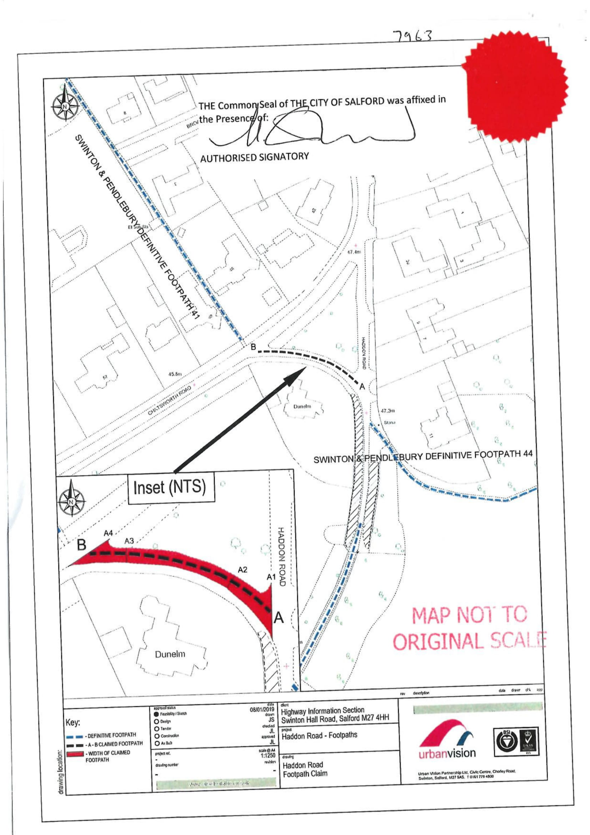

To take just one example from many a young mother was witnessed (email from N.M 24.5.2021) pushing a pram on Chatsworth Road, “desperately” trying to get out of the way of a very large wagon, but was prevented from escaping into the triangle of trees, and she “was in tears and very shaken up”.
See for example the potentially relevant factors stated in Hale v Norfolk County Council [2000] EWCA Civ 290 as to whether it can be assumed that a fence or hedge has been erected to separate land over which there is a highway from land enjoyed by the landowner: “the nature of the district through which the road passes, the width of the margins, the regularity of the line of hedges, and the levels of the land adjoining the road; and (I would add) anything else known about the circumstances in which the fence was erected”.

