Order Decision
Site visit made on 30 November 2021
by Helen Heward BSc (Hons) MRTPI
an Inspector appointed by the Secretary of State for Environment, Food and Rural Affairs
Decision date: 17 December 2021

Order Ref: ROW/3240495
- This Order is made under Section 53 (2)(b) of the Wildlife and Countryside Act 1981 (the 1981 Act) and is known as Definitive Map Modification (Restricted Byway 2, Belton) Order 2018 (2).
- The Order is dated 19 April 2018 and proposes to modify the Definitive Map and Statement (DMS) for the area by adding to them a Restricted Byway and upgrading an existing way to a Restricted Byway as shown on the Order plan and described in the Order Schedule.
- There were two objections outstanding when North Lincolnshire Council submitted the Order to the Secretary of State for Environment, Food and Rural Affairs for confirmation.
Summary of Decision: The Order is confirmed.

Procedural Matters
- I considered the case based on written representations as none of the parties requested an inquiry or hearing. I carried out an unaccompanied site visit.
- The Order would record on the Definitive Map and Statement:-
- A Restricted Byway to be added over Order route section A-B and
- A path to be upgraded to a Restricted Byway over Order route sections B-C and C-D.
- All as described in the North Lincolnshire Council Definitive Map Modification (Restricted Byway 2, Belton) Order 2018 (2).

The Main Issues
- S53(2)(a) of the 1981 Act states that as regards every DMS, the surveying authority shall as soon as reasonably practicable after the commencement date, by order make such modifications to the map and statement as appear to them to be requisite in consequence of the occurrence, before that date, of any of the events specified in subsection (3).
- S53(3)(c)(i) of the 1981 Act provides that a modification order should be made on the discovery of evidence which, when considered with all other evidence available, shows that a highway shown on the DMS as a highway of a particular description ought to be there shown as a highway of a different description.
- S53(3)(c)(ii) provides that a modification order should be made on the discovery of evidence which, when considered with all other evidence available, shows that a public right of way which is not shown on the DMS subsists, or is reasonably alleged to subsist over land in the area to which the map relates.
- Objector A owns a parcel of land adjacent to part of the Order route. Their main objection/concern is that the designation of the Order route as Restricted Byways would prevent them from having a continued vehicular right of access to their land. They argue that vehicular access enables them to enjoy the peace and quiet and to maintain their land and keep it within bounds, which on occasion requires driving to the land with appropriate machinery. Secondly Objector A is concerned that the width of the Restricted Byway specified in the Order would encroach onto their land.
- Objector B agrees with the Council that it is a highway for vehicles but argues that the maxim “once a highway always a highway” prevails, the Council has not kept their List of Streets (LoS) up-to-date, and that this [s53] procedure is not a lawful way to change a public highway into a ‘mere’ Right of Way. They submit that in Mason it was held that the definitive map was not concerned with ordinary carriageways or cartways and that ordinary roads used by vehicular traffic were not within its scope. Therefore Objector B argues that the route should be recorded on the LoS as a full highway forming part of the ordinary roads network and not on the DMS.
- However, Mason predates the 1981 Act. S66 of the 1981 Act defines a Byway Open to All Traffic (BOAT) as “a highway over which the public have a right of way for vehicular and other kinds of traffic, but which is used mainly for the purpose for which footpaths and bridleways are so used”.
- The meaning under s66 was clarified in the judgement in the Court of Appeal in Masters. The case concerned a modification of map to indicate route as a byway instead of a Road Used as a Public Path (RUPP). Roch LJ held that Parliament did not contemplate that ways shown in definitive maps and statements as RUPPs should disappear altogether from the maps and statements simply because no current use could be shown, or that such current use of the way as could be established by evidence did not meet the literal meaning of s66(1) and that Parliament did not intend that highways, over which the public have rights for vehicular and other types of traffic, should be omitted from definitive maps and statements because they had fallen into disuse if their character made them more likely to be used by walkers and horse riders than vehicular traffic.
- The judgment means that for a carriageway to be a BOAT equestrian or pedestrian use is not a precondition, or that such use is greater than vehicular use. The test relates to its character or type and in particular whether it is more suitable for use by walkers and horse riders than mechanically propelled vehicles (MPV’s)).
- Part 6 of the Natural Environment and Rural Communities Act 2006 (the 2006 Act) extinguished public rights of way for MPV’s over every highway not already shown on the DMS as a BOAT unless saved by one or more of five exceptions set out in s67(2).
- The Order would record the route as a Restricted Byway. A Restricted Byway is a highway on which the public has a right of way on foot, on horseback or leading a horse and in or on vehicles other than by MPV’s.
- In considering whether or not this Order should be confirmed I must confine my considerations to determining whether or not the Order route should be recorded on the DMS as a public right of way, and if so it’s status against the relevant tests under s53 of 1981 Act applying s67 of the 2006 Act.
- Whilst considerations of the character of the way may spill over into considering the ordinary road network it is not my role to determine whether the Council should have kept the LoS up to date. The depiction of a route on the DMS is a record only of the existence of those rights. Other rights may exist. The LoS and DMS are not mutually exclusive, rather they are separate legal records with different purposes.
- The Council tend to agree with Objector B that the Order route ought to appear on the LoS. I see no reason why if I were to conclude that the Order route should be recorded as either a Restricted Byway or BOAT on the DMS that this should preclude the Council from recording the route on the LoS.
- Therefore the main issues are whether on a balance of probabilities the evidence indicates that a public right of way for vehicles was once in existence along the Order route, and if so whether the Order route should be recorded as a Restricted Byway or BOAT on the DMS.

Reasons

Evidence that a public right of way for vehicles was once in existence
- The Council made the Order having discovered from its records evidence to suggest that the route in question should be recorded on the DMS.

Inclosure Award
- The Isle of Axeholme Inclosure Act 1795 (the 1795 Act) Section XXV provided for “power for special Commissioners to set out publick and private Roads”. It states that all such publick Carriage Roads shall be and remain Forty Feet in Breadth between the Ditches or Fences and that the public roads shall be from time to time supported and kept in repair in the same manner as the other public roads within the respective parishes.
- As well as allotting land, the 1803 Inclosure Award for the Isle of Axeholme set out public and private roads. Three roads in the Belton section make up the Order route: Temple Road, North Moor Road and Beltoft Lane Road.
- From studying the copies of extracts of the accompanying map it is clear that Order route sections A-B and B-C comprise parts of Temple Road. Part of Order route section C-D comprises part of North Moor Road (from“C” to a bend referred to as “New Intake”). From New Intake to “D” comprises part of Beltoft Lane Road. They were awarded as public Carriage Roads of a breadth of 40’.
- The Council advises that having examined the Lindsey Quarter Session records, 1820-1940, at Lincolnshire Archives they discovered no evidence to indicate that any public rights over the route have since been extinguished or diverted.
- There is good evidence from the 1795 Act and the 1803 Inclosure Award that in 1803 the Order route was established as a public vehicular highway created under an Act of Parliament.

The Belton Tithe Commutation Map 1842
- Tithe Commissioners were concerned solely with identifying tithable lands, not with roads or their status, so are not conclusive evidence about public roads. But the maps can mark roads quite accurately and afford supporting evidence.
- The Belton Tithe Commutation Map 1842 provides a good indication that by 1842 Temple Road and Beltoft Lane Road were in existence. A section of North Moor Road at the western end of Order route section B-C near to the Three Cocked Hat wood can be seen. This Tithe Map adds evidence that these sections of the Order route were established by 1843, although it is not evidence of a public vehicular highway.
- The absence of a road depicting all of North Moor Road on the Tithe Map could have been because it crossed common land that was not tithable. The evidence in this respect is less conclusive.
- The depiction of all but a part of section C-D in a manner broadly consistent with the map and documentary evidence from the 1803 Inclosure Award for the Isle of Axeholme is evidence of some weight that most of the Order route was considered by the Tithe Commissioners to be a public carriageway in 1842.

Railway Documents
- Part of the Order route was included in a book of reference and deposited plan for the Isle of Axeholme Light Railway Act, circa 1896-7. The submitted evidence appears to relate only to a small section of the Order route where the railway crossed the Order route near Point B. The documents describe feature 151 as an ‘occupation road’ not a highway.
- Railway deposited documents were prepared as part of a public process and usually based upon a survey. Public rights of way which crossed the route of the railway had to be retained and accommodated according to their status. Therefore although it was not their primary purpose they can provide good evidence relating to public rights of way.
- The indication of an ‘occupation road’ was normally used to describe a road laid out for the benefit of the occupiers of adjoining properties and not a public highway. Therefore this evidence is not consistent with the existence of public rights over the route by vehicles.

Finance Act Documents
- The 1910 Finance Act imposed a tax on the incremental value of land which was payable each time it changed hands. In order to levy the tax a comprehensive survey of all land in the UK was undertaken between 1910 and 1920. This survey was carried out by the Board of Inland Revenue under statutory powers, and it was a criminal offence for any false statement to be made for the purpose of reducing liability. The existence of public rights of way over land had the effect of reducing the value of the land and hence liability for the tax; they were therefore recorded in the survey.
- In this case, the entire Order route is shown uncoloured on the final maps produced for Part 1 of the Finance Act. Although not definitive, the opinion that roads were left uncoloured on these maps if they were vehicular highways, was upheld in Fortune. This too is strong evidence of the existence of a public highway along the Order route.

Conclusions on the evidence that a public right of way for vehicles was once in existence along the Order route
- On a balance of probabilities a public right of way for vehicles was once in existence along the Order route. I now turn to consider the effect of the 2006 Act upon rights for MPV’s.

Whether the route should be recorded as a BOAT or a Restricted Byway

Character of the way
- On my site visit I observed that the route largely gives access to fields and a few buildings. When considered as a whole it does provide a through route from the A161 main road in the west to a minor road between Beltoft and Derrythorpe in the east. However, the surrounding metalled road network would provide a more convenient route for vehicles.
- Masters held that when considering the definition of a BOAT it was the concept or character of the way that was being described and whether it is more suitable for use by walkers and horse riders. Masters concerned a RUPP and an application made under different provisions under the 1981 Act. Nevertheless, the judgement provided an interpretation of the definition of a BOAT at s66(1) of the 1981 Act and is applicable in this case.
- I observed that the way is mainly a grass or unmade track, but ruts made by vehicles were evident in places. My observations concurred with the impression given by the photographic images included in the Council’s evidence. In most vehicular tracks can be seen. Not all non-tarmacked roads are not part of the ordinary road network. There is little evidence about the amount of use of the Order route by different types of traffic, but I found that the character of the way is such that it would be more suitable for use by walkers and horse riders than MPV’s.
- I conclude that the Order route would satisfy the definition of a BOAT in s66 of the 1981 Act. However, as the Order route is not shown on the DMS as a BOAT, and part 6 of the 2006 Act extinguished public rights of way for MPV’s over every highway not already shown on the DMS as a BOAT, I must now turn to consider if one or more of the five exceptions in S67 applies in this case.

Subsection 67(2)(a)
- S67(2)(a) excepts ways whose main lawful use by the public during the 5 years preceding commencement of the Act on 2 May 2006 was by motor vehicles rather than by other users, e.g. walkers, horse riders or horse-drawn vehicles.
- Objector A states that they have enjoyed vehicular rights prior to 2006 and argues that Objector A argues that they and previous consecutive owners of their land have all enjoyed uninterrupted access to the land without question or hinderance. They are concerned that the effect of designation of the Order route as a Restricted Byway would be to prevent them having lawful authority to access their land by MPV and prevent them from maintaining the land and keeping it within bounds, which on occasion requires driving to the land.
- Provisions within s34(1)(b) of the Road Traffic Act 1988 provide that if without lawful authority a person drives a MPV on any road being a footpath, bridleway, or Restricted Byway [they] are guilty of an offence. Order route section B-C-D is an existing public footpath to which this would already apply, but section A-B is not.
- However, where a public right of way for vehicles is extinguished by s67(1) of the 2006 Act s67(5) of the 2006 Act provides that where, immediately before commencement, the exercise of an existing public right of way to which subsection (1) applies (a) was reasonably necessary to enable a person with an interest in land to obtain access to the land, or (b) would have been reasonably necessary to enable that person to obtain access to a part of that land if he had had an interest in that part only, the right becomes a private right of way for MPV’s for the benefit of the land or (as the case may be) the part of the land.
- There is little evidence about Objector A’s use of the Order route prior to 2 May 2006 by vehicles, save that they submit that on occasion they need to drive to the land to maintain it, including taking equipment that they could not do so otherwise.
- The Council’s submissions contemplate how Objector A might access their land by MPV, but there is conjecture and I find scant quantified evidence regarding Objector A’s use of the route, or part of, by MPVs during the relevant five-year period. There is no evidence from any other users of the route regarding use by MPV’s. I find insufficient evidence to conclude that the requirements of the exception under s67(2)(a) are met.

Subsection 67(2)(b)
- S67(2)(b) provides that s67(1) does not apply to an existing public right of way if “immediately before commencement it was not shown in a Definitive Map and Statement but was shown in a list required to be kept under s36(6) of the Highways Act 1980”; that is a list of highways maintainable at the public expense. There is no evidence to this effect in this case.

Subsections 67(2)(c) and (d)
- There is good evidence from the 1803 Inclosure Award for the Isle of Axeholme that the Order route comprises highways for all traffic created under an Act of Parliament. The 1795 Act states that all publick Carriage Roads shall be and remain Forty Feet in Breadth. This would provide room for vehicles to pass. Nonetheless, there is little in the evidence to demonstrate that the Order route, or any part thereof, was expressly created or constructed for MPV’s, nor that it was created by the construction, in exercise of powers conferred by virtue of any enactment, of a road intended to be used by MPV’s.

Subsection 67(2)(e)
- There is insufficient evidence that the route, or any part thereof, was created by virtue of use by MPV’s during a period ending before 1st December 1930.

Conclusions regarding BOAT status and rights for MPV’s
- The Order route would satisfy the definition of a BOAT in s66 of the 1981 Act but public rights for MPV’s have been extinguished. Therefore it could not be recorded as a BOAT and should be recorded as a Restricted Byway.

Encroachment and width
- Objector A has owned land in the vicinity of Order route sections A-B and B-C since 1998 and submits Registered Title documents. They argue that the Land Registry are ‘not in the habit of registering more than can be proved from the title deeds’ but representations state that eastwards of Objector A’s land there is a tract and then Temple Drain and a clearly marked track and they acknowledge that a Land Registry search prior to purchase indicated a public footpath. It is submitted that Objector A has maintained the tract. In Smith it was held that an adverse possession or squatter’s title cannot be acquired on land over which a public right of way exists.
- The documentation from the 1795 Act and the 1803 Inclosure Award for the Isle of Axeholme provide good evidence both that the Order Route comprises of publick Carriage Roads which were required to be and remain “Forty Feet in Breadth between the Ditches or Fences”. Objector A questions whether there is evidence of registration of the road and therefore the creation of the road at the required breadth of 40’.
- The case of Cubitt concerned ‘setting out’ and public acceptance. If an Inclosure Act and Award provided for a new highway to come into existence following various statutory processes such as certification, then if, for example, there was no certification, no highway came into existence. However it was possible, even if there was no certification, for a highway to come into existence following Inclosure by the normal common law rules of dedication and acceptance, if there was acquiescence by the owner and use by the public. Moreover the ‘presumption of regularity’ operates where the validity of an act done by a public authority depends on the existence of a state of facts which cannot, with the passage of time, be proved. It presumes the authority acted lawfully and in accordance with its duty and presumes that the formal requirements have been carried out.
- Established boundary hedgerows along much of the way also infer that the way could have been as wide as 40’. In the vicinity of Objector A’s land vegetation could obscure the width. There are no objections regarding width from any other person having interests in land to either side of the Order route. I conclude that the Order route width should be recorded as 40’ (12.2m).

Conclusion
- Having regard to these and all other matters raised I conclude that the evidence shows that on a balance of probabilities the Order should be confirmed.

Formal Decision
- The Order is confirmed.

Helen Heward

Inspector
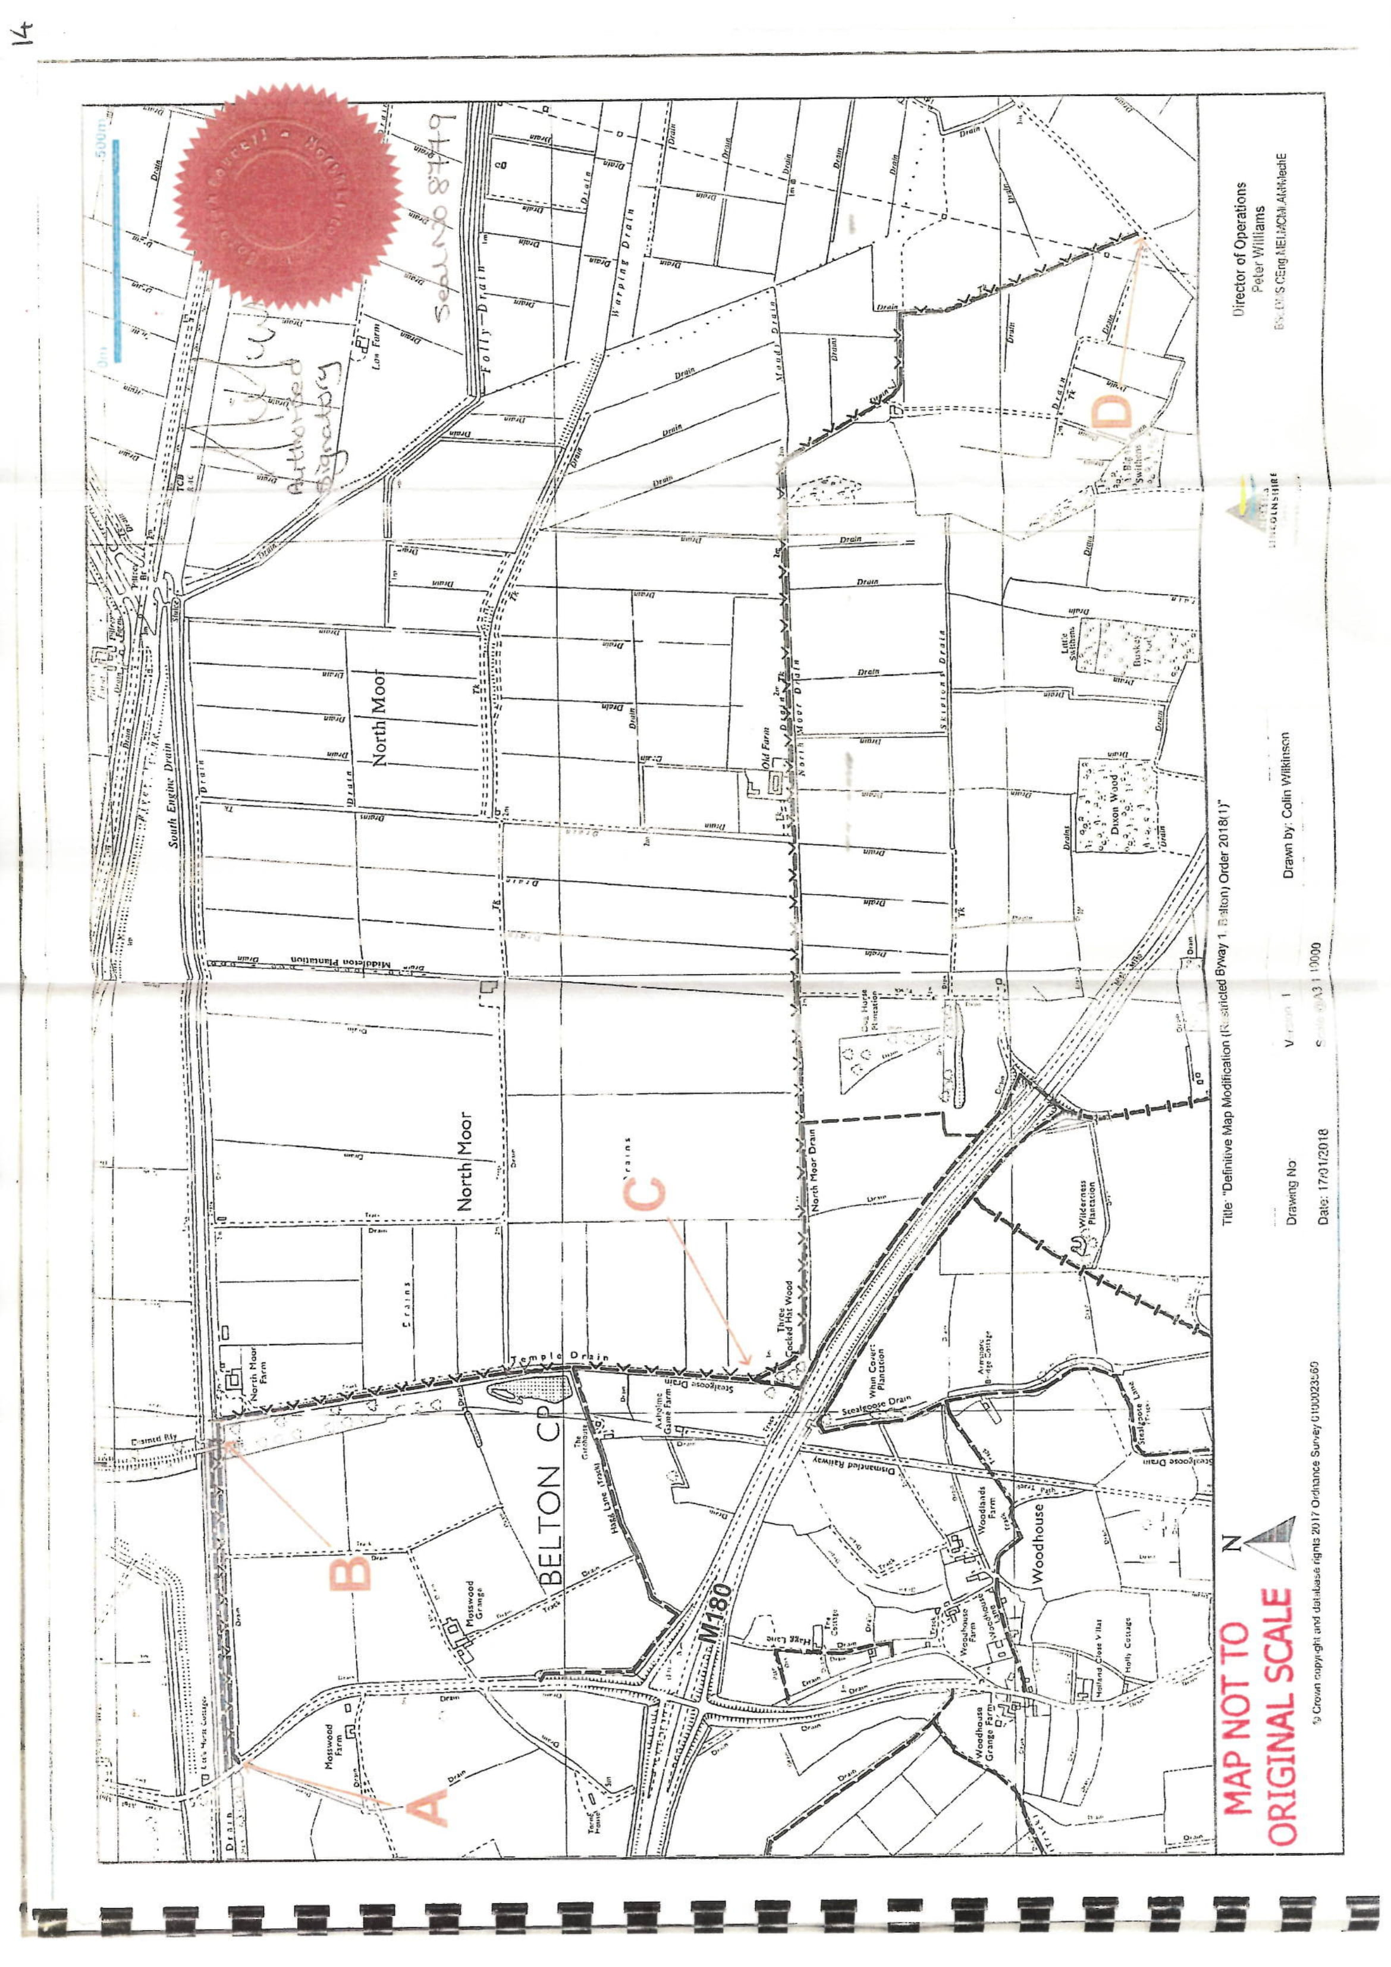

Suffolk County Council v Mason (CA)[1978] 1 WLR 716, (HL)[1979] AC 705, [1979] 2 All ER 369
Masters v Secretary of State for the Environment, Transport and the Regions [2001] Q.B. 151; [2000] 3 W.L.R. 1894; [2000] 4 All E.R. 458; [2000] 4 P.L.R. 134; [2001] J.P.L. 340; (2000) 97(35) L.S.G. 39; (2000) 150 N.L.J. 1422; [2000] N.P.C. 95; Times, September 12, 2000; Official Transcript;
Fortune v Wiltshire Council [2010] EWHC B33 and Fortune v Wiltshire Council [2012] EWCA Civ 334
R(oao) Smith v Land Registry (Peterborough Office) & Cambridge County Council [2009] EWHC 328 (Admin)
Cubitt v Maxse [1873] LR 8 CP 704

