Application Decision
by Richard Holland
Appointed by the Secretary of State for Environment, Food and Rural Affairs
Decision date: 20 January 2022
Application Ref: COM/3280152
Burbage Common, Hinckley, Leicestershire
Register Unit No: CL1
Commons Registration Authority: Leicestershire County Council

- The application, dated 7 July 2021, is made under Section 38 of the Commons Act 2006 (the 2006 Act) for consent to carry out restricted works on common land.
- The application is made by Hayward Architects for Acorns Coffee Shop.
- The works to the Acorns Coffee Shop building comprise:

- erection of two external shelters (canopies), one to the front and one to the rear totalling 63m²; and
- erection of two vertical half round timber windbreaks, one of 3.6m length to the front and one of 2.6m in length to the rear.

Decision
- Consent is granted for the works in accordance with the application dated 7 July 2021 and the plans submitted with it subject to the following conditions:
- the works shall begin no later than 3 years from the date of this decision; and
- the areas beneath the canopies shall remain accessible to the public at all times.
- For the purposes of identification only, the location of the proposed works is shown in red on the attached plan.
Preliminary Matters
- I have had regard to Defra’s Common Land consents policy in determining this application under section 38, which has been published for the guidance of both the Planning Inspectorate and applicants. However, every application will be considered on its merits and a determination will depart from the policy if it appears appropriate to do so. In such cases, the decision will explain why it has departed from the policy.

- Planning permission has been granted by Hinckley & Bosworth Borough Council (HBBC) for canopies to front and rear of Acorn Coffee Shop Visitors Centre (Decision 21/00435/FUL of 21 June 2021).

- In describing the works the application form refers to ‘shelters’ whereas the published application notice and application plan refer to ‘canopies’, which I consider to be a more accurate description of the works proposed. The application form also refers to ‘paving to ground’ but no paving works are described in the application notice and the applicant subsequently advised that such works would be the subject of a separate application. The application form makes no reference to windbreaks, but they are referred to in the application notice and are clearly shown and described in the application plan.

- I am satisfied that the works the subject of this application are the installation of external canopies and windbreaks at the café and that no person wishing to comment on the application has been prejudiced by the inconsistent wording used in the application documents.
- This application has been determined solely on the basis of written evidence. I have taken account of the representation made by Natural England (NE) and the Open Spaces Society (OSS).
- I am required by section 39 of the 2006 Act to have regard to the following in determining this application:-
- the interests of persons having rights in relation to, or occupying, the land (and in particular persons exercising rights of common over it);
- the interests of the neighbourhood;
- the public interest; and
- any other matter considered to be relevant.

Reasons

The interests of those occupying or having rights over the land
- Burbage Common is owned by HBBC, which was consulted about the application but did not comment. The common land register records that four persons have rights to graze cattle, horses and sheep over the common. The applicant advises that none of the rights are exercised. All four rights holders were consulted about the application but none commented. There is no evidence before me to suggest that the works are likely to harm the interests of those occupying or having rights over the land.

The interests of the neighbourhood and public rights of access
- The interests of the neighbourhood test relates to whether the works will impact on the way the common land is used by local people and is closely linked with interests of public access. The outside seating area at the front of the café has been in place for some time, while the area at the rear is new. A windbreak is proposed for each area. The canopies and windbreaks will provide shelter from rain and wind and are proposed in the wake of COVID-19 to improve the outdoor space for customers so that the café can continue to function.

- Although both front and rear areas may be used for general access over the common, the area to the front of the building is more likely to be used by customers of the café. The canopies will sit above these areas and will not impede public access. Nor will the windbreaks seriously impede access as they will be located only at one end of each canopy.

The public interest

Nature conservation
- The café is approximately 900m to the north of the Burbage Wood and Aston Firs Site of Special Scientific Interest (SSSI). NE advises that the proposed works will not impact upon the special features of the SSSI and I am satisfied that the works will not harm any nature conservation interests.

Conservation of the landscape
- The common has no special landscape designation and the proposed works are to an existing building next to a car park. Nevertheless, the works will increase the café’s visual impact to some extent. However, the canopy will be well below the café’s height and be constructed in timber to match the existing external finish. The timber windbreaks will have gaps which will help lessen their visual impact. The canopies (including the windbreaks) are, for the most part, light and airy structures which will not seriously detract from the appearance of the common.

Archaeological remains and features of historic interest
- There is no evidence before me to suggest that these interests will be harmed by the works.

Other matters
- The common is subject to access rights granted by a scheme of regulation under the Commons Act 1899 and OSS draws attention to the need for the areas below the canopies to remain accessible to the public and not just be for the benefit of café users. The applicant confirms that both areas will be open to use by all; this can be secured by attaching a suitable condition to the consent.

Conclusion
- I conclude that the proposed works will not significantly harm the interests set out in paragraph 8 above. Consent is therefore granted for the works subject to the conditions set out in paragraph 1.

Richard Holland

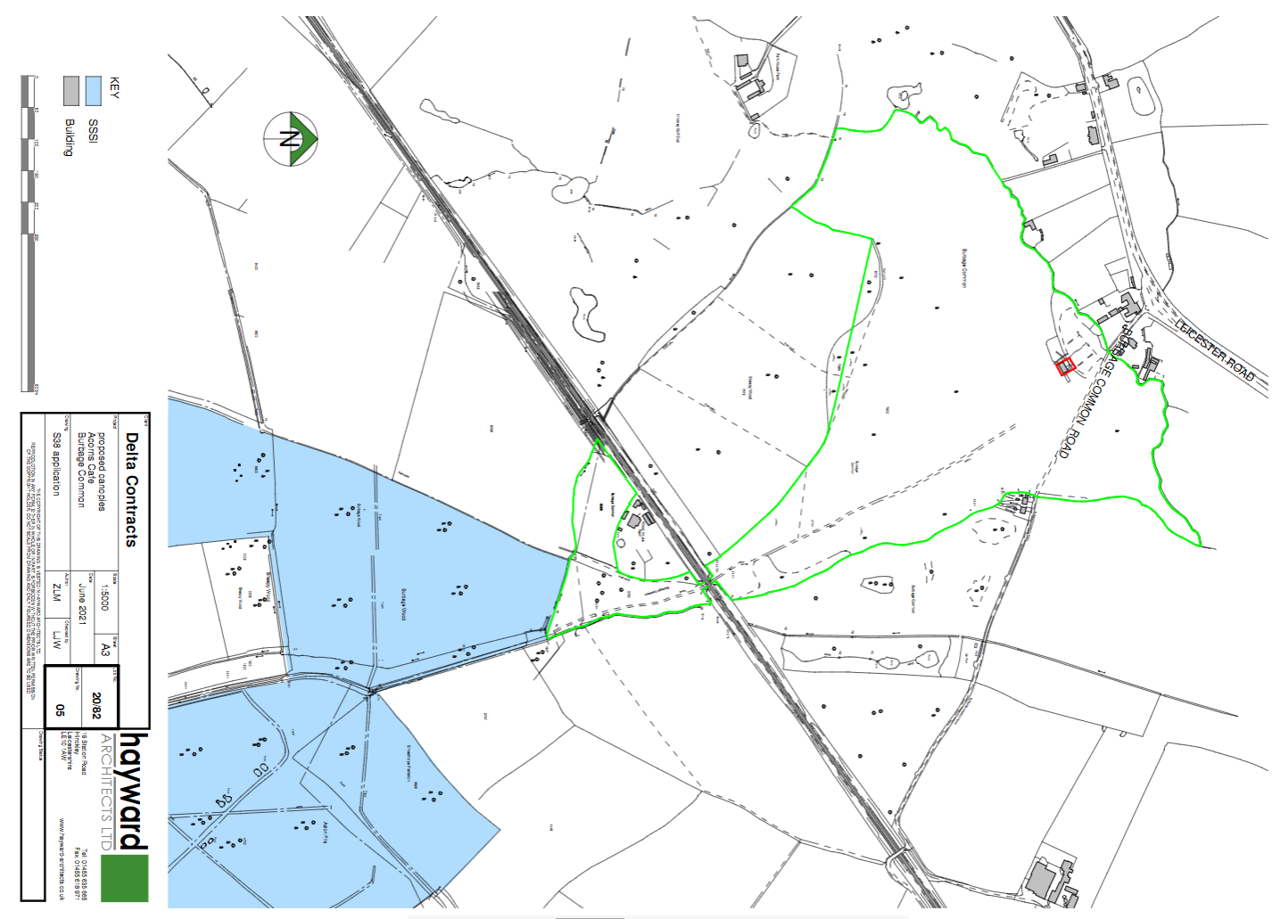

Common Land consents policy (Defra November 2015)

