- Inclusive Transport Strategy – Evaluation
  - Baseline Report
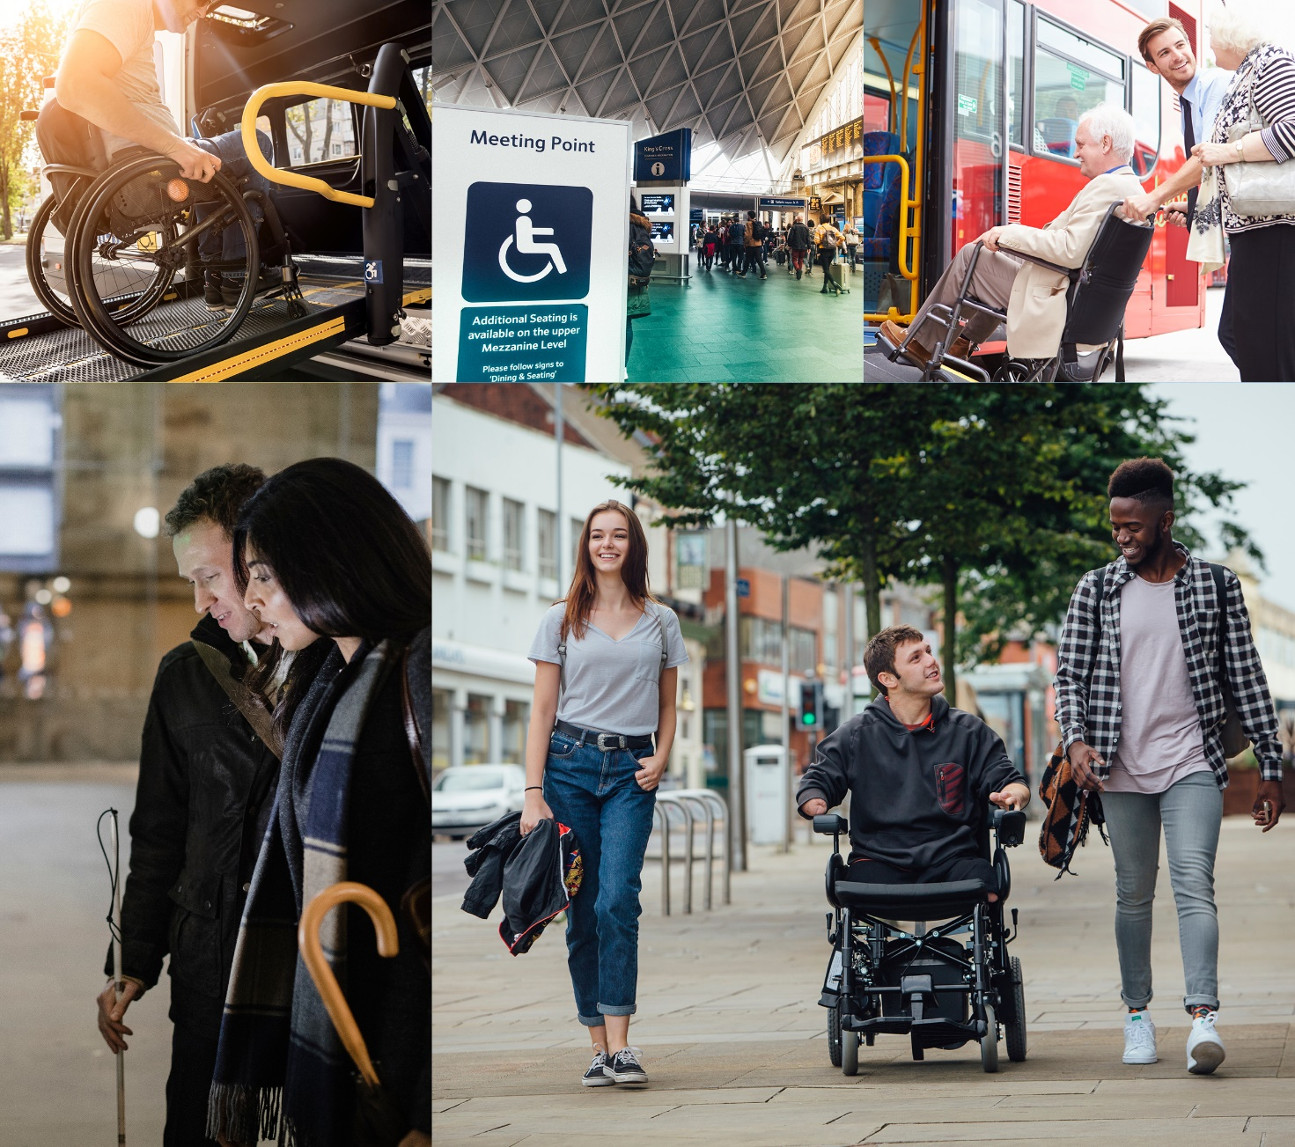

Authors: Bernard Steen, Helen McCarthy, Joy Mhonda, Georgia Lucey, Joshua Vey, Nevena Ilic
Date: 24 November 2021
Prepared for: Department for Transport
At NatCen Social Research we believe
that social research has the power to
make life better. By really understanding
the complexity of people’s lives and what
they think about the issues that affect
them, we give the public a powerful and
influential role in shaping decisions and
services that can make a difference to
everyone. And as an independent, not for
profit organisation we’re able to put all
our time and energy into delivering social
research that works for society.

NatCen Social Research
35 Northampton Square
London EC1V 0AX
T 020 7250 1866
www.natcen.ac.uk

A Company Limited by Guarantee
Registered in England No.4392418.
A Charity registered in England and Wales (1091768) and Scotland (SC038454)
This project was carried out in compliance with ISO20252
- Contents

1 Executive summary 5
1.1 Travelling with confidence 5
1.2 Travelling with ease 6
1.3 Travelling at no extra cost 7
2 Introduction 9
2.1 Background 9
2.2 Evaluating the ITS 9
2.3 Evaluation context 10
2.4 The structure of this report 11
3 Summary of methods 12
3.1 Defining and analysing ‘disability’ 12
3.2 The ITS Panel Survey 12
3.3 Survey of assistance dog users 12
3.4 Qualitative research 13
3.5 The Inclusivity Scorecard 14
4 Transport mode 15
4.1 Key findings 15
4.2 Public transport 15
4.3 Private vehicles, taxis and PHVs 17
4.4 Confidence when travelling 18
5 Improved information and awareness 21
5.1 Key findings 21
5.2 Journey planning and information 21
5.3 Facilities 25
5.4 Assistance 28
6 Inclusive infrastructure 32
6.1 Key findings 32
6.2 Ability to travel 32
6.3 Accessible vehicles 35
7 Better staff training 39
7.1 Key findings 39
7.2 Interacting with staff 40
7.3 Assistance dog users and access refusals 44
7.4 Staff training 46
8 Promotion of passenger rights and enforcement 48
8.1 Key findings 48
8.2 Interactions with other passengers 49
8.3 Complaints 51
9 Discussion and priorities for future research 56
9.1 Discussion 56
9.2 Priorities for future research 57
Appendix A. Glossary of terms 60
Appendix B. Mode use by impairment type 61
Endnotes 62

Executive summary
The Inclusive Transport Strategy (ITS): Achieving Equal Access for Disabled People, published in July 2018, is an ambitious programme of work which aims to create a transport system that offers equal access for disabled passengers by 2030. At its core, the ITS has an ambition for disabled people to have the same access to transport as everyone else, and to be able to travel confidently, easily and without extra cost.
The Department for Transport (DfT) is committed to monitoring and evaluating the delivery of the ITS. The evaluation is theory-based, meaning that it is based around a Logic Model which sets out in detail how the ITS actions are expected to lead to the realisation of the ITS ambitions. The final report, in 2023, will bring together various data sources to assess each element of the Logic Model. This will allow an assessment of the extent to which the ITS has succeeded in realising its ambitions.
This report is the evaluation baseline. It provides a detailed picture of disabled people’s experiences using the transport network. It is based on extensive primary research with disabled people; the wider travelling public; bus and train operators; and taxi and private hire vehicle Local Licensing Authorities. This involved both quantitative surveys and qualitative depth-interviews. Work on the evaluation commenced in March 2020, at a time when the COVID-19 pandemic was beginning to significantly impact the extent and nature of transport use. As a result, the research focused on people’s perceptions and experience the twelve months prior to March 2020.
The evidence shows that the transport network is working well for most people most of the time, and that experiences when travelling are generally positive. However, the research identified a broad range of challenges to overcome before the ITS ambitions are fully realised. These are summarised below.

Travelling with confidence
Between March 2019 to March 2020, disabled people travelled less, used public transport less, and were less confident travelling than non-disabled people.
The National Travel Survey shows that in 2019 disabled people in England made 73% of the number of journeys made by non-disabled people, by any mode.
- Socio-economic differences between disabled and non-disabled people do not fully explain these different rates of transport use. For some disabled people, there were significant barriers to travelling: across modes, only 69% were confident travelling, compared to 90% of non-disabled people. A small but significant minority cited their disability as the primary reason for not using some modes.
- Disabled people were less likely to use public transport, were less likely to drive themselves, and were more likely to be driven by others, including family, friends, carers, and taxi drivers.
There were many factors which disproportionately affected disabled people’s confidence to travel.
- These included: travelling alone; the familiarity of the journey; the reliability of the mode used; the level of personal comfort available on the journey; and having to change modes. Improving public transport for all passengers – for example, by increasing the regularity of services – would disproportionately benefit disabled users.
- For some disabled people, being able to plan their journeys around accessibility adjustments and the availability of toilets was crucial for confidence.
- Although useful, journey planning technology such as apps or digital train station maps were not yet widely used by disabled people. In part, this was a consequence of inconsistent provision. There is scope to make technology more personalised, such as allowing disabled taxi and PHV users to specify their needs in detail when booking via an app.
Assistance from staff can boost confidence for disabled people. However, when assistance fails the negative effects on confidence can be severe.
- When assistance fails it can lead to disabled people deciding to avoid travelling altogether. Some train users reported being left stranded at stations or unable to alight. Most assistance dog users had been illegally denied service by a taxi driver.
- Across modes, some staff expressed impatience with disabled passengers who needed more time, or needed information repeated. Across modes, there was inconsistency in the standards of disability awareness training that staff receive.
Other public transport passengers can cause difficulties for disabled people.
- Across modes, negative experiences involving other passengers were more common for disabled people, including passengers not vacating priority seating, not moving out of the way to let people on or off, or being drunk or noisy.
- Almost half of disabled people were not confident asking others to vacate a priority seat. Those with less visible disabilities were amongst the least confident asking.

Travelling with ease
There is a diversity of travel needs and preferences. Ease of travel depended on a wide range of factors, including the ease of buying tickets, infrastructure at stations and stops, the design of vehicles, and the availability of toilets.
It remains important to provide disabled people with a variety of methods for buying tickets.
- For some disabled people, there are significant challenges involved in using apps, websites or vending machines to buy tickets, whilst for others, queuing at stations and interacting with staff can be challenging.
- Those with cognitive impairments – including memory impairments, difficulties with learning or understanding, and social or behavioural difficulties – were particularly likely to have difficulty buying tickets, using any method.
It can be difficult for disabled people to get to public transport, and a minority experience problems with accessibility once they reach stations or stops.
- There can be challenges to navigating the streetscape due to uneven pavements and potholes, or obstacles such as cars and outdoor seating. Bus stops can be difficult to reach, and Blue Badge parking can be hard to find.
- Seven percent of disabled train users, and the same proportion of bus users, had a negative experience with accessibility at a station or stop, or onboard, such as a ramp not working. Disabled people can struggle without escalators or lifts, which may be out of order without warning, and only a minority of train stations provide step-free access.
Some disabled people have difficulties getting on or off transport. Once onboard, dedicated wheelchair space, handrails, priority seating and toilets are all important.
- Sixteen percent of disabled bus users had an experience of not having enough time to get on or off, compared to just 3% of non-disabled people. Often, disabled people are not given enough time to sit down before a bus starts moving, and can fall over, or experience significant anxiety. Nine percent of disabled train users had experienced not having enough time to board or alight a train. Large gaps between trains and platform edges can be problematic.
- Issues with toilets were particularly common on trains, for both disabled and non-disabled people: 28% of people had experienced difficulties, often due to toilets being out of order, locked, or otherwise inaccessible. Disabled people were more likely than non-disabled people to have had difficulties accessing toilets on trains due to overcrowding. Once accessed, toilets were often dirty, or did not provide enough space.
Audio-visual information onboard public transport was often crucial for disabled people to know where they were.
- However, provision is inconsistent and of variable quality. Disabled people felt audio could be clearer and easier to hear, and visual designs could be improved.
- While apps can provide rich and detailed real time journey information, access depends on having a smartphone which is charged and has Wi-Fi or mobile data and being able to use it.
When people have negative experiences on public transport, they are unlikely to formally complain.
- Only around half of those who formally reported an issue found it easy to do so. Both disabled and non-disabled people often found it hard to know who to complain to, and many felt that complaining was not worth it, either because it would not be acted on, or because the negative experience in question happened too often to warrant reporting.
- For visually impaired assistance dog users who are denied access to taxis, it can be difficult or impossible to collect the necessary details about the driver or vehicle to make a complaint.

Travelling at no extra cost
The cost of transport can be a barrier. Disabled people are more likely to rely on taxis, which are relatively more expensive than other modes. More could be done to promote awareness of concessionary travel.
- On average, disabled people have lower household incomes than non-disabled people. Despite this, disabled people were more likely to be frequent taxi users, which are relatively more expensive than other modes. Disabled people explained that barriers to using other modes were often a factor in this choice.
- However, the cost of taxis was a barrier for some. For wheelchair users, the costs can be even higher, as operators charge higher rates for the larger vehicles some people require.
- Just 10% of disabled people who had travelled by train in the last year had a Disabled Person’s Railcard. Of those disabled people who had travelled by train in the last year but did not have a Disabled Person’s Railcard, a quarter were not aware they existed, and awareness was lower amongst those on low incomes. Thirty percent of disabled people had a concessionary bus pass, and around half of these were disability related passes.

Introduction

Background
The UK government has an ambition for disabled people to have the same access to transport as everyone else, and to be able to travel confidently, easily and without extra cost. However, in 2019, disabled people in England made 73% of the number of journeys made by non-disabled people, by any transport mode.
For the purposes of this research, ‘disability’ is defined in line with the Equality Act 2010: a person is defined as disabled if they have a physical or mental health condition or impairment, lasting or expected to last 12 months or more, which has an impact on their ability to carry out day-to-day activities. By this definition, 22% of the UK population is disabled (14.1 million people), and working-age adults who identify as disabled grew from 15% in 2010/11 to 19% in 2019/20. Forty-six percent of those of pensionable age report having a disability and by 2039, 13% of the population will be aged over 75 – an increase from 9% in 2019.
The government’s ambitions for improving transport are set out in the Inclusive Transport Strategy (ITS). Five themes underpin the strategy and over 95 actions and policies have been designed to make progress towards achieving a more equal transport system. The five themes are:
- Awareness and enforcement of passenger rights
- Staff training
- Improved information
- Inclusive physical infrastructure
- Future of inclusive transport
Future of inclusive transport is a long-term objective of the ITS, and therefore impact cannot currently be evaluated. This theme is therefore not covered in this report.
Equal access will bring clear benefits to disabled people and to UK society more broadly. The ITS covers all transport modes and sets out policies in place to support access and changes that the strategy will help to deliver. It also targets all disabled people, including those with less visible disabilities.

Evaluating the ITS
The Department for Transport (DfT) have committed to monitoring and evaluating the delivery of the strategy, in order to:
- Learn and build an understanding of the actions that represent best value for money and use the findings to develop further policy interventions
- Understand how the landscape of inclusive transport is changing to help to inform where future efforts should be directed
- Make the results of the ITS visible to stakeholders, including disabled people and Parliament
The DfT commissioned the National Centre for Social Research (NatCen), an independent research organisation to conduct the evaluation on their behalf. Underpinning the strategy is a Logic Model (LM) that sets out how the ITS actions will lead to change. The evaluation will bring together various data sources to explore the ITS Logic Model and the extent to which different steps have been evidenced. This is a Theory-Based evaluation which draws on the available evidence to assess the extent to which the theoretical chain of events shown in the LM can be shown to have worked in practice. This report (2021) is the ITS evaluation baseline, providing a detailed picture of disabled people’s experiences using the transport network. The final report in 2023 will highlight observed changes and substantiate, invalidate or revise the theory, contained in the LM, about why the ITS may have contributed to those changes.
From 2020 to 2023, NatCen’s role is to bring together ITS metrics and evaluative measures that build a picture of whether and how the transport system is changing and how this is impacting the experiences of disabled people. As part of the evaluation, NatCen will conduct primary research with disabled people and the travelling public, transport providers and Local Licensing Authorities. This baseline report includes findings from the following research activities:
- A nationally representative survey among disabled people and the travelling public referred to throughout the report as the ITS Panel Survey
- Survey among assistance dog users
- Qualitative interviews with disabled people
- Collation of key inclusivity statistics from transport operators
- Qualitative interviews with train and bus operators
- Qualitative interviews with Local Licensing Authorities (for taxi and private hire vehicles)
The report also draws from the 2019/2020 inclusivity scorecard. The Scorecard brings key statistics together and is a key tool to measure how the DfT and its stakeholders are delivering against the ITS. It also tracks delivery of the desired outcomes articulated in the ITS logic model.

Evaluation context
The DfT commissioned NatCen as ITS Evaluator in March 2020, a time when coronavirus (COVID-19) infections were rising which resulted in the UK Government placing the country under a nationwide lockdown on 23 March 2020. The travel restrictions that were mandated during lockdown resulted in most people being unable to use public transport in their usual manner. To avoid delays to the delivery of the evaluation, the DfT, in consultation with the Disabled Persons Transport Advisory Committee (DPTAC), elected to continue with the evaluation.
Prior to commencing data collection, the DfT commissioned NatCen to conduct a pilot study of the ITS panel survey with disabled and non-disabled people. The pilot explored whether people would be able to confidently answer questions about their travel experiences before the lockdown. The pilot results showed that recall difficulties on key questions around frequency of travel, confidence when travelling and ease of travel were rare among both disabled and non-disabled people. Most participants were quite or very confident that their answers were accurate. The pilot results were used to inform the design of the ITS panel survey and the qualitative research with disabled people, with participants reflecting on their experiences in the 12-month period before the UK COVID-19 lockdown began in March 2020.
It is important to acknowledge that the long-term effects of the COVID-19 pandemic on travel attitudes and behaviour may have consequences for measuring the impact that the ITS makes on disabled people’s experience of public transport. It will be challenging to separate changes that may be attributable to the ITS from changes that may be due to the pandemic, especially if the pandemic affects the travel attitudes and behaviour of disabled and non-disabled people differently. There is scope to monitor this using regular surveys such as the National Travel Survey (NTS) and National Travel Attitudes Survey (NTAS). Future ITS evaluation activity will need to fully consider COVID-19 impacts.

The structure of this report
The report is broadly structured around the key themes of the ITS:
- Chapter 1 Executive summary: provides an overview of the key findings
- Chapter 2 Introduction to the report: provides background to the ITS and research.
- Chapter 3 Summary of methods: provides a summary of the methods used for data collection.
- Chapter 4 Disability and transport use: presents key findings related to disabled people’s overall use of different transport modes and confidence when travelling.
- Chapter 5 Information and assistance: explores disabled people’s experiences of accessing information as well as using assistance to travel.
- Chapter 6 Inclusive infrastructure: discusses the accessibility of transport, in particular in relation to the design of infrastructure and vehicles.
- Chapter 7 Staff training: explores disabled people’s experiences with transport staff as well as the existing training provided to staff.
- Chapter 8 Promotion of rights: discusses disabled people’s experiences with other passengers and their experiences of making complaints.
- Finally, Chapter 9 concludes with a discussion of what the findings mean for disabled people’s ability to travel.
This report is accompanied by a Technical Report which provides detail on the research methodologies and copies of the research tools.

Summary of methods
In this chapter we provide a summary of the primary research methodologies used to create the evidence for this baseline report. More detail can be found in the ITS Technical Report.

Defining and analysing ‘disability’
For the purposes of this research, we define disability in line with the Equality Act 2010. Under this definition, a person is disabled if they have a physical or mental health condition or impairment, lasting or expected to last 12 months or more, which has an impact on their ability to carry out day-to-day activities. All survey questions to measure disability followed the Government Statistical Service (GSS) harmonisation guidance.

The ITS Panel Survey
In August 2020, a nationally representative random probability survey of British adults was conducted using the NatCen Panel, online and over the phone. The aim of the survey was to provide high-quality quantitative baseline estimates for the ITS evaluation. The survey sought to understand the views and experiences of disabled people, and to allow robust comparisons to be made between disabled and non-disabled people. Respondents were asked about how often they used different modes of transport; any negative experiences using different modes or interacting with staff; their experiences of reporting issues; and the factors that affect their confidence when travelling, amongst many other topics.
Disabled people were oversampled to allow for subgroup analysis – of the 3,039 people who took part, 1,140 were disabled. The response rate amongst those invited to take part was 76%. For general population analysis, weights were used which correct for design effects and non-response bias based on a large number of individual and local characteristics.
Random samples of disabled and non-disabled people will differ in their socio-economic profiles. When making comparisons between these two groups, differences may simply reflect their distinct socio-economic profiles. To tackle this, we developed a custom set of weights which allow us to make comparisons between disabled people and non-disabled people as if these groups were similar according to a set of key socio-economic characteristics. Based on a review of the literature, and initial analysis of the survey data, the characteristics used in these weights were age, sex, region, economic activity (whether in employment or not), and housing tenure. Throughout this report, we provide percentages using the standard general population weight, but we only report on differences between disabled and non-disabled people when those differences are statistically significant at the 5% level, and remain statistically significant at the 5% level when using the custom comparison weights. That is to say, we only report differences when we can be confident that they are not solely explained by the underlying socio-economic differences discussed above.

Survey of assistance dog users
An online and telephone survey of assistance dog users was carried out from December 2020 to February 2021. The aim of the survey was to understand the experiences of assistance dog users travelling by taxi and private hire vehicle (PHV), and in particular to understand the prevalence of ‘access refusals’, in which assistance dog users are illegally denied service. The survey asked respondents about their experiences of access refusals, whether they had made complaints, and the effect of access refusals on their behaviour and confidence. The online survey was compatible with major screen reader software, including JAWS and NVDA, which allow people with visual impairments to use computers. Participants were offered the option of conducting the survey over the phone if they preferred.
There is currently no comprehensive sampling frame of assistance dog users. In order to reach the target population, we relied on organisations that provide assistance dogs, or work with assistance dog users, to promote the survey. Organisations shared the survey via a range of channels, including email invitations, newsletters, social media, and radio. In total, 198 assistance dog users took part. Where the base for a question is over 50, we report percentages, and where the base is under 50, we report absolute figures. Due to the self-selecting nature of the achieved sample, we are not able to confidently generalise from the results to the wider population of assistance dog users. No statistical tests or weights have been applied. Findings from the survey should be treated as best estimates given the inherent challenges involved in surveying this population.

Qualitative research

Interviews with disabled people
Follow-up depth interviews were carried out with respondents from the ITS Panel Survey. Disabled participants were able to opt-in to take part in the interviews at the end of the survey and 40 people were interviewed. The qualitative interviews aimed to provide a richer and more detailed picture of how disabled people experience travel than was possible using the survey, and to explore the key facilitators and barriers to travel in-depth. Participants were asked about the way their disability or impairment impacted their travel behaviours; the most common journeys they made; the barriers they faced to making other journeys; and their suggestions for improvements.
The fieldwork took place between August and early September 2020. To ensure that a diverse range of views were represented, a purposive sampling approach was used to select participants on the basis of their disability or impairment, type of travel, and age. Full details can be found in the ITS Technical Report. Participants were offered a £40 gift voucher as a thank you for taking part.
Interviews lasted 45 minutes and were conducted over the phone or over video call where necessary. Participants were able to make requests regarding any additional needs at the point of opting in and these were accommodated during the interview. The discussion guide can be found in the ITS Technical Report.

Research with train and bus operators, and Local Licensing Authorities
Qualitative research was conducted with train and bus operators, as well as Local Licensing Authorities (LLAs) responsible for the licensing of taxis and private hire vehicles. The aim of the qualitative research was to understand how operators are delivering on the actions and ambitions of the ITS, and to understand what they saw as the key challenges they faced. The research consisted of two phases: a short information gathering phase (scoping exercise), and follow-up telephone interviews.
As part of the scoping phase, organisations responded to several questions regarding their accessibility processes and disability awareness training in a template. A total of 21 scoping questionnaires were completed by train operators (four), bus operators (seven) and LLAs (ten).
Follow up telephone interviews, lasting 45 minutes, were conducted with a small number of those who responded to explore these themes in more detail (two interviews each with bus and train operators and five with LLAs). Transport operators and LLAs were initially invited to participate in the research by the DfT and opted in directly to NatCen. It should be noted that as this strand of the research used a qualitative methodology, it did not aim to provide a representative picture of the views and experiences of transport operators and LLAs, but to capture the range and diversity. Further detail can be found in the ITS Technical Report.

The Inclusivity Scorecard
As part of the ITS evaluation, an Inclusivity Scorecard has been developed and published alongside this report. The scorecard brings together a series of key indicators that provide an overview of the current state of progress towards the ITS aims.
The scorecard includes 23 different indicators, which were identified after consultation with key stakeholders within DfT. All indicators have been sourced either from public databases or directly from governmental departments. The scorecard includes indicators for three ‘baseline’ years (2016/17, 2017/18 and 2018/19) so that trends can be observed prior to the start of the ITS. It includes indicators for the first ITS scorecard year (2019/20) and will be updated annually for future years until 2024, so that changes can be monitored over time.

Transport mode
The majority of this report explores how disabled people experience public transport, including barriers to equal access. This chapter provides an overview of transport mode use amongst disabled people and their confidence in using transport and makes comparisons with the non-disabled population.

Key findings
- In comparison to non-disabled people, disabled people were less confident travelling, less likely to take public transport or to drive themselves, and more likely to be driven by friends, family, carers, or taxi and private hire vehicle (PHV) drivers.
- Disabled people were much less likely than non-disabled people to be frequent train users, or to have used trains at all in the last year. They were also less likely to have travelled by plane or by maritime.
- Disabled people with mobility impairments, or who used mobility aids, were less likely to have used public transport than other disabled people. In particular, they were much less likely to have used trains.
- Disabled people were less likely than non-disabled people to have driven themselves using a car, van or motorcycle. This was primarily due to disabled people being less likely to hold a driving license. Roughly a quarter of disabled people cited their disability as a reason for not holding a driving license.
- Disabled people were much more likely than non-disabled people to be frequent taxi and PHV users, and this was particularly true of disabled people with cognitive impairments. Taxis and PHVs are typically more expensive than other modes, and qualitative interviews confirmed that the higher rates of taxi and PHV use are often related to the multiple barriers disabled people face using other modes.
- In general, across modes, disabled people were less confident travelling than non-disabled people. Disabled people were most likely to be confident travelling by private car, and least likely to be confident travelling by bus or train.
- Key factors that negatively affected travelling confidence for disabled people included: unfamiliarity with the journey; having to travel during busy periods; having to travel alone; and the need to change mode during a journey.

Public transport
In 2019, disabled people took an average of seven trips for every ten taken by non-disabled people, by any mode. Figure 1, using data from the ITS Panel Survey, shows the proportion of disabled and non-disabled people who used different modes of public transport at least once in the year preceding the COVID-19 pandemic. For buses and trains, it also shows the proportion who were frequent users, defined as travelling by bus or train at least once a week.
Figure 1: Public transport mode use amongst disabled and non-disabled people
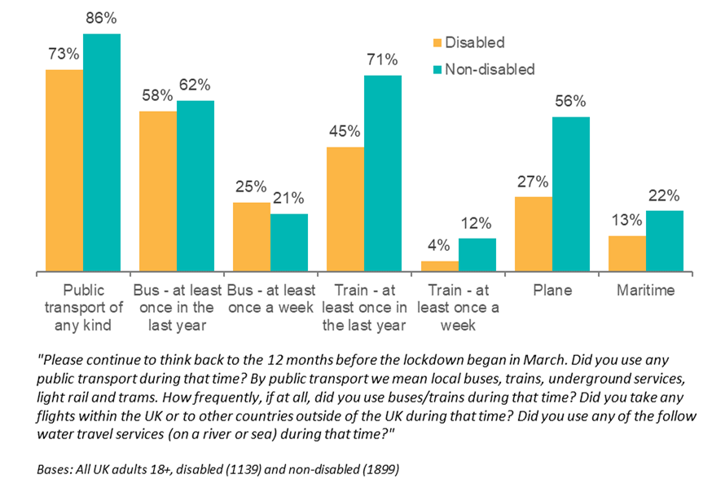
Disabled people were far less likely to have used trains. They were also less likely to have travelled by plane or maritime modes than non-disabled people. Although disabled people were no more or less likely to have used buses, when using the comparison weight described in Section 2.2 to make the socio-demographic profile of the non-disabled population similar to that of the disabled population, disabled people were around 10% more likely to be bus users.
Lower rates of public transport use amongst disabled people do not appear to be driven by a reduced need for public transport. When survey respondents were asked to explain in their own words why they did not use a given mode, disabled people were less likely than non-disabled people to say that they had no need to travel by that mode, or that they used their car instead. Instead, for each mode, a notable minority cited their disability as a barrier, ranging from a low of 5% for taxis to a high of 16% for buses and planes. Disabled people were more likely to cite anxiety, fear and stress than non-disabled people on buses (7% of disabled people compared to <1% of non-disabled people) and trains (4% of disabled people compared to 1% of non-disabled people).
The likelihood and frequency of using different transport modes varied between disabled people. Those with limited mobility, and those who had used a mobility aid, were less likely to be public transport users than other disabled people: only 65% of those with a mobility impairment had used public transport at all in the last year, compared to 79% of other disabled people; and 64% of disabled people who had used a mobility aid had travelled by public transport, compared to 77% of other disabled people. This difference was particularly clear for trains: 34% of disabled people with a mobility impairment had used trains, compared to 55% of other disabled people. Relatedly, those with physical disabilities – including limited mobility, stamina or dexterity, and those who used mobility aids or required accessible toilets – were more likely to cite their disability when asked to explain why they did not use a given mode. Detailed charts are shown in Appendix A.

Private vehicles, taxis and PHVs
Figure 2 shows the proportions of disabled and non-disabled people who travelled by car, van or motorcycle as a driver or as a passenger. Those who travelled as a driver drove themselves at least once in the year preceding the pandemic, and those who travelled as a passenger did not drive themselves but were driven by a friend, relative or carer. Also shown is the proportion of disabled and non-disabled people who used taxis or PHVs at least once in the year preceding the pandemic, and the proportion who used these modes at least once a week.
Figure 2: Private vehicle, taxi and PHV use amongst disabled and non-disabled people
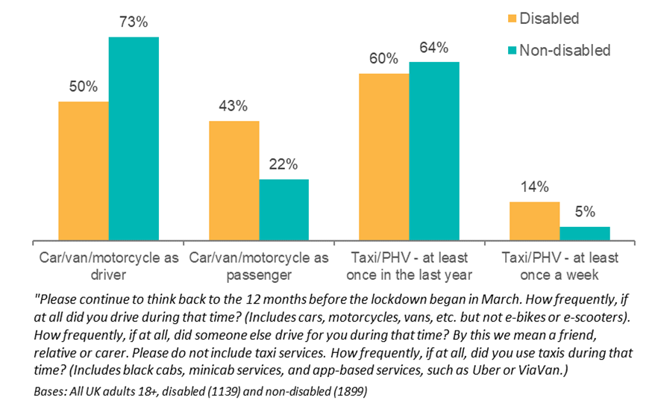
Disabled people were much less likely to be drivers. However, the lower rates of driving are not accompanied by greater public transport use: not all car journeys can be easily replaced by public transport, and disabled people face barriers (explored throughout this report) in accessing and using public transport. Perhaps as a result, disabled people were still reliant on private vehicles, taxis and PHVs: they were twice as likely to be driven by friends, family, or carers, and almost three times as likely to be frequent taxi and PHV users.

Driving
The gap between disabled and non-disabled people who drove themselves was primarily driven by the fact that disabled people were less likely to have a driving license – 57% of disabled people had a license, compared to 82% of non-disabled people. When asked to explain in their own words why they didn’t have a license, a quarter cited their disability or medication. When comparing disabled to non-disabled license-holders, there was no difference in the proportion who drove in the last year. Disabled people were less likely to drive daily, but this difference disappeared when comparing employed disabled drivers to employed non-disabled drivers.
However, it should also be noted that the onset of disability can cause difficulties in driving for those who already drive. A small minority (6%) of disabled people with a license and vehicle access did not drive at all in the year preceding the pandemic, and qualitative interviews confirmed that the onset of conditions like arthritis and hypermobility can cause difficulties.

Taxis and PHVs
Disabled people made greater use of both taxis and PHVs than non-disabled people. This was particularly true of those with cognitive impairments, 26% of whom were frequent taxi and PHV users compared to 12% of all other disabled people, and just 5% of non-disabled people. Since taxis and PHVs are typically a more expensive mode of transport, higher rates of use amongst disabled people (and those with cognitive impairments in particular) are likely determined by the multiple barriers involved in using other modes for these groups, as discussed throughout this report.
A small proportion (5%) of disabled people who did not use taxis and PHVs said that this was directly linked to their disability, and this was particularly likely to be the case for those with limited mobility, dexterity impairments, and those who had used a mobility aid such as a wheelchair, mobility scooter, or walking frame. Qualitative interviews highlighted that previous bad experiences can prevent disabled people from using taxis and PHVs, including rude or dismissive drivers, drivers failing to follow instructions, and access refusals.

Confidence when travelling
In general, across modes, disabled people were less confident travelling than non-disabled people, as shown in Figure 3. Disabled people were most likely to be confident travelling by private car, and least likely to be confident travelling by bus or train. Compared to non-disabled people (2%), they were much more likely to report having no, or very low, confidence levels when travelling (11%). This was particularly common amongst those with mental health or cognitive impairments.
Figure 3: Proportion of disabled and non-disabled people at least somewhat confident travelling by different modes
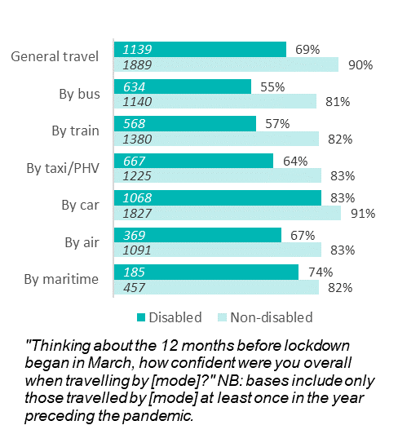
The survey revealed how everyday features of travelling could affect disabled people’s confidence. As shown in Figure 4, key factors affecting travelling confidence for disabled people included: familiarity with the journey; having to travel during busy periods; having to travel alone; and the need to change mode during a journey.
Figure 4: The effect of journey features on travelling confidence, for disabled and non-disabled people

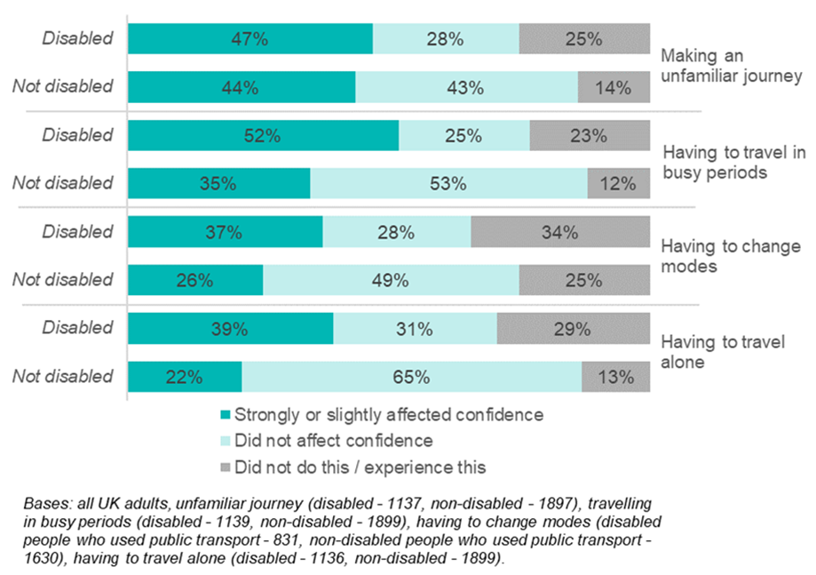
Travelling alone
Disabled people were much less likely to travel alone and doing so was more likely to impact their confidence than non-disabled people. Those with conditions that affected their mobility or stamina were less likely than other disabled people to travel alone, and those with mental health or mobility impairments were more likely to have their confidence affected. Qualitative interviews revealed the importance of travelling companions for people with a range of conditions across all modes. Companions provide both physical assistance and emotional support, particularly for those with mental health conditions.

Familiarity
Disabled people were less likely to have made an unfamiliar journey and this was particularly evident among those with conditions that affected their mobility or stamina. Those with mental health conditions were more likely than other groups to report that making an unfamiliar journey affected their confidence travelling. Interviews highlighted how people felt more equipped to deal with unexpected changes on a familiar route than on an unfamiliar route.

Travelling in busy periods
Twenty-three percent of disabled people did not travel in busy periods. Those with conditions or impairments that affected their mobility or stamina were less likely to have travelled during busy times than other disabled people. Beyond changing the time of travel, interviews also revealed that some people chose to avoid particular routes or stations that were considered particularly crowded. Disabled people were more likely to feel that travelling in busy periods affected their confidence than non-disabled people, and this was particularly evident amongst those with mental health or cognitive impairments.
Twenty-six percent of disabled bus users had a negative experience of overcrowding, compared to 15% of non-disabled people. Thirty-two percent of train users had a negative experience of overcrowding, with no difference between disabled and non-disabled people. However, disabled people were much more likely to find overcrowded trains a barrier to accessing toilets: 7% of disabled train users had experienced this, compared to 3% of non-disabled train users. Interviews highlighted the range of difficulties that crowding caused. It was associated with difficulties (and anxiety) around getting a seat, fear of falling and in some cases more pain from standing during the journey. For those with hearing impairments, crowding made it harder to hear announcements and for those who used mobility aids or assistance dogs it made it harder to manoeuvre and raised fears that dogs would be injured.
If I'm pushed or jarred, it causes a spasm in my back and I just lose feeling in my legs and I collapse on the floor. That is my main one with crowds, that's what I get very anxious over. [Male, 40-64, multiple conditions, including mobility-related and mental health]

Multi-mode journeys
Disabled people were more likely than non-disabled people to feel that their confidence was affected when having to make multi-modal journeys, and this was particularly true of those with mental health issues or cognitive impairments. Those with conditions or impairments that affected their mobility or stamina were less likely to make multi-modal journeys. Multi-modal journeys were described in interviews as ‘overwhelming’. Many of the factors that made travelling stressful, such as difficulties boarding and alighting, anxiety about getting a seat and availability of staff to provide assistance, were exacerbated because they were more likely to be experienced multiple times. In addition, the timing of connections and the potential implications of missing a connection made such journeys more difficult.
“I've already been anxious getting on one bus, and I've come off and I feel butterflies and I feel like crying, because of that journey... It's too much anxiety. If you go in a taxi, which are much more expensive… there isn't as much worry and anxiety.” [Female, 40-64, mobility-related impairment]

Improved information and awareness
“More needs to be done to make it [transport] more inclusive for a wider range of disabled passengers, with better information made available to people who are not able to see graphical information” – Guide Dogs UK
This chapter discusses the importance of journey planning and information for disabled people, including the role of technology, buying tickets, and accessing real-time information. It then covers the importance of toilets and other facilities, before considering the role of dedicated passenger assistance services.

Key findings
- For some disabled people, journey planning is crucial. Being able to plan journeys around accessibility facilities like ramps and lifts, or around toilets, is crucial for some disabled people’s confidence travelling.
- Journey planning technologies such as apps, or digital train station maps, are not yet widely used by disabled people. Apps could be made available more consistently across services, and there is potential to develop more targeted app functionality.
- It remains important to provide a variety of methods for buying tickets. For some disabled people, there are significant challenges involved in using apps, websites or ticket vending machines, whilst for others, queuing at stations and interacting with staff are problematic.
- For some disabled people, audio-visual (AV) information on journeys is crucial. However, provision of AV information on buses is inconsistent and of variable quality. Audio information could be clearer and easier to hear, and visual information could be better designed.
- Disabled people with cognitive impairments often have distinct needs with respect to planning and information. They are more likely to struggle to buy tickets and are less aware of the assistance available.
- Toilets are not always available, accessible or usable. Disabled train users reported finding toilets out of order or dirty, or simply unable to access them due to overcrowding. Many toilets do not have the necessary space or facilities.
- Experiences using assistance services were broadly positive. However, there is scope to improve awareness of assistance services on trains, at airports, and on maritime transport. When assistance services fail, the consequences can be severe, with disabled passengers left stranded.
- Awareness of railcards, bus passes, lanyards and other journey assistance tools could be greater. Transport operators could do more to promote awareness.

Journey planning and information
Being able to plan journeys in detail and access information in real time are particularly important factors for some disabled people. Negative experiences due to a lack of information, either before travel or en route, are relatively common: on buses, 12% of disabled users have had a negative experience due to a lack of information before a journey or en route, compared to 6% of non-disabled users; on trains, there was no difference between disabled and non-disabled users, with 12% of people having had negative experience of this kind.

Journey planning and the role of technology
For some disabled people, being able to plan a journey in detail is crucial. As shown in Figure 5, 13% of disabled people did not travel if information about the availability of accessibility facilities (e.g. ramps or lifts) was lacking, and 21% felt that the lack of this information affected their confidence. This was confirmed in qualitative interviews, with participants highlighting the importance of planning for their confidence:
I can't go anywhere without being organised. I don't have the confidence to just go any more, which I did have before my disability. [Planning], it's everything… [Female, 40-64, mobility-related impairment]
Figure 5: The effect of a lack of information about accessibility adjustments and toilet facilities on confidence travelling, for disabled and non-disabled people
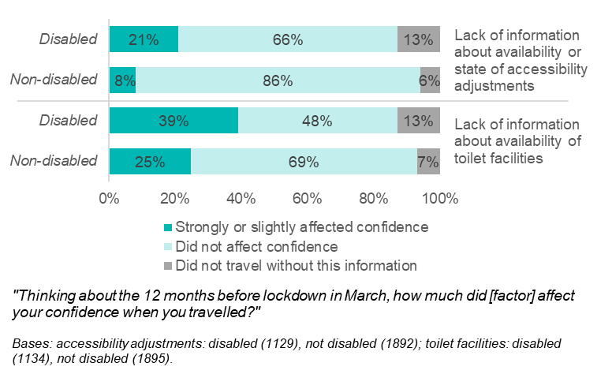
Information about access to toilets is especially important for some people (discussed further in Section 5.3). Thirteen percent of disabled people did not travel if information about the availability of toilets was lacking, and 39% felt the lack of information affected their confidence, compared to just 24% of non-disabled people. The importance of information about toilets was particularly notable amongst disabled women. In qualitative interviews, some participants confirmed that they deliberately plan journeys around the availability of toilets.

Technology could be more widely used
Despite some disabled people reporting that they found journey planning technology helpful, there is scope for these tools to be more widely used. In qualitative interviews, there was a view that the ability to view digital maps of train stations enables disabled people to understand which platforms they will be able to access, and to determine how much time they will need. However, only 20% of disabled people had used such a map, with those aged 18-39 more likely to have done so than older disabled people, and those in London more likely to have done so than those elsewhere.
Similarly, the use of apps was relatively rare. Only 7% had used a smartphone app to help them travel because of their disability, and 12% had accessed real-time information about access facilities on train stations on their mobile phones. Of those who had used Passenger Assist, only 22% had ever used an app to book it. Disabled people were also more likely to report finding it difficult to book taxis and PHVs via an app (8%) than non-disabled people (2%).
There are several possible factors behind these relatively low rates of use. Some factors are not specific to transport apps and websites themselves. In general, younger people were much more likely to make use of apps and websites than older people, who are also more likely to be disabled. In qualitative interviews, one view was that planning was often of limited value because the transport services themselves are unreliable, including unannounced route changes, delays and cancellations.
However, the low rates of use may also be partly explained by inconsistencies in the availability and functionality of apps and websites themselves. Interviews with local taxi and PHV licensing authorities and with bus and train operators highlighted that not all provide apps, and in qualitative interviews, disabled people explained that there is inconsistent provision between bus services. Disabled people highlighted limitations in the functionality of apps, including not showing when train stations are having maintenance work done which limits accessibility, or not showing train station closures. In the case of taxi and PHV apps, disabled people reported being unable to specify their needs in advance, unlike when booking a taxi or PHV over the phone, which can enable them to request specific vehicles or drivers.

Buying tickets
People with different disabilities experience a range of difficulties purchasing tickets, and it remains important to cater for a variety of needs. Some disabled passengers seek to avoid the social interaction of purchasing tickets in-person, whereas others struggle with machines and apps. As shown in Figure 6, almost a third of disabled people would have some difficulty buying tickets as a result of their disability. This is particularly common amongst those with impairments of their vision, dexterity, or their cognition.
Figure 6: Proportion of disabled people who would have difficulties buying tickets due to disability
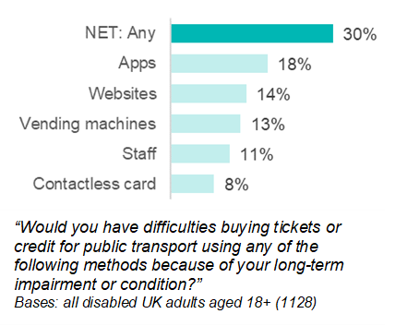
In open text survey responses, and in qualitative interviews, reasons for experiencing difficulties when buying tickets centred around three broad themes: access to and confidence using technology; challenges arising from physical disabilities; and anxiety. We discuss these in turn.
Disabled respondents were asked whether they would have difficulties buying tickets due to their disability or impairment. Difficulties in buying tickets via apps or websites were more common among older disabled people: 22% of disabled people aged 60 or over would have difficulty using an app and 17% would have difficulty with a website, compared to just 6% and 5% respectively of disabled people aged 18 to 39. The most common reasons in open text survey responses for not using apps or websites to purchase tickets were: lacking access to a smartphone or computer with internet access, and lacking the confidence or ability to use these technologies. There was a view that apps, websites, and ticket vending machines are confusing and difficult to use. Some disabled people did not trust themselves to purchase the right ticket and preferred to speak to a member of staff. In the case of vending machines, a view expressed in both the survey responses and qualitative interviews was that it is not clear how to apply railcard discounts.
Certain methods of buying tickets can be particularly challenging for those with physical disabilities. Both ticket vending machines and buying from staff often involve queuing, which some participants found painful and tiring. There was also a view that other passengers can become impatient with disabled people when they take longer to use a vending machine. Participants who use mobility scooters or wheelchairs described challenges getting close enough to ticket vending machines or being able to see over staff counters. Use of apps, websites and ticket vending machines can be challenging for those with dexterity or visual impairments, or those with limited literacy. Those with hearing impairments can struggle to hear staff, especially through screens:
“There's only so many times you can say 'What was that?' or 'Sorry, what do you mean?'. So you just go, 'Okay' and then you walk away with your ticket and you're like, I'm not really sure what they said.” [Male, 18-39, hearing impairment]
Buying tickets from staff can lead to anxiety for some disabled people, and there were reports (in open text survey responses) of ticket staff being rude or impatient. In both survey responses and qualitative interviews, some disabled people described deliberately avoiding social interaction due to their mental health.
It should be noted that a significant number of people have no need to purchase tickets, and use Freedom Passes and other passes instead. When asked how they buy tickets, 22% of disabled people said they travel for free in this way, compared to 9% of non-disabled people.

Real-time information on journeys
A key aim of the Inclusive Transport Strategy is to ensure that the vast majority of local buses have visible and audible next stop and route announcements and £2 million in funding was made available by DfT to hasten the roll-out. As of 2019/20, 42% of local buses in England provided audio-visual (AV) information, up from 26% in 2012/13. Train operators are required under ORR’s Accessible Travel Policy to provide, where possible, real-time audio-visual (AV) information on trains. Disabled and non-disabled people were equally likely to find AV information useful: of those who had noticed AV information on a bus journey, 75% found it moderately or very helpful. In qualitative interviews, views were generally positive, and in some cases, participants were dependent on AV information on buses.
However, there is evidence of inconsistency in the provision of AV information on buses. Only 53% of disabled bus users had noticed AV information on their bus journeys, and this was much more common in London and other urban areas. In scoping research with seven bus operators, AV information was provided on all buses by only one operator, and on no buses for two operators. The remaining four operators had mixed provision of AV information across their fleet. Only one of the seven operators had accessed the new DfT funding, and one operator was unaware of it. Of those operators that managed bus stops, they were either unsure how many had real-time AV information on arrivals and departures or had no stops with this technology. This was reflected in qualitative interviews with disabled people: there was a view that provision of AV on buses and at stops is inconsistent and is particularly poor in rural areas.
In addition to gaps in provision, participants highlighted ways in which AV information could be improved, on both buses and trains. In both cases, there was a view that audio announcements can be hard to hear, especially when there is background noise, and not only for those with hearing problems. Relatedly, some participants expressed a desire for larger and clearer visual displays. For both buses and trains, positive views were expressed for visual displays that graphically show multiple stops along the route and the current location of the train or bus. In contrast, rolling LED strips can be challenging, and some disabled people with cognitive impairments can struggle to recall information as they wait for the display to cycle around.
Apps can provide much of the same functionality as AV information systems, including real-time information on arrivals, departures, and journey progress. In qualitative interviews, there were positive views expressed for train apps that show how busy particular carriages are, and for taxi and PHV apps that show the number plate and driver’s name. However, participants explained that apps are only useful when there is sufficient mobile data coverage or onboard Wi-Fi, and rely on mobile phones being charged.

Cognitive impairments
Disabled people with cognitive impairments – including difficulties with learning, understanding or concentrating, problems with memory, or social or behavioural difficulties – often face unique challenges accessing and processing the information required to plan and navigate journeys. This group were more likely to have difficulties than other disabled people when buying tickets, across all methods including apps, websites, ticket vending machines, and from staff. They were more likely to find booking taxis and PHVs over the phone or via an app difficult, and were more than three times as likely as other disabled people to have had a negative experience on buses due to a lack of information either before or during a journey. There are also barriers to getting assistance: disabled people with cognitive impairments were less aware of the assistance available on trains, at airports, or on maritime services, and were less likely to feel they are eligible for assistance on trains (see Section 6.4 below).
Explanations for these differences emerged from qualitative interviews with disabled people, and again showed that there is a diversity of needs. Some disabled people with cognitive impairments find interacting with staff challenging and feel uncomfortable asking staff to repeat answers when they are struggling to understand. For some, more visual information would be helpful, including maps and diagrams. However, for others, visual information can be difficult to understand, and it is easier to be able to ask questions of staff. There was a general view that taking public transport can often be overwhelming and can lead to a feeling of sensory overload when there are long queues, large crowds, audio announcements and other background noise.

Facilities
Toilets, refreshments and waiting rooms are an integral part of some disabled people’s travel experience. Despite this, these facilities are sometimes unavailable, inaccessible or in poor condition.

Toilets
Across transport modes and disabilities, access to toilets is crucial for disabled people to be able to travel with confidence (discussed in Section 6.2). Almost a third (31%) of disabled people required accessible toilet facilities when using transport or at stations, ports, terminals and airports. The main issues experienced by disabled people were a lack of toilets, difficulties accessing toilets where they are available and obstacles to using toilets once inside. These are addressed in turn below.

Availability and access to toilets
Difficulties accessing and using toilets on trains were widespread: of the people who attempted to use toilets on a train or at a train station, 28% experienced difficulties accessing them – there was no difference here between disabled and non-disabled people. The most common difficulties were largely the same for disabled and non-disabled people, and included the toilet being out of order (46%), dirty (40%), or locked or otherwise inaccessible (41%). Regarding the latter, qualitative interviews highlighted that the new buttons for opening, closing and locking train toilets can be difficult for visually impaired people to manoeuvre, and that national radar keys for accessible toilets don’t always work. Disabled people were much more likely to have found toilets inaccessible due to overcrowding on trains: 38% of disabled people who had difficulties accessing a toilet on a train or station had experienced this problem, compared to 13% of non-disabled people. Some qualitative interviews revealed that during the rush-hour, passengers use train toilets as seats, while 8% of disabled people said that they had witnessed other passengers using accessible toilets on public transport who they believed did not need to. Figure 7 shows the most common difficulties experienced by disabled people.
Figure 7: Difficulties accessing toilets on trains and at train stations experienced by disabled people
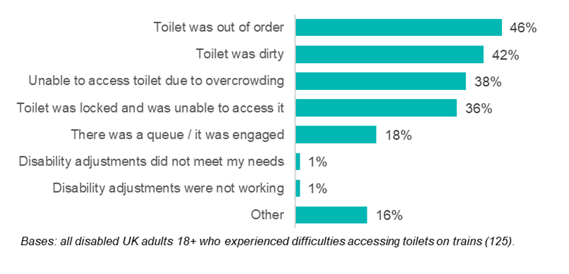
Similar issues were reported with other transport modes. In qualitative interviews, participants highlighted that access to toilets at motorway service stations was hindered by crowding and queues, as well as by the toilets often located on the upper floor, making them difficult to reach and resulting in some disabled people avoiding using service stations. Participants reported that some toilets in airports could be difficult to get to and lacked signposting. On planes, queueing can be a barrier to disabled people’s access to toilets, thus one participant suggested having a separate accessible toilet on board.
Across modes, qualitative interviews uncovered that passengers with non-visible disabilities faced an additional barrier of fear of judgement from other passengers for using the toilets when it is not obvious that they have a disability. They explained that this is because many people, including those with visible disabilities, do not understand the needs of people with non-visible disabilities.

Obstacles to using toilets
Difficulties using toilets were primarily related to a lack of cleanliness and poor design. In qualitative interviews, it was reported that accessible toilets at bus and service stations are often dirty, while 42% of disabled people experienced difficulties using train or train station toilets for the same reason. In terms of design, interviews revealed that some standard train toilets do not provide enough space for a wheelchair or walking frame, and that some train, bus station and train station toilets lack facilities for changing, washing and placing things on. Furthermore, the toilet, sink and handles being low down and spread apart in accessible toilets can make them difficult to use for some non-wheelchair users, while the lights being on a timer can leave disabled people stuck in the dark. Disabled toilets also often serve as baby changing rooms, reducing their availability for disabled users.

Changing Places
The Changing Places consortium is a group of organisations that campaign for, and maintain a list of, toilets known as ‘Changing Places’ toilets. These provide extra space and equipment needed by some disabled people. In July 2020, provision of Changing Places toilets was made compulsory in new public buildings.
One fifth (20%) of disabled people required the additional facilities to meet their needs. People with cognitive or dexterity impairments were more likely to need them than other disabled people. Qualitative interviews showed a variation in experiences of Changing Places. Positive experiences highlighted their ability to cater for individuals with different needs, with handles for weight-bearing, washing facilities and other features. However, while some participants found Changing Places spacious enough to fit different types of mobility aids, others didn’t use them because they could not fit their mobility scooter. A significant barrier to using Changing Places was simply the limited number available, making them difficult to locate. Some participants hadn’t heard of them or were confused as to how they differ from regular accessible toilets.
During interviews with train operators, participants reported a lack of accessible toilets in general and Changing Places in particular. Two of the larger operators revealed that over 60% of their stations are managed without accessible toilets, while a third said “a considerable amount” lack accessible toilets. Only one train operator, the largest of the operators interviewed, said that out of the over 200 stations they manage, only two stations had Changing Places facilities.

Refreshments and waiting rooms
Travelling can be a stressful experience for some disabled people, and waiting rooms and food/drink concessions are important facilities that can enable people to sit down and/or take a break from crowds. However, qualitative interviews with disabled people highlighted that food/drink concessions were often only available at large bus and train stations, which participants found to be too busy, noisy and understaffed. Consequently, participants suggested designated “quiet areas” for disabled people, similar to those at airports. This was seen as particularly beneficial for passengers with mental health or cognitive impairments.
Research with transport operators revealed plans for improvements to station facilities; however, there are some challenges to faster rollout. One train operator was aiming to get Safe Places Accreditation to provide quiet space at stations for people with autism and other disabilities. Other train operators interviewed stated that improvements to facilities are being addressed through the Accessible Travel Policy (ATP) 2020, which sets out, amongst other things, the arrangements and assistance that a transport operator will provide to serve the interests of disabled people using its services. However, participants cited challenges offering consistency due to legacy differences in fleet types, and a perceived lack of investment and guidance on accessibility standards. A bus operator also cited lack of funding as a barrier, particularly for smaller operators.

Assistance
Being able to access support when navigating public transport and stations, and when buying tickets, is integral to some disabled people’s ability to travel. However, there is scope to improve awareness of forms of assistance amongst disabled people. As shown in Figure 8, awareness is lower amongst younger people, people with mental health conditions and those with cognitive impairments.

Passenger Assist
For some disabled train users, the availability of assistance on a journey was key to their confidence when travelling. Passenger Assist is a service that rail passengers can request, which can involve helping passengers on and off trains, reserving wheelchair spaces and seats, provision of information, and more general assistance. However, a lack of awareness of the Passenger Assist service and confidence in its ability to support disabled passengers hampered its use.
Figure 8: Proportion of disabled people who were aware of forms of assistance
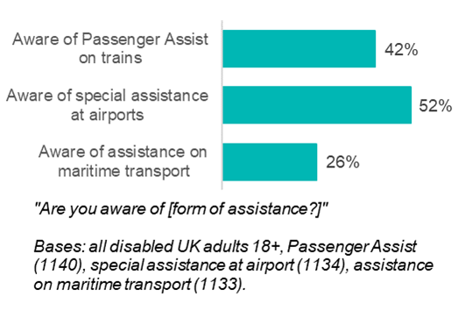
Just 42% of disabled people were aware of Passenger Assist on trains – less than the proportion of non-disabled people (50%). However, this gap disappears when looking at people with physical disabilities, such as mobility, dexterity and stamina impairments. Awareness was greatest amongst disabled people with vision impairments (59%) than those with other disabilities (41%).
Of the disabled people who had heard of Passenger Assist, 13% had ever used or attempted to use it (which amounts to 5% of disabled people overall, including those who had not heard of Passenger Assist). Disabled people with mobility impairments were more likely to have used it than those without (18% and 6% respectively). Of the disabled people aware of Passenger Assist but that did not use the service, the vast majority said it was because they didn’t need it or want to use it. Five percent said they didn’t use it because they had no confidence that the service could support them, 6% were unsure how to access the support; 6% were unable to pre-notify the service, and 5% did not want to give advance notice. Of those who used it, 90% felt satisfied or very satisfied with the service overall, while 93% felt satisfied with the helpfulness of Passenger Assist staff. This is consistent with ORR statistics from 2019/20, which show that 86% of Passenger Assist users were satisfied with the whole process.
In qualitative interviews, some participants reported finding the Passenger Assist service to be unreliable. One participant shared their experience of being taken to the wrong platform and left there, while a blind interviewee said that staff only show up about half the time, which he blamed on breakdown in communication between the passenger and the assistance team. A survey respondent highlighted poor organisation and customer service:
“I've had so many occasions of booking assistance and when I arrive at the station, they have no record of it and the staff usually make it known that it's an inconvenience! I've had more than one experience of booking Passenger Assist in advance and then being forced to miss my stop because the assistance wasn't waiting at my arrival station” (Female, 18-39, mobility-related impairment)
Suggestions were made as to how communication could be improved to avoid leaving people stranded, such as for booking of assistance to be confirmed in an app or text message and for passengers to have a way of directly contacting the person meeting them. Another improvement suggestion was for Passenger Assist to be available later in the evening across all operators. While in theory assistance should be available whenever a service is running some disabled people described not being able to travel at night as the support was not available.

Special assistance at airports
Special assistance at airports is available for people who feel that their health condition or disability could impair their ability to travel. Help is available from arrival at the airport and can cover the journey through the departure/arrival airports, boarding the aircraft, assistance during the flight, and help transferring between flights. In general, experiences using special assistance were positive. However, there is scope to improve awareness of the service.
Just over half (52%) of disabled people surveyed were aware of being able to request special assistance at airports, lower than the proportion of non-disabled people (66%). As with Passenger Assist, awareness was higher amongst older people than younger people. Disabled people with mental health or cognitive impairments were less likely to be aware of the service. It should be noted that special assistance at airports may not be restricted to disabled people: under the Equality Act definition used throughout this research, a person is only disabled if their illness or impairment has lasted or is expected to last 12 months or more. As an example, someone who has broken a leg in an accident is not disabled under this definition, but may be able to use special assistance at airports. This may be a factor in the higher rate of awareness of special assistance amongst non-disabled people.
Use of special assistance was reasonably common, with 38% of disabled people who were aware of it requesting it the last time they flew, either prior to arriving (29%) or when they arrived at the airport (9%). People with mobility impairments were much more likely to have requested the service last time they flew (62%) than those without (20%). Out of those who were aware of special assistance but didn’t use it last time they flew, the majority said they did not need it (77%), whilst 10% preferred to travel independently and 5% felt it would not help them.
The vast majority of those who requested special assistance found the process to be very (54%) or fairly (40%) easy. The Civil Aviation Authority Consumer Survey indicates that in 2019, 82% of people were satisfied with the assistance they received at airports. However, qualitative interviews showed variation in experiences based on access and staff behaviour. Whilst some participants found special assistance easy to locate next to the drop-off point, others argued that it is not well signposted and can be difficult to find in large airports, especially abroad. It was also criticised for not offering the option to meet passengers in the car park. Positive experiences of staff centred on going out of their way to meet passengers’ needs, whilst negative ones focused on not being aware of passengers’ specific requirements. Qualitative interviews revealed that while some participants were happy with being transported in wheelchairs and minibuses by a member of staff, others suggested introducing self-driven electric buggies to allow disabled people more independence.

Maritime travel assistance
Only 13% of disabled people had used maritime transport in the last year, including ferries and cruises. Perhaps as a result, there was limited awareness of assistance on maritime services: just 26% of disabled people were aware of being able to request special assistance when using maritime transport, lower than the proportion of non-disabled people (37%). As with assistance on trains and at airports, disabled people with cognitive or mental health impairments were less likely to be aware of assistance services. Twenty-four percent of disabled people who were aware of being able to book assistance actually did so when they last travelled.

Railcards, bus passes and journey assistance tools
Awareness and uptake of railcards, bus passes and journey assistance tools was relatively low. Just 7% of disabled people said that they held a Disabled Person’s Railcard. There were 246,336 Disabled Persons Railcards in circulation at the end of 2019/20 – an increase of 3.1% on the previous year. When asked why they did not have one, 25% said they didn’t know they existed, compared to 36% who said they did not use trains often enough to justify the cost. Despite the significant cost savings from having a railcard, people living in low income households were less likely to be aware that they existed. People with visual impairments were more likely to have one (23%) than people with other disabilities (5%).
Concessionary bus travel is available to older people and disabled people. Older persons and disabled persons bus passes entitle holders to free off-peak travel on weekdays and anytime on weekends or bank holidays. In 2018/19, there were 8.2 million older person’s passes and 900,000 disabled person’s passes in circulation in England. Thirty percent of disabled people had some form of concessionary bus travel, including 14% of disabled people who held a disabled person’s bus pass. Of the roughly half (51%) of disabled people who held a concessionary pass but did not hold a disabled person’s pass, 18% said this was because they didn’t know the latter existed. Only 5% of disabled bus users had a journey assistance tool such as a card or lanyard which can be shown to staff to explain whether a person has specific needs. Of those disabled bus users who did not have one, half said they didn’t know they existed. Awareness was lower amongst those with mobility, stamina or cognitive impairments, compared to other disabled people.

Awareness-raising and communication
As discussed above, while experiences using assistance services are broadly positive, there is scope to raise awareness and use, as well as some room for improvement of assistance services.
All train operators interviewed promote Passenger Assist; however, some requested guidance on how to improve awareness. In promoting services, train operators said that they provided information for disabled passengers on their websites, through local advertising campaigns and posters, as well as on social media, but argued that social media should be better utilised.
Of the bus operators interviewed, the three largest had promotional campaigns for Journey Assistance Cards. These cards can be used by disabled people with limited vision or hearing, communication difficulties, or special educational needs, and are intended to help disabled people notify bus staff of their needs. One operator felt that promotion is not needed as the Cards have been around for 10 years. Nonetheless, operators accepted the need for more awareness raising of Assistance Cards and Sunflower lanyards, especially on social media, as promotion currently centres around websites and advertising campaigns on buses and trams.
Some bus and train operators also used ambassadors and outreach days to promote schemes and consult disability groups on how to improve services. They engaged with charities and Access Advisory Panels, involving them in activities such as undercover auditing and development of disability schemes, such as an assistance card that could be shown to bus drivers to discreetly communicate accessibility needs. Additionally, bus and train operators advocated for greater hiring of disabled staff to connect their organisation with disability groups, spread awareness of disability services and inform the company of disabled people’s perspectives.

Inclusive infrastructure
“In transport, where infrastructure lasts 100 years and vehicles 20 or more, producing something which excludes disabled people has a lasting negative impact.” – Disabled Persons Transport Advisory Committee
“The actual design of streets is another issue…many people with sight loss cannot walk to places when they want to, or how they want to.” – Royal National Institute of Blind People
This chapter will explore the inclusivity of infrastructure over the course of a journey: starting with the affordability of different modes; exploring people’s ability to get to transport infrastructure, like stops and stations; and will conclude with accessibility of the infrastructure itself.

Key findings
- The ability to access transport infrastructure, including the condition of the streetscape and the availability of parking, played a role in how easily disabled people could travel. Accessibility of transport infrastructure, including both stations/stops and vehicles, played an important role in influencing passenger satisfaction across different modes. Those with mobility or dexterity impairments were more likely to report problems with accessibility.
- The relative affordability of different modes could be a barrier to use, as disabled people on average had lower incomes that non-disabled people. While buses were generally considered affordable, the cost of taxis was felt to be a barrier.
- Small adjustments such as provision of adequate, sheltered seating and considerations around layout and positioning of bus and train stops affected how easily people were able to travel.
- Having sufficient time and space to board and alight vehicles and to manoeuvre while vehicles were stationary was also important to disabled passengers. However, some disabled people do not feel they are always given enough time, which can cause significant anxiety.
- The introduction of minimum accessibility requirements by DfT has helped transport operators and Local Licensing Authorities (LLAs) to improve services and better enforce policies. However, operators and LLAs felt limited in the improvements they could implement without greater funding from government and a more regionally or nationally consistent set of accessibility requirements.

Ability to travel
As discussed in Chapter 3, disabled people are less likely to travel by public transport and more likely to depend on private vehicles, taxis and PHVs than non-disabled people. There are a range of factors that affect disabled people’s confidence and ability to travel, including: factors relating to information; facilities and assistance (discussed in Chapter 4); factors relating to the behaviour of staff (Chapter 6); and factors relating to the behaviour of other passengers (Section 7.2).

Affordability
Affordability was highlighted as a barrier to using public transport by participants in qualitative interviews across a range of modes. In these cases, participants made comparisons between the costs of travelling by car and travelling by public transport, as well as weighing up comfort, ease and convenience. While it was occasionally noted that cars were expensive to run, some participants made use of the Motability scheme to offset these costs – a scheme which was generally viewed favourably.
Buses were generally considered to be an affordable transport option, especially for those with a concessionary bus pass. Overall, 30% of disabled people held a card that allowed them to use local buses for free or at a discounted rate and 14% held a Disabled Persons Concessionary Bus Pass or Freedom Pass. The use of bus passes was widespread and they were seen to encourage travel by bus. In contrast, the cost of trains was considered a barrier, and the use of the concessionary railcards was less common: only 7% held a Disabled Persons Railcard. Barriers to use included not knowing about the cards, not believing they would be eligible, and not being able to justify the expense, given how rarely they used trains. The pricing and ticketing of trains was felt to be unnecessarily complicated. Cost was also considered a barrier to travel by air and maritime transport for a small number of participants, as this type of travel was associated with wider costs of holidays.
Despite the survey showing that disabled people made greater use of taxis and PHVs (see Chapter 3), in qualitative interviews, taxis and PHVs were generally considered too expensive to use often, or in some cases, at all. Overall, 4% of disabled people reported being charged more due to their condition or impairment when travelling by taxi or PHV. In contrast, almost half (47%) of assistance dog users who responded to the survey had been charged more by taxis or PHVs occasionally or regularly as a result of travelling with an assistance dog. LLAs also explained that differences in costs for different sized wheelchair accessible vehicles caused issues with travellers who sometimes did not understand why there were differences in prices for taxis or PHVs.

Access to transport
Being able to get to public transport infrastructure was key to disabled people’s ability to travel. The qualitative interviews showed that moving around the streetscape can be difficult for those with mobility impairments (including those who did not use mobility aids) or visual impairments. Uneven pavements or potholes and obstacles on the pavement, including parked cars, outdoor seating, signs, e-scooters, or even overgrown vegetation, caused issues for disabled people moving around, with participants concerned about falling over or walking into obstacles.
The location or positioning of transport infrastructure was also highlighted as a barrier to use. Some bus stops were reported as being too far away for participants to walk to. Beyond this, however, the positioning of bus stops, for instance on busy roads without pedestrian crossings, on steep hills, or outside busy shops were all factors that made accessing transport difficult.
The lack of availability of Blue Badge parking at train stations or bus stations also made access to transport more challenging. As of March 2020, 4.3% of the population in England held a Blue Badge, and train stations are required to reserve 5% of spaces for Blue Badge holders. Despite this, participants reported there not being enough spaces available. More generally, participants noted a general lack of availability of Blue Badge parking as well as issues with the amount of space provided and the time limits on those spaces. Some felt that these facilities did not adequately account for the additional time disabled people needed, especially when using mobility aids. However, it is worth noting that Blue Badges are not only available to those with mobility impairments. DfT data shows that as of March 2020, there were 22,463 blue badges issued to people with non-visible disabilities in England.
Air travel was mostly accessed by private vehicle or taxis or PHVs for disabled and non-disabled travellers alike. However, disabled people were more likely than non-disabled people to cite travelling with someone else as the reason for choosing this option, highlighting the importance of travelling with others (see Section 3.3).

Design and layout of transport infrastructure
Once disabled people arrived at the train or bus station, the design or layout of the station affected how easily they found it to travel. Across transport modes, availability of seating in waiting rooms and at bus stops or train stations was seen as vital, as was having a warm and dry, but ventilated, space to wait for transport. The absence of these facilities could act as a barrier to travel or make travelling less comfortable.

Trains
Seven percent of disabled train users reported a negative experience with accessibility either on the train or at the station in the survey. Those with vision or hearing impairments, and those with mobility or dexterity impairments, were more likely than other disabled people to have had a negative experience with accessibility.
The qualitative interviews revealed a range of accessibility issues encountered by disabled people when using stations. These included: a lack of lifts or escalators and a high number of stairs (for bridges or underpasses); issues with ticket barriers, such as being too narrow or closing too quickly; and the gap between the platform and the train being too big for those with mobility or visual impairments. Issues with the station, such as poor lighting or not having enough sheltered seating, were also raised. Even in larger stations, a lack of accessible infrastructure or long distances to walk was highlighted.
“A train station the size of … Birmingham New Street, or Grand Central as it's called now - the lack of escalators or lifts at the platform is shocking.” [Female, 40-64, mobility-related impairment].
Train operators were aware of accessibility limitations of stations, particularly the lack of step-free access from road to platforms. Of the four train operators participating in the scoping exercise, one indicated that 20% of the stations they manage did not have step-free access; at the other end of the scale, one operator reported that 60% of their stations lacked step-free access. Operators suggested that DfT should lead on improvements to station accessibility, with aspects such as level boarding and improvements to tactile wayfinding seen as priorities. All operators reported providing alternative options for individuals when accessibility services were out of action.
Most train operators reported having an operational lead on inclusion and most reported having a specific board member responsible for inclusion. However, there were variations in how embedded these roles were within organisations. In a positive example, the operator had a steering group to drive through improvements on accessibility issues throughout the organisation leading to faster changes.

Buses
Seven percent of disabled bus users reported having a negative experience with accessibility on buses or at bus stops. Beyond specific accessibility issues, disabled bus users (15%) were more likely than non-disabled bus users (10%) to report a negative experience with a bus stop, including issues with lighting. Other issues at bus stops identified in qualitative interviews included a lack of shelters, a lack of pavements on roads that led to bus stops, and poor phone connectivity at bus stops. These issues can discourage use of buses as disabled people find it harder to get to bus stops and less comfortable while waiting for buses.
Some bus operators had an operational lead on inclusive travel, whilst others did not. Interviews with operators also suggested there were differences in how involved the board was in championing an inclusive service. Those with a greater level of board involvement felt that it led to better engagement on accessibility throughout the organisation. Upgrading bus stops, including improving seating and shelters, was seen as a key priority, but bus operators highlighted that many bus stops were managed by other bodies. For both buses and trains, some operators had disabled staff members leading their accessibility and inclusion work. This helped to ensure that the lived experiences of disabled people were represented in key decision making.

Air and maritime travel
Issues with the design and layout of infrastructure related to air and water travel were less frequently highlighted. However, 4% of people reported concerns about check-in and the security process at airports as a reason not to fly. In interviews, disabled travellers identified long queues and lack of seating during security screening as barriers to travelling by air. Similarly, 5% of all travellers reported the amount of time taken to get to a ferry terminal or pier as a reason not to use this mode of transport. However, qualitative interviews revealed that people appreciated that there was usually seating available when waiting for maritime travel.

Accessible vehicles
This section explores factors that affect the accessibility of vehicles particularly with respect to boarding and alighting and adjustments within vehicles.

Boarding and alighting
Boarding and alighting from buses, trains, cars, taxis and PHVs presented significant challenges for those with mobility related needs. Often, this was a consequence of simply not being given enough time to board or alight, as shown in Figure 9.
Figure 9: Proportion of disabled and non-disabled train and bus users who did not have enough time to board or alight
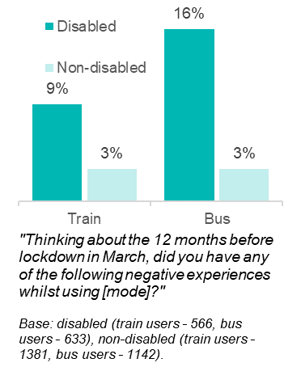

Cars, taxis and PHVs
Where cars were particularly low in design, or too high from the kerb, this could make them difficult to get in or out of. As with other modes, it could be too painful or physically challenging for some disabled participants to get in or out without physical assistance from someone else.

Buses
Overall, 16% of disabled bus users had experience of not having enough time to board or alight a bus, compared to just 3% of non-disabled bus users. Those with mobility or dexterity impairments were particularly likely to be affected by this. Qualitative interviews revealed that steps made it physically challenging or impossible for participants with mobility impairments to board and alight from buses, especially when using a mobility aid. Some indicated that it can be too painful or physically challenging to board or alight without assistance when buses lack lowering capabilities or if the driver doesn’t deploy the accessibility aid. Failure to deploy an accessibility aid and insufficient time to sit before a bus pulled away were issues reported in interviews by those with less visible disabilities. Among non-users of buses, such challenges were cited as reasons for stopping use. When available, accessibility aids, such as ramps and raised kerbs, were cited as key enablers.

Trains
Disabled train users were more likely to have experienced not having enough time to get on or off a train (9%) than non-disabled train users (3%). This particularly affected disabled passengers with mobility or dexterity impairments. As with buses, qualitative interviews highlighted that large gaps or steps between the vehicle and platform made boarding and alighting physically challenging for those with mobility issues, especially for users of mobility aids. For some, it was physically impossible to board or alight without physical assistance from someone else. Walking through a train while it was still moving to access the exit was particularly difficult for those with mobility impairments or balance difficulties and led to participants feeling anxious about being able to get off in time.
Awareness of difficulties faced by disabled passengers when boarding and alighting was reflected in qualitative interviews with transport operators. Steps taken by one bus operator to address access issues included the introduction of Kassel kerbs and infrastructural improvements to bus stops and stations. Similar improvements made by a train operator included the introduction of level boarding at the train stations they managed and the purchase of power chairs, using a DfT minor works budget. Other train operators identified the ability for disabled passengers to board and alight from trains at all the stations they manage without requiring any physical assistance as a key priority for accessibility. Due to the extent of infrastructural changes required at the train platform interface, and the level of investment required, operators suggested that large government investment would be needed.
“We [train operators] try and deliver what we're supposed to, from legislation obligations, but it can almost feel like putting a sticking plaster over something without actually resolving the ultimate issue, which is ‘I [disabled passenger] can't physically get on to my station, or it's not got those things [accessible infrastructure]’. Ultimately, that is major funding but that has to come from a department basis” [Train operator].

Vehicle design
Vehicle design affected travelling experience, particularly for those with mobility impairments.

Buses and trains
On buses, the availability of space for wheelchairs and the positioning and availability of handrails were key for those with mobility or stamina-related impairments. Five percent of disabled bus users reported issues accessing wheelchair space. Interviews highlighted the difficulties presented by a lack of handrails to support people to stand for longer when a seat was not available, as well as issues reaching handrails when buses were crowded. Disabled people with hearing impairments described difficulties communicating with drivers, due to the glass covering drivers’ booths, which was problematic where buses did not have AV information (see Section 4.2).
On trains, only 2% of disabled passengers reported issues accessing wheelchair space. However, accessibility issues related to facilities (such as toilets) and availability and suitability of assistance and information (see in Chapter 4).
Bus and train operators reported that the introduction of accessibility requirements and increased funding helped them to meet the minimum accessibility standards for all vehicles. Some operators had gone beyond these. Examples given by bus operators included making their bus fleet fully AV compliant, introducing ‘dementia friendly’ floors to make it easier for passengers with dementia to navigate the bus, or providing bespoke solutions to individual customers. One train operator had set up ‘trial days’ to enable passengers to feedback on the accessibility of new carriages. Operators generally felt progress was good but highlighted that greater funding and a nationally consistent, up-to-date set of requirements would be needed to further improve the accessibility of vehicles. For example, without greater funding, operators would not be able to purchase new vehicles or retrofit old ones. Additionally, without consistent vehicle specification, not all buses can be made spacious enough for all wheelchair users. Some operators also reported that the coronavirus pandemic had negatively impacted bus profitably, further reducing the funding available for the changes required.

Taxis and PHVs
When using taxis or PHVs, interview participants benefitted from the modern features available onboard many wheelchair accessible vehicles. Such features included wide opening doors, faster wheelchair locking mechanisms and more space. Greater space improved comfort, especially for users of mobility aids and assistance dogs. Space was also a reason for preferring private cars to public transport. Others preferred their own cars due to their specialist adaptations.
Local Licensing Authorities (LLAs) cited three key difficulties in relation to accessibility: overcoming barriers to provision of wheelchair accessible vehicles, maintaining a publicly available list of wheelchair accessible vehicles (known as a S167 designated list), and a lack of passenger awareness around different types of wheelchair accessible vehicle.

Barriers to provision
In some areas, there were difficulties with incentivising the provision of fully wheelchair accessible vehicles due in large part to the relatively high cost of these vehicles. Such vehicles also tended to make a smaller return, since wheelchair users comprise a smaller part of the customer base. This was particularly challenging within small or rural authorities.
“The feedback [from the drivers] has been atrocious, to be honest with you: a) they don't want it, b) they feel, 'Well, what's the point of putting wheelchair-accessible vehicles when it's only a certain percentage of the population?'” [Local Licensing Authority]
LLAs highlighted their role in incentivising drivers to purchase wheelchair accessible vehicles, including both taxis and PHVs, for example by offering reduced licensing fees or relaxing requirements on the age at which vehicles needed to be taken out of service. Such policies were considered important since without these, drivers would simply purchase the cheapest vehicle on offer – usually non-wheelchair accessible PHVs. However, one LLA suggested that without additional funding from central government, it would be difficult to significantly incentivise take up. Finally, authorities suggested that a consistent set of national policy requirements for vehicles would be perceived as fairer and would make it easier to enforce.
“National standards for all private hire and taxi licensing would help (…) Where we can get a clear steer from central government on an issue, it really helps local authorities in terms of consistency, and from an enforcement point and advising the trade.” [LLocal Licensing Authority]
LLAs were able to drive accessibility improvements across their fleet by introducing new policies, for example, by setting new requirements on the proportion of wheelchair accessible vehicles in an operator’s fleet or the number of new licences available for wheelchair accessible vehicles per year. Authorities also reported that updated guidance about what counts as a wheelchair accessible vehicle had helped ensure consistency.

Maintaining the S167 list
The scoping exercise indicated that most, but not all, participating authorities maintained a publicly available list of wheelchair accessible vehicles (known as a S167 list) or had at least one wheelchair accessible vehicle under their jurisdiction. Of those interviewed, all had introduced or were in the process of creating such a list. Having a list was considered beneficial for knowing more about the accessibility of their fleet and enabling authorities to prosecute access refusals if necessary.
Updating the lists over time and capturing information consistently was identified as a key challenge for authorities that had recently merged to form a single unitary authority and had formerly comprised of multiple and independent licensing authorities.

Lack of customer awareness
A final barrier was around passenger awareness of the vehicles most appropriate for their needs. Users of larger wheelchairs require larger, specialised vehicles, for which a higher fare could be charged, which could lead to passengers feeling they had been overcharged. In other cases, drivers of smaller wheelchair accessible vehicles may justifiably refuse the fare if the passenger is using a larger wheelchair which is not suitable for the vehicle. This can lead to complaints by passengers who feel they have been wrongly turned away. If a driver accedes to a request and transports a passenger in a smaller vehicle, this puts the passenger at risk. Whilst LLAs had training in place to ensure drivers knew how to transport passengers correctly and safely, they suggested DfT could do more to raise passenger awareness around the varying types and costs of wheelchair accessible vehicles.

Better staff training
“Staff training should involve talking directly to disabled people themselves so that staff gain a better understanding and empathy for the day-to-day problems they encounter on the transport system.” – Age UK
“Our members have reported issues with how transport staff handle disabled passengers. Transport users with [less visible] disabilities often find their usage of disabled seats questioned and the level of understanding varies amongst staff which is why compulsory training is necessary.” – UNISON
“Often when disabled people’s needs are not met when using public transport, it’s the process of customer service that’s at fault rather than a funding issue.” – All Party Parliamentary Group for Young Disabled People
This chapter discusses the role of transport staff in ensuring that disabled people are able to travel with confidence and ease. It first presents findings on disabled people’s experiences interacting with transport staff, before considering the unique experiences of assistance dog users. Lastly, it discusses the state of staff training.

Key findings
- Around three quarters of disabled people felt that public transport staff understand the needs of disabled people very or fairly well. This is true for both bus (72%) and train (76%) staff. Views regarding taxi and PHV drivers and telephone operators were also positive, with 96% of disabled people feeling fairly or very well treated.
- Despite this, disabled people were more likely to have negative experiences with bus, train, taxi and PHV staff than non-disabled people. In some cases, negative experiences with staff affected confidence to travel. Amongst those who had a negative experience with staff on public transport, almost half (49%) of disabled people felt it had affected their confidence.
- There was evidence of inconsistency in standards of disability awareness amongst staff, across modes. Whilst staff were reported as helpful, supportive, and reassuring to disabled passengers, there were instances where they were rude, disrespectful, and poorly informed. In particular, some staff expressed impatience with disabled passengers who may need more time or need information to be repeated.
- Most assistance dog users had been refused service by a taxi or PHV driver. Roughly three-quarters (76%) of assistance dog users surveyed who had used a taxi or PHV had experienced an access refusal in past year. Most of these refusals were illegal, with drivers failing to show a medical exemption certificate.
- Inconsistency in awareness and behaviour was reflected in training provision. The extent and nature of training provided by train and bus operators and local taxi and PHV licensing authorities (LLAs) varied, with some providing extended bespoke training packages delivered in collaboration with disability groups, while others provided only basic training in which disability awareness was briefly covered.
- Interviews with disabled passengers suggest that there are some situations in which it would be difficult to provide a better service without greater staff availability. For example, the absence of bus conductors can be problematic for some disabled passengers, as can an absence of on-platform staff.
- Disabled people with cognitive impairments often have a different experience of interacting with transport staff. Compared to other disabled people, they were less likely to feel that staff understand their needs, and more likely to have negative experiences with staff, which was more likely to negatively affect their confidence to travel.

Interacting with staff
In general, disabled people felt well understood and well treated by staff. Figure 10 shows that clear majorities felt that the needs of disabled people were fairly or very well understood by staff across modes.
Figure 10: Disabled people's perception of how well staff across modes understand disabled people's needs
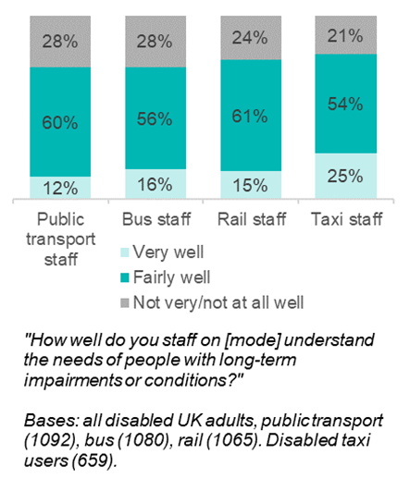
This finding is consistent with other research. The 2019 Transport Focus Bus Passenger Survey found that 76% of disabled passengers were very or fairly satisfied with the helpfulness and attitude of bus drivers. The 2019/20 National Rail Passenger Survey found that 66% of disabled people thought the helpfulness and attitude of staff on their train was very or fairly good. The ITS Panel Survey showed that the overwhelming majority (98%) of respondents felt either very well (54%) or fairly well (44%) treated by taxi/PHV drivers and telephone operators, with no difference in views between disabled people and non-disabled people. Qualitative interviews also revealed a largely positive attitude towards staff at airports and on planes, and on maritime services.
Despite this, disabled people were more likely than non-disabled people to have negative experiences with staff across all modes, as shown in Figure 11. These negative experiences were more likely to have an impact on confidence in travelling for disabled people than for non-disabled people. Negative experiences with staff were particularly common amongst those with cognitive impairments – including memory impairments, difficulties with learning or understanding, or social and behavioural difficulties. Sixteen percent in this group had a negative interaction with staff on public transport in relation to their disability, compared to just 4% of other disabled people. This group was also less likely to feel that staff on public transport understood the needs of disabled people well.
Figure 11: Proportion of disabled and non-disabled travellers who had negative experiences with staff
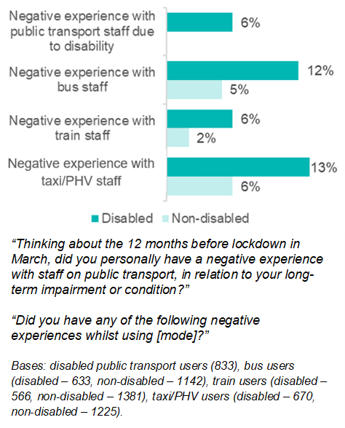
In qualitative interviews it emerged that whilst staff can be helpful, supportive, and reassuring to disabled passengers, there were instances where they were rude, disrespectful, and poorly informed. In particular, some staff expressed impatience with disabled passengers who may need more time or need information to be repeated. Across modes, both positive and negative interactions with staff centred around five key areas: providing information; providing assistance; accommodating disabled people’s needs; managing other passengers; and the availability of staff. We explore these themes in turn.

Providing information
Staff can be a vital source of information for disabled travellers. However, some staff can be impatient with disabled people who might struggle to understand information, or need information repeated.
On buses, participants in qualitative interviews described helpful drivers alerting passengers of their stop when automated systems are not available, or reading out information when a passenger’s carer is not present. Similarly, on trains, staff can provide reassurance and support, helping disabled people navigate what can feel like a complicated journey: for example, by giving advice on a train journey involving multiple changes. However, across modes, disabled people felt that some staff can be unwilling to assist, rude, dismissive, or impatient. Participants explained that short, blunt answers can make them feel upset, embarrassed, or vulnerable, and that drivers can become irritable when asked to repeat themselves by passengers with hearing problems or cognitive impairments. There was a sense that staff are rushed and don’t feel they have time to be empathetic and helpful, leading to frustration when disabled passengers take longer:
“The driver of the bus was very unpleasant I put my free bus pass on the machine to register it and he said loudly IT DOSENT WORK as if I should have known and then mumbled under his breath at me. It took me a while to pick up the card as I have arthritis in my hands and other joints and he became angry.” (Female, 65+, mobility-related impairment)
Participants described how taxi and PHV drivers can be kind, polite and helpful. For disabled people, a talkative driver can be reassuring, and there was a perception among some that access to a dedicated individual who is trustworthy and supportive can significantly increase confidence. However, some disabled people reported being asked inappropriate questions about their disability. There were also concerns around the potential for some drivers or their behaviours to induce anxiety for people with mental health impairments: people in this group indicated that anxiety and stress can be heightened when drivers ask for directions, as can poor communication and language skills.

Providing assistance
Disabled people described the benefits of both formal and informal assistance from staff (see Section 4.4 above on formal assistance services, such as Passenger Assist on trains). In qualitative interviews, positive experiences included platform staff alerting the train driver that a passenger has an assistance dog so that the driver could wait long enough for the passenger to board and find a seat. However, when rail staff fail to provide the assistance requested by disabled train users, passengers have been unable to board the train, or unable to alight and therefore miss their stop. Some participants described how communication failures have impacted them:
“The failure of one particular assistance can lead then to your whole journey unravelling and then you get […] to where you should be interchanging and there's no one there to assist you because there's been a breakdown in communication. They haven't been told that you're actually coming an hour later.” [Male, 40-64, multiple conditions, including mobility-related, vision and other impairments]
A view expressed in qualitative interviews was that some staff have poor awareness and understanding of disability. Staff can make assumptions about disabled people’s needs, such as bringing out a wheelchair for a person with a visual impairment but no mobility difficulties, which can feel humiliating, or they simply do not recognise certain conditions as a disability, such as bowel conditions.
Furthermore, some staff can simply be unwilling to help. Some taxi and PHV drivers stay in their car and will not help passengers with getting in or out of the vehicle, carrying luggage or shopping, or manoeuvring wheelchairs or other mobility aids. At train stations, some staff are unwilling to take passengers to platforms:
“My overall impression is, 'Oh, okay, we've got to take you down to the platform. If I give you directions, can you not find it yourself?' That tends to be the attitude of the majority of people at [train station staff].” [Male, 40-64, multiple impairments, including mobility-related and visual]

Accommodating needs
In addition to providing direct assistance, staff have the capacity to make journeys easier for disabled passengers in the way that they deliver the service. For example, participants with visual impairments reported that buses do not always stop to check if passengers want to get on, which creates challenges to travelling by bus for those who cannot see the bus to flag it down.
“It is blatantly obvious. I am standing there with a big great dog with a yellow harness on it saying, 'This is a guide dog'. 'Oh, I'd better check to make sure they want to get on this bus,' and they [the drivers] don't, and I've complained to the bus company numerous times saying, 'You need to give better awareness training to your bus drivers.'” [Male, 40-64, multiple impairments, including mobility-related and visual]
Similarly, there was a view that some drivers assume a passenger with a mobility aid can walk while the bus is in motion. Passengers experienced instances of significant fear and anxiety, as well as pain (from falling over), and embarrassment. There was some sympathy expressed that drivers are bound by the requirements of their timetable, but a feeling that some contingency should be built in:
“Once you're on the bus and you're past the first obstacle, they have to go. I can kind of understand that they have a timetable, but why? Why can't they have time to allow for disabled people?” [Female, 40-64, mobility-related impairment]
Helpful taxi and PHV drivers will pull up on the right side of the road to allow the disabled passenger to safely exit onto the curb, as close as possible to the destination; but not all drivers do so.
At airports, negative experiences centred around the process of airport security. Disabled passengers can feel pressure from staff to get through security quickly; some can find it be challenging to remove clothing or unpack luggage quickly, especially those with mobility or dexterity disabilities.
“Then you always feel pressured into taking everything off, your shoes, belts, everything out of your handbag, everything out of your hand luggage or whatever. That's not easy to do when you've got mobility issues. Bending and stretching and whatnot, and again I just feel as if you're always being rushed, especially with the volume of people if the airport is busy.” [Female, 40-64, mobility-related impairment]
There was a view that staff need to be better aware that some passengers cannot stand for long periods, and that this can be problematic especially when queuing to go through airport security.

Managing other passengers
The behaviour of other passengers can make a significant difference to disabled people’s travelling experience, as discussed in Section 7.2. On buses, participants gave examples of bus drivers helping to manage the behaviour of other passengers, including making school children line up and enter the bus one at a time. However, there was also a feeling that drivers are not sufficiently engaged in ensuring that other passengers vacate priority seating, and in managing bad behaviour and conflicts that can arise. Similarly, on trains there was a view that one of the primary benefits of having onboard staff was their ability to deal with antisocial passengers.

Staff availability
Despite the benefits that helpful and understanding staff can bring, in some situations it seems that it would be difficult to provide a better experience for disabled people without greater staff availability. On buses, there was a view that drivers can be difficult to approach, especially when the bus is moving, and that they have too many roles to fulfil when bus conductors are not present. Disabled passengers can feel they have no source of support when feeling confused or “paranoid”:
“It would be helpful to have somebody on the bus, just moving about upstairs and downstairs all the time, to make sure that things are okay. The driver is not enough.” [Female, 40-64, multiple impairments, including hearing and other conditions]
On trains, there was a concern that staff are often insufficiently available to help with passengers who refuse to vacate priority seats, and drunk or disorderly passengers who can make disabled passengers feel uncomfortable and unsafe. Similarly, if there are insufficient staff on a platform and multiple disabled passengers needing assistance to board, this can cause problems. An absence of staff presence on some platforms was felt to be particularly problematic, as disabled passengers may need a staff member to ask questions, or to help them on or off the train. On trains, there was a concern that conductors are being expected to fulfil too many roles.

Assistance dog users and access refusals
It is currently illegal for taxi and PHV drivers to refuse to transport an assistance dog on any grounds except medical ones. If the driver is medically exempt, they are legally obliged to display an exemption notice issued by the LLA in their vehicle windscreen. It is also illegal for drivers to charge more to transport an assistance dog.
Despite this, over three-quarters (76%) of assistance dog users surveyed who used either taxis or PHVs in the 12 months before March 2020 had experienced an access refusal of some kind during that period. ‘Hard refusals’ involve situations in which a driver refuses to transport an assistance dog or drives away, whilst ‘soft refusals’ involve situations in which an assistance dog user successfully persuades a driver who initially refuses. As shown in Figure 12, both types of refusal were common, as were experiences of being made to feel unwelcome, or being provided poor service, when travelling with an assistance dog.
Figure 12: Proportion of assistance dog users who used taxis/PHVs who experienced access refusals or poor service
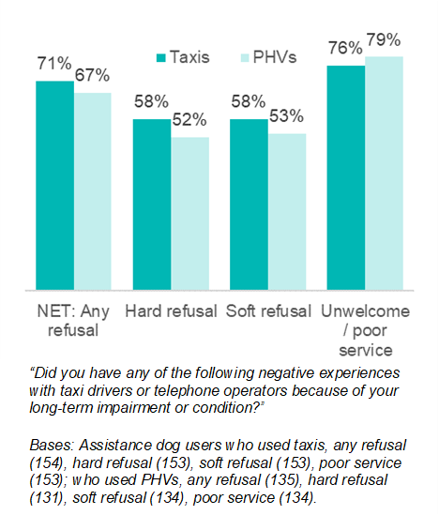
Overall, 63% of taxi users and 59% of PHV users who experienced a refusal said this happened only occasionally. However, 18% of taxi users and 16% of PHV users who experienced a refusal said it happened on most or all journeys. Almost half (47%) of taxi and PHV users surveyed had been charged more by a driver or operator to travel with their dog. As discussed in section 4.3, there are also some awareness gaps among disabled passengers of the charging levels for the different types of accessible vehicles.
Although drivers must present a medical exemption notice in order to refuse to transport an assistance dog, survey respondents said that this was done in only 8% of cases, for both taxis and PHVs. As Figure 13 shows, respondents were refused for a range of reasons, including a dislike of dogs, religious and cultural reasons, and the possibility that other passengers might be allergic. Many respondents were not given any reason at all.
Figure 13: Reasons given for access refusals for taxis and private hire vehicles for those with assistance dogs
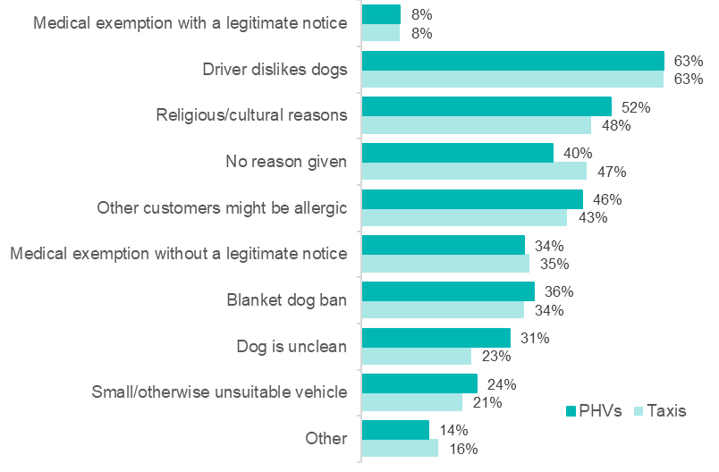
Experiencing a refusal had a strong impact on confidence travelling by taxi/PHV. Of those who had experienced a hard or soft refusal, nine out of ten said this had slightly (31%) or strongly (59%) affected their confidence. Overall, 31% of respondents were not confident in travelling with their assistance dog in a taxi or in a PHV, and 85% said they would travel much more often (52%) or a bit more often (33%) by taxi or PHV if service was guaranteed.
“Thinking about the 12 months before lockdown in March, which of the following reasons has a taxi/private hire vehicle driver given you for refusing or resisting transporting you with your assistance dog?”
Bases: assistance dog users who took taxis (109), PHVs (90)
Research with LLAs suggests that more could be done to train drivers and to make them aware of the need for a medical exemption notice. LLAs explained that very few, if any, of their drivers have exemption notices, despite the fact 10-20% of the population is estimated to be allergic to pets. One LLA explained that it is more often the case that once enforcement action is taken against a driver, the driver informs the LLA that they have an allergy, at which point the LLA asks for proof. Some LLAs described using ‘mystery shopper’ exercises with assistance dog users to get feedback on the issue.
Complaints, and the resulting prosecutions and sanctions, are covered in more detail in Section 7.3.

Staff training
Across modes, there was evidence of inconsistency in the level of training provided to staff. In this section we discuss the current extent of staff training, and perceived barriers to improvement, for bus, train, and taxi staff. Staff in other modes, such as maritime and aviation, are also provided with training, but this was out of scope for the research and is not discussed below.

Bus staff
Since March 2018, legislation has required all bus drivers to be trained in disability awareness. This training can be provided as part of the Driver Certificate of Professional Competence (DCPC), which all drivers complete, or separate to it. As of March 2020, 97% of operators in England required drivers to meet this requirement, and all drivers and on-bus staff were required to meet it. Of the five bus operators involved in the scoping research, all had some level of disability awareness training for customer facing staff, but there was inconsistency in the provision of training for non-customer facing staff.
Qualitative interviews with two bus operators suggested inconsistency in the level and nature of training available. One operator provided a full day of dedicated disability awareness training and a day on customer service, which included sections on disability. Local and national disability groups had been involved in the design of the training. The course covered a broad range of topics, including different types of disability (both visible and less visible), mental health, neurodiversity, journey assistance cards, legislation and disability rights. The other operator enabled drivers to attend training delivered by charities, focussing on guide dogs and helping passengers with dementia.
Together, the scoping exercise and interviews with operators confirm variation in the level of training bus staff are required to attain, which staff are trained, which topics are covered, and which disability groups are represented in the design and delivery of training.

Rail staff
All train operators must adhere to the Accessible Travel Policy guidance published by the Office of Rail and Road (ORR), which includes guidance on disability training for staff, as part of their licensing. Scoping research with train operators showed that all had mandatory disability awareness training for customer facing staff, delivered at induction and refreshed every two years. There was variation in whether training was available to non-customer facing staff, and whether there was any refresher training offered. None of the training offered was accredited, but developed internally by the operators.
Qualitative interviews showed further variation. One operator provided a two-day induction including some sections on disability, and had some sessions run by a dementia charity. This operator was planning on introducing dedicated disability training in the near future. A second operator had recently launched a large disability training programme for all staff, with some sections led by disabled trainers who are “well connected in the disability community” and provide ‘lived experience’ stories from a range of disabled train users. An Accessible Advisory Panel was involved in the design of the training, which covers a wide range of topics, including different types of disabilities, including cognitive and neurodevelopmental impairments. The training also covers recognising disability lanyards, less visible disabilities, the social model of disability, amongst other topics. This operator felt the Office of Rail and Road (ORR) guidance for train operators was good. DfT have produced a cross-modal training package on accessibility. However, neither of the two operators interviewed for this strand of the research had used the DfT package when developing their training, as they felt it was neither sufficiently extensive nor mode-specific enough.

Taxi staff
DfT statistics show that the proportion of LLAs in England requiring that their drivers go through disability awareness training has increased from 44% in 2019 to 47% in 2020, and for PHV drivers from 41% to 44%.
Research with LLAs revealed variation in the extent and scope of training given to both drivers and licensing staff. With respect to drivers, a majority of the LLAs involved in the scoping research required drivers to attend disability equality and awareness training in their licensing policies. Some only required training on induction, whilst others required (or were planning to require) refreshers every three years. LLAs used a variety of training packages and there was variation in whether disabled people or disability organisations were involved in the design or delivery of the training. There was also variation in which organisations delivered the training, including the local council themselves, external providers such as local colleges, the Institute of Licensing, or taxi operators (in the case of the larger operators). Equally, there was variation in the level of ongoing effort in ensuring licensees provided an accessible service, with some LLAs, but not all providing ongoing advice, voluntary disability awareness training, and circulating details of enforcement actions taken.
Qualitative interviews with LLAs confirmed the diversity of approaches used, with some LLAs including modules on disability within wider training packages, often alongside more general diversity and inclusion training, and others providing additional disability-specific training, including safeguarding training. The topics covered also varied, and whilst training tended to cover general disability awareness issues, more specific training tended to focus on wheelchair and assistance dog users.
The extent to which training is taken up by LLA staff was highlighted as an issue by one authority. They reported low take-up levels, except amongst enforcement officers who took the training to enable them to recognise when drivers made mistakes in securing wheelchairs within vehicles. In addition to licensing staff, there was a view that administrative staff should attend training to enable them to effectively deal with calls from disabled people.
Despite clear inconsistencies across areas, LLAs were positive about the effectiveness of training and its broader utility. For example, there was a view that mandatory and high-quality driver training is useful when deciding to prosecute a driver, as it limits the scope for drivers to claim they were unaware of their responsibilities.

Promotion of passenger rights and enforcement
“We would like stronger signposting to where older and disabled people can take complaints and suggestions. We have received feedback that some older people don’t bother to make complaints because they think it’s a waste of time and they will not receive a response from the operator.” – Age UK
"The general sense is that the various complaint mechanisms across different modes are passive - in that they are ready to receive complaints if people bring their complaints – rather that proactive. This assumes that consumers have a level of understanding of their rights … and a level of awareness of, and confidence in, complaint systems that we believe does not exist.” – Disabled Persons Transport Advisory Committee
This chapter discusses the importance of interactions with other passengers for disabled people’s travelling experience. It then considers the complaints process, including the reasons that people choose not to complain about negative experiences. Finally, it explores complaints about illegal taxi and PHV service refusals for assistance dog users.

Key findings
- Disabled people were more likely to have experienced a negative interaction with other passengers than non-disabled travellers. The most common types of issues experienced were related to noisy or drunk passengers as well as passengers not moving to let people on or off transport. Negative experiences with other passengers affected disabled people’s confidence when travelling.
- Disabled people, particularly those with less visible disabilities, were less confident than non-disabled travellers asking other passengers for a priority seat when they needed it. Other passengers occupying priority seating made it unavailable to disabled travellers.
- Overall, few people made formal complaints about negative experiences. Reasons for not complaining included thinking the issue would not be acted upon. Disabled people were more likely than non-disabled people to cite this reason when complaining about buses and trains.
- Disabled people reported that making complaints was tricky and time-consuming despite transport operators and Local Licensing Authorities (LLAs) describing their aim of having an accessible and responsive complaints process. People reported making complaints through multiple channels to ensure the complaint was taken forward.
- Around a third of people felt dissatisfied with how their complaint was handled. There was no difference in levels of dissatisfaction between disabled and non-disabled people. Amongst disabled people, satisfaction with how complaints were handled was linked to the level of customer service received, whether it was timely and empathetic, and the outcome received.
- Around half of assistance dog users who experienced service refusal when attempting to use taxis or PHVs reported them. Of those who had reported the refusals, only half reported them to the LLA who have the powers to take enforcement actions. Reasons for not reporting included a perception that the issue would not be taken seriously or a view that the process would take too long.
- LLAs encountered barriers in pursuing enforcement action against service refusals where there was a lack of evidence or where complainants chose not to pursue the issue. Mandatory use of CCTV in and outside the vehicles was a suggestion made to overcome these issues and improve service provision.

Interactions with other passengers
The behaviour of other passengers has a significant impact on disabled people’s experience of travelling.
Over half (56%) of disabled people had a negative experience with other passengers on public transport, compared to 47% of non-disabled people (see Figure 14). This difference was true across modes, including buses, trains and taxis/PHVs. For some disabled people, negative experiences were a frequent occurrence: with one in five people who had a negative experience saying this happened at least once a month. The most common difficulties experienced by disabled people were in relation to noisy (27%) and drunk passengers (28%); passengers not moving to let people on or off transport (27%) and passengers not moving out of priority seating (21%).
Figure 14: Proportion of disabled and non-disabled travellers who had a negative experience with other passengers
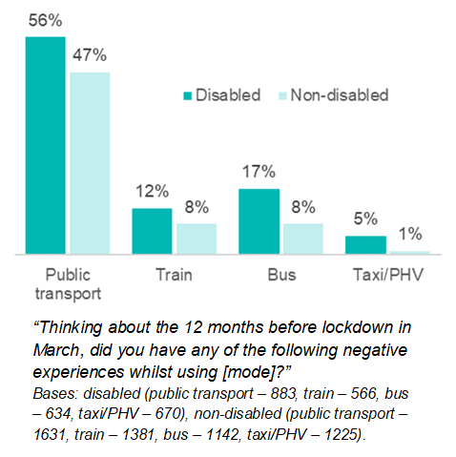
These issues were echoed in the qualitative interviews. Disabled people described unpleasant interactions with drunk and rowdy passengers leading to increased anxiety. Issues with other passengers blocking walkways and entrances/exits were also raised by those with sensory impairments and non-visible disabilities. This was noted as a particular problem during peak times. Participants with mental health conditions described increased anxiety when having to interact with other passengers to ask for help or support.
However, it is worth noting that the qualitative research also highlighted participants’ positive experiences on buses and trains, with other passengers reported as helping with baggage, providing directions, or providing assistance during medical emergencies.
Across the board, disabled travellers were typically not confident asking other passengers to give up their seat. Disabled people were less confident (13%) than non-disabled people (19%) asking for a priority seat when they needed it. Non-disabled people (43%) were also more likely than disabled people (29%) to report never needing to ask for a priority seat. Only 12% of disabled people were confident asking for a standard seat. Encouragingly, the National Travel Attitudes Survey shows that 91% of people report that they would give up a seat for someone with an illness, impairment, or condition that makes it more difficult to use public transport.
People who felt their disability was clearly visible were twice as likely to be confident in asking for priority seating than those who felt their disability was less visible (see Figure 15).
Figure 15: Confidence in asking another passenger to vacate a priority seat, by visibility of disability
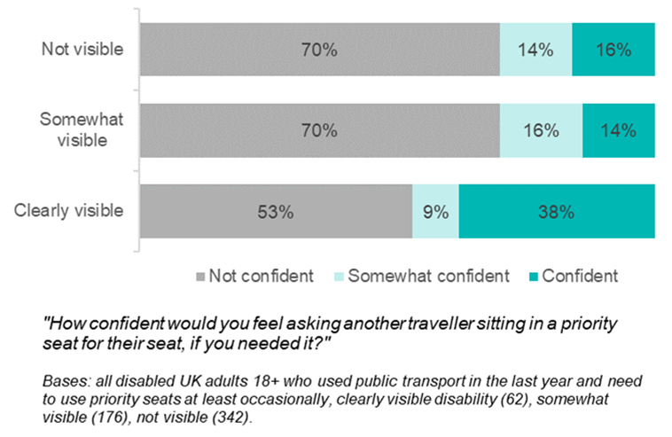
The visibility of the disability and the confidence required to ask for a seat was commented on by one participant who described their experience on a train:
“I've always got my walking stick with me, and I say, 'Excuse me, I've got the seat reserved.' There's a few grumbles and I just stand there. (…) the underlying problem is that you do get people sitting in your seat and there will come a time when somebody will simply refuse to move” [Male, 65+, multiple conditions, including mobility-related and other impairments].
Those with less visible disabilities found it harder to ask other passengers to give up a priority seat and sometimes felt they were being judged by others when they did use them. The interviews also highlighted how other cues, such as people wearing headphones, can put people off asking for seating.
Negative interactions with other passengers, including experiences of overcrowding, were significantly more likely to impact the confidence of disabled travellers compared to non-disabled travellers. Forty percent of disabled people felt that their travelling confidence was affected by negative interactions with other passengers. Those with mental health conditions were more likely to say their confidence had been affected than other disabled people. Limiting the frequency of travel, choosing not to travel or experiencing greater anxiety when travelling were all consequences of low confidence.

Complaints
This section explores the reasons for not making complaints, the types of complaints made and complaint handling processes, including enforcement. Due to the low incidences of travellers reporting complaints, there are limitations on the comparisons that can be made between disabled and non-disabled travellers.
In general, few people complained about their negative experiences to transport operators or relevant authorities. The Bus Users UK data indicated that for the 2019/2020 period, 5% of complaints made by bus passengers were accessibility related. On trains, 0.4 accessibility complaints were received per 100,000 journeys.

Reasons for not reporting
Most people who had negative experiences whilst travelling did not make a complaint. This was consistent for both disabled and non-disabled people. Experiences included poor staff behaviour, harassment from other passengers and accessibility issues. Figure 16 shows the key reasons for not reporting across modes.
Figure 16: Reasons for not reporting negative experiences amongst bus, train, and taxi/PHV users
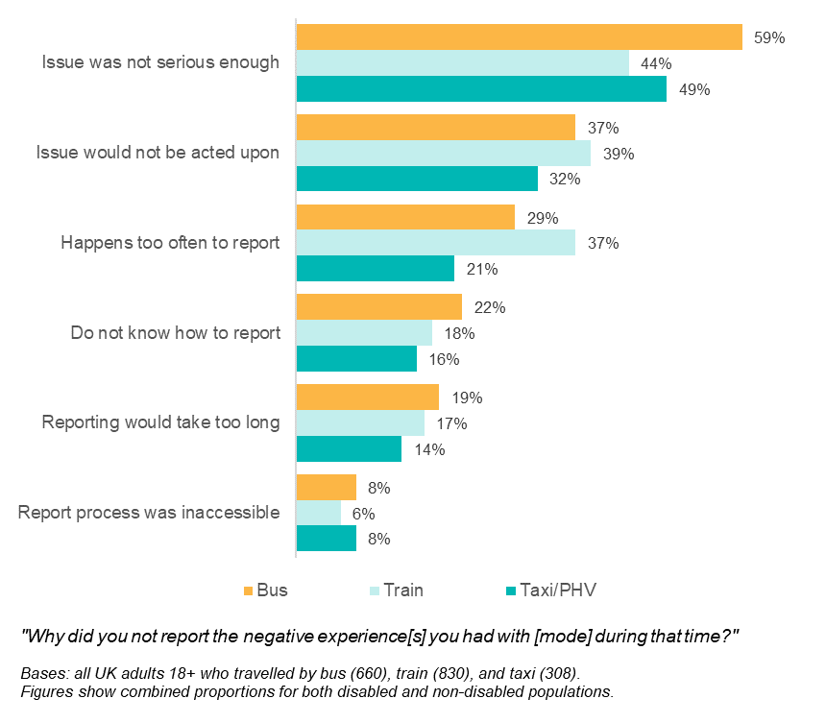
Across modes, the most common reason for not filing a complaint was a belief that the experience was not serious enough to report. This was followed by not believing that a report would be acted upon; this perception was more likely to be held by disabled than non-disabled people when making complaints about taxis/PHVs and buses. Qualitative interviews revealed a perception, across disabled groups, that transport staff would not take the complaint seriously or would provide an excuse for their actions.
Interview participants also reported that negative experiences happen too often to report every time, especially for bus and train-users. Frequent negative experiences included cancellations, missed stops, delays and long waits that were not the driver’s fault.
A smaller proportion of disabled people felt the process of reporting complaints was not accessible (13% of disabled bus users, 7% of disabled train users, 19% of disabled taxi/PHV users). However, interviews revealed that participants sometimes felt that they did not have sufficient information to make the complaint, such as the details of the staff member involved. This could be a particular issue for those with visual impairments, who could struggle to see driver registration details in order to make a complaint about service refusals.
In qualitative interviews, those who did complain reported doing so when the issue caused condition-related pain, discomfort, anxiety or stress, or when they had incurred additional costs and were chasing a refund.

Types of complaints
Overall, there were few differences in the types of negative experiences reported between disabled and non-disabled users. Due to low base sizes for some survey questions, there is limited scope to identify which types of negative experience were more likely to be reported than others. However, across modes, there is evidence that negative experiences with staff behaviour were more likely to be reported than other experiences.
Qualitative interviews with disabled users confirmed this. The nature of complaints fell into three key broad categories:
- Customer service. Complaints were filed when customer service was lacking – especially where it related to needs related to a person’s disability not being accommodated. For example, where people did not receive their pre-booked Passenger Assist support. There were also complaints related to staff members’ behaviour, such as drivers being rude and/or not understanding the disabled person’s condition.
- Other travellers. Complaints that related to the behaviour of other passengers or road users, including people being intoxicated, disrespectful, or occupying disabled spaces/seating.
- Availability and cancellations. Participants complained about public transport delays, cancellations, and issues related to service running.

Complaint processes and enforcement
People reported mixed experiences when filing a complaint, with many finding the process difficult. Across modes, and for both disabled and non-disabled people, only around half of those who reported an issue found it easy to do so (49% of bus users; 45% of train users; 49% of taxi/PHV users).
Qualitative interviews gave insight into these difficulties. Participants felt that it was difficult to know who to complain to and that the complaint system was tricky and time-consuming to navigate across all modes. Disabled people described instances of filing a complaint in multiple formats to ensure it was formally received. This view contrasted with that of transport operators, who stated that the aim of their complaint systems was to make it easy for passengers to make complaints in order to encourage reporting of issues.
The complaints procedures may give us further indication as to where difficulties arise. Research with transport operators and LLAs revealed that many organisations do not offer specific online reporting tools for disabled travellers. Instead, complaints for all travellers are filed through generic customer feedback portals, such as via email, phone or online contact forms.
There was also variation in complaint handling procedures. The majority of organisations categorised complaints based on whether they related to disability or not, which allowed accessibility issues to be easily monitored. Others categorised complaints based on how the complaint had been received, for example online or over the phone. Examples of good monitoring procedures included monthly reporting of disability-related complaint statistics and handling of complaints by a specific accessibility team.
Target timeframes for organisations to respond to complaints varied. As good practice, some offer immediate (within 1 day) acknowledgement of the complaint, with substantive response then ranging from 5-20 days. Organisations stressed the importance of maintaining good communication with the complainant throughout the process, ensuring they have an opportunity to provide evidence, are informed of progress, and understand the reasoning behind eventual actions taken and/or outcomes.
In spite of the practices that operators and LLAs have in place, only around a third of people who reported a negative experience were satisfied with how it was handled (35% of bus-users; 35% of train-users; 33% of taxi/PHV-users). While there were no differences between disabled and non-disabled bus and train users, disabled taxi or PHV users (62%) were more likely to be dissatisfied with how their complaint had been handled than non-disabled people (32%).
Qualitative interviews with disabled people suggested two reasons for mixed levels of satisfaction:
- Customer service. Participants who received a professional, tailored and supportive service from organisations, with a response within the promised time frames were satisfied with complaint handling. Dissatisfaction arose when organisations were difficult to contact and did not understand individual situations.
- Complaint outcome. Receiving acknowledgement of fault, a formal apology, or a financial reimbursement aided respondent satisfaction. However, those who received little or no response, a denial of responsibility or had issues still ongoing reported dissatisfaction.
Rail users were asked whether they had heard of the Rail Ombudsman – an independent organisation who offers a free service to help with unresolved or poorly-handled complaints. Overall, 34% of people had heard of the service, with no difference between disabled and non-disabled passengers. Those with mental health or cognitive impairments were less likely than other disabled people to be aware of the Ombudsman.

Service refusals by taxi drivers and operators
LLAs have particular powers in relation to the service provided by taxis and PHVs. Enforcement actions that authorities can pursue for service refusals to assistance dog users include: driver training/re-training; written or verbal warnings; fines; licensing sanctions; and driver dismissal. Legal prosecutions under the Equality Act are undertaken in serious or repeat cases. Although LLAs reported that service refusal is not tolerated, there were relatively low numbers who reported prosecution or licensing sanctions over the past year. One LLA reported suspending two drivers in the previous year over service refusals to assistance dog users.
Over three-quarters (76%) of assistance dog users surveyed who used taxis had experienced an access refusal of some kind in the 12 months before March 2020. Over half (58%) who had experienced a refusal had reported the most recent incident.
As observed for the other modes, the key reasons participants gave for not reporting a service refusal included: a perception that the report would not be acted upon (33%); not knowing how to make a report/who to report to (27%); a perception that their experience was not serious enough to report (23%); and that it happens too often to report every time (23%). LLAs highlighted that some complaints are not made because visually impaired assistance dog users are unable to collect the necessary evidence, such as the vehicle number plate or the driver’s details. This was confirmed by survey respondents:
“I have no vision at all, so to collect the details to be able to identify the driver would have been impossible … in the end I left it there”. [Male, 40-64, visual impairment].
While 69% of all assistance dog users surveyed were aware of the role LLAs play in investigating incidents, only around half (53%) of those who reported their most recent refusal reported them to LLAs. Those who reported their most recent refusal had reported to multiple organisations, with 69% complaining to taxi companies directly and 37% reporting to a representative organisation, such as Guide Dogs UK. The main reasons for not reporting to LLAs were linked to a perception that the report would not be acted upon, including due to past negative experiences, or a feeling the reporting process would take too long. Due to the low numbers of cases reported, subsequent findings are given in figures rather than percentages.
Among the 37 assistance dog users surveyed who had reported refusals to LLAs, in the majority (26), no legal action was taken. Participants described a range of reasons why no legal action was taken. In some cases, there was insufficient evidence (6 out of 26 participants), and in others the LLA deemed there to have been no legal violation (3 out of 26 participants). In open text responses, participants described LLAs failing to respond, telling the complainant to contact the taxi company instead, arguing that non-compliance was too widespread to justify taking action, or denying that it was fair for the LLA to force a driver to transport a dog against their will. In some cases, training with drivers or written warnings had been pursued by the LLA instead.
Only around a third (13 out of 37) of participants were satisfied with the handling of their case by the LLA. However, of the 8 participants for whom legal action was taken, 7 were satisfied with the outcome of the prosecution. When reports of refusals were made to organisations other than LLAs, only around a quarter of individuals (6 out of 23) were satisfied with their outcome.
Interviews with LLAs revealed that there are three main barriers to enforcement of service refusals:
- Those relating to the complainant. LLAs rely on members of the public coming forward to report the refusal as well as continuing to pursue the complaint throughout the enforcement process. LLAs highlighted how they occasionally had to abandon enforcement actions when complainants no longer wanted to participate. In addition, there are disability-specific barriers to providing evidence, such as the fact that not all visually impaired passengers can identify drivers.
- Those relating to LLAs. A lack of licensing staff contributes to longer timeframes of complaint handling and issue resolution. In addition, due to the scope of the legislation, if incidents occur outside the operating jurisdiction of the LLA, even though the driver is licensed by the authority, they are unable to pursue prosecutions under the Equality Act. Instead they rely on the neighbouring authority to pursue prosecution.
- Those relating to the drivers. Driver denial or lack of assistance in providing evidence inhibits enforcement.
LLAs suggested the lack of substantial evidence for prosecution could be addressed through vehicle regulation changes, such as making it mandatory for all vehicles to have CCTV both in and outside.
Eighty percent of all assistance dog users who responded to the survey said they would be likely to report a future service refusal to LLAs. Others said it would be dependent on the circumstances at the time, such as the incident severity, whether they have enough details to report, or whether they felt mentally/physically able to go through with the report. Factors that would give assistance dog users greater confidence to report refusals to LLAs included: better assurance that LLAs would take their situation seriously and take action against drivers and operators; and making LLA contact details more readily available in taxis.

Discussion and priorities for future research

Discussion
The evidence highlights that the transport network is working well for most people, and experiences when travelling are generally positive. Both disabled and non-disabled people highlight encounters with exemplary staff and helpful and considerate passengers on their journeys. However, there are many areas where disabled people face difficulties using the transport network as any other person would. Across many areas, disabled people report more negative experiences than non-disabled people. This included not having confidence to travel, not having enough time to board or alight a bus or train and having difficulties accessing parts of the transport system, such as insufficient space for a scooter or wheelchair.
The difficulties experienced are across the key ITS areas of focus. Disabled people’s confidence is impacted by aspects such as inaccessible infrastructure, insufficient or inappropriate information and a lack of understanding from staff and other passengers. Their ability to travel with ease is impacted by inaccessible infrastructure, a lack of information and service failures, such as cancellations or overcrowding. Disabled people report a greater reliance on taxis compared to non-disabled people and this makes travel costly for some groups. Similarly, there was low awareness and take up of disabled railcards and bus passes which can reduce travel costs.
Disabled people are less likely to use public transport than non-disabled people and have a heavier reliance on private cars and taxis. The research highlighted that disabled people are less likely to make unfamiliar journeys and often experience inconsistency in service provision which impacts confidence. Furthermore, smaller changes like bus drivers giving disabled people time to sit before moving will positively improve the experience of disabled bus users. In order to encourage greater use of the transport network, and promote positive experiences, there is a role for government, operators, regulators and the travelling public to play.
Transport operators acknowledge that infrastructural changes are required to make the transport network more accessible. Train operators highlight the substantial costs of infrastructural changes needed to make train stations accessible. Local Licensing Authorities (LLAs) indicate that larger, wheelchair accessible vehicles are expensive for taxi and PHV drivers and that incentives are needed to encourage greater provision. Transport operators say Changing Places facilities are few and far between. Here, it is felt that funding from central Government is vital to invest in these important areas. It is, however, important that the provision of funding is publicised, and access actively encouraged; one operator participating in the research was not aware of the £2 million funding pot to provide visible and audible next stop and route announcements.
It is clear that transport operators and LLAs are making some progress towards a more accessible network for disabled people. Staff training was highlighted as a key accessibility tool. It was, however, evident that training and accessibility guidelines implemented varied across the board. While there was a view among some that training standards should be led by operators, the role for public bodies like the Office for Rail and Road and the DfT was perceived as pivotal. The Office for Rail and Road Accessible Travel Policy guidance for train operators were perceived as a good foundation for ensuring access for disabled people. This central input was lacking for buses and each operator had different procedures. However, the DfT accessibility guidelines for buses and coaches had helped bus operators to improve services.
Staff are pivotal to ensuring that the transport network is accessible for disabled people and significantly contribute to promoting confidence. Disabled users feel that the delivery of service is inconsistent and there is a perception that staff do not always understand their needs. Incidents of rudeness, impatience, and dismissiveness were reported and particularly impacted those with less visible disabilities, including people with cognitive and mental health conditions. From the reported experiences, we can conclude there is more work required to educate staff on the range of needs of disabled people, including those with less visible disabilities. To ensure inclusivity, some operators have formed links with disabled organisations and their training modules were delivered in collaboration with the groups. The importance of including those with lived experience to promote a customer-centred accessibility agenda was highlighted.
Whilst staff are a key aspect of the service experience when using public transport, some disabled people feel that their independence can often be compromised when they seek assistance. For those using airport special assistance service for example, there was a view that the service was more geared towards those who have mobility disabilities. Some people felt that self-driven electric buggies would allow disabled people greater independence. It is therefore important for accessibility services and adjustments to reflect the diversity of needs and to enable disabled people to use the network with confidence.
The role of other passengers is also important to the experiences of disabled people. Disabled people report some negative experiences from other passengers, with impacts including other passengers blocking walkways and entrances/exits, as well as occupying priority seating. More work around passengers being more considerate to the needs of disabled people will be important in addressing the issues currently seen. Similarly, it will be important for transport operators and LLAs to ensure that their complaints reporting procedures are easy for people to use and encourage disabled people to report accessibility incidents.
The ITS evaluation baseline findings illustrate important areas for government, transport operators and LLAs to focus on. The core ITS themes covered in this report: awareness and enforcement of passenger rights; staff training; improved information and inclusive physical infrastructure are all highlighted as needing further work. The 2023 report will be able to show whether the work that is being done across the network is beginning to impact the experiences of disabled people and how the ITS may have contributed to those changes.

Priorities for future research
This report contains the findings from the first year of the ITS evaluation. Subsequent years will build on the work presented here. The key research objectives for subsequent years will be to understand how disabled people’s experiences of public transport are changing, and, where possible, to understand what difference the ITS is making.
In addition to these research objectives, the findings presented in this report raise new, specific research questions. There may be scope to explore these questions in subsequent years of the evaluation. We have grouped these questions around the main substantive themes explored in this report:

Mode use and confidence
- In general, disabled people used all public transport modes less than non-disabled people, but there was significant variation in mode use by the type of impairment. For example, disabled people with cognitive impairments were more likely to be frequent users of taxis and PHVs. Since most of the disabled people in the ITS Panel Survey reported multiple types of impairment, there is scope for multivariate analysis to explore which impairment types are the strongest predictors of lower or higher rates of use of any given mode. Similarly, there is scope for multivariate analysis of other key outcome measures, such as confidence or awareness of services.
- Disabled people were more likely to be frequent taxi/PHV users than non-disabled people, and this was particularly true of those with cognitive impairments. Taxis and PHVs are typically a more expensive mode of transport than others. There is scope for more detailed research to understand exactly why disabled people are more reliant on taxis and PHVs. What kinds of journeys are disabled people using taxis for? On any given taxi/PHV journey, what is it about the public transport alternative that makes it less appealing or accessible? Research could seek to understand the cost burden that this places on disabled people or the mechanisms that would need to be in place to allow more disabled people to migrate to more cost-effective modes.

Information and awareness
- The research has shown that for many disabled people journey planning is crucial, including having access to information about accessibility facilities and toilets. However, relatively few disabled people made use of newer digital technologies to access this information. Future research could seek to understand the extent of awareness of these digital services amongst disabled people and barriers to greater use. There is also scope for research to understand the other methods disabled people use for journey planning, and how disabled people would like to be able to access this information in future.
- Qualitative interviews highlighted the negative impact for disabled people when the Passenger Assist service fails, including being left stranded or unable to alight a train. Research has previously been conducted to understand what proportion of Passenger Assist users have experienced this, and the causes of service failures. Future research could aim to bring together and synthesise this existing research in the context of the ITS.

Inclusive infrastructure
- The ITS Panel Survey found that one in five disabled people felt they needed the extra facilities provided in Changing Places toilets. However, the Changing Places campaign estimates that closer to 2% of disabled people require the extra equipment and space provided in Changing Places toilets (roughly 250,000 people out of 13.9 million disabled people in the UK). Further research could aim to understand the reasons for this discrepancy.
- The survey did not explore the costs of travel in any detail. There is scope for research to understand how affordable disabled people perceive different modes to be. Additionally, research could seek to map out how much disabled people spend on travel, and whether cost functions as a greater barrier for disabled people than non-disabled people.

Better staff training
- The research has shown that disabled people with cognitive impairments often have a different experience of interacting with public transport staff than other disabled people. People with cognitive impairments were less likely to feel that their needs were understood and more likely to report negative experiences with staff. There is scope for further research to explore the unique experiences of people with cognitive impairments in more detail, including exploring the experiences of people with different types of cognitive impairments, and understanding exactly what training public transport staff require to effectively support this group.

Passenger rights and enforcement
- The vast majority of assistance dog users who experienced an access refusal from a taxi or PHV driver were not shown a medical exemption certificate, and LLAs reported that they issue very few certificates. Research could explore why so few taxi and PHV drivers have exemption certificates.
- Disabled people were more likely to think that their complaints about public transport would not be acted on. There is scope to understand the reasons for this perception, and for more detailed research with transport operators to understand their complaints procedures and the facilitators for improving customer complaints handling processes.

- Glossary of terms
Term | Meaning
Assistance dog | A dog which is specially trained to support the needs of people with disabilities and medical conditions.
Blue Badge | A parking permit valid for people with disabilities, allowing them to park in designated disabled parking bays.
Changing Places | Standard accessible toilets do not meet the needs of all disabled people. Changing Places are toilets that include additional space (to accommodate the need for carers) and specialist equipment (such as changing benches and hoists).
Disability | A person is defined as disabled if they have a physical or mental health condition or impairment, lasting or expected to last 12 months or more, which has an impact on their ability to carry out day-to-day activities (as per the Equality Act 2010).
Disabled Persons Railcard | A discount railcard which entitles people with eligible disabilities to save one-third on rail travel in Britain.
Freedom Pass | A travel pass paid for by local councils granting free public transport for older people and eligible disabled people in London.
Inclusive Transport Strategy | A governmental strategy aimed at creating a transport system which offers equal access to disabled passengers by 2030.
Journey Assistance Card | A card which can be shown to bus drivers to indicate the need for extra support or assistance.
Logic Model | A logic model is a description of a chain of causes and effects, showing how the actions involved in an intervention or policy are expected to lead to the intended outcomes. Logic models are typically presented in graphical form.
Motability scheme | A scheme which enables eligible disabled individuals to exchange their mobility allowance to lease a new car, wheelchair accessible vehicle or powered wheelchair.
Passenger Assist | A service for older and disabled rail passengers, which can involve helping passengers on and off trains, reserving wheelchair spaces and seats, provision of information, and more general assistance.
Priority seating | Seating on public transport which is designated for disabled people, older people and those who are pregnant or less able to stand. This is often more spacious than standard seating and is closer to the entrance/exit.
Sunflower lanyard | Also known as the Hidden Disabilities Sunflower, the sunflower lanyard indicates to people around the wearer that they may need some extra support or assistance.

- Mode use by impairment type
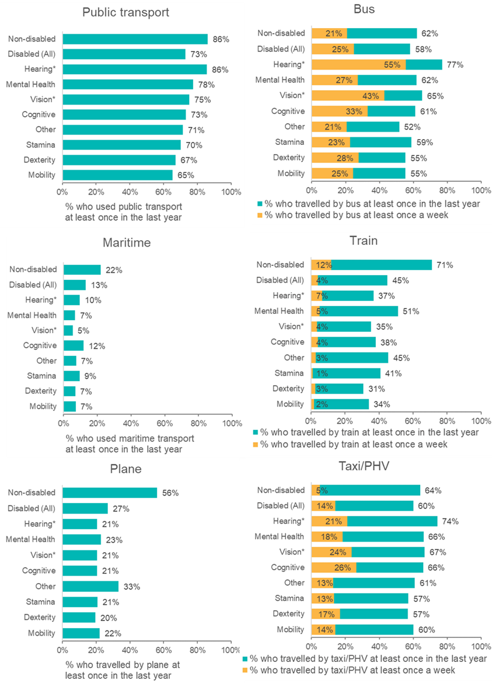
*Base sizes for disabled people with hearing impairments and vision impairments are below 100.
Bases: non-disabled (1899), disabled – all (1139), hearing (77), mental health (352), vision (66), cognitive (138), other (168), stamina (423), dexterity (217), mobility (554).

Endnotes

‘Theory based’ evaluation is an approach to evaluation that involves developing a ‘theory of change’ that explains how an intervention is expected to produce its results. The theory sets out a sequence of events and results, commonly referred to as the ‘Logic Model’. The theory of change sets out the mechanisms of change, and the assumptions underlying the theory. The evaluation proceeds by gathering evidence to support each element of the theory of change.
Department for Transport (2020). National Travel Survey: England 2019.
Department for Transport (2020) National Travel Survey: England 2019.
Department for Work and Pensions (2021) Family Resources Survey: financial year 2019 to 2020.
Department for Work and Pensions (2021) Family Resources Survey: financial year 2019 to 2020.
Government Office for Science (2016) Future of an ageing population.
Department for Transport (2018) Understanding the impact of the Inclusive Transport Strategy: A framework for monitoring and evaluation.
Department for Transport (2020) National Travel Survey: England 2019.
Information on the frequency with which a particular mode was used was only collected for buses and trains.
Bus use is more common amongst those not in employment and those in low income households, who are also more likely to be disabled. Although a similar proportion of disabled and non-disabled people used buses, when we adjust the non-disabled population to be more comparable to the disabled population, we see a significant difference.
The vast majority of non-disabled people who travelled for free using a Freedom Pass or similar were over 60 (94%). In contrast, 77% of disabled people who travelled for free were over 60.
Department for Transport (2020) Annual Bus Statistics: England 2019/20.
In the survey, this question asked respondents about the kinds of toilets they personally need, thus the answers to this are in reference to both accessible and non-accessible toilets depending on what the participant said they required.
"Changing Places toilets for severely disabled people to be compulsory in new public buildings." Press release. Gov.uk.
Safe Places are businesses or public services organisations which commit to providing support to vulnerable people if they feel scared or at risk.
The difference between disabled and non-disabled people persists when looking only at those with physical disabilities, or when controlling for differences like age, education and frequency of taking flights.
The difference persists when looking only at physical disabilities, or controlling for age, education, frequency of mode use.
Office of Rail and Road (2020) Disabled Persons Railcards (DPRC) 2019-20 factsheet.
Department for Transport (2019) Concessionary Travel Statistics England 2018/19.
The Motability scheme is a government supported programme that enables disabled people in receipt of the higher rate mobility allowance to lease a car or mobility scooter.
Freedom passes apply to London.
Significant at the 10% level.
Kassel kerbs reduce the gap between pavements and the bus platform, allowing drivers to dock consistently closer to the edge of the bus stop.
Minimum accessibility standards are dictated by the following two definitions, as described in the Inclusive Transport Strategy: Rail vehicle accessibility: “by 2020 all passenger trains will have to meet modern accessibility standards, which includes the provision of wheelchair spaces, audio visual passenger information systems, priority seating and accessible toilets, where toilets are provided.” PSVAR: “Buses designed to carry over twenty-two passengers on local and scheduled routes must comply with the Public Service Vehicles Accessibility Regulations (PSVAR), and coaches must comply from 1st January 2020.”
Under section 167 of the Equality Act Local Licensing Authorities are able to maintain a designated list of wheelchair accessible vehicles. Without a designated list under this section, taxi and PHV drivers are not subject to the requirements of section of 165.
Department for Transport (2017) Access for wheelchair users to Taxis and Private Hire Vehicles: Statutory Guidance.
Transport Focus (2020) Bus Passenger Survey Data Hub.
Chan S.K., Leung D.Y.M. (2018) ‘Dog and Cat Allergies: Current State of Diagnostic Approaches and Challenges’, Allergy Asthma Immunol. Res. 10:97–105.
Department for Transport (2020) Annual Bus Statistics: England 2019/20.
According to the social model of disability, disability is a result of the physical and social barriers that make it difficult or impossible for people with impairments to do certain things. Disability is therefore socially constructed and should not be identified with the impairments that people have.
Department for Transport (2020) Taxi and Private Hire Vehicle Statistics, England: 2020.
Department for Transport (2020) National Travel Attitudes Study: Wave 3.
Unpublished figures provided directly to the research team by Bus Users UK.
Office of Rail and Road (2020) Annual Rail Consumer Report 2020.

