Order Decision
Site visit made on 24 August 2021
by John Dowsett MA DipURP DipUD MRTPI
an Inspector appointed by the Secretary of State for Environment, Food, and Rural Affairs
Decision date: 22 October 2021

Order Ref: ROW/3265359
- This Order is made under Section 257 of the Town and Country Planning Act 1990 and is known as the Doncaster Borough Council Public Footpath No 6 Adwick Le Street (Part) Order 2020.
- The Order is dated 15 July 2020 and proposes to extinguish the public right of way shown on the Order plan and described in the Order Schedule.
- There were two objections outstanding when Doncaster Metropolitan Borough Council submitted the Order to the Secretary of State for Environment, Food and Rural Affairs for confirmation.
Summary of Decision: The Order is confirmed subject to the modifications set out below in the Formal Decision.

Procedural matter
- The Order has been made to extinguish part of Footpath Number 6 in order to allow development authorised by a planning permission to be carried out. The Order as made, however, contains a technical error. The Order refers to an approval referenced: 17/00826/REMM. This is a Reserved Matters approval which is not, of itself, a planning permission being a submission made to satisfy conditions attached to an outline planning permission. It is, nonetheless, clear from the evidence that I have been provided with that that the reserved matters approval followed an outline planning permission relating to the development, referenced: 10/02812/EXTM, which was granted on 30 March 2017. A copy of the decision notice for this planning permission has also been submitted.
- The lack of a reference to the outline planning permission is a slight omission that does not fundamentally affect the Order and is capable of being rectified by a minor modification to the second paragraph of the Order, which sets out the description of the development permitted. Modifying the Order in this manner to correct this small technical error would not prejudice the interests of any of the parties involved.

Background
- Footpath Number 6 commences at the junction of a stretch of carriageway, known locally as Pit Lane, with Roman Ridge on the west side of Woodlands Village. From there it runs generally north west following the line of the lane, which was formerly an access to Brodsworth Colliery, until it meets a road named Country Way. From here it turns south west and follows the line of Country Way, past a car park serving Brodsworth Country Park, where it becomes a surfaced path running generally westward through the country park to a footbridge over the A1 trunk road. At the western end of the footbridge the path terminates where it meets the carriageway of Doncaster Road.
- Outline planning permission was granted on 30 March 2017 (Reference: 10/02812/EXTM) for residential development on part of the former colliery site and, subsequently, reserved matters approval was granted on 10 October 2017 for the erection of 342 dwellings (Reference: 17/00826/REMM). I have no evidence that would indicate that the relevant conditions attached to the planning permission have not been discharged. Part of the definitive line of Footpath Number 6 runs through the site of this permitted residential development.
- At the time of the site visit the development was in progress with at least 130 plots occupied and a substantial number under construction. Groundworks were underway for the remaining, southern, part of the site which would amount to approximately 90 dwellings.
- It is proposed to extinguish public user rights over the whole width of Footpath Number 6 for a length of 192 metres where it passes through that part of the site where dwellings are being constructed, between points A and B as shown on the Order Map. A new combined footway and cycleway with a width of 16 feet (4.88 metres), which is the recorded width of the current footpath, would be created adjacent to the estate roads, a short distance to the south of the current line of the footpath, to link with the unaffected section of footpath to the east at the point where it currently meets Country Way beyond the development site.
- I am advised that the affected section of the footpath has been temporarily closed in the interests of safety whilst construction works are taking place. However, this temporary closure is not relevant to the issue of whether the footpath should be permanently stopped up.

The Main Issues
- Section 257(1) of the Town and Country Planning Act 1990 (the Act) provides for an Order to be made authorising the stopping up (or diversion) of a footpath if it is necessary to do so in order to enable development to be carried out in accordance with planning permission already granted under Part III of the same Act. Section 257(3) also allows for an Order to be made authorising the stopping up or diversion of a footpath, bridleway, or restricted byway which is temporarily stopped up or diverted under any other enactment.
- Paragraph 7.15 of DEFRA Circular 1/09 (version 2 of October 2009) advises that in considering whether or not to confirm the Order, the disadvantages or loss likely to arise as a result of the stopping up or diversion of the way to members of the public generally, or to persons whose properties adjoin or are near the existing public right of way, should be weighed against the advantages of the proposed Order.
- Paragraph 7.15 of the Circular also makes it clear that, in considering an Order of this kind, the merits of the development are not at issue. However, it should not be assumed that because planning permission has been given necessitating closure of a footpath that confirmation of the ensuing Order will automatically follow.

Reasons

Whether the extinguishment of the footpath is necessary to allow the development to be carried out
- It is evident from the documents submitted, including the Illustrative Masterplan drawing for the reserved matters approval (Drawing number 7439-BDP-BRD-A-(PL)-MP-001 Revision G) and the Footpath Layout Plan (Drawing number 2022-2019-300 Revision P0 - as annotated by the Council) that a number of properties would be built over the current definitive line of Footpath Number 6. The present line of the footpath would also pass through the proposed garden areas of several other dwellings.
- I saw when I visited the site that construction work had started on a number of dwellings that are on the current line of the footpath. The dwelling on Plot 91 had been constructed to a level of approximately 10 courses of brickwork above the foundation blockwork, and the dwellings on Plots 125-129 had been constructed up to damp proof course level. The dwellings on Plots 123 and 124 had slightly higher blockwork walls above the level of the damp proof course. Work had not yet commenced on Plots 83-90 which would also be on the current line of the footpath.
- The situation where work has been commenced has been considered by the courts in Ashby & Dalby v Secretary of State for the Environment & Kirklees MBC and Hall v Secretary of State for the Environment where it was held that an Order can be made and confirmed under Section 257 of the Act provided that the works have not been substantially completed and that part of the planning permission spent.
- Although construction has started on several dwellings, it was clear that there is still a significant amount of work required for them to be habitable and for them to be able to function as the dwellings authorised by the planning permission. From what I saw when I visited the site, I am satisfied that the relevant part of the permitted development has not yet been substantially completed. A grant of planning permission does not authorise the obstruction of a Right of Way and the planning permission for this site cannot be fully and lawfully implemented in accordance with its terms if Footpath Number 6 were to be retained on its existing lines.
- Consequently, I find that the extinguishment of the footpath is necessary to allow the development to be carried out.

The extent of inconvenience or loss likely to arise as a result of the extinguishment of the right of way to members of the public generally, or to persons whose properties adjoin or are near the existing public right of way
- Footpath Number 6 provides a walking route from Woodlands village and Adwick le Street to access the Brodsworth Country Park and, at its western end, facilitates onward connections to the village of Pickburn and other public footpaths that lead from that village. For walkers coming from the west, it provides a connection with the Byway that runs from north to south along Roman Ridge following the line of the former Roman road.
- The permitted development would create a combined footway and cycleway alongside the estate roads which would be located a very short distance to the south of the current definitive line of the section of Footpath Number 6 that would be extinguished, and which would meet Country Way at the same point as the present footpath. As such it would not meaningfully increase the walking distance between the start and end points of the current right of way. The new footway/cycleway would be lit, hard surfaced, and properly drained and would maintain the current level of connectivity between the two sections of the footpath that are not affected by the Order.
- I accept that the use of this new footway/cycleway would entail crossing the estate road at two points. Nevertheless, the approved layout indicates that these crossing points would incorporate raised sections of carriageway and, consequently, the crossing points would be at the same level as the footways. There is no evidence before me that would indicate that these roads would carry a significant volume of traffic or that vehicle speeds would be high. Indeed, the carriageway geometry at the crossing points, together with the presence of raised tables, would serve to keep vehicle speeds low.
- The objectors have raised concerns that the footway/cycleway may not be provided and would not have the same level of protection as the current footpath. The Reserved Matters Approval is subject to a condition that requires the development to be implemented in accordance with the submitted details. The details shown on drawing numbers 7439-BDP-BRD-A-(PL)-MP-001 Revision G and Drawing number 2022-2019-300 Revision P0 clearly show the provision of the footway/cycleway. I saw when I visited the site that the estate roads at this point together with the adjoining footway/cycleway have been constructed to base course level.
- It is proposed that the streetworks within the development be adopted by the Council as Highway Authority and I have been provided with a copy of an Agreement under Section 38 of the Highways Act 1980, dated 9 May 2019, which sets this out. The plan attached to the Section 38 Agreement shows that the entire length of the new footway/cycleway is included in the works for adoption, following satisfactory completion and a maintenance period. The agreement also sets out that, from the date of the final completion of the construction works, the roads and footway/cycleway shall become a highway and remain forever open for use by the public at large. The agreement further contains provisions that, should the developer default on their obligations under the terms of the agreement, the Council as Highway Authority can carry out works to bring the streetworks up to adoptable standard and recover the costs of such works from either the developer or from the National House Building Council, which is acting as Surety for the developer and is party to the agreement. The adoption of the footway/cycleway as a highway would give it the same rights for the public to pass and re-pass as the present right of way.
- Prior to the development commencing there were no houses or other buildings directly served by the footpath and, consequently, the extinguishment of the section of the footpath would not cause any disadvantage or loss in this respect. In contrast, facilitating the development of new housing would assist in meeting national and local policy objectives to increase the supply of housing and the provision of the footway/cycleway linking to the remaining sections of Footpath 6 would allow residents of the new development to access Woodlands village and the community woodland.
- Whilst the objectors have suggested that the approved layout could be amended to retain the current route of the footpath, I have no power to amend the planning permission that has been granted and cannot consider the planning merits of the approved scheme.
- The objectors also suggest that due to the heritage value of the footpath, which was historically a walking route for miners from Woodlands village to Brodsworth Colliery, the original route to the colliery yard should be maintained. The colliery closed in 1990 and the site was cleared and subsequently comprehensively reclaimed and restored as Brodsworth Community Woodlands.
- The former colliery is shown on the extract from the Definitive Map that has been provided although the date of the Ordnance Survey base map is not shown. I observed when I visited the site and the surrounding area that no buildings or features that could be clearly associated with the colliery are now extant or visible, apart from the spoil heaps. These have now been landscaped and reclaimed and are not recognisable as such to the casual observer without reference to historic maps.
- The effect on designated or non-designated heritage assets is not one of the relevant tests when considering an Order made under Section 257 of the Act and is a matter that would have fallen for consideration as part of the planning application process. Whilst I recognise that the historic route of the footpath may have some heritage significance, the historic context of the western end of the route to the colliery has now been lost. Even if this were a matter that I was able to consider, it would not lead me to a different overall conclusion.
- I therefore find that there would not be any inconvenience or loss to members of the public which would arise as a result of the extinguishment of the right of way.

Conclusions
- For the above reasons, I conclude that the Order should be confirmed subject to modification to include reference to the correct planning permission for the development.

Formal Decision
- I confirm the Order subject to the following modifications:
- The deletion of the second paragraph of the Order, which describes the development permitted, and the insertion in its place of: “Planning permission granted for residential development on the site of the old colliery at Adwick le Street under planning references 10/02812/EXTM and 17/00826/REMM”.

John Dowsett

INSPECTOR

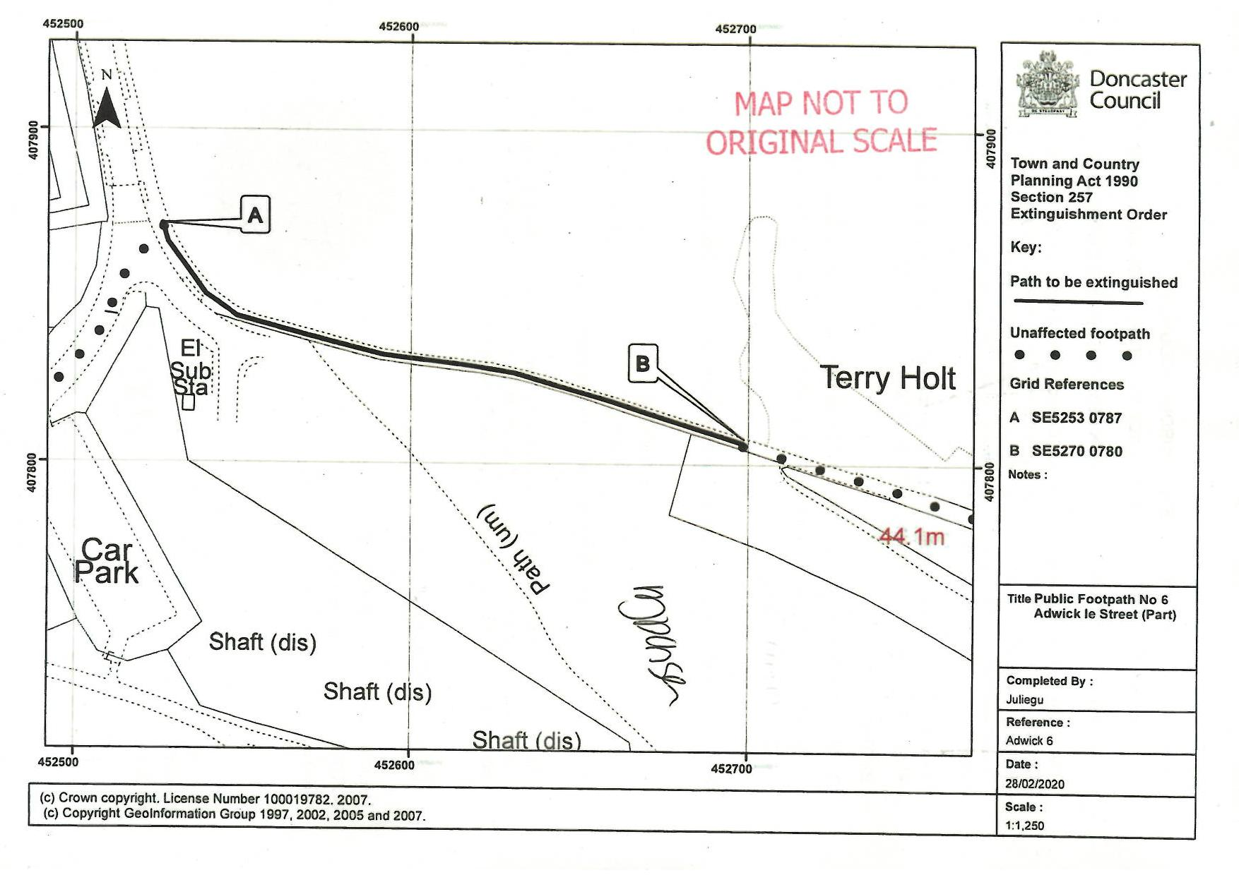

[1978] 40 P & CR 362, (CA) [1980] 1 WLR 673, [1980] 1 All ER 508
[1998] EWHC 330 (Admin)

