Order Decision
Site visit made on 11 October 2021
by Andrew McGlone BSc MCD MRTPI
an Inspector appointed by the Secretary of State for Environment, Food and Rural Affairs
Decision date: 5 November 2021

Order Ref: ROW/3262259
- This Order is made under Section 119 of the Highways Act 1980 (‘the 1980 Act’) and is known as Public Bridleway D31 (Part) West End Farm in the Parish of Keyham and the District of Harborough Public Bridleway Diversion Order 2020.
- The Order is dated 30 January 2020 and proposes to stop up the bridleway shown on the Order plan and described in the Order Schedule and an create alternative route.
- There was one objection outstanding when Leicestershire County Council submitted the Order for confirmation to the Secretary of State for Environment, Food and Rural Affairs.
Summary of Decision: Order is confirmed.

The Main Issues
- Section 119(6) of the Highways Act 1980 involves three separate tests for an Order to be confirmed. These are:
TEST 1: whether it is expedient in the interests of the landowner, occupier or the public for the path to be diverted. This is subject to any altered point of termination of the path being substantially as convenient to the public.
TEST 2: whether the proposed diversion is substantially less convenient to the public.

TEST 3: whether it is expedient to confirm the Order having regard to the effect which— (a) the diversion would have on public enjoyment of the path as a whole, (b) the coming into operation of the Order would have as respects https://pinso365.sharepoint.com/_layouts/15/sharepoint.aspxother land served by the existing public right of way, and (c) any new public right of way created by the order would have as respects the land over which the right is so created and any land held with it.
- In determining whether to confirm the Order at Test 3 stage, (a)-(c) are mandatory factors. On (b) and (c) of Test 3, the statutory provisions for compensation for diminution in value or disturbance to enjoyment of the land affected by the new paths must be taken into account, where applicable. Regard must also be had to any material provision contained in a rights of way improvement plan (“ROWIP”) for the area under section 119(6A). Other relevant factors are not excluded from consideration and could, for instance, include those pointing in favour of confirmation.

Reasons

Whether it is expedient in the interests of the owner of the land that the path in question should be diverted
- The existing bridleway extends through a kennels from point A for its initial section after leaving Snow Lane. The kennels are temporarily closed as they are due to be renovated before being brought back into use by the landowners Mr Singh and Ms Viggers who purchased the property in April 2018. In October and November 2018 new regulations came into force for boarding kennels in England. These set out the minimum conditions and guidance of boarding kennels to obtain a license and operate as a business.
- Due to changes to these regulations and the position of the bridleway the business would not, according to Mr Singh and Ms Viggers, be able to satisfy numerous conditions to obtain a boarding license. Some of the conditions referred to would appear to be achievable with good management practices. However, conditions relating to different animals (including dogs boarding and not boarding at the premise) mixing and members of the public would not be achievable due to the route of the existing bridleway. Without a change to the situation, the business cannot operate and the refurbishment of the facilities, which are required, cannot proceed. This is affecting the landowner’s ability to operate a business and employ staff.
- Whilst the kennels (and cattery) may have operated successfully without incident in previous years, the current legislation is applicable. There are no details of the renovation before me, but the layout of the site and presence of woodland and Melton Brook would influence how the kennels could potentially be laid out. Based on these factors, a diversion of the bridleway would still be a likely requirement in any event.
- The presence of the bridleway ought to have been a known fact to Mr Singh and Ms Viggers when they purchased the site, but it is not clear that they would have been aware of the legislation that came into effect some months after their purchase and the bearing it has had on the business which had operated from the site for many years prior.
- I consider it is in the interests of the landowners that the bridleway be diverted.

Whether any new termination point is substantially as convenient to the public
- The diversion would not alter the termination points of the path at points A or B.

Whether the new path will not be substantially less convenient to the public
- The existing route of around 1.7 km would be extended by around 55 metres as it would skirt around the kennels along Melton Brook to point C before extending southwards towards point B. The new route would, from point C, run broadly parallel to the existing route. The additional distance between points A and C would be less direct and add a modest amount of travelling time onto users’ journeys which are highly likely to be for recreational purposes, though the additional distance would not inconvenience users.
- The ground traversed by the proposed route rises gently from point C in a similar manner to the existing bridleway from point A. The diversion would be waymarked and easy to find and follow next to Melton Brook due to line of sight. Visually, this would be helped by the bridleway being covered in stone. The proposed route would be 4 metres wide between points A and C before widening to 5 metres between points C and B. This would allow the public and horses to use the bridleway and compare to the initial section of the existing route through the kennels. The use of bridle gates would be easier for users compared to the existing field gates, though I accept they could be installed on the existing route also. The surface would be stoned which would offer an improvement to the existing route which is not surfaced for its full length and can get muddy.
- An alternative diversion route has been proposed by the objectors which would see the bridleway return to its existing routing next to the dwelling south of the kennels. However, I am considering the merits of the proposed diversion and not an alternative.
- In respect of this issue, the proposed diversion would be straightforward to navigate, not create any additional degree of difficulty to users and the modest additional time it would take would not mean that the proposed route would not be substantially less convenient to the public if it were diverted.

The effect of the diversion on the public enjoyment the path as a whole
- The existing route is part of a network of public rights of way south of Keyham. Collectively the routes provide opportunities for shorter and longer circular or out and back walks to be undertaken. The bridleway itself does form part of a short circular route from Snow Lane and back into the village using D34.
- The proposed bridleway would diverge from the existing route by around 12 metres at its widest point. Users’ enjoyment of the bridleway and its surroundings would be similar with views of the countryside becoming more extensive to the south towards point B. Moreover, the proposed diversion would mean that users, who could include horses and dog walkers, would not need to travel through the kennels, thus avoiding mixing with boarding dogs.
- I therefore consider that the enjoyment of those who seek pleasure from informal recreation on footpaths such as these would not be diminished because of the Order.

The effect of the diversion on other land served by the existing path and the land over which the new path would be created
- There is nothing to indicate that the proposed diversion will have any adverse effect on land served by the existing route or on the land over which the diverted route would be created.
- No evidence has been submitted which suggests that the proposed diversion would have any negative impact upon the land over which the diverted bridleway would run which is within the same land ownership.

Rights of Way Improvement Plan (‘ROWIP’)
- The Leicestershire Rights of Way Improvement Plan Action Plan 2011 – 16 sets out broad strategic actions to meet current and future needs of the public who recognise the importance of access to the countryside and the need to promote access to it. No evidence has been submitted to suggest that the proposed diversion would conflict with the policies set out in the ROWIP.

Effect on neighbouring property
- Concerns have been raised by the objectors around privacy and security. Whilst the proposed diversion would be closer to Long Meadow Farm, there is a limited line of sight of the windows in the dwelling due to boundary fences, buildings on the farm and the trees next to and south of Melton Brook. The proposed route would allow for long-range views of the dwelling at Long Meadow Farm but these, even during the winter months, would be in the context of vegetation and of the upper floor or roof. Ground levels fall away the closer you are to Melton Brook.
- Having walked D34, I saw that there is a fence around the rear garden of Long Meadow Farm. D34 crosses the hardstanding close to the dwelling which means that, together with the other buildings, views of the rear garden are not possible. D34 to my mind offers a better opportunity to assess activity at the property given its proximity and the lack of physical barriers such as the boundary fence and the buildings. Any extra security measures over those currently in existence is a matter for the occupants as there is no substantive evidence to suggest that the diversion will lead to increased crime given that there are no incidents relating to the existing route.
- Long Meadow Farm may be reconfigured or developed in the future but there are no plans or schemes before me of what this may entail. It is a potential scenario nothing more. Moreover, the value of property is not a relevant consideration to the substantive matters in this case.
- Some additional noise may be created by users due to the stone surface, but this would be localised and limited to periods of use. It would not adversely affect the wider area or neighbours living conditions.

Whether it is expedient to confirm the Order
- I have concluded that it is expedient in the interests of the landowners to divert the path, and that the resulting diversion will not be substantially less convenient to the public. The proposed route is likely to be more enjoyable to use for the majority of people, and there would be no adverse impact upon the land currently served by the footpaths or the land which the diverted path would cross. I am satisfied that it is expedient to confirm the Order.

Conclusion
- Having regard to these, and all other matters raised in the written representations, I conclude that the Order should be confirmed.

Formal Decision
- The Order is confirmed.

Andrew McGlone
INSPECTOR

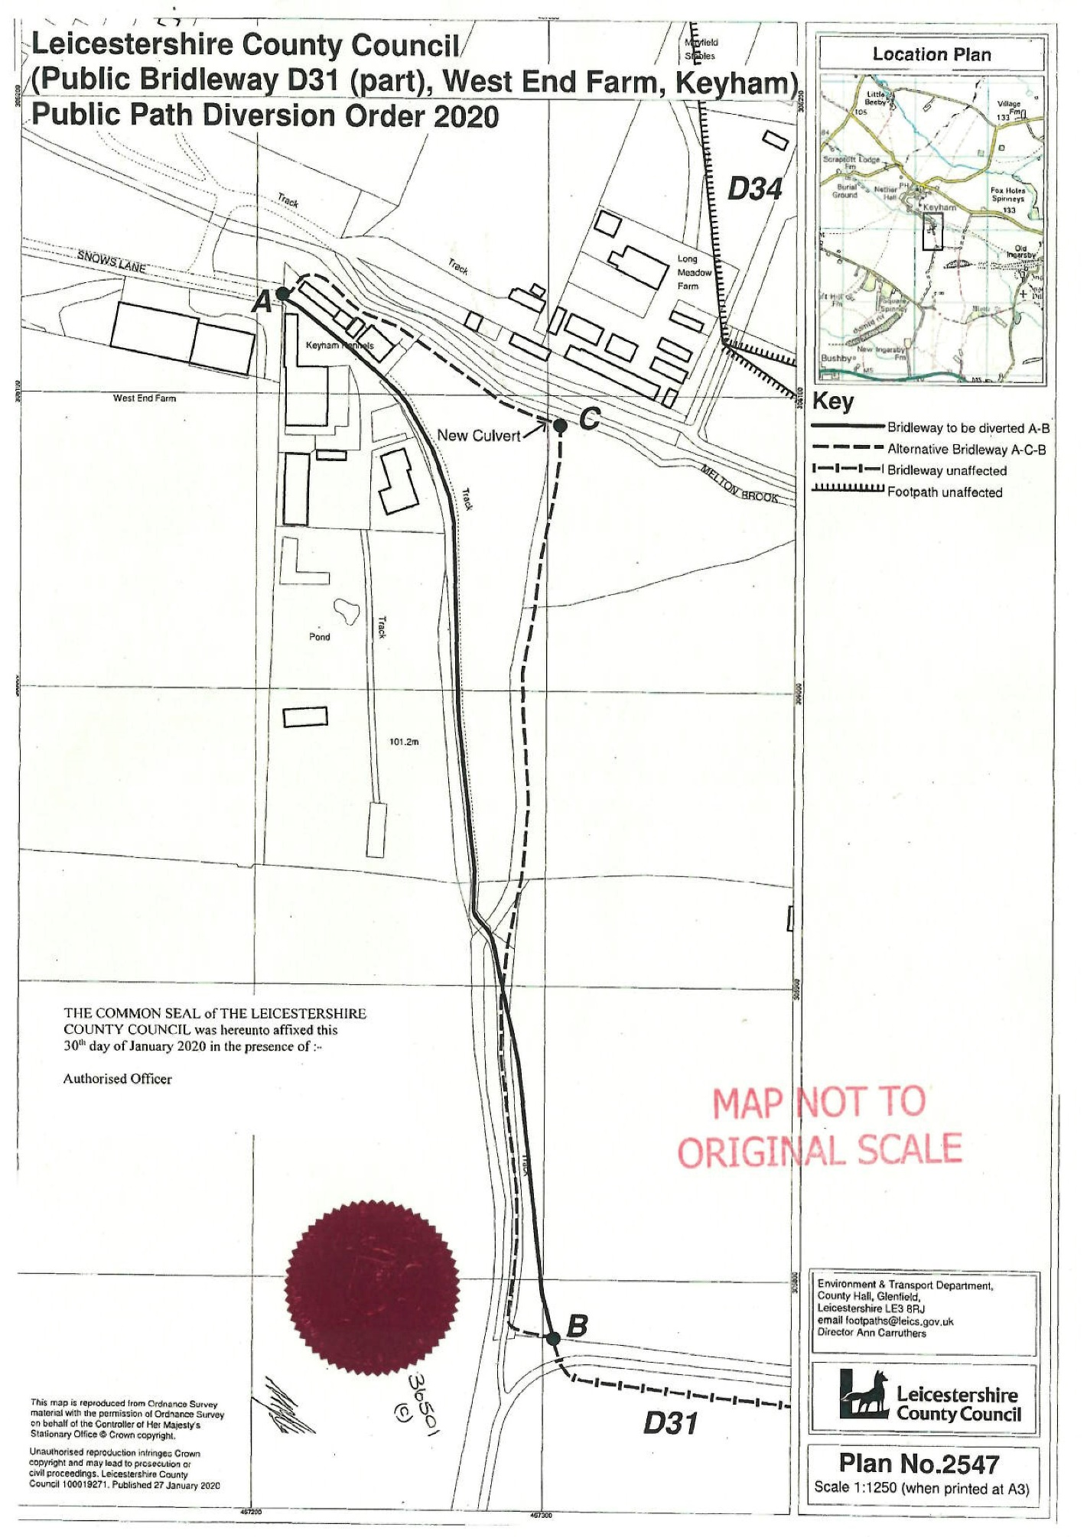

Department for Environment, Food and Rural Affairs for boarding kennels in England and The Animal Welfare (Licensing of Activities Involving Animals) (England) Regulations 2018

