Order Decision
Site visit made on 31 August 2021
by K R Saward Solicitor, MIPROW
an Inspector appointed by the Secretary of State for Environment, Food and Rural Affairs
Decision date: 22 October 2021

Order Ref: ROW/3242778
- This Order is made under Section 53(2)(b) of the Wildlife and Countryside Act 1981 (‘the 1981 Act’) and is known as the Norfolk County Council (Martham) Modification Order 2017.
- The Order is dated 14 August 2017 and proposes to modify the Definitive Map and Statement for the area by adding a footpath from Damgate Lane to Martham Footpath No. 2 next to the River Thurne as shown in the Order plan and described in the Order Schedule.
- There was 1 objection outstanding when Norfolk County Council submitted the Order to the Secretary of State for Environment, Food and Rural Affairs for confirmation.
Summary of Decision: The Order is confirmed.

Procedural Matters
- The one objection letter is endorsed by around 40 landowners, farmers, and residents of Damgate Lane, Martham. The reasons for opposition refer to: (i) the impact of walkers arriving by car to use the claimed path and causing obstruction (ii) the unsuitability of the track for vehicular access (iii) harm to livestock from dogs and (iv) the effect of increased vehicular and pedestrian traffic on the living conditions of residents and wildlife. None of these reasons influence whether or not a public right of way subsists along the route identified in the Order. As such, they can have no bearing upon my decision.
- The objector suggests that those who have walked the route recreationally have done so in the belief that public rights exist and that farmers/landowners permitted the use by local people. In cases such as this, where there is claimed use by the public, it is pertinent whether the use took place with consent. That being so, I shall proceed with my assessment of the evidence on the basis that the Order is contested.
- One representation was submitted in support of the Order from The Ramblers’ Association Norfolk Area (‘The Ramblers’).

Main Issue
- The Order has been made under section 53(2)(b) of the 1981 Act in consequence of the occurrence of an event specified in section 53(3)(b). This provides that the Definitive Map and Statement shall be modified following the expiration of any period such that the enjoyment by the public of the way during that period raises a presumption that the way has been dedicated as a public path.
- The main issue is whether the evidence as a whole suffices to show that, on the balance of probabilities, there is a public right of way that should be recorded on the Definitive Map and Statement. The burden of proof lies with those who assert the existence of a public path.

Legal framework
- The Order results from an application made by Martham Parish Council, which relied upon claimed use of the route by the public on foot. The Order was made on the basis of that user evidence leading to the presumed dedication of a footpath under statute, namely, section 31 of the Highways Act 1980 (‘the 1980 Act’). Having made the Order, the County Council now takes a neutral stance.
- Under section 31 of the 1980 Act, there must have been use of the claimed route by the public as a footpath ‘as of right’ and without interruption, over a period of 20 years immediately prior to its status being brought into question so as to raise a presumption that the route had been dedicated as a public footpath. This may be rebutted if there is sufficient evidence that there was no intention on the part of the relevant landowner/s during the 20 year period to dedicate the way for use by the public.
- It is important to note that these provisions are concerned with whether public rights of way have already come into effect. A definitive map modification order does not create new rights but seeks to record those in existence.
- Despite the Order being made on the basis of the user evidence, I address the historical evidence considered by the Council as part of its research along with that tendered by The Ramblers.
- Section 32 of the 1980 Act requires that documentary evidence is taken into consideration ‘before determining whether a way has or has not been dedicated as a highway’ – and that such weight is given to this evidence as ‘justified by the circumstances, including the antiquity of the tendered document, the status of the person by whom and the purpose for which it was made or compiled, and the custody in which it has been kept and from which it was produced.’
- There is no need for there to be evidence of both use of the path over a 20-year period and supporting documentary evidence. One or other may suffice or dedication may be inferred at common law.

Background
- The Order route commences at Damgate Lane where the metalled road serving the dwellings along the lane ends. It proceeds in a northerly direction to connect with Martham Footpath No. 2 which extends beside the River Thurne.
- The route follows a grass and compacted earth track at a width varying between 2.5 to 3.1 metres approximately. By the time of my visit, a long stretch of the northern half of the track, which passes across marshland, had become overgrown although a clear trampled line through the vegetation enabled passage.
- Starting from the southern end, a long stretch of the track is tree lined on one or both sides. It is evident that the southern section of the track is well used by vehicular traffic from its rutted condition and presence of tyre tracks. I gather that the route is used by farm vehicles. The track affords access to the adjacent fields and there are gated entrances to several of those fields, some of which display ‘private’ signs. Public and private rights can co-exist over the same land and public rights may be acquired over a private right of way.

Documentary evidence
- The Council reports that the Order route was set out in the 1812 Enclosure Award as a private road leading to a staithe provided for the use of the parishioners of Martham. The southern part appears on Bryant’s map of 1828 as far as the buildings south of Martham Broad. The Order route is listed under two apportionments in the Tithe Award of 1841 as a ‘Road’ and ‘Staithe’ respectively without any indication the route was considered to be public.
- The northern part of the route is coloured on the map drawn-up under the Finance Act 1910 and shown as being in the same ownership as the southern riverbank and staithe. The remainder of the Order route is uncoloured. This could be because it was considered a public vehicular highway or more likely indicates an occupation road given that a public highway would be unlikely to end abruptly in the marshes.
- Thus, these historical documents indicate the physical existence of a track over many years. They do not show the presence of a public footpath but that does not prevent the subsequent acquisition of rights through public use.
- The Ramblers produce a newspaper cutting from the Eastern Evening News on 17 June 1966 featuring a 7 mile walk around Martham, written by one of its former Secretaries, which includes the Order route. This gives some limited supporting evidence of use of the route by members of the public generally at that time which was not restricted to occupants of the village. However, for the purposes of statutory dedication a later period falls for consideration, as below.

Statutory dedication

Bringing into question
- The first matter to be established in relation to section 31 of the 1980 Act is when the right of the public to use the route was brought into question. The 20-year period is calculated retrospectively from the date when the right of the public to use the way was brought into question (section 31(2)).
- At the northern end of the Order route there is a locked field gate across the track preventing vehicular access. There are no notices on the gate. To one side is a wooden ‘kissing’ gate for pedestrian access. Quite when this gate was erected is not entirely clear but it appears to have been around 2010. The field gate obstructs pedestrian access across the full width of the track at this one point. The public appear not to have taken this to be a challenge to their use as a whole. As the application is for a public footpath, I agree with the Council that the installation of the field gate was probably insufficient to have called that use into question.
- In the absence of an alternative date, the matter bringing the right of the public to use a way into question is the date on which the application was made. The application is dated 15 October 2014 although not registered with the Council until 19 November 2014, providing a 20 year period of 1994-2014.

Evidence of use by the public
- The application was accompanied by 17 user evidence forms providing evidence from 18 users. The earliest claimed use is from 1966. Twelve of the users claim use on foot throughout the relevant 20-year period. Three others can show 14-15 years immediately prior to the application being made. The regularity of claimed use varies between daily, weekly, monthly to around 6 times per year.
- Although there is not a high volume of evidence, there is a reasonable amount of consistent evidence covering the entirety of the 20-year period. Each witness refers to seeing other individuals or groups of walkers using the track, at least occasionally, if not more often. This indicates that, in all likelihood, the amount of use has not been confined to those completing user evidence forms.
- All used the track for pleasure either as part of a circular walk or to the river and back, including for dog walking. Three of the users, each claiming over 30 years use, do not live in Martham demonstrating that the use has not been confined to local residents of the parish. A couple of residents refer to occasionally seeing vehicles or horse riders but there is no indication that these other users were members of the public.

As of right
- The track is unregistered land and the owner has not been identified. None of the owners of adjacent land claim ownership although all would use the track to access their land. As the Council suggests, it is possible that the adjacent landowners each own up to the centre line of the track. Several completed ‘landowner evidence forms’ in 2015 in response to the application. I shall treat these responses as though made by those owning the track in the absence of clarification either way, and to ensure their points are addressed.
- Norfolk Wildlife Trust owns land to one side of the northern half of the Order route. Whilst accepting the route to be public, the response on behalf of the Trust describes its status as a permissive path albeit the Trust has never given permission to anyone.
- Another adjacent landowner acknowledges public use as a footpath, bridleway for horses and also used by vehicles over 40 plus years.
- There are other landowners who explicitly contest the existence of public rights. They include an owner of land beside the southern stretch since 1964 who acknowledges public use of the route since 1989. Similarly, an owner of plots on either side of the route is aware of continuous use of the route by members of the public since 1976 but has ticked the box to indicate that permission was given for use of the whole or part of the route. In the absence of any details this carries little weight when all the users say they were never given consent. A qualified answer is given by one user who confirms never receiving permission to use the route “although Patrick (who lives at the bottom of Damgate Lane) gave us permission to pick fruit down there”. The most logical explanation is that this statement refers to the hedgerow/trees bearing fruit at the side of the track. It does not in my view give cause to conclude that consent was being given to use of the track itself.
- A different landowner indicates that walkers were told “now and again over several years” that the route was not public and users were stopped or turned back during foot and mouth. The information is no more explicit. Without clarification, little weight can be given to these contentions which are directly contradicted by the users who all claim never to have been stopped or turned back.
- Much of the adjacent land on both sides of the track belongs to the same owner who states there has been a right to access the staithe at the river for loading and unloading goods and not for public access. There was a locked post placed at the entrance of the track in 2000-2005 to prevent access and the Fire Service hold a key. This landowner is aware of dog walkers using the route but has only ever stopped “cars/motorbikes that should not be there”. One user confirms the presence of a single removable post on the track to prevent traffic around the year 2000. The post did not prevent pedestrian access and so does not undermine the claim for statutory dedication.
- A further neighbouring landowner, who also does not accept the route to be public, has seen or is aware of a “few locals walking dogs once a day” along the route. This landowner has stopped or turned back people “driving on the track for no reason”. No mention is made of turning walkers back.
- The Environment Agency owns land adjacent to the river beyond the northern termination point of the track. It has known or accepts the route to be a public footpath. The respondent is aware of members of the public using the route for “free fishing”. Anglian Water are responsible for the sewage pumping station located just before the southern end of the route. It similarly considers the route to be a public footpath used by dog walkers.
- The picture emerging is that adjoining landowners were aware of the public use on foot over many years. Whilst there is some acknowledgment of a public path, most of those owners contest its public status without having communicated any objection to the users.
- Historically, the evidence supports the route providing a link between the river and village used by parishioners to take goods to and from the public staithe where wherries could load and unload. The Ramblers suggest that the boatmen who stopped at the staithe may not have been residents of Martham and may have used the track to walk into the village to obtain fresh food or refreshment. Furthermore, people from West Somerton may have walked round the riverbank possibly fishing and returning home by walking the Order route. The Ramblers understand the riverbank near to the staithe to be used as mooring place for Broads river cruisers and so people from those vessels might use the route to access shops and pubs in the village.
- Whilst these scenarios are all possible, they are supposition. In practical terms it matters very little in light of the user evidence relied upon. Even if historical use of the route was limited to the inhabitants of Martham, it does not prevent the subsequent acquisition of rights by the wider public. None of the users who completed user evidence forms were accessing the staithe and the evidence supplied includes forms completed by users living elsewhere than Martham.
- Despite the assertion by the objector, there is insufficient evidence to indicate that permission has ever been given to any members of the public to use the route as a public footpath. Being aware and acquiescing in the public use does not amount to landowner ‘consent’ which must have been communicated to the users. The neighbouring landowners who provided evidence were aware of members of the public using the track on foot. Walkers would easily be observed and there is no suggestion of the use being anything other than open.
- Even if users mistakenly thought it was a public path, that would not preclude the acquisition of public rights. In contrast, if users ignored warnings or requests not to continue then that would indicate use by ‘force’. There is no evidence that was the position here. On the balance of evidence, I find that the use was without secrecy, force, and consent.

Whether any landowner demonstrated a lack of intention to dedicate
- A lack of intention to dedicate requires overt acts on the part of the landowner so as to show the public at large that there was no intention to dedicate the right. ‘Intention’ is an objective test of what a reasonable user would have understood the owner’s intention to be rather than what the landowner subjectively intended, or the user subjectively assumed.
- Partway along the Order route there was signage attached to a tree at the end of a hedgerow dividing the track from the field. One sign said “PRIVATE” with “NO PUBLIC RIGHT OF WAY” written beneath. Another sign said: “HORSES ONLY” with a third sign saying: “HORSE RIDE OPEN”. This signage was photographed by the Council during a site visit in April 2016. When the signs first appeared is unclear. They were positioned well back from the track and immediately beside the entry point to the adjacent field, where the Council noted many horse tracks within the field. The cumulative evidence points firmly to the signs being directed at horse riders who were being permitted to use the field rather than use of the track.
- Where there is a locked field gate across the track, pedestrian access was still available via the ‘kissing’ gate installed next to it. Provision of this gate facilitates pedestrian access and lends support to the landowner acquiescing in the use of the track by walkers.
- The evidence indicates opposition by some neighbouring landowners to unauthorised vehicular use of the track but pedestrian use appears to have gone unchallenged.

Conclusion on statutory dedication
- Having regard to the totality of evidence, I am satisfied that the use by the public has been enjoyed as of right and without interruption for the full 20 year period under consideration. There is no substantive evidence that any landowner had demonstrated a lack of intention to dedicate the route as a footpath during this period. Therefore, the tests in section 31 of the 1980 Act are met and the way is deemed to have been dedicated as a public footpath. Whilst there is some suggestion of vehicular use or use on horseback, there is insufficient evidence before me that any such use was exercised by the public, as of right.

Conclusion
- I am therefore satisfied that a public footpath is deemed to have been dedicated over the Order route and that consequently, on the balance of probabilities, a public right of way subsists.
- Having regard to these and all other matters raised at the in the written representations I conclude that the Order should be confirmed.

Formal Decision
- I confirm the Order.

KR Saward

INSPECTOR

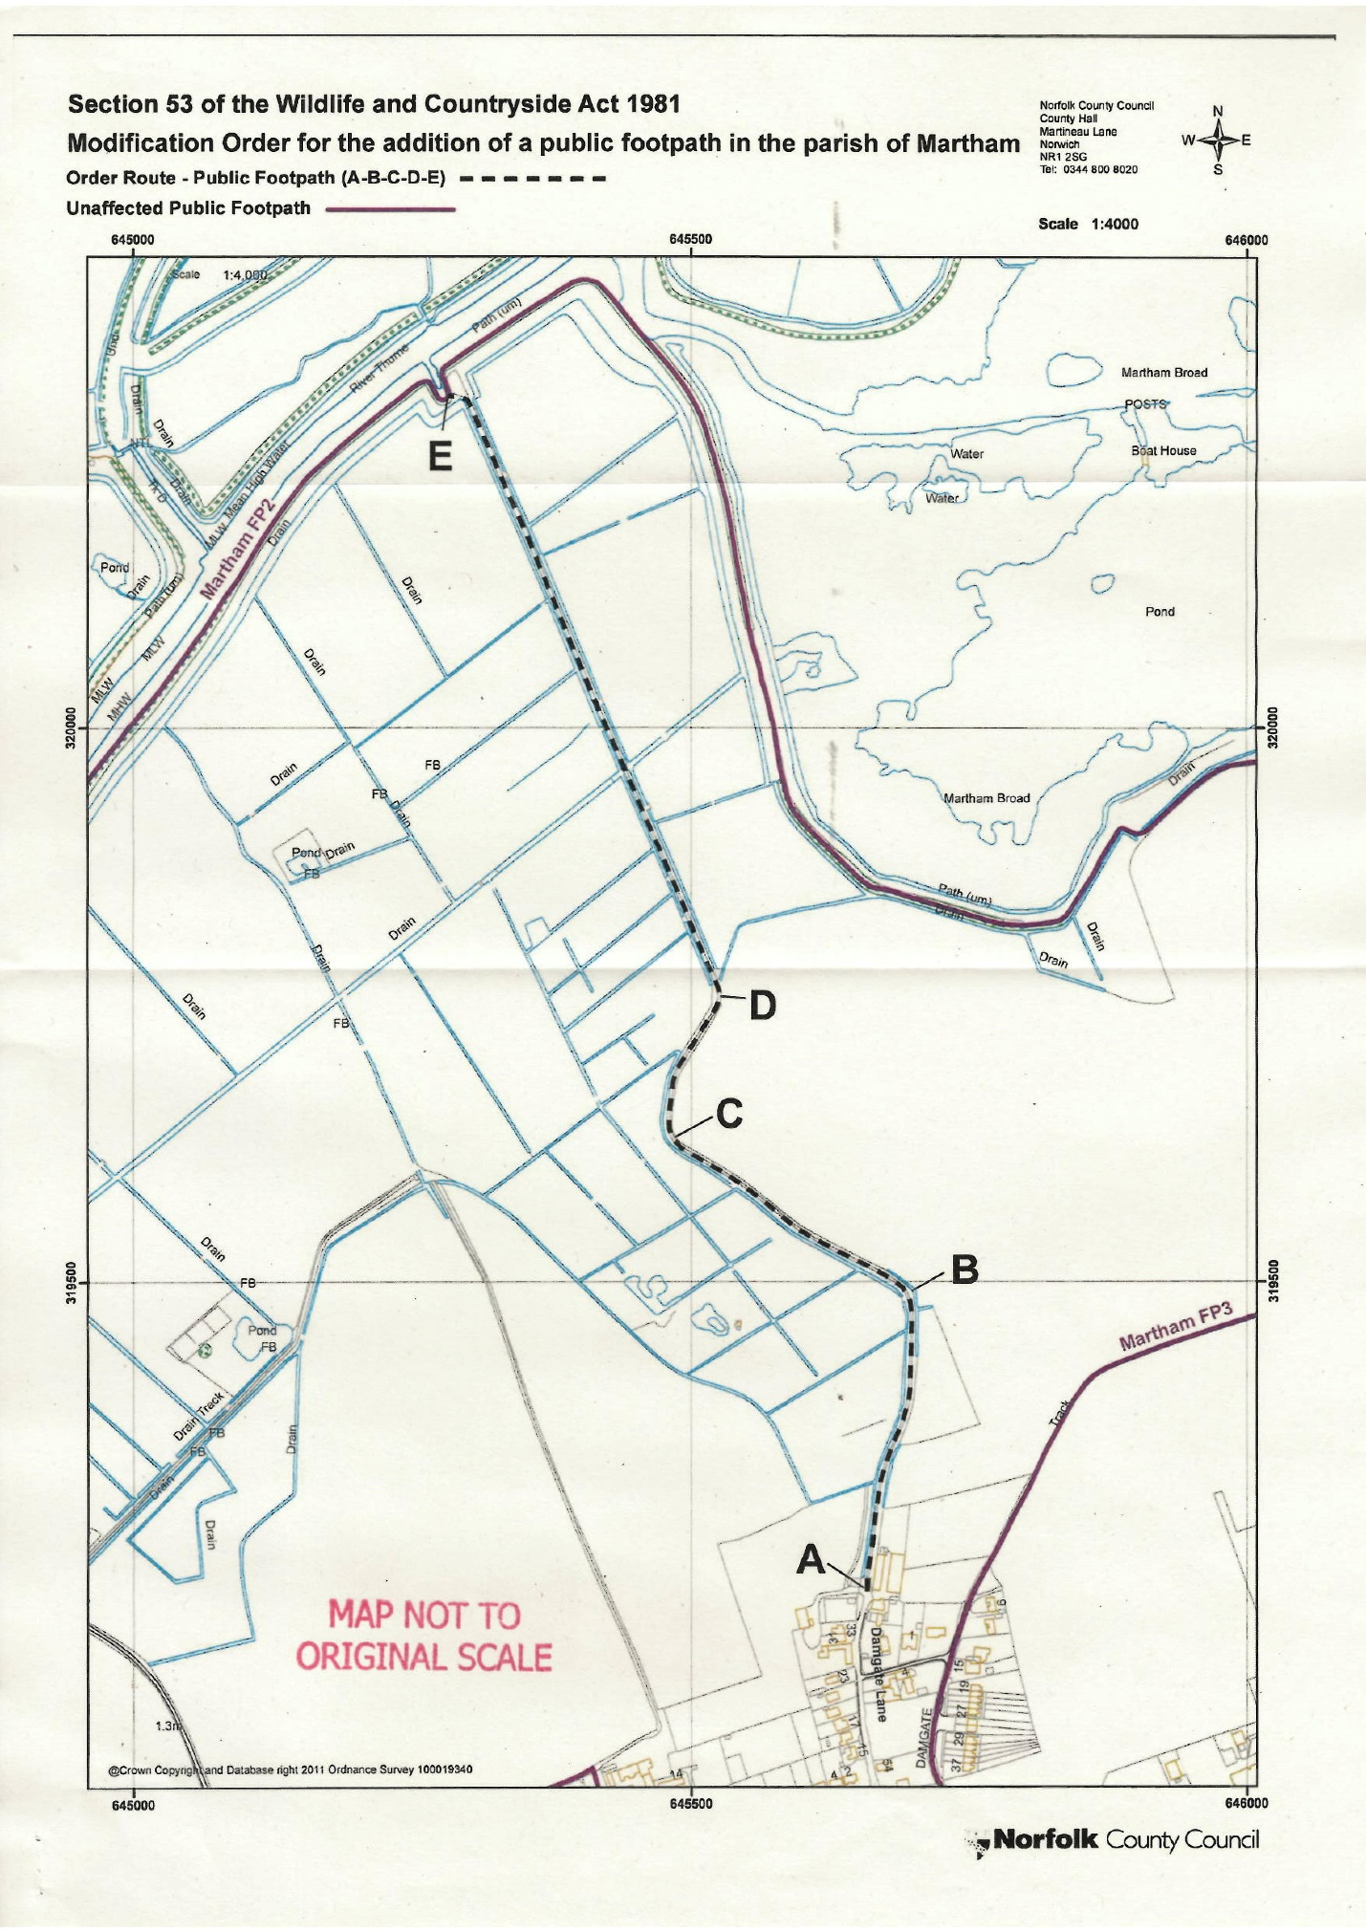

Meaning without secrecy, force, or permission
For the purposes of section 31 “owner”, in relation to any land, means a person who is for the time being entitled to dispose of the fee simple in the land (section 31(7)).

