Application Decision
by Richard Holland
Appointed by the Secretary of State for Environment, Food and Rural Affairs
Decision date: 1 December 2021

Application Ref: COM/3277158
Hackney Marsh, London Borough of Hackney
Register Unit No: CL17
Commons Registration Authority: Hackney Council.

- The application, dated 10 June 2021, is made under Article 12 of the Ministry of Housing and Local Government Provisional Order Confirmation (Greater London Parks and Open Spaces) Act 1967 for consent to carry out works on common land.
- The application is made by Hackney Council.
- The works comprise:
- upgrading an existing self-binding 346m long gravel footpath with an exposed aggregate finish (total area 660m²);
- 495m of new concrete pathways with an exposed aggregate finish (total area 1062m²);
- removal of steps (to be replaced with a ramp);
- returning 636m² of hardstanding back to parkland;
- entrance improvements including installation of boulders, tree trunks, gabions and landform to prevent vehicle incursions and areas of new paving and exposed aggregate surfacing;
- removal of 116m of entrance railing; and
- re-enclosure of the park’s play area with 53m of steel bow-top railing resulting in an additional enclosure of 330m² of the park’s play area.

Decision
  - Consent is granted for the works in accordance with the application dated 10 June 2021 and the plans submitted with it, subject to the condition that the works shall begin no later than three years from the date of this decision.
  - For the purposes of identification only the location of the works is shown in red on the attached plan.

Preliminary Matters
  - Article 7 of Ministry of Housing and Local Government Provisional Order Confirmation (Greater London Parks and Open Spaces) Act 1967 (the 1967 Act) provides that a local authority may in any open space provide and maintain a variety of facilities for public recreation subject to conditions. Article 12 of the 1967 Act provides that in the exercise of powers under Article 7 the local authority shall not, without the consent of the Minister, erect, or permit to be erected, any building or other structure on any part of a common.
  - I have had regard to Defra’s Common Land consents policy in determining this application, which has been published for the guidance of both the Planning Inspectorate and applicants. However, every application will be considered on its merits and a determination will depart from the policy if it appears appropriate to do so. In such cases, the decision will explain why it has departed from the policy.

  - This application has been determined solely on the basis of written evidence. I have taken account of the representations made by Natural England (NE), Historic England (HE), Daubeney Fields Forever (DFF), Joanna Ellis, Chris Spencer, JØrn Tomter and Tom Watson.

  - I am required by section 39 of the Commons Act 2006 to have regard to the following in determining applications under Article 12 of the 1967 Act:-
- the interests of persons having rights in relation to, or occupying, the land (and in particular persons exercising rights of common over it);
- the interests of the neighbourhood;
- the public interest; and
- any other matter considered to be relevant.

Reasons

The interests of those occupying or having rights over the land
  - The common is owned and managed by the applicant, Hackney Council (the Council). The common land register records no rights of common over the land. I am satisfied that the works will not harm the above interests.

The interests of the neighbourhood and the protection of public rights of access
  - The common is known locally as Daubeney Fields and is described by the Council as a hidden park sandwiched between two large estates in the east of Hackney. The works are proposed to improve its entrances, to expand and improve the path network and to retain the play area as a dog-free space. The interests of the neighbourhood test relates to whether the works will impact on the way the common land is used by local people and is closely linked with interests of public access.
  - Daubeney Fields (the park) is not well-used by local people as its unwelcoming entrances hide it from the street and discourage visitors. The proposed improvements have been designed in collaboration with the park user group and include the removal of 116m of railing and 14.5m of hedge to improve sight lines and make the entrances more welcoming. Boulders, tree-trunks, gabions and landform will be introduced at the entrances for play and to prevent vehicle incursions.
  - Although the park has six entrances they are not connected by a path network. The current path layout encourages users to walk straight through the park rather than to use it for recreation and significantly limits access for anyone with mobility issues. The Council says the path works will link all the entrances together and encourage far greater use of the whole green space by the local community.
  - The park’s play area was transformed in 2018 and 60m of boundary railing was removed the following year. A beech hedge was planted in its place but failed to establish due to competition with existing trees. The proposed bow-top railing will run along the hedge line to enclose the play area and re-establish it as a dog-free area.
  - Representations from interested parties are largely in favour of the works, although there are concerns about two sections of path interfering with recreational use and DFF expressed concerns about the proposed path surface material.
  - In response, the Council has agreed to consult further with the local community about the two sections of path before it decides whether to go ahead with them. DFF’s concerns are partly about the speed at which cyclists might travel through the park over hard surfaced paths which may endanger other users. To address the concerns the Council has offered to work with DFF to select an appropriate aggregate surface.
  - I consider that the proposed works will encourage people to visit the park, including those with limited mobility who may have previously found it difficult to use and who will benefit in particular from the replacement of steps with a ramp. Visitors will benefit from greater connectivity between areas of the park and from additional and improved play facilities for children. I conclude that the works will be of substantial benefit to the neighbourhood and public rights of access.

Nature conservation and conservation of the landscape
  - NE confirms that the park is not subject to any statutory nature conservation designations although it is a Borough Grade II site of local importance for nature conservation. The entrance proposals include the removal of three trees as well as the removal of 14.5m of hedge and what appears to NE to be an area of scrub. Whilst some related impact on the semi-natural habitat of the park is envisaged, NE advises that it does not see this as being significant in terms of biodiversity loss and that intended new gardens and wildflower meadow will mitigate against this to a certain degree.
  - I am satisfied that the proposed works are unlikely to harm nature conservation interests.
  - The park has no particular landscape designation and sits between two residential estates in an urban setting. The works are proposed to make the park more inviting to visitors and long open views into it complemented by swathes of wildflower meadow will be created at the Meeson Street and Daubeney Road entrances.
  - DFF is concerned that the proposed new path surfaces might detract from the natural look and feel of the park. Although the upper material of the paths has yet to be finalised, I am satisfied that the Council will engage with DFF to find an aesthetically suitable surface. Returning more than 600m² of hardstanding to parkland will also help to improve the appearance of the common.
  - I conclude that the proposed works are intended to make the park visually more attractive to visitors and that they will bring some improvements to the landscape.

Archaeological remains and features of historic interest
  - HE considers that the works are unlikely to have a significant effect on heritage assets or archaeological interests and has no objection to the proposals. I am satisfied that the works will not harm any archaeological remains or features of historic interest.

Conclusion
  - I conclude that the works will benefit neighbourhood and public use of the common, including use by those with limited mobility. They will also bring some improvements to the landscape and will not harm the other interests set out in paragraph 6 above. The works are those that a local authority may, under Article 7 of the 1967 Act, provide and maintain for persons resorting to the open space and consent for the works is granted subject to the condition set out at paragraph 1.

Richard Holland

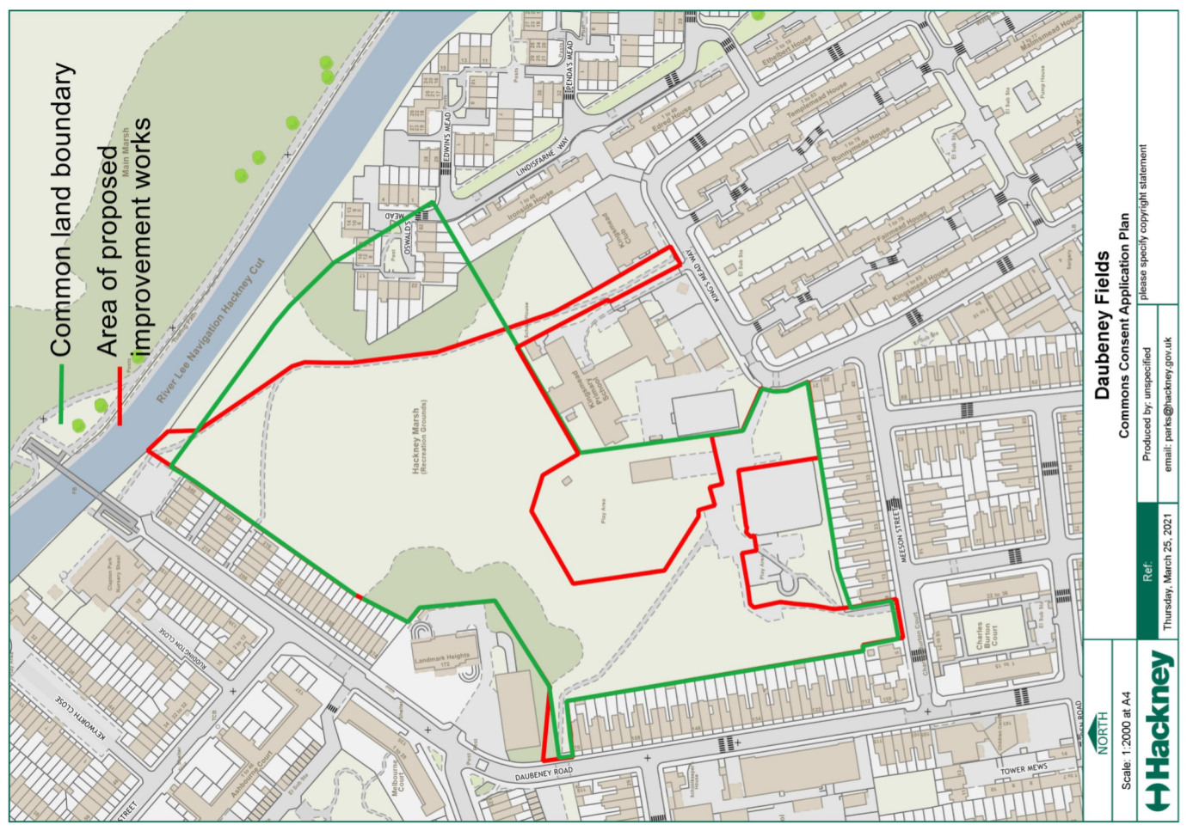

Common Land consents policy (Defra November 2015)
Section 39(2) of the 2006 Act provides that the public interest includes the public interest in; nature conservation; the conservation of the landscape; the protection of public rights of access to any area of land; and the protection of archaeological remains and features of historic interest.

