Agriculture
in the
United Kingdom
2020

Produced by:
Department for Environment, Food and Rural Affairs
Department of Agriculture, Environment and Rural Affairs (Northern Ireland)
Welsh Government, Knowledge and Analytical Services
The Scottish Government, Rural and Environment Science and Analytical Services

Agriculture
in the
United Kingdom
2020

Produced by:
Department for Environment, Food and Rural Affairs
Department of Agriculture, Environment and Rural Affairs (Northern Ireland)
Welsh Government, Knowledge and Analytical Services
The Scottish Government, Rural and Environment Science and Analytical Services

© Crown copyright 2021
Cover image supplied by allou via iStock / Getty Images

Contents
1
Preface 8
Legal Basis
Changes
National Statistics status
Content of document
Summary 10
Farm Structures
Incomes and productivity
Commodities
Environment
Organics
Trade
Food chain
Chapter 1 Key Events 13
Government and policy
Key contextual factors
Animal Health
Chapter 2 Structure of Industry 17
Summary
Introduction
Land use, crop areas and livestock numbers (Figure 2.1, Tables 2.1 and 2.2)
Numbers and sizes of holdings and enterprises (Tables 2.3 and 2.4)
Age of holders (Table 2.6)
Chapter 3 Farming Income 26
Summary
Introduction
Real term trends and summary measures in agricultural income (Table 3.1 and figure 3.1)
Summary measures for the UK (Table 3.2)
Farm business incomes by farm type (Table 3.3)
Distribution of farm incomes and performance (Table 3.4 and figure 3.3)
Definitions and explanatory note (Table 3.5)
Coronavirus (COVID-19) disruption and the production of these statistics
Revisions
Chapter 4 Accounts 37
Summary
Introduction
Summary of long-term trends in real terms (adjusted for inflation) (Figure 4.1 and table 4.1)
Detailed comparison between 2020 and 2019 using current prices (not adjusted for inflation) (Table 4.2)
Headline figures for 2020 (comparisons with 2019 in current prices)
Outputs: Crops (comparisons with 2019 in current prices)
Outputs: Livestock (comparisons with 2019 in current prices)
Intermediate consumption (comparisons with 2019 in current prices)
Compensation of employees (comparisons with 2019 in current prices)
Other subsidies on production (comparisons with 2019 in current prices)
Capital available to the agricultural industry (Table 4.3)
Revisions to data in this chapter
Chapter 5 Productivity 50
Summary
Introduction
Total factor productivity (Figure 5.1)
Details of volume changes of outputs and inputs (Table 5.1)
Partial factor productivity (Table 5.2 and Figure 5.2)
Revisions
Chapter 6 Prices 56
Summary
Data sources
Exchange Rates (Figure 6.1)
Annual Price Indices for 2020
Revisions
Chapter 7 Crops 65
Summary
Cereals
Wheat
Barley
Oats
Straw
Oilseed rape and linseed
Sugar beet
Protein crops (Field Peas and Field Beans)
Fresh vegetables
Plants and flowers
Potatoes
Fresh Fruit
Data Sources and Revisions
Chapter 8 Livestock 81
Summary
Meat production (Table 8.1)
Cattle and calves: beef and veal (Table 8.2)
Pigs and pig meat (Table 8.3)
Sheep and lambs: mutton and lamb (Table 8.4)
Poultry and poultry meat (Table 8.5)
Milk (Table 8.6)
Hen eggs (Table 8.7)
Revisions
Chapter 9 Intermediate Consumption 94
Summary
Introduction
Inputs
Animal Feed (Table 9.1)
Oil prices (Figure 9.1)
Energy (Figure 9.2)
Other input costs
Chapter 10 Public Payments 100
Summary
Introduction
Payments (Tables 10.1 to 10.3, figure 10.1)
Direct Payments made through key measures of the Rural Development Programmes (Table 10.4)
Take-up of Agri-Environment Schemes (Tables 10.5, 10.6, 10.7)
All Common Agricultural Policy payments by funding stream (Table 10.7)
Chapter 11 Environment 112
Summary
Introduction
References
Chapter 12 Organic Farming 126
Summary
Introduction
Area of land farmed organically (Figure 12.1, table 12.1)
Land use and livestock numbers (Tables 12.2 and 12.3)
Organic operators (Tables 12.4 and 12.5)
Chapter 13 Overseas Trade 134
Summary
Introduction
Value of trade in food, feed and drink (Figure 13.1)
Value of trade in food, feed and drink by types of commodity (Tables 13.1a, 13.1b, 13.1c and figures 13.2, 13.3)
Total value of trade in food, feed and drink by trading partner (Figures 13.2 and 13.3)
Value of exports and imports by degree of processing (Figures 13.4, 13.5)
Value and volume of trade in key commodities (Tables 13.2 and 13.3)
Chapter 14 The Food Chain 145
Summary
Contribution of the agri-food sector to the national economy (Figure 14.1, table 14.1)
Agri-food sector employees and self-employed farmers (Figure 14.2)
Food manufacturing
Food wholesaling
Food retailing
Non-residential catering
Trade in food, feed and drink (Table 14.1)
Food production to supply ratio (Figure 14.3)
Distinction between competitiveness and food security
Origins of food consumed in the United Kingdom (Figure 14.4)
Consumers’ expenditure (Figure 14.5)
Changes in consumers’ price indices (Figure 14.6)
Chapter 15 Key Statistics for the EU 153
Summary
Introduction
Agricultural Income (Figure 15.1)
Agricultural production (Figures 15.2 to 15.6)
Wheat
Cows’ milk
Pig meat
Beef and veal
Sheep and goat meat
Price Indices
Data Revisions

Preface

Legal Basis
- Agriculture in the United Kingdom (AUK) 2020 fulfils the requirement under the Agriculture Act 1993 that Ministers publish an annual report on such matters relating to price support for agricultural produce as they consider relevant. The Government will draw on this information when considering the policy issues, including proposals by the European Commission in respect to the Common Agricultural Policy (CAP) and the provision of agricultural support.

Changes
- Some of the figures now given for past years may differ from those published in proceeding issues. This is because of the use of later information, changes in scope and nature of available data, and improvements in statistical methods. Where modifications to the data are made a ‘Revisions’ section will be added to the chapter to explain the changes.

National Statistics status
- National Statistics status guarantees that our statistics meet the highest standards of trustworthiness, quality and public value, and it is our responsibility to maintain compliance with these standards. These statistics last underwent a full assessment [Assessment Report 271 Statistics on Agriculture] against the Code of Practice for Statistics in 2014. Since the latest review by the Office for Statistics Regulation, we have continued to comply with the Code of Practice for Statistics. We have also made improvements to enhance the quality of this publication by improving quality assurance procedures.

Content of document
- The latest available data are used throughout this document. Most of the data are on calendar year basis and for 2020. Some data for 2020 are provisional and may be revised as more data becomes available. Where 2020 data are not yet available the most recent data is presented.

- The following points apply throughout:

- All figures relate to the United Kingdom unless otherwise stated
- Unless stated otherwise, Defra is the source for all data presented in tables and charts
- In the tables
- means ‘nil’ or ‘negligible’ (less than half the last digit shown)
.. means ‘not available’ or ‘not applicable’
- The figures for imports and exports include those from intervention stocks and the figures for exports include re-exports. Imports are based on country of consignment. Exports are based on country of reported final destination. The source of overseas trade statistics is HM Revenue and Customs
- Where statistics are shown for the European Union (EU) as a whole they represent the present Member States in all the years regardless of when they became members
- Values are expressed as either current or as a real term value:
- Current (or nominal) value is the value expressed in historical monetary terms
- Real term value is the current value adjusted to take account of inflation

Summary
All figures relate to 2020 and change between 2019 and 2020 unless otherwise stated

Farm Structures
- The Utilised Agricultural Area (UAA) decreased by 1.5% to 17.3 million hectares, covering 71% of land in the UK.
- The total croppable area decreased by 1.8% to 6.0 million hectares.
- The cereal crops area decreased by 5.4% to 3.0 million hectares.
- The area of oilseed crops planted decreased by 24% to 415 thousand hectares.
- The total number of cattle and calves decreased by 1.3% to 9.6 million. The beef and dairy herds remained largely unchanged at approximately 1.5 and 1.9 million animals, respectively.
- Total pig numbers decreased by 0.5% to 5.1 million.
- Sheep and lamb numbers decreased by 2.6% to 32.7 million.
- The total labour force on commercial holdings decreased by 0.8% to 472 thousand.

Incomes and productivity
- In 2020 agriculture’s contribution to the national economy was 0.49% and its share of employment was 1.44%. Both figures were almost unchanged from 2019.
- Farm Business Income (FBI) varies greatly with just over a fifth of UK farms failing to make a positive FBI in 2019/20 while 26% of farms had a FBI of over £50,000.
- Total Income from Farming (TIFF) is estimated to have been £4.1billion, a fall of £768m (15.7%)
- The value of Gross Output fell by £764m (2.8%) to £26.7bn.
- The cost of intermediate consumption fell by £88m (0.5%) to £17.3bn.
- Gross value added at basic prices (GVA) fell by £676m (6.7%) to £9.4bn.
- The annual Agricultural Price Index (API) for agricultural outputs increased by 4.6%, while for agricultural inputs it decreased by 0.2%.
- Total factor productivity of UK agriculture decreased by 6.7%. This was driven by a decrease in overall levels of production combined with a small increase in volumes of inputs.

Commodities
- Harvested production of wheat decreased by 40% to 9.7 million tonnes, the smallest UK wheat harvest since 1981. The value of production was 36% lower at just under £1.6bn.
- Harvested production of barley increased by 0.9% to 8.1 million tonnes. The value of production was 1.7% lower at £1.1bn.
- Sugar beet production decreased by 23% to just under 6 million tonnes. The value of production was 18% lower at £172m.
- The value of vegetable production increased by 8.8% to £1.6bn.
- The value of fruit production increased by 16% to just over £1bn.
- The value of beef and veal increased by 4.0% to £2.9bn
- The value of pig meat increased by 10% to £1.4bn
- The value of mutton and lamb production increased by 9.4% to £1.3bn
- The value of poultry meat increased by 5.3% to £2.8bn
- The value of milk and milk products decreased by 1.8% to £4.4bn
- The value of eggs increased by 11% to £730m

Environment
- In 2020 utilised agricultural land use stood at 71% of the total area of the United Kingdom
- Since the late 1990’s nitrogen and phosphate application rates have fallen
- A comparison of soil nutrient balances (in kg per hectare) from the year 2000 to 2019 shows a 24% decrease for nitrogen and a 46% decrease for phosphate.
- Estimated greenhouse gas and air pollution emissions from agriculture have fallen between the year 2000 and the most recent data available:
  - In 2019 nitrous oxide emissions have fallen by 9.6%
  - Methane emissions in 2019 have decreased by 9.9%
  - 2019 data for ammonia show a decrease of 5.6%
- The farmland bird index has decreased significantly since 1970 with the index for all farmland species in 2019 less than half of 1970 levels.

Organics
- The area of land farmed organically increased by 0.8% to 489 thousand hectares.
- The area in-conversion increased by 12% to just over 31 thousand hectares.

Trade
- The value of food, feed and drink exports decreased by £3.7bn (15%) to £21.4bn.
- The value of food, feed and drink imports decreased by £3.2bn (6.2%) to £48.0bn.
- The trade gap in food, feed and drink increased by £0.5bn (2.0%) to £26.6bn.

Food chain
- In 2019 the agri-food sector in the United Kingdom accounted for a total estimated Gross Value Added (GVA) of £127bn or 6.4% of national GVA, unchanged from 2018. The manufacturing sector increased 8.7%, followed by the agriculture sector at 6.5%.
- Employment in the agri-food sector fell by 1.0% over the 12-month period to the fourth quarter of 2020 to just under 4 million. The largest decrease was in wholesaling, falling by 17,000 employees (7.1%).
- Total factor productivity of the UK food chain beyond the farmgate rose by 0.9% between 2017 and 2018. Productivity in the wider economy rose by 0.1% in 2018.

Chapter 1 Key Events

Government and policy
The Countryside Stewardship application round for 2021 agreements opened in February 2020, providing an opportunity for more farmers and land managers to get ready for the future and be paid for environmental work.

In April Defra launched the Pick for Britain website together with industry to help match those who had lost their jobs or been furloughed with seasonal farm labour jobs across the UK.

In April and in light of the disruption caused by the coronavirus (COVID-19) outbreak, the RPA took the decision to extend by one month the window to submit applications for the Basic Payment Scheme (BPS) and make a claim for Countryside Stewardship (CS), Environmental Stewardship (ES) and woodland legacy revenue payments.

The government also temporarily relaxed competition laws in March, which allowed supermarkets to work together. This benefitted many dairy farmers and milk producers who were able to redirect their milk supplies into retail suppliers. On 18 June the Dairy Response Fund opened for applications from dairy farmers most affected by the disruption to the hospitality sector and provided grants of up to £10,000 to help them to sustain their businesses.

In June Defra launched a £6 million round of the Farming Recovery Fund to help eligible farmers recover from the February flooding in parts of Herefordshire, Shropshire, Worcestershire, Gloucestershire, Staffordshire, Nottinghamshire and North and East Yorkshire.

In July Defra announced that farmers would no longer need to comply with the EU-derived greening requirements from the 2021 Basic Payment Scheme year.

In November the Agriculture Bill was passed into law to become the Agriculture Act 2020. Later in the month, Defra launched the ‘Path to Sustainable Farming’, which set out a roadmap for the Agricultural Transition Period. This included further details on the three future environmental land management schemes; the Sustainable Farming Incentive, Local Nature Recovery and Landscape Recovery, as well as plans to introduce a Farming Investment Fund, a lump sum exit scheme and a scheme to support new entrants to the sector.

In December Defra and the Home Office announced that the Seasonal Workers Pilot would be extended for 2021 and expanded to grant 30,000 seasonal workers permission to work on UK farms for a period of up to six months. This expansion formed part of a package to support the horticulture sector, together with additional efforts to boost domestic recruitment for the sector and a Defra-led review into the use of automation by the sector.

On 24 December the government agreed a deal with the European Union, which maintained zero tariffs and zero quotas on trade in goods between the UK and EU.
By December the Rural Payment Agency had successfully paid just under 98% of Basic Payment Scheme (BPS) claims despite the challenges caused by the coronavirus pandemic.

Key contextual factors

Coronavirus (COVID-19) pandemic and EU Exit

The year 2020 saw two events of global significance impact in a wide-reaching way on all aspects of farming and the food chain: the coronavirus (COVID-19) pandemic and the UK leaving the EU. These impacted directly in a wide range of areas including markets, supply chains and prices and indirectly by causing change, disruption and uncertainty.

Exchange rates

The relationship between the pound and euro has a key bearing on the fortunes of UK farming. Direct subsidies received by farmers are set in euros then converted to sterling in September each year. A strong euro therefore increases the value in pounds of the payments for that year. In addition, the majority of UK exports of agricultural commodities are made to the Eurozone. The pound weakened against the euro throughout 2016 and 2017. It remained stable but weak throughout 2018 and 2019, increasing the competitiveness of UK exports but also pushing up the price of imports, including inputs such as fertilisers and pesticides.

Weather (source: Met Office)

The UK experienced another year of extreme weather in 2020; it was both warmer and sunnier than usual, but also one of the wettest years on record, resulting in flooding in many areas.

Winter

Although an unremarkable month in terms of precipitation, January 2020 was notably warm with monthly mean temperatures of 2.0 °C above average. February was also warmer than average, but to a lesser degree. Nevertheless, three named storms occurred in February which contributed to it being the wettest on record; many areas experienced over three times the average total precipitation for that month.

Spring

March 2020 was a typical month in terms of temperature and precipitation but was sunnier than usual in most areas of the UK (except Scotland). April 2020 was the sunniest on record but was also one of the warmest and driest for most of the UK with monthly-mean temperatures of 1.7 °C above average. The record-breaking dry, sunny weather continued into May with England and Wales experiencing the driest and second driest May on record, respectively. However, rainfall in May was above average in north-west Scotland and some parts of central southern England. Whilst May 2020 was warmer than usual, a cold spell between the 11th to the 15th meant that monthly-mean temperatures were only 1.0 °C above average.

Summer

Temperatures remained warmer than average (by 1.0 °C) in June 2020, but most northern and western areas were duller than usual, and rainfall was well above average (double in some areas) for most of the UK, except Orkney, Shetland and south-east England. July 2020 was a cool month for much of the UK and continued to receive above-average rainfall throughout many areas except southern England; monthly-mean temperatures were 0.8 °C below average. The relatively cooler, wetter weather carried into August and rainfall was 135% of average overall. However, a warm period between the 5th and 22nd of August meant that the whole month was warmer than average by 1.0 °C.

Autumn

September 2020 was a particularly dry month across most of the UK (except Norfolk) with some areas receiving less than half the average rainfall. September was sunnier than average overall, but unremarkable in terms of temperature. The weather became more unsettled in October and many locations received more than double the amount of normal rainfall, despite a drier period from the 14th to the 18th. October was also duller than usual, but again, experienced close to average temperatures. In November, western areas continued to receive substantial rainfall, but eastern coastal counties were drier than usual. November was also a particularly mild month with temperatures 1.5 °C above average overall. Most of the UK also received substantial rainfall in December 2020, with more than double the average in some areas, except Scotland and Northern Ireland. There were also fewer frosts than normal in December due to temperatures being well above average between the 10th and 23rd.

Animal Health

Avian influenza

In England in 2020 there were 14 outbreaks of highly pathogenic avian influenza (HPAI) H5N8 in domestic poultry. This comprised of: five outbreaks in Norfolk, two in North Yorkshire, and one occurrence per county of Devon, Dorset, Herefordshire, Gloucestershire, Leicestershire, South Derbyshire and Worcestershire. In addition, there was one outbreak of HPAI H5N1 in North Yorkshire. A further two outbreaks of low pathogenic avian influenza occurred in Kent (H5N2) and East Staffordshire (H5N3).
Scotland recorded one outbreak of HPAI H5N8 in the Orkney Islands in 2020.
There were no outbreaks of HPAI and LPAI in Wales and Northern Ireland in 2020

Bovine Tuberculosis (bTB)

Note: More information on Bovine Tuberculosis can be found at the TB hub

The government published its response to the 2018 Godfray review of the strategy for achieving bovine tuberculosis free status for England by 2038.

Despite the coronavirus pandemic, TB testing of cattle in England continued where, in Official Veterinarians’ (OVs’) judgements, it could be done safely in accordance with the government’s public health guidance. To make allowances for social distancing, temporary changes were made. Movement restrictions were not placed on Officially TB Free herds in England undergoing routine or targeted surveillance skin tests if animals under 180 days of age were left untested because, in OVs’ judgements, they could not be handled safely.

The Veterinary Medicines Directorate granted permission for field trials of both the Cattle BCG vaccine and the associated DIVA (Detecting infected Animals among vaccinated animals) skin test.

Following public consultation, the government introduced scope for ‘no-cull’ buffer zones around licensed badger vaccination sites in the Edge Area, located between the High and Low Risk Areas.

Natural England (NE) licensed eleven new badger TB control areas in 2020. This brought the total number of intensive culling areas in England to forty-four including two in the Low Risk Area. NE’s Chief Scientific Adviser and Defra’s Chief Veterinary Officer concluded that the industry-led licensed culling operations in 2020 were again conducted effectively, safely and humanely. NE also licenced seven new supplementary badger culling areas bringing the total number of supplementary badger culling areas to ten.

The government also continue to support privately led, licensed badger vaccination in the Edge Area. In its response to the Godfray Review in March 2020, the government set out its ambition for wider deployment of badger vaccination in the future.

In 2020, Wales had the lowest number of new TB herd incidents recorded since 2002, continuing the long-term downward trend of new incidents. Compared to 2019, there was a 20% decrease in the number of animals slaughtered for TB controls purposes. This decrease is partly due to a revised inconclusive reactor policy implemented in early 2020. In Wales, following discussions with industry, cattle testing inconclusive at standard interpretation of the skin test in persistent breakdowns continue to be removed. However, cattle testing inconclusive at severe interpretation will be subject to both a gamma interferon test and an antibody test (IDEXX). No single test, or combination of tests for bovine TB provides 100% test specificity or sensitivity. The skin test is the only official test recognised for demonstrating Officially TB-Free status. The Welsh Government is using alongside the skin test a number of ancillary tests such as the gamma test, the flexible extended gamma test and the IDEXX Antibody Test, a blood test, which detects a different immune response to bovine TB from the skin TB test and the Interferon-gamma test, to improve the detection of bovine TB infected animals.

In Scotland, there were 14 new confirmed TB breakdowns, which is consistent with another year of officially TB-free status. Scotland continue to monitor the effectiveness of their surveillance programme. In 2020, this included a change to herd status policy for mesenteric lesions in skin reactors, whereby a herd status will remain as officially TB free suspended (OTFS), pending culture results, where mesenteric lesions only are found in skin test reactors. This change was in light of relatively poor predictive values of mesenteric lesions in skin reactors in Scotland.

In Northern Ireland, herd incidence for 2020 was 8.44% with animal incidence standing at 0.747%. Herd incidence has risen over the past year (from 7.84% in 2019) while animal incidence has reduced slightly. Herd and animal incidence rates may have been affected by the challenge of delivering the NI bTB programme during the coronavirus pandemic (especially given disruption to herd testing in March and April), however, both indices remain significantly below the high point reached in November 2017.

Since the restoration of the devolved institutions in January 2020 and the appointment of Edwin Poots MLA as Minister of Agriculture, Environment and Rural Affairs, significant progress has taken place on the development of a new bTB Eradication Strategy for Northern Ireland. The Strategy has been the product of several years’ work and builds on the 2016 recommendations of the TB Strategic Partnership Group and subsequent public consultation on the Department’s response.

Chapter 2 Structure of Industry

Summary
Key results for 2020 compared to 2019
- The Utilised Agricultural Area (UAA) decreased by 1.5% to 17.3 million hectares, covering 71% of land in the UK.
- The total croppable area decreased by 1.8% to 6.0 million hectares.
- The cereal crops area decreased by 5.4% to 3.0 million hectares.
- The area of oilseed crops planted decreased by 24% to 415 thousand hectares.
- The total number of cattle and calves decreased by 1.3% to 9.6 million. The beef and dairy herds remained largely unchanged at approximately 1.5 and 1.9 million animals, respectively.
- Total pig numbers decreased by 0.5% to 5.1 million.
- Sheep and lamb numbers decreased by 2.6% to 32.7 million.
- The total labour force on commercial holdings decreased by 0.8% to 472 thousand.

Introduction
The tables in this chapter show the size and structure of the agricultural industry in the United Kingdom. They provide information on land use and livestock numbers, on the distribution of these between holdings, on the labour force and the age of farm holders.

Data in this chapter are sourced primarily from the June Surveys of Agriculture carried out in the four UK countries each year. The exceptions to this are the holder age data (sourced from the EU Farm Structure Survey) and most of the land use data in Scotland (sourced from Single Application Form (SAF) subsidy data). Also, cattle data are sourced from the Cattle Tracing System (CTS) in England, Wales and Scotland and from the equivalent Animal and Public Health Administration (APHIS) system in Northern Ireland.

From 2009 onwards, England data relate to commercial holdings only. The term “commercial” covers all English holdings which exceed thresholds specified in the EU Farm Structure Survey Regulation EC 1166/2008. These thresholds are based on either land and cropping areas or livestock numbers as follows:

- More than 5 hectares of agricultural land, 1 hectare of orchards, 0.5 hectares of vegetables or 0.1 hectares of protected crops
or
- More than 10 cattle, 50 pigs, 20 sheep, 20 goats, or 1,000 poultry.
For more information on the June Survey and for more detailed results, please see the pages for England, Scotland, Wales and Northern Ireland.

Land use, crop areas and livestock numbers
(Figure 2.1, Tables 2.1 and 2.2)

Figure 2.1 Breakdown of croppable area on agricultural holdings, June 2020 compared to 2019

At June 2020 the Utilised Agricultural Area (UAA) was 17.3 million hectares, covering 71% of the total UK land area. UAA is made up of arable and horticultural crops, uncropped arable land, common rough grazing, temporary and permanent grassland and land used for outdoor pigs. It does not include woodland and other non-agricultural land.

On the whole, the proportion of croppable land used for each purpose remained similar between 2019 and 2020, however some categories did see value changes (see Figure 2.1).

Cereal crops accounted for 50% of the croppable area. Wheat and barley were the predominant cereal crops, both at 1.4 million hectares. The area of barley planted fell from 2 million hectares in 1984 to a low of 0.9 million hectares in 2006. However, since then the area has increased and now sits at 1.4 million hectares.

The area of oilseed rape decreased in 2020 by 28% to 380 thousand hectares.

The total number of cattle and calves decreased between 2019 and 2020, by 1.3% from 9.7 million to 9.6 million. The beef and dairy herds have remained largely unchanged in recent years at approximately 1.5 and 1.9 million animals respectively.

In 2020, the number of lambs under one year old decreased by 1.1% to 16.5 million and the female breeding herd decreased by 4.2% to 15.4 million. This led to a total UK sheep and lamb population of 32.7 million, a decrease of 2.6% compared to 2019.

The total number of pigs in the UK decreased by 0.5%, to 5.1 million in 2020. The main driver for this was the 3.1% decrease in sows in pig and other sows for breeding to 345 thousand.

The total number of poultry in the UK decreased by 2.7% to 182 million birds in 2020 compared to 187 million in 2019. Table chickens account for 65% of the total and fell by 2.6% to 118 million birds. Breeding fowl saw an increase of 3.0% between 2019 and 2020.

Table 2.1 Agricultural land use
Enquiries: Emma Howat on +44 (0) 3000 600 170, email farming-statistics@defra.gov.uk

Thousand hectares At June of each year
 | 2018 | 2019 | 2020
UAA (Utilised agricultural area) | 17,361 | 17,532 | 17,269
UAA as a proportion of total UK area | 71% | 72% | 71%
Total agricultural area | 18,703 | 18,849 | 18,628
Common rough grazing | 1,195 | 1,197 | 1,194
Total area on agricultural holdings | 17,509 | 17,652 | 17,434
Total croppable area | 6,084 | 6,132 | 6,024
Total crops | 4,667 | 4,714 | 4,481
Arable crops | 4,502 | 4,551 | 4,314
Cereals | 3,106 | 3,211 | 3,038
Oilseeds (includes linseed and borage) | 609 | 547 | 415
Potatoes | 140 | 144 | 142
Other crops | 647 | 649 | 719
Horticultural crops | 165 | 163 | 166
Uncropped arable land | 265 | 224 | 362
Temporary grass under 5 years old | 1,152 | 1,193 | 1,181
Total permanent grassland | 10,072 | 10,193 | 10,042
Grass over 5 years old | 6,178 | 6,207 | 6,118
Sole right rough grazing | 3,895 | 3,986 | 3,924
Other land on agricultural holdings | 1,353 | 1,328 | 1,368
Woodland | 1,016 | 1,033 | 1,065
Land used for outdoor pigs | 10 | 10 | 10
All other non-agricultural land | 326 | 284 | 293
Source: UK Agriculture departments June Survey/Census of Agriculture
Notes:
- As the results are based on sample surveys, they are subject to a degree of sampling error and do not take into account other sources of survey errors, such as non-response bias.
- Figures for England relate to commercial holdings only.
- Uncropped arable land includes all arable land not in production, including land managed in Good Agricultural and Environmental Condition (GAEC12), wild bird cover and game cover.
- Sole right rough grazing includes mountains, hills, heathland or moorland.
- Results for 2018 were revised in May 2019 to take account of corrections to the England data. More information on the revisions and the scale of the changes can be found in the updated statistical release at Structure of the Agricultural Industry.

Table 2.2 Crop areas and livestock numbers
Enquiries: Emma Howat on +44 (0) 3000 600 170, email: farming-statistics@defra.gov.uk

At June of each year
 | 2018 | 2019 | 2020
Crop areas (thousand hectares)
Total area of arable crops | 4,502 | 4,551 | 4,314
wheat | 1,748 | 1,816 | 1,387
barley | 1,138 | 1,162 | 1,388
oats | 171 | 182 | 210
rye, mixed corn and triticale | 49 | 51 | 53
oilseed rape | 583 | 530 | 380
linseed | 25 | 15 | 33
potatoes | 140 | 144 | 142
sugar beet (not for stock-feeding) | 114 | 108 | 111
peas for harvesting dry and field beans | 193 | 178 | 233
maize | 221 | 228 | 228
Total area of horticultural crops | 165 | 163 | 166
vegetables grown outdoors | 116 | 115 | 118
orchard fruit | 24 | 24 | 23
soft fruit & wine grapes | 11 | 11 | 11
outdoor plants and flowers | 12 | 11 | 11
glasshouse crops | 3 | 3 | 3
Livestock numbers (thousand head)
Total cattle and calves | 9,891 | 9,739 | 9,615
cows in the dairy herd | 1,883 | 1,871 | 1,850
cows in the beef herd | 1,558 | 1,527 | 1,509
Total sheep and lambs | 33,781 | 33,580 | 32,697
female breeding flock | 16,286 | 16,035 | 15,370
lambs under one year old | 16,621 | 16,672 | 16,486
Total pigs | 5,012 | 5,078 | 5,055
sows in pig and other sows for breeding | 352 | 356 | 345
gilts in pig | 58 | 57 | 57
Total poultry | 188,960 | 187,072 | 181,957
table fowl | 124,384 | 121,590 | 118,388
laying flock (including pullets) | 39,727 | 41,346 | 39,758
breeding flock | 13,976 | 13,385 | 13,785
turkeys, ducks, geese, all other poultry | 10,872 | 10,750 | 10,025
Source: June Surveys/Census of Agriculture/SAF land data, Scotland Cattle Tracing System/APHIS
Notes:
- Figures for England relate to commercial holdings only.
- Includes non-commercial orchards.
- Dairy cows are defined as female dairy cows over 2 years old with offspring.
- Beef cows are defined as female beef cows over 2 years old with offspring.
- Scotland have revised their poultry time series from 2015 to 2019 to reflect new information from a poultry data provider.
- Results for 2018 were revised in May 2019 to take account of corrections to the England data. More information on the revisions and the scale of the changes can be found in the updated statistical release at Farming statistics – final crop areas, yields, livestock populations and agricultural workforce. For more details please see the introduction section of this chapter.

Numbers and sizes of holdings and enterprises
(Tables 2.3 and 2.4)
Note: Due to a delay in producing the England 2020 holding level dataset, these figures relate to 2019 and not 2020.

The number of agricultural holdings was 212 thousand in 2014 and increased by 3.3% to 219 thousand in 2019. Within that time period the total area on holdings increased by 2.3%, and the average area of all holdings decreased by 1.0% to 80.7 hectares in 2019. The average croppable area of holdings increased 3.1% between 2014 and 2019.

Table 2.3 Numbers of holdings and total area by size group
Enquires: Emma Howat on +44 (0) 3000 600 170, email: farming-statistics@defra.gov.uk

 | 2014  No. holdings | 2014  Area | 2019  No. holdings | 2019  Area
Size group (by total area)
under 20 hectares | 95 | 694 | 103 | 705
20 to under 50 hectares | 41 | 1,364 | 42 | 1,390
50 to under 100 hectares | 33 | 2,389 | 32 | 2,280
100 hectares and over | 42 | 12,810 | 41 | 13,277
Total | 212 | 17,257 | 219 | 17,652
Average area |  | 82 |  | 81
Average area on holdings  with >=20 hectares |  | 142 |  | 147
Size group (by croppable area)
0.1 to under 20 hectares | 47 | 308 | 46 | 294
20 to under 50 hectares | 19 | 634 | 18 | 590
50 to under 100 hectares | 15 | 1,075 | 14 | 981
100 hectares and over | 19 | 4,262 | 17 | 4,267
Total | 100 | 6,278 | 95 | 6,132
Average croppable area |  | 63 |  | 64
Source: June Surveys/Census of Agriculture/SAF land data Scotland.
Notes:
- All figures relate to June of each year
- Figures for England relate to commercial holdings only.
- Numbers of holdings are in thousands
- Areas are in thousand hectares except average areas which are in hectares
- Croppable area is defined as land under crops, temporary grass under five years old and uncropped arable land.
- In 2014 Wales updated their datasets resulting in a number of obsolete holdings being identified and removed.

Table 2.4 Numbers of holdings and areas by size group and country at June 2019
Enquiries: Emma Howat on +44 (0) 3000 600 170, email farming-statistics@defra.gov.uk

 | England | Wales | Scotland | Northern Ireland
Number of holdings (thousand)
Size group (by total area)
Under 20 hectares | 41 | 20 | 32 | 10
20 to under 50 hectares | 21 | 7 | 6 | 8
50 to under 100 hectares | 18 | 5 | 5 | 4
100 hectares and over | 25 | 5 | 9 | 2
Total | 106 | 37 | 51 | 25
Hectares (thousand)
Size group (by total area)
Under 20 hectares | 318 | 120 | 161 | 106
20 to under 50 hectares | 711 | 221 | 188 | 270
50 to under 100 hectares | 1,284 | 371 | 336 | 289
100 hectares and over | 6,893 | 1,052 | 4,974 | 358
Total | 9,206 | 1,764 | 5,660 | 1,023
Average area (hectares) | 87 | 48 | 112 | 41
Average area on holdings with >=20  hectares | 137 | 98 | 288 | 63
Source: June Surveys/Census of Agriculture/SAF land data Scotland.
Notes:
- England figures for 2020 are currently unavailable and so this table has not been updated with UK 2020 data
- Figures for England relate to commercial holdings only
- For more details please see the introduction section of this chapter.

The agricultural workforce in 2020 decreased by 0.8% to 472 thousand people compared to 2019. Farmers, business partners, directors and spouses account for the majority (64%) of the total labour force.

Table 2.5 Agricultural labour force on commercial holdings
Enquiries: Emma Howat on +44 (0) 3000 600 170, email farming-statistics@defra.gov.uk

Thousands (as at June each year)
 | 2018 | 2019 | 2020
Total labour force | 477 | 476 | 472
Farmers, business partners, directors and spouses | 296 | 299 | 301
Full time | 145 | 144 | 147
Part time | 152 | 155 | 153
Regular employees, salaried managers and casual workers | 181 | 177 | 171
Regular employees | . . | . . | . .
Full time | . . | . . | . .
Part time | . . | . . | . .
Seasonal, casual or gang labour | . . | . . | . .
Source: June Surveys/Census of Agriculture
Notes:
- Figures for England relate to commercial holdings only.
- Total labour force includes farmers and spouses
- Part-time is defined as working less than 39 hours per week (England & Wales), 38 hours per week (Scotland) and 30 hours per week (N. Ireland).
- Regular employees include salaried managers as not all UK countries collect separate estimates.
- For labour force numbers in earlier years see Structure of the agricultural industry
- . . means ‘not available’ or ‘not applicable’

Age of holders
(Table 2.6)
Table 2.6 shows the proportion of holders by age group. Agriculture typically has an aging workforce. In 2016, approximately 36% of all holders were over the typical retirement age of 65 years while the proportion of young people aged less than 35 years was 3%.

The proportions of holders in the central age bands of 45-54 years and 55-64 years have remained broadly unchanged over the previous decade. Since 2005 the proportion in the 35-44 years old band has decreased by 5% whilst the proportion in the oldest band, 65 years and over, has increased by 5%.

The average age of holders is defined using the median. This is the middle value when all holders’ ages are ranked in order. In 2016 the median age for holders in the UK was 60 years old, an increase of 1 year from 2013.

Table 2.6 Proportion of holders in each age group
Enquiries: Emma Howat on +44 (0) 3000 600 170, email farming-statistics@defra.gov.uk

Proportion of holders (%)
 | 2005 | 2007 | 2010 | 2013 | 2016
Holders' age
Under 35 years | 3 | 3 | 3 | 3 | 3
35 - 44 years | 14 | 12 | 11 | 10 | 9
45 - 54 years | 23 | 23 | 25 | 25 | 23
55 - 64 years | 29 | 29 | 29 | 28 | 29
65 years and over | 31 | 33 | 32 | 34 | 36
Median age (years) | 58 | 59 | 59 | 59 | 60
Source: EU Farm Structure Survey, 2016
Notes:
- The holder is defined as the person in whose name the holding is operated. The data in this table relate to all holders whether or not the holder is also the manager of the holding.
- Holdings run by an organisation (such as limited companies or institutions) do not have a holder and are therefore excluded from these figures.
- Figures from 2010 onwards relate to commercial holdings only for all of the UK. More information on commercial holdings can be found in the introduction section.

Chapter 3 Farming Income

Summary
- In 2020 agriculture’s contribution to the national economy was 0.49% and its share of employment was 1.44%. Both figures were almost unchanged from 2019.
- In 2020 Total Income from Farming in the United Kingdom is estimated to have been £4.1 billion.
- Farm Business Income (FBI) varies greatly with just over a fifth of UK farms failing to make a positive FBI in 2019/20 while 26% of farms had a FBI of over £50,000.

Introduction
This chapter presents Farm Business Income and Total Income from Farming (TIFF) data.

Farm Business Income (FBI) is the preferred measure for comparisons of farm type and represents the return to all unpaid labour (farmers, spouses and others with an entrepreneurial interest in the farm business) and to all their capital invested in the farm business including land and farm buildings.

Total Income from Farming (TIFF) represents business profits and remuneration for work done by owners and other unpaid workers. It is used to assess UK agriculture as a whole.

Table 3.5, found at the end of this chapter, provides more detailed information on definition, method used and similarities and differences for the two income measures

Real term trends and summary measures in agricultural income
(Table 3.1 and figure 3.1)
Real term values are adjusted to take into account inflation to allow more meaningful comparisons between years over the longer term.

The key drivers of agricultural income include the volume of production, commodity prices and the cost of inputs. These are themselves driven by a range of factors such as the weather, exchange rates, oil price and global supply and stocks of commodities. As a result, UK agricultural income tends to be volatile and fluctuates from year to year.

Table 3.1 Trends in measures of farm incomes in the UK (in real terms at 2020 prices)
Enquiries: Robin Karfoot on +44 (0)20 802 66449, email: farmaccounts@defra.gov.uk

Real terms at 2020 prices
 | 2013-2017 | 2018 | 2019 | 2020
Total Income from Farming (£ million) | 5,331 | 5,114 | 5,169 | 4,119
Entrepreneurial labour input (thousand Annual Work Units) | 193 | 197 | 198 | 200
Total Income from Farming per AWU of  entrepreneurial agricultural labour (£/AWU) | 27,595 | 26,030 | 26,056 | 20,562
Source: Defra
Notes:
- 2013-2017 figures are a 5-year average
- Annual Work Unit (AWU) equals the work performed by one person who is occupied on an agricultural holding on a full-time basis in one year

Table 3.1 shows that Total Income from Farming was considerably lower in 2020 than general levels in recent years.

Over the longer term, UK TIFF rose strongly between 2000 and 2008 (see Figure 3.1). Since then, TIFF has remained close to or within the £4bn-£6bn range, but with some big year-on-year fluctuations, particularly in recent years. Looking more closely at recent years, TIFF fell sharply in 2015 driven by lower commodity prices and a stronger pound. In 2016 the exchange rate improved but a poor harvest and continued low commodity prices kept income low. In 2017, Total Income from Farming reached the highest point for 20 years as a result of a favourable combination of a weaker pound, strong commodity prices and high levels of production. In 2018, extreme weather conditions led to poor yields and pushed up the price of key inputs. These factors were not fully offset by strong commodity prices resulting in an 18% fall in TIFF that year. In 2019, favourable weather produced modest increases to both crop output and TIFF.

Figure 3.1 Long term trends in real terms at 2020 prices

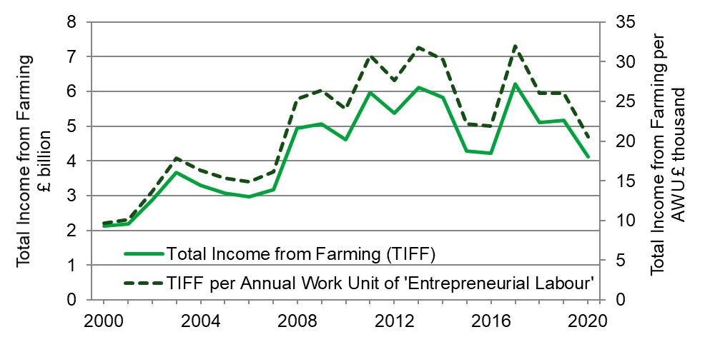

Source: Defra

‘Total Income from Farming per Annual Work Unit of entrepreneurial labour’ is an alternative measure of income that divides income by the labour contribution of owners plus any other unpaid labour and allows comparisons to be made with other countries. Since 2000 it has followed a similar trend to Total Income from Farming (TIFF) but has performed slightly better relative to a baseline of the year 2000.

Summary measures for the UK
(Table 3.2)
Table 3.2 shows main measures, at current price, for the agriculture industries in the UK as a whole. These are shown at current prices, which is the value based on actual price during the reference year. Table 3.2 also presents the contribution that agriculture makes to the economy (at basic prices) and employment share. Basic price is the market price plus directly paid subsidies linked to the production of specific products.

Table 3.2 Summary measures for the UK at current prices
Enquiries: Robin Karfoot on +44 (0)20 802 66449, email: farmaccounts@defra.gov.uk

Units are £ million (unless specific otherwise)
 | 2018 | 2019 | 2020
Gross output at basic prices | 26,752 | 27,481 | 26,717
Intermediate consumption | 16,990 | 17,370 | 17,282
Gross value added (GVA) at basic prices | 9,763 | 10,111 | 9,435
Total Income from Farming | 4,735 | 4,886 | 4,119
Agriculture's share of all-economy regional GVA at basic prices (%) | 0.51% | 0.51% | 0.49%
Agriculture's share of all-economy regional employment (%) | 1.47% | 1.45% | 1.44%

Notes:
- Figures for 2020 are provisional and subject to revision
- UK data as received by end April 2021. The latest UK data is available on GOV.UK
- Latest Welsh data is available on the Welsh Government website
- Latest Scottish data is available on the Scottish Government website
- Latest Northern Ireland data is available on the DAERA website

As a share of the UK national economy, measured in Gross Value Added (GVA), agriculture contributed an estimated 0.49% in 2020. This represents a small fall compared to the 0.51% contribution in 2019. Whilst there was a small fall in UK all-economy GVA, the fall in GVA from agriculture was relatively much larger.

Employment in agriculture represented 1.44% of total employment across the whole UK economy in 2020, a fall from 1.45% in 2019. Both employment in agriculture and all-economy employment fell slightly.

Farm business incomes by farm type
(Table 3.3)
Estimates of Farm Business Income for 2020/21 (i.e. year ended February 2021 and harvest 2020) at current prices are shown in Table 3.3 for England and Northern Ireland alongside outturn data for earlier years. These estimates include Basic Payment Scheme receipts which are recorded as due for the appropriate accounting year, e.g. receipts of the 2020 Basic Payment Scheme are recorded in the 2020/21 accounting year. Note that forecasts of Farm Business Income in Wales for 2020/21 have not been produced this year and forecasts of Farm Business Income are not produced in Scotland.

The estimates of Farm Business Income are averages. It should be noted that across different regions and farm types some farmers receive considerably more or less than these averages.

Challenging weather conditions (the extremely wet autumn and winter of 2019 and the spring drought of 2020) along with the coronavirus (COVID-19) pandemic are expected to be the key drivers influencing Farm Business Income in 2020/21. The average 2020 Basic Payment is expected to be around 2% higher across all farm types compared to 2019.

On cereal farms in England, average income is forecast to fall by around 43% in 2020/21. Despite prices remaining firm, areas and yields are expected to be impacted by the wet autumn and winter of 2019 (which caused disruption to autumn planting and then waterlogging of winter crops) and very dry spring of 2020. Lower crop output is forecast to be only partially offset by a decrease in input costs, notably for machinery depreciation, fertiliser costs (reflecting lower prices and reduced crop areas) and other crops costs.

On general cropping farms in England, average incomes are expected to fall by just over a third. As with cereal farms, lower crop output is predicted to be the key driver with a fall in wheat output a major influencing factor. Despite price rises for peas, beans, oilseed rape and sugar beet, yields are expected to be heavily impacted by the adverse weather conditions. For oilseed rape, reduced yields are also expected to be compounded by a reduction in crop area and continuing problems with cabbage stem flea beetle. The fall in output is expected to be only partially offset by a reduction in input costs.

Average income on dairy farms in Northern Ireland is expected to increase by 23% in 2020/21 in response to a rise in milk output, cattle output and higher support payments. In contrast, income on dairy farms in England is forecast to fall by 10% with increased costs (reflecting higher feed costs) a contributing factor. It is predicted that this will not be offset by a small rise in output from milk, the result of relatively stable milk prices and slightly higher production overall compared to 2019/20. Additionally, in 2020, coronavirus impacted some farms in England more severely than others depending on their supply chains to the retail or hospitality sectors.

In England, income on lowland grazing livestock farms is forecast to increase by 78%, albeit from a relatively low base. A rise in input costs (notably feed) will be more than offset by an increase in output from cattle and sheep. Higher average prices influenced by tight supplies and an increase in retail demand is expected to help offset the closure of hospitality outlets. Similar drivers are forecast to result in the average income on grazing livestock farms in Less Favoured Areas increasing by 33% in Northern Ireland and by 42% in England. Sheep breeding stock prices, an important source of income on upland farms, are also expected to be higher compared to 2019.

Forecasts for specialist pig farms are subject to a considerable degree of uncertainty, reflecting both the structure of the sector and the relatively small sample of these farms in the Farm Business Survey (FBS) in England. In England, income is forecast to fall by around 87%. A rise in input costs driven by increased feed costs (linked to the rise in cereal prices), is expected to be compounded by a fall in output from pig enterprises influenced by falling prices and a change in livestock valuation with the value of weaners, store pigs and cull sows estimated to be lower at closing, compared to opening, valuation.

As with pig farms, forecasts for specialist poultry farms in England are subject to a considerable degree of uncertainty, again due to the structure of the sector and the relatively small sample of these in the survey. In England average income on specialist poultry farms is expected to rise by about 48% compared to 2019/20. Increased egg prices following strong retail demand during coronavirus related lockdowns are expected to be a major driver increasing poultry output. Output from poultry meat is also forecast to rise. In comparison, input costs are predicted to go up by around 2%.

Incomes on mixed farms in England are expected to increase by 8%. The changes reported previously for specialist farm types will all have influenced the incomes for this farm type.

Table 3.3 Farm business income by country and type of farm
Enquiries: Alison Wray +44 (0)20 802 66119, email: fbsqueries@defra.gov.uk

Average farm business income per farm (£ farm)
Standard Output (SO) Typology | 2017/18 | 2018/19 | 2019/20 | 2020/21
England
Cereals | 62,000 | 67,500 | 63,000 | 36,000
General cropping | 87,000 | 106,500 | 84,500 | 55,000
Dairy | 118,500 | 79,500 | 85,000 | 76,000
Grazing livestock (lowland) | 20,500 | 12,500 | 9,500 | 17,000
Grazing livestock (LFA) | 27,000 | 15,500 | 23,000 | 32,000
Specialist pigs | 30,000 | 29,500 | 37,500 | 5,000
Specialist poultry | 95,000 | 74,500 | 88,000 | 130,000
Mixed | 43,500 | 45,500 | 29,000 | 31,000
Wales
Dairy | 82,500 | 46,500 | 50,500 | ..
Grazing livestock (lowland) | 24,000 | 17,000 | 16,500 | ..
Grazing livestock (LFA) | 27,000 | 19,000 | 22,500 | ..
Scotland
Cereals | 34,500 | 61,000 | 41,000 | ..
General cropping | 67,500 | 132,000 | 69,000 | ..
Dairy | 76,500 | 68,000 | 51,000 | ..
Grazing livestock (lowland) | 30,500 | 11,500 | 13,500 | ..
Grazing livestock (LFA) | 24,500 | 16,000 | 15,500 | ..
Mixed | 29,500 | 35,500 | 8,000 | ..
Northern Ireland
Dairy | 68,000 | 58,000 | 52,000 | 64,000
Grazing livestock (LFA) | 17,500 | 14,500 | 15,000 | 20,000

Table 3.3 (continued) Farm business income by country and type of farm
Enquiries: Alison Wray +44 (0)20 802 66119, email: fbsqueries@defra.gov.uk

Average farm business income per farm (£ farm)
Standard Output (SO) Typology | 2017/18 | 2018/19 | 2019/20 | 2020/21
United Kingdom
Cereals | 59,500 | 66,500 | 60,500 | ..
General cropping | 82,500 | 110,500 | 80,500 | ..
Dairy | 98,500 | 69,000 | 70,000 | ..
Grazing livestock (lowland) | 21,000 | 12,500 | 10,500 | ..
Grazing livestock (LFA) | 24,500 | 16,500 | 19,500 | ..
Specialist pigs | 34,500 | 32,500 | 39,500 | ..
Specialist poultry | 95,000 | 74,500 | 88,000 | ..
Mixed | 41,000 | 43,000 | 25,500 | ..
ALL TYPES | 47,500 | 44,000 | 39,000 | ..
In real terms (at 2019/20 prices)
United Kingdom
Cereals | 62,500 | 68,000 | 60,500 | ..
General cropping | 86,500 | 113,000 | 80,500 | ..
Dairy | 103,500 | 70,500 | 70,000 | ..
Grazing livestock (lowland) | 22,000 | 13,000 | 10,500 | ..
Grazing livestock (LFA) | 26,000 | 16,500 | 19,500 | ..
Specialist pigs | 36,000 | 33,000 | 39,500 | ..
Specialist poultry | 99,000 | 76,500 | 88,000 | ..
Mixed | 42,500 | 44,000 | 25,500 | ..
ALL TYPES | 49,500 | 45,000 | 39,000 | ..
Notes:
- .. means ‘not available’ or ‘not applicable’
- All figures are at current prices.
- Figures for 2020/21 are provisional and subject to revision.
- All figures rounded to nearest £500.
- Accounting years ending on average in February.
- UK total include farm types that are present though not listed individually for some member countries.
- Total for all farm types includes data for horticulture.
- Real terms figures are adjusted for inflation using GDP deflator.

Distribution of farm incomes and performance
(Table 3.4 and figure 3.3)
Table 3.4 shows the variation in the level of Farm Business Income, Net Farm Income and Cash Income across farms in England, Wales, Scotland and Northern Ireland for 2019/20.

Around 21% of farms in the UK failed to make a positive Farm Business Income, although there was some variation between countries. The proportion in Scotland was higher at 29% and slightly lower in England and Wales at 20% and 19% respectively. In Northern Ireland 17% of farms did not see a positive Farm Business Income. Just under half of farms in the UK fell into the lower income brackets (less than £20,000). At the top end of the scale, 26% of farms in the UK had a Farm Business Income of more than £50,000. However, there was again some variation between UK countries in this highest income category, with Wales and Northern Ireland each having 17% of farms in the highest income band, while for both England and Scotland the proportion of farms was 28%
A greater proportion of farms fall into the lower band income ranges for Net Farm Income. This is because Net Farm Income is a narrower measure of income; it is net of an imputed rent on owned land and an imputed cost for unpaid labour (apart from farmer and spouse). On this basis 36% of farms in the UK failed to make a profit.

Table 3.4 All farm types: distribution of farm incomes by country 2019/20
Enquiries: Alison Wray +44 (0)20 8026 6119 email: fbs.queries@defra..gov.uk

Percentage of farms
 | England | Wales | Scotland | Northern  Ireland | United  Kingdom
Farm Business Income
Less than zero | 20 | 19 | 29 | 17 | 21
1 to less than £5,000 | 7 | 8 | 5 | 8 | 7
£5,000 to less than £10,000 | 8 | 12 | 6 | 12 | 8
£10,000 to less than £20,000 | 11 | 20 | 9 | 20 | 13
£20,000 to less than £30,000 | 10 | 9 | 10 | 9 | 10
£30,000 to less than £50,000 | 15 | 16 | 14 | 16 | 15
£50,000 and over | 28 | 17 | 28 | 17 | 26
Average (£ thousand per farm) | 46 | 26 | 26 | 26 | 39
Net Farm Income
Less than zero | 36 | 33 | 38 | 34 | 36
1 to less than £5,000 | 6 | 11 | 4 | 5 | 6
£5,000 to less than £10,000 | 6 | 11 | 8 | 12 | 7
£10,000 to less than £20,000 | 10 | 17 | 11 | 18 | 12
£20,000 to less than £30,000 | 9 | 7 | 8 | 6 | 8
£30,000 to less than £50,000 | 10 | 11 | 14 | 12 | 11
£50,000 and over | 23 | 10 | 17 | 14 | 20
Average (£ thousand per farm) | 32 | 14 | 14 | 18 | 26
Cash Income
Less than zero | 9 | 7 | 10 | 6 | 9
1 to less than £5,000 | 6 | 6 | 3 | 4 | 5
£5,000 to less than £10,000 | 5 | 6 | 3 | 7 | 5
£10,000 to less than £20,000 | 11 | 17 | 9 | 18 | 12
£20,000 to less than £30,000 | 11 | 15 | 13 | 19 | 12
£30,000 to less than £50,000 | 15 | 17 | 18 | 14 | 15
£50,000 and over | 43 | 31 | 44 | 31 | 41
Average (£ thousand per farm) | 79 | 44 | 56 | 44 | 68

Figure 3.2 shows the differences in performance of farms in England for 2019/20. Performance is measured as “£ of output per £100 of input”. An imputed value for unpaid labour is added to the input costs. The chart illustrates the significant variation in performance with 55% of farms failing to recover their costs in that year.

Figure 3.2 Distribution of performance across farms 2019/20: England only

Source: Farm Business Survey
Notes:
- Performance is based on the ratio of farm business output to farm business costs which includes an adjustment for unpaid labour.

Definitions and explanatory note
(Table 3.5)
There are two main measures of agricultural income which are closely related and complement each other. Total Income from Farming provides an estimate of total income for agriculture as a whole whereas Farm Business Income provides a breakdown of average incomes by farm type. Table 3.5 compares the two measures in terms of definition, methodology and main similarities and differences.

Table 3.5 Comparison table showing main similarities and differences between Total Income from Farming (TIFF) and Farm Business Income (FBI) statistics

 | Total Income from Farming | Farm Business Income
Geographic scope | United Kingdom | England
Reference period | Calendar year | 12-month period March to February.
Definition | Represents business profits and remuneration for work done by owners and other unpaid workers. | Represents the return to all unpaid labour (farmers, spouses and others with an entrepreneurial interest in the farm business) and to all their capital invested in the farm business including land and farm buildings.
Method | Gross output at basic prices  plus Other subsidies less taxes  less Total intermediate consumption, rent, paid labour  less Total consumption of fixed capital (depreciation)  less interest | Total output from agriculture (includes crop and livestock valuation change)  plus Total output from agri-environment schemes  plus Total output from diversification  plus Single/Basic payment scheme  less Expenditure (costs, overheads, fuel, repairs, rent, depreciation, paid labour)  plus Profit / (loss) on sale of fixed assets.
Differences | The main aggregate measure of farm income used to assess agriculture as a whole. | The preferred measure for comparisons of farm type.
 | Treatment of stocks: the physical changes in stocks valued at average calendar year prices. | Treatment of stocks: the change in the book value of stocks between the start and end of the accounting year.
Similarities | Does not subtract imputed rent for owner occupiers. | Does not subtract imputed rent for owner occupiers.
 | Complete range of on-farm activities including diversified activities where they are included in the farm accounts. | Complete range of on-farm activities including diversified activities where they included in the farm accounts.

Coronavirus (COVID-19) disruption and the production of these statistics
Some data used in the estimation of the UK agricultural accounts, i.e. TIFF statistics, tables and figures 3.1 to 3.2 are supplied by statisticians in the Devolved Administrations. Due to the unusual situation in 2020 caused by coronavirus, some data for Scotland were not available in time for publication in this edition. Basic imputation and forecasting techniques were used to estimate the Scottish contribution where it was not available.

The Scottish Government has now published 2020 TIFF estimates and this data will be included in the second estimation of TIFF in the UK 2020 release due to be published on the gov.uk website in November 2021.

Revisions
Total Income from Farming

TIFF is sensitive to small percentage changes in the values of outputs and intermediate consumption. A combination of a revision downwards in output and revision upwards in intermediate consumption leads to more sizeable revisions in percentage terms to Gross Value Added and Total Income from Farming. Any revisions are largely planned, as more data become available and estimates are replaced with actual data.

Farm Business Survey

Compared with the provisional 2019/20 results published in the 2019 edition of AUK, the outturns published for England were higher for cereals, dairy, grazing livestock LFA and specialist poultry farms while those for lowland grazing livestock farms, specialist pig and mixed farms were lower. For cereals, general cropping, dairy, grazing livestock LFA and specialist poultry the forecasts were within the confidence intervals of the survey outturns. Average income for lowland grazing livestock farms was lower than predicted largely due to an over estimation of the value of output from both cattle and sheep and, to a lesser extent, crops. Similarly, for specialist pig farms income was lower than expected due to an overestimation of output from pigs. On mixed farms, average income was lower than forecast as a result of an over estimation of crop and livestock output, while input costs were under-estimated.

In Northern Ireland, actual income on dairy farms matched the provisional 2019/20 income estimate. For LFA grazing livestock farms average income was higher than expected largely due to an under estimation of the value of output.

Chapter 4 Accounts

Summary
Key results for 2020 in real terms (adjusted for inflation) and compared to 2019
- Total Income from Farming (TIFF) is estimated to have been £4,119m, a fall of £768m (15.7%)
- The value of Gross Output fell by £764m (2.8%) to £26.7bn
- Crop output fell by £999m (10%) to £9.0bn. Output from wheat fell by £885m (36%) to £1,550m and output from oilseed rape fell by £227m (39%) to £358m.
- Output of livestock for meat increased by £540m (6.7%) to £8.6bn
- Output of livestock products in 2020 fell by £34m (0.7%) to £5.2bn
- The cost of intermediate consumption fell by £88m (0.5%) to £17.3bn
- Gross value added at basic prices (GVA) fell by £676m (6.7%) to £9.4bn
- Sterling remained stable against the euro and as a result the value of payments under the Basic Payment Scheme changed very little

Introduction
This chapter shows production and income accounts for agriculture in the United Kingdom.

These accounts conform to internationally agreed accounting principles required by the United Kingdom’s Office for National Statistics.

Total Income from Farming is the total profit from all UK farming businesses on a calendar year basis. It measures the return to all entrepreneurs for their management, inputs, labour and capital invested.

Table 4.1 shows values in real terms, i.e. values adjusted for inflation. Real term values provide more meaningful comparisons of how agriculture has performed over longer periods. Table 4.2 presents account values for 2020 and 2019 without adjusting for inflation. It also includes year-on-year percentage changes in value along with the contributing changes in volume and price. Also included as Table 4.3 is the Aggregate agricultural balance sheet, which presents the net worth of the industry at end December each year. See Table 4.4 for a glossary of definition of terms used in tables 4.1, 4.2 and 4.3.

Unless otherwise stated all comparisons are with the previous year (2019).

Summary of long-term trends in real terms (adjusted for inflation)
(Figure 4.1 and table 4.1)
Values in this section are expressed in real terms at 2020 prices. The figures have been adjusted to take into account inflation, which allows more meaningful comparisons between years over the longer term. This section puts 2020 Total Income from Farming in the context of past figures. The make-up of the 2020 figure is examined in detail further on in this chapter.

The key drivers of agricultural income include the volume of production, commodity prices and the cost of inputs. These are themselves driven by a range of factors such as the weather, exchange rates, oil price and global supply and stocks of commodities. As a result, UK agricultural income tends to be volatile and fluctuate from year to year. In addition to these ever-present factors, agriculture in 2020 was also influenced by the coronavirus (COVID-19) pandemic and the UK leaving the EU.

Table 4.1 shows that Total Income from Farming (TIFF) in 2020 was £4,119m, a fall of £1,050m (20%) in real terms (adjusted for inflation) compared with 2019. This is the lowest value (in real terms) since 2007.

Over the longer term, UK TIFF rose strongly between 2000 and 2008 (see Figure 4.1). Since then, TIFF has remained close to or within the £4bn-£6bn range, but with some big year-on-year fluctuations, particularly in recent years. Looking more closely at recent years, TIFF fell sharply in 2015 driven by lower commodity prices and a stronger pound. In 2016, the exchange rate improved but a poor harvest and continued low commodity prices kept income low. In 2017, Total Income from Farming reached the highest point for 20 years as a result of a favourable combination of a weaker pound, strong commodity prices and high levels of production. In 2018, extreme weather conditions led to poor yields and pushed up the price of key inputs. These factors were not fully offset by strong commodity prices resulting in an 18% fall in TIFF that year. In 2019, favourable weather produced modest increases to both crop output and TIFF.

Figure 4.1 Total Income from Farming in the United Kingdom (in real terms at 2020 prices)

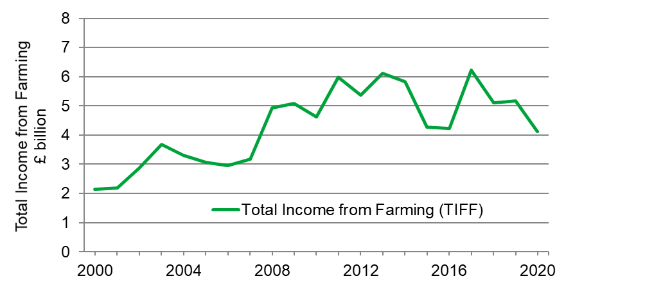
Source: Defra

The GDP deflator used to adjust prices to real terms is sourced from Office for National Statistics.

Table 4.1 Production and income accounts in real terms (adjusted for inflation)
Enquiries: Robin Karfoot on +44(0)20 80266449, email: farmaccounts@defra.gov.uk

£ million
 | 2013-2017 | 2018 | 2019 | 2020
Total crop output | 10,169 | 10,235 | 10,596 | 9,018
Total livestock output | 15,556 | 15,712 | 15,424 | 15,072
10 Other agricultural activities | 1,257 | 1,344 | 1,361 | 1,341
11 Inseparable non-agricultural activities | 1,387 | 1,552 | 1,638 | 1,239
12 Output (at market prices) | 28,370 | 28,843 | 29,019 | 26,670
13 Total subsidies (less taxes) on product | 38 | 50 | 50 | 47
14 Gross output at basic prices | 28,408 | 28,893 | 29,069 | 26,717
25 Total intermediate consumption | 17,939 | 18,349 | 18,374 | 17,282
26 Gross value added at market prices | 10,431 | 10,494 | 10,646 | 9,388
27 Gross value added at basic prices | 10,469 | 10,544 | 10,696 | 9,435
28 Total consumption of Fixed Capital | 4,622 | 4,701 | 4,819 | 4,626
29 Net value added at market prices | 5,809 | 5,793 | 5,826 | 4,762
30 Net value added at basic prices | 5,847 | 5,843 | 5,876 | 4,809
31 Other taxes on production | -115 | -106 | -106 | -100
32 Other subsidies on production | 3,542 | 3,403 | 3,339 | 3,165
33 Net value added at factor cost | 9,274 | 9,139 | 9,110 | 7,874
34 Compensation of employees | 2,849 | 2,915 | 2,855 | 2,767
35 Rent | 636 | 607 | 590 | 544
36 Interest | 774 | 741 | 722 | 667
37 Total Income from Farming | 5,331 | 5,114 | 5,169 | 4,119
Notes:
- A GDP deflator is used to convert current prices (table 4.2) to real terms prices.
- 2013-2017 figures are a 5-year average
- Output is net of VAT collected on the sale of non-edible products. Figures for output at market prices exclude subsidies on products.
- Subsidies (less taxes) on product are payments linked to the production of agricultural products.
- Other subsidies on production are payments not linked to production from which agricultural producers can benefit as a consequence of engaging in agricultural activities e.g. Basic Payment Scheme, agri-environment schemes.
- Interest refers to charges on loans for current farming purposes and buildings and works less interest on money held on short term deposit
- See Appendix to Chapter 4 for aggregate accounts terms and definitions

Detailed comparison between 2020 and 2019 using current prices (not adjusted for inflation)
(Table 4.2)
This comparison of the Total Income from Farming account from the two most recent years is made between values that have not been adjusted for inflation (‘current prices’). This approach is considered the most intuitive for comparisons over a short time period. The data is followed by commentary offering explanation for the values estimated for 2020 and how they have changed since 2019.

Headline figures for 2020 (comparisons with 2019 in current prices)
In 2020, Total Income from Farming in current prices (not adjusted for inflation) fell by £768m to £4,119m, a 15.7% fall from 2019.

Almost the entire fall in TIFF can be explained by Gross Output at basic prices which fell by £764m. Overall costs in 2020 were similar to 2019, as were total subsidies.

The main contributors to this decrease are the fall in the value of output from wheat (£885m, 36%), oilseed rape (£227m, 39%) and inseparable non-agricultural activities (£310m, 20%).

Gross Value Added (GVA) at basic prices, which measures agriculture’s contribution to the Gross Domestic Product (GDP), fell by 6.7% (£676m) to £9,435m in 2020.

Table 4.2 Changes in outputs and inputs at current price
Enquiries: Robin Karfoot on +44 (0)20 802 66449, email: farmaccounts@defra.gov.uk

£ million
 | 2019 | 2020 | 2019 to 2020 change (%)
 |  |  | Value | Volume | Price
Output at market prices
1 Cereals | 3,629 | 2,759 | -24% | -26% | 3%
of which: wheat | 2,434 | 1,550 | -36% | -40% | 6%
barley | 1,072 | 1,054 | -2% | 0% | -2%
oats | 117 | 150 | 28% | 41% | -9%
2 Industrial crops | 984 | 737 | -25% | -28% | 5%
of which: oilseed rape | 586 | 358 | -39% | -41% | 3%
protein crops | 145 | 155 | 7% | -1% | 8%
sugar beet | 210 | 172 | -18% | -23% | 6%
other industrial crops | 33 | 30 | -9% | -9% | 0%
3 Forage plants | 231 | 217 | -6% | -6% | 0%
4 Vegetables & horticultural products | 2,855 | 2,968 | 4% | 2% | 2%
of which: fresh vegetables | 1,481 | 1,611 | 9% | 3% | 6%
plants and flowers | 1,374 | 1,358 | -1% | 0% | -1%
5 Potatoes (including seeds) | 764 | 824 | 8% | 4% | 4%
6 Fruit | 917 | 1,041 | 13% | -4% | 19%
7 Other crop products including seeds | 637 | 472 | -26% | -36% | 15%
Total crop output | 10,017 | 9,018 | -10% | -14% | 5%
8 Output of livestock | 9,339 | 9,864 | 6% | -1% | 7%
primarily for meat | 8,034 | 8,573 | 7% | -1% | 7%
of which: cattle | 2,729 | 2,929 | 7% | 3% | 4%
pigs | 1,342 | 1,442 | 7% | 2% | 5%
sheep | 1,250 | 1,346 | 8% | -4% | 13%
poultry | 2,671 | 2,813 | 5% | -4% | 9%
gross fixed capital formation | 1,306 | 1,291 | -1% | -6% | 6%
of which: cattle | 758 | 781 | 3% | -1% | 4%
pigs | 6 | 5 | -13% | -1% | -12%
sheep | 272 | 270 | -1% | -14% | 16%
poultry | 270 | 235 | -13% | -13% | 0%
9 Output of livestock products | 5,242 | 5,208 | -1% | 0% | 0%
of which: milk | 4,462 | 4,383 | -2% | 0% | -2%
eggs | 659 | 730 | 11% | 0% | 11%
Total livestock output | 14,582 | 15,072 | 3% | -1% | 4%
10 Other agricultural activities | 1,287 | 1,341 | 4% | 3% | 1%
11 Inseparable non-agricultural activities | 1,549 | 1,239 | -20% | -21% | 1%
12 Output (at market prices) | 27,434 | 26,670 | -3% | -7% | 4%
13 Total subsidies (less taxes) on product | 47 | 47 | 0% | . . | . .
14 Gross output at basic prices | 27,481 | 26,717 | -3% | -7% | 4%
continued

Table 4.2 Changes in outputs and inputs at current price (continued)

£ million
 |  |  |  |  | 2019 to 2020 change (%)
 |  |  | 2019 | 2020 | Value | Volume | Price
Intermediate consumption
15 Seeds |  |  | 837 | 977 | 17% | 16% | 0%
16 Energy |  |  | 1,392 | 1,290 | -7% | 3% | -10%
of which: electricity & fuels for heating |  |  | 460 | 455 | -1% | 0% | -1%
motor and machinery fuels |  |  | 932 | 835 | -10% | 4% | -14%
17 Fertilisers |  |  | 1,388 | 1,147 | -17% | -6% | -12%
18 Plant protection products |  |  | 1,001 | 1,097 | 10% | 0% | 10%
19 Veterinary expenses |  |  | 460 | 460 | 0% | 0% | 0%
20 Animal feed |  |  | 5,529 | 5,586 | 1% | -1% | 2%
of which: compounds |  |  | 3,354 | 3,418 | 2% | 1% | 1%
straights |  |  | 1,442 | 1,588 | 10% | 4% | 6%
feed for on farm use or purchased from other farms |  |  | 734 | 580 | -21% | -19% | -3%
21 Total maintenance |  |  | 1,790 | 1,822 | 2% | 0% | 2%
of which: materials |  |  | 1,056 | 1,068 | 1% | -3% | 4%
buildings |  |  | 733 | 755 | 3% | 4% | -1%
22 Agricultural services |  |  | 1,287 | 1,341 | 4% | 3% | 1%
23 FISM |  |  | 151 | 175 | 16% | . . | . .
24 Other goods and services |  |  | 3,536 | 3,387 | -4% | -7% | 3%
25 Total intermediate consumption |  |  | 17,370 | 17,282 | -1% | -1% | 0%
26 Gross value added at market prices |  |  | 10,064 | 9,388 | -7% | . . | . .
27 Gross value added at basic prices |  |  | 10,111 | 9,435 | -7% | . . | . .
28 Total consumption of Fixed Capital |  |  | 4,556 | 4,626 | 2% | -1% | 2%
of which: equipment |  |  | 2,086 | 2,117 | 1% | 1% | 1%
buildings |  |  | 1,069 | 1,058 | -1% | -1% | 0%
livestock |  |  | 1,400 | 1,451 | 4% | -3% | 7%
cattle |  |  | 824 | 881 | 7% | 1% | 6%
pigs |  |  | 6 | 5 | -14% | -1% | -13%
sheep |  |  | 278 | 285 | 2% | -11% | 16%
poultry |  |  | 292 | 281 | -4% | -4% | 0%
29 Net value added at market prices |  |  | 5,508 | 4,762 | -14% | . . | . .
30 Net value added at basic prices |  |  | 5,555 | 4,809 | -13% | . . | . .
31 Other taxes on production |  |  | -100 | -100 | - | . . | . .
32 Other subsidies on production |  |  | 3,156 | 3,165 | 0% | . . | . .
33 Net value added at factor cost |  |  | 8,612 | 7,874 | -9% | . . | . .
34 Compensation of employees |  |  | 2,699 | 2,767 | 3% | -2% | 5%
35 Rent |  |  | 558 | 544 | -2% | . . | . .
36 Interest |  |  | 468 | 444 | -5% | . . | . .
37 Total Income from Farming |  |  | 4,886 | 4,119 | -16% | . . | . .
Notes:
- See Appendix to Chapter 4 for aggregate accounts terms and definitions
- Price figures are average unit prices that may not be consistent with farm-gate prices presented elsewhere in this publication
- .. means ‘not available’ or ‘not applicable’

Outputs: Crops (comparisons with 2019 in current prices)
The value of Total Crop Output for 2020 was £9,018m, a fall of £999m or 10% compared with 2019. In general, cereals and industrial crops struggled, whilst horticultural crops fared much better overall.
The value of output from cereals was £2,759m, a fall of £870m (24%) on 2019. This fall was largely explained by wheat output which fell in value by £885m (36%) to £1,550m. Drilling of winter wheat in 2019/20 was badly affected by significant winter rain meaning that some planting was abandoned in favour of spring sowing of other crops. The very dry spring caused further problems and, whilst the harvest got off to a good start, heavy rain in mid / late August caused losses and quality issues. The result was a 24% fall in wheat area and reduced yields contributing to the smallest UK wheat harvest (by volume) since 1981. A price rise of 6.1% for wheat was not nearly enough to compensate for the 40% fall in volume.
The value of output from barley fell by £18m (1.7%) to £1,054m. The large number of growers switching from winter wheat to spring barley meant that, despite the difficult season, barley production in 2020 was up slightly on the record harvests seen in 2019. The price of barley fell by 2.1%, due to plentiful supplies and lower demand from brewers because of hospitality venues being closed during coronavirus lockdowns.
The value of output from oilseed rape (OSR) fell by £227m (39%) to £358m. The planted area of oilseed rape fell again in 2020, this time by 28%, giving the smallest area since 1989 and contributing to a 41% fall in volume. Wet weather during crop establishment and infestations of cabbage stem flea beetle proved problematic for growers.
The value of sugar beet fell by £38m (18%) to £172m. The dry spring and aphid infestations following two mild winters resulted in a 23% fall in production.
The value of output from fresh vegetables rose by £129m (8.7%) to £1,611m. Both volume and average price saw small rises in 2020, though fortunes were mixed over a wide variety of crops. Some crops such as carrots and onions struggled with the wet winter and very dry spring though the mixture of heat and rains later in the year proved favourable, particularly for brassica production.
The value of output from plants and flowers fell by £16m (1.2%) to £1,358m. The sector was impacted by the first coronavirus lockdown that closed garden centres during a critical selling period. Many nurseries successfully adapted their businesses and were able to recoup some sales later in the year.
The value of output from potatoes rose by £61m (7.9%) to £824m. Both volume and price were slightly higher in 2020 than in 2019.
The value of output from fruit rose by £124m (13%) to £1,041m. This was driven by a rise in average prices of 19%, which outweighed a 4.4% drop in volume. Despite a good harvest, Bramley apples saw a big rise in price due to low stocks carried over. Strawberries and blackcurrants also enjoyed significantly higher prices in 2020.

Outputs: Livestock (comparisons with 2019 in current prices)
The value of total livestock output for 2020 was £15,072m, a rise of £490m or 3.4% compared with 2019. This was mainly driven by livestock primarily for meat rather than livestock products such as milk.
The value of output from livestock primarily for meat rose by £540m (6.7%) to £8,573m, with all four main livestock groups (cattle, pigs, sheep and poultry) seeing rises in value of between 5% and 8% on 2019.
The value of output from cattle (for meat) rose by £200m (7.3%) to £2,929m. Both volume and price showed small rises. The closure of hospitality outlets due to coronavirus reduced demand for high value cuts. Initial concerns that these cuts would be minced and carcase value would fall appear not to have been too damaging overall.
The value of output from pigs rose by £100m (7.4%) to £1,442m. Both volume and price showed small rises as the market for pig meat proved resilient to coronavirus lockdowns.
The value of output from sheep rose by £96m (7.7%) to £1,346m. The volume of sheep meat production fell by 4.3% but this was outweighed by a 13% rise in price. The Easter lamb market was disrupted by the first coronavirus lockdown. However, retail volumes were boosted by demand for takeaways throughout the second half of the year and prices were helped by reduced competition from New Zealand lamb.
The value of output from poultry (for meat) rose by £142m (5.3%) to £2,813m. The main driver was broiler meat production which increased in both volume and price. An increased demand was seen for free-range and organic chickens as consumers sought more luxury meals at home during coronavirus lockdowns. The turkey market was forced to reduce placements as large Christmas gatherings were not anticipated to be possible.
The value of output from milk fell by £78m (1.8%) to £4,383m. Milk consistently has the highest value of any individual item on the account by a considerable margin. In 2020 output from milk was worth 50% more than output from cattle (for meat) and almost three times as much as output from wheat. The observed fall in value was almost entirely due to a fall of 0.55 pence per litre (1.8%) in the average farmgate price to 28.56 pence per litre. The level of milk production was maintained, whilst market demands in the dairy sector shifted from hospitality (e.g. liquid milk for coffee) to households (e.g. butter for baking) during coronavirus lockdowns.
The value of output from eggs rose by £71m (11%) to £730m. This was almost entirely driven by an 11% increase in price, partly due to a continued move from caged production to higher welfare and organic systems. Demand for eggs benefited from an increase in baking during coronavirus lockdowns.

Intermediate consumption (comparisons with 2019 in current prices)
Intermediate consumption is the goods and services used as inputs in the processes of production, e.g. feed, energy and fertiliser. The total cost of Intermediate Consumption in 2020 was £17,282m, a fall of £88m or 0.5% compared with 2019. This modest change is the sum of several more substantial rises and falls in the component cost categories, mostly influenced by weather events and the coronavirus pandemic.
The cost of seeds rose by £140m (17%) to £977m. This was almost entirely due to a 16.5% rise in the volume of seeds, with many cereal farmers sowing increased areas in spring 2020 in response to the unfavourable drilling and establishment conditions over winter 2019/20 before returning to winter varieties in late 2020. Increased seed rates per hectare and an increase in the use of cover crops also contributed.
The cost of energy fell by £102m (7.3%) to £1,290m. This was almost entirely due to a fall of £97m (10%) in the cost of motor and machinery fuels. There was a 4.5% increase in the volume of fuel used mainly due to the increase in spring sown cereals, but this was outweighed by a 14% fall in price due to lower global demand for oil because of coronavirus related lockdowns.
The cost of fertilisers fell by £241m (17%) to £1,147m. This was the largest nominal change of all the itemised Intermediate Consumption costs and resulted from falls in both the volume and price of fertilisers. Volume fell by 6.2% due to less fertiliser-intensive spring crops replacing winter sown crops for the 2020 harvest. The price of fertilisers fell by 12% as production is heavily reliant on energy, which fell in price in 2020.
The cost of plant protection products rose by £96m (9.6%) to £1,097m. A reduced volume of fungicide was used due to lower than usual disease pressure thanks to the mild and dry spring, but price was higher because of the banning of chlorothalonil. The volume of herbicide used rose as post emergence applications on winter sown crops were postponed from late 2019 to early 2020.
The cost of animal feed rose by £57m (1.0%) to £5,586m. Animal feed is consistently the biggest percentage share of total Intermediate Consumption and comprises compounds, straights and feed produced and used on farm or purchased from other farms. Compounds consistently make up the majority of animal feed costs and in 2020 the cost of compounds rose by £65m (1.9%) to £3,418m. The price rise of 0.8% was kept down partly by compounders switching from wheat to barley where possible. The cost of straights rose by £146m (10%) to £1,588m owing to a 4.3% rise in volume and 5.6% rise in price. The cost of animal feed kept within the agricultural industry fell by £154m (21%) to £580m.
The cost of other goods and services fell by £149m (4.2%) to £3,387m. This was mainly driven by a significant reduction in the volume of straw purchased from other farms as a result of good stocks from 2019 and limited supply following the poor harvest in 2020.

Compensation of employees (comparisons with 2019 in current prices)
The total cost of compensation of employees in 2020 was £2,767m, a rise of £68m or 2.5% compared with 2019. The rise was mainly driven by wage increases as the UK Labour force working in agriculture decreased slightly. Factors that are likely to have affected the labour market include coronavirus restrictions, restricted international travel, and the introduction of the furlough scheme, which impacted both regular and casual workers.

Other subsidies on production (comparisons with 2019 in current prices)
In 2020, production-linked payments (‘Total subsidies (less taxes) on product’) were down by £0.15m to £47.1m. Other subsidies on production which include the Basic Payment Scheme and agri-environment payments totalled £3,165m, a rise of £9m or 0.3% compared with 2019.

Capital available to the agricultural industry
(Table 4.3)
The agricultural balance sheet values the assets and liabilities for the agricultural industry at the end of each calendar year and estimates the net worth of the industry. The latest available data is for 2019 rather than 2020, pending publication of the revised estimates for Total Income from Farming for 2020 later in 2021 (usually November).

Table 4.3 shows overall net worth of the UK agricultural industry is estimated to be £268,972m at December 2019, an increase of £11,561m (4.5%) from 2018 (without adjusting for inflation). The value of farmland is estimated to have risen by 5.4%, driven mostly by an increase in average land price. Total liabilities are estimated to be 2.3% higher in 2019 as lending to UK agriculture continues to increase.

Table 4.3 Aggregate balance sheet for the agricultural industry
Enquiries: Robin Karfoot on +44 (0)20 802 66449, email: farmaccounts@defra.gov.uk

£m (at current prices)
 | 2017 | 2018 | 2019
Fixed assets total | 254,794 | 262,908 | 275,119
Land | 212,326 | 219,184 | 231,095
Buildings, plant, machinery and vehicles | 36,172 | 37,548 | 37,813
Breeding livestock | 6,297 | 6,175 | 6,211
Current assets total | 15,318 | 15,406 | 15,244
Trading livestock | 4,358 | 4,086 | 4,073
Crops and stores | 3,979 | 4,340 | 4,166
Debtors, cash deposits | 6,981 | 6,980 | 7,005
Total Assets | 270,112 | 278,314 | 290,363
Long and medium term liabilities total | 14,160 | 14,699 | 15,451
AMC and SASC | 2,182 | 2,552 | 2,795
Building Societies and Institutions | 1,681 | 1,594 | 1,919
Bank loans | 9,683 | 9,914 | 10,007
Family Loans | 525 | 546 | 650
Other | 88 | 93 | 80
Short term liabilities total | 6,172 | 6,205 | 5,940
Leasing | 33 | 20 | 20
Hire purchase | 1,525 | 1,562 | 1,571
Trade Credit | 2,407 | 2,408 | 2,239
Bank overdrafts | 2,166 | 2,166 | 2,055
Other | 41 | 48 | 56
Total Liabilities | 20,331 | 20,903 | 21,391
Net worth | 249,781 | 257,411 | 268,972
Source: Defra
Notes:
- The valuations of land and breeding livestock are at average market prices; cost, net of consumption of fixed capital; those of buildings, plant, machinery and vehicles are replacement.
- Estimated values for arable land and pasture in Great Britain & Northern Ireland based on land area from The June Survey of Agriculture and Horticulture.
- AMC is Agricultural Mortgage Company and SASC is Scottish Agricultural Securities Corporation
In real terms, using the GDP deflator to adjust for inflation, net worth grew by 2.7% in 2019 compared with 2018. Agricultural Industry net worth is closely linked to the value of farmland. Over a longer period, net worth in real terms grew strongly from the early 2000s in line with land values (see Figure 4.2). However, since the land price market peaked at the end of 2015, there has been a modest decline in average land price, but with significant differences across both land type and regions in the United Kingdom. During this period of asset value growth, the value of total liabilities also grew, but at a slower overall rate.

Figure 4.2 Indices of Assets, Liabilities and Net worth of the agricultural industry; in real terms
1973=100

Source: Defra
Notes:
- Adjusted for inflation using GDP deflator

Revisions to data in this chapter
Figures for 2020 are provisional and subject to revision.

Revisions are intended to increase the precision of the estimates. Values for very recent years in time series are routinely revised since the previous edition of AUK as the result of more data becoming available after the publication of AUK. Sometimes additional revisions are necessary to refine the methodology or correct historical errors.

Total Income from Farming is sensitive to small percentage changes in the values of outputs and intermediate consumption. In particular, the combination of a revision downwards in output and revision upwards in intermediate consumption leads to more sizeable revisions in percentage terms to Gross Value Added and Total Income from Farming.

Chapter 4 Appendix - Definition of account items and terms used in tables 4.1 and 4.2

Item | Term | Derived from | Definition
1 to 7 | Crop outputs |  | Crops, other crop products including seeds
8 | Livestock outputs including capital formation |  | Production of animals including that used as the means of production, e.g. breeding animals.
9 | Livestock product outputs |  | Milk, eggs
10 | Other agricultural activities |  | Agricultural activities that do not result in sales of final product, e.g. quota leasing, contract work.
11 | Inseparable non-agricultural activities |  | Non-agricultural activities included within the business level accounts and are inseparable
12 | Output at market prices |  | Output excluding subsidies. The output of the agricultural industry includes non-agricultural activities and transactions within the industry.
13 | Subsidies (less taxes) on product |  | Subsidies and taxes linked to the production of an agricultural product. All subsidies are recorded on an ‘as due’ basis.
14 | Gross output at basic prices | 12+13 | Output at market price plus directly paid subsidies that are linked to production of specific product.
15 to 22 | Intermediate consumption items |  | Includes seeds, energy, fertilisers, plant protection products, veterinary expenses, animal feed
23 | FISIM |  | Financial Intermediation Services Indirectly Measured (FISIM) is an estimate of the value of services provided by financial intermediaries, such as banks, for which no explicit charges are made, and which are paid for as part of the margin between rate applied to savers and borrowers.
24 | Other goods and service |  | Includes livestock and crop costs, water costs, insurance premiums, bank charges, professional fees, rates, and other farming costs.
25 | Intermediate consumption | Sum of 15 to 24 | Consumption of goods and services
continued

Chapter 4 Appendix - Definition of account items and terms used in tables 4.1 and 4.2

Item | Term | Derived from | Definition
26 | Gross value added at market prices | 12-25 | Gross output at market prices less intermediate consumption.
27 | Gross value added at basic prices | 14-25 | Gross output at basic prices less intermediate consumption.
28 | Consumption of fixed capital |  | The value (at current prices) of capital assets used in the production process, e.g. buildings, plant, machinery, vehicles and livestock.
29 | Net value added at market prices | 26-28 | Gross value added at basic prices less consumption of fixed capital.
30 | Net value added at basic prices | 27-28 | Gross value added at basic prices less consumption of fixed capital.
31 | Other taxes on production
32 | Other subsidies on production |  | Subsidies and taxes not linked to production of a specific product.
33 | Net value added at factor cost | 30+31+32 | Net value added at basic prices plus other subsidies (less taxes) on production.
34 | Compensation of employees |  | The full costs of employees to the business including national insurance contributions.
35 | Rent
36 | Interest |  | Charges on loans for current farming purposes and buildings and works less interest on money held on short term deposit.
37 | Total Income from Farming | 33-34-35-36 | Income to those with an entrepreneurial interest in the agricultural industry, e.g. farmers, partners, spouses and most other family workers.

Chapter 5 Productivity

Summary
Key results for 2020 compared to 2019

- Total factor productivity of UK agriculture decreased by 6.7%. This was driven by a decrease in overall levels of production combined with a small increase in volumes of inputs.
- Volume of all outputs decreased by 6.3%. This was driven by a 12.4% decrease for crops, plus small (less than 1%) decreases for both livestock and livestock products.
- Volume of all inputs increased slightly by 0.5%
- Since 1973 total factor productivity has increased by nearly 50%, driven by a 32% increase in the volume of outputs and a 12% fall in the volume of inputs.

Introduction
Productivity is a measure of how well inputs are converted into outputs, giving an indication of the efficiency and competitiveness of the agriculture industry. While external factors such as weather conditions or disease outbreaks may have short term impacts on productivity, it is improvements in productivity over a longer period that drive increases in agricultural income.

The headline measure, total factor productivity, shows the change in the volume of output leaving the industry per unit of all inputs entering the industry, including fixed capital and labour. The partial factor productivity indicators show the volume of output leaving the industry per unit of one particular type of input, in this case intermediate consumption, consumption of fixed capital, labour and land.

Total factor productivity
(Figure 5.1)
Total Factor Productivity of the agriculture industry in the United Kingdom decreased by 6.7% between 2019 and 2020. The annual decrease is driven by a fall of 6.3% for outputs combined with a small increase of 0.5% in the volume of inputs. As shown in figure 5.1. this continues the pattern of fluctuations seen from around the year 2000 onwards. Despite this inter-annual variability, the long-term trend is still one of slow but steady overall improvement.

Since 1973, Total Factor Productivity has increased by nearly 50%, driven by a 32% increase in the volume of outputs and a 12% fall in the volume of inputs.

Figure 5.1 Total factor productivity (1973=100)

Source: Defra

Details of volume changes of outputs and inputs
(Table 5.1)
Total outputs decreased by 6.3% between 2019 and 2020, driven by a decrease of 12.4% in the volume of all crops and a decrease of 0.6% in the volume of all livestock outputs.

Cereals decreased by 26% in 2020, a sharp contrast to 2019, which had seen some of the highest levels of production ever recorded for the UK. The wet weather in autumn 2019 during the planting season for winter cereals prevented sowing across significant areas and also led to poor establishment for many crops that were planted. There was then a dry spell in the spring of 2020 that delayed development. There was a compensatory increase in spring crops, which have lower yields than winter sown cereals, and this, together with the poor start to crop development and very wet weather during the main harvest of winter wheat in 2020, led to a fall in the outputs of cereals, which for wheat was the lowest since 1981.

Both oilseed rape and sugar beet saw similar sharp falls, with decreases of 41% and 23% respectively. Both crops were adversely affected by insect pests and wet weather at critical stages.

Livestock outputs showed an overall decrease of 0.6%. There was some disruption to the livestock sector due to coronavirus (COVID-19) restrictions that led to animals being delayed going to markets. Production was later adapted to market conditions where this was feasible.

Milk increased by 0.1% whilst eggs decreased by 0.4%. Milk production was held back during the start of the year to adapt to market conditions following the shutdown of hospitality and institutional outlets during the first coronavirus lockdown and without this might have seen a larger increase in outputs.

Total volume of meat production decreased by 0.6%. Cattle, pigs and other animals saw increases of 2.8%, 2.3% and 2.5% respectively. However, sheep and poultry both fell by 4.3% and 3.8% respectively.

Table 5.1 Total factor productivity volume indices
Enquiries: Alistair Murray on +44 (0) 20 802 6121, email: alistair.murray@defra.gov.uk

2015=100
 | 2019 | 2020 | % Change from 2019
1 Output of cereals | 98.7 | 72.7 | -26.3
wheat | 96.0 | 60.1 | -37.3
rye | 100.0 | 100.0 | 0.0
barley | 106.2 | 103.4 | -2.6
oats and summer cereal mixtures | 100.1 | 151.4 | 51.2
other cereals | 155.9 | 150.5 | -3.4
2 Output of industrial crops | 79.6 | 57.0 | -28.4
oil seeds | 69.0 | 42.6 | -38.3
oilseed rape | 68.9 | 40.8 | -40.8
other oil seeds | 87.1 | 187.7 | 115.5
protein crops | 78.8 | 78.0 | -1.0
sugar beet | 124.8 | 96.2 | -23.0
other industrial crops | 104.6 | 95.5 | -8.7
3 Output of forage plants | 100.0 | 100.0 | 0.0
4 Output of vegetables and horticultural products | 96.9 | 98.4 | 1.5
fresh vegetables | 91.5 | 94.1 | 2.8
plants and flowers | 103.1 | 103.2 | 0.1
5 Output of potatoes | 93.9 | 97.7 | 4.0
6 Output of fruit | 100.7 | 96.3 | -4.4
7 Output of other crop products | 110.4 | 83.0 | -24.8
Total crop output (sum 1 to 7) | 95.8 | 83.9 | -12.4
8 Output of livestock (meat) | 105.9 | 105.2 | -0.6
cattle | 100.7 | 103.5 | 2.8
pigs | 107.9 | 110.4 | 2.3
sheep | 102.5 | 98.1 | -4.3
poultry | 113.2 | 108.9 | -3.8
other animals | 100.8 | 103.3 | 2.5
9 Output of livestock products | 104.5 | 104.0 | -0.4
milk | 101.3 | 101.4 | 0.1
eggs | 118.2 | 117.7 | -0.4
raw wool | 92.3 | 92.5 | 0.3
other animal products | 180.6 | 141.4 | -21.7
Total livestock output (8 + 9) | 105.4 | 104.8 | -0.6
10 Inseparable non-agricultural activities | 121.2 | 96.1 | -20.7
11 All outputs | 102.7 | 96.3 | -6.3
continued

Table 5.1 Total factor productivity volume indices (continued)
2015=100
 | 2019 | 2020 | % Change from 2019
12 Seeds | 103.5 | 120.6 | 16.6
13 Energy | 95.6 | 98.4 | 3.0
electricity and fuels for heating | 101.1 | 101.2 | 0.1
motor and machinery fuels | 93.0 | 97.2 | 4.5
14 Fertilisers | 96.5 | 90.5 | -6.2
15 Plant protection products | 78.0 | 78.0 | -0.1
16 Veterinary expenses | 86.4 | 86.5 | 0.2
17 Animal feed | 104.4 | 106.6 | 2.1
compounds | 107.9 | 109.2 | 1.1
straights | 97.0 | 101.2 | 4.3
18 Total maintenance | 102.6 | 102.6 | -0.1
materials | 102.5 | 99.9 | -2.5
buildings | 102.8 | 106.4 | 3.5
19 FISIM | 100.0 | 100.0 | 0.0
20 Other goods and services | 100.5 | 99.5 | -1.0
21 Intermediate consumption (excluding Agricultural services) | 99.2 | 100.3 | 1.1
22 Consumption fixed capital (excluding livestock) | 104.7 | 104.8 | 0.1
equipment | 109.1 | 109.7 | 0.6
buildings | 96.8 | 96.0 | -0.8
23 All Labour | 100.9 | 100.8 | 0.0
Compensation of employees | 98.0 | 96.0 | -2.0
Entrepreneurial workers (farm and specialist contractor) | 102.4 | 103.4 | 1.0
24 Land | 102.2 | 100.7 | -1.5
25 All Inputs and Entrepreneurial Labour | 100.5 | 101.0 | 0.5
Total factor productivity (11 divided by 25) | 102.2 | 95.3 | -6.7

Partial factor productivity
(Table 5.2 and Figure 5.2)
Partial productivity shows the impact key inputs have on productivity. It measures total outputs against a part of the inputs. Table 5.2 shows the most recent data with a base year of 2015, for direct comparison with the figures in Table 5.1. Figure 5.2 presents the long-term time series for this data and uses 1973 as the base year (1973=100). It shows that labour is the key input in driving productivity gains. Productivity by labour shows a steady increase over the whole period. Labour volumes are now approximately half of what they were in 1973. However, over the last few years growth in labour productivity is due to increased output rather than a reduction in labour number.

Table 5.2 Partial factor productivity
2015=100
 | 2019 | 2020 | % Change from 2019
Productivity by intermediate consumption | 103.6 | 96.0 | -7.3
Productivity by capital consumption | 98.1 | 91.9 | -6.4
Productivity by labour | 101.8 | 95.5 | -6.2
Productivity by land | 100.4 | 95.6 | -4.9
Total factor productivity | 102.2 | 95.3 | -6.7

Figure 5.2 Partial productivity indicators (1973=100)

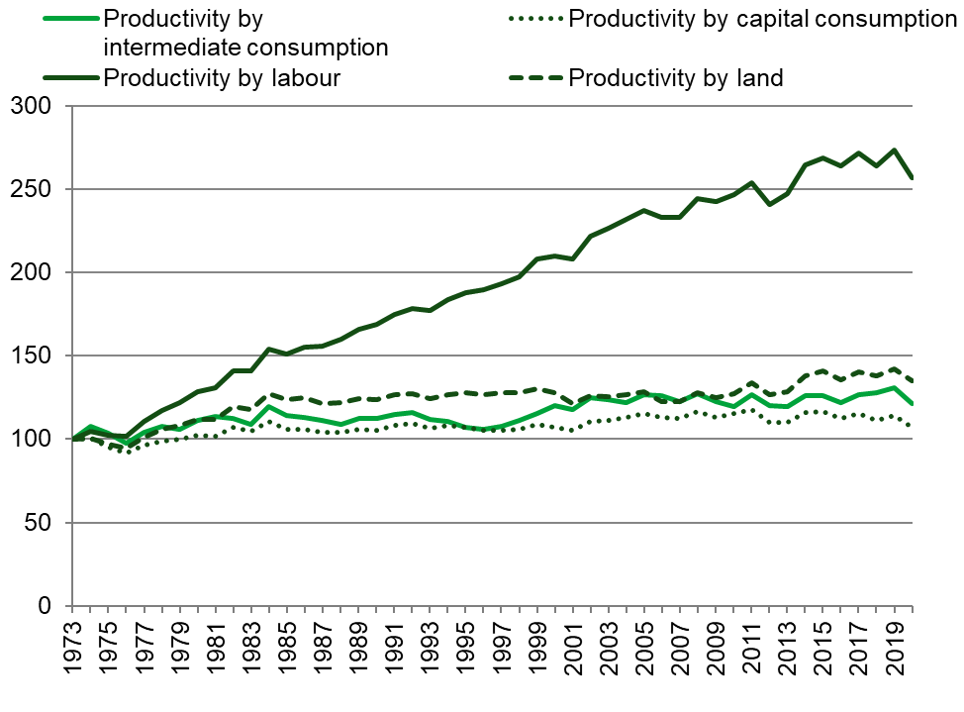
Source: Defra

Revisions
All figures for 2020 are provisional and subject to revision.

Revisions are generally as a result of more up-to-date data becoming available or as a result of methodology reviews. The main change in recent years was the introduction of land in the productivity indicator, from 2014 estimates onwards. The volume of land is based on the utilised agricultural area. The price used for land is based on the rental value. Owned land is given a notional rent value. As a result of high land values it has become a key component of the productivity indicator. The inclusion of land has resulted in a slight reduction in productivity gains.

Chapter 6 Prices

Summary
Key results for 2020 compared to 2019

- The annual Agricultural Price Index (API) for agricultural outputs increased by 4.6%, while for agricultural inputs it decreased by 0.2%.
- The price index for crop products increased by 5.7%, with lower prices for oats, potatoes and barley offset by higher prices for fresh fruit, forage plants and wheat.
- The price index for animals and animal products increased by 3.8%. Higher producer prices were reported across all sectors except for milk, with the largest increase for sheep and lambs.
- The slight fall in the index for inputs was driven by lower prices for fertilisers and energy, partly offset by an increase in prices for pesticides and animal feed.

Data sources
The Agricultural Price Index (API) measures the monthly price changes in agricultural outputs and inputs for the UK. The output series reflects the prices farmers receive for their products, also referred to as farmgate prices. Information is collected for all major crops (for example wheat and potatoes), and for livestock and animal products (for example sheep, milk, and eggs).

The input series reflects the prices farmers pay for goods and services and is split into two groups: goods and services currently consumed, and goods and services contributing to investment. Goods and services currently consumed refer to items that are used up in the production process (for example fertiliser or seed). Goods and services contributing to investment relate to items that are required but not consumed in the production process (for example tractors or farm buildings).

Exchange Rates
(Figure 6.1)
Fluctuating global currency prices can have significant effects on the prices of both agricultural inputs and outputs (see figure 6.1). After a fall in the pound against the euro and, to a lesser extent, the dollar in March 2020, the pound remained relatively stable but weak for the remainder of the year. This weak pound benefitted farmers with augmented Basic Payment Scheme payments (payments are set in euros) and export prices, while also increasing the cost of commonly imported farming inputs such as pesticides and animal feed. In contrast, the pound against the dollar strengthened throughout the year with December seeing the pound hit its highest level in 2020.

Figure 6.1 Exchange rate of sterling against the euro and US dollar

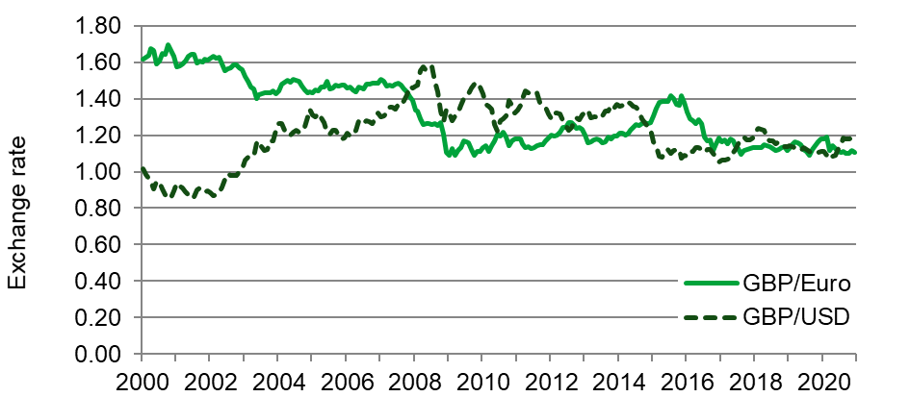

Annual Price Indices for 2020

(Figures 6.2 to 6.10, table 6.1)

Figure 6.2 Monthly price indices for total outputs and total inputs from 2015 to 2020

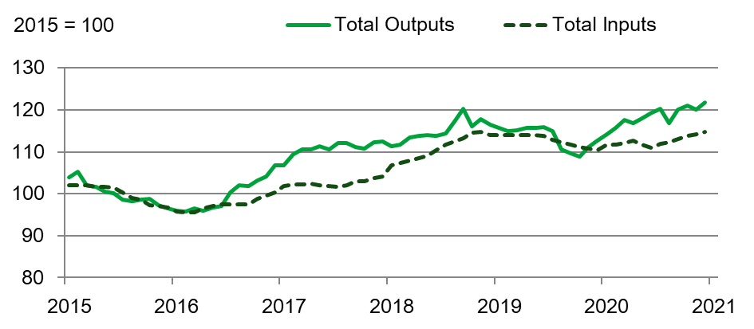
Compared with 2019, the annual Agricultural Price Index increased by 4.6% for outputs and decreased by 0.2% for inputs (see figures 6.2 and 6.3). This represents a period of relative stasis for input prices and the first sustained increase in output prices since 2016/17.

Figure 6.3 Annual price index for total outputs and total inputs from 2015 to 2020

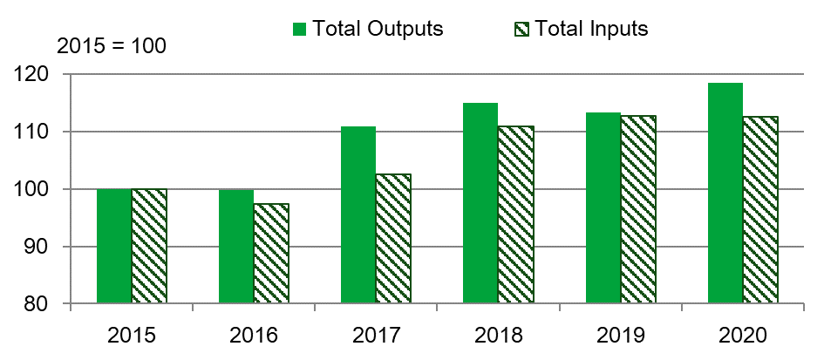
In comparison with 2019, the ratio of outputs to inputs increased markedly, with outputs outstripping inputs by the largest amount since 2017.

Figure 6.4 Monthly cereal price index 2019 and 2020
2015 = 100

The annual price index for crop products increased by 5.7% in 2020 compared with 2019, driven by significantly higher prices for fresh fruit, forage plants (wheat straw) and cereals. As shown in figure 6.4, cereals prices rose steadily throughout the first half of 2020 – a trend which began in late 2019. Cereals prices then increased rapidly during the second half of 2020 as a result of a rise in wheat prices. The winter planting season was ruined for many growers with heavy rain leading to waterlogging and a delay in planting. Many farmers were forced to abandon winter planting and wait for spring, and to grow alternative crops such as spring barley, oats and pulses. The spring drought / hot weather caused further problems and, whilst the harvest got off to a good start, heavy rain in mid / late August caused losses and quality issues. The result is the lowest wheat harvest since 1981. Low yield, combined with a reluctance of producers to sell their limited stock, pushed prices to highs not seen since 2012/13.

Figure 6.5 Monthly potato price index 2019 and 2020

2015 = 100

The price index for potatoes decreased 3.9% compared with 2019. Potato prices in 2020 closely tracked those in the previous year (see figure 6.5), despite lower demand. Prices remained stable during the first half of 2020, after a jump in March, when potato supplies tightened. Potato prices then began to fall as movement of new crop dominated the market. With lifting halted in October for many growers due to wet weather, prices rebounded and continued to rise for the remainder of 2020.

Figure 6.6 Monthly sheep and lambs price index 2019 and 2020

2015 = 100

The price index for animal and animal products increased by 3.8% relative to 2019, with higher prices across all sectors except for milk. In contrast to the normal seasonal variation in 2019, sheep and lamb prices remained high throughout 2020, with strong demand and tight supply due to fewer lambs being slaughtered (see figure 6.6). The price index for sheep and lambs was 14% higher in 2020 compared with 2019.

Figure 6.7 Monthly cattle price index 2019 and 2020
2015 = 100

Cattle prices showed a significant increase, with the price index 7.1% higher than in 2019 (see figure 6.7). Cattle prices throughout the majority of 2020 were higher than the corresponding month in 2019, with higher prices for both prime cattle and calves. Prices hit a low in April 2020 due to coronavirus (COVID-19) market disruption but made a rapid recovery through quarter three. Generally, the higher cattle prices can be attributed to increased demand in response to changing consumer behaviour.

Figure 6.8 Monthly pig price index 2019 and 2020
2015 = 100

Pig prices showed a significant departure from 2019 (see figure 6.8). Prices remained stable but high from January to July, after which they fell consistently. Lower pig prices in Europe, coupled with disrupted slaughter schedules at abattoirs and difficulty exporting to China, pushed pig prices down from July onwards. However, the strong performance of pig prices throughout much of 2020 meant that, compared with 2019, the price index for pigs was 7.4% higher.

Figure 6.9 Monthly animal feed price index 2019 to 2020
2015 = 100
In contrast to 2019, animal feed prices showed an annual increase of 2.5% on 2019 prices (see figure 6.9), with straight feed principally responsible. Animal feed costs tend to closely follow cereals prices and indeed both showed an overall price increase but with sluggish movements in quarters two and three. Significantly higher prices were also reported for rapeseed meal due to the poor oilseed rape harvest and soya beans due to lower global production and increasing demand from China.

Figure 6.10 Monthly fertiliser price index 2019 to 2020
2015 = 100

Fertiliser prices (see figure 6.10) showed an annual decrease of 12% in 2020, with prices relatively stable throughout the year but consistently lower than 2019. Fertiliser prices are closely tied to global energy prices. This, coupled with reduced global demand for straight (single nutrient) fertilisers and competition between suppliers, pushed fertiliser prices down to their lowest since 2017.

Table 6.1 Agricultural Price Indices 2018-2020
Enquiries: Si Maxwell on +44 (0)20 8026 4098, email: simon.maxwell2@defra.gov.uk

 | 2018 | 2019 | 2020
Total outputs | 115.1 | 113.3 | 118.5
Crop products | 122.5 | 122.5 | 129.5
Cereals | 135.6 | 127.2 | 133.5
Wheat | 132.4 | 128.1 | 138.8
Barley | 145.0 | 123.2 | 119.3
Oats | 134.3 | 137.5 | 120.1
Potatoes | 121.0 | 130.9 | 125.8
Industrial crops | 113.6 | 119.2 | 123.1
Oilseed rape | 118.6 | 124.9 | 128.9
Sugar Beet | 101.4 | 97.5 | 103.7
Forage plants | 206.6 | 134.3 | 176.8
Fresh vegetables | 119.7 | 125.2 | 128.8
Fresh fruit | 119.5 | 130.2 | 172.2
Flowers and plants | 105.3 | 105.3 | 105.7
Other crop products | 100.0 | 100.0 | 100.0
Animals and animal products | 110.6 | 107.7 | 111.8
Animals (for slaughter & export) | 108.3 | 104.7 | 111.2
Cattle and calves | 104.1 | 98.3 | 105.3
Pigs | 111.5 | 114.1 | 122.6
Sheep and lambs | 117.5 | 109.1 | 124.1
All poultry | 107.2 | 105.6 | 106.2
Animal products | 114.2 | 112.5 | 112.7
Milk | 119.7 | 118.0 | 116.8
Eggs | 82.2 | 82.3 | 90.8
Total inputs | 110.9 | 112.7 | 112.6
All goods and services currently consumed in agriculture | 112.1 | 114.0 | 113.7
Seeds | 111.6 | 113.3 | 113.4
Energy and lubricants | 119.2 | 122.8 | 109.9
Fertilisers and soil improvers | 100.8 | 103.2 | 90.5
Plant protection products | 134.2 | 133.0 | 145.8
Veterinary services | 109.1 | 115.1 | 115.1
Animal feed | 113.2 | 114.3 | 117.1
Straight feed | 121.1 | 121.0 | 128.2
Compound feed | 109.6 | 111.2 | 112.1
Maintenance of materials | 106.6 | 108.9 | 112.7
Maintenance of buildings | 109.6 | 112.1 | 112.3
Other goods and services | 107.0 | 109.8 | 110.2
Goods and services contributing to investment | 105.6 | 107.0 | 107.7
Materials | 104.6 | 105.5 | 106.3
Buildings | 107.9 | 110.5 | 110.7

Revisions
Revisions were made to 2019 for sugar beet, energy and lubricants, maintenance of materials, maintenance of buildings, and veterinary services to reflect more accurate price data. A revision was also made to plant protection products for all years due to a change in methodology.

Chapter 7 Crops

Summary
Key results for 2020 compared to 2019

- Harvested production of wheat decreased by 40% to 9.7 million tonnes, the smallest UK wheat harvest since 1981. The value of production was 36% lower at just under £1.6bn.
- Harvested production of barley increased by 0.9% to 8.1 million tonnes. The value of production was 1.7% lower at £1.1bn.
- Oilseed rape production decreased by 41% to just over 1.0 million tonnes, mainly due the lowest planted area since 1989. The value of production was down just over 39% at £358m.
- Sugar beet production decreased by 23% to just under 6 million tonnes. The value of production was 18% lower at £172m.
- The value of vegetable production increased by 8.8% to £1.6bn.
- The value of fruit production increased by 16% to just over £1bn.

Cereals

Table 7.1 Total cereals; production, value, supply and use
Enquiries: Allan Howsam on +44(0)20 802 66123, email: Crops-statistics@defra.gov.uk

Thousand tonnes (unless specified otherwise)
 | 2018 | 2019 | 2020
Production
Area (thousand hectares) | 3,106 | 3,211 | 3,038
Volume of harvested production | 21,085 | 25,517 | 18,962
Value of production (£ million) | 3,258 | 3,629 | 2,759
Supply and use
Production | 21,085 | 25,517 | 18,962
EU Imports | 3,350 | 1,752 | 2,724
Non-EU imports | 1,908 | 2,404 | 2,129
EU exports | 1,343 | 2,793 | 1,702
Non-EU exports | 82 | 377 | 565
Total new supply | 24,918 | 26,503 | 21,548
Change in farm and other stocks | 53 | 2,436 | -2,667
Total domestic uses | 24,864 | 24,067 | 24,215
Production as % of total new supply for use in the UK | 85% | 96% | 88%
Notes:
- All cereal production estimates have been standardised to 14.5% moisture content.
- Value of production includes arable area payments but excludes set-aside payments and farm saved seed. Taxes, where applicable, are deducted.

In 2020, total cereal production of wheat, barley, oats and minor cereals (rye, triticale and mixed grain) in the UK was just under 19 million tonnes, a 26% decrease compared to 2019. This decrease was due to a combination of decreased area and lower yields. The value of production decreased by 24% to just under £2.8bn, primarily due to lower domestic production.

Average yields for wheat, barley and oats were lower in 2020 compared to 2019, and below the 5-year average. Arable crops suffered from two main contrasting periods of weather – heavy rainfall during the winter planting season caused waterlogging and compaction, followed by a spring drought which affected the establishment of spring sown crops. Due to the difficulties faced in the winter planting season, growers looked to spring sowing to replace failed winter crops – spring barley, oats and pulses were planted to compensate for winter wheat and oilseed rape especially.

Crops sown in early autumn on heavier soils yielded better than those grown on lighter soils as they were able to retain more moisture during the critical grain fill period. Harvest 2020 got off to a good start with the harvest of winter barley beginning in July and harvest of winter wheat starting in earnest at the beginning of August. Harvest progress was good until mid-August when the weather broke with heavy rain and wind which caused some disruption and damage to crops. September’s weather was generally favourable, and the harvest was effectively complete by 29 September 2020.
Wheat prices for 2020 were above 2019 values with prices generally increasing as the year progressed. Feed barley prices were similar to 2019, but malting barley prices lower. UK supplies of wheat decreased due to lower production whereas supplies of barley increased.

For data and information for cereals on a crop year basis (July to June) please see the official UK cereal balance sheets published by the Agriculture and Horticulture Development Board here.

Wheat

Table 7.2 Wheat; production, value, supply and use
Enquiries: Allan Howsam on +44 (0)20 802 66123, email: Crops-statistics@defra.gov.uk

Thousand tonnes (unless specified otherwise)
 | 2018 | 2019 | 2020
Production
Area (thousand hectares) | 1,748 | 1,816 | 1,387
Yield (tonnes per hectare) | 7.8 | 8.9 | 7.0
Volume of harvested production | 13,555 | 16,225 | 9,658
Value of production (£ million) | 2,111 | 2,434 | 1,550
Sales | 2,012 | 1,999 | 1,916
On farm use | 212 | 229 | 70
Change in stocks | -113 | 207 | -436
Prices (£ per tonne)
Milling wheat | 163 | 162 | 173
Feed wheat | 157 | 147 | 160
Supply and use
Production | 13,555 | 16,225 | 9,658
EU imports | 1,823 | 668 | 1,515
Non-EU imports | 668 | 552 | 586
EU exports | 356 | 959 | 363
Non-EU exports | 2 | 152 | 143
Total new supply | 15,688 | 16,334 | 11,253
Change in farm and other stocks | 209 | 1,908 | -2,714
Total domestic uses | 15,479 | 14,426 | 13,987
Flour milling | 6,589 | 5,814 | 5,930
Animal feed | 7,667 | 7,367 | 6,857
Seed | 271 | 281 | 215
Other uses and waste | 952 | 963 | 985
Production as % of total new supply for use in UK | 86% | 99% | 86%
% of home-grown wheat in milling grist | 81% | 87% | 81%
Notes:
- All cereal production estimates have been standardised to 14.5% moisture content.
- Excludes farm saved seed.

Harvested production of wheat was 40% lower in 2020 than 2019 at just under 9.7 million tonnes. This was primarily due to a reduction in both the planted area and yield which fell by 24% and 22%, respectively. This represents the lowest production since 1981. The value of production of wheat was 36% lower in 2020 at nearly £1.6bn.
Domestic Human and Industrial wheat demand for flour milling (including starch and bioethanol) was 2% higher in 2020 compared to 2019 at 5.9 million tonnes, with imports increasing by 47% to 1.13 million tonnes due to reduced domestic supply. In 2020, the two UK biofuel plants were either closed (Vivergo) or running at reduced capacity (Ensus) and using quantities of imported maize as an alternative to domestic wheat when market conditions were favourable. Usage of wheat for animal feed was 6.9% lower at just under 6.9 million tonnes due to reduced availability and the price differential compared to barley.

Total wheat imports in 2020 were 72% higher than 2019 at 2.1 million tonnes mainly due to demand from the milling sector. Exports in 2020 were 506 thousand tonnes compared to 1.1 million tonnes in 2019, with tight domestic supplies reducing the quantity of wheat available for export. Exports to the EU fell by 62% and to non-EU countries by 5.9%.

Barley

Table 7.3 Barley; production, value, supply and use
Enquiries: Allan Howsam on +44 (0)20 802 66123, email: Crops-statistics@defra.gov.uk

Thousand tonnes (unless specified otherwise)
 | 2018 | 2019 | 2020
Production
Area (thousand hectares) | 1,138 | 1,162 | 1,388
Yield (tonnes per hectare) | 5.7 | 6.9 | 5.9
Volume of harvested production | 6,510 | 8,048 | 8,117
Value of production (£ million) | 1,015 | 1,072 | 1,054
Sales | 758 | 707 | 749
On farm use | 294 | 272 | 290
Change in stocks | -37 | 93 | 14
Prices (£ per tonne)
Malting barley | 179 | 146 | 130
Feed barley | 148 | 125 | 128
Supply and use
Production | 6,510 | 8,048 | 8,117
EU imports | 102 | 66 | 94
Non-EU imports | 0 | 0 | 2
EU exports | 773 | 1,580 | 1,150
Non-EU exports | 78 | 211 | 418
Total new supply | 5,761 | 6,323 | 6,645
Change in farm and other stocks | -147 | 389 | 32
Total domestic uses | 5,908 | 5,935 | 6,573
Brewing/distilling | 1,853 | 1,908 | 1,639
Animal feed | 3,822 | 3,787 | 4,696
Seed | 188 | 187 | 225
Other uses and waste | 45 | 52 | 53
Production as % of total new supply for use in UK | 113% | 127% | 122%
Notes:
- All cereal production estimates have been standardised to 14.5% moisture content.
- Value of production excludes farm-saved seed.

The value of barley decreased by 1.7% between 2019 and 2020 to £1.05bn, whilst the area of barley increased by 19%. The area change was driven by an increase for spring barley of 52% to 1,076 thousand hectares which offset a 31% decrease in winter barley area to 312 thousand hectares. Growers switched to spring barley to compensate for failed winter crops and / or utilise land too wet to sow in autumn.

The 2020 barley harvest increased by 0.9% compared to 2019, to a total volume of 8.1 million tonnes, the largest production for over 30 years.

Barley exports fell by more than 223 thousand tonnes to just over 1.5 million tonnes in 2020. The UK had a surplus of barley available to export after two successive large harvests.

Demand for barley from the brewing, malting and distilling sector was hit by the coronavirus (COVID-19) related restrictions applied to the hospitality sector; usage for 2020 was 1,639 thousand tonnes compared to 1,908 thousand tonnes in 2019, a decrease of 14%. Demand for barley from the animal feed sector increased by 24% to 4.7 million tonnes in 2020, with barley significantly increasing its share of the cereal feed ration. This increased usage was due to barley being available in greater volumes and competitively priced compared to feed wheat.

Oats

Table 7.4 Oats production, value, supply and use
Enquiries: Allan Howsam on +44 (0)20 802 66123, email: Crops-statistics@defra.gov.uk

Thousand tonnes (unless specified otherwise)
 | 2018 | 2019 | 2020
Production
Area (thousand hectares) | 171 | 182 | 210
Yield (tonnes per hectare) | 5.0 | 5.9 | 4.9
Volume of harvested production | 850 | 1076 | 1031
Value of production (£ million) | 127 | 117 | 150
Sales | 100 | 92 | 101
On farm use | 27 | 32 | 33
Change in stocks | 0 | -7 | 17
Prices (£ per tonne)
Milling oats | 150 | 148 | 137
Feed oats | 128 | 113 | 105
Supply and use
Production | 850 | 1076 | 1031
EU imports | 36 | 23 | 24
Non-EU imports | 0 | 0 | 0
EU exports | 31 | 93 | 62
Non-EU exports | 1 | 2 | 4
Total new supply | 854 | 1004 | 989
Change in farm and other stocks | -9 | 139 | 32
Total domestic uses | 863 | 865 | 957
Milling | 544 | 522 | 561
Animal feed | 290 | 313 | 362
Seed | 24 | 29 | 25
Other uses and waste | 4 | 1 | 9
Production as % of total new supply for use in UK | 100% | 107% | 104%
Notes:
- All production estimates have been standardised to 14.5% moisture content.
- Value of production excludes farm saved seed.

In 2020, the harvested production of oats decreased by 4.2% to 1.031 million tonnes driven by a decrease in yield (down 17%) offsetting an increase in area (up 15%). The value of production increased to £150m (up 28%).

UK oats usage is dominated by the oat milling sector which increased by 7.6% to 561 thousand tonnes in 2020, this represented the sixth successive year when milling production exceeded 500 thousand tonnes. Oat exports decreased from 95 thousand tonnes to 66 thousand tonnes - the majority of UK exports continue to be to EU countries. Imports were similar to 2019 at 24 thousand tonnes.

Straw
Cereal straw production in 2020 was estimated at 6.1 million tonnes; a decrease of 38% on the 2019 crop, which was the largest crop for over 15 years at 9.9 million tonnes. Subsequently farmers had stocks of bedding crops left over, though the wet winter weather meant that the winter crops baled were lower than usual. Around 79% of the cereal area was baled, which is higher than the 2019 figure (75%). There were increased proportions baled across all crops, but with lower crop areas in total this led to a similar total area 2.3 million hectares baled to that baled in 2019 (2.3 million hectares). Wheat straw yields were on average 2.8 tonnes per hectare, winter barley 2.8 tonnes per hectare, spring barley 2.3 tonnes per hectare and oats yielding 2.7 tonnes per hectare.

Oilseed rape and linseed

Table 7.5 Oilseed rape production; value, supply and use
Enquiries: Lisa Brown on +44 (0)20 802 66340, email: Crops-statistics@defra.gov.uk

Thousand tonnes (unless specified otherwise)
 | 2018 | 2019 | 2020
Production
Area (thousand hectares) | 583 | 530 | 380
Yield (tonnes per hectare) | 3.4 | 3.3 | 2.7
Volume of harvested production | 2,012 | 1,752 | 1,038
Value of production (£ million) | 654 | 586 | 358
Sales | 674 | 620 | 459
change in stocks | -20 | -35 | -100
Prices (£ per tonne) | 325 | 334 | 347
Supply and use
Production | 2,012 | 1,752 | 1,038
EU imports | 206 | 258 | 223
Non-EU imports | 0 | 96 | 279
EU exports | 135 | 74 | 114
Non-EU exports | 0.2 | 0 | 0
Total new supply | 2,083 | 2,032 | 1,425
Production as % of total new supply for use in UK | 97% | 86% | 73%

While the extreme weather in 2020 (including the fifth driest spring on record) had a big impact on the domestic crop, UK oilseed rape (OSR) has also been affected by the cabbage stem flea beetle since an EU ban on the use of neonicotinoids came into force in 2018. Growers have moved away from growing OSR due to the banning of neonicotinoids treatments which has affected the management of cabbage stem flea beetle, which together with poor planting and growing conditions caused a further decline in production. UK capacity was further impacted following an explosion at a key crushing facility on the Thames, which took one of the country’s biggest crushers offline in June.

With the poor growing conditions, yields for OSR have fallen by 17% to 2.7 tonnes per hectare. The value of oilseed rape production was £358m, down 39% on 2019 (£586m). The 2020 planted area decreased by 28% to 380 thousand hectares (530 thousand hectares in 2019) with an average oil content of 44%. The volume of harvested production at 1.04 million tonnes was down 41% (1.75 million tonnes in 2019), the lowest production since 1989. The average price of OSR in 2020 was £347 (average prices weighted by volumes of sales (£ per tonne)) up 3.7% from the 2019 price of £334.

Table 7.6 Linseed production; value, supply and use
Enquiries: Lisa Brown on +44 (0)20 802 66340, email: Crops-statistics@defra.gov.uk

Table 7.6 Linseed figures are no longer presented here as the area grown in the UK is so small. Historical data can be found in the datasets (Table 7.6). Area data can be found in chapter 2 (Structure of the industry) Table 2.2 Crop areas and livestock numbers.

Sugar beet

Table 7.7 Sugar Beet production and value; Refined Sugar production and supply
Enquiries: Lisa Brown on +44 (0)20 802 66340, email: Crops-statistics@defra.gov.uk

Thousand tonnes (unless specified otherwise)
 | 2018 | 2019 | 2020
Sugar Beet
Area (thousand hectares) | 110 | 100 | 104
Yield (tonnes per hectare) | 69 | 78 | 58
Volume of harvested production | 7,600 | 7,763 | 5,980
Value of production (£ million) | 214 | 210 | 172
Sugar content | 18% | 17% | 16%
Price (average market price (£ per adjusted tonne)) | 28 | 27 | 29
All Sugar (refined basis)
Production | 1,148 | 1,189 | 906
EU imports | 526 | 514 | 271
Non-EU imports | 422 | 430 | 428
EU exports | 236 | 180 | 91
Non-EU exports | 125 | 68 | 70
Total new supply | 1,734 | 1,886 | 1,443
Production as % of total new supply for UK use | 66% | 63% | 63%
Notes:
- Average price include transport allowance and bonus
- Sugar coming out of the factory in the early part of the year is regarded as being part of production in the previous calendar year.

This was the second beet crop in recent years that was grown without the use of neonicotinoid seed treatment to control aphids and the spread of virus yellow diseases. After a second mild winter in a row, the crop suffered high aphid infestation and emergency authorisation was given for the use of neonicotinoid sprays. However due to the large aphid population and the dry spring weather the crop did not establish well. Summer growth was average, though harvesting was difficult and protracted due to wet Autumn weather. Yields in 2020 fell 26% to 58 tonnes per hectare, the value of production was £172m, down 18% (£210m in 2019) and the area planted increased by 3.9% to 104 thousand hectares (100 thousand hectares in 2019). The 2020 volume of harvested production was just below 6 million tonnes a reduction of 23% (7.8 million tonnes in 2019) and the average price was £28.80 (average market price (£ per adjusted tonne)) up 6.4% (£27.10 in 2019).

Protein crops (Field Peas and Field Beans)

Table 7.8 Protein crops (Field Peas and Field Beans)
Enquiries: Allan Howsam on +44 (0)20 802 66123, email: Crops-statistics@defra.gov.uk

Thousand tonnes (unless specified otherwise)
 | 2018 | 2019 | 2020
Peas for harvesting dry
Area (thousand hectares) | 38 | 41 | 52
Yield (tonnes per hectare) | 2.8 | 3.9 | 3.1
For animal feed
Volume of harvested production | 90 | 147 | 94
Value of production (£ million) | 17 | 26 | 19
For human consumption
Volume of harvested production | 17 | 13 | 66
Value of production (£ million) | 2 | 2 | 12
Field beans
Area (thousand hectares) | 155 | 137 | 181
Yield (tonnes per hectare) | 2.6 | 4.0 | 3.0
Volume of harvested production | 402 | 548 | 544
Value of production (£ million) | 80 | 104 | 111
Notes:
- Peas exclude vining peas
- Animal feed figures cover only that part of the crop which is assumed to be used for stock-feed including for pets and specialist bird food. It also includes an estimate for those varieties originally grown for human consumption but did not meet the required grade. The percentage utilised for animal feed is variable with typical estimates ranging from 30-60%

The overall area of pulses in 2020 showed an increase from those seen in 2019 with an increase in the area of both beans and peas. Pulses remained a popular crop option due to greening requirements of the Common Agricultural Policy, although restrictions on the use of plant protection products on crops grown on Ecological Focus Areas (EFA) and UK exit from the EU may affect the area planted going forward. Pulses are a good source of energy and protein and can be used in the diets of poultry, cattle and pigs as well as aquaculture and pet food.

The total area of field peas increased by 26% between 2019 and 2020 to around 52 thousand hectares. The proportion of this area utilised for animal feed decreased to 59% from 92% in 2019. Total production for animal feed decreased by 36% to an estimated 94 thousand tonnes. This decrease in feed use can be attributed to a large carry over from last season and an extended period of outside grazing in 2020 reducing demand; as a consequence, the production used for human consumption increased to around 41% with production increasing 5-fold to an estimated 66 thousand tonnes. Field peas yield averaged at 3.1t/ha compared to 3.9t/ha in 2019 due to crops grown on lighter soils suffering from poor establishment, however quality was generally good and there were few virus and diseases prevalent in 2020.

The area of field beans was 32% higher in 2020 than 2019 at 181 thousand hectares with the area of spring beans bolstered by growers looking for alternative crops to replace failed winter wheat. Despite the increased area, production decreased by 0.7% to an estimated 544 thousand tonnes due to a lower estimated yield of 3.0t/ha compared to 4.0t/ha in 2019. Winter beans suffered due to sowing conditions (wet and cold seedbeds) and a dry spring. Spring beans were sown in good dry conditions and established well but some areas were affected by moisture deficits and by Bruchid beetle activity which reduced yields and quality.

Fresh vegetables

Table 7.9 Fresh vegetables production, value, supply and use
Enquiries: Lisa Brown on +44 (0)20 802 66340, email: Crops-statistics@defra.gov.uk

Thousand tonnes (unless specified otherwise)
 | 2018 | 2019 | 2020
Production
Area (thousand hectares): | 117 | 115 | 119
Grown in the open | 116 | 115 | 118
Protected | 0.8 | 0.8 | 0.8
Value of production (£ million): | 1,426 | 1,481 | 1,611
Grown in the open | 1,107 | 1,146 | 1,254
Protected | 319 | 335 | 357
Selected crops:
Cabbages | 73 | 75 | 80
Carrots | 178 | 163 | 173
Cauliflowers | 50 | 57 | 75
Calabrese | 53 | 69 | 79
Lettuces | 190 | 196 | 207
Mushrooms | 134 | 140 | 139
Onions | 138 | 142 | 148
Tomatoes | 73 | 84 | 89
Prices for selected crops (farm gate price (£ per tonne))
Cauliflowers | 561 | 634 | 762
Tomatoes | 1,089 | 1,378 | 1,369
Supply and use
Total production | 2,468 | 2,423 | 2,472
EU imports | 1,985 | 2,007 | 1,859
Non-EU imports | 283 | 349 | 321
EU exports | 111 | 122 | 101
Non-EU exports | 35 | 21 | 6
Total new supply | 4,591 | 4,635 | 4,545
Production as % of total new supply for use in UK | 54% | 52% | 54%
Notes:
- Data for vegetables and salad crops grown in the open is from the June Survey
- Protected area excludes area of mushrooms

The value of vegetable production increased by 8.8% to £1.6bn between 2019 and 2020, with total production increasing by 2.0% at 2.5 million tonnes.

A very wet winter followed by a very dry spring had a negative effect on all crops, especially on heavy soils which became unworkable. Drought conditions improved toward the end of May. Through July and August, the hot weather and regular showers helped with crop growth across nearly all sectors. Salad crop planting was delayed until the soil conditions improved. Outdoor salad demand decreased from the loss of the restaurant trade during the lockdown to slow the spread of coronavirus, although this was slightly mitigated by the hot weather which increased demand for salads in July/August. The lockdown generally increased the demand of fresh vegetables (excluding salads), although profit margins were tighter and production costs increased (e.g. implementing social distancing measures for staff).

Brassica yields increased with the help of the wet Autumn, and most sectors saw an increase in the winter planted area due to higher retail demand. Calabrese (broccoli) production increased by 29% in 2020 to 78 thousand tonnes (60 thousand tonnes in 2019), with a 16% increase in value to £79m (£69m in 2019). The planted area increased by 22% to 8.6 thousand hectares (7 thousand hectares in 2019) and a 14% reduction in the market price to £1.35 per kg. Cauliflower production increased by 9.8% to 98 thousand tonnes (84 thousand tonnes in 2019), with a 32% increase in value to £75m (£57m in 2019). The planted area increased by 4.4% to 9.7 thousand hectares (9.3 thousand hectares in 2019) and a 21% increase in the market price to 90p per head.

The 2020 carrot season finished early after the challenging growing conditions with some crops re-sown after original losses. Again, the summer mix of weather helped yields maintain a reasonable level, reducing by 2.9% to 68 tonnes per hectare (70 tonnes per hectare in 2019). Production was down 10% at 72 thousand tonnes (80 thousand tonnes in 2019) and a 6.2% increase in value to £173m (£163m in 2019).

Domestic production as a percentage of total new supply to the UK for all fresh vegetables was 54% compared to 52% in 2019.

Plants and flowers

Table 7.10 Plants and flowers area, value of production and trade
Enquiries: Lisa Brown on +44 (0)20 802 66340, email: Crops-statistics@defra.gov.uk

Thousand tonnes (unless specified otherwise)
 | 2018 | 2019 | 2020
Production
Area (thousand hectares) | 12 | 12 | 12
Value of production (£ million) | 1,339 | 1,374 | 1,358
Flowers and bulbs | 122 | 119 | 124
Pot plants | 307 | 317 | 283
Hardy ornamental nursery stock | 910 | 937 | 950
Trade (£ million)
Total imports (exc. Channel Islands) | 1,194 | 1,228 | 1,177
Bulbs | 71 | 75 | 80
Cut flowers | 696 | 693 | 617
Foliage | 54 | 52 | 48
Indoor plants | 130 | 140 | 156
Outdoor plants | 85 | 90 | 90
Trees | 82 | 98 | 100
Other | 76 | 81 | 87
Total exports | 80 | 76 | 66
Bulbs | 7 | 8 | 7
Cut flowers | 39 | 33 | 26
Foliage | 2 | 1 | 1
Indoor plants | 8 | 11 | 10
Outdoor plants | 3 | 4 | 3
Trees | 4 | 4 | 3
Other | 18 | 17 | 16
Notes:
- Areas relate to field areas multiplied by the number of crops in the year and hence differ from those shown in table 2.2.
- Trade totals may differ to the sum of the components due to rounding.

The value of production in the ornamental sector decreased by 1.2% between 2019 and 2020 to £1.4bn. The ornamental industry had a difficult start to the year facing a particularly difficult time at the start of the first lockdown with coronavirus related restrictions causing garden centres to close during the critical selling period of the marketing year. Nurseries changed selling strategies where possible to include online sales, home deliveries and click and collect orders, many using these methods for the first time. Some lost sales were recovered later in the year when demand increased, and growers produced faster growing plants to replenish the earlier losses.

In 2020, hardy nursery stock showed a 1.4% increase in value at an estimated £950m (£937m in 2019). Flowers and bulbs showed a 3.9% increase in value at an estimated £124m (£119m in 2019). The pot plant sector saw a 11% decrease in value at £283m (£317m in 2019).

Potatoes

Table 7.11 Potatoes production, value, supply and use [a]
Enquiries: Lisa Brown on +44 (0)20 802 66340, email: Crops-statistics@defra.gov.uk

Thousand tonnes (unless specified otherwise)
 | 2018 | 2019 | 2020
Production
Area sown (thousand hectares) | 140 | 144 | 142
Area harvested (thousand hectares) | 122 | 117 | 120
Yield (tonnes per hectare harvested) | 42 | 45 | 46
Volume of harvested production | 5,060 | 5,307 | 5,513
For human consumption | 3,182 | 3,428 | 3,877
Seed | 357 | 366 | 365
Stockfeed and waste | 1,520 | 1,513 | 1,270
Sales | 5,482 | 5,288 | 5,137
For human consumption | 3,689 | 3,490 | 3,571
Seed | 357 | 366 | 365
Sold for stockfeed | 1,435 | 1,433 | 1,201
End year stocks | 2,429 | 2,368 | 2,674
Change in stocks | -507 | -61 | 307
Value of production (£ million) | 652 | 764 | 824
Sold for human consumption | 635 | 649 | 637
Sold for seed (including farm saved seed) | 89 | 112 | 120
Sold for stockfeed | 14 | 14 | 12
Change in stocks | -87 | -11 | 55
Prices (£ per tonne)
early/maincrop (for human consumption) | 172 | 186 | 178
Seed | 250 | 316 | 329
Stockfeed | 10 | 10 | 10
Supply and use
Total production | 3,540 | 3,795 | 4,243
Imports | 2,361 | 2,553 | 2,321
Exports | 641 | 691 | 592
Net trade | 1,720 | 1,862 | 1,730
Early/maincrop | -8 | -43 | 46
Seed | -91 | -100 | -102
Processed (raw equivalent) | 1,819 | 2,005 | 1,786
Total new supply (raw equivalent) | 5,260 | 5,657 | 5,972
Production as % of total new supply for use in UK | 67% | 67% | 71%
Notes:
- Prices are average price paid to registered producers
- Negative net trade values indicate net exports

It was a fairly good season for potato growers overall, with little change year-on-year and growers coping well with changing weather conditions. In 2020, the value of potatoes was £824m, an increase of 7.9% from 2019 mainly due to the change in stocks value. The annual average price for potatoes for human consumption was 4.0% lower at £178 per tonne. The value of production for human consumption in 2020 was £637m, 1.8% lower than in 2019. Harvested production increased by 3.9% to 5.5 million tonnes with the production used for human consumption rising by 13% to 3.9 million tonnes.

Fresh Fruit

Table 7.12 Fresh fruit production, value, supply and use
Enquiries: Lisa Brown on +44 (0)20 802 66340, email: Crops-statistics@defra.gov.uk

Thousand tonnes (unless specified otherwise)
 | 2018 | 2019 | 2020
Production
Area (thousand hectares) | 34 | 35 | 34
Orchard fruit | 24 | 24 | 23
Soft fruit | 11 | 11 | 11
End year stocks | 84 | 65 | 61
Value of production (£ million) | 805 | 903 | 1,045
Orchard fruit | 238 | 259 | 321
Soft fruit | 566 | 644 | 724
Sales | 788 | 917 | 1,044
Change in stocks | 17 | -14 | 1
Selected crops:
Dessert apples | 126 | 142 | 158
Culinary apples | 49 | 42 | 81
Pears | 16 | 23 | 20
Raspberries | 137 | 161 | 140
Strawberries | 348 | 404 | 473
Prices for selected crops (farm gate price (£/tonne))
Dessert apples | 607 | 685 | 788
Culinary apples | 517 | 526 | 880
Pears | 590 | 833 | 796
Raspberries | 8,686 | 9,261 | 9,311
Strawberries | 2,471 | 2,814 | 3,836
Supply and use
Total production | 731 | 688 | 657
EU imports | 1,300 | 1,379 | 1,248
Non-EU imports | 2,361 | 2,279 | 2,299
EU exports | 154 | 159 | 173
Non-EU exports | 2 | 3 | 3
Total new supply | 4,235 | 4,184 | 4,028
Change in stocks | 17 | -14 | 1
Total domestic uses | 4,218 | 4,198 | 4,027
Production as % of total new supply for use in UK | 17% | 16% | 16%
Notes:
- Orchard fruit includes field area of commercial and non-commercial orchards only.
- Stock data relates to apples and pears.
- Value of production excludes change in stocks for apples and pears
- Value of production includes glasshouse fruit.
- Excludes change in stocks for apples and pears
- EU trade data no longer includes dried fruit.

The trend of early bud and flower development seen in recent years continued in 2020 with the warmer than average winter. This continued though the hot summer and crops were harvested a week or more earlier than the long-term trend. Some orchard fruit had issues with the frequent rains and some waterlogging/flooding occurred in the first quarter of the year, resulting in both root and tree death in that latter part of the year when the hot weather returned.

Bramley orchards had a good year with favourable growing conditions and the later summer rains helped with crop size and better than expected yields. The 2020 harvest was early, but demand was strong due to poor yield in 2019 and resulting low stocks. Prices saw a 50% increase year-on-year with an average marketed price of £1.44 per kg. Production increased by 5% to 89 thousand tonnes, value increased by 65% to £77m and yields were 37.4 tonnes per hectare, a 52% increase.

The raspberry crop continues to move towards the pot grown sector. The mild winter helped the early crop but the variable weather later in August meant those yields were lower than usual. The 2020 crop showed a reduction in value of 14% at £133m, production was 14% lower at 14 thousand tonnes with an overall average yield of 10 tonnes per hectare, a 15% decrease.

The value of fruit production increased by 16% between 2019 and 2020 to just over £1bn, with orchard fruit increasing by 24% to £321m and soft fruit increasing by 12% to £724m. The value of dessert apples increased by £16m to £158m in 2020, an 11% increase on 2019. Meanwhile the value of pears showed a 13% decrease to £20m.

Domestic production of fresh fruit as a percentage of total new supply remained static at 16%.

Data Sources and Revisions
Further detailed information on vegetables, plant and flowers and fruit statistics can be found in the annual publication Horticultural Statistics. Some of the more detailed commentary in this chapter is based on data in that report that is not presented here.

Figures for 2020 are provisional and may be subject to revision.

There have been revisions to the data for oats back to 2018, and 2019 for wheat and barley, 2016 for Potatoes, and some fruit data to 2017.

Chapter 8 Livestock

Summary
Key results for 2020 compared to 2019
- The value of beef and veal increased by 4.0% to £2.9bn
- The value of pig meat increased by 10% to £1.4bn
- The value of mutton and lamb production increased by 9.4% to £1.3bn
- The value of poultry meat increased by 5.3% to £2.8bn
- The value of milk and milk products decreased by 1.8% to £4.4bn
- The value of eggs increased by 11% to £730m

Meat production
(Table 8.1)
Total meat production increased by 2.4% to 4.1 million tonnes. This was driven by increases in cattle, pigs and poultry production, but partly offset by a decrease in sheep production.

The total value of meat increased by 6.3% to £8.5bn. Most notable was the total value of pigs which increased by 10% due to an 8.3% increase in prices and a 2.7% increase in production; and the total value of sheep which increased by 9.4% despite a 3.6% decrease in production, due to a 14% rise in prices.

Table 8.1 Meat production
Enquiries: Adam Trower on +44 (0) 2080 265 069, email: defra.fisu@defra.gov.uk

 | 2018 | 2019 | 2020
Home-fed production ('000 tonnes)
Cattle | 901 | 917 | 935
Pigs | 890 | 919 | 944
Sheep | 299 | 318 | 306
Poultry | 1,873 | 1,887 | 1,951
Total production | 3,962 | 4,041 | 4,137
Value of production (£ million)
Cattle | 2,952 | 2,817 | 2,929
Pigs | 1,253 | 1,305 | 1,442
Sheep | 1,261 | 1,230 | 1,346
Poultry | 2,626 | 2,671 | 2,813
Total value | 8,093 | 8,024 | 8,529

Cattle and calves: beef and veal
(Table 8.2)
The value of beef and veal production increased by 4.0% to £2.9bn. This increase in value was driven by an increase in home-fed production of 1.9%. The average price in 2020 was similar to 2019 at 334 pence per kg, following a 7.5% drop between 2018 and 2019. This drop was believed to be caused by an imbalance of supply and demand, with supply outstripping demand (as more beef was on the market).

For beef, the largest actual growth in retail volumes was in mince, burgers and steak. These cuts proved popular during a large part of 2020, with mince-based meals offering good versatility to consumers. The sunniest spring on record also helped kick off barbecue season early, boosting sales of beef burgers. This helped reverse the trend of declining steak consumption at home.

Table 8.2 Cattle and calves; beef and veal
Enquiries: Adam Trower on +44 (0) 2080 265 069, email: defra.fisu@defra.gov.uk

Thousand tonnes (unless otherwise stated)
 | 2018 | 2019 | 2020
Population
Total cattle and calves (thousand head at June) | 9,891 | 9,739 | 9,615
Dairy cows | 1,883 | 1,871 | 1,850
Beef cows | 1,558 | 1,527 | 1,509
Production
Total home-fed marketings (thousand head) | 2,835 | 2,855 | 2,854
Steers, heifers and young bulls | 1,991 | 2,007 | 2,047
Calves | 143 | 156 | 106
Cows and adult bulls | 701 | 691 | 700
Average dressed carcase weight (kg)
Steers, heifers and young bulls | 341 | 346 | 346
Calves | 68 | 61 | 76
Cows and adult bulls | 301 | 309 | 312
Production (dressed carcase weight)
Home-fed production | 901 | 917 | 935
Value of production (£ million) | 2,952 | 2,817 | 2,929
Value of home-fed production | 2,974 | 2,839 | 2,982
Change in work-in-progress | -12 | -12 | -48
Minus imported livestock | 9 | 9 | 5
Plus breeding animals exported | 0 | 0 | 0
Subsidies | 39 | 39 | 40
Value of production at basic price (£ million) | 2,992 | 2,857 | 2,969
Prices
Finished cattle (pence/kg deadweight): All prime cattle | 361 | 334 | 334
Supply & use (dressed carcase weight equivalent)
Home-fed production | 901 | 917 | 935
Imports from EU | 343 | 303 | 311
Imports from the rest of the world | 22 | 14 | 6
Exports to EU | 125 | 140 | 133
Exports to the rest of the world | 15 | 27 | 35
Total new supply | 1,125 | 1,067 | 1,085
Home-fed production as % of new supply for UK use | 80% | 86% | 86%
Notes:
- Measures of home-fed marketings, dressed carcase weights, production and value include animals raised and slaughtered in the UK, excluding any animals removed from the food chain.
- A valuation of the change in work-in-progress of animals to be slaughtered.
- Subsidies refer to the Scottish Suckler Beef Support Scheme.
- Value of production at basic price includes subsidies and taxes.
- Dressed carcase weight does not include meat offal or trade in preserved or manufactured meat products. Boneless meat has been converted to bone-in weights to enable calculation of home fed production as % of total new supply. Volumes may be different to those in Chapter 13 -Trade.
- EU imports include meat from live finished animals.

Pigs and pig meat
(Table 8.3)
Pig meat production rose by 2.7% (25 thousand tonnes) to 944 thousand tonnes in 2020. This increase was driven by an increase in carcase weight of 2.5% for clean pigs despite a decrease of 1.7% for sows and boars. Together with the increased carcase weight, there was also a 0.5% rise in slaughter throughput of both clean pigs and a 1.2% decrease in slaughter of sows and boars.

Clean pig prices have increased by 8.3% (12.4 pence per kg) to 161 pence per kg. This increase of both prices and production has led to a 10% (£136m) increase in the value of production to £1.44bn.

At the beginning of the coronavirus (COVID-19) pandemic, pig meat saw an increased in-home demand believed to be driven by consumers cooking breakfast whilst homeworking. Towards the end of the year, there were growing concerns for pig slaughter as there were reports of a backlog from abattoirs not taking pigs. This is believed to have been caused by abattoirs being unable to process the pigs and producers losing China export licences due to coronavirus in abattoirs. This backlog began to clear at the end of the year.

Table 8.3 Pigs and pig meat
Enquiries: Adam Trower on +44 (0) 2080 265 069, email: defra.fisu@defra.gov.uk

Thousand tonnes (unless otherwise specified)
 | 2018 | 2019 | 2020
Population
Total pigs (thousand head at June) | 5,012 | 5,130 | 5,148
Sows in pig and other sows for breeding | 352 | 356 | 345
Gilts in pig | 58 | 57 | 57
Production
Total home-fed marketings (thousand head) | 10,464 | 10,645 | 10,693
Clean pigs | 10,190 | 10,385 | 10,436
Sows and boars | 274 | 260 | 257
Average dressed carcase weight (kg)
Clean pigs | 83 | 85 | 87
Sows and boars | 144 | 146 | 144
Production (dressed carcase weight)
Home-fed production | 890 | 919 | 944
Value of production (£ million) | 1,253 | 1,305 | 1,442
Value of home-fed production | 1,256 | 1,308 | 1,442
Change in work in progress | -3 | -3 | -1
Minus imported livestock | . . | . . | . .
Plus breeding animals exported | 0 | 0 | 1
Prices (pence per kg deadweight)
Clean pigs | 147 | 149 | 161
Supply and use of pigmeat (dressed carcase weight equivalent)
Home-fed production | 890 | 919 | 944
Imports from EU | 792 | 756 | 758
Imports from rest of the world | 1 | 1 | 1
Exports to EU | 173 | 158 | 129
Exports to rest of the world | 81 | 118 | 147
Total new supply | 1,429 | 1,401 | 1,428
Home-fed production as % of new supply for use in UK | 62% | 66% | 66%
Notes:
- Measures of home-fed marketings, dressed carcase weights, production and value include animals raised and slaughtered in the UK, excluding any animals removed from the food chain.
- A valuation has been made of the change in work-in-progress of animals to be slaughtered.
- Dressed carcase weights do not include meat offal or trade in preserved or manufactured meat products. Boneless meat has been converted to bone-in weights to enable calculation of home fed production as % of total new supply. Volumes may be different to those in Chapter 13 - Trade.
- EU imports include meat from live finished animals.
- . . indicates that no data are available

Sheep and lambs: mutton and lamb
(Table 8.4)
The value of production increased by 9.4% (£115m) to £1.3bn. A price increase of 14% (59.2 pence per kg) for clean sheep offset a 3.6% decrease in home fed production. Continued uncertainty regarding the potential effects of the UK leaving the EU have impacted on this sector more heavily than cattle or pigs. There was an overall decrease in slaughter throughput of 2.3% to 15 million head due to a decrease of 0.7% (95 thousand head) for clean sheep and a 15% (263 thousand head) decrease for ewes and rams. Carcase weights for ewes and rams rose by 0.2kg to 26.9kg, and for clean sheep and lambs decreased by 0.2kg to 19.7kg.

During the first coronavirus lockdown in the spring, lamb and mutton volumes dropped considerably as Easter plans were cancelled and retail demand drastically reduced. This created growing concern for the sector throughout the first half of 2020. As the year progressed retail volumes started to gather pace and sector concerns reduced. This increase in retail volumes is believed to be largely driven by the takeaway industry.

Table 8.4 Sheep and lambs: mutton and lamb
Enquiries: Adam Trower on +44 (0) 2080 265 069 email: defra.fisu@defra.gov.uk

Thousand tonnes (unless otherwise specified)
 | 2018 | 2019 | 2020
Population
Total sheep and lambs (thousand head at June) | 33,781 | 33,580 | 32,697
Breeding flock 1 year and over | 16,286 | 16,035 | 15,370
Lambs under one year old | 16,621 | 16,672 | 16,486
Production
Total home-fed marketings (thousand head) | 14,908 | 15,343 | 14,985
Clean sheep and lambs | 13,240 | 13,578 | 13,482
Ewes and rams | 1,668 | 1,765 | 1,502
Average dressed carcase weight (kg)
Clean sheep and lambs | 19 | 20 | 20
Ewes and rams | 25 | 27 | 27
Production (dressed carcase weight)
Home-fed production | 299 | 318 | 306
Value of production (£ million) | 1,261 | 1,230 | 1,346
Value of home-fed production | 1,271 | 1,240 | 1,360
Change in work-in-progress | -9 | -9 | -14
Minus imported livestock | 0 | 0 | 0
Plus breeding animals exported | 0 | 0 | 0
Subsidies | 7 | 7 | 7
Value of production at basic prices (£ million) | 1,268 | 1,237 | 1,353
Prices Finished sheep (pence/kg dressed carcase weight)
Great Britain | 444 | 416 | 475
Supply and use (dressed carcase weight equivalent)
Home-fed production | 299 | 318 | 306
Imports from the EU | 21 | 21 | 22
Imports from the rest of the world | 76 | 59 | 58
Exports to the EU | 92 | 101 | 98
Exports to the rest of the world | 4 | 6 | 9
Total new supply | 299 | 290 | 279
Home-fed production as % of new supply for use in UK | 100% | 109% | 110%
Notes:
- Measures of home-fed marketings, dressed carcase weights, production and value include animals raised and slaughtered in the UK, excluding any animals removed from the food chain.
- A valuation of the change in work-in-progress of animals to be slaughtered.
- Subsidies refer to Scottish Upland Sheep Support Scheme.
- Including subsidies and taxes.
- Price is unweighted average of weekly prices at representative markets.
- Supply and use figures do not include meat offal or trade in preserved or manufactured meat products. Boneless meat has been converted to bone-in weights to enable calculation of home fed production as % of total new supply. Volumes may be different to those in Chapter 13 – Trade.
- EU imports include meat from live finished animals.

Poultry and poultry meat
(Table 8.5)
The increased prices and production of table chickens drove an overall increase of 5.3% (£142m) in the value of the poultry meat sector to £2.81bn. Overall production of poultry increased by 3.4% to 1.95 million tonnes, with table chickens accounting for 87% of the total. Turkey meat production increased by 9.2%, following on from a 43% increase in 2019.

As well as an increase in production, table chickens price increased by 3.6% (5 pence per kg), whilst turkey prices decreased 7.2% (14 pence per kg). Geese and duck prices both decreased by 5.9% to 608 and 264 pence per kg, respectively.

Throughout 2020, table chickens have been considerably affected by coronavirus, with wood shavings for bedding and dust masks for farm staff difficult to source. Poultry abattoirs have also been impacted by coronavirus and have had to implement coronavirus secure work areas to reduce the risk of outbreaks. Although practical difficulties have affected the broiler industry, there has been an increase in demand of free range and organic chicken due to homeworkers looking for quality, high-welfare options during lockdown. Similarly, the turkey market has been impacted by coronavirus. Uncertainty about Christmas saw a reduction in turkey placements as reduced demand for big turkeys through retail was anticipated.

Table 8.5 Poultry and poultry meat
Enquiries: Adam Trower on +44 (0) 2080 265 069 email: defra.fisu@defra.gov.uk

Thousand tonnes (unless otherwise specified)
 | 2018 | 2019 | 2020
Population
Number (thousand head at June) | 188,880 | 187,072 | 183,144
Table chickens | 124,384 | 121,590 | 118,388
Laying and breeding fowl | 53,623 | 54,732 | 54,733
Turkeys, ducks, geese and all other poultry | 10,872 | 10,750 | 10,023
Production
Slaughterings (millions) | 1,161 | 1,134 | 1,174
Table chickens | 1,137 | 1,108 | 1,149
Turkeys | 9 | 12 | 14
Ducks & geese | 15 | 14 | 11
Production (carcase weight) | 1,873 | 1,887 | 1,951
Chickens and other table fowls | 1,674 | 1,642 | 1,701
Boiling fowls (culled hens) | 76 | 84 | 83
Turkeys | 91 | 131 | 143
Ducks & geese | 32 | 30 | 24
Value of production (£ million) | 2,626 | 2,671 | 2,813
Table chickens | 2,076 | 2,097 | 2,250
Change in work-in-progress in fowls | 10 | -10 | -11
Turkeys, ducks, geese | 369 | 388 | 357
Exports of live poultry | 141 | 155 | 168
Hatching eggs for export | 78 | 88 | 91
Minus live poultry imported | 39 | 27 | 7
Minus hatching eggs imported | 10 | 20 | 36
Prices (pence per kg carcase weight)
Chickens and other table fowls | 124 | 127 | 132
Boiling fowls (culled hens) | 9 | 9 | 9
Turkeys | 178 | 190 | 177
Ducks | 288 | 280 | 264
Geese | 550 | 646 | 608
Supply and use (dressed carcase weight equivalent)
Production | 1,873 | 1,887 | 1,951
Imports from the EU | 549 | 547 | 473
Imports to the rest of the world | 36 | 25 | 14
Exports to the EU | 271 | 256 | 312
Exports to the rest of the world | 82 | 109 | 97
Total new supply | 2,105 | 2,093 | 2,029
Production as % of new supply for use in the UK | 89% | 90% | 96%
Notes:
- Laying and breeding fowl are hens and pullets kept mainly for producing eggs for eating.
- Carcase weight figures do not include meat offal or trade in preserved or manufactured meat products. Boneless meat has been converted to bone-in weights to enable calculation of home fed production as % of total new supply. Volumes may be different to those in Chapter 13 – Trade.
- A valuation has been made of the change in work-in-progress of fowls to be slaughtered.
- Prices are average producer prices

Milk
(Table 8.6)
Milk production for human consumption increased by 0.1% to 15.1 billion litres, continuing the year-on-year increases seen since 2016. The dairy herd fell by around 0.6% to 1,859 thousand head but production increased indicating a rise in the average yield per cow of 63 litres to 8,204 per annum. The average milk price across the 2020 calendar year (excluding bonus payments) was 28.6 pence per litre (ppl), a 1.1% (0.3ppl) decrease on 2019. The total value of production decreased by 1.8% to £4.38bn.

At the start of 2020 there were concerns about the reduction in retail demand due to lockdown – particularly milk demand from cafes. However, milk benefited from in-home demand through 2020, with higher demand for commodities such as butter from the baking trend seen during the first lockdown. It is also believed that there has been an increase in cooking from scratch in lockdown which has increased milk and yoghurt demand.

Table 8.6 Milk
Enquiries: Adam Trower on +44 (0) 2080 265 069 email: defra.fisu@defra.gov.uk

Million litres (unless otherwise specified)
 | 2018 | 2019 | 2020
Population and yield
Dairy herd (thousand head) | 1,885 | 1,871 | 1,859
Average yield per dairy cow (litres per annum) | 7,962 | 8,142 | 8,204
Production
Milk from the dairy herd | 15,013 | 15,232 | 15,250
Raw milk leaving farm | 14,751 | 14,985 | 15,008
Milk processed on farm | 124 | 107 | 101
On-farm use | 138 | 140 | 141
Volume for human consumption | 14,874 | 15,092 | 15,110
Value of production (£ million) | 4,491 | 4,462 | 4,383
Raw milk leaving farm | 4,381 | 4,361 | 4,286
Processed milk products from farm | 69 | 60 | 57
On-farm use | 41 | 41 | 40
Prices (pence per litre)
Farmgate price excluding bonus payments | 29 | 29 | 29
Farmgate price including bonus payments | 30 | 29 | 29
Supply and use
Production (excludes on farm use from 2015) | 14,874 | 15,092 | 15,110
Imports | 133 | 118 | 118
Exports | 957 | 906 | 906
Total new supply | 14,051 | 14,304 | 14,322
For liquid consumption | 6,653 | 6,284 | 6,254
for manufacture | 7,127 | 7,765 | 7,796
Butter | 291 | 397 | 398
Cheese | 4,474 | 4,465 | 4,620
Cream | 279 | 315 | 333
Yoghurt | 385 | 470 | 531
Condensed milk | 323 | 354 | 351
Milk powders | 884 | 1,015 | 888
Other products | 490 | 749 | 676
Dairy wastage and stock change | 271 | 255 | 272
Other uses | 128 | 130 | 130
Production as a % of new supply | 106% | 106% | 105%
Notes:
- Dairy herd figures are the average size of the dairy herd across the whole year.
- Dairy herd is defined as dairy cows over two years of age with offspring.
- Milk from dairy herd excludes suckled milk. Milk from beef cows is no longer recorded as no longer considered significant. This item has been removed from this table but can still be found in the accompanying dataset to 2016.
- On-farm use is farmhouse consumption and milk fed to livestock.
- Raw milk leaving farm is the value of raw milk sold to other businesses (dairies) for processing.
- Processed milk products from farm are sold direct to the consumer.
- Prices are average milk producer prices, net of delivery charges
- Condensed milk includes that used in the production of chocolate crumb and in the production of machine skimmed milk.
- “Other uses” include farmhouse consumption, milk fed to stock and on farm waste. Excludes suckled milk.

Hen eggs
(Table 8.7)
The number of laying fowl decreased by 4.3% (1.78 million birds) to 39.76 million; the first year-on-year reduction since 2015. The value of egg production for human consumption increased 11% to £730m; £71m higher than in 2019 and the highest value in the time series since 1973. Overall production of eggs decreased by 2.1% on 2019, with the production of eggs for human consumption (as opposed to hatching) down by 1.8% on 2019. Production of eggs for hatching increased by 6.9% on 2019. The average price of eggs increased by 13% (8.6 pence per dozen) to 76 pence per dozen.

Compared to other livestock commodities, eggs have adapted well to the changing market coronavirus created. Particularly during the first lockdown there was an increase of in-home demand due to home-baking. In addition to coronavirus, there were some concerns throughout the year due to avian flu, with the risk that free-range eggs may lose their status as birds were kept indoors to reduce the spread.

For 2020, exports of eggs/egg product to the EU and the rest of the world show decreases of 67% and 51% respectively based on HMRC data, following unusually high volumes in 2019. Imports of egg/egg products from the EU fell by 6.5%, whilst imports of egg/egg products from the rest of the world decreased by 11%.

Table 8.7 Hen eggs
Enquiries: Adam Trower on +44 (0) 2080 265 069 email: defra.fisu@defra.gov.uk

Million dozen (unless otherwise specified)
 | 2018 | 2019 | 2020
Population
Number of laying fowl (thousands) | 39,852 | 41,535 | 39,758
Production
Volume of production of eggs | 1,102 | 1,128 | 1,104
Eggs for human consumption | 959 | 979 | 962
Eggs for hatching | 122 | 119 | 128
Other | 21 | 30 | 15
Value of production of eggs for human consumption (£ million) | 642 | 659 | 730
Prices (pence per dozen)
Weighted average of eggs graded in the UK | 67 | 67 | 76
Supply and use
UK production of eggs for human consumption | 959 | 979 | 962
Eggs sold in shell | 820 | 852 | 852
Eggs processed | 139 | 127 | 109
Imports from the EU | 157 | 151 | 141
Imports from the rest of the world | 1 | 1 | 1
Exports to the EU | 35 | 79 | 26
Exports to the rest of the world | - | - | -
Total new supply | 1,082 | 1,052 | 1,077
Production as % of new supply for use in the UK | 89% | 93% | 89%
Notes:
1. “Other” eggs include hatching eggs for export and waste
2. Eggs for hatching and hatching egg exports are not valued as they are included in the final value for poultry in table 8.5
- Prices are those paid by packers to producers in the United Kingdom and take account of all egg systems - intensive, free range, barn and organic. Bonus payments are included
- EU trade figures include shell egg equivalent of whole (dried, frozen and liquid) egg, egg yolk and albumen.
- indicates a 'nil' or 'negligible' value

Revisions
Figures in these tables for 2020 are provisional and may be subject to revision.

Revisions have been made to previous data due to on-going revisions caused by estimated survey data being replaced with actual data when it is received; survey respondents supplying amended figures for previous survey periods; changes to data supplied by Scotland and Northern Ireland and amended administrative data; updates to trade data supplied by HMRC; and methodological changes.

Chapter 9 Intermediate Consumption

Summary
Key results for 2020 in current prices (not adjusted for inflation) and compared to 2019

- The total cost of intermediate consumption (inputs) was £17,282m, a fall of £88m or 0.5%.
- The total value of animal feed rose by £57m (1.0%) to £5,586m.
- The cost of energy fell by £102m (7.3%) to £1,290m.
- The cost of fertilisers fell by £241m (17%) to £1,147m.

Introduction
Chapter 4 provides more detailed information on input costs and gives a full breakdown of the value, volume and prices referred to in this chapter.

Inputs
The cost of intermediate consumption fell by £88m (0.5%) to £17.3bn. Lower oil prices led to lower energy and fertiliser costs, though these were partially offset by higher seed costs due to difficulties with cereal crop establishment.

Animal Feed
(Table 9.1)
The cost of animal feed is the largest item of expenditure recorded in the production and income account. Usage remained broadly level from 1994 to 2008 (around 25 million tonnes) before rising steadily to reach a peak of nearly 30.8 million tonnes in 2018, and then fell to 29.8 million tonnes in 2020. Despite the broadly increased usage, the value of animal feed used within the agricultural industry has closely followed trends in commodity prices, shaped by exchange rates and world prices.

The total value of all animal feed increased by 1.0% between 2019 and 2020 to £5.6m and the total volume of all animal feed decreased by 2.9% to 29.8m tonnes. Total compound feed production increased by 1.3% with increases in calves (10%), sheep (8.1%), pigs (5.9%) and cattle (1.0%) offsetting a decrease in poultry (2.1%). 2020 saw sufficient quantity and quality of forage despite the wet winter weather and spring drought (supplemented by carry-over stock from 2019) which diluted the need for supplementary compound feed. The pig sector saw increased usage due to a shift to heavier carcase weights for slaughtering. The poultry sector, especially broilers, saw decreased usage due to reduced demand from the hospitality sector which was affected by coronavirus (COVID-19) related restrictions. Defra June 2020 Survey results show a decrease in cattle, calf, pigs, poultry, sheep and horse populations. Besides compound feed usage there was an increase of 2.7% in purchased straight concentrates and a 13% decrease in inter/intra farm sales, caused by a fall in the volume of wheat availability.

Table 9.1 Animal Feed

Enquiries: Allan Howsam on +44 (0) 20 802 66123
email: allan.howsam@defra.gov.uk

Thousand tonnes (unless otherwise specified)
 | 2018 | 2019 | 2020
Compounds
Cattle | 5,319 | 4,983 | 5,035
Calves | 284 | 249 | 276
Pigs | 2,055 | 2,118 | 2,243
Poultry | 5,101 | 5,106 | 4,997
Sheep | 986 | 783 | 846
Total compounds plus imports minus exports | 13,643 | 13,180 | 13,353
Straight concentrates | 6,830 | 6,981 | 7,167
Non-concentrates | 525 | 525 | 525
Feed produced and used on farm or purchased from other farms | 9,785 | 9,958 | 8,708
Total all purchased animal feed | 30,782 | 30,644 | 29,753
Value of purchased animal feed (£ million) | 5,585 | 5,529 | 5,586
Source: Defra
Notes:
- Figures include direct inter-farm and intra-farm transfer and maize for stockfeed
- Figures for 2020 are provisional and subject to revision.
- Compounds are those produced in the UK and exclude imports and exports
- Poultry feed includes that produced by 'retail' compounders but excludes production from integrated poultry units which are included within the straight concentrates data
- Straight concentrates are cereals, cereal offal, proteins and other high energy feeds.
- Non-concentrates are low energy bulk feeds expressed as concentrate equivalent. Brewers’ and distillers’ grains, hay, milk by-products and other low-energy bulk feeds expressed in terms of equivalent tonnage of high energy feeds.
- 'Maize for stockfeed' is included within the 'Inter/intra transfer' category.
- See table 4.2 for a breakdown of the value of purchased animal feed.

Oil prices
(Figure 9.1)

Figure 9.1 Europe Brent Spot Price

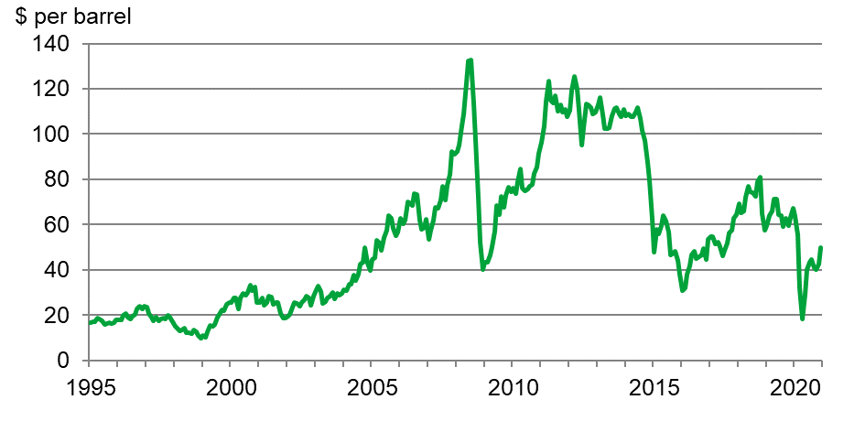
Source: US Energy Information Administration

Some inputs, such as fuel, electricity and fertilisers, are closely linked to oil price. Consequently, oil price plays a role in the increase or decrease of the costs for running machinery and for heating, lighting, drying crops and the cost of fertiliser purchases.

Figure 9.1 shows the trend in Europe Brent crude oil prices since 1995. Oil prices peaked in July 2008 at just over $130 per barrel, but by the end of 2008 fell sharply as a global crisis hit. Between 2010 to mid-2014, oil prices were high but relatively stable due to a weak global economy and tension in the Middle East.

From July 2014, as strong global production exceeded demand, prices fell rapidly and reached below $40 per barrel by December 2015. In comparison, prices in 2016 began to steadily rise and by October 2018 had reached just over $80 a barrel amid fears of US sanctions and global shortages. However, this was still much lower compared to the high prices seen at the start of the decade.

In 2020, coronavirus related restrictions resulted in a rapid contraction in global demand for oil, particularly for travel. This caused the price to collapse to below $20 per barrel for the first time since 2002. The price rebounded strongly but still finished the year cheaper than at the start.

Energy
(Figure 9.2)

Figure 9.2 Index of energy use in UK agriculture by value and volume
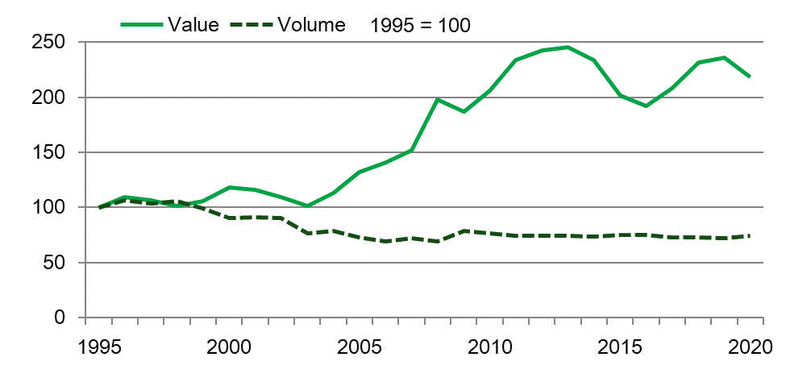

Source: Defra

In 2020 the cost of energy fell by £102m (7.3%) to £1,290m. This was almost entirely due to a fall of £97m (10%) in the cost of motor and machinery fuels. There was a 4.5% increase in the volume of fuel used, mainly due to additional sowing in the spring, but this was outweighed by a 14% fall in price due to lower global demand for oil because of coronavirus related restrictions.

Figure 9.2 shows that over the long term the value of energy costs has followed a similar but smoother pattern to that of the crude oil price (see Figure 9.1). The volume of energy used by the farming industry decreased during the 2000s and has remained very stable for the last decade.

Fertiliser

(Figure 9.3)

Figure 9.3 Index of fertiliser use in UK agriculture by value and volume
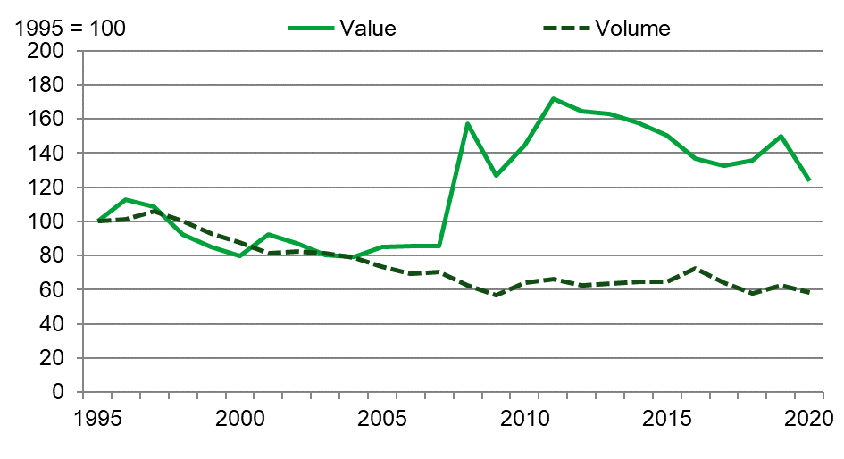
Source: Defra

As the price of oil directly influences the price of energy it also affects the cost of fertiliser. Natural gas is used in the process of manufacturing nitrogen fertilisers and its price is closely linked to the price of oil. Consequently, if the price of oil rises so does the cost of producing fertiliser. Figure 9.3 shows that although fertiliser usage has almost halved since the mid-90s, the cost of the fertiliser used has increased significantly, driven by price. In 2020 the cost of fertilisers fell by £241m (17%) to £1,147m, compared to 2019. This was the largest nominal change of all the itemised Intermediate Consumption costs and resulted from falls in both the volume and price of fertilisers. Volume fell by 6.2% due to less fertiliser-intensive spring crops replacing winter sown crops for the 2020 harvest. The price of fertilisers fell by 12% due to the low oil prices seen during 2020.

Other input costs
The cost of seeds rose by £140m (17%) to £977m. This was almost entirely due to a 16% rise in the volume of seeds used, with many cereal farmers sowing larger than usual areas in spring 2020 in response to the unfavourable drilling and establishment conditions over winter 2019/20, before returning to winter varieties in late 2020. Increased seed rates per hectare and an increase in the use of cover crops also contributed.

The cost of plant protection products rose by £96m (9.6%) to £1,097m. A reduced volume of fungicide was used due to lower than usual disease pressure thanks to the mild and dry spring, but price was higher because of the banning of chlorothalonil. The volume of herbicide used rose as post emergence applications on winter sown crops were postponed from late 2019 to early 2020.

The cost of other goods and services fell by £149m (4.2%) to £3,387m. This was mainly driven by a significant reduction in the volume of straw purchased from other farms as a result of good stocks from 2019 and limited supply following the poor harvest in 2020.

Chapter 10 Public Payments

Summary
Key results for 2020 compared to 2019

- Total direct payments to farmers are expected to increase by 1.3% to £3.3bn.
- Basic Payment Scheme (BPS) payments, including greening and young farmer, are expected to increase by 1.4% to £2.8bn.
- Payments linked to agri-environment schemes are expected to increase by 0.7% to £368m.
- Payments under the Less Favoured Area Support Scheme (LFASS) are expected to decrease by 41% to £30m.

Introduction
Values shown for a particular year refer to schemes operating in that year. Unless otherwise stated, data is for 2020 and comparisons are based on 2020 compared with 2019. Values are shown in current price, i.e. not adjusted for inflation and are expressed as amounts expected to be paid.

Payments
(Tables 10.1 to 10.3, figure 10.1)
Payments made to UK farmers under the Basic Payment Scheme (BPS0 are set in euros and converted to sterling using the exchange rate set by the European Central Bank for the month of September as a whole. In 2020 the rate was €1 = £0.891, unchanged from 2019.

Table 10.1 shows that the euro exchange rate used to calculate the value of payments made to farmers under the 2020 Basic Payment Scheme was unchanged and the value of direct payments to farmers is estimated to be only slightly higher than in 2019.

Table 10.1 Basic Payment Scheme and euro exchange rate
Enquiries: Alistair Murray on +44 (0)20 802 66121, email: farmaccounts@defra.gov.uk

 | 2018 | 2019 | 2020
Basic Payment Scheme (£ million) | 2,729 | 2,766 | 2,804
Exchange rate (€/£) | 0.893 | 0.891 | 0.891
Financial Discipline (%) | 1.41 | 1.43 | 0.00
Notes:
- Figures for 2020 are provisional and subject to revision
- Basic payment scheme includes Greening payments

Basic Scheme payments include Core Basic Payment Scheme, Greening and Young Farmer Payments, as well as Financial Discipline adjustments and redistributive payments. The European Commission sets the rate of Financial Discipline annually, details of which can be found in table 10.1. Financial Discipline is a mechanism that allows for a reduction in direct payments to farmers when the European Commission forecasts that annual expenditure under pillar 1 of the Common Agricultural Policy (CAP) may exceed the financial ceiling agreed by the European Council; this was not applied in the UK in 2020. Redistributive payments are voluntary and are designed to help smaller holdings; in the UK, only Wales introduced redistributive payments.

Figure 10.1 details the value of overall direct payments to UK farmers and shows the breakdown between coupled and decoupled payments. Since 2013, Scotland is the only UK nation to operate coupled payments, i.e. a form of financial support linked to production. These are the Suckler Beef Scheme and the Scottish Upland Sheep Scheme. Decoupled payments are those not linked to production and include the Basic Payment Scheme and agri-environment schemes.

Figure 10.1 Direct Payments to farmers

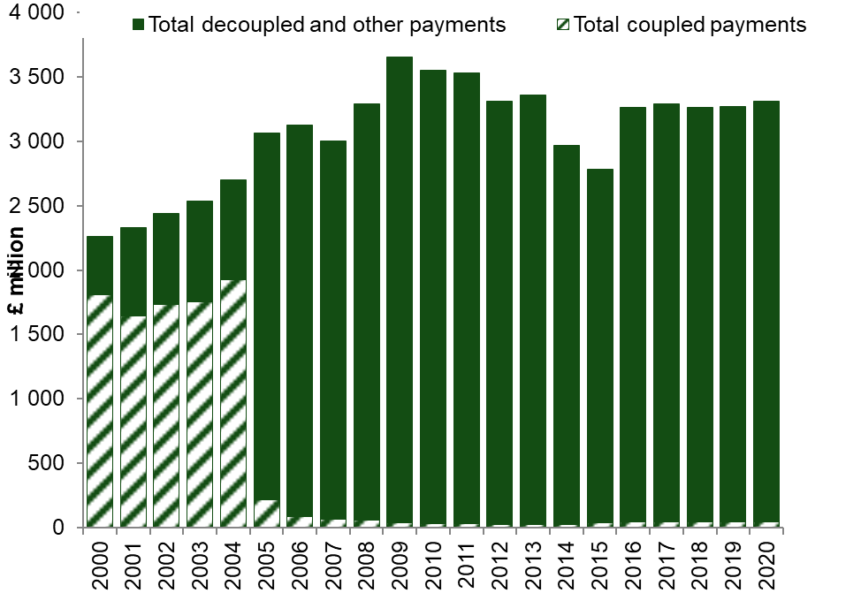

Table 10.2 shows coupled support payments to farmers in Scotland are unchanged at £47m.

Payments under the agri-environment schemes in the United Kingdom rose by £2.4m (0.7%) to £368m whilst Less Favoured Area Support Scheme payments fell by £21m (41%) to £30m.

Overall total payments to farmers rose by £42m (1.3%) to £3.3bn, in part reflecting the stable euro to sterling exchange rate.

Table 10.2 Direct payments to farmers and UK State Aid to agricultural & food chain sector businesses
Enquiries: Alistair Murray on +44 (0)20 802 66121, email: farmaccounts@defra.gov.uk

£ million
 | 2018 | 2019 | 2020
Coupled payments (linked to production)
Scottish Upland Sheep support scheme | 7 | 7 | 7
Scottish Suckler Beef support scheme | 39 | 40 | 40
Total coupled payments | 46 | 47 | 47
Decoupled and other payments (not linked to production)
Basic/Single Payments Scheme | 2,729 | 2,766 | 2,804
Agri-environment schemes | 374 | 365 | 368
Less Favoured Areas support schemes | 72 | 51 | 30
Animal disease compensation (income) | 28 | 26 | 25
Other | 12 | 14 | 37
Total decoupled and other payments | 3,215 | 3,221 | 3,263
Total direct payments minus levies | 3,261 | 3,268 | 3,310
Animal disease compensation (capital) | 52 | 48 | 46
UK State Aid to Agriculture | 252 | 272 | 316
Notes:
- Figures for 2020 are provisional and subject to revision
- Basic Payment Scheme was introduced in 2015, prior to this Single Payment Scheme operated.
- For information on the various agri-environment schemes please see table 10.3
- Animal disease compensation is paid for livestock compulsorily slaughtered under disease control measures, split into income (34%) and capital (66%). The capital payments are not included in Total Income from Farming.
- “Other” payments include various one-off payments, Advisory Services, and New Entrants
- UK State Aid to the Agricultural Sector under EU ABER and de minimis regulations (not included in Total Income from Farming)

Table 10.3 gives details of payments for 2020 broken down by country and scheme.

Table 10.3 Direct payment to farmers by country in 2020
Enquiries: Alistair Murray on +44 (0)20 802 66121, email: farmaccounts@defra.gov.uk

£ million
 | England | Wales | Scotland | NI | UK
Coupled payments (linked to product)
Scottish Upland Sheep support scheme | . . | . . | 7 | . . | 7
Scottish Suckler Beef support scheme | . . | . . | 40 | . . | 40
Total coupled payments | . . | . . | 47 | . . | 47
Decoupled payments (not linked to production)
Basic Payment Scheme (inc Greening) | 1,823 | 257 | 430 | 293 | 2,804
Less Favoured Areas support schemes | . . | . . | 30 | . . | 30
Agri-environment schemes
Environmental Stewardship Scheme | 164 | . . | . . | . . | 164
New Countryside Stewardship Scheme: Agri-Environment-Climate | 136 | . . | . . | . . | 136
Glastir | . . | 44 | . . | . . | 44
Agricultural Environment Climate Scheme | . . | . . | 12 | . . | 12
New Countryside Stewardship Scheme: Organic Farming | 5 | . . | . . | . . | 5
Environmentally Sensitive Areas Scheme / Environmental Farming Scheme | . . | . . | . . | 4 | 4
Rural Priorities / Land Manager Options | . . | . . | 2 | . . | 2
New Entrants Scheme | . . | . . | 2 | . . | 2
Advisory services, farm management and farm relief services | 4.9 | . . | . . | . . | 5
Other - COVID-19 support/recovery fund € | 1 | 1 | . . | 21 | 23
Other - Farming Flood Recovery Fund | 6 | . . | . . | . . | 6
Animal disease compensation (income) | 12 | 6 | - | 7 | 25
Total decoupled payments | 2,152 | 309 | 476 | 326 | 3,263
TOTAL PAYMENTS | 2,152 | 309 | 524 | 326 | 3,310
Notes:
- Less favoured areas include Areas of Natural Constraint (ANC) in Northern Ireland, Less Favoured Areas Support Scheme (LFASS) in Scotland
- Basic Payment Scheme includes Greening payments
- Glastir was introduced in 2013
- Environmentally Sensitive Areas/Environmental Farming Scheme began in July 2017
- Land Managers Options closed to new applicants from 2014; Rural Priorities closed end of 2013. Payments continue to be honoured
- Other – COVID-19 support/recovery fund are exceptional measures to support farming businesses during the period of COVID-19 restrictions
- Other – Farming Flood recovery fund is a one-off emergency payment, part paid in 2019, extended to 2020
- .. means ‘not available’ or ‘not applicable’

Direct Payments made through key measures of the Rural Development Programmes
(Table 10.4)
Rural Development in the United Kingdom is managed on a decentralised basis by the main administrative regions of the country through four Rural Development Programmes (RDPs): one for England, Northern Ireland, Scotland, and Wales.

Table 10.4 shows details of payments made through two key measures of these programmes: Less Favoured Areas and agri-environment. Due to changes in the management and implementation of the Rural Development Programme in 2015, care should be taken when making comparisons with data provided in table 10.4 and earlier years.

Table 10.4 Direct Payments made through key measures of the Rural Development Programmes
Enquiries: Alistair Murray on +44 (0)20 802 66121, email: farmaccounts@defra.gov.uk

£ million
 | 2018 | 2019 | 2020
England
Environmental Stewardship Scheme | 223 | 193 | 164
New Countryside Stewardship Scheme: Agri-Environment-Climate | 62 | 89 | 136
New Countryside Stewardship Scheme: Organic Farming | 5 | 6 | 5
Wales
Glastir | 57 | 52 | 44
SSSI | 2 | 3 | -
Scotland
Less Favoured Areas support schemes (LFA) | 63 | 51 | 30
Agricultural Environment Climate Scheme | 8 | 14 | 12
Rural Priorities / Land Manager Options | 10 | 4 | 2
New Entrant Scheme | 3 | 4 | 2
Northern Ireland
Area of Natural Constraints (LFA) | 9 | - | -
Countryside Management Scheme | 3 | 1 | -
Environmentally Sensitive Areas Scheme / Environmental Farming Scheme | 3 | 4 | 4
Notes:
- 2020 figures are provisional and subject to revision
- Environmental Stewardship Scheme includes Entry Level Pilot Scheme, OELS, ELS and HLS. Scheme ended in December 2014 but payments continue to be made
- Countryside Stewardship Scheme opened in 2015 with first agreements going live in 2016
- Glastir was introduced in 2013
- Land Managers Options closed to new applicants from 2014; Rural Priorities closed end of 2013. Payments continue to be honoured.
- Countryside Management Scheme includes agreements that commenced prior to 2013
- Environmental Farming Scheme began in July 2017
- - means ‘nil’ or ‘negligible’

England’s agri-environment schemes (AES) receive funding from the Rural Development Programme for England (RDPE). The new Countryside Stewardship Scheme is the current agri-environment scheme (AES) for England and consists of two tiers, a Mid-Tier and a Higher Tier. The agri-environment-climate measure includes payments made under both tiers. The organic measure includes payments for organic conversion and maintenance. The Environmental Stewardship Scheme closed to new applicants in 2014 but existing agreements continue to be managed until they reach their agreed end date and it remains the main scheme on which payments are made. In 2020 AES payments in England under both schemes totalled £164m.

The Scottish Rural Development Programme (SRDP) is the main source of funding for land management in Scotland. The Rural Priority and Land Manager option scheme payments totalled £2m. Payments made under the Less Favoured Area Support Scheme totalled £30m.

The principal Welsh agri-environment scheme is Glastir which is funded by the Welsh Government Rural Communities Rural Development Programme and payments totalled £44m.

Under the Rural Development Programme for Northern Ireland, agri-environment payments under the Countryside Management Scheme and the Environmental Farming Scheme totalled £4m. The Area of Natural Constraints (LFA) Scheme ended in 2017.

Take-up of Agri-Environment Schemes
(Tables 10.5, 10.6, 10.7)
Agri-environment schemes provide an incentive to farmers to adopt land management and farm practices that are beneficial to the environment. The take-up of agri-environment schemes is shown by area of land under each type of scheme currently in existence in the United Kingdom (Table 10.5) and by the number of agreements (Table 10.6). Due to the differing requirements of schemes, care should be taken when making comparisons. See the chapter 10 Appendix for notes on specific schemes. Fluctuations in areas and numbers occur as old schemes expire and new schemes begin.

Table 10.5 Agri-environment schemes – area under schemes
Enquiries: Elizabeth Finch on +44 (0)20 802 66226, email: elizabeth.finch@defra.gov.uk

Thousand hectares
 | 2018 | 2019 | 2020
England
Environmental Stewardship Entry Level Scheme | 2,167 | 1,981 | 1,788
Environmental Stewardship Higher Level Scheme | 1,106 | 1,050 | 951
New Countryside Stewardship Scheme | 502 | 746 | 901
Wales
Glastir Entry | 451 | 209 | -
Glastir Advanced (on Entry) | 327 | 397 | 321
Glastir Commons | 120 | 119 | 114
Glastir Organic | 61 | 67 | 57
Decoupled Advanced | 54 | 34 | 185
Scotland
Land Managers Options | - | - | -
Rural Priorities | 214 | 167 | 37
Agri-environment Climate Scheme | 847 | 1,002 | 1,175
Northern Ireland
Countryside Management Scheme | 46 | 8 | -
Environmentally Sensitive Areas Scheme | - | - | -
Environmental Farming Scheme | 20 | 38 | 53
Notes:
- - means ‘nil’ or ‘negligible’

Table 10.6 Agri-environment schemes – number of agreements
Enquiries: Elizabeth Finch on +44 (0)20 802 66226, email: elizabeth.finch@defra.gov.uk

Number of agreements (rounded to the nearest hundred)
 | 2018 | 2019 | 2020
England
Environmental Stewardship - Entry Level Scheme | 11,200 | 9,700 | 8,900
Environmental Stewardship - Higher Level Scheme | 11,600 | 11,000 | 10,000
New Countryside Stewardship Scheme | 9,700 | 13,800 | 17,700
Wales
Glastir Entry | 2,900 | 1,700 | -
Glastir Advanced (on Entry) | 1,800 | 1,900 | 1,800
Glastir Commons | 200 | 200 | 200
Glastir Organic | 600 | 600 | 500
Decoupled Advanced | 500 | 500 | 600
Scotland
Land Managers Options | - | - | -
Rural Priorities | 2,000 | 1,700 | 1,400
Agri-environment Climate Scheme | 2,000 | 2,500 | 3,000
Northern Ireland
Countryside Management Scheme | 600 | 100 | -
Environmentally Sensitive Areas Scheme | - | - | -
Environmental Farming Scheme | 1,300 | 2,900 | 5,000
Notes:
- - means ‘nil’ or ‘negligible’

All Common Agricultural Policy payments by funding stream
(Table 10.7)
Table 10.7 shows all agricultural market support under the Common Agricultural Policy. This is different to the other tables in this chapter, which show expenditure feeding into the agricultural account only, i.e. only those payments received by units as a consequence of engaging in agricultural activity. The market price support element of this table can be paid to non-agricultural units. In addition, readers should note the difference in timings as the data is for European Union agricultural financial years (see table footnote) and shown in euros.

Table 10.7 All Common Agricultural Policy (CAP) payments by funding stream
Enquiries: Rosemary Ambrose, email: Rosemary.Ambrose@ukcoordinatingbody.gov.uk

Euros million (EU financial years)
 | 2018 | 2019 | 2020
Total UK CAP payments | 3,934 | 4,229 | 4193
Total Pillar 1 | 3,174 | 3,228 | 3201
Direct Aids | 3,126 | 3,186 | 3160
Market price support | 48 | 42 | 41
Total Pillar 2 | 760 | 1,001 | 992
EAFRD | 581 | 776 | 766
Co-financing | 179 | 225 | 227
Total England CAP payments | 2,474 | 2,672 | 2720
Total Pillar 1 | 2,084 | 2,100 | 2096
Direct Aids | 2,036 | 2,058 | 2055
Market price support | 48 | 42 | 41
Total Pillar 2 | 390 | 572 | 624
EAFRD | 341 | 502 | 530
Co-financing | 49 | 70 | 94
Total Wales CAP payments | 397 | 397 | 383
Total Pillar 1 | 263 | 265 | 263
Direct Aids | 263 | 265 | 263
Market price support | - | - | -
Total Pillar 2 | 134 | 132 | 120
EAFRD | 95 | 93 | 83
Co-financing | 39 | 39 | 37
Total Scotland CAP payments | 698 | 784 | 712
Total Pillar 1 | 503 | 539 | 519
Direct Aids | 503 | 539 | 519
Market price support | - | - | -
Total Pillar 2 | 195 | 245 | 193
EAFRD | 127 | 159 | 127
Co-financing | 68 | 86 | 67
Total Northern Ireland CAP payments | 365 | 376 | 378
Total Pillar 1 | 324 | 324 | 323
Direct Aids | 324 | 324 | 323
Market price support | - | - | -
Total Pillar 2 | 41 | 52 | 55
EAFRD | 18 | 22 | 26
Co-financing | 23 | 30 | 29
Notes:
- All figures are based on EU financial year 16th October – 15th October. Figures exclude financial corrections/penalties.
- Market price support covers interventions in agricultural markets, e.g. public intervention and private storage aid. Most of these schemes are administered by the Rural Payments Agency on behalf of the UK.
- Pillar 2 funds rural development, e.g. for agri-environment schemes, competitiveness of agriculture and economic diversification and quality of life in rural areas.
- EAFRD is the European Agricultural Fund for Rural Development. Member states are required to co-finance these receipts with a contribution from their exchequer. Figures are based on in-year quarterly returns, rather than the annual account (in order to provide the split between EAFRD and co-financing)
- - means ‘nil’ or ‘negligible’

Chapter 10 Appendix - Notes on specific agri-environment schemes

Country/scheme | Notes
England
Environmental Stewardship Entry Level Scheme | Includes Entry Level Pilot Scheme, OELS, Uplands ELS (from 2010) and HLS linked to ELS. Scheme ended in December 2014.
Environmental Stewardship Higher Level Scheme | Includes Freestanding HLS and HLS linked to ELS. Scheme ended in December 2014.
new Countryside Stewardship Scheme | Scheme opened in 2015 with first agreements going live in 2016. Area is for Mid and Higher Tier strands only.
Wales
Glastir Entry | Expired in 2019. Figures include all Glastir Advanced (on entry) contracts up to and including 2018.
Glastir Advanced (on Entry) | From 2019, Glastir Advanced (on entry) contracts are not necessarily linked to Glastir Entry contracts.
Glastir Commons | Includes Glastir Advanced (on Commons).
Glastir Organic
Decoupled Advanced | First agreements started in 2016.
Scotland
Land Managers Options | Closed to new applicants from 2014.
Rural Priorities | Scheme ended in December 2013. As contracts may have multiple options, the area may be repeated.
Agri-environment Climate Scheme | First agreements started in 2016. As contracts may have multiple options, the area may be repeated.
Northern Ireland
Countryside Management Scheme | Includes agreements which commenced under NIRDP 2000-2006 and 2007-2013; agreements continue to be honoured. The NI Countryside Management scheme ended in December 2019.
Environmentally Sensitive Areas Scheme | Commenced under 2000-2006 NIRDP; all agreements expired in 2016.
Environmental Farming Scheme | Scheme began in July 2017. Organic hectares are included in the total scheme area

Chapter 11 Environment

Summary
- In 2020 utilised agricultural land use stood at 71% of the total area of the United Kingdom.
- Since the late 1990’s nitrogen and phosphate application rates have fallen.
- A comparison of soil nutrient balances (in kg per hectare) from the year 2000 to 2019 shows a 24% decrease for nitrogen and a 46% decrease for phosphate.
- Estimated greenhouse gas and air pollution emissions from agriculture have fallen between the year 2000 and the most recent data available:
  - In 2019 nitrous oxide emissions have fallen by 9.6%
  - Methane emissions in 2019 have decreased by 9.9%
  - 2019 data for ammonia show a decrease of 5.6%
- The farmland bird index has decreased significantly since 1970 with the index for all farmland species in 2019 less than half of 1970 levels.

Introduction

(Figure 11.1, and tables 3.2 and 14.1)

This chapter provides an overview of the change in inputs (fertiliser, pesticide and water usage) and environmental management over time as well as the monitoring of environmental impacts to which agriculture contributes.

Figure 11.1 Agriculture’s environmental footprint
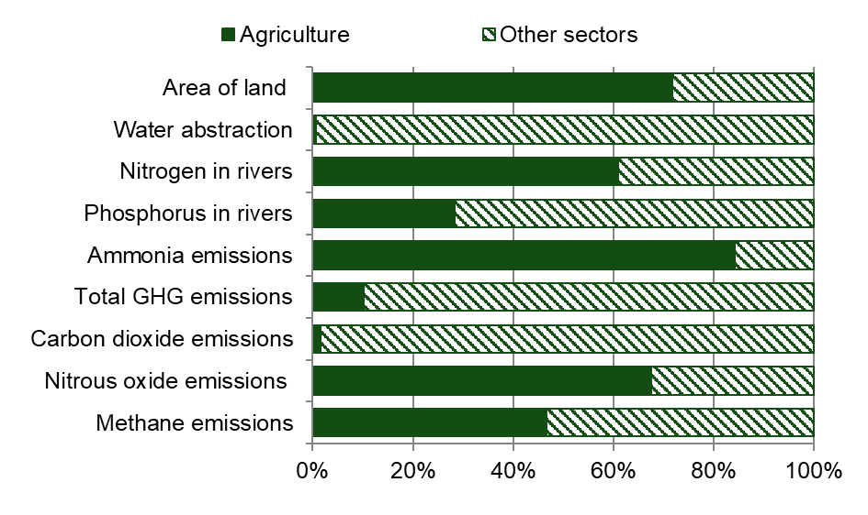
Source: Collated by Defra.
Notes:
All data are UK and for 2019 except for the following:
- Water abstraction is England
- Nitrogen in rivers is England & Wales, 2004
- Phosphorus in river is Great Britain, 2006 estimate

Whilst agriculture contributes less than 1% to the United Kingdom’s economy (see Table 3.2), it provides around three-quarters of the indigenous food we eat (see Table 14.1) and at around 70% is the predominant form of land use (see Figure 11.1). As well as being vital for food production, agriculture helps to shape the landscape, providing important recreational, spiritual and other cultural benefits. This can be viewed in terms of delivering vital ecosystems services, with food production being a provisioning service whilst other environmental and societal benefits are delivered by, for example, cultural and regulating services.

Agricultural production and the associated land use and management are key drivers of the environmental impacts from the sector. A key challenge is to decouple production from its environmental impact so that production can be increased whilst reducing the overall environmental footprint. This is sometimes referred to as sustainable intensification.

Farm practices and the use of inputs (particularly fertilisers and pesticides) directly influence the environmental pressures from farming including the quality, composition and availability of habitats and impact on air, water and soils.

In recent years, the key drivers of change in terms of environmental pressures from agriculture are declines in the number of livestock, specifically ruminants, and reductions in fertiliser applications, particularly on grassland. Reforms to the Common Agricultural Policy, and in particular the decoupling of subsidy payments from production, have been instrumental to these drivers of change. As a result of these reforms, agriculture has become more responsive to market conditions which may influence both positive and negative environmental impacts.

Land use

Figure 11.2 Agricultural land use
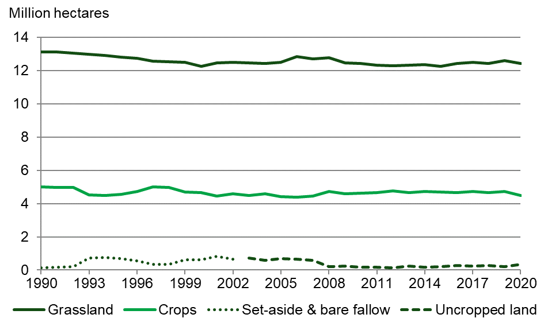
Source: June survey of Agriculture, Defra
Notes:
- Grassland includes temporary and permanent grasslands, sole rights rough grazing and common rough grazing areas
- Set-aside was a scheme within CAP that required farmers to put land out of production

In 2020 the proportion of utilised agricultural land used for grassland was 72% with 26% used for crops. Grassland and crop land use have both remained relatively stable from 1990 to 2020. The ending of the set-aside scheme in 2008 meant that the area of uncropped land fell sharply that year. From 2008 onwards the area of uncropped land has fluctuated around that level, mainly influenced by commodity prices and weather conditions.

Pesticide usage

(Figure 11.3)

Plant protection products are used to regulate growth and to manage pests and diseases in crops. They play a major role in maintaining high crop yields and therefore greater production from agricultural land. However, they can have detrimental impacts on the environment, particularly on terrestrial and aquatic biodiversity.

The need for pesticide usage varies from year to year depending on growing conditions, particularly the weather which influences disease, weed and pest pressures. In addition, longer term variations are due to changes in the range and activity of active substances, the economics of pest control, and resistance issues. In the United Kingdom the treated area of arable crops (number of hectares multiplied by number of applications) has remained relatively stable since 2008, whilst the total weight of pesticide applied has shown an overall decline highlighting the complexities.

Figure 11.3 Pesticide use on cereals, Great Britain
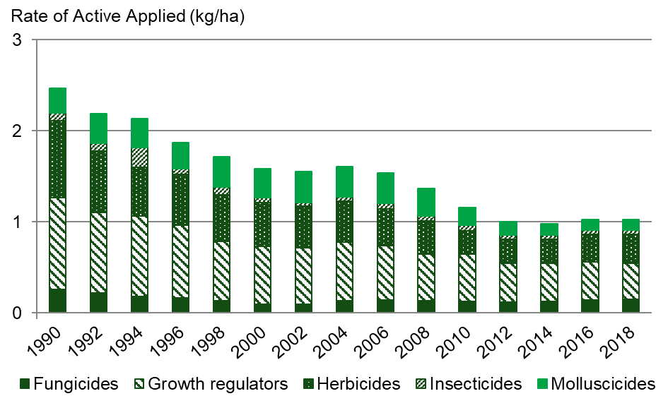
Source: Pesticide Usage Survey
Notes:
- Based on most recent data available at 12/04/2021
- All pesticides include seed treatments

In recent years cereals accounted for the majority of both treated area and the weight of pesticides applied to arable crops in the United Kingdom. The majority of UK cereals (more than 80%) are grown in England. Figure 11.3 shows the application rates for different types of pesticides used on cereal crops in Great Britain and how these have fluctuated over time.

Further information can be found on the pesticide usage webpage: https://secure.fera.defra.gov.uk/pusstats/surveys/index.cfm

Water use
(Figure 11.4)

Figure 11.4 Water abstraction, England

Source: Environment Agency
Notes:
- Most recent data available as of 12/04/2021.
- Spray irrigation includes small amounts of non-agricultural irrigation.
- 2015 figure has a break in the series where information concerning abstractions in the country of England and the Dee/Wye regional charge areas (formally the Wales regional charge area) has been amalgamated into the North West and Midlands regional charge areas respectively.

Water abstraction from groundwater and surface water sources may be needed for irrigation purposes to maintain high yields and good crop quality, particularly in areas with low rainfall and for certain crop types. Over abstraction can be detrimental to aquatic ecosystems and limit resource for other industries. In 2017 less than 1% of the total water abstracted in England was attributed to agriculture, most of which took place in the south and east of the country.

Volumes of water abstracted for agricultural purposes is highly variable from year to year and greatly influenced by rainfall amounts, especially during the growing season. In 2017, the recorded abstraction rate in England was 109 million cubic litres which was a slight decrease from 110 million cubic litres in 2016.

Further information on the water abstraction webpage

Fertiliser use

(Figures 11.5 and 11.6)

Nitrogen and phosphorous are key nutrients needed for crop growth. A deficit in either or both of these nutrients can have a negative impact on crop yields and levels of production. The main source of these nutrients are mineral fertilisers and organic fertilisers such as manures and slurries from livestock. Various factors such as application method, over-application and natural losses from soils and manures can have an adverse impact on the environment. These impacts include water quality (nitrogen and phosphorous levels in waterbodies), air quality (ammonia emissions) and climate change (nitrous oxide emissions.)

Most agricultural soils do not contain enough naturally occurring plant-available nitrogen to meet the needs of a crop throughout the growing season so supplementary nitrogen applications are needed each year. Nitrogen usually has a large immediate effect on crop growth, yield and quality. Correct rate and timing of applications is important to ensure crop growth requirements are met.

Annual levels of use of nitrogen and phosphate application are influenced by fertiliser prices, crop prices, crop type and weather-related issues during the growing season, for example the fall in nutrient application rates in 2009 was related to high fertiliser prices.

Figure 11.5 Nitrogen (N) use (kg/ha) on all crops and grass, Great Britain
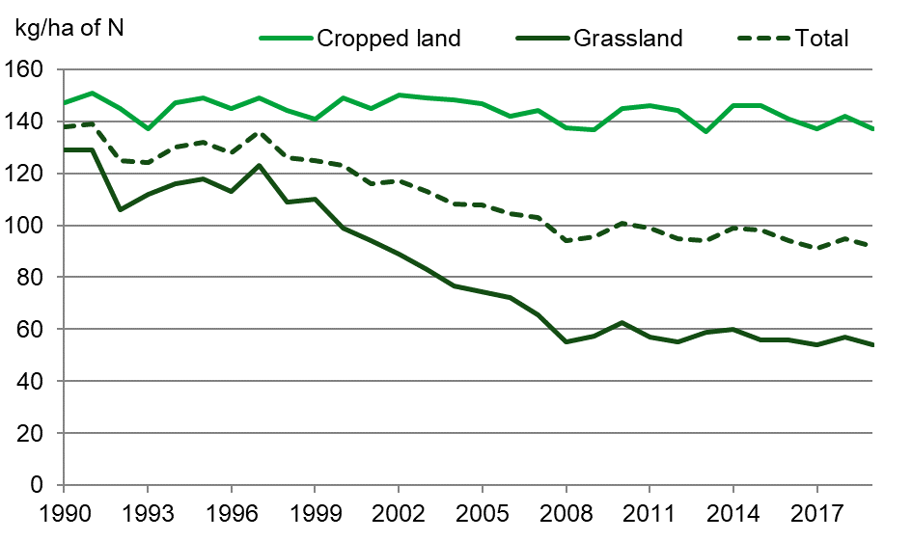
Source: British Survey of Fertiliser Practice

In Great Britain between 1990 and 2019 the overall mineral nitrogen application rate on tillage crops has largely been in the range of 140 -150 kg/ha. In 2019, nitrogen use on tillage crops decreased by 5kg/ha to 137kg/ha. For grassland, nutrient application rates have always been lower than for cropped land. Between 1990 and 2019 there has been a downward trend in the overall mineral nitrogen application rate on grassland and in 2019 the rate was 54 kg/ha (see Figure 11.5). A reduction in total cattle numbers is thought to have contributed to this, possibly in conjunction with some improvements in manure use efficiency.

Phosphate is applied in fertilisers and manures, particularly to replace the quantities removed in harvested crops. Most British soils can hold large quantities of phosphate in forms that are available for crop uptake over several years. Therefore, managing the supply of phosphate is based on maintaining appropriate levels in the soil with the timing of applications less critical

Figure 11.6 Phosphate (P2O5) use (kg/ha) on all crops and grass, Great Britain
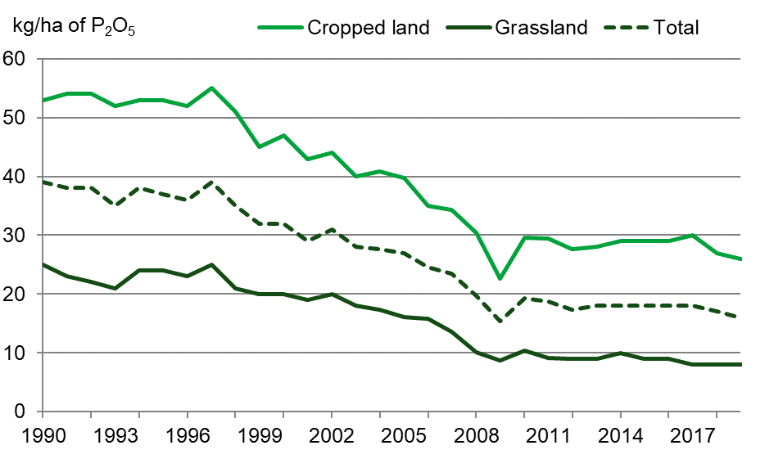
Source: British Survey of Fertiliser Practice

From 1990 to 2019 total mineral phosphate application rates have declined to a rate of 16 kg/ha in 2019 (see Figure 11.6). More recently the decline has levelled off with a similar rate seen since 2012.

Further information found in the British Survey of Fertiliser Practice annual report

Soil nutrient balances

(Figure 11.7 and 11.8)

Soil nutrient balances provide an indication of the overall environmental pressure from nitrogen and phosphorus in agricultural soils. They measure the difference between nutrients applied to soils (largely as fertilisers and manures) and those removed from soils by the growth of crops, including grass for fodder and grazing. An increase in the balance per hectare indicates a greater environmental risk from nutrient losses and their associated emissions whereas a decrease in the balance per hectare broadly indicates a reduced environmental risk. However, there is a risk that nutrient deficits lead to poor soil fertility and subsequent loss of yields.

Figure 11.7 Nitrogen (N) soil nutrient balance
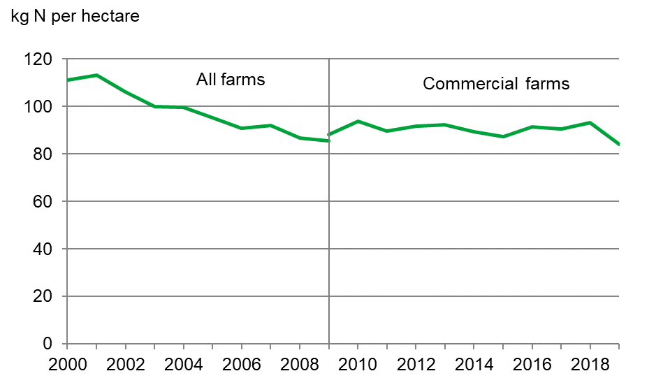
Source: Defra, Soil Nutrient Balances
Notes:
- There is a break in the time series in 2009 when moving from all forms to only commercial farms

Provisional estimates for 2019 show that the nitrogen balance for the UK was a surplus of 84 kg/ha on managed agricultural land (see Figure 11.7).

This is a decrease of 9.0 kg/ha (10%) compared to 2018. This decrease was driven by a 1.9 kg/ha (1.0%) decrease in inputs whilst offtake increased by 7.1 kg/ha (7.0%.) The increase in offtake was attributed to significantly higher cereal crop yields and production in 2019.

The longer-term trend (compared to 2000) shows an overall reduction of 27 kg/ha (24%). The main drivers for this fall have been reductions in the application of inorganic (manufactured) fertilisers and manure production (due to lower livestock numbers), although this has been partially offset by a reduction in the nitrogen offtake (particularly forage) over the same period.

Figure 11.8 Phosphorous (P) soil nutrient balance
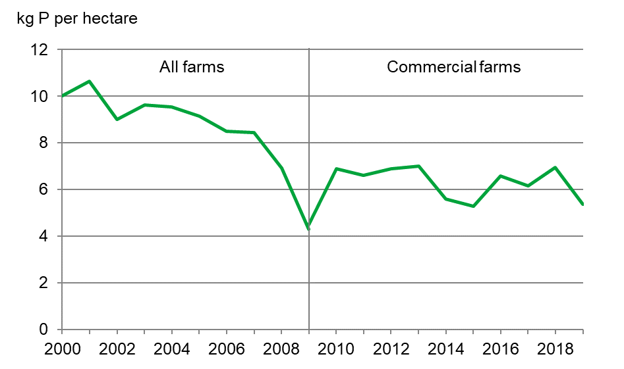
Source: Defra, Soil Nutrient Balances
- There is a break in the time series in 2009 when moving from all forms to only commercial farms

Provisional estimates for 2019 show that the phosphorus balance for the UK was a surplus of 5.4 kg/ha on managed agricultural land (see Figure 11.8).

This is a decrease of 1.6 kg/ha (23%) compared to 2018. This decrease was driven by a 0.4 kg/ha (2%) decrease in inputs whilst offtake increased by 1.2 kg/ha (7%.) The increase in offtake was attributed to significantly higher cereal crop yields and production in 2019.

The longer-term trend (compared to 2000) shows an overall reduction of 4.6 kg/ha (46%) with similar drivers as nitrogen.

Further information found on the soil nutrient balances publication can be found here:-https://www.gov.uk/government/statistics/uk-and-england-soil-nutrient-balances-2019

Water quality
Agriculture contributes to the pollution of water bodies through fertilisers and manure (nutrients), pesticides, sediments and faecal bacteria. Rainfall may wash a proportion of fertiliser off fields into local water bodies or cause soluble nutrients to filter into groundwater. Pesticides can be washed into water bodies by rainwater or may enter them directly if they are sprayed close to water. Pesticides can also enter groundwater via soil infiltration. In addition, erosion can wash topsoil into water bodies and these soils can carry large amounts of phosphates and agri-chemicals bonded to clay particles.

High nutrient concentrations, particularly phosphorus, can cause nutrient enrichment (eutrophication) resulting in excessive growth of macrophytes and algae which can deplete dissolved oxygen levels. Excessive levels of nutrients must be removed from water bodies used for drinking water to meet legal limits, with water companies incurring significant costs. It has been estimated that agriculture accounts for around 61% of the total nitrogen in river water in England and Wales [1] and around 28% of the total phosphorus load in river water in Great Britain [2], although this estimate may also include phosphorus from septic tanks [3].

Due to the implementation of the Water Framework Directive (WFD) a revised approach to monitoring water quality across the UK was introduced in 2009. The WFD assesses water quality using three categories (ecological quality, chemical quality and hydrological quality). For each site each category is assigned a grade which are then combined to provide an overall classification. The combined score is based on ‘one out, all out’, e.g. if one category is ranked as ‘poor’ the water body will be classified as ‘poor’.

As in 2018, 36% of surface water bodies assessed under WFD in the UK were in ‘high’ or ‘good’ status in 2019. Diffuse water pollution from agriculture and rural land use has been directly attributed to 28% of failures to meet the WFD standards in England [4].

Further information on the status of water bodies in the United Kingdom

Greenhouse gas emissions

(Figure 11.9 and 11.10)

Agriculture accounts for approximately 10% of total greenhouse gas emissions in the UK. Three greenhouse gasses emitted by agriculture are nitrous oxide, methane and carbon dioxide.

Agriculture is the major source of both nitrous oxide and methane emissions in the UK, accounting for nearly 68% of total nitrous oxide emissions and 47% of all methane emissions in 2019. In contrast, agriculture only accounted for about 1.7% of total carbon dioxide emissions in the UK.

Figure 11.9 Nitrous oxide emissions
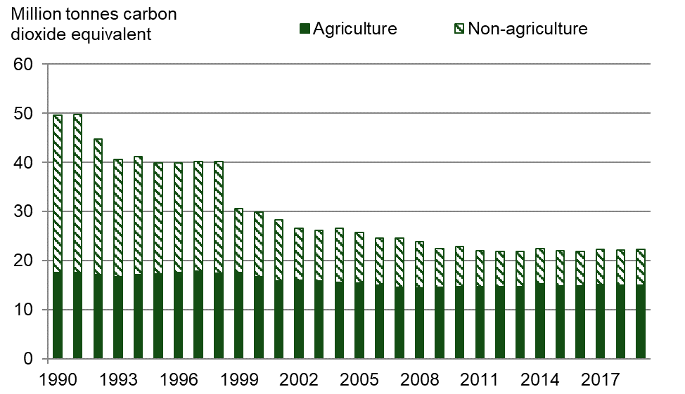
Source: Department for Business, Energy and Industrial Strategy (BEIS, formerly DECC)

Nearly 90% of agricultural nitrous oxide emissions come from soils, particularly as a result of nitrogen fertiliser application, manure (both applied and excreted on pasture) and leaching/run-off. In 2019 nitrous oxide emissions from agriculture are estimated to have fallen by 15% since 1990 and 9.6% since 2000 (see Figure 11.9). This is consistent with trends in fertiliser usage over the same period.

Figure 11.10 Methane emissions

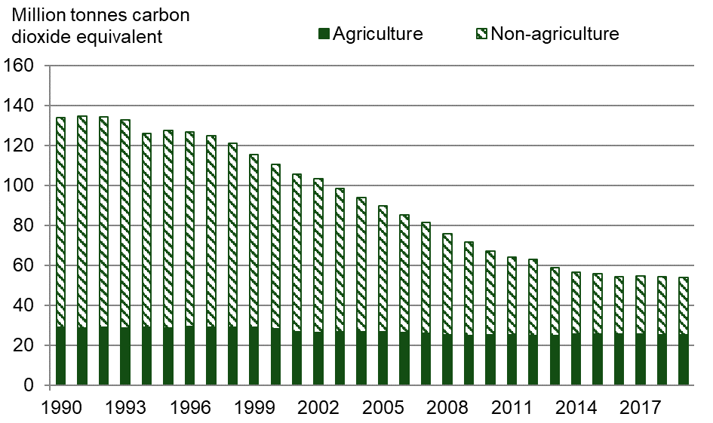
Source: Department for Business, Energy and Industrial Strategy (BEIS, formerly DECC)

The majority (nearly 90%) of methane emissions from agriculture arise from enteric fermentation (digestive processes) in ruminating animals, with manure management practices accounting for the remainder. In 2019, methane emissions from agriculture are estimated to have fallen by 13% since 1990 and 10% since 2000 (see Figure 11.10), mainly as a result of decreasing livestock numbers, particularly in cattle. However, since 2009 the long-term fall has stalled and in recent years methane emissions have remained largely similar to 2009 values.

Further information on greenhouse gas emissions from agriculture

Air quality

(Figure 11.11)

Ammonia emissions impact on air quality and subsequently human and animal health. In addition, deposition of ammonia can damage sensitive habitats due to eutrophication and the acidification of soils. In 2019 agriculture accounted for 88% of the UK’s ammonia emissions.

Figure 11.11 Ammonia Emissions

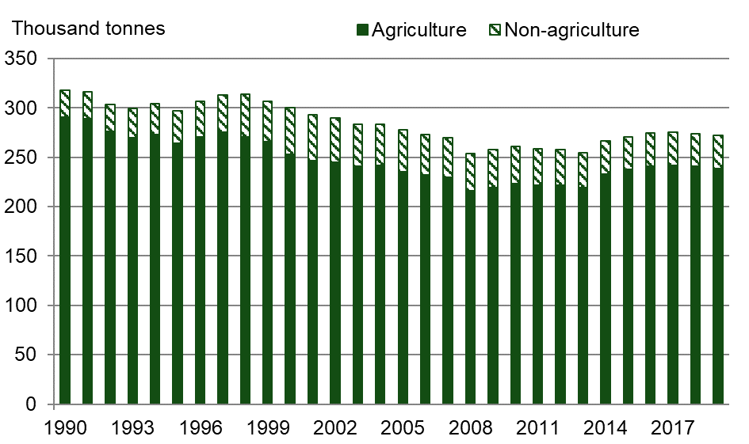
Source: National Atmospheric Emissions Inventory

The main sources of ammonia emissions in the UK are agricultural soils and livestock, in particular cattle. In 2019 ammonia emissions from agriculture are estimated to have fallen by 18% since 1990 and 5.6% since 2000 (see Figure 11.11) due to long-term reductions in cattle numbers and more efficient fertiliser use. However, this represents a slight increase since emissions from agriculture reached their lowest point in 2008. This recent increase is largely due to an increase in ammonia emission from Agricultural soils.

Further information and a detailed breakdown found on the Defra emissions of air pollutants webpage

Soils
The success of UK agriculture depends upon healthy soils; they are arguably a farmer’s most valuable asset. Soil degradation costs England and Wales an estimated £0.9bn - £1.4bn per year [5]. In the face of a changing climate and increase in food demand, it is important to mitigate the risks to long-term productive capacity and encourage famers to manage their soils in a sustainable way. While rates of soil erosion in England are not excessively high, it is estimated to affect around 17% of land in England and Wales with impacts in the form of loss of productive capacity and nutrients, but also off-site costs to the environment. Around 3.9 million hectares of our soils are at risk of soil compaction which could lead to a total yield penalty of around £163 million per year [5].

Actions to improve soil organic matter can be mutually beneficial for soil and production. For example, early establishment of crops in the autumn reduces soil erosion risk during the late autumn and winter months [6] and can also increase winter cereal yields [7].

Biodiversity

(Figure 11.12)

Bird populations are considered to be a good indicator of the general state of wildlife as they have a wide habitat distribution, they are near the top of the food chain and there are long-term datasets available for the UK. Agriculture provides valuable resources in terms of winter food, spring forage and nesting habitats for farmland bird populations. The largest declines in farmland bird populations occurred between the late 1970s and early 1990s due to the impact of rapid changes in farmland management. Whilst agri-environment schemes offer specific measures designed to help stabilise and recover farmland bird populations, the situation is complex with other pressures such as weather effects and disease pressures adversely impacting some species.

Figure 11.12 Farmland Bird Index
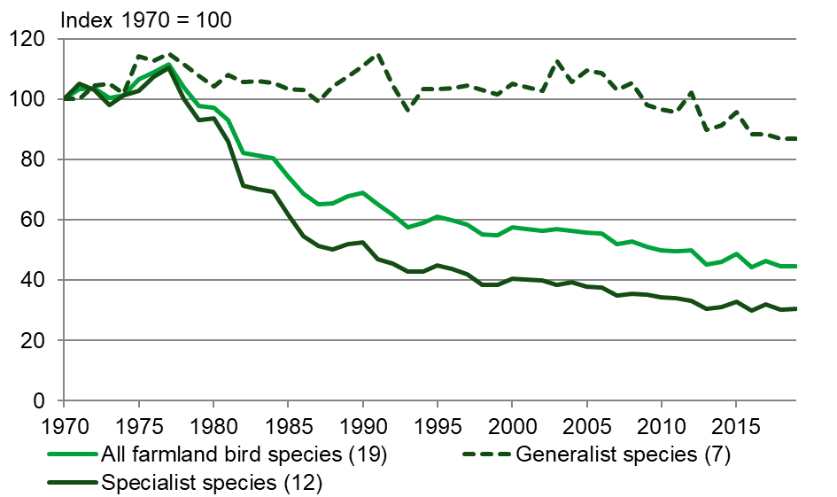
Source: BTO/RSPB

The farmland bird index comprises 19 species of bird. The long-term decline of farmland birds in the UK has been mainly driven by the decline of the 12 species known as the ‘specialists’ that are restricted to, or highly dependent on, farmland habitats (see Figure 11.12). Between 1970 and 2019, populations of farmland specialists declined by about 70% whereas farmland generalists have declined by about 13%. The 2019 index for all farmland bird species was at 44.6, less than half of its level in 1970.

Further information on the farmland bird index

References
[1]. Hunt, D.T.E., et al, 2004, Updating an estimate of the sources of nitrogen to waters in England and Wales. Defra project WT03016.
[2]. White, P.J. and Hammond, J.P., 2006, Updating the estimate of the sources of phosphorus in UK waters. Defra project WT0701CSF.
[3]. May, L., et al, 2011, The impact of phosphorus inputs from small discharges on designated freshwater sites. Report to Natural England and Broads Authority, SWR/CONTRACTS/08-09/112.
[4]. POSTnote 478 October 2014 Diffuse Pollution of Water by Agriculture,
[5]. SP1606 Total costs of soil degradation project 2011 Defra.
[6]. (Chambers et al. 2000; Evans 1990)
[7]. Green et al. (1985) found a 0.35% reduction in wheat yield and a 0.43% reduction in barley yield for every day of sowing later than mid-September.

Chapter 12 Organic Farming

Summary
Key results for 2020 compared to 2019

- The area of land farmed organically increased by 0.8% to 489 thousand hectares.
- The area in-conversion increased by 12% to just over 31 thousand hectares.
- England has 61% of the organically managed land, Scotland has 19%, Wales 18% and Northern Ireland the remainder.
- Within England nearly half of all organic land falls within the South West region.
- There were 5.8 thousand organic operators in the United Kingdom.

Introduction
Organic farming is a method of farming that requires farmers to operate to a system based on ecological principles which impose strict limitations on the inputs that can be used in order to minimise damage to the environment and wildlife. Emphasis is placed on natural methods of production and pest control.

All foods sold as organic must originate from growers, processors and importers who are registered with an approved certification body and subject to regular inspection. During these inspections, the crop areas and numbers of livestock present on the organic holding are recorded. Due to the nature of the inspections, the data is collected at varying times through the year. The data presented in this chapter therefore does not give an exact snapshot of organic farming at any specific time of year and this should be considered when interpreting the results.

Area of land farmed organically
(Figure 12.1, table 12.1)

Figure 12.1 Area of land in-conversion and fully organic

Source: Organic certification bodies collated by Defra statistics

In 2020 the United Kingdom had a total area of 489 thousand hectares farmed organically up from 485 thousand hectares in 2019. Organically farmed area includes both the fully converted area (where organic production comes from) and area under conversion.
The organically farmed area represents 2.8% of the total farmed area on agricultural holdings in the United Kingdom. Before an area can be considered as fully organic, it must undergo a conversion process. The area in-conversion showed a 12% increase in 2020.

Table 12.1 Organic and in-conversion land area by region
Enquiries: Sarah Thompson on +44 (0)20 802 66462, email: organic-stats@defra.gov.uk

Thousand hectares
 | 2017 | 2018 | 2019 | 2020
Land area, in-conversion
North East | 0.8 | 1.6 | 1.7 | 0.4
North West | 1.0 | 0.6 | 0.5 | 1.5
Yorkshire & Humberside | 0.8 | 0.6 | 0.7 | 0.5
East Midlands | 0.8 | 1.1 | 1.6 | 1.3
West Midlands | 5.1 | 4.4 | 2.0 | 2.6
Eastern | 1.2 | 1.2 | 2.1 | 2.6
South East (inc. London) | 1.7 | 2.0 | 2.3 | 2.8
South West | 8.4 | 8.7 | 8.0 | 8.7
England | 19.8 | 20.3 | 19.0 | 20.4
Wales | 7.3 | 3.6 | 1.8 | 1.8
Scotland | 5.1 | 8.5 | 6.8 | 8.7
Northern Ireland | 0.4 | 0.5 | 0.5 | 0.3
United Kingdom | 32.6 | 32.9 | 28.1 | 31.3
Land area, fully organic
North East | 22.6 | 21.6 | 22.3 | 22.2
North West | 13.9 | 11.6 | 11.5 | 11.0
Yorkshire & Humberside | 10.2 | 9.7 | 10.3 | 10.0
East Midlands | 12.6 | 12.6 | 13.7 | 11.2
West Midlands | 27.6 | 28.7 | 30.3 | 32.0
Eastern | 13.9 | 12.1 | 16.4 | 15.6
South East (inc. London) | 42.5 | 39.4 | 42.8 | 41.2
South West | 137.2 | 133.3 | 134.3 | 138.0
England | 280.5 | 269.0 | 281.6 | 281.3
Wales | 78.8 | 81.4 | 82.6 | 81.3
Scotland | 117.6 | 83.1 | 85.3 | 87.0
Northern Ireland | 7.9 | 7.6 | 7.6 | 8.0
United Kingdom | 484.8 | 441.1 | 457.1 | 457.6
Total UK organic land area | 517.4 | 474.0 | 485.2 | 489.0
Source: Organic certification bodies collated by Defra statistics
Notes:
- Total UK organic land area includes in-conversion and fully organic

Land use and livestock numbers
(Tables 12.2 and 12.3)
Permanent pasture accounted for the biggest share of the organic area (62%), followed by temporary pasture (20%) and cereals (8.7%). The three main crop types grown organically are cereals, vegetables including potatoes and other arable crops.

The number of poultry farmed organically in the United Kingdom increased by 11% between 2019 and 2020, rising to just over 3.8 million birds. However, this equates to only 2.1% of the total UK poultry population. Sheep reared organically decreased by 6.5% to 731 thousand animals and accounted for 2.2% of the total UK flock. Pigs reared organically decreased by 20% to 27 thousand animals and accounted for 0.5% of the total UK pig herd. Organically reared cattle numbers increased by 1.0% to 304 thousand animals and accounted for 3.2% of the total UK herd.

Table 12.2 Organic and in-conversion land area by use; United Kingdom
Enquiries: Sarah Thompson on +44 (0)20 802 66462, email: organic-stats@defra.gov.uk

Thousand hectares
 | 2017 | 2018 | 2019 | 2020
Land area, in-conversion
Cereals | 1.9 | 2.2 | 3.0 | 3.7
Other crops | 0.8 | 0.9 | 0.9 | 1.5
Fruit & nuts | 0.1 | 0.1 | 0.1 | 0.1
Vegetables (including potatoes) | 0.4 | 0.8 | 1.1 | 0.8
Herbs & ornamentals | - | 0.1 | - | 0.1
Temporary pasture | 7.4 | 7.3 | 6.1 | 6.5
Permanent pasture | 17.4 | 20.3 | 15.4 | 17.4
Woodland | 0.3 | 0.5 | 0.8 | 0.9
Unutilised land | 0.2 | 0.4 | 0.4 | 0.2
Unknown | 4.1 | 0.3 | 0.2 | 0.2
Total | 32.6 | 32.9 | 28.1 | 31.3
Land area, fully organic
Cereals | 35.4 | 34.8 | 36.8 | 39.0
Other crops | 6.6 | 6.5 | 8.0 | 7.7
Fruit & nuts | 1.7 | 1.6 | 1.9 | 1.9
Vegetables (including potatoes) | 9.2 | 8.5 | 8.3 | 8.7
Herbs & ornamentals | 5.9 | 6.6 | 0.4 | 0.3
Temporary pasture | 84.9 | 54.5 | 89.0 | 90.5
Permanent pasture | 316.0 | 309.9 | 290.0 | 287.1
Woodland | 8.6 | 7.1 | 14.4 | 15.1
Unutilised land | 5.4 | 3.5 | 4.2 | 2.6
Unknown | 11.1 | 8.1 | 4.2 | 4.7
Total | 484.8 | 441.1 | 457.1 | 457.6
Source: Organic certification bodies collated by Defra statistics
Notes:
- Permanent pasture includes rough grazing.
- Land areas provided without a crop category or land use description are classified as “unknown”.
- In 2019 data issues have been identified with the detailed split of crops provided for 2017 and 2018. The overall totals for 2017 and 2018 remain unaffected but the breakdowns are subject to a degree of error and therefore should be treated with caution.
- - means ‘nil’ or ‘negligible’

Table 12.3 Estimates of organic livestock numbers; United Kingdom
Enquiries: Sarah Thompson on +44 (0)20 802 66462, email: organic-stats@defra.gov.uk

Thousand head
 | 2017 | 2018 | 2019 | 2020
Cattle | 294 | 324 | 301 | 304
Sheep | 887 | 827 | 782 | 731
Pigs | 39 | 37 | 34 | 27
Poultry | 3,060 | 3,381 | 3,464 | 3,837
Other livestock | 3 | 6 | 6 | 7
Source: Organic certification bodies collated by Defra statistics
Notes:
- Certification bodies record production data at various times of the year, so figures should be treated with care as they will not represent an exact snapshot of organic livestock farming.
- Data relates to fully organic only.
- "Other Livestock" includes goats, farmed deer, horses, camelids and any livestock not recorded elsewhere.

Organic operators
(Tables 12.4 and 12.5)
There were 5,754 certified organic operators in the United Kingdom in 2020, a decrease from 6,129 in 2019.

The figures shown in table 12.4 are not directly comparable between years due to the recalibration of how producers are classified by some control bodies in 2018 and 2020, see footnotes (2) and (3).

Table 12.4 Number of organic operators – by region
Enquiries: Sarah Thompson on +44 (0)20 802 66462, email: organic-stats@defra.gov.uk

Number of operators
 | 2017 | 2018 | 2019 | 2020
North East | 132 | 113 | 116 | 117
North West | 308 | 263 | 274 | 241
Yorkshire & Humberside | 275 | 240 | 246 | 227
East Midlands | 388 | 350 | 353 | 328
West Midlands | 514 | 475 | 460 | 468
Eastern | 543 | 477 | 457 | 419
South East (inc. London) | 1,254 | 1,196 | 1,217 | 1,092
South West | 1,623 | 1,522 | 1,504 | 1,415
England | 5,037 | 4,636 | 4,627 | 4,307
Wales | 751 | 759 | 737 | 701
Scotland | 578 | 577 | 559 | 541
Northern Ireland | 220 | 216 | 206 | 205
United Kingdom | 6,586 | 6,188 | 6,129 | 5,754
Source: Organic certification bodies collated by Defra statistics
Notes:
- Organic operators include producers, processors and producer/processors. Processors can include abattoirs, bakers, stores and wholesalers. The recorded location depends on the address registered with the certifier bodies and so larger businesses may be recorded at their headquarters.
- In 2018, work was carried out to clarify how operators were recorded. This resulted in a number of operators that were previously recorded as processors being recorded in the correct categories of wholesalers/traders/retailers etc. We were unable to backdate these changes so earlier data is not directly comparable.
- In 2020, work was carried out by some control bodies to group existing operators together, so they effectively became ‘one operator’ whilst previously they may have been separate operators with separate licences.

Table 12.5 Numbers of organic crop and livestock producers and processors 2020 – by region
Enquiries: Sarah Thompson on +44 (0)20 802 66462, email: organic-stats@defra.gov.uk

Number of operators
 | No. crop producers | No. crop producers and processors | No. livestock producers | No. livestock producers and processors
North East | 67 | 4 | 52 | 4
North West | 101 | 11 | 76 | 9
Yorkshire & Humberside | 87 | 7 | 60 | 4
East Midlands | 143 | 9 | 112 | 4
West Midlands | 296 | 15 | 170 | 10
Eastern | 145 | 8 | 75 | 5
South East (inc. London) | 295 | 36 | 165 | 19
South West | 973 | 66 | 713 | 45
England | 2,107 | 156 | 1,423 | 100
Wales | 579 | 13 | 498 | 10
Scotland | 354 | 10 | 283 | 8
Northern Ireland | 135 | 6 | 123 | 3
United Kingdom | 3,175 | 185 | 2,327 | 121
Source: Organic certification bodies collated by Defra statistics
Notes:
- Mixed organic holdings will be recorded under both the crop and livestock headings above, so the above numbers cannot be added together to get total producers/processors by region as this will lead to double counting. For totals please see table 12.4.

Chapter 13 Overseas Trade

Summary

Key results for 2020 in real terms (adjusted for inflation) and compared to 2019
- The value of food, feed and drink exports decreased by £3.7bn (15%) to £21.4bn.
- The value of food, feed and drink imports decreased by £3.2bn (6.2%) to £48.0bn.
- The trade gap in food, feed and drink increased by £0.5bn (2.0%) to £26.6bn.
- Principal destinations for exports were the Irish Republic (£3.9bn), France (£2.0bn), USA (£1.9bn) and the Netherlands (£1.6bn).
- The main countries of despatch for imports into the UK were the Netherlands (£5.3bn), Germany (£4.5bn), Irish Republic (£4.4bn) and France (£4.4bn).
- In spite of a decrease of 26% whisky continued to have the highest export value, totalling £3.9bn.
- Fresh fruit and vegetables together remained the highest value category for imports, totalling £6.4bn which was a 5.7% decrease.
- Exports of fresh vegetables fell by 19% to £111m, whilst exports of fresh fruit increased by 11% to £184m.

Introduction
The Overseas Trade Statistics presented in this chapter are based on data collected by HM Revenue and Customs and are compiled from returns made by importers and exporters. Before the completion of the Single Market in the European Union at the end of 1992, all overseas trade data for the United Kingdom was compiled from Customs declarations made by traders. Since the beginning of 1993, the collection of trade statistics has been divided into two categories: that transacted between the United Kingdom and countries outside the European Union (extra-EU trade) and that between the United Kingdom and its European Union partners (intra-EU trade). Extra-EU trade statistics are compiled, as before, from Customs declarations by importers, exporters and their agents, while intra-EU trade statistics are compiled using a system linked to traders’ VAT returns, known as Intrastat.

The trade statistics shown here may not match those shown in the commodities tables in Chapter 7 where, for example, trade in meat includes the carcase weight equivalent of trade in live animals and trade in milk is of raw milk before processing, and not of processed and packaged milk and cream as shown here.

Value of trade in food, feed and drink
(Figure 13.1)

Figure 13.1 Value of trade in food, feed and drink at 2020 prices; United Kingdom

The value of exports of food, feed and drink was £21.4bn in 2020. To compare 2020 exports with previous years, it is necessary to adjust for the effects of economic inflation. The real terms value of exports was £3.7bn or 15% lower in 2020 than 2019. The longer trend is of rising real terms export values. Since 2005 the real terms value of exports has risen by £7.5bn or 54%. This long-term trend is a consequence of the combination of the relative strength of sterling, proactive responses to disease related issues, and an upward trend in world commodity prices.

The value of imports of food, feed and drink was £48.0bn in 2020. To compare 2020 imports with previous years it is necessary to adjust for the effects of economic inflation. The real terms value of imports was £3.2bn or 6.2% lower in 2020 than 2019. The longer trend is of rising real terms import values. Since 2005 the real terms value of imports has risen by £15.3bn or 47%. The trade gap widened by 2.0% between 2019 and 2020. Over the longer term it has widened by 42% from £18.8bn (in 2005) to £26.6bn (in 2020) in real terms.

Looking at exports of specific food types, the largest percentage decrease in real terms occurred in the fish category which showed a fall of 24% to £1.6bn, followed by exports of dairy and eggs which decreased by 14% to £1.8bn. Exports of beverages also fell, by 24% to £6.4bn.

In real terms, imports of sugar and sugar preparations fell by 13% to £1.1bn, and imports of dairy and eggs by 9.0% to £3.2bn between 2019 and 2020. Imports of meat fell by 12% to £6.2bn, and imports of fish similarly decreased by 12% to £3.2bn.

Value of trade in food, feed and drink by types of commodity
(Tables 13.1a, 13.1b, 13.1c and figures 13.2, 13.3)

Table 13.1a Value of trade in food, feed and drink at 2020 prices; United Kingdom
Enquiries: David Lee on +44 (0)208 026 3006, email: david.lee@defra.gov.uk

£million
ITC Division Code | Type | 2018 | 2019 | 2020
Exports
01 | Meat & Meat Preps | 2,027 | 2,194 | 2,044
02 | Dairy & Eggs | 2,042 | 2,113 | 1,811
03 | Fish & Fish Preps | 1,933 | 2,131 | 1,629
04 | Cereals & Cereal Preps | 2,314 | 2,598 | 2,253
05 | Fruit and Veg & Preps | 1,366 | 1,356 | 1,240
06 | Sugar & Sugar Preps | 487 | 463 | 424
07 | Coffee, tea, etc. | 1,670 | 1,643 | 1,569
08 | Animal feed | 1,280 | 1,195 | 1,151
09 | Misc. edible preps | 2,287 | 2,344 | 2,219
11 | Beverages | 8,265 | 8,376 | 6,397
22 + S4 | Oils/fats & Oilseeds | 671 | 621 | 615
 | Total | 24 342 | 25 036 | 21 350
Imports
01 | Meat & Meat Preps | 7,341 | 7,084 | 6,239
02 | Dairy & Eggs | 3,700 | 3,547 | 3,230
03 | Fish & Fish Preps | 3,449 | 3,675 | 3,226
04 | Cereals & Cereal Preps | 4,421 | 4,524 | 4,448
05 | Fruit and Veg & Preps | 11,990 | 12,259 | 11,419
06 | Sugar & Sugar Preps | 1,270 | 1,278 | 1,117
07 | Coffee, tea, etc. | 4,040 | 4,047 | 3,926
08 | Animal feed | 2,554 | 2,588 | 2,540
09 | Misc. edible preps | 3,533 | 3,685 | 3,654
11 | Beverages | 6,327 | 6,383 | 5,941
22+S4 | Oils/fats & Oilseeds | 2,022 | 2,038 | 2,217
 | Total | 50 647 | 51 109 | 47 957
Source: HMRC
Notes:
- 2020 figures are provisional and subject to revision

Table 13.1b Value of trade in food, feed and drink with EU countries at 2020 prices; United Kingdom
Enquiries: David Lee on +44 (0)208 026 3006, email: david.lee@defra.gov.uk

£million
SITC Division  Code | Type | 2018 | 2019 | 2020
Exports
01 | Meat & Meat Preps | 1,637 | 1,629 | 1,426
02 | Dairy & Eggs | 1,592 | 1,593 | 1,362
03 | Fish & Fish Preps | 1,373 | 1,431 | 1,215
04 | Cereals & Cereal Preps | 1,642 | 1,849 | 1,525
05 | Fruit and Veg & Preps | 1,068 | 1,047 | 953
06 | Sugar & Sugar Preps | 356 | 326 | 258
07 | Coffee, tea, etc. | 1,212 | 1,179 | 1,121
08 | Animal feed | 893 | 785 | 717
09 | Misc. edible preps | 1,503 | 1,477 | 1,365
11 | Beverages | 3,109 | 3,158 | 2,563
22 + S4 | Oils/fats & Oilseeds | 582 | 537 | 532
 | Total | 14 967 | 15 010 | 13 037
Imports
01 | Meat & Meat Preps | 6,029 | 5,864 | 5,186
02 | Dairy & Eggs | 3,645 | 3,497 | 3,181
03 | Fish & Fish Preps | 1,177 | 1,295 | 1,116
04 | Cereals & Cereal Preps | 3,556 | 3,524 | 3,482
05 | Fruit and Veg & Preps | 7,558 | 7,864 | 7,235
06 | Sugar & Sugar Preps | 875 | 863 | 699
07 | Coffee, tea, etc. | 2,757 | 2,823 | 2,755
08 | Animal feed | 1,429 | 1,465 | 1,541
09 | Misc. edible preps | 2,870 | 2,968 | 2,943
11 | Beverages | 4,573 | 4,678 | 4,285
22+S4 | Oils/fats & Oilseeds | 1,137 | 1,134 | 1,111
 | Total | 35 606 | 35 975 | 33 533
Source: HMRC
Notes:
- Figures for 2020 are provisional and subject to revision

Table 13.1c Value of trade in food, feed and drink with non-EU countries at 2020 prices; United Kingdom
Enquiries: David Lee on +44 (0)208 026 3006, email: david.lee@defra.gov.uk

£million
SITC Division  Code | Type | 2018 | 2019 | 2020
Exports
01 | Meat & Meat Preps | 386 | 561 | 618
02 | Dairy & Eggs | 446 | 516 | 448
03 | Fish & Fish Preps | 557 | 697 | 414
04 | Cereals & Cereal Preps | 667 | 745 | 728
05 | Fruit and Veg & Preps | 295 | 307 | 287
06 | Sugar & Sugar Preps | 130 | 137 | 166
07 | Coffee, tea, etc. | 455 | 461 | 448
08 | Animal feed | 384 | 409 | 434
09 | Misc. edible preps | 780 | 862 | 854
11 | Beverages | 5,141 | 5,203 | 3,834
22 + S4 | Oils/fats & Oilseeds | 89 | 82 | 82
 | Total | 9 330 | 9 979 | 8 313
Imports
01 | Meat & Meat Preps | 1,299 | 1,206 | 1,054
02 | Dairy & Eggs | 48 | 44 | 49
03 | Fish & Fish Preps | 2,266 | 2,373 | 2,111
04 | Cereals & Cereal Preps | 857 | 992 | 966
05 | Fruit and Veg & Preps | 4,410 | 4,373 | 4,184
06 | Sugar & Sugar Preps | 393 | 413 | 418
07 | Coffee, tea, etc. | 1,275 | 1,217 | 1,171
08 | Animal feed | 1,120 | 1,118 | 999
09 | Misc. edible preps | 656 | 710 | 711
11 | Beverages | 1,742 | 1,694 | 1,656
22+S4 | Oils/fats & Oilseeds | 881 | 900 | 1,106
 | Total | 14 947 | 15 039 | 14 425
Source: HMRC
Notes: (tables 13.1, 13.1a and 13.1b)
Defra's aggregate 'Food, Feed and Drink' is composed of the following divisions from the Standard International Trade Classification:
- Figures for 2020 are provisional and subject to revision
- Meat [01]: meat from cattle, sheep, pigs, goats, poultry, horses etc.; preparations including blood, juices, sausages, livers, offal.
- Dairy [02]: includes milk (skimmed or otherwise), butter, buttermilk, cream, yoghurt, ice cream, whey, cheese and curd, all types of eggs both in and out of shell.
- Fish [03]: All types of edible marine life excluding mammals, fresh, frozen, processed, prepared or preserved.
- Cereals [04]: includes rice, wheat, barley, oats, maize, grain sorghum and preparations including sweet biscuits, waffles, gingerbread, and uncooked/unstuffed pasta.
- Fruit and vegetables [05]: includes fresh, frozen or prepared fruit (except crystallised) and vegetables, nuts (except groundnuts), vegetable and fruit juices of all kinds except wine (see division 11), jams, marmalades, fruit or nut puree/paste etc.
- Sugar [06]: includes both natural sugar and sugar confectionery (but not chocolate or cocoa), both natural and artificial honey, and liquorice.
- Coffee, tea, etc. [07]: includes all types of tea, coffee (e.g. green, decaffeinated), extracts and substitutes thereof; cocoa and chocolate (of all kinds): all kinds of spices.
- Animal feed [08]: includes hay, fodder, bran, sharps and other residues derived from cereals or leguminous plants, oil-cake and other solid residues, other residues, brewing dregs, all types of pet or animal food.
- Miscellaneous [09]: includes margarine, shortening, homogenised products or preparations not elsewhere specified, sauces, vinegar, soups, yeasts, cooked/stuffed pasta, food preparations for infant use.
- Beverages [11]: includes alcoholic drinks of all kinds; also natural or artificial mineral and aerated waters sweetened or otherwise.
- Oils [22+S4]: includes groundnuts (peanuts), soya beans, sunflower seeds, rape seeds, palm nuts, linseed, poppy seeds etc., lard, pig fat, olive oil, rape oil, corn oil, linseed oil, beeswax etc.
- Division 00, which covers all live animals, is excluded from the aggregate 'Food, Feed and Drink' because it includes non-food animals, particularly race horses. S4 stands for Section 4 in the SITC and covers animal and vegetable oils, fats and waxes.

Total value of trade in food, feed and drink by trading partner
(Figures 13.2 and 13.3)

Figure 13.2 Exports of food, feed and drink by country of destination 2020

£ million

Figure 13.3 Imports of food, feed and drink by country of dispatch 2020

£ million

Value of exports and imports by degree of processing
(Figures 13.4, 13.5)
Trade in food, feed and drink covers a wide range of products from raw agricultural commodities through lightly processed foods such as meat, cheese and butter, powdered milk, flour and sugar to highly processed products such as confectionery, canned meats, jams, alcoholic drinks and ice cream. By grouping foods into unprocessed, lightly processed and highly processed, additional insights in trading patterns can be found.

Figure 13.4 Exports in food, feed and drink by degree of processing at 2020 prices; United Kingdom
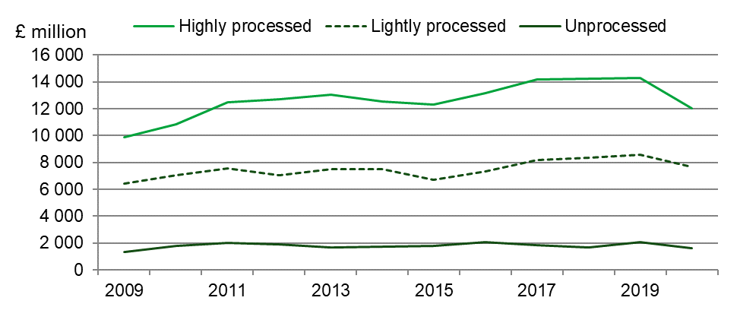
Exports of highly processed foods such as confectionery, canned meats, jams, alcoholic drinks and ice cream, decreased by 3.8% in real term value between 2011 and 2020. Exports of lightly processed food and drink, i.e. goods that retain their raw recognisable form, such as meat, cheese, butter and oils & fats rose by 1.9% in real term value between 2011 and 2020. Exports of unprocessed commodities, such as fresh fruit & vegetables, nuts, un-milled cereal and eggs decreased by 19% in real term value between 2011 and 2020.

Figure 13.5 Imports in food, feed and drink by degree of processing at 2020 prices; United Kingdom
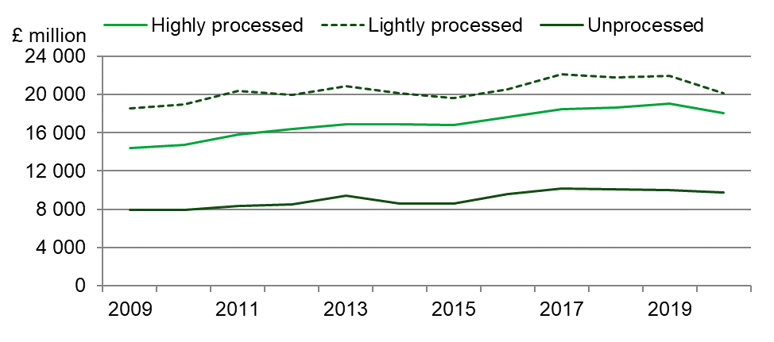
Imports of highly processed foods increased by 14% in real term value between 2011 and 2020. Imports of lightly processed food and drink decreased by 1.0% in real term value between 2011 and 2020. Imports of unprocessed commodities increased by 17% in real term value between 2011 and 2020.

Value and volume of trade in key commodities
(Tables 13.2 and 13.3)
The value of exports across a range of different commodities has broadly increased year-on-year in recent times. However, in 2014 and 2015, commodity prices for many sectors fell, due to a slowdown of global economic markets and the effect of exchange rates. Subsequent years have seen a return to export growth in most of the main product groups. However, the effect of the coronavirus (COVID-19) pandemic in 2020 affected both trade and the economy.

The value of exports of whisky, which represents the highest valued individual food, feed and drink item, decreased by 26% in real terms to £3.9bn in 2020. It is 26% lower than in 2011 in real terms. Imports of salmon decreased by 23% to £495m but were 62% higher than 2011 in real terms. The value of imports of un-milled wheat increased by 55% in real terms to £409 m in 2020 in reaction to reduced domestic supplies. Exports of cheese fell by 13% in real terms to £654 million as a result of strong global demand for UK dairy products.

Imports of fresh fruit and fresh vegetables decreased by 5.7% in real terms to £6.4bn. Despite the slight decrease, the range, quality and consumer awareness of healthy eating options remain high.

The value of wine imports in 2019, a high value commodity, decreased by 7.2% in real terms on 2019, to £3.4bn, whereas the value of wine exported from the UK decreased by 23% in real terms to £535m.

The overall volume of exports of food, feed and drink in 2020 decreased by 12% to 13.5 billion tonnes. The long-term trend for the volume of exports is slightly upwards, although in 2020 it was 1.3% higher than in 2011. Import volumes have been increasing more rapidly over recent years, and the volume of imports of 41.5 billion tonnes in 2020 was 23% higher than 2011.

The food, feed and drink Index provides a comparison of trade which accounts for the value density of different food groups. For example, high value per tonne exports (e.g. whisky) are given more weight in this indicator than low value per tonne exports (e.g. wheat and barley). According to the index, food, feed and drink exports in 2020 decreased by 9.6% on the previous year, while imports decreased by 2.1%.

Table 13.2 Trade in key commodities in real terms at 2020 prices; United Kingdom
Enquiries: David Lee on +44 (0)208 026 3006, email: david.lee@defra.gov.uk

£million
Commodity | Flow | 2018 | 2019 | 2020
Whisky | Imports | 233 | 203 | 195
 | Exports | 5,196 | 5,316 | 3,913
Wine | Imports | 3,564 | 3,714 | 3,446
 | Exports | 667 | 695 | 535
Cheese | Imports | 1,833 | 1,830 | 1,696
 | Exports | 728 | 749 | 654
Poultry meat | Imports | 1,380 | 1,301 | 972
 | Exports | 323 | 320 | 296
Poultry meat products | Imports | 1,165 | 1,225 | 1,125
 | Exports | 149 | 129 | 110
Beef and veal | Imports | 1,258 | 1,059 | 977
 | Exports | 468 | 490 | 384
Wheat, unmilled | Imports | 489 | 264 | 409
 | Exports | 68 | 194 | 90
Lamb and mutton | Imports | 402 | 332 | 314
 | Exports | 396 | 422 | 438
Pork | Imports | 920 | 1,015 | 882
 | Exports | 315 | 414 | 422
Breakfast cereals | Imports | 322 | 339 | 320
 | Exports | 520 | 511 | 519
Milk and cream | Imports | 194 | 148 | 120
 | Exports | 372 | 352 | 285
Bacon and ham | Imports | 587 | 601 | 520
 | Exports | 67 | 71 | 50
Butter | Imports | 389 | 308 | 240
 | Exports | 296 | 271 | 188
Eggs and egg products | Imports | 185 | 167 | 167
 | Exports | 105 | 119 | 116
Fresh vegetables | Imports | 2,660 | 2,720 | 2,519
 | Exports | 140 | 137 | 111
Fresh fruit | Imports | 4,082 | 4,117 | 3,929
 | Exports | 168 | 165 | 184
Salmon (inc. smoked) | Imports | 554 | 639 | 495
 | Exports | 685 | 871 | 604
Source: HMRC
Notes: See notes for table 13.3

Table 13.3 Trade in key commodities by volume; United Kingdom
Enquiries: David Lee on +44 (0)208 026 3006, email: david.lee@defra.gov.uk

Thousand tonnes (unless otherwise specified)
Commodity | Flow | 2018 | 2019 | 2020
Whisky | Imports | 20 | 19 | 20
(million litres pure alcohol) | Exports | 374 | 382 | 330
Wine | Imports | 1,416 | 1,430 | 1,475
(million litres) | Exports | 121 | 102 | 92
Cheese | Imports | 523 | 538 | 496
 | Exports | 190 | 209 | 193
Poultry meat | Imports | 488 | 478 | 409
 | Exports | 373 | 393 | 451
Poultry meat products | Imports | 375 | 383 | 360
 | Exports | 54 | 37 | 30
Beef and veal | Imports | 290 | 254 | 246
 | Exports | 110 | 136 | 117
Wheat, un-milled | Imports | 2,486 | 1,222 | 2,102
 | Exports | 358 | 1,116 | 506
Lamb and mutton | Imports | 78 | 63 | 59
 | Exports | 83 | 95 | 88
Pork | Imports | 457 | 453 | 384
 | Exports | 218 | 245 | 259
Breakfast cereals | Imports | 147 | 151 | 149
 | Exports | 186 | 191 | 218
Milk and cream | Imports | 314 | 229 | 218
 | Exports | 881 | 863 | 792
Bacon and ham | Imports | 215 | 195 | 170
 | Exports | 21 | 19 | 14
Butter | Imports | 84 | 79 | 79
 | Exports | 62 | 69 | 61
Eggs and egg products | Imports | 89 | 87 | 76
 | Exports | 54 | 93 | 31
Fresh vegetables | Imports | 2,268 | 2,356 | 2,179
 | Exports | 145 | 143 | 107
Fresh fruit | Imports | 3,661 | 3,657 | 3,547
 | Exports | 156 | 162 | 176
Salmon (inc. smoked) | Imports | 76 | 93 | 82
 | Exports | 100 | 124 | 97
Food, feed and drink | Imports | 122 | 122 | 120
Index, 2009=100 | Exports | 127 | 131 | 119
Source: HMRC
Notes: (Tables 13.2 and 13.3)
- Figures for 2020 are provisional and subject to revision
- Whisky includes bourbon, scotch (malted and blended) and other whiskies.
- Wine includes grape must, vermouth and wine of fresh grapes (sparkling and still).
- Cheese includes grated or powdered, processed, blue-veined and fresh (e.g. curd).
- Poultrymeat (inc. poultry offal) includes carcase meat, cuts and offal (inc. liver).
- Poultry meat products includes prepared, preserved, salted or cooked poultrymeat and offal (inc. liver).
- Beef and veal includes carcase meat and cuts, both bone-in and boneless.
- Wheat, un-milled includes durum, other wheat (inc. spelt) and meslin.
- Lamb and mutton includes carcase meat and cuts, both bone-in and boneless.
- Pork includes carcase meat and cuts, both bone-in and boneless.
- Breakfast cereals includes cereal grains worked or prepared for breakfast cereals
- Milk and cream includes milk (inc. skimmed milk) and cream, not concentrated or sweetened.
- Fresh vegetables excludes potatoes, dried legumes and processed vegetables.
- Fresh fruit excludes jams, juices, dried and processed fruit.
- Salmon (inc. smoked) includes fresh, chilled, frozen or smoked, but not canned
- Note: Definitions of 'fresh vegetables' and 'fresh fruit' used have been revised in 2009 to be consistent with those used for AUK Chapter 5.

Chapter 14 The Food Chain

Summary
- In 2019 the agri-food sector in the United Kingdom accounted for a total estimated Gross Value Added (GVA) of £127bn or 6.4% of national GVA, unchanged from 2018. The manufacturing sector increased 8.7%, followed by the agriculture sector at 6.5%.
- Employment in the agri-food sector fell by 1.0% over the 12-month period to the fourth quarter of 2020 to just under 4 million. The largest decrease was in wholesaling, falling by 17,000 employees (7.1%).
- Total factor productivity of the UK food chain beyond the farmgate rose by 0.9% between 2017 and 2018. Productivity in the wider economy rose by 0.1% in 2018. Benchmarking against a wider economy measure shows that the average annual growth in the food chain between 2008 and 2018 was 0.3% compared to 0.2% in the wider economy. For more information on productivity please see the Total Factor Productivity of the United Kingdom Food Chain publication.
- Excluding the effect of price rises (constant prices), consumers’ expenditure on food and alcoholic drinks decreased by 13% in 2020 and was 1.0% lower than in 2010. Expenditure on food eaten out decreased by 40% in 2020, whilst expenditure on household food increased by 7.7%.

Contribution of the agri-food sector to the national economy
(Figure 14.1, table 14.1)

Figure 14.1 Gross Value Added of the agri-food sector, 2019 (£ billion)

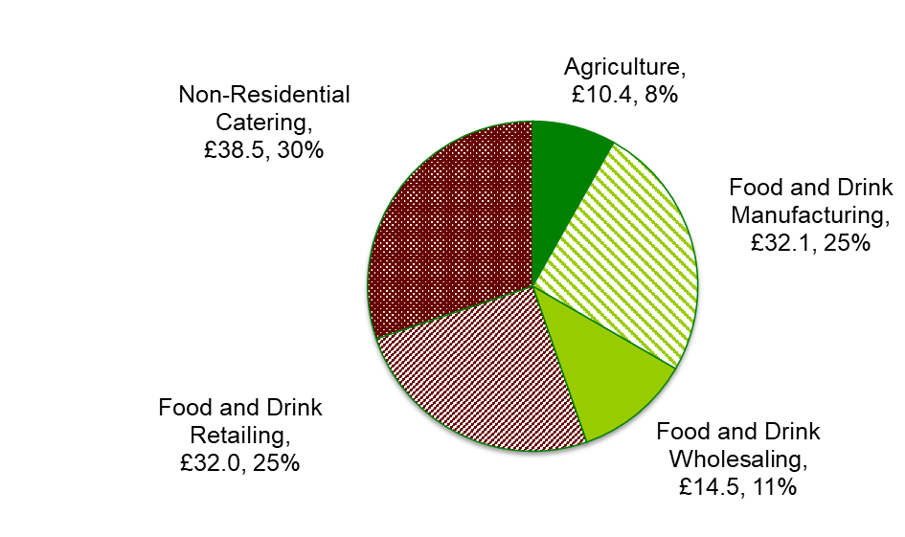
Source: Annual Business Survey (ONS) and Aggregate Agricultural Accounts (Defra).

In 2019 the agri-food sector contributed £127bn to the economy, 6.4% of the national GVA. Within this, retailing, manufacturing and non-residential catering accounted for over one quarter each. Wholesaling covered 11% of the sector. Agriculture made the smallest contribution at 8%.

In 2018 all sectors increased their productivity, except agriculture which fell by 1% compared to 2017. Wholesaling saw the highest increase of 2.2% while catering saw the lowest increase of 0.3%.

Between 2008 and 2018, the average annual growth rate of the food chain was 0.3% whereas the wider economy’s average annual growth rate was 0.2%. For more information please see the Total Factor Productivity of the United Kingdom Food Chain publication.

Table 14.1 Agri-food sector contribution to the national economy
Enquiries: David Lee on +44 (0)20 802 63006, email: david.lee@defra.gov.uk

£ million (unless specified otherwise)
 | 2018 | 2019 | 2020
Agri-food sector's contribution to total economy (Gross value added at current prices) | 121,979 | 127,481 | ..
Agriculture | 9,775 | 10,408 | ..
Food Manufacturing | 29,521 | 32,091 | ..
Food Wholesaling | 14,218 | 14,485 | ..
Food Retailing | 30,971 | 32,034 | ..
Food Non-Residential Catering | 37,494 | 38,463 | ..
% of national gross value added (current prices) | 6.4% | 6.4% | ..
Workforce in the food sector (thousand persons)
Agriculture | 426 | 427 | 425
Food Manufacturing | 404 | 419 | 413
Food Wholesaling | 237 | 235 | 218
Food Retailing | 1,112 | 1,106 | 1,144
Food Non-Residential Catering | 1,790 | 1,809 | 1,758
% of total workforce in employment | 13% | 13% | 13%
Trade in food, feed & drink (in real terms at 2019 prices)
Imports of food, feed and drink | 50,647 | 51,109 | 47,957
% of total UK imports | 9.3% | 8.8% | 9.8%
Exports of food, feed and drink | 24,342 | 25,036 | 21,350
% of total UK exports | 6.2% | 6.4% | 6.9%
UK Food Production to Supply Ratio ('Self-Sufficiency')
% of all food | 60% | 61% | 60%
% of indigenous type food | 74% | 76% | 74%
Household final consumption expenditure on food and alcoholic drinks
at current prices | 228,295 | 234,368 | 208,056
household food | 104,378 | 106,583 | 116,361
food eaten out | 64,757 | 66,969 | 41,013
alcoholic drinks | 59,160 | 60,816 | 50,682
at constant 2010 prices (£ million) | 230,691 | 231,735 | 202,493
household food | 104,927 | 105,783 | 113,961
food eaten out | 66,108 | 66,281 | 39,770
alcoholic drinks | 59,656 | 59,671 | 48,762
% of total household final consumption expenditure | 16.8% | 16.9% | 16.9%
household food | 7.7% | 7.7% | 9.4%
food eaten out | 4.8% | 4.8% | 3.3%
alcoholic drinks | 4.4% | 4.4% | 4.1%
Producer prices for agricultural products (2015 = 100) | 115.1 | 113.4 | 118.5
Consumer price index (2015 = 100):
food | 101.8 | 102.9 | 103.4
alcoholic drinks | 100.0 | 101.0 | 102.0
all items | 105.9 | 107.8 | 108.7
Sources: Annual Business Survey (ONS), Aggregate Agricultural Accounts (Defra), Labour Force Survey GB (ONS), Overseas Trade Statistics (HMRC), Consumer Price Indices (ONS).
Notes:
- 2020 figures are provisional and subject to revision
- .. means 'not available' or 'not applicable'.

Agri-food sector employees and self-employed farmers
(Figure 14.2)

Figure 14.2 Agri-food sector employees and self-employed farmers, 2020 (millions)

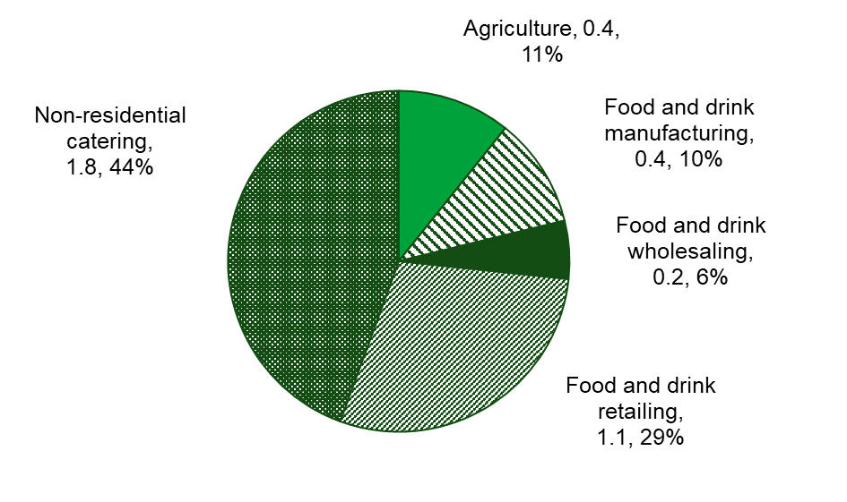
Source: Labour Market Trends (ONS), June Survey of Agriculture and Horticulture (Defra)

In the fourth quarter of 2020, the agri-food sector employed 4 million people, or 13% of all employees in Great Britain. This proportion has been broadly the same since 2001. Agriculture accounts for less than half a million employees or 11% of the agri-food sector (figure 14.2).

In the twelve months to December 2020, employment in the agri-food sector decreased by 1.0%. Employment fell in 2020 in wholesaling (7.1%), in non-residential catering (2.8%), manufacturing (1.4%) and in agriculture (0.6%). Employment in 2020 rose only in retailing, by 3.4%. Employment across the whole economy decreased by 1.0% over the same period.

Employment in the agri-food sector has risen 9.7 since 2000. Changes in each of the sectors since that time show that employment in agriculture, manufacturing and wholesaling reduced by 24%, 14% and 1.2% respectively, while non-residential catering and retailing increased by 40% and 5.0% respectively.

Food manufacturing
Food manufacturing productivity increased by 0.7 per cent in 2018 and has shown no significant change over the last 10 years. For more information on productivity please see the Total Factor Productivity of the United Kingdom Food Chain publication.

Food wholesaling
Food and drink wholesale productivity increased by 2.2% in 2018 and in the last 10 years has shown an average annual increase of 0.7%.

Food retailing
Food retail productivity in 2018 increased by 0.4% and in the last 10 years has shown an average annual increase of 0.3%.

Non-residential catering
Non-residential catering (NRC) showed an increase in productivity of 0.3% in 2018. Productivity of NRC was at its strongest prior to the recession, then dipped to its lowest level in 2009, but since the recession has seen an increase. This sector would have been affected strongly by the recession that started in 2008 and lasted through most of 2009. Challenging economic conditions make it difficult for companies to make proportionate savings across all inputs, especially as labour is a relatively high component. Conversely, consumers find it easier to make these types of savings by reducing spending on food; during periods of economic downturn it is likely that consumers will make savings through eating out less and switching to home cooking.

Trade in food, feed and drink
(Table 14.1)
In 2020, the value of food, feed and drink exports was £21.4bn, a decrease of 15% on 2019. In 2020 the value of food, feed and drink imports decreased by 6.2% to £48.0bn in real terms, resulting in the trade gap in food, feed and drink of £26.6bn in real terms, an increase of 2.0% since 2019. See Chapter 13 for more detail on overseas trade.

Food production to supply ratio
(Figure 14.3)

Figure 14.3 Food production to supply ratio, 2020
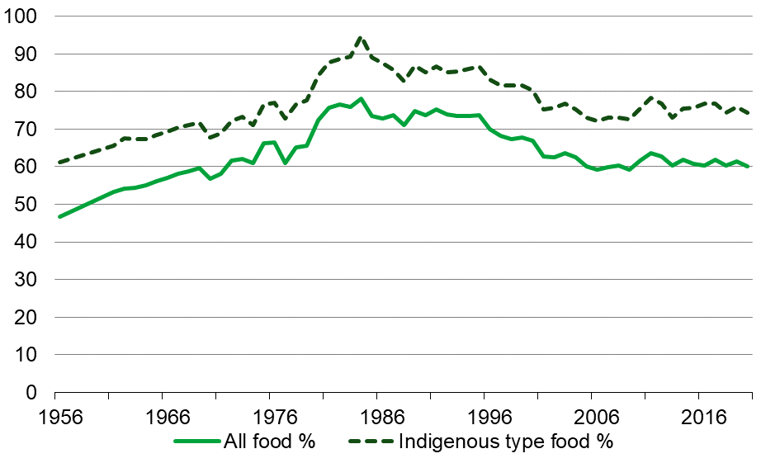
Source: Defra 2020

Food Production to Supply Ratio (commonly referred to as the “Self Sufficiency Ratio”), is calculated as the farmgate value of raw food production divided by the value of raw food for human consumption, and is estimated to be 60% for all food in 2020 and 74% for indigenous type food. This compares with 61% and 76% respectively in 2019. The overall farmgate value of United Kingdom food production was 1% higher when compared to 2018.

Distinction between competitiveness and food security
The food production to supply ratio provides a very broad indicator of the ability of United Kingdom agriculture to meet consumer demand - also described as competitiveness. The ratio is not an appropriate measure of “food security” since it fails to account for many dimensions of this complex issue.

A detailed analysis is given in the Defra publication ‘UK Food Security Assessment’.

The key points on food production to supply ratio and food security from this paper are:

- Diversity enhances security. The United Kingdom sources foods from diverse stable countries, mainly European countries, and imports can make up for domestic supply shortages (see Figure 14.4).
- A high food production to supply ratio fails to insulate a country against many possible disruptions to its supply chain.
- Production potential is more relevant at European Union level than United Kingdom level, and the European Union as a whole has a food production to supply ratio of around 90%.
- Further trade liberalisation is unlikely to affect food security within the European Union.

Origins of food consumed in the United Kingdom
(Figure 14.4)
Figure 14.4 includes the proportion of United Kingdom food consumption that is produced in the United Kingdom. This should not be confused with the Food Production to Supply Ratio given in Figure 14.3. Figure 14.4 looks purely at the breakdown of food that the United Kingdom actually consumes.

The Food Production to Supply Ratio (see figure 14.3) considers all United Kingdom food production, including food that the United Kingdom exports instead of consuming. A further, much smaller difference is that the United Kingdom food production used in the food production to supply ratio calculations has been adjusted to take account of the balance of trade in important inputs into agriculture.

Figure 14.4 Origins of food consumed in the United Kingdom: 2005, 2010, 2015, 2020
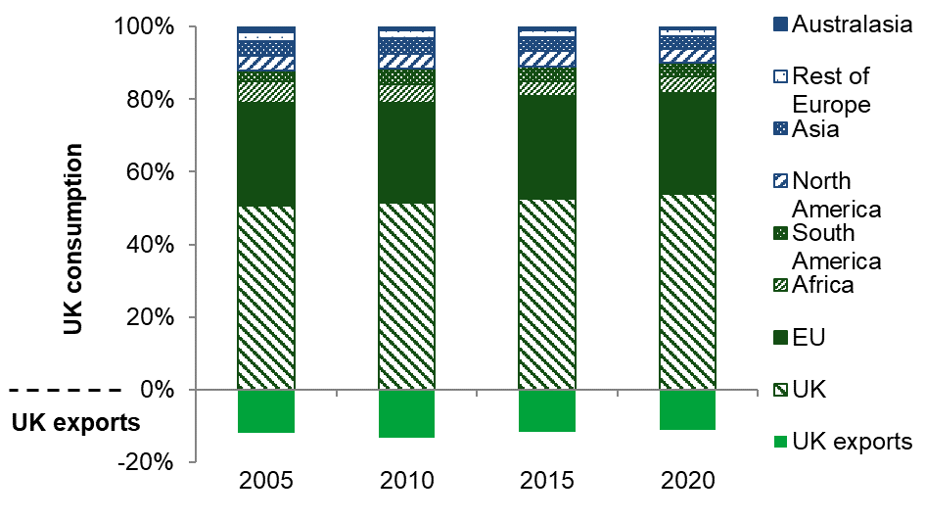
Source: HMRC and Defra 2020
Notes:
- Based on the farm-gate value of raw food.
- Consumption of UK origin consists of UK domestic production minus UK exports.
- UK exports are given as a percentage of total UK consumption.
- Membership of the EU increased between 2002 and 2013, from 15 to 28 countries.

Consumers’ expenditure
(Figure 14.5)

Figure 14.5 Consumers’ expenditure on food, drink and catering

Source: Consumer trends, ONS.
Notes:
- Food includes non-alcoholic drinks
- Drink represents alcoholic drinks only.

Excluding the effect of price rises (constant prices), consumers’ expenditure on food and alcoholic drinks decreased by 13% in 2020 to £202bn and was 1.0% lower than in 2010. Expenditure on food eaten out decreased by 40% in 2020, whilst expenditure on household food increased by 7.7%.

Consumer expenditure on food and alcoholic drinks (at current prices) decreased by 11% to £208bn in 2020. Household food expenditure increased 9.2%, food eaten out fell 39% and expenditure on alcoholic drinks fell 17% in 2020.

At current prices, which incorporate inflation (see figure 14.5), consumers spent 21% more overall on food and drink in 2020 than in 2010; in that period household food saw the biggest increase at 44%, while food eaten out saw a decrease of 18%.

Changes in consumers’ price indices
(Figure 14.6)

Figure 14.6 Changes in the food price index (in constant prices)
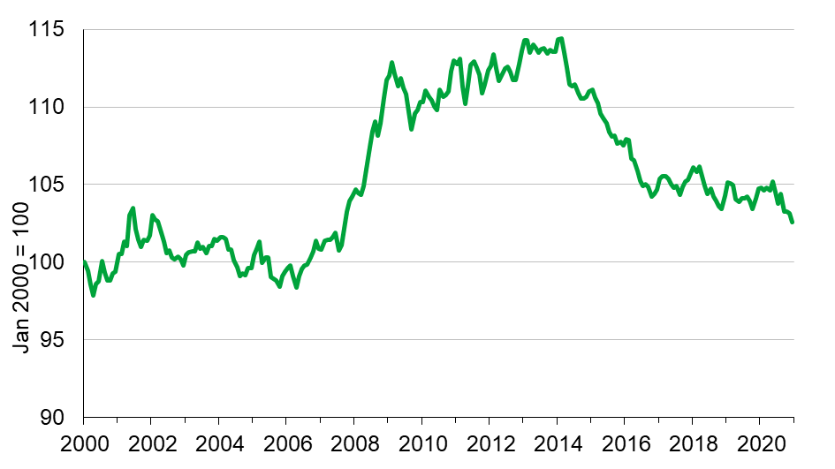
Source: Consumer Price Index (ONS)

Historically (1975 to 2000) food prices tended to rise more slowly than general inflation, as measured by the Retail Price Index (RPI). Food prices in real terms were fairly stable between 2000 and 2007, as measured by the Consumer Price Index (CPI), before rising by 12% between July 2007 and February 2009. Prices then returned to real terms stability until February 2014.

From a peak in February 2014, food prices fell steadily to October 2016 and, after improving in 2017, fell again to November 2018. Food prices fluctuated in 2019 before falling sharply in the second half of 2020.

Chapter 15 Key Statistics for the EU

Summary
The United Kingdom (UK) left the European Union (EU) on 31 January 2020, entering a transition period that ended on 31 December 2020. During the transition period the UK continued to report data to Eurostat. With effect from 2020, due the UK’s departure from the EU, Eurostat stopped producing data for the European Union 28 Member States and instead published aggregate data for the remaining European Union 27 Member States.

Comparing the EU-27 Member States with the UK in 2020:

- The UK was the largest producer of sheep and goat meat producing over 300 thousand tonnes.
- The UK was the third largest producer of milk and beef and veal behind France and Germany.
- Germany was the largest producer of pig meat followed by Spain and France. The UK in comparison was the ninth largest producer.

Introduction
This chapter presents simple analyses of agriculture in the European Union to enable the United Kingdom to be compared with the EU Member States (EU-27). The source of the data is the Eurostat website where a range of data are available, including statistics from the agricultural accounts found in Chapter 4, which were provided by the United Kingdom. Eurostat is the statistical office of the European Union. Its task is to provide the European Union with statistics at a European level that enable comparisons between countries and regions.

Agricultural Income
(Figure 15.1)
There are various ways to measure the economic performance of the agricultural industry.
The European Union favours the use of Indicator A, Agricultural income as defined by real factor income per Annual Work Unit (AWU), to measure economic performance. Real factor income is net income (adjusted for inflation) excluding employee, rent and interest costs and as such corresponds to remuneration available for all the factors of production. An annual work unit is the equivalent of each full-time worker in the agricultural industry. Real Factor Income should not be confused with total income of farming households (see chapter 4) or the income of a person working in agriculture (see chapter 3).

Figure 15.1 Indicator A: Index of the income from agricultural activity
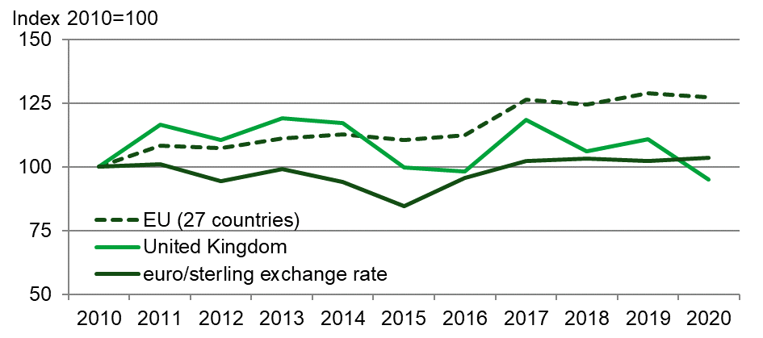
Source: Eurostat, Defra

Figure 15.1 shows the trends for Indicator A of the United Kingdom and the European Union (27) as a whole, as well as the trend for euro/sterling exchange rates which influence agricultural incomes in the UK. Agricultural labour on farm has remained relatively stable in recent years, so any variance over time will largely reflect changes in agricultural income.

Agricultural income, as defined by Indicator A, for the UK was 14% lower in 2020 than in 2019 compared to a reduction of 1.2% for the European Union (27) as a whole.

After a period of relative stability for the UK, the agricultural income, as defined by indicator A, fell sharply in 2015. Incomes did recover in 2017 but thereafter the downturn continued and in 2020, agriculture income was 5.0% lower than 2010.

Between 2010 and 2016 the index of agricultural income, as defined by Indicator A, for the EU (27) as a whole, was fairly level. There was sharp increase in 2017 but the following three years (2018-2020) saw relatively minor changes in real terms. Nevertheless, in 2020, agricultural income for the EU (27) as a whole, was 27% higher than 2010.

Agricultural production
(Figures 15.2 to 15.6)

Wheat

Figure 15.2 Production of wheat in 2020, UK compared with the largest producing member states

Source: Eurostat

Figure 15.2 shows the quantity of common wheat, spelt, and durum wheat produced by the largest producing EU-27 Member States in 2020 in comparison with the UK. France continues to be the largest producer of wheat in the European Union, producing 30 million tonnes, followed by Germany (22 million tonnes) and Poland (12 million tonnes). The UK harvest of 10 million tonnes for 2020 is well below the typical production of around 15 million tonnes.

Cows’ milk

Figure 15.3 Production cows’ milk in 2020, UK compared with the largest producing Member States

Source: Eurostat, Defra
Figure 15.3 shows the quantity of cows’ milk produced by the largest producing Member States in 2020 in comparison to the UK. Germany was the largest producer of cows’ milk in the European Union, producing 33 million tonnes, followed by France (25 million tonnes). In comparison with the EU-27 Member States the United Kingdom placed third producing 15 million tonnes.

Pig meat

Figure 15.4 Production of pig meat in 2020, UK compared with the largest producing Member States

Source: Eurostat, Defra

Figure 15.4 shows the quantity of pig meat produced by the largest producing EU-27 Member States in 2020 in comparison with the UK. Germany was the largest producer of pig meat in the European Union, producing 5.1 million tonnes in 2020 followed by Spain (5.0 million tonnes) and France (2.2 million tonnes). Together these three countries produced half of the total pig meat in the European Union in 2020. In comparison with the EU-27 Member States the United Kingdom placed nineth producing under just under 1 million tonnes.

Beef and veal

Figure 15.5 Production of beef and veal in 2020, UK compared with the largest producing Member States

Source: Eurostat, Defra

Figure 15.5 shows the quantity of beef and veal produced by the largest producing EU-27 Member States in 2020 in comparison with the UK. France was the largest producer of beef and veal in the European Union, producing 1.4 million tonnes, followed by Germany (1.1 million tonnes). In comparison with the EU-27 Member States the United Kingdom placed third producing just under 1 million tonnes.

Sheep and goat meat

Figure 15.6 EU production of sheep and goat meat in 2020, UK compared with the largest producing Member States

Source: Eurostat, Defra
Figure 15.6 shows the production of sheep meat and goat meat by the largest producing Member States in 2020 in comparison with the UK. In comparison to the EU-27 Member States the United Kingdom was the largest producer of sheep meat and goat meat, producing 306 thousand tonnes, followed by Spain (124 thousand tonnes) and France (86 thousand tonnes).

Price Indices

Figure 15.7 Producer Price Indices for total agricultural production
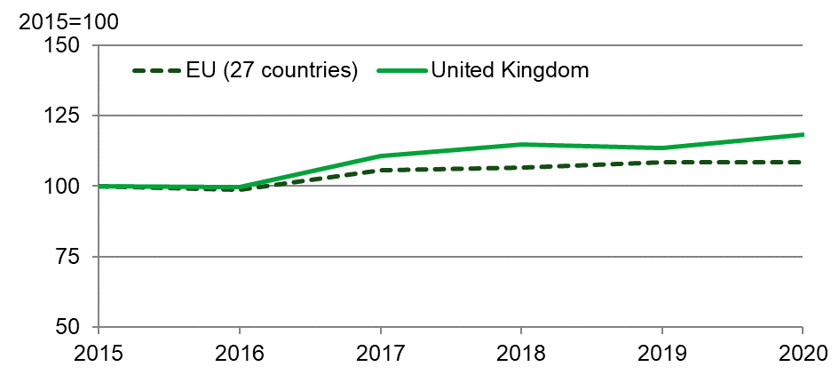
Source: Eurostat, Defra

The output agricultural producer price index (PPI) measures the rate of change in price of agricultural products as they leave the farm gate or as they enter the production process. Crops, Livestock and Livestock products are included. Charts 15.7 and 15.8 show the trend in agricultural output and input producer prices since 2015 respectively, They, also, allow a direct comparison to be made between the United Kingdom and the European Union (27) as a whole. In Chart 15.7, when 2020 is compared with the base year of 2015, the output PPI for the United Kingdom rose by 18% whereas the European Union (27) rose by 8.5%.

Figure 15.8 Purchase Price Indices for the total means (inputs, consumables, etc) of agricultural production
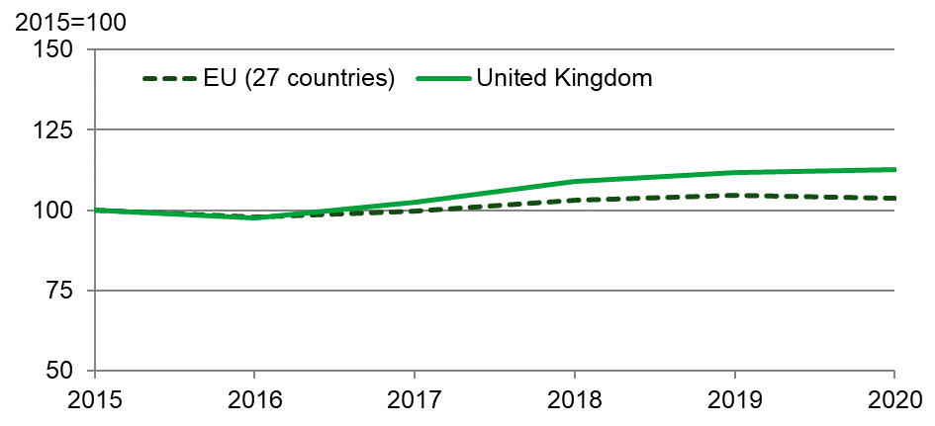
Source: Eurostat

The inputs agricultural producer price index (PPI) measures the rate of change in price of agricultural inputs used in the production process. Included are intermediate consumption of goods and services (e.g. fertilisers, pesticides, feed, seed, energy) and gross fixed capital formation in investments goods (machinery, equipment, buildings).
In Chart 15.8, when 2020 is compared with the base year of 2015, the inputs PPI for the United Kingdom rose by 13% whereas the EU (27) rose by 3.7%. Both charts illustrate a similar trend for the UK and EU (27) over the last five years.

Data Revisions
There are minor amendments to the Agricultural Income data series (Figure 15.1) following updates to data sourced from Eurostat.

