Application Decision
by Richard Holland
Appointed by the Secretary of State for Environment, Food and Rural Affairs
Decision date: 10 November 2021

Application Ref: COM/3278001
NORTH CORNER CLIFF, CORNWALL
Register Unit No: CL444
Commons Registration Authority: Cornwall Council
- The application, dated 24 June 2021, is made under Section 38 of the Commons Act 2006 (the 2006 Act) for consent to carry out restricted works on common land.
- The application is made by Cornwall Council.
- The works comprise a 38 m section of retaining wall, 23 m section of rock armour, 7 m length of post and rail balustrade fencing, 35 m length of post and rail fence and 115 m of temporary fencing. All 1,270 m² of the common required for temporary works (excavation and temporary storage). The duration of the temporary works is 6 to 9 months.

Decision
- Consent is granted for the works in accordance with the application dated 24 June 2021 and the plan submitted with it subject to the following conditions:

i. that works shall begin no later than three years from the date of this decision; and

ii. the temporary works shall be removed and the common restored within one month following completion of the permanent works.
- For the purposes of identification only the location of the works is shown outlined in red on the attached plan.
Preliminary Matters
- I have had regard to Defra’s Common Land consents policy in determining this application under section 38, which has been published for the guidance of both the Planning Inspectorate and applicants. However, every application will be considered on its merits and a determination will depart from the policy if it appears appropriate to do so. In such cases, the decision will explain why it has departed from the policy.
- This application has been determined solely on the basis of written evidence.
- I have taken account of the representations made by the Open Spaces Society (OSS), Natural England (NE), South West Coast Path Association (SWCP) and Linda Carter.
- I am required by section 39 of the 2006 Act to have regard to the following in determining this application:-
- the interests of persons having rights in relation to, or occupying, the land (and in particular persons exercising rights of common over it);
- the interests of the neighbourhood;
- the public interest; and
- any other matter considered to be relevant.

Reasons

The interests of those occupying or having rights over the land
- The applicant confirms that the Lanarth Estate is the landowner and has been consulted about the application. The landowner has not objected to the proposed works. There are no registered rights of common. I am satisfied that the works will not have any adverse impact on the interest of those occupying and the interests of those having rights over the land is not at issue.

The interests of the neighbourhood and the protection of public rights of access

8. The interests of the neighbourhood test relates to whether the works will unacceptably interfere with the way the common land is used by local people. The common is located between the main access road to Coverack, the B3294, and an area of cliff overlooking Coverack Beach. The applicant explains that the purpose of the works is to construct a new coastal defence to reduce the risk of coastal erosion to the common, nearby properties and infrastructure. An existing seawall (south seawall) currently protects most of the road, however the northern end, along the edge of the common is undefended. In recent years, several storms have eroded cliffs to the north of the seawall, increasing the risk to the common and road. The works form part of the Coverack North Coast Protection Scheme to protect Coverack Cove Cliff from further erosion. The applicant confirms that there are no viable or appropriate alternatives to the works. The common is currently a communal grassed area with recreational seating and a wooden rail fence along the seaward edge. The wooden fencing will be reinstated upon completion of the construction works and balustrade fencing is needed to protect the public from the cliff edge. The temporary fencing is required for health and safety during construction works. The works form part of planning application (PA21/05228).

9. In response to concerns about access, the applicant confirms that the common will not be accessible during the construction period which is expected to last up to nine months. Once the construction works have been completed, the condition, accessibility and recreational value of the common will be the same as it is currently. The South West Coast Path and access to nearby properties at North Corner Lane will not be impacted by the works.

10. The works will restrict access to the common for a duration of up to 9 months, after which the temporary works will be removed and the common will be fully accessible. I accept that the permanent fencing is required to protect the public from the cliff edge. I consider that the works will help to protect and maintain the common and therefore benefit use of the common by local people in the long term. I conclude that the works will benefit the interests of the neighbourhood and protect public rights of access.

Nature conservation and conservation of the landscape

11. The common lies within the Lizard Heritage Coast Area of Outstanding Natural Beauty (AONB). The applicant explains that the concrete retaining wall cladding is intended to blend in with the adjacent south seawall and the balustrade, supported by granite posts, will match existing balustrading along the cliff line. The replacement timber fencing will match the existing timber fencing to be removed. The applicant confirms that there will be no loss of common and considers that the works are compatible with the character of the immediate location within the AONB and does not compromise the special qualities and characteristics of the wider AONB.

12. NE comments that given the timescales, maintaining the viability of the grass turf and restoration is likely to be particularly challenging and recommends that as part of any restoration, efforts are made to improve the species diversity using an appropriate wildflower mix. The applicant advises that a specialist sub-contractor will be used to remove, store and maintain the grass turf off site. Upon completion of the works, the grass land will be returned to its original condition and, where appropriate, a wildflower mix will be used in areas outside of the maintained grassland used for recreational purposes. The applicant confirms that an Ecological Mitigation and Enhancement Strategy (EMES) considers there to be no long term biodiversity loss from the Coverack North Coast Protection Scheme.

13. The common will be restored upon completion of the works. The permanent works are intended to connect and match nearby/existing fencing and seawall. I am satisfied that the works are in keeping with the character of the common and will not harm nature conservation interests. By helping to prevent erosion of the common, the works will conserve the landscape and the natural beauty of the AONB in the long term.

Archaeological remains and features of historic interest

14. I am satisfied that there is no evidence before me to indicate that the works will harm any archaeological remains and features of historic interest.

Other matters

15. Concerns raised about erosion of unprotected sections of cliff in the vicinity and the possible impact of the works on the local sewage system are outside the scope of my considerations.

Conclusion

16. I conclude that the works will help protect and maintain the common for the enjoyment of those visiting it and will not harm the other interests set out in paragraph 6 above. Consent is granted for the works subject to the conditions set out in paragraph 1.

Richard Holland

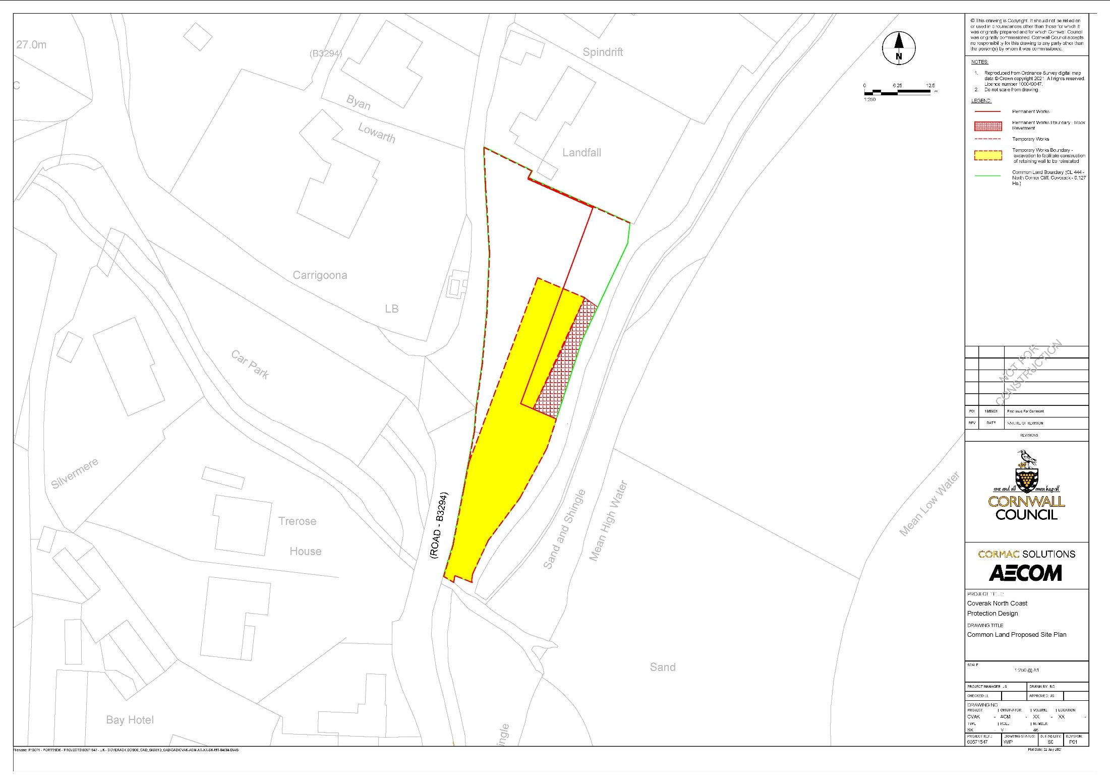

Common Land Consents policy (Defra November 2015)
Section 39(2) of the 2006 Act provides that the public interest includes the public interest in; nature conservation; the conservation of the landscape; the protection of public rights of access to any area of land; and the protection of archaeological remains and features of historic interest.

