Application Decision
by Richard Holland
Appointed by the Secretary of State for Environment, Food and Rural Affairs
Decision date: 28 October 2021
Application Ref: COM/3277982
Far Common and Low Common, Maltby, Rotherham
Register Unit No: CL75
Commons Registration Authority: Rotherham Metropolitan Borough Council

- The application, dated 24 June 2021, is made under Section 38 of the Commons Act 2006 (the 2006 Act) for consent to carry out restricted works on common land.
- The application is made by Bell Ingram LLP for Northern Powergrid (Yorkshire) PLC.
- The works of up to approximately 14 days duration comprise:
- replacement of three steel overhead line support masts with two modern wood rutter poles and one modern single wood pole; and
- laying of temporary track matting over the site access route (3m wide x 255m long) and the three pole working areas (each of 20m x 20m) covering a total of approx. 4365m².

Decision

1. Consent is granted for the works in accordance with the application dated 24 June 2021 and the plans submitted with it subject to the following conditions:
- the works shall begin no later than 3 years from the date of this decision; and
- all track matting shall be removed, and the land shall be fully reinstated, within one month from the completion of the works.

2. For the purposes of identification only, the location of the proposed works is shown in red on the attached plan.
Preliminary Matters

3. I have had regard to Defra’s Common Land consents policy in determining this application under section 38, which has been published for the guidance of both the Planning Inspectorate and applicants. However, every application will be considered on its merits and a determination will depart from the policy if it appears appropriate to do so. In such cases, the decision will explain why it has departed from the policy.

4. This application has been determined solely on the basis of written evidence. I have taken account of the representation made by Natural England (NE) and the Open Spaces Society (OSS).

5. I am required by section 39 of the 2006 Act to have regard to the following in determining this application:-
- the interests of persons having rights in relation to, or occupying, the land (and in particular persons exercising rights of common over it);
- the interests of the neighbourhood;
- the public interest; and
- any other matter considered to be relevant.

Reasons

The interests of those occupying or having rights over the land

6. The land is owned by the Trustees of the Sandbeck Settlement 1988, from whom Northern Powergrid has secured wayleave agreements to manage the overhead apparatus on the land. The Trustees were consulted about the application but did not comment. The rights section of the common land register for CL75 records that the single registered right to graze animals over the land was extinguished on 20 March 1980.

7. There is no evidence before me to suggest that the works are likely to harm the interests of those occupying or having rights over the land (and in particular persons exercising rights of common over it).

The interests of the neighbourhood and public rights of access

8. The current condition of the three steel masts is poor. They have been in place for 60-70 years and have come to the end of their asset life. They need to be replaced with modern wood equivalents to ensure continual distribution and supply of electricity to the local area. Furthermore, Northern Powergrid is required to replace them under environmental obligations as over the course of their lifespan they have been painted with lead-based paint, which is now classed as a contaminated substance.

9. The interests of the neighbourhood test relates to whether the works will impact on the way the common land is used by local people and is closely linked with interests of public access. The applicant advises that the common is a popular area to exercise and walk pets and is used on a daily basis.

10. I consider that the works are likely to have some impact on public access. However, no fencing is proposed and works will only take place at one pole position at any one time. A contractor will be on hand to guide members of the public around the works, which will temporarily cease to allow safe access if necessary. The applicant intends to keep public access open throughout the duration of the works, which is expected to be no more than 14 days, and I am satisfied that such access will be maintained as far as is practically possible during the works. I conclude that the works will not have an unacceptable or lasting impact on local and public access rights over the common.

The public interest

Nature Conservation

11. NE confirms that the application land is not subject to any statutory nature conservation designations but is approximately 125m from the Maltby Low Common Site of Special Scientific Interest (SSSI) at its closest point. NE further confirms that the applicant’s pre-application consultation with it and Yorkshire Wildlife Trust (YWT), which manages the site, established that the works will not impact on the special features of the SSSI.

12. NE advises that the whole common is designated as a Local Nature Reserve (LNR), which is also managed by YWT, although the applicant suggests that the application land is not within the LNR area. In any case, neither NE nor YWT have raised any concerns about the impact of the works on nature conservation and I am satisfied that the works will not harm such interests.

Conservation of the landscape

13. The temporary track matting will protect the ground from the movement of heavy plant machinery required to carry out the works. Whilst it is likely to flatten and damage the vegetation beneath to a certain extent, it will prevent churning and rutting of the surface, which would cause more serious and long term visual harm to the landscape. The applicant will agree a restoration specification with the commons management committee and the landowner to ensure that the common will be restored to its former, if not better, condition.

14. The temporary works will be short term and the land will be re-instated upon completion of the works and removal of the matting, which can be secured by attaching a suitable condition to the consent. The permanent works will replace decaying metal masts with new wooden poles, which I consider are likely to be visually preferable.

Archaeological remains and features of historic interest

15. There is no evidence before me to suggest that the above interests will be harmed.

Conclusion

16. I conclude that the proposed works will not significantly harm the interests set out in paragraph 5 above; indeed, the removal of decaying steel masts and their replacement with new wooden poles will be of some improvement to the landscape. The works will also confer a public benefit by helping to maintain the local electricity supply. Consent is therefore granted for the works subject to the conditions set out in paragraph 1.

Richard Holland

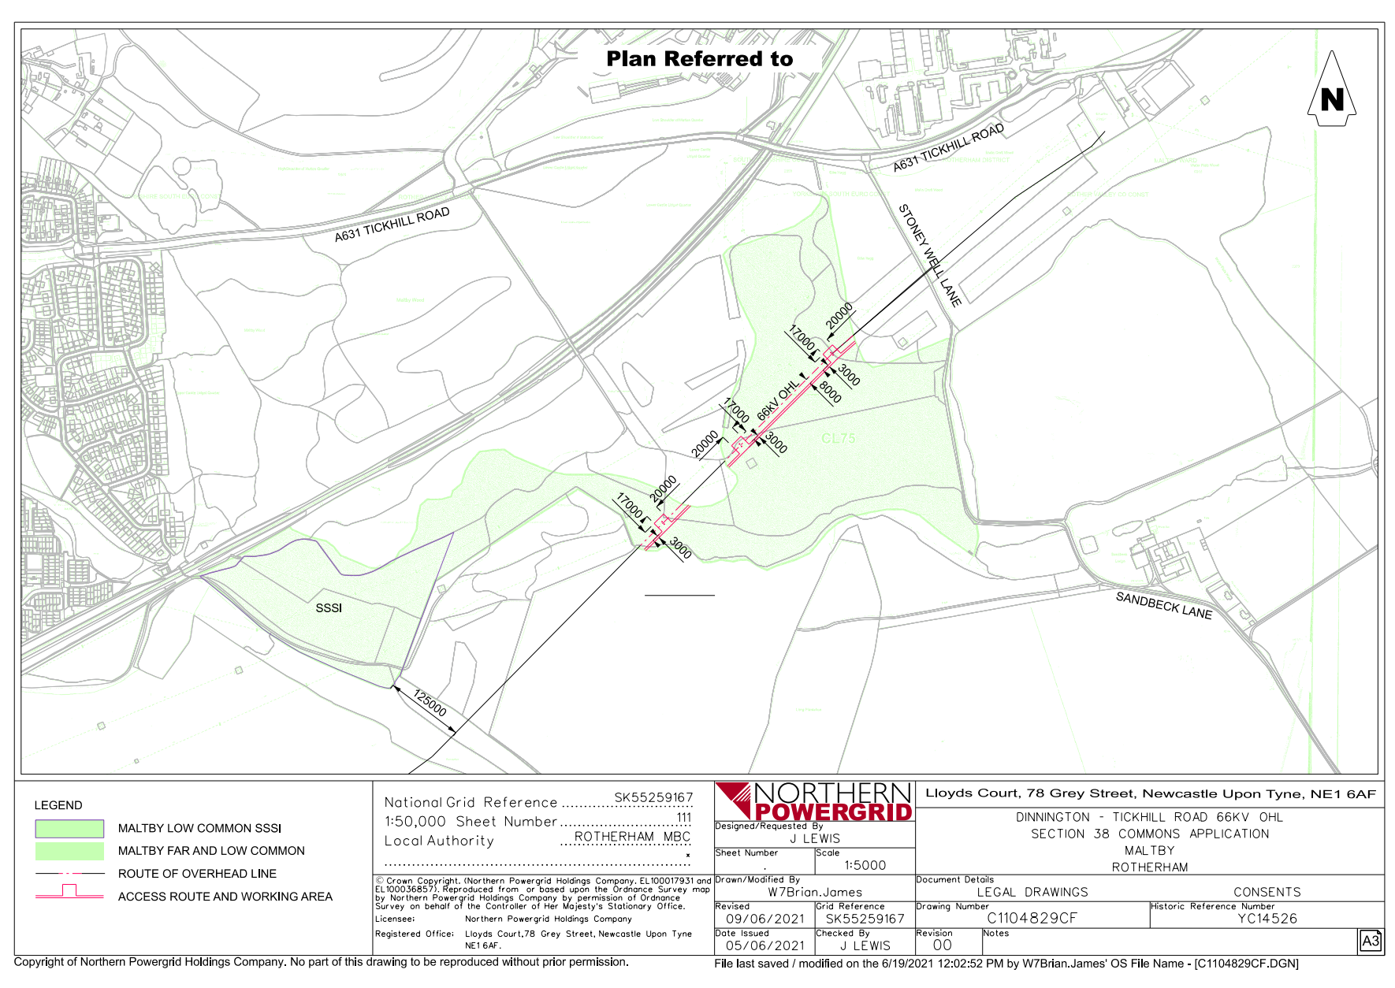

Common Land consents policy (Defra November 2015)
Section 39(2) of the 2006 Act provides that the public interest includes the public interest in; nature conservation; the conservation of the landscape; the protection of public rights of access to any area of land; and the protection of archaeological remains and features of historic interest.

