Application Decision
by Richard Holland
Appointed by the Secretary of State for Environment, Food and Rural Affairs
Decision date: 28 October 2021

Application Ref: COM 3244129
Wray Common, Reigate, Surrey
Register Unit No: CL40
Commons Registration Authority: Surrey County Council.
- The application, dated 18 November 2019, is made under Section 38 of Commons Act 2006 (the 2006 Act) for consent to carry out restricted works on common land.
- The application is made by Reigate and Banstead Borough Council.
- The works comprise:
- a total of 1460m of earth embankments of up to 1.4m in height along common land boundaries at the northern and southern edge of Croydon Road, the eastern edges of Wray Park Road, the eastern and western edges of Raglan Road and the northern and southern edges of Batts Hill; and
- 8 x metal drop posts at access points.

Decision
  - Consent is granted for the works in accordance with the application dated 18 November 2019 and accompanying plans.

  - For the purposes of identification only the location of the works is shown as red lines on the attached plan.

Preliminary Matters
  - The application is wholly retrospective, with all works carried out.
  - I have had regard to Defra’s Common Land Consents Policy in determining this application under section 38, which has been published for the guidance of both the Planning Inspectorate and applicants. However, every application will be considered on its merits and a determination will depart from the policy if it appears appropriate to do so. In such cases, the decision will explain why it has departed from the policy.
  - This application has been determined solely on the basis of written evidence. I have taken account of the representation made by Natural England (NE) and Surrey County Council’s Archaeological Officer.
  - I am required by section 39 of the 2006 Act to have regard to the following in determining this application:-
- the interests of persons having rights in relation to, or occupying, the land (and in particular persons exercising rights of common over it);
- the interests of the neighbourhood;
- the public interest; and
- any other matter considered to be relevant.

Reasons

The interests of those occupying or having rights over the land
  - The applicant, Reigate and Banstead Borough Council (the Council), owns and manages the land. The works are therefore in the interests of the landowner.
  - The common land register for Wray Common (CL40) records no rights of common. The Council advises that two parties claim vehicular access rights over Wray Common. Both were consulted by the applicant but neither has commented. There is no evidence before me to suggest that the interests of those with vehicular access rights will be harmed by the works.

The interests of the neighbourhood and the protection of public rights of access
  - The application states that the works are needed because CL40 is vulnerable to incursions. Whilst no further details about this are given in the application form, NE points to a local newspaper‘s reporting of a small number of travellers camping on the site in September 2018 and April 2019. The Council subsequently wrote to local residents to advise that as the common regularly experiences illegal encampments measures would be taken in October 2019 to prevent vehicular access.
  - The interests of the neighbourhood test relates to whether the works will unacceptably interfere with the way the land is used by local people and is closely linked with public rights of access. CL40 lies within a residential area of Reigate and is separated into a number of compartments by roads running through it.
  - I consider it likely that the common is well used by local people and the wider public for recreational purposes. It is subject to rights of public access under Section 193 of the Law of Property Act 1925, which includes the right of access on horseback, although the Council advises that there are no bridleways on the common and that no specific provision has been made for horse riding as the roads fragmenting the common would make it unsafe.
  - Photographs submitted by the Council show that some members of the public will find the embankments difficult to cross to access the common; wheelchair and pushchair users may find it impossible. However, gaps to allow access for wheelchairs and pushchairs have been placed strategically to link with road crossing points and other footpaths; the Council wishes to discourage people from accessing the common by crossing stretches of busy road. A photograph of a pair of drop posts in place between embankments at Batts Hill shows adequate gaps for pedestrians, wheelchair users and pushchairs.
  - I consider the embankments to be in the interests of the neighbourhood as they protect the common from damage that may be caused by vehicular access and deter illegal encampment. I conclude that public access onto the common is not significantly impeded by the embankments or by the 8 drop posts, which have only a very small impact on access.

Nature conservation
  - NE describes Wray Common as a remnant piece of common, which contains some woodland pasture and parkland but has no biodiversity designations. There is no evidence before me to suggest that the works will harm nature conservation interests.

Conservation of the landscape
  - The grass-seeded embankments were preferred by the Council to wooden posts as they are more in keeping with the surrounding landscape and I consider that this is likely to be the case. The drop posts at access points onto the common are painted yellow and are presumably intended to be a highly visible deterrent to anyone attempting to gain unauthorised vehicular access onto the common at those locations. Whilst they are not in keeping with the surroundings, they are few in number and I am satisfied that they do not cause serious visual harm to the common, which has no special landscape designation.

Archaeological remains and features of historic interest
  - Surrey County Council’s Archaeological Officer advises that a search of the Surrey Historic Environment Record suggests that it is highly unlikely that currently unknown assets in the form of buried archaeological remains will be present within the area and that there is no impact in heritage terms. I am satisfied that the works are unlikely to harm archaeological remains and features of historic interest.

Conclusion
  - I conclude that the works do not significantly harm any of the interests set out in paragraph 6 above; indeed, they are in the interests of the neighbourhood by helping to protect the common from the harmful effects of unauthorised vehicular access and encampment. Consent should therefore be granted subject to the conditions set out in paragraph 1.

Richard Holland

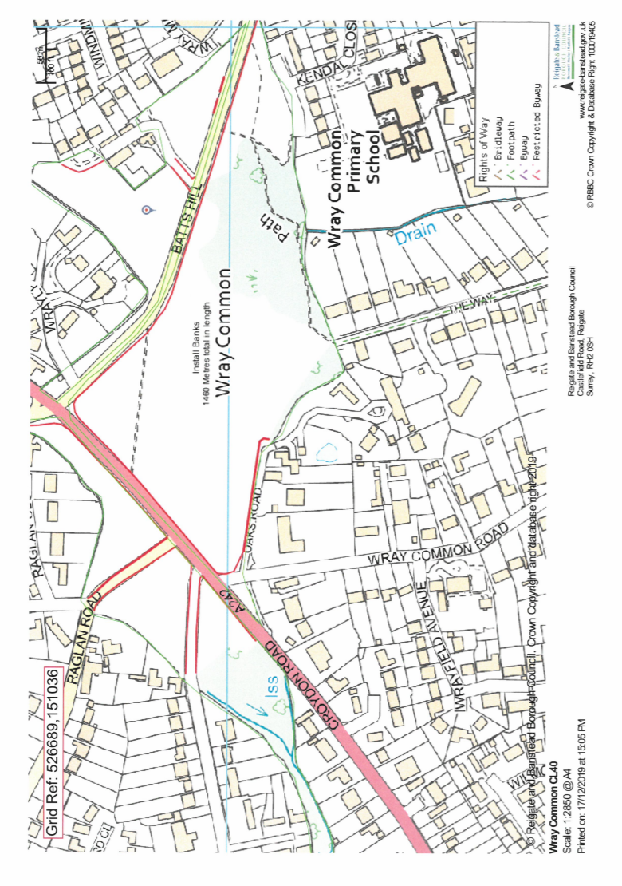

Common Land Consents Policy (Defra November 2015)
Section 39(2) of the 2006 Act provides that the public interest includes the public interest in; nature conservation; the conservation of the landscape; the protection of public rights of access to any area of land; and the protection of archaeological remains and features of historic interest.

