Application Decision
by Richard Holland
Appointed by the Secretary of State for Environment, Food and Rural Affairs
Decision date: 28 October 2021

Application Ref: COM 3244131
Redhill and Earlswood Commons, Reigate, Surrey
Register Unit No: CL39
Commons Registration Authority: Surrey County Council.
- The application, dated 18 November 2019, is made under Section 38 of Commons Act 2006 (the 2006 Act) for consent to carry out restricted works on common land.
- The application is made by Reigate and Banstead Borough Council.
The works comprise:
- a total of 958m of earth embankments of up to 1.2m in height along the northern edge of Pendleton Road and the southern edge of Somerset Road; and
- a total of 956m of 0.6m high wooden posts with 1.5m spacing. 206m along the eastern edge of Horley Road and northern edge of Earlswood Road; 346m along the northern edge of Pendleton Road running up junctions with Willow Road, Yeats Close and Clarence Road; 207m (including 3 drop posts) along the northern edge of Whitepost Hill, two small sections of Elm Road leading to trackway and the entire length of the trackway edge; and 197m along the eastern and western edges Woodlands Road, the northern edge of Woodland Avenue, eastern edge of the A23 and the southern end of Hooley Lane.

Decision
  - Consent is granted for the works in accordance with the application dated 18 November 2019 and accompanying plans, subject to the following conditions:-
- those works that have not been carried out shall begin no later than three years from the date of this decision; and
- the common shall be fully reinstated within six months from the completion of works.

  - For the purposes of identification only the location of the works is shown as red lines on the attached plans.

Preliminary Matters
  - The application is mostly retrospective, with all works carried out except for the 207m section of posts along the northern section of Whitepost Hill.
  - I have had regard to Defra’s Common Land Consents Policy in determining the application under section 38, which has been published for the guidance of both the Planning Inspectorate and applicants. However, every application will be considered on its merits and a determination will depart from the policy if it appears appropriate to do so. In such cases, the decision will explain why it has departed from the policy.
  - This application has been determined solely on the basis of written evidence. I have taken account of the representations made by Natural England (NE), the Open Spaces Society (OSS) and Surrey County Council’s Archaeological Officer.
  - I am required by section 39 of the 2006 Act to have regard to the following in determining this application:-
- the interests of persons having rights in relation to, or occupying, the land (and in particular persons exercising rights of common over it);
- the interests of the neighbourhood;
- the public interest; and
- any other matter considered to be relevant.

Reasons

The interests of those occupying or having rights over the land
  - The applicant, Reigate and Banstead Borough Council (the Council), owns and manages the land. The works are therefore in the interests of the landowner.
  - The common land register for Redhill and Earlswood Commons (CL39) records that all provisionally registered rights became void on 8 August 1979. A number of parties claim vehicular access rights over, or have leases over, land within CL39. All such persons were consulted by the applicant but none have commented. There is no evidence before me to suggest that the interests of leaseholders and those with vehicular access rights will be harmed by the works.

The interests of the neighbourhood and the protection of public rights of access
  - The application states that the works are needed because CL39 is vulnerable to incursions. Whilst no further details about this are given in the application form, NE points to a local newspaper‘s reporting of a small number of travellers camping on Redhill Common in early summer 2018. The Council subsequently wrote to local residents to advise that as the common regularly experiences illegal encampments measures would be installed in April 2019 to prevent vehicular access. The letter refers to ‘Swing Common’, which the Council confirms is the traditional name for a triangular piece of land at Somerset Road. Whilst it forms only a small part of CL39, I accept that the application includes works over a larger area to serve the same purpose.
  - The interests of the neighbourhood test relates to whether the works will unacceptably interfere with the way the land is used by local people and is closely linked with public rights of access. CL39 is a large area of common land bounded by residential areas. Much of it is fragmented by roads, especially around the edges. It is home to Redhill Youth Football Club, Merstham Cricket Club and a café that hires out boats for use on Earlswood boating lake.
  - I consider it likely that the common is well used by local people and the wider public for recreational purposes. It is subject to rights of public access under Section 193 of the Law of Property Act 1925, which includes the right of access on horseback, although the Council advises that horse riding has never been provided for due to concerns over damage to biodiversity and safety for visitors.
  - Photographs submitted by the Council show that some members of the public will find the embankments difficult to cross to access the common; wheelchair and pushchair users may find it impossible. However, gaps to allow access for wheelchairs and pushchairs have been placed strategically to link with road crossing points and other footpaths, which also serves to discourage the crossing of busy stretches of road to access the common.
  - I consider the works to be in the interests of the neighbourhood as they protect the common from damage that may be caused by vehicular access and deter illegal encampment. I conclude that public access onto the common is not significantly impeded by the embankments and that the wooden posts have only a small impact on access as the 1.5m gaps between them provide enough room for pedestrians, wheelchair users and pushchairs.

Nature conservation
  - NE advises that Earlswood Common is designated as a Local Nature Reserve (LNR) and a Site of Nature Conservation Interest (SNCI). It contains a variety of habitats including two large lakes, a number of smaller ponds, wetland corridors and scattered trees and woodland. Semi-improved grassland, which includes the nationally rare plant Chamomile, is also present. Animal species include Roe deer, rabbits and foxes. Redhill Common is a wooded parkland and is not designated as a LNR or SNCI.
  - In commenting on the works, NE has not raised any objections to them on nature conservation grounds. The Council advises that wooden posts were selected for Pendleton Road, as opposed to embankments, as they will not have a detrimental impact on the Chamaemelum nobil, which grows there. I am satisfied that the works are unlikely to have a detrimental impact on nature conservation interests.

Conservation of the landscape
  - Neither the embankments, which have been seeded with grass, nor the posts are out of keeping with the common which has no special landscape designation.

Archaeological remains and features of historic interest
  - The Council advises that there is a Scheduled Ancient Monument (SAM) in the form of a bowl barrow located 20 metres from Pendleton Road; it consulted Historic England (HE) about the works. No comments were received from HE although Surrey County Council’s Archaeological Officer understands that HE is satisfied that the works will not impact upon the ‘nearby designated heritage asset’ and that a search of the Surrey Historic Environment Record indicates that the works are not within an area identified as being of high archaeological potential.
  - I am satisfied that the works along the edge of the common land at Pendleton Road are unlikely to harm the SAM and that, more generally, the works are unlikely to harm any archaeological remains and features of historic interest.

Other matters
  - OSS contends that the works constitute an encroachment onto the common and are therefore prohibited by section 11(5) of the Surrey Act 1985. The applicant considers that the works prevent encroachment onto the common by unauthorised vehicles and are therefore within the scope of the Act. However, applicants should satisfy themselves that an application for consent for works is needed under the 2006 Act. This application has been decided on its merits.

Conclusion
  - I conclude that the works do not significantly harm any of the interests set out in paragraph 6 above; indeed, they are in the interests of the neighbourhood by helping to protect the common from the harmful effects of unauthorised vehicular access and encampment. Consent should therefore be granted subject to the conditions set out in paragraph 1.

Richard Holland

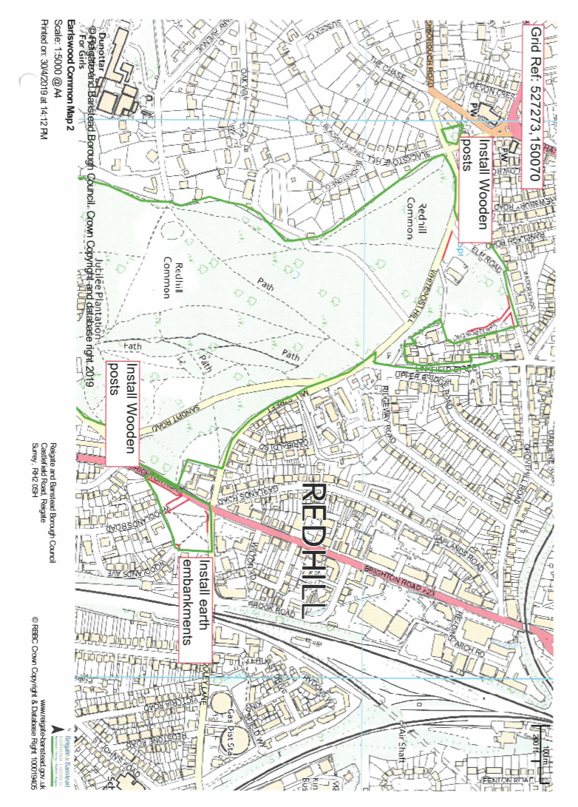

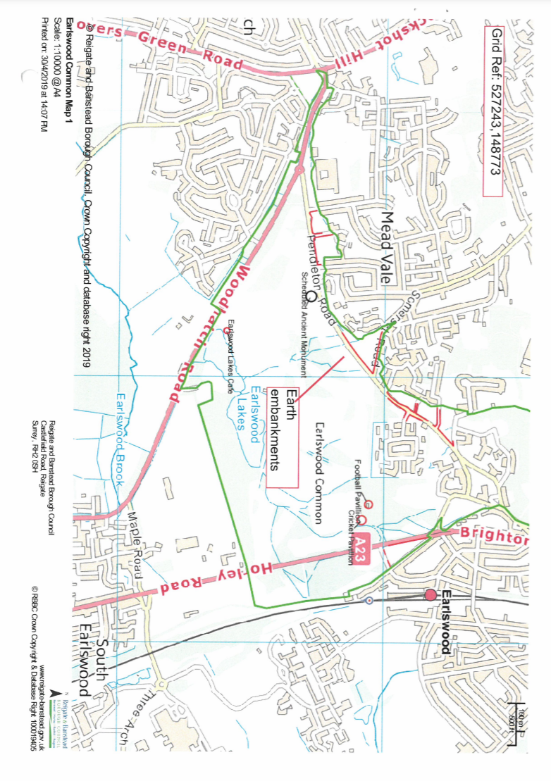

Common Land Consents Policy (Defra November 2015)
Section 39(2) of the 2006 Act provides that the public interest includes the public interest in; nature conservation; the conservation of the landscape; the protection of public rights of access to any area of land; and the protection of archaeological remains and features of historic interest.

