Order Decision
Site visit made on 27 July 2021
by Heidi Cruickshank BSc (Hons), MSc, MIPROW
an Inspector appointed by the Secretary of State for Environment, Food and Rural Affairs
Decision date: 27 September 2021

Order Ref: ROW/3243919
- The Order is made under Section 53(2)(b) of the Wildlife and Countryside Act 1981 and is known as the Dorset County Council (A Footpath from Verlands Road to the A353 Preston Road, Weymouth at Preston) Definitive Map and Statement Modification Order, 2017.
- The Order is dated 10 November 2021 and proposes to record a route to the north-east of Preston as a public footpath. Full details of the route is given in the Order map and described in the Order Schedule.
- There were three objections outstanding when Dorset County Council submitted the Order to the Secretary of State for Environment, Food and Rural Affairs for confirmation.
Summary of Decision: The Order is confirmed.

Procedural Matters
- No-one requested to be heard in relation to this Order and so I dealt with the matter by way of the written representations procedure. I made an accompanied site visit in relation to the sections A - C. With agreement from the parties, I took advantage of the visit to make an unaccompanied inspection of the section C – D, including Footpath 27 (FP27).

Main issues
- The Order is made under section 53(2)(b) of the Wildlife and Countryside Act 1981 ("the 1981 Act") by reference to section 53(3)(c)(i), which states that an Order should be made to modify the Definitive Map and Statement (DMS) for an area on the discovery of evidence which, when considered with all other relevant evidence available, shows:
“that a right of way which is not shown in the map and statement subsists or is reasonably alleged to subsist over land in the area to which the map relates, being a right of way to which this Part applies.”
- It is also made under section 53(3)(c)(iii), namely that any other particulars contained in the map and statement require modification.
- Dorset County Council, the Order-making authority (the OMA) relied on the evidence of use to demonstrate that there had been deemed dedication of the Order route under the statute of section 31 of the Highways Act 1980 (“the 1980 Act”). The relevant sub-sections are set out below:

(1) Where a way over any land, other than a way of such a character that use of it by the public could not give rise at common law to any presumption of dedication, has been actually enjoyed by the public as of right and without interruption for a full period of 20 years, the way is to be deemed to have been dedicated as a highway unless there is sufficient evidence that there was no intention during that period to dedicate it.

(2) The period of 20 years referred to in subsection (1) above is to be calculated retrospectively from the date when the right of the public to use the way is brought into question, whether by a notice such as is mentioned in subsection (3) below or otherwise.

(3) Where the owner of the land over which any such way as aforesaid passes—

(a) has erected in such manner as to be visible to persons using the way a notice inconsistent with the dedication of the way as a highway, and

(b) has maintained the notice after the 1st January 1934, or any later date on which it was erected,

the notice, in the absence of proof of a contrary intention, is sufficient evidence to negative the intention to dedicate the way as a highway...
- The 1980 Act requires that the relevant period of use be calculated retrospectively from the date on which the status of the way is ‘brought into question’. To give rise to a presumption of dedication, it needs to be shown that there has been use, without interruption, as of right, that is without force, secrecy or permission, throughout the relevant twenty-year period. In objection, it was argued that the user evidence could not be relied upon to show that deemed dedication had occurred.
- I will consider whether the evidence as a whole is sufficient to show that there is a public right of way that should be recorded on the DMS. My decision will be whether or not a public right of way subsists on the balance of probabilities.

Reasons

Background
- The Order route lies north-east of the village of Preston, which itself lies north-east of Weymouth. The Order route continues generally easterly from the eastern end of Verlands Road to join FP27 and the A353 Preston Road (the A353) at point D. FP27 runs north-west from the A353 across Winslow Hill and then westerly to join Winslow Road. Winslow and Preston Roads run parallel to join Sutton Road, which runs generally north from the A353.
- The OMA received an application dated 12 October 2009 under Section 53(2) of the 1981 Act to add the claimed route to the DMS. Having investigated the claim the matter was heard at a meeting of the Roads and Rights of Way Committee on 30 July 2015, who resolved that the Order should be made.

Documentary evidence
- Concerns were raised in objection that too much weight had been placed on the documentary evidence. The main case for confirmation has been made on the basis of the user evidence, however, I consider that documentary evidence can assist in determining the reliability, or otherwise, of that evidence.

Maps
- I understand that there was no feature shown on the Order route prior to the 1958 Ordnance Survey (OS), scale 1:2500 (25 inches: 1 mile), which shows a physical feature on the Order Route. Verlands Road had properties to the south almost to matching the properties now existing. To the north White Horse Drive had been developed but not Valley Close or Sutton Park. Verlands Road was shown by a double-dashed feature, continuing east and then as a ‘Track’. Between points A and B it was shown with double pecked lines and between points B and C with one pecked line to the north indicating it was unfenced and a solid line running along the southern border indicating a fence, hedge or bank. From the field boundary at point C to point D there was a dashed line annotated ‘FP’, with the surveyor differentiating it from the track based on their own observations. This map also shows a ‘Track’ running from the end of Winslow Road, similarly not yet fully built out, leading to a dashed line annotated ‘FP’. This route accords with the now-recorded alignment of FP27.
- The smaller scale 1963 map shows a similar situation, albeit with less detail, and this is also seen in the OS base map used in the DMS, sealed 1989. The Order base map shows a feature between points A and C, with solid lines either side, which would indicate fences or hedges. There is no indication of a feature between points C and D.
- I was referred to an OS map from 1952-1961 where it was noted neither the Order route nor FP27 were shown, although other footpaths and tracks were noted by reference to the key. This may indicate that the surveyor did not recognise these features but, given that the large-scale 1958 OS map shows that these features were in existence, they may not have been relevant to this map. In relation to the 1973 OS map FP27 is shown but the copy is unclear in relation to the area of the Order route. The ‘current’ OS map shows FP27 but not the Order route, however, this map takes information from the DMS to show the rights of way as recorded. As a result, the Order route would not be shown as the point of this process is to decide whether it should be recorded.
- In relation to the feature to the north of point C, which was referred to as a chalet style building, I understand this not to have been present since at least the early 1990s. I agree with the objectors that the track may have been used in connection with this building, however, such presumably private use would not prevent public use.

Photographs
- Photographs of the Order route over the period 2004 and 2010 were submitted by the applicant. The photograph from January 2004 was taken from approximately point A2 towards points B and C. A post and wire fence is visible to the north of the surfaced area with a feature continuing towards point C between the boundaries.
- The April 2006 photograph, which appears to have been taken from a location off Sutton Park, shows the hedge and fence with additional temporary electric fencing to the north of the Order route from point A2, with a pony in the field.
- The photograph dated 22 August 2009 shows a kissing gate at point C with fencing and barbed wire on the eastern side preventing use. The fence to the south of the Order route is visible, although not to the north form this angle. I agree with the OMA that there are clear signs of previous use of the track west of point C and I also note through the kissing gate itself. By 24 September 2009 the kissing gate at point C was blocked with vegetation and the fence to the north of the Order route between points B and C had been removed.
- In November 2009 the photograph shows a sign at point C stating: “NO PUBLIC RIGHT OF WAY DAMAGING THIS FENCE IS A CRIMINAL OFFENCE WE WILL SEEK TO PROSECUTE”. By January 2010 the kissing gate had been removed and replaced with fencing, which remains in place as I noted on my site visit.
- Photographs taken by the OMA and included in the 2015 Committee report assist in showing the situation at that point with a grassed area to the south, near point A and an unmade track continuing east between fencing and hedging. There was a gate across the Order route at point B, with a sign ‘PRIVATE PROPERTY Please Keep Out’ led into the field with fencing only to the south. Another sign of this nature was also in place at point A2. There was some evidence suggesting use of a route or routes within the field containing Winslow Hill, although whether these relate to Order route is in question.

Aerial Photographs
- In relation to the aerial photographs the 1972 black and white photograph shows the layout of Verlands Close, with Sutton Park appearing to be in process of development, with some properties not yet built. I am satisfied that there is a track between points A and B. It is less clear whether there was fencing on either side of section B – C by this time or still just to the south as in the earlier OS maps. I am satisfied that there is a worn line between points C and D, indicating a used route. The route of FP27 is visible on the north side of what was then a single field east of Winslow and Verlands Road.
- The 1986 black and white photograph is poor quality but suggestive of a feature from A to C. However, the continuation into the field follows only a short section directly from point C before linking to a circular route around Winslow Hill, from which there appears to be a link on FP27 north of point D.
- The 2002 colour photograph shows the track clearly to point B and a feature continuing beyond that, although not as clearly defined. On Winslow Hill a circular route around the base can be seen, with a very faint line towards D. By this time it seems the fencing of FP27 to the north of the field has been carried out, with further subdivision of the field to the west and south. A similar situation prevails in 2005, with other routes shown in the Winslow Hill field, including FP27 from point D.

Summary
- The documentary evidence does not provide evidence of status of the Order route. I note the argument of objectors that the photographs only show a feature in the period 2004 – 2009, however, the evidence must be looked at in the round. The documents assist, so far as they can, in showing a physical feature in this location from at least the time of the survey for the 1958 OS map. It is unlikely that the feature has ‘come and gone’ between the various bits of evidence such that it did not physically exist. I am satisfied on the balance of probabilities, that the physical feature has been on the ground in one form or another, apparently available as a through-route, until the blocking of the route with fencing at point C in August 2009.

User evidence, section 31 of the Highways Act 1980
- There appears to be no disagreement that there was blocking of the Order route in August 2009 by way of fencing across the access at point C. I am satisfied that this is the date on which use was brought into question giving rise to a relevant twenty-year period August 1989 – August 2009.
- The evidence of use arises from the user evidence forms (“UEFs”) submitted in connection with the application. A total of 83 UEFs refer to use from the 1940s until use was stopped by the blocking of the kissing gate. The levels of user build over time, which makes sense when considering the development of the surrounding land; as mor people live locally, more people would be likely to know of the route and use of it.
- As referred to by objectors there is evidence of a high level of use by dog walkers, which is not surprising, with dogs need daily exercise. I am also unsurprised to find use for ‘pleasure’ as a common reason, given the landscape to which the Order route provides access with views to the sea to the south and, via other routes, to the hills and the Osmington White Horse to the north. I also note reference to use for access to and from the property/business to the east, which would otherwise need to make use of the A353.
- The occurrence of use varies, as I would expect, being daily, weekly, monthly or just occasionally for some. Some people have fairly indicated where their use has varied over time, being more or less in certain years, perhaps in connection with changes in work, retirement or the gain or loss of a dog.
- It was suggested that people were wandering generally on Winslow Hill and it would be fair to say that around a quarter of the UEFs indicated use of a circular route around Winslow Hill, which would tally with the route seen in some of the aerial photography. Around two-thirds of the users indicate use of another route to the east of Winslow Hill, via a farm track which runs outside the boundary of the field containing Winslow Hill. A good number of users indicate a kissing gate in this boundary, providing access to this track. On balance I am satisfied that users accessing this track would cross FP27 at point D. Taking account of the contours in the area, I am satisfied that those travelling to and from the stile on FP27 leading to the A353 would be likely to follow a similar alignment. I am therefore satisfied that the alignment C – D is appropriate for recording by the Order.
- The section A – C provides the link to and from this area, and any routes used thereon. There was some uncertainty among users as to whether the fence to the north of the section A2 – B had fallen down through disrepair or had been deliberately removed. However, it was noted by many that the fence had been removed and also that a gate had been installed at point A2, allowing use of the field as a whole to the boundary to the south of points A2 – C.
- I note the concern in objection that some UEFs had two different sets of handwriting. Although not a handwriting expert I agree that this is the case. Nevertheless, looking across the UEFs as a whole, and taking account of the additional work undertaken by the OMA in telephoning certain users to clarify matters in their UEFS, I am satisfied that reliance can be placed upon that evidence. I take account that the user evidence is supported by what is seen as having physically existed on the ground through the documentary evidence.
- I consider the level and type of use reported by the UEFs supports the claim for a public right of way on foot over the Order route in the relevant twenty-year period. In order for use to give rise to a presumption of dedication the use must be ‘as of right’, that is without force, without secrecy and without permission.
- There was no suggestion that use was secretive, with many users noting that they saw the owner of the field alongside section A2 – C and some mentioned saying hello. In relation to force one person referred to climbing over a locked gate, which I believe to have been that at A2. However, this seems to have been in the same time frame as the blocking of the kissing gate at point D and, therefore, use was already in question. Similarly, reference to the cutting of locks and fences can only have occurred after the locking and fencing, that is after the use was brought into question. No-one indicated that they had permission to use the route, although I agree with the OMA that those who worked or had ownership interest in the land at various times does not count towards public use.
- I am satisfied that the evidence shows use by the public, as of right, throughout the entire twenty-year period 1989 – 2009 such that a public footpath is deemed to have been dedicated.

Lack of intention to dedicate
- Dedication does not arise if there is sufficient evidence that there was no intention, on the part of the landowner, during that period to dedicate it. The current owners of the land crossed by section A2 – C indicated interest in the land from around 1990, when they rented it, with my understanding being that ownership was from 2003. There was no evidence put forward of actions taken prior to 2009 to indicate a lack of intention to dedicate a public right of way.
- I understand a Deposit under Section 31(6) of the Highways Act 1980 was made on 20 October 2011, which included land crossed by points C – D. However, the challenge to the Order Route was prior to that and, therefore, this is not relevant in relation to the Order route.
- There is insufficient evidence to show a lack of intention to dedicate a public right of way within the relevant twenty-year period.

Remaining Matters

Width
- Width matters were raised in relation to two particular areas, one being an area south of points A - A1 and the other the route between points A2 - C.
- Comments on section at A – A1 this related to an area of grass which it was said had been used for parking vehicles. Photographs from the Committee Report show this to have been a mown grass ‘verge’, although at the time of my site visit the area was quite overgrown, with no indication of recent parking use. The property to the south appeared to be in process of redevelopment, which may have led to a change in use of the grassed area, which now lies outside a close-board fence, enclosing the property.
- In relation to other section, my attention was drawn to the now existing fence north of the Order Route A2 - B in relation to the alignment of the former fence north of the Order route between points B and C. The objectors had suggested that the newer fence to the west had been put in a slightly different position to the fence which formerly continued east to point C, giving an impression of a wider route.
- The UEFs show that the majority of users referred to a 2m width in this area, being a clear route between two fence-lines, as shown by the documentary evidence. The section to the west is a little wider, due to the vehicular access required to adjacent land. I am satisfied, on the balance of probabilities, that the widths identified in the Order are supported by the evidence, albeit that the way in which they are expressed may be a little unclear. I understand the Order to be setting out how the width varies at the particular points, with the overall width reasonably defined by the features shown on the OS base map used in the Order, such that, for example, section B – C is 2 metres.

Other matters
- The law does not allow me to consider such matters as the need for a right of way to be recorded; whether money should be spent elsewhere; or, whether issues could arise from dog fouling or fly tipping.

Conclusions
- Considering the evidence as a whole I am satisfied, on the balance of probabilities, that there has been use of the Order route throughout the relevant twenty-year period, giving rise to deemed dedication, with insufficient evidence of a lack of intention to dedicate a right of way over the land.
- Having regard to these and all other matters raised in the written representations, I conclude that the Order should be confirmed.

Formal Decision
- I have confirmed the Order.

Heidi Cruickshank

Inspector

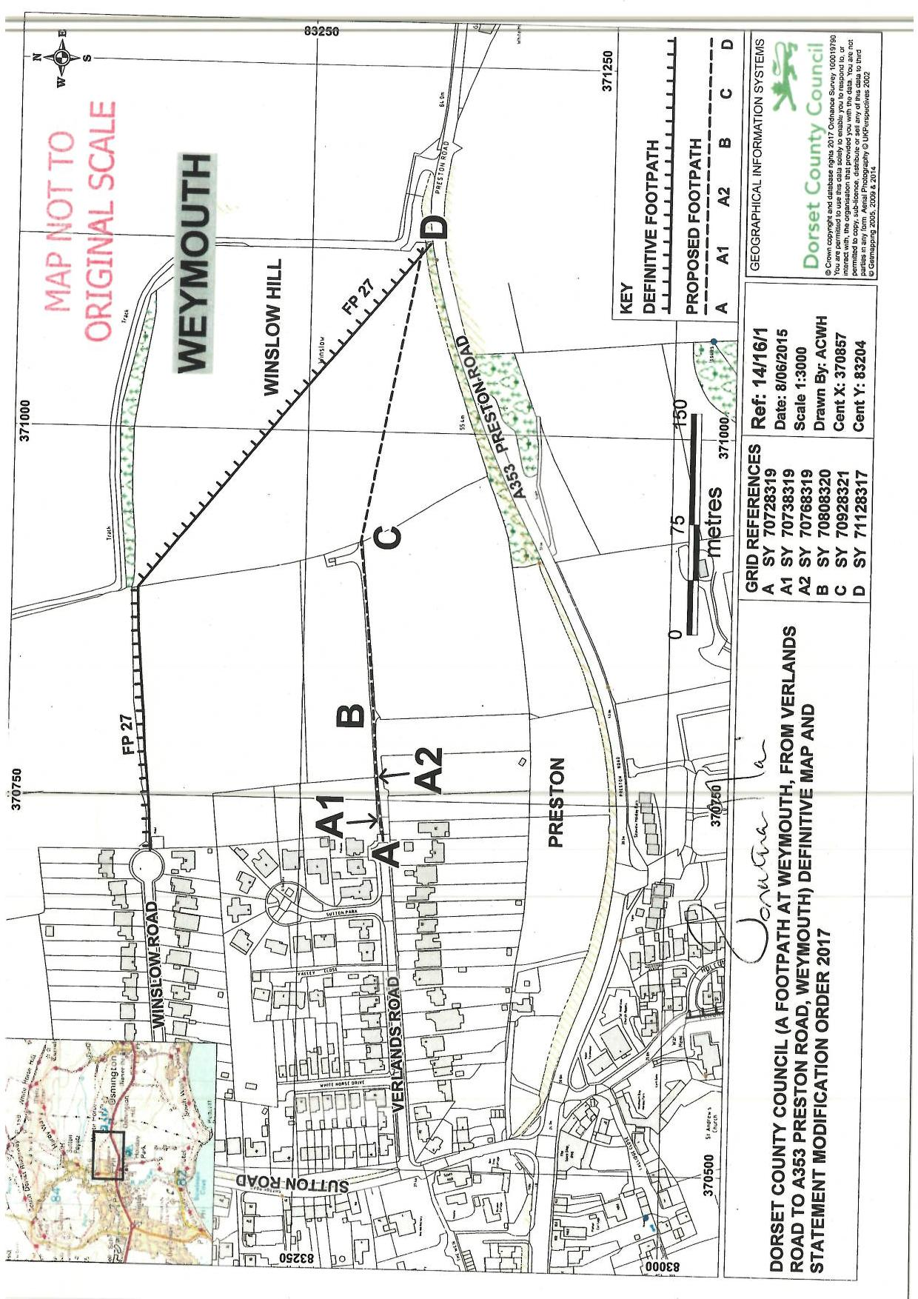

Points A - D, with A1 and A2, are identified on the Order map.

