Order Decision
Site visit made on 14 July 2021
by Helen Heward BSc Hons MRTPI
an Inspector appointed by the Secretary of State for Environment, Food and Rural Affairs
Decision date: 27 SEPTEMBER 2021

Order Ref: ROW/3240110
- This Order is made under Section 53(2)(b) of the Wildlife and Countryside Act 1981 (the 1981 Act) and is known as the Northumberland County Council Definitive Map Modification Order (No 13) 2018, Byway Open to All Traffic No 39 (Parish of Chollerton).
- The Order is dated 22 October 2018 and proposes to alter the Definitive Map and Statement for the area by adding a byway open to all traffic as shown on the Order Plan and described in the Order Schedule.
- There were a number of objections outstanding when Northumberland County Council (the Council) submitted the Order to the Secretary of State for Environment, Food and Rural Affairs for confirmation.
Summary of Decision: The Order is proposed for confirmation subject to modifications set out in the Formal Decision.

Procedural Matters
- I considered the case based on written representations as none of the parties requested an inquiry or hearing. I carried out an unaccompanied site visit on 14 July, after the 18 week date of 6 July 2021, but before the week of 16 August 2021 as the parties had been informed. On the same day as my site visit the Council submitted comments in response to the Trail Riders Fellowship (TRF) statement of case and proposed a modification to the Order statement as a consequence. Although I was not in possession of those comments on my site visit, I had looked at all of the issues raised by TRF on my visit and did not consider it necessary to revisit the site prior to making my decision.
- If confirmed with the modifications set out in this interim Order Decision, the Order would record on the Definitive Map and Statement a byway open to all traffic (BOAT) as proposed over the Order route as described in the Northumberland County Council Definitive Map Modification Order (No 13) 2018, Byway Open to All Traffic No 39 (Parish of Chollerton) and shown on the accompanying map, SAVE THAT:-
- The description in the Order Schedule would be amended to
- add the words “or thereabouts” after 14 metre wide,
- delete references to two gates adjacent to the quarry haul road, and
- delete references to the section described as “a 7 metre wide metalled bridleway for a distance of 150 metres to a point on the U8154 road, 20 metres west of St Marys Church, Great Swinburne”.
- The Order map would be amended to reposition Point N to reflect the above.
- As well as the proposed addition to the Definitive Map and Statement, the Order includes a consequential modification to the description of Chollerton Bridleway 23. No objections are raised in this regard.
- A submission by TRF supports the Council’s opinion that the Order route is a public vehicular road but makes representations about the classification as a BOAT, the effect of a quarry haul road crossing the Order route and the description of the Order route and width. Mr X who lives locally and farms land adjacent to the route objects for a number of different reasons.

Main Issues
- S53(2) (a) of the 1981 Act states that as regards every definitive map and statement, the surveying authority shall as soon as reasonably practicable after the commencement date, by order make such modifications to the map and statement as appear to them to be requisite in consequence of the occurrence, before that date, of any of the events specified in subsection (3).
- Section 53(3)(c)(i) of the 1981 Act provides that a modification order should be made on the discovery of evidence which, when considered with all other evidence available, shows that a public right of way for vehicles which is not shown on the definitive map and statement subsists, or is reasonably alleged to subsist over land in the area to which the map relates.
- A BOAT is “a highway over which the public have a right of way for vehicular and all other kinds of traffic, but which is used by the public mainly for the purposes for which footpaths and bridleways are so used”. Sub section 67(1) of the Natural Environment and Rural Communities Act 2006 (the 2006 Act) provides that upon commencement on 2 May 2006 any existing public right of way for mechanically propelled vehicles (MPVs) was extinguished if it was over a way which, immediately before that date, was not shown on the Definitive Map and Statement or was shown as either a footpath, bridleway or restricted byway, unless such rights were saved by virtue of falling into one of the categories for exemption.
- Subsection 67(2)(b) of the 2006 Act provides that subsection 67(1) does not apply to an existing public right of way if “immediately before commencement it was not shown in a Definitive Map and Statement but was shown in a list required to be kept under section 36(6) of the Highways Act 1980”; that is a list of highways maintainable at the public expense.
- In this case the main issues are whether there is evidence which, when considered with all other relevant evidence available, and on a balance of probabilities, shows that a public right of way for vehicles was once in existence along the Order route and if so whether MPV rights have been extinguished under the 2006 Act, and if the character of the route is such that it satisfies the definition of a BOAT.

Reasons

Evidence that a public right of way for vehicles was once in existence along the Order route
- The Council made the Order having discovered from its records evidence to suggest that the route in question should be recorded on the Definitive Map and Statement as a public vehicular highway.
- TRF submit that Greenwood’s County Map 1828 depicts a Cross Road and provide a copy of a key for the map. TRF argue that in a paper ‘Greenwood’s Map of Northumberland 1828 & Bridle Roads’ there is evidence of 14 ways that Greenwood recorded public roads on his 1828 map and that depictions of ‘Bridle Road’ or ‘Bridle Way’ raises a strong inference that Greenwood was aware of different road status. TRF argue that therefore the fact that this route is not so annotated raises a strung presumption that it was a public road for all traffic. I agree that the map extract does provide an impression of a track depicted by two broken lines across the landscape roughly in the general locality of the Order route. However, the map was a commercial map and there is no clear definition of a ‘cross road’. The weight I attach to this map as evidence that the Order route was a vehicular highway is limited.
- An extract of an 1860 Ordnance Survey (OS) Map at a scale of 1:2500 together with an extract from a book of reference indicates two hatched lines broadly along the Order route near Swinburn Mill, the number 55 is written on it and the book of reference describes 55 as .952 acres and a public road. However only part of the Order route can be seen. The route is also seen on OS maps from 1866, 1897/8, 1925 and 1952. The Council acknowledge that the depiction could indicate a track or path. I agree. These documents provide some evidence of a route but cannot be used to presume a public right for vehicles and this limits the weight that can be attached to OS map evidence.
- Under the Local Government Act 1894 new Urban and Rural District Councils took over all but “main roads” from the County Councils. In 1929, responsibility for maintenance was handed over to County Councils. In this case the Order route is shown on a Rural District Council Handover Map of 1932. The route has been marked in red. There is no key, nonetheless the identification of the route on this map in a similar manner to other known publicly maintainable roads infers that it too was considered a publicly maintainable road and I attach some weight to this evidence.
- The Restriction of Ribbon Development Act, 1935, required councils to record public roads (but not footpaths and bridleways) to which the Act applied. The Order route appears on a map of roads numbered 225 and is described in a schedule as “225. Road from a point on the Gunnerton - Barrasford Sanatorium Road, 160 yards south west of Barrasford Road end via Swinburn Mill, St Mary’s R.C Church and Birdshaw Plantation to the Corbridge Woodburn road A68 at Peaslands Plantation”. These records were public documents and I attach some weight to this evidence.
- The route appears marked as ‘U8154’ on the base map used for the original Definitive Map survey coloured brown. The Council advise that known public roads were generally coloured brown to indicate the extent of the road network. U8154 appears again on the Draft Definitive Map and subsequent Provisional Map. Nearby Bridleway 15 (later 23) is seen to terminate on the U8154. The Description for Bridleway 23 describes the route as “From Bridleway No 22 south of Greens Fell in a north-easterly direction to join the public road north of the footbridge over the Swinburn”.
- It is unlikely that Bridleway 23 would have ended on the Order route if it did not meet another highway, and the Definitive Map and Statement do not identify any footpaths or bridleways along the Order route. Public Footpath 15 also meets the Order Route and is described as “From the A68 (Ridsdale - Corbridge) road south of the Old Quarries in a south-westerly direction to the public road north-east of Great Swinburn then continuing in an easterly direction at Ox Hills to rejoin the A68 (Risdale-Corbridge) road at its junction with the Great Swinburn – Colwell road”. I think it reasonable to infer that at the time the Definitive Map and Statement were prepared the Council considered the Order route to be a public road and I attach some weight to this evidence.
- The Order route appears on the County Council Highways Maps of 1951 and 1964 coloured purple and labelled U8154. The Council inform me that purple indicated an unclassified road but there is no key. However in the 1964 County Road Schedule the route is identified as U8154 Swinburn Castle Road, 1.63 miles long and described as “From C.213 east of Camphill Plantation south-eastwards via St. Mary’s Church, Great Swinburn, to join A68 opposite its junction with C.221”. In the 1974 County Road Schedule it is similarly identified and described but with the addition of grid references NY930769 for the junction with the C213 and NY942775 for the junction with the C221.
- The entire route is clearly marked and identifiable on an OS based map of the County of Northumberland List of Streets which are highways maintainable at the public expense as of 2 May 2006. Evidence pertaining to maintenance liability is not definitive in identifying the legal status of the ways shown and referred to. The Council concedes that it is not known on what basis the route was added to the List of Streets, and that public footpaths and bridleways could have been included. However, there is little evidence that the Council put a “blanket” unclassified designation in the List of Streets and the Council submit that in Northumberland there is no evidence to suggest that public paths and bridleways were deliberately shown in the List of Streets. I find the evidence from the List of Streets to be a reasonable argument that raises the presumption that the Order route was considered a publicly maintainable vehicular road.
- Individual pieces of evidence have limitations, but together they create an overall body of evidence which leads me to conclude that the probability is that a publicly maintainable vehicular highway existed along the proposed Order route at, and over time, before 2 May 2006.
- I return to consider the character and appearance of the Order route below.

Rights for MPV’s
- In this case there is clear evidence that the Order route was recorded on the List of Streets and not recorded on the Definitive Map and Statement at the relevant time. Having regard to Subsection 67(1) and 67(2)(b) of the 2006 Act I find that rights for MPV’s have not been extinguished.

The character of the Order route
- S66 of the WCA 1981 provides that a BOAT is one (a) over which the public have a right of way for vehicular and all other kinds of traffic, (b) but which is used mainly for the purpose for which footpaths and bridleways are so used.
- TRF submit that the Order route is a carriageway and argue that the route does not meet the statutory test for being recorded as a BOAT. TRF did not set out their case because they allege that the Council has not put forward a case. Nonetheless, I must consider the matter having regard to all of the evidence before me, including my observations from my site visit.
- In Masters Hooper J held that the definition in S66 was to be construed purposively and that the purpose of giving a definition was to distinguish byways from ordinary roads. The Court of Appeal upheld the decision of Hooper J in the High Court that what was being defined in the WCA 1981 was the concept of the character of such a way.
- Where the route leaves unenclosed ground at the C213 I observed some evidence of a metalled surface. However the surface and construction of the Order route appeared to be stonier and more broken up than that associated with the adjacent C213 and the character is quite different from the vehicular highway network in the locality. I could see some vehicular tracks across this first section, but they appeared to lead to a field gate to adjacent land rather than following the Order route which turns to run southeast.
- Where the Order route turns I observed that it becomes enclosed. Some walling demarking the sides could be made out through vegetation and trees. I agree with the Council that the character of this section is of a ‘green lane’ with encroaching vegetation.
- At the end of this section I observed a gate and then the quarry haul road with a metalled surface running across the Order route. I saw several lorries and noted that all followed the direction of the haul road. The traffic was travelling roughly at right angles to the direction of the Order route, crossing over, rather than travelling along the Order route. Even if I were to accept an argument that this very short section of the Order route crossed by the quarry haul road is not used mainly for the purpose for which footpaths and bridleways are so used, I would still conclude that such usage would not materially impact the character of the Order route as a whole.
- The section south of the quarry road continues beyond another gate as a grassed track running across a field to the point where the eastern end of Bridleway 23 meets the Order route. From here it runs south-easterly over a low narrow bridge and on to Mill Cottage. In a few places this latter section appeared to have stony or semi-metalled patches, elsewhere it appeared soft and boggy with deep ruts.
- Overall I found that the character of the Order route from Point M to the point where it meets the metalled lane southeast of Mill Cottage to be that of a route mainly used by walkers or those on horses. Whilst vehicles and other forms of traffic might be using some sections, on a balance of probability I think it most likely that those using the Order route between the C213 and Mill Cottage would mainly be doing so for walking or on horseback. I am satisfied that this section of the Order route meets the statutory definition of a BOAT found in section 66(1) of the 1981 Act as a right of way for vehicular and all other kinds of traffic, used by the public mainly for the purposes for which footpaths and bridleways are so used.
- The final section, from Mill Cottage to Point N on the Order map, is a metalled road. The Council acknowledge that this southern end of the Order route is used by motor vehicles as the access to Swinburne Mill Farm and Mill Cottage. On my visit I found the surface, width, layout, and character of this section did not appear to have the character of a route mainly used by walkers or those on horses. Rather I found it to have the character and appearance of a road used primarily as a motor road and was largely indistinguishable from the vehicular highway at Great Swinburne. I am not satisfied that this section of the Order route meets the statutory definition of a BOAT found in section 66(1) of the 1981 Act for the reasons given. Therefore to confirm the Order it would be necessary for it to be modified to exclude it.

Other Matters
- Section 53(3)(c)(i) of the 1981 Act provides that a modification order should be made on the discovery of evidence which, when considered with all other evidence available, shows that a public right of way for vehicles which is not shown on the definitive map and statement subsists, or is reasonably alleged to subsist over land in the area to which the map relates. The process does not provide for recording, or not, what might be considered desirable or preferable.
- Consequently, in reaching my decision I cannot attach weight to concerns about the safety of the route at the crossing with the quarry haul road, use of the route as a short cut, for the safety of local residents from increased traffic, about erosion from increased vehicular use and future maintenance, and farm gates being left open and disturbance to young livestock. Nor can I attach weight to arguments about loss of tranquillity, harm to the natural environment, disturbance for churchgoers and people visiting the graveyard and potential adverse impacts for recreational walkers, riders, cyclists, landowners, and farmers. Similarly it is not within my power to choose to record the route as a bridleway for such reasons.

Gates
- Gates might be in poor condition and difficult to open but that is not to say that they have always been so. Although not common it is not unusual for publicly maintainable vehicular highways to have gates across them. The Council is not in a position to confirm if the gates near to the quarry haul road are legal structures and has consequently proposed a modification to the Part II Statement description to omit reference to them. The changes would not have a material effect upon the Order route and as I am proposing other modifications, I find no reason to object to this.

Width
- TRF understood the Order to specify the width of the first section of the Order route as 11m wide and submit that in the vicinity of where the Order route commences at Point M there was no delineated road feature on the First revision 25” scale OS map (circa (1896). The Council clarified that the unenclosed section of land is part of the C213 road. The start of the Order route, at Point M, adjoins this area.
- The Council clarified that the width of the Order route running south-westwards from Point M is 14m. Alongside this first section a stone wall can be seen beyond a grassed verge to one side and a grassed/vegetated area with some trees to the other. 14m is greater than the width of the trodden path and the overall width is somewhat ill defined. In the absence of evidence to the contrary, and with the addition of the words “or thereabouts” after 14 metres, I consider that the Order route description would describe this section as reasonably accurate as possible in the circumstances.

Consequential Modifications
- Bridleway 23 joins the Order route south of the haul road. In confirming the Order for the creation of Chollerton Byway Open to All Traffic No 39 along this section it will be necessary to modify the Definitive Statement description of the route of Bridleway 23. I am satisfied that the wording in the Order for this is appropriate.

Conclusions
- On a balance of probabilities the evidence collectively points toward a public right of way for vehicles having existed along the Order route. There is no evidence that MPV rights have been extinguished or that the Order Route was shown in a Definitive Map and Statement. There is evidence that it was shown on the Council’s List of Streets prior to the 2006 Act. I went on to find that the character of the Order route between Point M and Mill Cottage satisfies the statutory definition of a BOAT. But I was not satisfied that the character of the Order route between Mill Cottage and Point N satisfied the definition of a BOAT.
- I conclude that the Order route between Point M and Mill Cottage should be recorded on the Definitive Map and Statement as Byway Open to All Traffic No 39 (Parish of Chollerton) and the Definitive Statement for Chollerton Bridleway No 23 altered accordingly.
- Therefore, and having considered all other matters raised, and for the reasons set out above, I conclude that the Order should be confirmed subject to modifications.

Formal Decision
- The Order is proposed for confirmation subject to the following modifications:
- Amend the Schedule Part I map to illustrate the southern end of the Order route ending at a new Point N immediately north-east of Mill Cottage where the Order route meets a metalled road.
- Amend the Schedule Part 1 statement to read:-

“A 14 metre wide, or thereabouts, metalled byway open to all traffic, from the C213 road 700 metres east of Barrasford Park Flats, in a south-westerly direction for a distance of 45 metres then as an 11 metre wide byway incorporating a 3 metre wide track in a south-easterly and southerly direction for a distance of 480 metres crossing the Barrasford Quarry haul road, then continuing as a 6 metre wide grass surfaced byway in a general southerly and south-easterly direction for a distance of 505 metres across pasture fields, then continuing as a stone/gravel path crossing the Swin Burn via a bridge, at level, in a general south-westerly and south-easterly direction for a distance of 430 metres to a point north-east of Mill Cottage.”
- As the proposed modifications would result in a section of the way not being shown that was shown in the Order made by the Council, I am required by virtue of Paragraph 8 (1) (b) and (2) of Schedule 15 of the Wildlife and Countryside Act 1981 to give notice of the proposal to modify the Order and to give an opportunity for objections and representations to be made to the proposed modification. A letter will be sent in connection with the advertisement of the notice and the deposit of the associated documents to all persons to whom this Order Decision has been sent.
Helen Heward

INSPECTOR

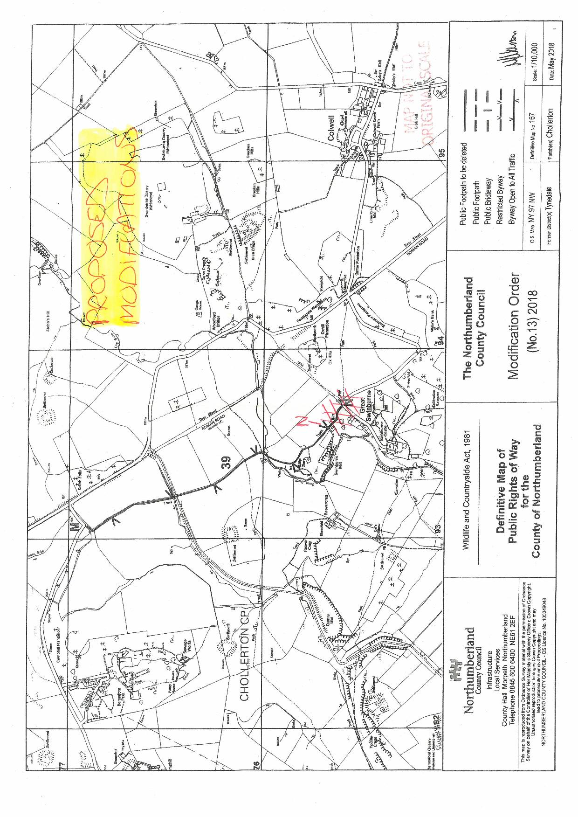

Section 66 of the 1981 Act
Masters v Secretary of State for the Environment and Somerset CC (DC) (1999)
Masters v Secretary of State for the Environment and Somerset CC (CA) (2000)

