Order Decision
Inquiry opened on 26 November 2019
by Heidi Cruickshank BSc (Hons), MSc, MIPROW
an Inspector appointed by the Secretary of State for Environment, Food and Rural Affairs
Decision date: 27 September 2021

Order Ref: ROW/3224376M1
- The Order is made under Section 119 of the Highways Act 1980 and is known as The Cornwall Council Public Footpath No. 3 Colan (Trevithick Manor Farm) Public Path Diversion Order 2018.
- The Order is dated 20 November 2018 and proposes to divert the footpath running generally north-west – south-east from the junction with the A392 near the King’s Head to the C0181, Trevilley Lane, in the parish of Colan onto an alternative alignment, as shown in the Order map and described in the Order Schedule.
- In accordance with paragraph 2(3) of Schedule 6 to the Highways Act 1980 I have given notice of my proposal to confirm the Order subject to modifications.
- One objection was received in response to the notice.
Summary of Decision: The Order is confirmed subject to

modifications set out in the Formal Decision.

Procedural Matters
- Following notice of the proposed modifications to the Order one objection was received. I was satisfied that the matter could be dealt with by way written representations. This decision is made taking account of the evidence relating to the original decision, which was subject of a public Inquiry, as well as the additional points arising from the subsequent written representations.

Main Issues
- The matters raised in objection related to ownership issues; implementation and maintenance matters; and insurance concerns. Responses to the issues raised were made by Cornwall Council, the order-making authority (OMA), and Persimmon Homes (PH), as the applicants for the Order.

Reasons
- Concern regarding ownership referred primarily to the red-line boundary on planning documents. These documents do not necessarily relate to ownership, but to the development. Having taken account of all the ownership evidence provided I am satisfied that PH has appropriate interest in relation to the vehicular cul-de-sac within which the proposed footpath to point D1 is sited. The OMA, in their role as the Highway Authority, have no concerns as to the appropriateness of the proposal for a kissing gate in this location in relation to ownership, maintenance and the highway extent. I am satisfied that these matters, which were discussed to some extent at the original Inquiry, are not a barrier to the proposed improvements for users in this area.
- With regard to compliance to BS 5709:2018 I am satisfied that the appropriate party to deal with such matters is the OMA, in their role as the relevant Highway Authority. The proposal for a kissing gate arose from a Road Safety Review. Exploration of relevant matters at the Inquiry led to the proposed modification to the Order, which had a pedestrian gate as a limitation. I am satisfied that the OMA and PH as landowners are of the view that a kissing gate is appropriate and can be implemented in this location. Maintenance responsibility is not a matter required to be included in an Order.
- Matters of occupiers’ liability insurance are not relevant to my decision and not required to be included in any Order of this type.
- I note that no owners or occupiers of properties in the vehicular cul-de-sac within which the proposed right of way to point D1 is sited, nor living anywhere else within the Goldings, nor any other potential landowner have raised any concerns in relation to the proposed modifications.

Conclusion
- For the reasons already set out in the Interim Order Decision, issued on 15 June 2020, I am satisfied that the Order should be confirmed. I am satisfied that the concerns raised in relation to the proposed modifications do not provide evidence or argument which should prevent the alteration to alignment and limitation, which I consider will improve public access in the area.

Formal Decision
- In exercise of the powers transferred to me, the Order is confirmed subject to the modifications previously proposed:
  - Within Part 2 of the Schedule:
    - replace text “…314…” with text “…323…”;
    - amend “…SW 8291/6004…” to “…SW 8291/6003…”;
    - amend “…point D…” to “…point D1…”;
  - Within Part 3 of the Schedule:
    - replace text “…Pedestrian…” with text “…Kissing…”;
    - amend “…SW 8291/6004…” to “…SW 8291/6003…”;
    - amend “…point D…” to “…point D1…”;
  - On Order map:
    - modify part of alignment of FP3 to the south;
    - remove point D;
    - add point D1.

Heidi Cruickshank

Inspector

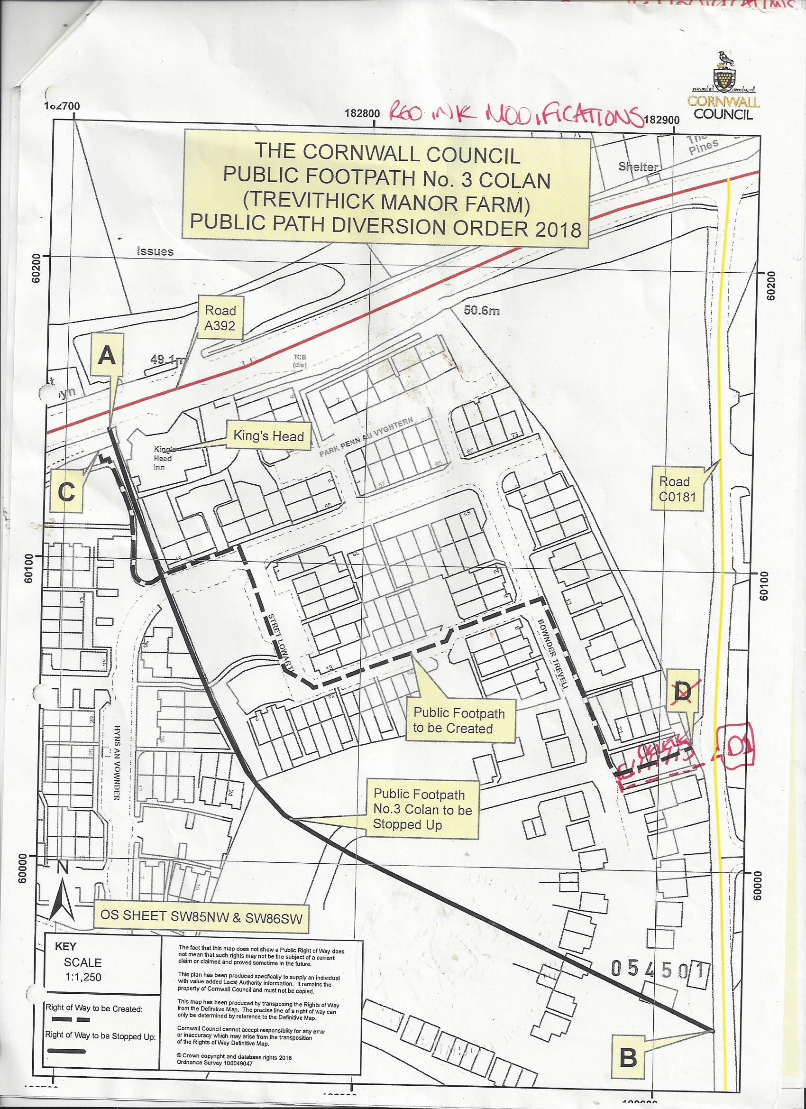
NOT TO SCALE

Points are shown on the Order map
British Standard: Gaps, gates and stiles. Specification

