Order Decision
Site visit made on 7 September 2021
by Martin Small BA(Hons) BPl DipCM MRTPI
an Inspector appointed by the Secretary of State for Environment, Food and Rural Affairs
Decision date: 05 October 2021

Order Ref: ROW/3259257
- This Order is made under Section 118 of the Highways Act 1980 (the 1980 Act) and is known as the Surrey County Council Bridleway No 29 (Woldingham) Public Path Part Extinguishment Order 2019.
- The Order is dated 25 September 2019 and proposes to extinguish part of the width of the public right of way shown on the Order plan and described in the Order Schedule.
- There was one objection outstanding when Surrey County Council submitted the Order to the Secretary of State for Environment, Food and Rural Affairs for confirmation.
Summary of Decision: The Order is confirmed

Procedural Matters
- As there were no requests for an accompanied site visit, I undertook the visit unaccompanied.

The Main Issues
- The Order is made under Section 118 of the Highways Act 1980, the Council having concluded that this part of public bridleway was not needed for public use. However, at the confirmation stage, I must be satisfied that it is expedient to stop up that part of the bridleway proposed in the Order having regard to the extent that it appears that it would, apart from the Order, be likely to be used by the public, and the effect which the extinguishment of the right of way would have as respects the land served by the path, taking into account provisions for compensation.
- In reaching my decision, I am required to disregard any temporary circumstances preventing the use of the bridleway when determining the likely use that may be made of it.
- I must also have regard to any material provisions contained in the Rights of Way Improvement Plan for Surrey (Revised 2014).

Reasons

The extent to which it appears that the bridleway would, apart from the Order, be likely to be used by the public
- Bridleway No 29 forms part of a network of rights of way around Woldingham. All parties accept that the bridleway is used by walkers and horse riders for recreational use. Therefore, were it not for vehicles parked adjacent to West Stables and Fox Barn on the south side of the bridleway between points A and B on the Order Map, I consider it is possible that there would be use of the full width of this section of the bridleway including the part to be extinguished, the indications being that it would serve a primarily recreational purpose.
- However, the section of the bridleway between points A and B is between 4.0 and 6.7 metres in width. Only part of this width is to be extinguished to allow the owners of West Stables and Fox Barn to park outside their properties without parking within the width of the public bridleway. A width of 4.0 metres, the minimum width considered acceptable for a bridleway by the Council, would be retained. The retention of a bridleway is consistent with the Rights of Way Improvement Plan.
- The Council had received no complaints about the parked cars obstructing the route prior to the Order being made, despite cars having been parked there since the former farm buildings were converted to dwellings in 1994. There are no objections in principle to the Order from the British Horse Society, nor any objections from the Ramblers’ Association, the Open Spaces Society or Woldingham Parish Council, which between them represent users and local people. No objections were made by any of the utility companies.
- The legal route has previously been diverted onto its current alignment but this does not preclude further changes should the relevant legal tests be met. Whilst the bridleway could be blocked by residents’ or other vehicles this is the case now and any such obstruction would be temporary. If it became a regular problem the Council would be obliged to take enforcement action.
- Therefore, whilst I consider it is possible that the part of the bridleway to be extinguished would, apart from the Order, be used, the evidence does not support a demand for it. Accordingly, I find that likely use by the public is not such that the Order should not be confirmed, and I conclude that it is expedient that this part of the bridleway be stopped up.

The effects which the extinguishment would have as respects land served by the bridleway, account being taken of the provisions as to compensation
- In addition to providing a recreational route the section between points A and B provides vehicular access to West Stables and Fox Barn. The Order will not prevent this access. I am satisfied therefore that there would be no adverse effect on land served by the bridleway, and that it is expedient to confirm the Order in this regard.

Other Matters
- As a bridleway would be retained there would be no loss of rights of way for future generations nor any diminution in the ability to enjoy an active lifestyle. There is no reason why the Order should encourage households to have more vehicles or set an undesirable precedent. Whether or not the owners of West Stables and Fox Barn would benefit financially from the partial extinguishment is not relevant to the confirmation of the Order.

Conclusions
- Having regard to these and all other matters raised in the written representation, I conclude that the Order should be confirmed.

Formal Decision
- I confirm the Order.

Martin Small INSPECTOR
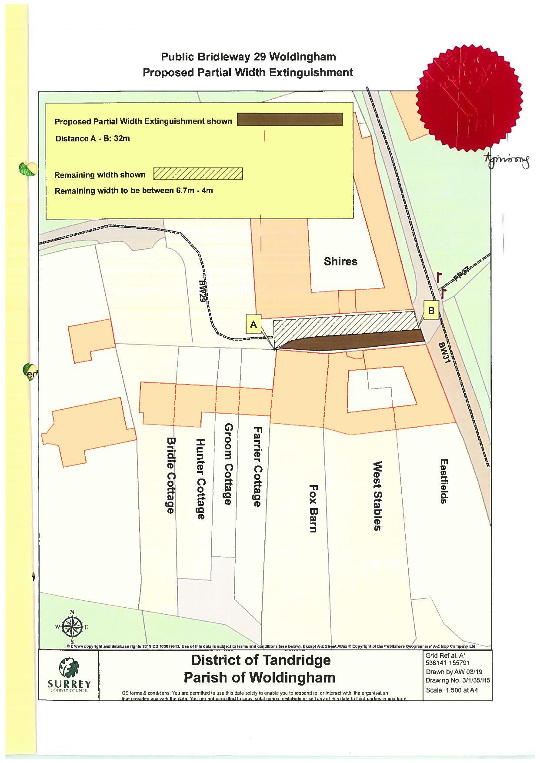
MAP NOT TO ORIGINAL SCALE

