LOGO & HEADER

|  |
| --- |
| **Order Decision** |
| Inquiry opened on 14 January 2020 |
| **by Sue Arnott fiprow** |
| **an Inspector appointed by the Secretary of State for Environment, Food and Rural Affairs** |
| **Decision date: 03 SEPTEMBER 2021** |

|  |
| --- |
| **Order Ref: ROW/3226086M** |
| * This Order is made under Section 53(2)(b) of the Wildlife and Countryside Act 1981. It is known as the Lancashire County Council (Higher Boarsgreave, Bacup) Definitive Map Modification Order 2016. |
| * The Order is dated 9 March 2016. It proposes to modify the definitive map and statement for the area by recording a public bridleway and deleting a section of a footpath above Higher Boarsgreave at Cowpe near Bacup, as shown on the Order map and described in the Order schedule. |
| * There were 14 objections outstanding (and one representation) when Lancashire County Council submitted the Order for confirmation to the Secretary of State for Environment, Food & Rural Affairs. * In accordance with Paragraph 8(2) of Schedule 15 to the Wildlife and Countryside Act 1981 I have given notice of my proposal to confirm the Order with modifications. |
| **Summary of Decision: The Order is confirmed, subject to the modifications previously proposed.** |

**Preliminary matters**

1. If confirmed with the modifications set out in paragraph 70 of my interim Order Decision issued on 28 January 2020, the Order would record on the definitive map and statement the public bridleway originally proposed but with extensions at both ends along sections marked on the modified Order map as X-A and H-Y. In addition, a gate at point D would be recorded as a limitation.
2. Following advertisement of my proposal to confirm the Order with these modifications, one objection was received. The arguments put forward in this objection were of a legal nature, rather than evidential, and applied to both the Order as made and the modifications proposed. Indeed no new evidence has been submitted. However, no objection is made to the deletion from the definitive map of the footpath currently recorded between points F and I.
3. Responding to the objector’s submissions, a further statement was provided by the order-making authority, Lancashire County Council (LCC), and additional comments were made by the Forest of Rossendale Bridleways Association (FRBA, the original applicant).
4. The objection made clear that it contained legal submissions relevant both to the original unmodified Order route and to the modifications I proposed which would increase the length of the bridleway to be recorded.
5. Although both LCC and FRBA queried this, I accepted that the legal submissions made by the objector were duly made, that (in most cases) they raised points that had not previously been argued, and that they inevitably related to both modified and unmodified parts of the Order. I therefore considered it appropriate to deal with the matter under both paragraphs 7 and 8 of Schedule 15 to the Wildlife and Countryside Act 1981 (the 1981 Act).
6. None of the parties asked to be heard at a further inquiry or hearing. Given the nature of the recent submissions, I have been content to deal with these through the ‘written representations’ procedure. However, in response to the objector’s contention that, at the least, the original inquiry[1] should be re-opened and the user evidence “fully tested” so as to address matters relating to the closure of public rights of way due to the outbreak of Food and Mouth Disease (FMD) in 2001, I have declined to do so. I explain my reasons for this more fully below.

**The Main Issue**

1. The main issue remains whether the evidence before me is sufficient to show, on a balance of probability, that the public rights of way claimed over the Order route subsist.
2. As I made clear in my interim decision, LCC made the Order under Section 53(2)(b) of the 1981 Act on the basis of events specified in sub-sections 53(3)(c)(i), (ii) and (iii).
3. Sub-section 53(3)(c)(iii) related to the proposed deletion of F-I. This part of the Order has not been challenged and I shall not address it further.
4. As regards the addition to the definitive map of section F-G as a bridleway and the upgrading of existing footpaths to bridleway status (encompassing both the original Order route A-B-C-D-E-F and G-H, and my proposed addition of A-X and H-Y) sub-sections 53(3)(c)(i) and (ii) respectively apply. The test in both cases is whether, on a balance of probability, the proposed bridleway subsists.

Reasons

1. I will firstly note that there has been no challenge to my conclusion that the status of A-X and H-Y should be considered for recording alongside the original Order route. I will therefore consider the points raised by the objector, Mr Kind, in relation to both the original Order and the modifications I have proposed.
2. There are four main issues raised in the objection. Firstly, Mr Kind claims that my treatment of the evidence of use by cyclists was unsound. Secondly, he takes issue with my assessment of the user evidence in general insofar as my conclusion that it was ‘uninterrupted’ is concerned, given that my interim decision did not mention consideration of temporary closure due to FMD in 2001. Thirdly, my application of the ‘sufficiency of user’ test is questioned on the basis of a supplementary description of my approach. Lastly, Mr Kind takes issue with the consequences of my acceptance that a bridleway had probably been established long ago at common law.
3. I propose to deal with these in reverse order.

***Dedication at common law***

1. At the inquiry, in both her opening statement for LCC and in closing, Mrs Myers made clear that the authority’s case relied on statutory dedication under Section 31 of the Highways Act 1980 (the 1980 Act). Incidental to her main submissions, she acknowledged that, given the pre-1991 usage, it would also be reasonable to imply dedication at common law.
2. In my interim decision, I analysed the evidence presented to me by all interested parties in the context of the case advanced by the order-making authority. Having concluded that a bridleway had been established on the basis of that evidence, there was no need for me to form a conclusion on the alternative at common law. However, being aware that a significant number of witnesses had provided evidence of their use before 1991[2], I added my final comment (at paragraph 64) “*that even had I not been satisfied that the case was made out under Section 31 of the 1980 Act, I would have accepted that, on a balance of probability, implied dedication of a bridleway had been demonstrated at common law.*”
3. Mr Kind does not challenge that conclusion. Nevertheless, he contends that in the light of this finding, my determination of the Order on the basis of the statutory test was irrational: if dedication at common law took place before 1991, then during the period 1991-2011 the route was already a bridleway. He submits that by preferring the statutory approach over the earlier dedication, this prevents the full consequences for the route being properly acknowledged and recorded.
4. Indeed, the timing and nature of the dedication of a right of way can affect liability for its future maintenance. In this case, the overwhelming majority of the Order route (and the proposed extensions) are already definitive footpaths and unquestionably maintained by the highway authority. As Mr Kind points out, if a bridleway is deemed to have been dedicated at common law before 1 January 1960 then it is publicly maintainable.
5. I do not disagree with Mr Kind’s proposition that establishing maintenance responsibility for a highway is important and that, if it is in any doubt, it would be prudent to address the issue when determining the legal status of the way. The subject was not raised previously in this case and there have been no other submissions which question liability for maintenance.
6. Whilst I understand the concerns expressed by this objection, I am satisfied that the evidence before me has been analysed in the context of the relevant legal tests arising from the submissions made by the parties at the inquiry (which did not include any material from Mr Kind). Further, I am satisfied that the outcome would have been same had I been asked to address the case for common law dedication first, other than to perhaps put beyond doubt any question over maintenance of the route.

***The ‘sufficiency of user’ test***

1. At paragraph 43 of my interim decision, I dealt with the volume of claimed usage and whether the numbers of claimants and the frequency of their use was sufficient to represent use by ‘the public’ as is required to satisfy the terms of Section 31 of the 1980 Act.
2. Mr Kind has taken issue with my explanation that “*In general terms, the number of users must be such as might reasonably be expected if the route had been unquestionably a public bridleway*.” He argues that this imports a test that is not in the legislation, nor derived from case law, and is irrational. In his submission the ‘public test’ is nothing more than that the persons using the way must have the character of the public, not that they be the wider public[3].
3. In fact, the phrase in my paragraph 43 echoes a description used by Lord Blackburn in the often cited nineteenth century case of *Mann v Brodie*[4]. It is not a new or additional test and I am satisfied that it has not led me to an incorrect conclusion.

***User ‘without interruption’***

1. As I have noted above, Mr Kind points out that my ‘final comment’ in respect of dedication at common law (at paragraph 64) indicates my acceptance of an established bridleway long before the relevant statutory period 1991-2011. He submits that the consequence of such a conclusion is to render any debate about possible interruption to user caused by FMD in 2001 irrelevant as a public bridleway would have already come into existence before that date.
2. Even so, the interim decision relied on conclusions I reached on the case for statutory dedication advanced by LCC, and therefore I consider it important that I address the point raised in the objection.
3. At paragraph 35 of my interim decision, I concluded the claimed use between 1991 and 2011 was “*without force, without secrecy, without permission and therefore ‘as of right’*.” Later, at paragraph 37, I found it to be “*continuous and uninterrupted throughout the relevant period*.”
4. Mr Kind argues that the view of the Court in the 2017 *Roxlena* case[5] was that interruption to user caused by path closures due to FMD in 2001 is capable of disrupting an otherwise continuous period of 20 years.
5. In that case, commenting on the relevant guidance published by the Planning Inspectorate, Mr Justice Kerr stated: “*I do not agree with the proposition in the Advice Note[6], … that an interruption which is more than de minimis but caused by measures taken against Foot and Mouth disease, is incapable in law of amounting to an interruption in use of a footpath or other way. I see no basis for that proposition. Use or non-use is a question of fact; the cause of any non-use is not the issue.”*
6. Although acknowledged as *obiter dicta* and not central to that case, Mr Kind appears to have accepted the Judge’s view as settled law.
7. No submissions were made by any of the parties at the inquiry in relation to the *Roxlena* case and its potential applicability here. LCC points out that Mr Kind was not present at the inquiry, nor has he seen (or heard) the detailed user evidence presented to the inquiry. The authority highlights the extensive nature of the signed witness statements in this case, none of which referred to use being stopped during the Foot and Mouth epidemic.
8. In truth my interim decision does not specifically consider the potential effect of any closures in 2001 because the matter was not put to the witnesses nor raised by the claimants themselves. With all due respect, it is not incumbent on Inspectors to pursue independent lines of questioning based on the incidental comments of Kerr J in an unrelated case unless prompted by the evidence before them. Nothing in the responses from any of the claimants caused me to do so. As I noted at paragraph 36 of my interim decision, only one person recalled one occasion when a gate was found to be locked during the whole 20-year period.
9. Again, I am satisfied that nothing is raised by this particular objection that would cause me to alter my conclusions, or to re-open the inquiry to seek further information from witnesses.

***Use by cyclists***

1. In the final point of objection, Mr Kind criticises my treatment of the evidence of 9 cyclists who claimed to have used the Order route during the relevant 20 years, arguing that my reasoning is irrational. Nonetheless, he agrees that my conclusion in paragraph 27 is correct: “*I am … satisfied that the cycling use that is claimed should be judged as contributing to the establishment of a public bridleway rather than a restricted byway*.”
2. That being the case, Mr Kind’s legal arguments will have no effect on my final determination of this Order.

**Conclusion**

1. I remain satisfied, on a balance of probability, that the evidence shows a public bridleway subsists along the route described in the Order between points A, B, C, D, E, F, G and H on the Order map together with sections A-X and H-Y as proposed following my interim decision. There has been no challenge to my proposal to record an additional limitation at point D or to the deletion of the public footpath between F and I.
2. Having regard to the above and all other matters raised at the inquiry and in the written representations, I confirm the Order with the modifications previously proposed.

**Formal Decision**

1. I confirm the Order subject to the following modifications:

On the Order map

* Add point X at grid reference SD 8419 2056 and point Y at grid reference SD 8443 2071
* Extend the line showing “Bridleway to be upgraded or added” to include A-X and H-Y

In the Order schedule[7]

PART I MODIFICATION OF THE DEFINITIVE MAP:

DESCRIPTION OF PATH OR WAY TO BE UPGRADED

* In line 1, delete “the gate at the end of”; in line 2, delete “point A” and substitute “point X”, and in line 7, delete “330 metres” and substitute “360 metres”;
* In line 11, after “point H” add “continuing for 80 metres to point Y on Rooley Moor Road…”;

PART II MODIFICATION OF THE DEFINITIVE STATEMENT:

VARIATION OF PARTICULARS OF PATH OR WAY

* For **Bacup 612** - amend *Position* to read: “…past Higher Boarsgreave to a point on Cowpe Road (U7774) at SD 8419 2056 and continuing as Bridleway 682” and *Length* to: “0.12 km”
* For **Bacup 682** – amend *Position* to read: “Bridleway from a point on Cowpe Road (U7774)(also recorded as Footpath 612) at SD 8419 2056 …” and *Length* to: “0.10 km”;
* For **Bacup 616** – amend *Position* to read: “… continuing as Bridleway 617”;
* For **Bacup 617** – amend *Kind of Path* to “Bridleway” and *Position* to read “terminating at SD 8443 2071 at Rooley Moor Road.”
* For **Bacup 618** – amend *Position* to read: “at junction of Bridleways 616 and 617 and Footpath 619 …”;
* For **Bacup 619** – amend Position to read: “at junction of Bridleways 616 and 617 and Footpath 618 …”.

Sue Arnott

**Inspector**

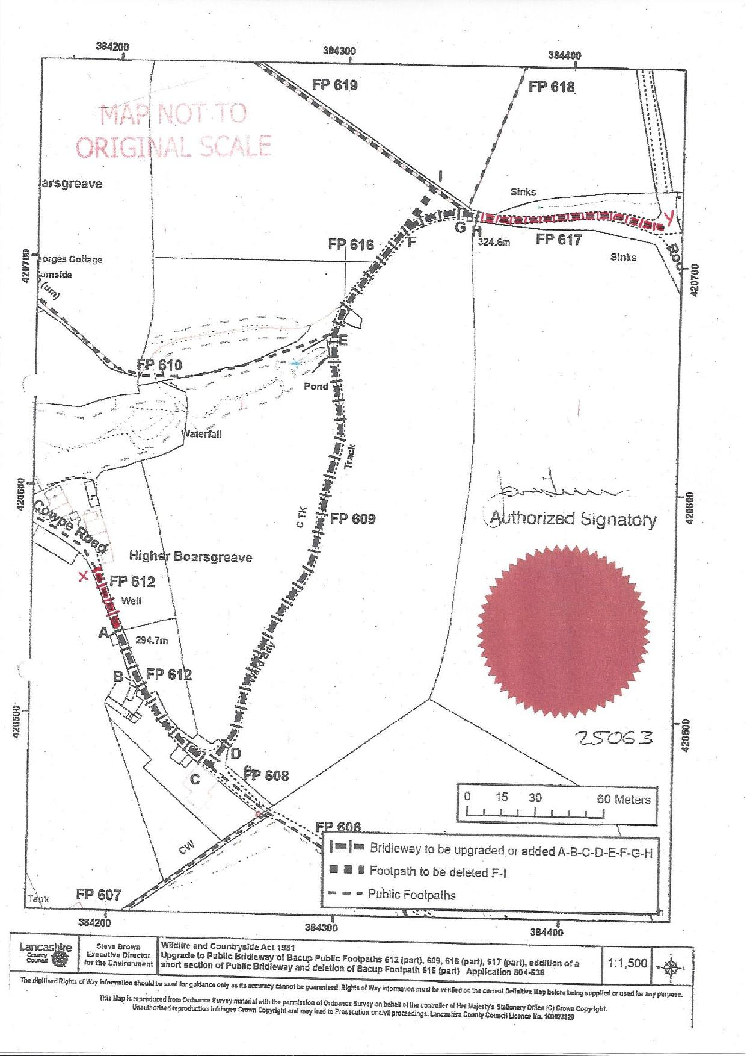

1. Held under paragraph 7 of Schedule 15
2. And which had been discounted for the purposes of statutory dedication during the relevant 20 years.
3. Mr Kind cites the case of R V Inhabitants of Southampton [1887] QBD 590 in support of his submission.
4. Mann v Brodie [1885] HL 378
5. R on the application of Roxlena v Cumbria County Council [2017] EWHC 2651 (Admin)
6. Public Advice Note 15
7. For clarity, the amended text is underlined