Hinton House COVID-19 Working Arrangements
Opening Hours 07:00 - 19:00, Monday to Friday

The following arrangements will enable building users to comply with Public Health England and government guidelines. The arrangements support the implementation of the Sellafield Ltd COVID-19 risk assessment, the current issue is available on the Conventional Safety COVID-19 risk assessment page via the following link; https://slportal.ssa-intra.net/pub/SC807/01106/Topic_pages/COVID-19.aspx or ask your Line Manager for a copy of the Enterprise Risk Assessment and relevant Warrington Office Risk Assessments.

ON ARRIVAL | WHEN IN THE BUILDING | ON EXITING
Hand sanitiser should be used prior to accessing the turnstiles  Signage is displayed at the entrance areas providing guidance on hygiene requirements for entry and the process for requesting a reactive clean of the turnstile should a person sneeze or cough when inside the turnstile.  Disable the tracing part of the NHS app whilst on Sellafield Ltd premises. | General  - Personnel are strongly advised to wear face coverings when moving around the building and in the event of an emergency evacuation. Security may require removal for security checks.  - Wash hands regularly with soap and water for 20 seconds. Follow the NHS advice on effective hygiene and handwashing.  - Hand sanitisers and cleaning materials are available for use, as required, throughout the building and café area.  - OneFM helpdesk is available for reporting issues and concerns with the building. (see Essential Contact Details below)  Workstation  - Wipe in – Wipe out Desk Sanitiser Stations are available throughout the office:  - ‘Wipe in’ – Wipe workstation and IT equipment before you start work  - ‘Wipe out’ – Wipe your workstation and IT equipment when you are preparing to leave the facility  Welfare  - Communal kitchen areas and tea points are available for use.  - Kitchen equipment such as microwaves and fridges should be wiped before and after use.  - Drinking water is available via the water fountains in the core areas.  - Existing hot drink vending machines are available.  - Gather & Gather Café at C core is open Monday- Thursday 8:00am -15:30pm, Friday 8.00am -14.30pm  - Face coverings must be worn in the café area. Hand sanitisers must be used when entering the café area.  - Handwashing/sanitising to be undertaken when closing and opening doors.  - Showers at Hinton House are available to use Mon-Fri between during office hours. Personnel must wipe in/wipe out in the changing area with the cleaning materials provided.  - The smoking shelter off the A-C link corridor is open. The door to the link corridor should remain closed, hand sanitising facilities are available. Smoking in front of Hinton House entrances is not permitted.  Office Facilities  - Sellafield Ltd plotters are available at H200, H380 (Jacobs) and H480.  - All print rooms/areas are open, only 1 person should access the print room/area at any time. DO NOT use cleaning products on the screens or keypads, wash/sanitise hands before and after use.  - When using meeting rooms/area/pods wipe in – wipe out tables before and after use, sanitising products that are provided.  If you develop COVID-19 symptoms while at work, you should:  - Collect your belongings and leave the building; avoid touching anything and ask for anything you may have touched to be wiped down.  - Return home immediately and comply with government advice for self-isolation; do not return to work until period of self-isolation is complete.  - Report situation to your line manager.  - Line managers must raise a condition report if a member of their team tests positive for COVID-19.  - Enhanced cleaning is available via OneFM Helpdesk, who can also be contacted for cleaning solution, if required. | - Put waste items in bins and clear your workstation.  - Wipe Out – wipe your workstations and IT equipment.  - Wash/sanitise hands.

Essential Contact Details
Building Manager - deana.thompson@sellafieldsites.com - 07870485475 | Building and accommodation queries
OneFM Helpdesk - onefm.helpdesk@sellafieldsites.com - 01925 832382 | Reactive works

Emergency Arrangements
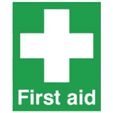 | Sellafield Ltd first aiders are operational during this period. If you require a first aider please summon a first aider, if none are available please ring x2222 from your desk phone or 01925 832222 from your mobile phone.

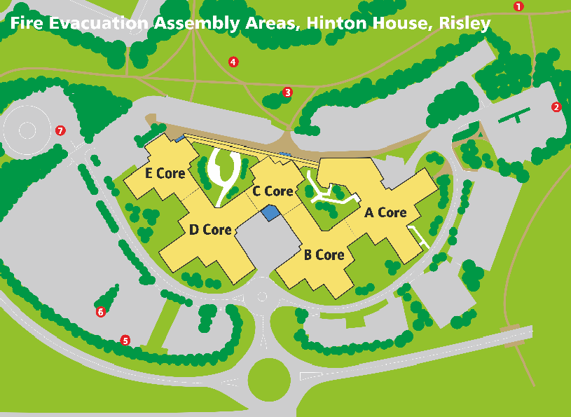
Visitors carpark

Emergency Fire Evacuations

If you see or suspect a fire:-
- Press the nearest red break glass unit then vacate the building as directed below.
- Report to the Incident Commander at the visitor’s car park providing the reason for activation of alarm.

On hearing the fire evacuation alarm:-
- Leave the building, quickly, calmly, using the nearest safe emergency exit.
- Follow the directions of the Fire Wardens.
- Do not use lifts.
- Do not stop or go back into the building to collect personal belongings.

Exit Point | Assembly Point
Core A | Assembly Point 1 or 2
Core B | Assembly Point 2, 5 or 6
Core C | Assembly Point 3, 4, 5 or 6
Core D | Assembly Point 5, 6 or 7
Core E | Assembly Point 7
*Note: Before 7am and after 7pm and at all times at the weekend, personnel should assemble at the visitor’s car park.
- Do not exit through the turnstiles, use the emergency exit doors.
- Assemble at the nearest designated assembly area to your emergency exit point (as above).
- Keep off the road to allow free access for emergency response vehicles.
- Do not leave the site unless authorised to do so.
Hinton House
July 2021 Rev 6
- Do not go back into the building until the klaxon horn has been sounded to signal that it is safe to do so.

