Application Decisions
Site visit made on 16 June 2021
by R J Perrins MA
an Inspector appointed by the Secretary of State for Environment, Food and Rural Affairs
Decision date: 10 September 2021

Application A Ref: COM/3272343
Pelsall Common North, Walsall, West Midlands
- The application, dated 11 December 2020, is made under section 16 of the Commons Act 2006 (‘the 2006 Act’) to deregister and exchange land registered as common land.
- The application is made by Walsall Metropolitan Borough Council
- The release land comprises a total of 4925m² (three areas in CL39 and one in CL113)
- The replacement land comprises 7491m² of land known as High Bridges.
Application B Ref: COM/3272370
Pelsall Common North, Walsall, West Midlands
Register Unit Nos: CL39 & CL113
Commons Registration Authority: Walsall Metropolitan Borough Council
- The application dated 30 March 2021 is made under Section 38 of the Commons Act
2006 (‘the 2006 Act’) for consent to carry out restricted works on common land.
- The application is made by Walsall Metropolitan Borough Council.
- The works comprise:-
- Mitigation pond
- Reed-beds
- Drainage headwalls and Manholes
- Crib wall
- The construction of a new access track to the canal towpath. This will connect the towpath to the Common
- Temporary heras fencing to protect members of the public during the course of the Section 38 works.

Decisions

Application A – Section 16 - Ref:COM/3272343
- Consent is granted and an Order of Exchange given in accordance with the application dated 11 December 2020, to deregister and exchange common land at Pelsall Common North, Walsall, West Midlands. As part of the Order of Exchange a copy of the application plans (Drawings A and B) showing the areas for deregistration and exchange are attached to these decisions.

Application B – Section 38 - Ref:COM/3272370
- Consent is granted for the works in accordance with the application dated 30 March 2021 August 2020 and accompanying drawings, subject to the following conditions: -
- the works shall begin no later than 3 years from the date of this decision; and
- the land shall be fully reinstated in accordance with the application within one month from the completion of the works.
- For the purposes of identification only, the location of the works is shown outlined on the attached drawing 001 attached to these decisions.

Preliminary Matters – Applications A & B
- I carried out an inspection of the release land and a good part of nearby Common on Wednesday 17 June 2021 in the company of representatives from; Walsall Metropolitan Borough Council (‘WMBC’); the Friends of Pelsall Common (‘FPC’); and Pelsall Civic Heritage Trust (‘PCHT’). I also inspected the land put forward for exchange prior to the arranged site visit. The parties were satisfied that there was no need for a further inspection of the exchange land with them present.
- Following advertisement of the applications, representations were received from Natural England (‘NE’), the Open Spaces Society (‘OSS’), PCHT and the residents of Moat Farm Estate and FPC. No other representations were received.
- The applications have been determined on the basis of the written evidence and my own observations of the sites and surrounds.
- In determining the applications, I have had regard to the latest edition of Defra’s Common Land Consents Policy (‘the 2015 Policy’) which has been published for the guidance of both the Planning Inspectorate and applicants. However, every application will be considered on its merits and a determination will depart from the policy if it appears appropriate to do so. In such cases, the decision will explain why it has departed from the policy.
- The common covers some 63 hectares and lies to the north of Pelsall and is divided by the Wryley and Essington canal. The majority of the common lies to the west of Norton Road (B4154) and it crosses that canal via York’s Bridge, a mid-nineteenth century brick-built bridge. The common is varied in appearance and management. North of the canal, there is clearly more of an emphasis on conservation, to the south the land is more intensively managed grassland.
- Natural England set out that the canal is designated as a Special Area of Conservation (‘SAC’) and Site of Special Scientific Interest (‘SSSI’). Pelsall Common North is a Local Nature Reserve (‘LNR’) and a Site of Importance to Nature Conservation (‘SINC’).

Application A the Section 16 Application

Main Issues
- Section 16 (1) of the 2006 Act provides, amongst other things, that the owner of any land registered as common land may apply for the land (‘the release land’) to cease to be so registered. If the area of the release land is greater than 200m² a proposal must be made to replace it with other land to be registered as common land (‘the replacement land’).
- I am required by section 16(6) of the 2006 Act to have regard to the following in determining this application:

(a) the interests of persons having rights in relation to, or occupying, the release land;

(b) the interests of the neighbourhood;

(c) the public interest, which includes the interest in nature conservation, conservation of the landscape, protection of public rights of access and the protection of archaeological remains and features of historic interest;

(d) any other matter considered to be relevant.

Reasons

Background
- On 7 February 2014 WMBC granted planning permission for the “Construction of a new road bridge over the canal next to York’s Bridge and re-alignment of Norton Road plus new parking bays for Pelsall North Common & wetland area.” The Walsall Metropolitan Borough Council (York’s Bridge Replacement Scheme) Bridge Scheme 2014 Confirmation Instrument 2014 was made on 4 July 2014. That scheme was to realign a section of Norton Road, providing a new bridge to the east of York’s Bridge. York’s Bridge would remain, continuing to provide private vehicular access to the north-west. The permission expired in 2017.
- That approved scheme was subject to a Section 16 application to deregister and exchange common land to facilitate the works. An Inspector, in a decision dated 12 May 2015, found that the replacement land offered was inappropriate as it was already subject to public rights access. Furthermore, in the absence of a legal undertaking, the Inspector was not satisfied that it could be guaranteed that the land in question would be replaced.
- On 15 December 2020 WMBC granted a new planning permission for “Construction of a new road bridge over Wryley and Essington Canal next to York’s Bridge and re-alignment of Norton Road, plus new parking bays for Pelsall North Common & wetland area (adjacent to Public Footpath Ald0.149.). The application includes the provision of an area of replacement common land to the south of the A4124 Lichfield Road, to be served by a new vehicle access and parking area” (‘the 2020 PP’).
- This application seeks to overcome the previous Inspector’s reasons for refusal.

The application
- The application is made to deregister three areas marked in red on drawing No MP/YB/S16/602 consisting of:
- The footprint of the new bridge - 2140 m².
- Land to be used as a site compound - 1940m².
- Land for material storage for construction and subsequent new car parking area - 845m².
- Those areas amount to a total of 4925m² which is estimated to be 0.02% of the total common land area. Given the proposed deregistration exceeds 200m² the WMBC have identified land known as High Bridges, Pelsall where the area put forward is some 7491m².

The Release Land
- The release land is on the eastern edge of Pelsall North Common running alongside Norton Road. The land to the north of the canal and east of Norton Road (‘Area A’) consists of scrub and predominantly young broadleaved trees. As I saw during my site visit there is no safe, useful, access and it is clear the general public do not use it for any purposeful activity. Although there was one unauthorised bike track in the northernmost part, and varying degrees of fly tipping near to the existing access way.
- Land to the south of the bridge and east of Norton Road (‘Area B’) is more open. At the time of my visit an informal pathway, more or less adjacent to the area being sought to be deregistered, led through long unmanaged, grasses and vegetation down to the canal. A number of mature trees, clad with Ivy, grow adjacent to the bridge. A strip of common land between Area B and adjacent residential properties is subject to the section 38 application.
- The area of common to the west of Norton Road (‘Area C’) is open and at the time of my visit was being maintained as wildflower meadow with informal cut paths through it. The land abuts the car park serving the public house.
- There has been some concern raised, by both FPC and OSS that the ownership of Pelsall Common was not vested to WMBC. Subsequently WMBC have submitted a copy of the Common’s Commissioner’s decision dated 7 June 1973 which confirms ownership was vested to WMBC. I see no reason to question the ownership further.
- The OSS have also expressed concern that the Church Commissioners, as owners of rights to mines and minerals beneath the common, have not joined the application. To that end I accept that section 61(3)(a) of the Act states that “references to the ownership or the owner of any land are references to the ownership of a legal estate in fee simple in the land or to the person holding that estate;”. Furthermore, an exchange may affect the interest over mines and minerals.
- However, and whilst I recognise the Commissioner’s 2013 letter appears to contradict those rights, there is nothing before me to corroborate the view that they must (my emphasis) join the application. To that end the Planning Inspectorate’s guidance notes, on completing an application to deregister or exchange common land, set out that the applicant must be the freehold owner of the land. Moreover, I am satisfied the Commissioners have been consulted and are aware of this application and potential outcomes. A further letter from them dated 29 October 2019 and confirming their 2013 view establishes that.

The Replacement Land.
- The replacement land is WMBC owned and some 7491 m² hectares in size. A narrow, elongated site which runs alongside the Lichfield Road and abuts the canal to the south. Densely vegetated with predominantly low-level native broadleaved species, there is no public access to the site.
- I was able to see the area that the PCHT have highlighted as being used to catch excess road surface water. That land has been partly cleared with a small bund and some fencing. Adjacent to it, a small, dropped kerb had been constructed to assist water flow off the highway. Whilst dry during my site visit, it was clear from ground conditions that this area was covered in water at some point.
- The OSS have questioned for what purpose the land was acquired and WMBC set out that it was acquired under a Compulsory Purchase Order. I see no reason to disagree with WMBC’s view that it is not necessary to appropriate the land for the purposes of open space as the application, if successful, would lead to it being registered as common in any event. Furthermore, the intention would be to manage it in accordance with the scheme of management under Part I of the Commons Act 1899, as per the existing common.
- Following concerns from PCHT regarding the installation of the dropped kerb, and potential pollutants in rainwater run-off onto the land, WMBC have undertaken works to reinstate the kerb alongside other drainage works. I discuss the implications of that below.
- It is proposed that a new car park would be constructed within the land (not included in the replacement land offer) to facilitate the use of the replacement land. Other landscaping works would be undertaken to enable public access.
- The land is not attached to Pelsall Common North or any other common land. I see no reason to disagree with the view of PCHT that whilst the land may be within a 1000m radius of the release land it is some 1130 metres by car or upon foot.

Assessment

The interests of those occupying or having rights over the land
- I see no reason to disagree with my colleague who found in 2015 that as WMBC indicated that it owned those parts of CL 39 and CL 113 affected by the proposal, as the applicants, their interests would not be adversely affected. In addition, the proposal would allow WMBC to meet their statutory duty in relation to York’s Bridge and Norton Road, in their role as the highway authority.
- My colleague went on to find that there were no rights of common registered in respect of either CL 39 or CL 113. The Church Commissioners are noted in the Register as claiming to be “…entitled to the rights and interests of the Lord of the Manor of the Deanery of Wolverhampton in that capacity other than the ownership of the land…[and] the owners in fee simple of mines and mineral substances…within and under the land…”. The National Coal Board claim ownership of any coal in or under the land and all rights incident thereto by virtue of the Coal Acts 1938 and 1943 and the Coal Industry Nationalisation Act 1946. That position remains today, WMBC confirm, in the application, that a copy of the notice was sent to those with a legal interest, or other rights over the land. As set out above, the Church Commissioners have no objection to the works, and I am satisfied that the proposal would not adversely affect these registered rights.
- Again, I see no reason to come to a different conclusion regarding the right of way serving Huddocks Moor Farm. The proposed works would retain York’s Bridge and a section of Norton Road would remain in place, with access provided by the works. I am satisfied that these rights would not be adversely affected.
- Turning to the private right of way registered over a small section of Common, running alongside the western boundary of 16 Mallard Close. The right remains reserved to the Canal and River Trust (‘the CRT’). The CRT has not objected to the works, nevertheless these rights would inevitably be affected by the proposed works during the construction. I note a strip of Common would remain adjacent to Mallards Close and an access track, to replace the informal path I walked on my site visit, is proposed as part of the scheme and section 38 application. In addition, access to the canal would, in any event, remain through the common land.
- Overall, therefore, I agree with the previous Inspector, that those occupying or having rights in relation to the release land would not be adversely affected by the proposal.

The interests of the neighbourhood
- The 2015 policy indicates that the issues to be considered in this context includes whether the exchange would prevent local people from using the common in the way they are used to, and whether or not there would be an interference with the future use and enjoyment of the common.
- The loss of the release land to the north of the canal, Area A, would not have any adverse effects upon the way in which local people would be able to use the common. As set out above this area is not used save for, what I was informed on the site visit, was an unauthorised cycle track. I do not know who that serves but could see it was an activity that was leading to harm by way of compaction and erosion to the common in any event. Thus, the release of this land would have minimal, if any, effect on general use of the common.
- With regards to Areas B & C there would be an effect with regards to access to the canal towpath on the eastern side of the bridge. Area B would be substantially reduced although access would be available as part of the scheme on the strip of common being retained as set out above. Area C would reduce the area of accessible common but at this location access to the remainder of it would remain largely unhindered.
- The 2015 policy also sets out that the outcome of proposed works on common land may add something that would positively benefit the neighbourhood. The previous Inspector found that York’s Bridge had been noted to have been proposed for improvement works for almost 40 years (and beyond at the time of this decision). The Inspector was satisfied that the changes to the road system had been through the appropriate planning procedures on the basis that the new bridge would provide benefit to the neighbourhood and wider community in this respect.
- Those procedures have been repeated prior to this application resulting in the 2020 PP. Opposition remains from those who would be most personally affected by the proposal, particularly those living in Mallard Close, along with those seeking restoration and strengthening of the bridge along with other highway safety solutions. However, the planning permission was granted and support for it, as set out in WMBC’s Appendix 11, is undisputed.
- Alongside this, York’s Bridge would be safeguarded and it is not for me to analyse the benefits or otherwise of alternative schemes under a Section 16 application; that has formed part of the normal planning process. The scheme would secure changes to the road network and improvements as set out by WMBC. The provision of parking would also be beneficial in serving public access to the common. There is support for the scheme from the FPC who point to the new green space at High Bridges being a positive for nearby residents. The OSS is not opposed to the scheme.
- Turning to the exchange land I recognise that it is, as set out above, some distance from the Common, a ‘good walk’ for many, whether as the crow flies or via the local rights of way network. In that respect I recognise the land would be limited in serving the needs of existing users of the common. Ideally exchange land would be adjacent to that it replaces. Nevertheless, policy is clear in that interests should be no worse off and replacement land should be equally advantageous to interests. An inadequate exchange will seldom be satisfactory.
- The exchange land proposed is currently, in the main, inaccessible due to a lack of maintenance and thick undergrowth. Access is also restricted in terms of nearby parking provision. However, the proposal would provide parking, fencing would be removed, and a pathway with benches would open up the land to the public. That would be unlike a good part of the common land it would replace, where access is limited.
- Whilst removed from the existing common, overall, the result would be more land open and accessible to the public. I see no reason to disagree with the FPC in that it would be a new local resource for recreation. Furthermore, it would have close links to the canal and towpath providing a route to the wider common. Concerns regarding pollution through surface road water run-off have been addressed by the works to the highway including removal of the dropped kerb and repair of drains as confirmed by WMBC. Furthermore, Condition 5 of the 2020 PP requires, amongst other things, ongoing monitoring and remedial measures with regards to habitat management.
- Considering all of these matters together, I find that the scheme would be in the interests of the neighbourhood.

The public interest

The protection of public rights of access
- The application form confirms that the release land is subject to access rights under section 193 of the Law of Property Act 1925. There is nothing to indicate that access to the replacement land would be restricted, and improvements would be made to ensure that was the case.
- Some parts of the release land (to the north-east of the bridge) are densely vegetated which restricts access, although Areas B & C are generally open to access. The parking, footpath creation and removal of fencing proposed for the replacement land would in my view mirror, if not increase, the publicly available accessible land in the location. The proposal would not diminish the total stock of access land available to the public given the replacement land is currently unused without any access informal or otherwise.
- For these reasons I am satisfied that the application would protect the public rights of access and the right to air and exercise, provided on the common.

Nature conservation
- NE have been consulted on the application and do not raise any concerns in respect of nature conservation. WMBC have undertaken a Habitats Regulations Assessment (‘HRA’) and an Ecological Impact Assessment (‘EIA’) as part of the bridge scheme and various mitigations and specific protection measures have been incorporated into the scheme. NE do not disagree with the EIA which concludes the works “are not predicted to result in any significant negative residual effects on designated sites, undesignated sites or protected or notable species”. There is nothing before me to draw me to any other conclusion.
- Furthermore the 2020 PP sets out conditions in relation to the drainage scheme method of working, a habitat management plan, measures for the protection of badgers, and removal of trees. The reasons for these conditions are set out in full in the 2020 PP but broadly seek to achieve protection of the Cannock Extension Canal SAC and Wyrley and Essington Canal SINC, the natural environment, and the wildlife within it.
- There would be inevitable tree loss to secure the scheme with resultant impact on the wildlife that is associated with them. Nevertheless, the matter has been dealt with under the planning process and would have formed part of the EIA and I note a landscape scheme is required as part of the 2020 PP and conditions would secure that and any replacement tree failures for a period of five years. As set out above concerns regarding pollutant run-off from the road and effects on the habitat have been addressed through recent works and conditions would ensure monitoring and remedial measures if required.
- At the time of my visit Areas B & C had been left to grow and appeared to be being managed as wildflower meadow. Again, this would have been considered by the EIA and there is nothing before me to suggest those areas of high conservation value would be harmed. Whilst there can be no doubt the release land will result in the loss of natural habitat, overall, I am satisfied that the nature conservation value of the common and surrounding land would be safeguarded through the planning process.

Conservation of the landscape
- There can be no doubt that the common is a valuable part of the local landscape along with the canal. As one leaves the adjacent built-up area the common provides delineation between the built and natural form. The more managed area to the south of the canal introduces the user and/or viewer to the more natural area to the north. The common’s contribution to the landscape is undisputed.
- I recognise a new bridge, road alignment, compounds and works would have a not insignificant effect upon that landscape. Although, the common to the east of Norton Road is already separated from the main part of the common and the bridge works would be toward the built-up areas and adjacent to the Fingerpost pub, where development already exists. Whilst there would inevitably be an effect upon the landscape it would not come as a surprise or be out of keeping with this part of the common.
- I say that recognising some concerns that the proposed bridge would be out of keeping with the character of the village. However, such considerations would have been a matter for the planning process. In the same way representations concerning the suitability of the bridge, the preservation and use of the existing bridge alongside a new footbridge, and installation of traffic signals, are not matters for my deliberation under this application, in the face of the 2020 PP. My focus is whether or not the land should be deregistered.
- For these reasons I do not consider that the exchange would have any unacceptable effect on the landscape of the common.

Archaeological remains and features of historic interest
- As the previous Inspector found, there is no evidence to indicate that the works would harm archaeological remains and features of historic interest. No reference has been made to archaeological remains in this area. York’s Bridge, a feature of historic interest, would be retained in any event. Concerns regarding the proximity of the new bridge to the old are matters for WMBC and should have been considered as part of the planning and design process. The proposed bridge would remove existing traffic from York’s Bridge, with the exception of those retaining private access rights, and the structural integrity of the bridge would inevitably be protected to serve that purpose.
- For these reasons, I am satisfied that there would be no overall harm with regard to archaeological remains or historic features arising from the proposal.

Any other matters
- Concern has been raised regarding the fact that the area proposed for deregistration, that would be used as a site compound, would not be re-registered once complete. In addition, that other sites off the common have not been considered, there is no commitment to re-register the land, or the alternative of seeking Section 38 consent for use as a compound has not been explored.
- Those concerns are not without merit. However, the land would be used to facilitate construction of the bridge not all of which would be on common land. To that end I accept WMBC’s reservations regarding pursuing a section 38 application for works not associated with the common. In the same way WMBC’s reservations about a commitment to re-register the compound land are not unfounded given the previous Inspector’s reservations in the absence of a legal undertaking.
- WMBC set out that the land would be made available for recreation use in conjunction with the common once works have been completed. There is nothing before me to suggest that is unlikely to happen and I have found the exchange land to be sufficient. Therefore, whilst I recognise the concerns, I do not consider that the deregistration of that part of the common for the compound should be fatal to the application.
- Matters concerning the planning procedures and permission; the Committee processes; the highway designation of Norton Road and potential issues arising from the proposed bridge alterations; are not matters relevant to the decision before me. I have not taken them into account.

Conclusion application A
- Having regard to all other matters, and to the criteria in section 16(6) of the 2006 Act, I conclude that granting the application would not be against the interests of those having rights in relation to the release land, or the public interest with regard to nature or landscape conservation, or the protection of archaeological remains, or features of historic interest.
- The exchange would enable the delivery of a highway scheme of wider public benefit. No issues have been raised which lead me to conclude that the exchange should not take place. The application will be allowed.

Application B the Section 38 Application

Main Issues
- I am required by section 39 of the 2006 Act to have regard to the following in determining this application:-

a. the interests of persons having rights in relation to, or occupying, the land (and in particular persons exercising rights of common over it);

b. the interests of the neighbourhood;

c. the public interest; and

d. any other matter considered to be relevant.
- Section 39(3) provides that consent may be given under Section 38(1) in relation to all or part of the proposed works, and subject to such modifications and conditions relating to the proposed works as are thought to be fit.

Background
- This application seeks permission for various works, some temporary, some permanent and as set out in the final bullet point on Page 1 above. The works cover two areas east of Norton Road and are part of the scheme as covered and set out in paragraph 14 above (‘the 2020 PP’).
- The larger area (‘Area 1’), to the north of the canal, adjoins Area A as set out in the Section 16 decision and consists of scrub and predominantly young broadleaved trees with limited public access. The smaller area (‘Area 2’) to the south of the canal runs parallel to Area B as set out in the Section 16 decision, it is currently unmanaged grassland, with some trees and shrubs with an informal path leading through it.
- Temporary works would consist of high visibility fencing to protect public access. Area 1 would be used for a workspace to enable the highway and bridge works. Following that, a mitigation pond would be created along with reed beds, landscaping and wildflower meadow. Area 2 would have a bound gravel pathway installed, linking the common to the canal, replacing the existing informal footpath.

Reasons

The interests of those occupying or having rights over the land
- Nothing has been provided to show that anyone occupying or having rights over the land in question would be adversely affected by the proposed works or temporary fencing. The Church Commissioners for England who have rights over the common have no objections to the scheme.

The interests of the neighbourhood and public rights of access
- The interests of the neighbourhood test relates to whether the works would unacceptably interfere with the way the common is used by local people and is closely linked with public rights of access.
- The areas of the common concerned are traditionally used for walking and informal recreation. That access is restricted because of the dense tree growth and lack of footpaths in Area 1. That contrasts with the common to the west of Norton Road which is clearly a valuable recreation asset to many and where the common can be accessed at various vantage points in the local surrounds. In Area 2 the current informal footpath is well used for access to the canal side.
- Against that background I find that the works to Area 1 would not have a detrimental effect to the neighbourhood and public rights of access given the area currently has restricted access. With regards to Area 2 there would inevitably be some disruption to the informal and valued access that currently exists. However, the proposal would see an improved footpath installed which would enable access to a wider sector of the community. To that end I accept the construction of a resin bound access would introduce disabled access where none currently exists.
- Other rights of access, as discussed in the Section 16 decision, would remain unhindered. Thus, from all that I have seen, and from the evidence before me, I find the proposed works would not have an unacceptable or lasting impact on local and public access rights over the common.

The public interest

Nature conservation and archaeological remains and features of historic interest
- My findings under the Section 16 application are relevant here. That is to say Natural England have no objections given the production of the HRA and EIA by WMBC. FPC consider the proposed works would provide safe habitats and would be an asset to the environment. Benefits of the reed beds and open water habitat, for medium great crested newt populations, are undisputed.
- Furthermore, I see no reason to disagree with WMBC’s view that the provision of the reed-bed and pond would improve diversity and combat surface water pollutants from rainwater run-off. It would also reduce waterlogging making the area more accessible. These would be positive outcomes for nature conservation interests.
- There is no evidence before me to suggest that the works would harm archaeological or historic interests. The effect of the 2020 PP upon the existing bridge, to which these works would form part, have been discussed in the section 16 decision.
- For these reasons I find there would be no adverse implications in respect of nature conservation or historic interest.

Conservation of the landscape
- The proposed works would include some tree felling which would inevitably have an adverse effect on the natural beauty of the common. Temporary fencing and the use of Area 1 as a workspace would compound that tree loss and visual harm to the landscape. However, as set out, the areas are little used, and the visual effect would predominantly be for those in vehicular traffic passing the site.
- Moreover, the use as a compound and fencing would be temporary. The balancing pond, reed beds, footpath and associated landscaping would, in time, compensate for the temporary disturbance. The mitigation pond and reed beds would be a positive addition to the landscape.
- In Area 2 the footpath installation would be alongside a crib wall which would be landscaped. WMBC set out that this would provide a pleasant aspect to the wall and would contribute to the works to improve wildlife, flora and fauna in the locale which in turn would improve the visual amenity for users of both canal and common. I see no reason to disagree.
- Planning conditions attached to the 2020 PP would secure hard and soft landscaping and would ensure that trees, shrubs and plants would be replaced, if required, for a period of five years.
- Thus, I am satisfied that overall, the works would not damage landscape interests and that the landscape of the common would be conserved.

Conclusion
- Having regard to the criteria set out above, and all the written representations, I conclude that the works would benefit local and public access on foot over the common and are unlikely to harm other interests, as discussed. In addition, the works, which form part of the road improvement scheme, would be of benefit to the wider public.
- Therefore, I find there would be no harm to the local neighbourhood, public rights of access or the landscape, and the application should succeed. Consent will be granted for the works subject to conditions to ensure the works will progress and reinstatement of the common will be timely.

Richard Perrins

Inspector

Order

On behalf of the Secretary of State for Environment, Food and Rural Affairs and pursuant to section 17(1) and (2) of the Commons Act 2006, I HEREBY ORDER Walsall Metropolitan Borough Council, as commons registration authority for the area in which the release land and the replacement land are situated:
- to remove the release land from its register of common land, by amending register units CL39 and CL113 to exclude the release land;
- to register the replacement land as common land, by amending register units CL39 and CL113 to include the replacement land; and
- to register as exercisable over the replacement land (in addition to remaining exercisable over the remainder of the land comprised in register units CL39 and CL113) any rights of common which, immediately before the date on which the release land is removed from the register, are registered as exercisable over the release land and the remainder of the land comprised in register units CL39 and CL113.

First Schedule – the release land

Colour On Plan | Description | Extent
Edged and shaded red | Land forming part of register units CL39 and CL113, comprising three constituent parts; the footprint of the proposed bridge an area of 2140 m² to the east of Norton Road; land to be used as a site compound an area of 1940m² also east of Norton Road; and land for construction storage and subsequent new car parking area to the west of Norton Road 845m². | 4925m²

Second Schedule – the replacement land

Colour On Plan | Description | Extent
Edged and shaded green | Land to the south-east of Lichfield Road and north-west of the Wryley and Easington canal known as High Bridges, Pelsall. | 7491m²

Richard Perrins

Inspector

Application A – Drawing A – Release Land (Not to scale)
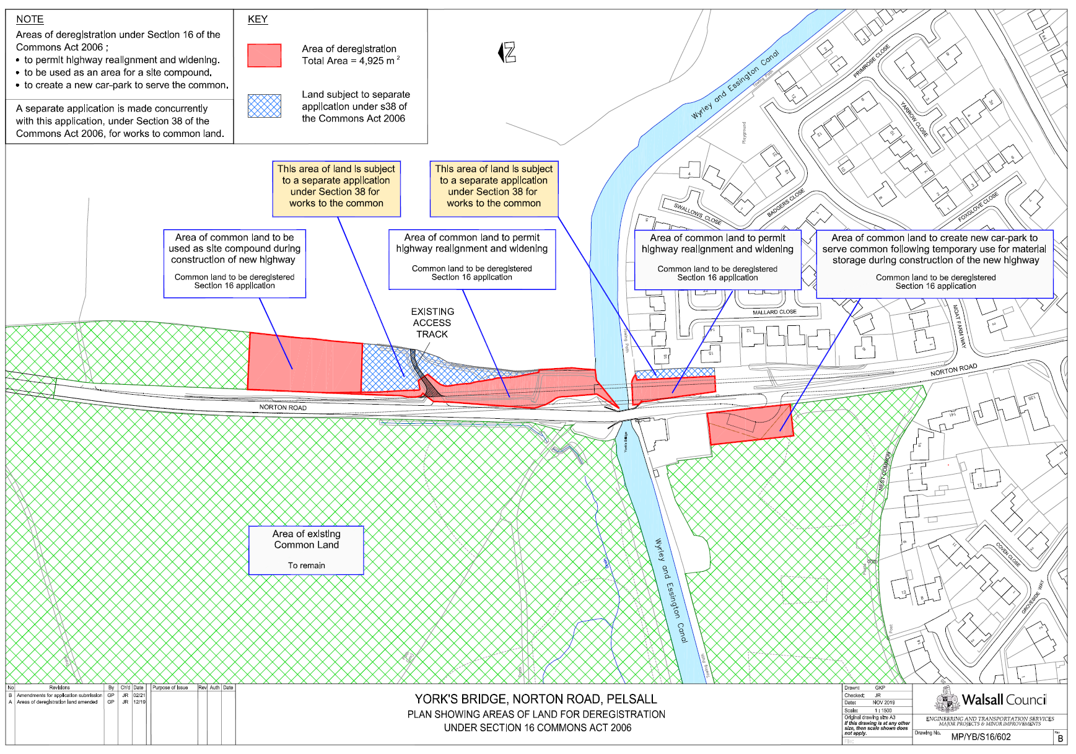

Application A – Drawing B – Replacement Land (Not to scale)
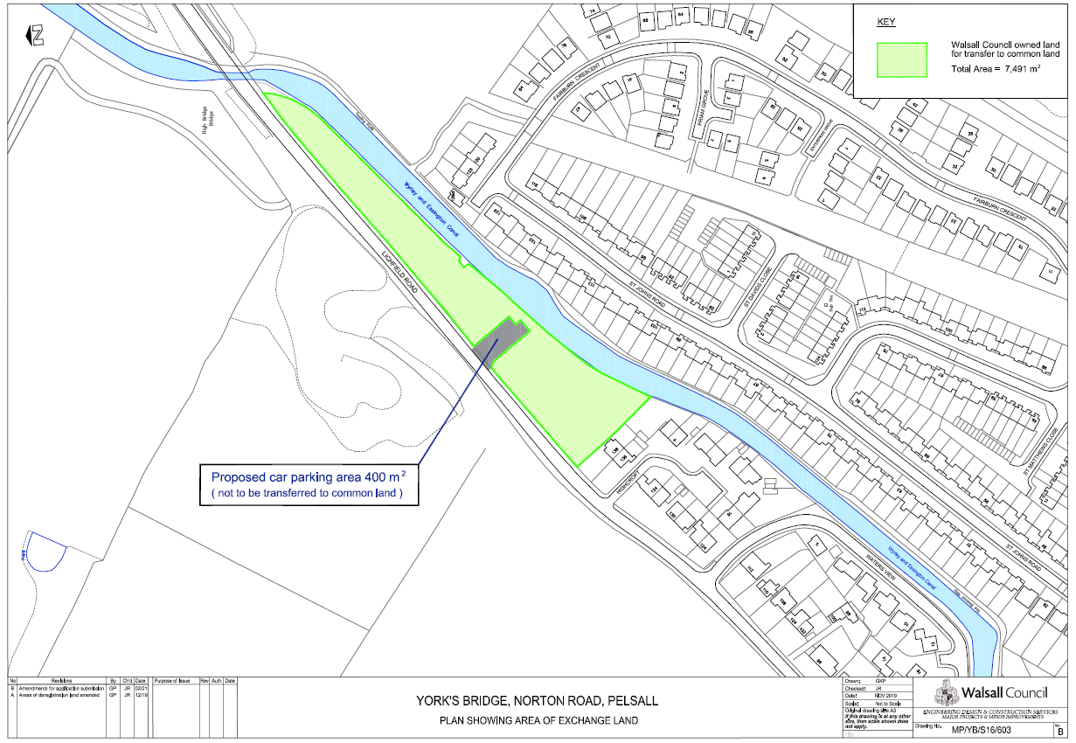

Application B – Drawing 001 – location of works (not to scale)

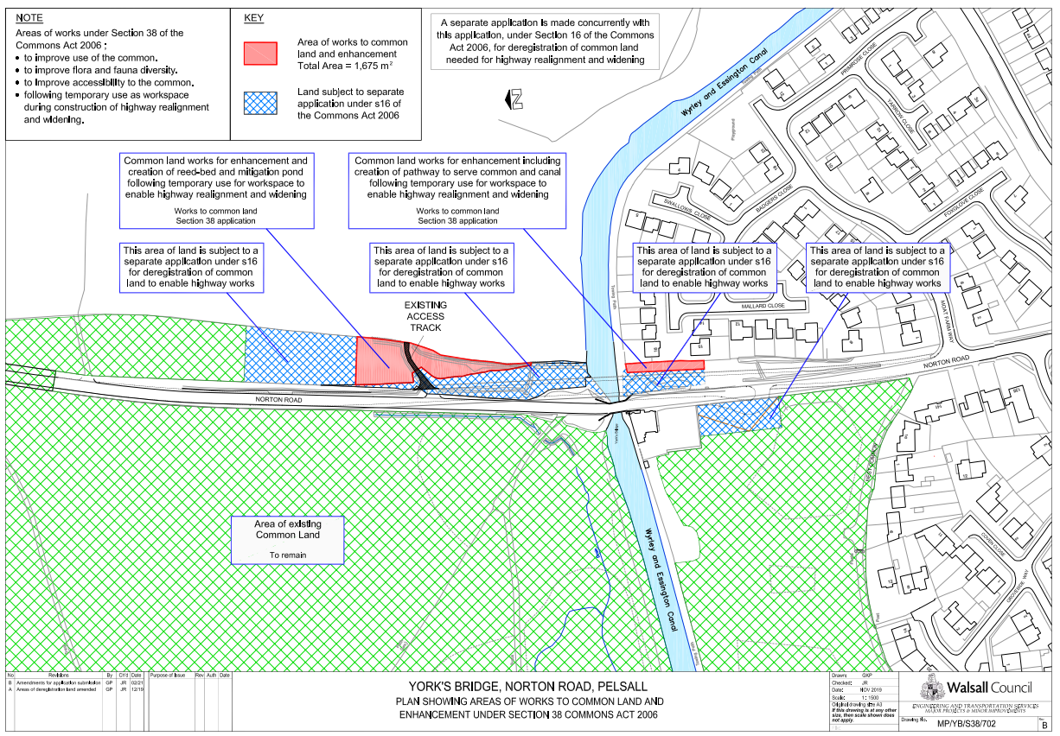

Ref:13/1256/FL
Ref: COM 626
Ref: 19/1042
Confirmation email and photographic evidence of completed works received 2 September 2021.
Section 39(2) of the 2006 Act provides that the public interest includes the public interest in; nature conservation; the conservation of the landscape; the protection of public rights of access to any area of land; and the protection of archaeological remains and features of historic interest.

