Order Decision
Site visit made on 28 June 2021
by Andrew McGlone BSc MCD MRTPI
an Inspector appointed by the Secretary of State for Environment, Food and Rural Affairs
Decision date: 13 July 2021

Order Ref: ROW/3262945
- This Order is made under Section 257 of the Town and Country Planning Act 1990 and is known as the Birmingham City Council (Public Footpath (ID:2086) (Part adjoining Wishaw Lane) Public Path Stopping Up Order 2020.
- The Order is dated 6 August 2020 and proposes to extinguish the public right of way shown on the Order plan and described in the Order Schedule.
- There were some three objections outstanding when Birmingham City Council submitted the Order for confirmation to the Secretary of State for Environment, Food and Rural Affairs.
Summary of Decision: Order is confirmed.

Procedural Matters
- An objector initially raised several procedural grounds relating to the notification process in terms of the Order, the ability to inspect the Order paperwork, the period and timing of consultation, referencing of the Order paperwork and the explanation offered of how the Order fitted with the Peddimore development programme. However, based on the evidence and responses to the concerns, which have not been countered, I consider reasonable steps were taken in accordance with Schedule 14 of the Town and County Planning Act 1990 (as amended) (‘the Act’).

The Main Issues
- Section 257(1) of the Act provides for an Order to be made authorising the stopping up (or diversion) of a footpath if it is necessary to do so in order to enable development to be carried out in accordance with planning permission already granted under Part III of the same Act. In this case the Order is for the stopping up of Public Footpath ID: 2086 (PROW 2086).
- The DEFRA Circular 1/09 version 2 makes clear that, in determining an order of this kind, the merits of the development are not at issue. However, it should not be assumed that because planning permission has been given necessitating closure of a footpath that confirmation of the ensuing order will automatically follow. Any disadvantages or loss likely to arise as a result of the path closure to members of the public may be weighed against the advantages arising from the development when determining the Order.
- There are two issues that must be considered here. These legal tests have been described by the Courts as ‘the necessity test’ and ‘the merits test’. Confirmation of the Order requires that both are satisfied.
- In considering whether or not to confirm the Order, I am obliged to take into account:
- any significant disadvantages or losses the stopping up of the path would cause to the general public, or to other individuals whose actionable rights of access would be extinguished by the process;
- any countervailing advantages to the public, or those individuals; and
- the planning benefits of, and the degree of importance attaching to, the development.

Reasons

The ‘need’ case

Whether the stopping up of Footpath 2086 is necessary to allow development to be carried out in accordance with planning permission already granted
- PROW 2086 leads from Wilshaw Lane in a generally easterly direction across fields to Wiggins Hill Road. It is part of a joined-up network of paths to and from various locations including Sutton Coldfield, Minworth, Castle Vale, Curdworth, Warwickshire and others.
- PROW 2086 is part of the land at Peddimore, Minworth which comprises the Peddimore Development site. The site was allocated under Policy GA6 of the Birmingham Development Plan for a high-quality employment site of 71 hectares to meet a shortfall in best quality employment land.
- Planning permission was granted by the Council on 2 September 2019 subject to numerous conditions (‘the planning permission’). The approved description of development is: hybrid planning application comprising: outline application with all matters reserved for an employment park comprising B1b, B1c, B2 and/or B8 uses, including ancillary offices (B1a), gatehouses and security facilities, service yards and HGV parking, plant, vehicular and cycle parking, landscaping, pedestrian and cycle infrastructure, green and blue infrastructure, ancillary business and community facilities (D1/D2/B1a/A3/sui generis) including a multi-purpose hub building and associated development. Full planning application for a new roundabout access from the A38, construction access and compound area, internal spine road, site gatehouse, primary substation and tower, engineering operations including foul pumping station, acoustic fencing, earthworks (including creation of development plot plateaus), pedestrian and cycle infrastructure and structural landscaping including drainage infrastructure and development platform within Peddimore Brook corridor for ancillary business and community facilities.
- The Peddimore Development is a new manufacturing and logistics site that will deliver 2.7 million square foot of employment space near to Birmingham City Centre and the motorway network. Commercial units ranging from 70,000 to 1 million sq. ft would be provided. The Peddimore Development site consists of three development zones: Zone 1A lies between the A38 and to the west of Wishaw Lane. Zone 1B is to the north-west of Wishaw Lane with Zone 2 extending to the west of, across, and to the east and south-east of Wishaw Lane. Site preparation work for the Peddimore Development started in March 2021 but the planning permission has yet to be implemented.
- The Order was made by Birmingham City Council in its capacity as local

planning authority. The Council was satisfied that it is necessary to close the section of PROW 2086 in question (shown as A1-B1 on the Order map) to enable development to be carried out in accordance with planning permission granted under the Act.
- Since the Order was made, a section of Wishaw Lane to the north and south of its junction with PROW 2086 has been stopped-up pursuant to a section 247 order. Hence, PROW 2086 would, if left in its current form, become a cul-de-sac. The Order would see the western part of PROW 2086 Wishaw Lane stopped up from point A1 to point B1 on the Order Map with the eastern part of the footpath stopped up temporarily during the proposed infrastructure works and it re-provided as a mown grass footpath.
- After the Order was made, four non-material amendments (NMAs) to the planning permission have been granted by the Council. Two of these are said not to be relevant to PROW 2086. A third NMA (Ref: 2021/00356/PA) amended the wording of condition No 9 so that development cannot take place within Development Zone 2 until an Order has been made to stop-up PROW 2086. The fourth NMA (Ref: 2021/02444/PA) updated the Path Network Plan and detailed infrastructure planning planting plans and referenced the updated plans in conditions 3,7, 8 and 9 of the planning permission.
- The later NMA’s followed discussions with various residents and bodies. These led to a revised strategy in respect of: the retained eastern section of PROW 2086; provision of a new bridleway extending between Wilshaw Lane and Wiggins Hill Road extending for some 1,307 metres; and a network of permissive paths, including one as an alternative route to the bridleway over a bund near to the retained section of PROW 2086. The bridleway would feed into a network of permissive paths across the wider development site. The Applicant is obliged to deliver the Path Network Plan strategy both through the conditions and through the terms of the Section 106 Agreement.
- Three planning applications are to be submitted to the Council to deliver Development Zone 1A which includes the two employment buildings (Units A and B). A Section 73 application was validated by the Council on 9 April 2021 and would, if granted, result in a new standalone planning permission which would sit alongside the planning permission. This application is for minor changes to secure improvements to landscaping around the edge of Development Zone 1A, increasing the floorspace to allow the provision of mezzanines within Unit B, and an increase in height on Development Zone 1A to accommodate stair towers on Unit B (Ref: 2021/02972/PA). I have not been informed that the s73 has been determined by the Council.
- The other two planning applications would be reserved matters schemes for Units A and B seeking approval for the detail of these buildings and the surrounding areas to include layout, design, external appearance and elevational appearance, hard and soft landscaping.
- The need for an order under section 257 of the Act may be satisfied by the existence of either a physical or legal obstacle to development proceeding. In this case it is argued that both make the Order necessary. Condition 9 of the fourth NMA prevents the commencement of development in respect of Development Zone 2 until a stopping up order has been made in respect of PROW 2086 between points A1 and B1.
- While Development Zones 1A and 1B are not directly affected by PROW 2086, the land within Zone 2 is required as part of the first phase enabling works. These include strategic landscaping which benefits from full planning permission and earthworks to ensure a balanced cut and fill and to allow for permissive paths to be created. This would avoid ground material from being exported and imported onto site. Furthermore, the largest plot on the Peddimore Development is within Zone 2. Hence, there is clearly a need for a section of PROW 2086 to be stopped up as without the Order there would be a physical and legal obstacle to the Peddimore Development proceeding.

Other merits or disadvantages of the alternative route that will be made available for public use

The effect on members of the public
- I note the points about the timing of the Order and its effect on the ability of the public to use the right of way network in the area. The Order would mean that members of the public would not be able to use the western side of PROW 2086 and there would be a gap between it being stopped up and the new bridleway and permissive paths being made available for use. These will take time to deliver due to the scale of development involved and the engineering works entailed, but the s106 and planning conditions would ensure that they are provided before any commercial floorspace is occupied. The development granted planning permission needs to be allowed to proceed and alternative routes would be available during the construction period for users.
- In the intervening period there may be some limited disadvantage to members of the public. However, as PROW 2086 has become a cul-de-sac following the stopping up of Wishaw Lane it means that it is no longer lawfully possible to travel along it to the north and south of its junction with the western side of PROW2086 to join up to any other right of way. It follows that the Curdworth Circular Walk, which PROW 2086 does not connect into, could continue to be enjoyed by users.
- There is nothing before me to show me that the stopping up order relating to footpath SC19 was not confirmed as suggested. Nevertheless, as Wishaw Lane has now been stopped up, it would not be possible to travel along it between the western side of PROW 2086 and SC19 in any event.

Any countervailing advantages to the public
- The combined action of the Order and the provision of a new bridleway would provide a longer section of off-road passage compared to the existing footpath. The bridleway could also be used by cyclists and horse riders in addition to pedestrians. It would feed into a network of permissive paths across the area. Consequently, there would be accessibility improvements across the area for pedestrians, cyclists and horse riders. These would be beneficial in overall terms to the public. The s106 agreement secures the provision, management, maintenance and permanence of the permissive paths.
- If the Peddimore Development proceeds as planned, there would be significant economic, social and environmental benefits to the region and sub-region and a contribution to the Government’s Build Back Better: Our Plan for Growth industrial policy. The benefits would be realised during the construction and/or operational phases through the direct, indirect or induced provision of jobs and a multimillion pound contribution to productivity in the West Midlands, business rate revenue, biodiversity net gain from green and blue infrastructure and improved accessibility.

Weighing the advantages and disadvantages
- There are significant advantages to the public flowing from the Order and there are very considerable benefits of the Peddimore Development. Balanced against these is the limited disadvantage to the general public and/or individuals from the stopping up of part of PROW 2086. The effects would be temporary and felt during the construction phase. However, part of PROW 2086 will continue to legally exist. Undoubtedly there will be a change to how the public access and travel across the area, but the bridleway would facilitate use by multiple modes of travel and onward connections to permissive paths. Overall, the disadvantage that arises from the Order and the development are not sufficient to outweigh the advantages of the development and they are not individually or collectively significant enough to prevent the confirmation of the Order.

Conclusion
- Having regard to these, and all other matters raised in the written representations, I conclude that the Order should be confirmed

Other matters
- Reference has been made in objections to the formation of a dog leg near to the junction of the bridleway and Wishaw Lane contrary to minimum segregation requirements of DfT LTN 2/04. However, this document is no longer extant, and its replacement does not require a route to be segregated.
- Comments made about PROW 1131 (SC23) are not relevant to the consideration of this Order as this path terminates where it joins Peddimore Lane which is to be stopped up following the Section 247 Order. PROW 1131 is also to be extended to the A38 junction footway and bridge. This would be delivered through the planning obligation and no commercial floorspace can be occupied until it has been completed.
- Comparisons between land forming part of the Peddimore Development site and that allocated under Policy GA6 are not relevant to the consideration of this Order.

Formal Decision
- The Order is confirmed.

Andrew McGlone
INSPECTOR

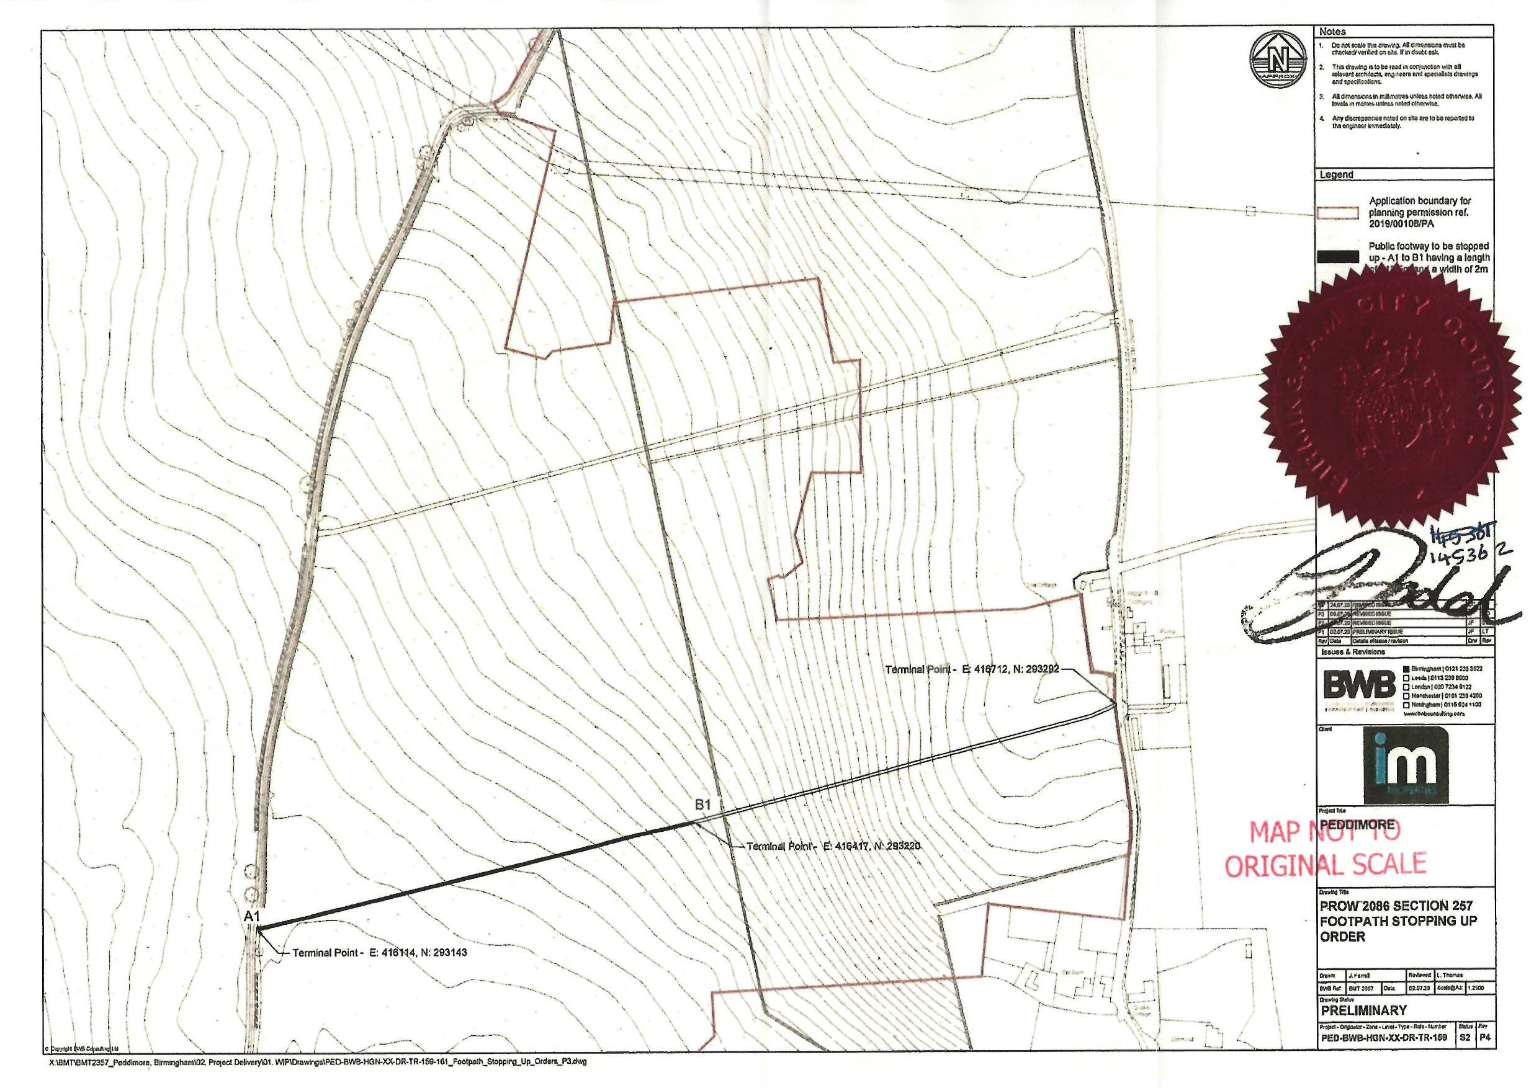

A point articulated by Lindblom LJ at paragraph 51 of his judgement in the Court of Appeal case R (Network Rail Ltd) v SSEFRA [2018] EWCA Civ 2069
Appendix 15, Statement of Case of the Applicant
Refs: 2020/05747/PA and 2020/05748/PA
Drawing Ref: PED-BWB-GEN-XX-TR-DR-007

