Order Decision
Inquiry held on 13 April 2021
by Mark Yates BA(Hons) MIPROW
an Inspector appointed by the Secretary of State for Environment, Food and Rural Affairs
Decision date: 29 July 2021

Order Ref: ROW/3247584
- This Order is made under Section 118 of the Highways Act 1980 (“the 1980 Act”) and is known as the West Oxfordshire District Council Milton under Wychwood Claimed Footpath (Whole) Public Path Extinguishment Order 2019.
- The Order was made by the West Oxfordshire District Council (“the Council”) on 4 November 2019 and proposes to extinguish an alleged public footpath (“the path”) in the parish of Milton under Wychwood, as detailed in the Order Map and Schedule.
- There was one objection outstanding at the commencement of the inquiry.
Summary of Decision: The Order is confirmed.

Preliminary Matters
- In light of the restrictions in place due to the Covid 19 pandemic, the public inquiry into the Order was held as a virtual event. I undertook an unaccompanied visit to the site and surrounding area on 30 March 2021 to look at the relevant features identified by the parties.
- An application for an award of costs was made at the inquiry and this will be the subject of a separate decision.
- Milton under Wychwood Parish Council (“the Parish Council”) has made an application to add the path to the definitive map and statement. This application is still to be determined by Oxfordshire County Council and it is not my role to make a ruling on this matter. The present Order seeks to extinguish any public rights that may exist over this route.
- The Parish Council points to the potential for the path to be made available for people to use. In reaching my decision I have disregarded the fact that it is not presently possible to use the whole length of the path.

Main Issues
- By virtue of Section 118 of the 1980 Act, before confirming the Order, I must be satisfied that it is expedient to extinguish the path having regard to:
- the extent (if any) to which it appears that the path would, apart from the Order, be likely to be used by the public, and
- the effect that the extinguishment of the path would have as respects land served by the path, having regard to the provisions for compensation.
- I also need to have regard to any material provision contained in a rights of way improvement plan (“ROWIP”) for the area.

Reasons

Background matters
- The path has historically proceeded along the edge of two sides of a field. It is adjacent to the rear boundaries of properties on The Sands and passes to the west of Calais Cottage. A recent residential development undertaken by Spitfire Bespoke Homes Limited (“the Applicant”) within the field means the path is now enclosed to the south and west by the boundary fencing in connection with five houses.
- The development required the diversion of two public rights of way within the field (Footpaths 301/5 and 301/13). An Order diverting these footpaths was confirmed by an Inspector following a hearing held on 9 February 2021. Another public footpath within the field (301/14) has been unaffected by the development.

The extent to which it appears the path would likely to be used by the public
- Whilst I cannot make a ruling on the status of the path, seventy-eight user evidence forms were provided in support of the Parish Council’s application. Leaving aside the potential issues associated with a few of these forms, when taken at face value they provide evidence of longstanding use of the path. There is clearly the potential for use of the path to endure.
- The fact that it is presently not possible to use the whole length of the path means that no comparison can be made between current use of the path and the public footpaths across the site. However, no evidence has been presented to indicate that those people who state that they previously used the path are likely to continue to use it in the future. Both the Council and the Applicant point to the changes to the site in light of the housing development, which they believe will limit any potential future use.
- Photographs taken prior to the development show the previous open nature of the site. There are signs of wear visible on an aerial photograph that could be reflective of public use, including over the alignment of the path. The path now passes between hedges and the solid high boundary fencing of the new properties. Although it has a more open aspect towards point C on the Order Map. In comparison, the public footpaths within the site pass through an area of open space with views of the surrounding countryside.
- The revised routes of Footpaths 301/5 and 301/13 have been constructed on site and comprise of hoggin paths designed to be permeable. The Parish Council no longer pursues its original concern about the potential boggy nature of the alternative paths. From the details provided, I find that these footpaths are likely to provide a suitable surface in this locality throughout the year. A management plan for the site makes provision for the continued maintenance of the footpaths.
- The realigned public footpaths provide links between Jubilee Lane, Frog Lane and the network of rights of way to the south. It is apparent that the path was generally used for recreational purposes and it served as a link between Jubilee Lane and Frog Lane. This direct link will be maintained by Footpath 301/13, which is slightly shorter in length than the path. In terms of the references to other rights of way in the village, I am not convinced they are directly comparable to the path given the alternative footpaths that are available across this site.
- In my view, the changes in the nature of the site arising from the development and the availability of convenient and pleasant alternative footpaths serving Jubilee Lane and Frog Lane means that it is unlikely the path will be used to any meaningful extent in the future. This issue will weigh heavily in favour of the confirmation of the Order.

The effect the extinguishment of the path would have with respect to land served by the path
- Reference has been made to a private right of access granted by the landowner to the owners and occupiers of certain properties on The Sands in relation to the section of the path between points B and C on the Order Map. However, no evidence has been provided to show that the extinguishment of this alleged public right of way would impact on any land served by it.

The consideration of the Order in light of any material provision contained in a ROWIP
- There is nothing to suggest that the extinguishment of the path is contrary to any material provision in the ROWIP.

Other matters
- The Council refers to the potential for a problem to arise with anti-social behaviour given the enclosed nature of the path and the impact this could have on the neighbouring properties. However, there is presently no evidence to support this assertion. Further, the Parish Council points to the lack of any significant problems with anti-social behaviour involving other enclosed paths in the village. Accordingly, I do not consider that I can place any weight on this matter in determining whether it is expedient to confirm the Order.

Conclusion
- Having regard to these and all other matters raised at the inquiry and in the written representations I conclude that it is expedient to confirm the Order.

Formal Decision
- I confirm the Order.

Mark Yates

Inspector

APPEARANCES
For the Council:

Mr O. Lawrence  He called:  Mr C. Wood  For the Applicant:  Ms R. Meager  She called:  Mr J. Yeoman  Objector:  Cllr J. Pratt |  | Barrister instructed by the Council  Planning Appeals Officer  Barrister instructed by the Applicant  Associated Director for Savills representing the Applicant  Vice Chairman for the Parish Council

DOCUMENTS TENDERED AT THE INQUIRY

1. Opening and closing statements on behalf of the Council

2. Opening and closing statements for the Parish Council

3. Costs application

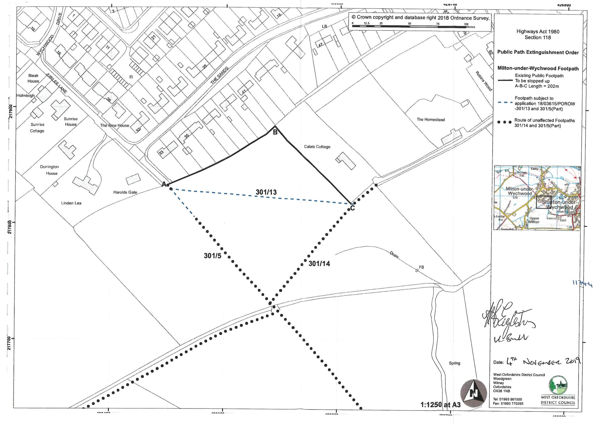

Referred to by parties at the inquiry as the ‘Calais Field’
Planning Inspectorate ref: ROW/3243062
Known as the Oxfordshire Rights of Way Management Plan

