Application Decision
by Richard Holland
Appointed by the Secretary of State for Environment, Food and Rural Affairs
Decision date: 16 August 2021

Application Ref: COM/3276625
DANBURY COMMON, ESSEX
Register Unit No: CL 48
Commons Registration Authority: Essex County Council
- The application, dated 27 May 2021, is made under Section 23 of National Trust Act 1971 (the 1971 Act) for consent to carry out restricted works on common land.
- The application is made by UK Power Networks.
- The works comprise the installation of a total of 280 m high voltage underground cable along the public highway on Woodhill Road and on a small section of verge on Penny Royal Road. Trenches will be backfilled and reinstated once the cables have been installed. Temporary fencing of approximately 95 m at any one time/per section.

Decision
  - Consent is granted for the works in accordance with the application dated 27 May 2021 and accompanying plan, subject to the following conditions:
  - the works shall begin no later than three years from the date of this decision; and
  - all fencing shall be removed and the common restored within one month from the completion of the works;
  - For the purposes of identification only the location of the works are shown in red and the common land coloured green on the attached plan.
Preliminary Matters
  - I have had regard to Defra’s Common Land Consents Policy in determining this application under section 23, which has been published for the guidance of both the Planning Inspectorate and applicants. However, every application will be considered on its merits and a determination will depart from the policy if it appears appropriate to do so. In such cases, the decision will explain why it has departed from the policy.

- This application has been determined solely on the basis of written evidence.

- I have taken account of the representation made by Historic England (HE).
- I am required by section 39 of the 2006 Act to have regard to the following in determining this application:-
- the interests of persons having rights in relation to, or occupying, the land (and in particular persons exercising rights of common over it);
- the interests of the neighbourhood;
- the public interest; and
- any other matter considered to be relevant.

Reasons

The interests of those occupying or having rights over the land
- The National Trust, as landowner, has been consulted about the application and confirms that the works are ‘desirable’ under section 23 of the 1971 Act. Rights to graze, shoot and gather firewood are registered over the common. The commoners have been consulted about the application and have not objected to the works. There is no indication that the works will impact on common rights. I am satisfied that the works will not impact adversely on the interests of those occupying or having rights over the common.

The interests of the neighbourhood and the protection of public rights of access
- The interests of the neighbourhood test relates to whether the works will unacceptably interfere with the way the common is used by local people. The applicant explains that the works are to install high voltage underground cables along the public highway to connect to and reinforce the existing electricity network in the area. Access to the common will not be restricted. Temporary fencing around the working areas is required for health and safety. The duration of the works is approximately 3 to 4 weeks.
- I am satisfied that the temporary fencing is needed around the working areas for health and safety purposes. I consider it unlikely that the works will interfere with the way the common is used, particularly given that the works are located on the highway and are of short duration. I conclude that the works will not impact on the interests of the neighbourhood and public rights of access.

Nature conservation and conservation of the landscape
- The common is part of the Danbury Site of Special Scientific Interest (SSSI). The applicant confirms that Natural England has issued assent for the small section of cable at Penny Royal Road and mitigation measures have been agreed for the route. The applicant adds that installing the cable underneath the highway will avoid further disturbance to the SSSI and the visual impact of an overhead line.
- The temporary fencing will be removed, the trenches backfilled and the common fully reinstated upon completion of the works. I am satisfied that the works will not have a lasting visual impact on the common. I conclude that the works will not harm nature conservation and will conserve the landscape in the long term.

Archaeological remains and features of historic interest
- HE advise that the remains of a Napoleonic Redoubt along the western end of the cable route are in the Essex Historic Environment Record and archaeological mitigation may be required. The applicant confirms that it has consulted Essex County Council Place Services and the Historic Environment Consultant about the works and the programme of mitigation measures required. In view of the applicant’s response, I am satisfied that the works will not harm archaeological remains and features of historic interest.

Conclusion

13. Defra’s policy advises that “…works may be proposed in relation to common land which do not benefit the common, but confer some wider benefit on the local community, such as minor works undertaken by a statutory undertaker (e.g. a water utility) to provide or improve the public service to local residents and businesses,…consent under section 38 may be appropriate where the works are of temporary duration (such as a worksite), where the works will be installed underground (such as a pipeline or pumping station), or where their physical presence would be so slight as to cause negligible impact on the land in question (such as a control booth or manhole), and the proposals ensure the full restoration of the land affected and confer a public benefit.”

14. I conclude that the works will not harm the interests set out in paragraph 6 above. I am satisfied that the works accord with Defra’s policy and will confer a public benefit by reinforcing the local electricity network. Consent is therefore granted for the works subject to the conditions set out in paragraph 1.

Richard Holland

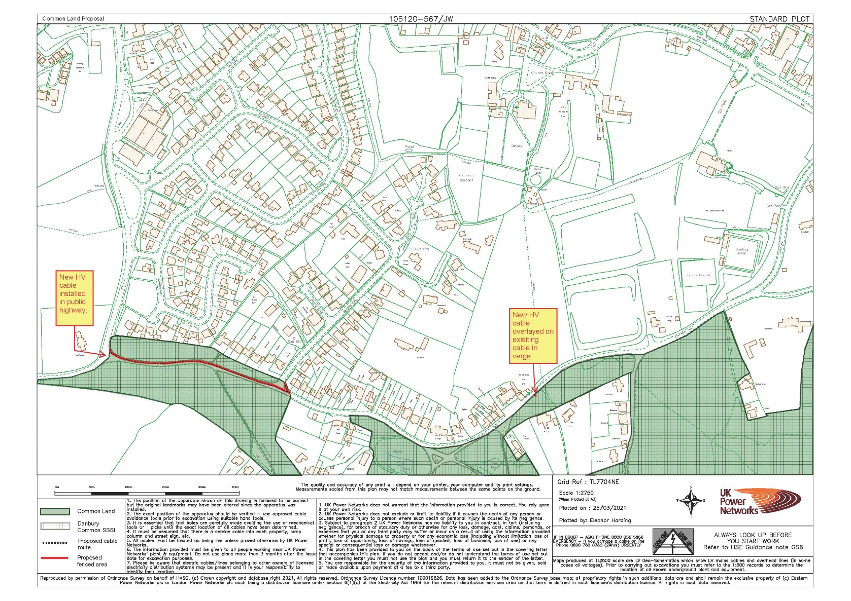

Common Land Consents Policy (Defra November 2015)
Section 39(2) of the 2006 Act provides that the public interest includes the public interest in; nature conservation; the conservation of the landscape; the protection of public rights of access to any area of land; and the protection of archaeological remains and features of historic interest.

