Application Decision
Site visit made on 30 July 2021
by R J Perrins MA
an Inspector appointed by the Secretary of State for Environment, Food and Rural Affairs
Decision date: 3 August 2021

Appeal Ref: COM/3259426
Quantock Common, Holford, Bridgwater, Somerset
- The application, dated 12 August 2020, is made under Section 38 of the
Commons Act 2006 (‘the 2006 Act’) for consent to carry out restricted works on common land.
- The application is made by the Quantock Commoners Association.
- The works are described as: To extend the period for an existing temporary stockproof wire fence of 264 metres, for a further 10 years the original permission was granted on the 21st of January 2005.

Decision
- Consent is granted for the works in accordance with the application dated 12 August 2020 and accompanying drawing, subject to the following condition: -

i. all fencing and gates shall be removed, and the land restored to its former condition, within 10 years of the date of this decision unless a further consent application is made and approved.
- For the purposes of identification only, the location of the works is shown outlined on the attached drawing.

Preliminary Matters
- The application was initially made on a set of superseded DEFRA forms and the information therein was subsequently transferred to the correct application forms which were undated; I have therefore used the application date on the original forms.
- The fencing was granted consent for a period of ten years on 21 January 2005. The 2005 decision makes it clear that any proposal for continued fencing after the expiry of that consent would require a new application. I observed from my site visit that the fencing given consent at that time remains in situ and is in good condition.
- Following advertisement of the application, 1 objection was received from the Open Spaces Society (OSS).
- I carried out an accompanied site visit with members of the Quantock Commoners Association on 30 July 2021. The weather on the day was bright and dry. I walked extensively around the area of Quantock Common and Holford to familiarise myself with the general area and the location, including access to the main A39.
- This application has been determined on the basis of the written evidence, the comments submitted and my own observation of the site and surrounds.

Main Issues
- I am required by section 39 of the 2006 Act to have regard to the following in determining this application:-

a. the interests of persons having rights in relation to, or occupying, the land (and in particular persons exercising rights of common over it);

b. the interests of the neighbourhood;

c. the public interest; and

d. any other matter considered to be relevant.
- Section 39(3) provides that consent may be given under Section 38(1) in relation to all or part of the proposed works, and subject to such modifications and conditions relating to the proposed works as are thought to be fit.
- In determining this application, I have had regard to the latest edition of Defra’s Common Land Consents Policy (‘the 2015 Policy’) which has been published for the guidance of both the Planning Inspectorate and applicants. However, every application will be considered on its merits and a determination will depart from the policy if it appears appropriate to do so. In such cases, the decision will explain why it has departed from the policy.

Reasons

The interests of those occupying or having rights over the land
- Nothing has been provided to show that anyone occupying or having rights over the land in question would be adversely affected by the stockproof fencing.

The interests of the neighbourhood and public rights of access
- The interests of the neighbourhood test relates to whether the works would unacceptably interfere with the way the common is used by local people and is closely linked with public rights of access.
- The area of the common concerned is traditionally used for walking, horse riding and other informal recreation. The bowling club car park is open to the public and I saw that it was well used. It is clear that the common is a valuable recreation asset to many. The common can be accessed at various vantage points in the local surrounds.
- Against that background I accept that the fencing has subdivided the common and prevents free access. However, it is clear the main footpaths are well used and access points where the fence line crosses those paths are well maintained and easy to use. Furthermore, much of the fence is on areas of the common where access would be restricted in any event due to the terrain and topography; rocky outcrops and steep slopes. In that light any subdivision has had minimal effect on how the common is used by local people. That is reflected by the lack of objection to this application from local residents.
- Thus, from all that I have seen, and from the evidence before me, I find that the fencing has not had an unacceptable or lasting impact on local and public access rights over the common.

The public interest

Nature conservation and archaeological remains and features of historic interest
- There is nothing before me to suggest that anything has changed since the matter was considered in 2005. That is to say English Nature (as was) had no objections, the National Trust supported the proposal as did the Parish Council. The Quantock Hills Area of Outstanding Natural Beauty (AONB) Service also set out that the fence was needed to actively manage the heathland Site of Special Scientific Interest and I note the current Countryside Stewardship Agreement expires in 2023. Natural England have made no adverse comments.
- There is no evidence before me to suggest that the works (which are complete in any event) would harm archaeological/historic interests. Thus, there would be no adverse implications in respect of nature conservation or historic interest.

Conservation of the landscape
- I accept the fencing has inevitably had an effect on the natural beauty of the common, with fencing and gates constructed where there would have been none. However, the fencing and gates, even to a first-time visitor do not come as a surprise, they do not draw the eye or lead the viewer to question how they came to be. Stock proof fencing and gates are not uncommon in the Quantocks, and the design reflects that seen locally elsewhere. Furthermore, given the passage of time, the landscape has started to evolve around the fence, with vegetation screening much of it, such that any effect on the landscape has further decreased. The fence is not, therefore, at odds with the natural beauty of the of the Quantock Hills AONB.
- In that light, the suggestion that a cattle grid and short section of fence would improve the effect carries little weight. Furthermore, it is not clear if the Open Spaces Society have visited the common in recent times. From my visit I could see that the proposed location of the cattle grid is not the only way livestock could access the village and subsequently the busy main road. It is clear that garden fences running along the rear of properties abutting onto the Common have become dilapidated in part. There is a well-used unrestricted footpath leading between residential properties to the south of the common. I was also able to walk, unrestricted, to the north past the dog pound and in turn head east back into the village beyond where the cattle grid would be, thus bypassing it. Moreover, it is not clear to me how far livestock could roam unhindered to the north and then onto the A39.
- Given all of that a cattle grid would not prevent livestock wandering onto the main road where, without evidence to the contrary, highway safety remains a significant factor. In addition, if the cattle grid were to be installed, the amount of fencing required to be reinstated to support the grid and the access restrictions/gates required elsewhere, as I have set out, would negate any benefit.
- Whilst coming to that view I accept that a grid would not need consent under the 2006 Act and fencing of the common in perpetuity should not be a given. To that end it seems to me that any proactive management of land should take into account all options for the future including costs and practical application. The Open Spaces Society suggest a cattle grid could be funded from elsewhere but supply no details. A cost/benefit analysis may be helpful for the next decision maker should a further application come forward after the expiry of this consent.

Conclusion
- Having regard to the criteria set out above, and all the written representations, I conclude that little has changed since the previous consent where the Secretary of State found that the works would not adversely affect the health, comfort and convenience of the local inhabitants. Therefore, I find there would be no harm to the local neighbourhood, public rights of access or the landscape, and the application should succeed, and permission granted for a period of 10 years. I shall condition that the fence be removed upon completion of those 10 years, unless a further application is made and approved, to ensure the common is restored to its previous condition.

Richard Perrins

Inspector

Plan
This is the plan referred to in my decision dated:
by RJ Perrins MA
Land at: Quantock Common, Holford, Bridgwater, Somerset
Reference: COM/3259426
Scale: Not to Scale

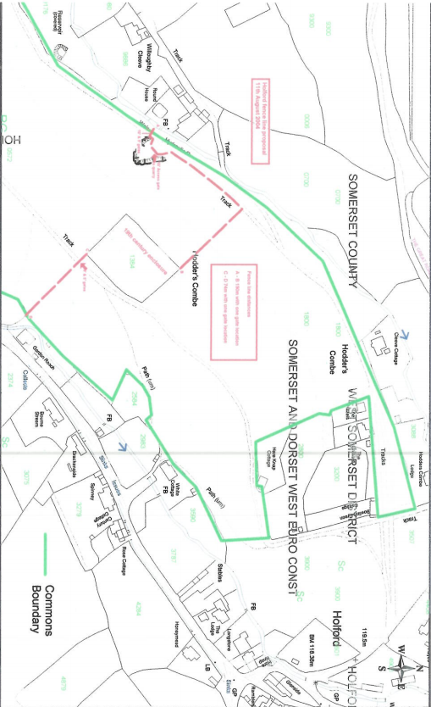

Ref: CLI 1/3/66
Section 39(2) of the 2006 Act provides that the public interest includes the public interest in; nature conservation; the conservation of the landscape; the protection of public rights of access to any area of land; and the protection of archaeological remains and features of historic interest.
Common Land Consents Policy (Defra November 2015)

