Application Decision
by Richard Holland
Appointed by the Secretary of State for Environment, Food and Rural Affairs
Decision date: 21 July 2021

Application Ref: COM/3265784
Huddinknoll Hill, Painswick, Gloucestershire
Register Unit No: CL159
Commons Registration Authority: Gloucestershire County Council
- The application, dated 26 November 2020, is made under Section 38 of the Commons Act 2006 (the 2006 Act) for consent to carry out restricted works on common land.
- The application is made by Mr Charles Hutton.
- The works comprise: i) re-locate and shorten the existing access track to Wood Cottage from Sevenleaze Lane, incorporate a duct for essential services and resurface approximately 24 square metres with compacted crushed stone; and ii) resurface the first 5m from Sevenleaze Lane (approximately 12 square metres) with tarmac.

Decision
- Consent is granted for the works in accordance with the application dated 26 November 2020 and the plans submitted with it subject to the following conditions:
- the works shall begin no later than 3 years from the date of this decision; and
- the land shall be fully reinstated within one month from the completion of the works.
- For the purposes of identification only the location of the works is shown in red on the attached plan. The southernmost point of the red line shows where the existing track meets Sevenleaze Lane (the road). The red line above it shows where the relocated track will meet the road.
Preliminary Matters
- I have had regard to Defra’s Common Land consents policy in determining this application under section 38, which has been published for the guidance of both the Planning Inspectorate and applicants. However, every application will be considered on its merits and a determination will depart from the policy if it appears appropriate to do so. In such cases, the decision will explain why it has departed from the policy.
- Planning permission for ‘amendments to access track’ was granted on 9 November 2020 by Stroud District Council (Application S.20/1456/FUL).
- This application has been determined solely on the basis of written evidence. I have taken account of the representations made by the Open Spaces Society (OSS).
- I am required by section 39 of the 2006 Act to have regard to the following in determining this application:-
- the interests of persons having rights in relation to, or occupying, the land (and in particular persons exercising rights of common over it);
- the interests of the neighbourhood;
- the public interest; and
- any other matter considered to be relevant.

Reasons

The interests of those occupying or having rights over the land
- The land is owned by Mr Detmar Blow and the common land register records that the J.O.T Blow Discretionary Trust Settlement holds rights to graze up to 400 sheep or 25 cattle over the whole of the register unit.
- The land is currently leased to Natural England (NE), which grazes sheep periodically on the common. The applicant advises that the proposals were worked up in consultation with the landowner and NE, which uses the track informally to access the common with vehicles to manage the livestock. Neither has commented directly on the proposals. However, in its email to the applicant of 11 February 2021, NE advised of an intention to bring back cattle grazing to the common and expressed support, as the land managers, for the installation of a gate at the road end of the relocated track (the new junction) to help make the site cattle-secure. I take from this that NE has no objection in principle to the proposed works in terms of land management or the exercising of grazing rights.
- I am satisfied that the works are unlikely to harm the interests of those having rights in relation to the land (and in particular persons exercising rights of common over it).

The interests of the neighbourhood and the protection of public rights of access
- The applicant seeks improvement to the only vehicular access to his property at Wood Cottage. The access track’s current junction to the road is at an acute angle with restricted visibility and is described by the applicant as being dangerous to oncoming traffic. Turning left requires a three-point turn, which compounds the hazard. The proposed works will move the junction further to the north and change it to a right angle, improving access and visibility.
- The interests of the neighbourhood test relates to whether the works will affect the way the common land is used by local people and is closely linked with public rights of access. The applicant describes the common as a strip of woodland that is well used by walkers, horse riders and dog owners. There are three main pedestrian tracks onto the common. The proposed new junction will provide a fourth.
- Any vehicle can access the first few metres of the track from the road at the current junction. A wooden agricultural gate then prevents further access onto the common by unauthorised vehicles. The gate will be removed and spoil from the new junction excavation will be placed across the current junction to permanently prevent any vehicular access from the road at that point. Blocking vehicular access at the current junction is a condition of the planning permission for the new junction. The applicant has confirmed that public access on foot will not be blocked.
- The applicant and NE would like a similar gate to be installed across the new junction. However, in response to OSS pointing out that the application includes no proposal for a gate structure, the applicant has advised that installing a gate will be a matter for future consideration and does not wish a gate to be considered as part of the application to be determined.
- Applicant photographs show the site of the proposed new junction to be uneven and thickly vegetated, which I consider is likely to make pedestrian access onto the common at that point very difficult. A new ungated junction will provide easier access for pedestrians at that point and will be additional to pedestrian access at the current junction, which will remain. I conclude that the proposals are in the interests of local and public access over the common.

Nature conservation
- A small number of trees will need to be removed to facilitate the works, which the applicant says have been identified and agreed with NE in line with the management plan for the common. The applicant advises that some trees at the edge of the common bordering the road are showing signs of Ash die-back, suggesting that they may anyway need be removed at some stage. NE’s email to the applicant suggests that gating the new junction will benefit conservation interests. However, as the provision of a gate does not form part of the application I give such comments little weight. NE did not make formal representations about the application and there is no evidence before me to suggest that the works will seriously harm nature conservation interests.

Conservation of the landscape
- A new junction will interrupt the roadside tree line and the proposed tarmacked element will introduce a new hard surfaced feature into the landscape. However, the surface (tarmac and compacted stones) area of the proposed track will be less than that of the existing track. Furthermore, the existing track (including the junction) will be re-seeded with green hay cut from other areas of the common to re-instate it to grass. I conclude that these factors will more than offset the visual impact of the new junction.
- The common lies within the Cotswolds Area of Outstanding Natural Beauty (AONB). The AONB Board was consulted about the application but did not comment. I am satisfied that overall, the works will not damage landscape interests and that the natural beauty of the AONB will be conserved.

Archaeological remains and features of historic interest
- There is no evidence before me to suggest that the proposed works will harm these interests.

Conclusion
- I conclude that the works will benefit local and public access on foot over the common and are unlikely to harm the other interests set out at paragraph 6 above. The new junction will provide for safer vehicular movement to and from Wood Cottage, particularly when turning left onto Sevenleaze Lane. Consent for the works is therefore granted subject to the conditions in paragraph 1.

Richard Holland

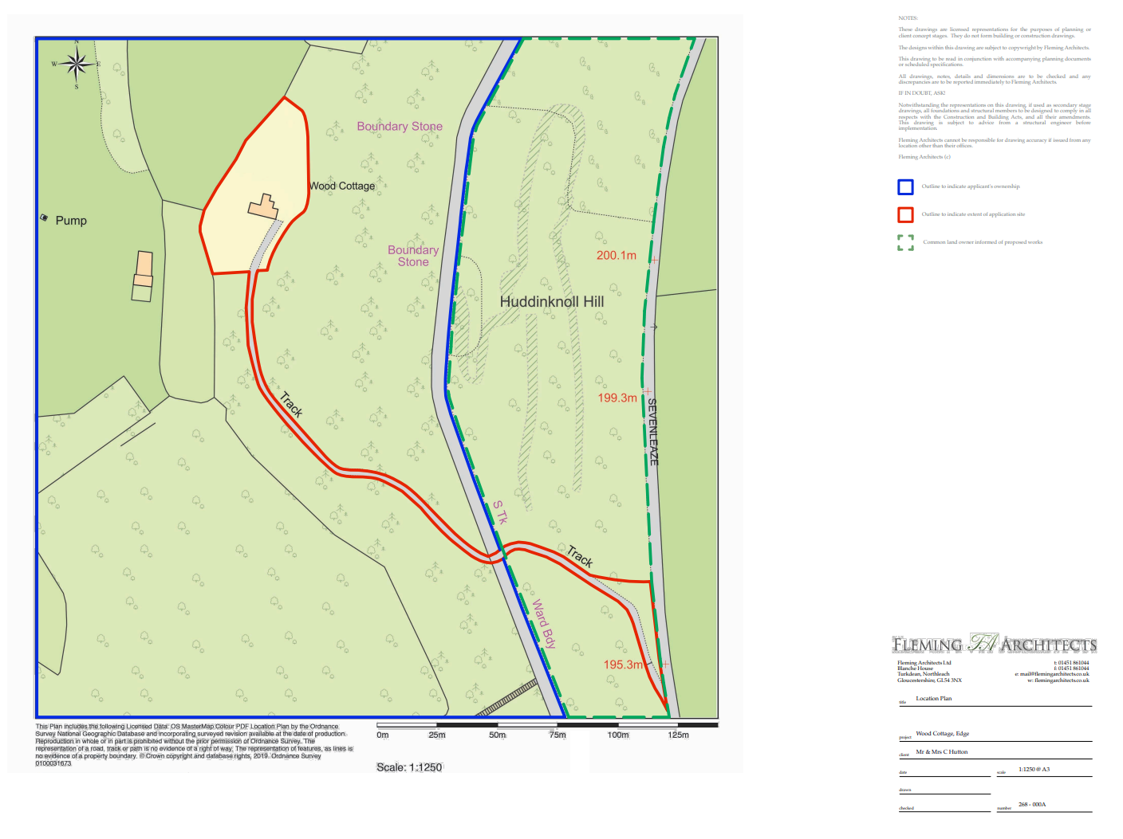

Common Land Consents policy (Defra November 2015)
Section 39(2) of the 2006 Act provides that the public interest includes the public interest in; nature conservation; the conservation of the landscape; the protection of public rights of access to any area of land; and the protection of archaeological remains and features of historic interest.

