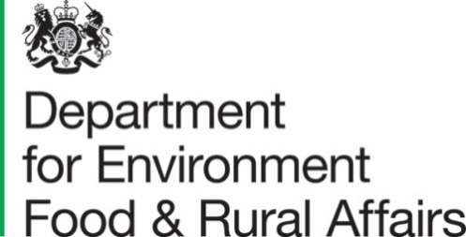
Published 22nd July 2021

Farmer Opinion Tracker for England – October 2020

This report contains estimates from the 2020 Farmer Opinion Tracker providing a snapshot of views and opinions towards Defra’s vision for farming at this time. Farmers were asked questions about business planning, relationships with farming organisations and Defra and the future of farming. All respondents had the opportunity to provide additional comments at the end of the survey. The key results are given below.

Key Messages
- Farmers on 63% of holdings said they either fully (7%) or roughly (56%) understood Defra’s vision for farming.
- Farmers on over half of holdings (54%) indicated that they will need to make changes to their farm business in the next 3-5 years.
- Approximately 89% of farmers on holdings said that Defra paying for environmental outcomes will be very (68%) or moderately (22%) important to their business in the future.
- Farmers on just over half (51%) of holdings feel positive about the future of farming (with 8% saying they felt very positive and 43% somewhat positive).
The open text comments analysis provides useful context around the statistics.
- Farmers were concerned about future trade deals and the impact of lower standards in food imports for British farming and wider society. Farmers felt that market prices were unfair and too low, and that they lacked control in supply chains.
- Experiences of existing agri-environmental schemes were described with practical recommendations for future scheme design. There was consensus that Defra had not provided enough clarity and information about Environmental Land Management (E.L.M) schemes and what farmers will be required to do and how much they will be paid.
- There was a perception that Defra undervalues food production and focuses instead on environmental outcomes. There was widespread concern about the barriers to undertaking environmental work, whether these were financial and legal, or from the lack of policy clarity and issues from public access. However, many farmers saw themselves as custodians of the landscape and were passionate about the environment.
- Farmers thought that Defra lacked understanding about the practicalities of farming life and in turn was “out of touch” and not “farmer-friendly”. There were references to the need for partnership working which supports farmers and takes a “human approach” to interactions. This was highlighted as important for the adoption of new schemes.
- Communication from Defra needs to be simple and meaningful for making decisions.
- Many farmers thought inspections need to be fairer and improved. A damaged relationship between the RPA and farmers was highlighted because of the failure to make payments on time, the difficulty of speaking to caseworkers, and the burden of red tape and paperwork.
- Many farmers were struggling to plan for the future and make decisions because of the uncertainty around trade deals and E.L.M. This combined with other stresses such as covid-19, climate change, late payments and the reduction in BPS was contributing to a poor wellbeing and farmers feeling nervous, doubtful and angry about the future.
- Some farmers were grappling with the possibility of exiting farming as they couldn’t see a viable future, and there were many references to “business survival”.
- Small farms, family farms, hill farms and tenanted farms were perceived to be most at risk from future changes, with assumptions that new schemes will not benefit them. Some farmers were reliant on diversification to survive, whereas other farms might not have the resources, flexibility or ability to diversify.

Contents

What you need to know about this release 4
Section 1 – Detailed results 5
1.1 Vision 5
1.2 Changes 6
1.3 Groups 11
1.4 Environment 13
1.5 Relationships 15
Section 2 – Open Text Comments 17
2.1 Markets and Future Trade 17
2.2 Environmental Management 17
2.3 Relationships and Communications 18
2.4 Regulation and Enforcement 18
2.5 The Reality of Agricultural Policy ‘On The Ground’ 18
2.6 Miscellaneous Themes 19
Section 3 – About these statistics 20
3.1 Methodology 20
3.2 Data analysis 20
3.3 Accuracy and reliability of the results 20
3.4 Uses and Users 20
3.5 Definitions 21

What you need to know about this release

Contact details

Responsible social researcher: Hannah Baker
Team: Future Farming Insights and Evaluation - Department for Environment, Food and Rural Affairs
Email: Farming.Research@defra.gov.uk

Responsible statistician: Emma Howat
Team: Farming Statistics - Department for Environment, Food and Rural Affairs
Email: farming-statistics@defra.gov.uk
Tel: 03000 600 170

Official Statistics

Official statistics are produced to the high professional standards and comply with the United Kingdom Statistics Authority’s Code of Practice for Statistics. The Code of Practice for Statistics sets the standards that producers of official statistics should commit to. Compliance with the Code gives you confidence that our published statistics have public value, are high quality, and are produced by people and organisations that are trustworthy.

Section 1 – Detailed results

1.1 Vision
Defra is setting out what they think the future for farming would look like. In this vision, England’s farmers improve the health of our environment and animals as part of a sustainable, productive agricultural sector. When asked if they know what Defra’s vision meant for farming, farmers on 63% of holdings said they either fully (7%) or roughly (56%) understood Defra’s vision (see Figure 1). This is a small decrease from 2019, as 10% of holdings said they fully understood the vision. In 2020, a further 33% said they didn’t know but would be interested to know more. Farmers on the remaining 4% of holdings don’t need to know what the future vision meant for farming.
Figure 1: Proportion of holdings that understand Defra’s vision for farming
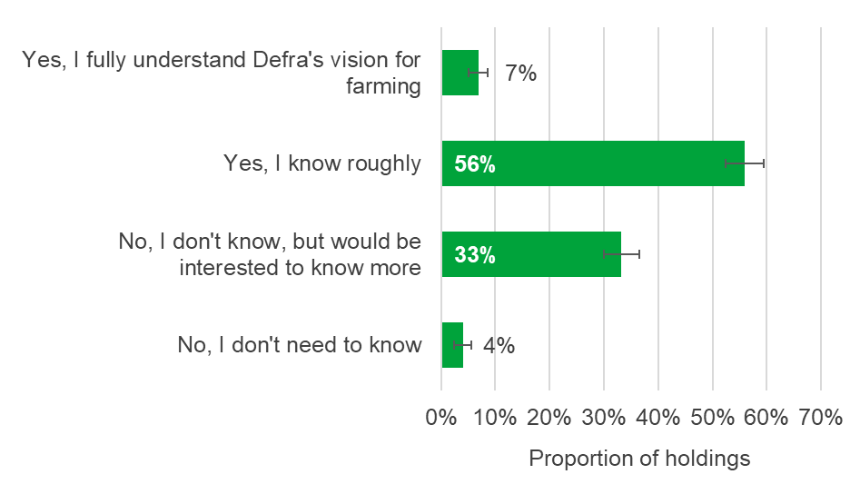

1.2 Changes
Whilst DEFRA move away from the EU’s Common Agricultural Policy, there will be a period of policy transition which will involve changes to the payments farmers receive and the regulations their businesses must follow. Farmers were asked whether they had all the information they needed at this point to help with their business planning (see Figure 2). Farmers on 30% of holdings said they had all (5%) or most (25%) of the information they required and a further 27% indicated that they didn’t have any information but knew where they could find it. Over a third (36%) of farmers on holdings said they didn’t have any of the information they needed for their business planning and were unsure where to find it, which increased to 45% of other crops holdings compared to 27% of pigs and poultry holdings. The remaining 7% of all holdings didn’t know if they had all the information they needed.
Figure 2: Proportion of holdings that have the information they need to inform business planning
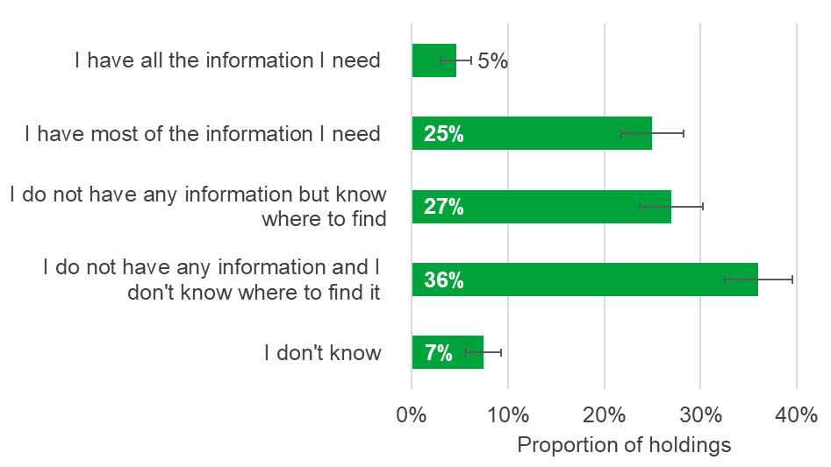
Farmers on over half (54%) of holdings believe they will need to make changes to their farm business in the next 3-5 years. This proportion varied over farm size, increasing to 65% of large holdings as opposed to 48% of smaller holdings (see Figure 3). Approximately 15% of all holdings indicated that they didn’t need to make any changes to their farming business and nearly a third (32%) didn’t know what changes they needed to make.

Figure 3: Proportion of holdings that need to make changes to their farm business in the next 3-5 years, by farm size
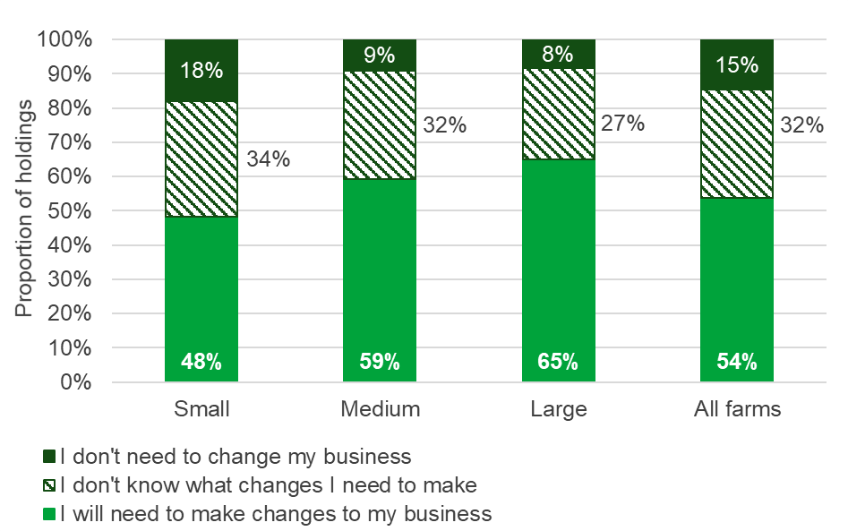

Farmers who answered that they will need to make changes to their farm business in the next 3-5 years were then asked what changes they will need to make (see Figure 4). Farms were most likely to stay farming but diversify their business into non-farming areas with farmers on 43% of holdings selecting this option. Over a quarter of farmers (28%) will stay farming but increase productivity and 27% of holdings would change their core agricultural enterprises. Fewer farmers indicated that they would leave farming, as 10% are planning on retiring or passing the farm onto the next generation and 6% would leave farming for other reasons. Farmers on 5% of holdings stated other changes they were planning to make to their farm business which included stay farming but use more sustainable methods and maximise environmental schemes.

Figure 4: Changes to farm business
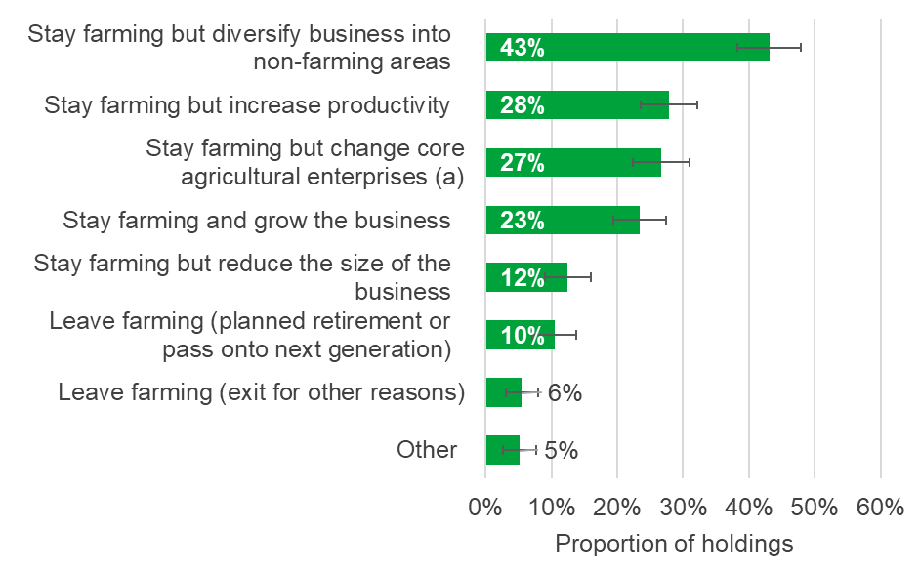
Note: Farms could select more than one option.
- for example, change crops and/or livestock

A high proportion of pig and poultry holdings intend to stay farming but increase productivity, as indicated by 46% of farmers on these holdings (see Figure 5). Farmers on lowland grazing livestock holdings and mixed holdings are less likely to make this change in the next 3-5 years (19%).
Farmers on nearly a quarter (23%) of holdings intend to stay farming and grow their business in the coming years. This varied across farm size, with 34% of larger holdings and 26% of medium holdings selecting this option compared to 17% of small holdings (see Figure 6).

Figure 5: Proportion of holdings that plan to stay farming but increase productivity, by farm type
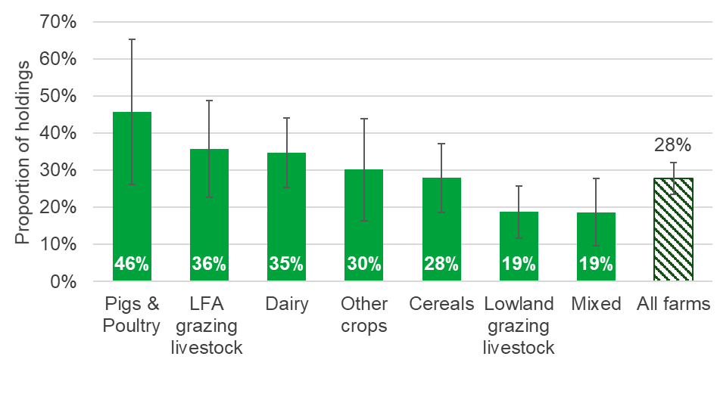
Note: Farms could select more than one option.

Figure 6: Proportion of holdings that plan to stay farming and grow the business, by farm size
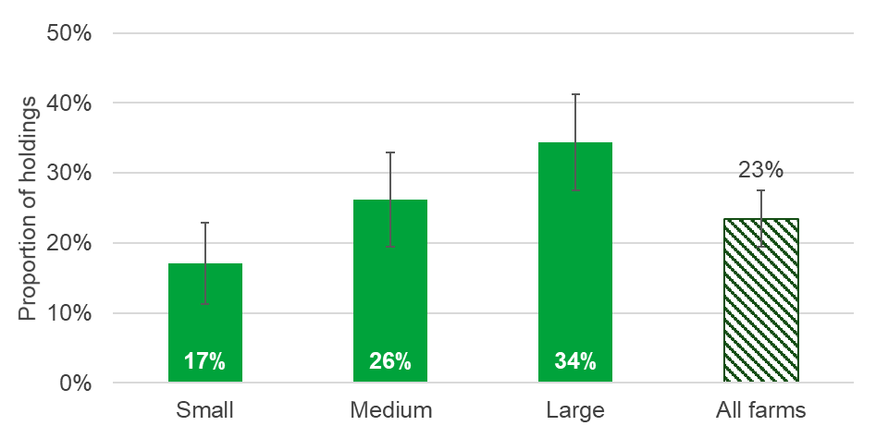
Note: Farms could select more than one option.

Farmers on 61% of holdings were either very (9%) or somewhat (52%) confident that they could respond to any changes that are needed. This proportion varied over farm types (see Figure 7), as 82% of farmers on pigs and poultry holdings were confident that they could respond to changes, compared to just over half (52%) of LFA grazing livestock holdings.
Figure 7: Proportion of holdings that are confident they can respond to changes, by farm type
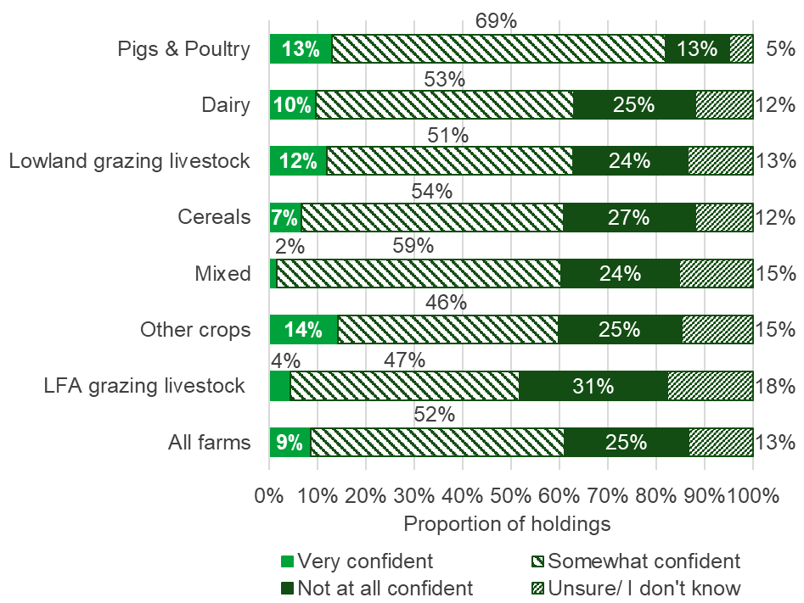

A quarter (25%) of farmers on all holdings said they were not at all confident that they could respond to changes, which increased to 34% of tenanted holdings. The remaining 13% indicated that they were unsure if they could respond to the changes that are needed on their farms.

1.3 Groups
Farming organisations and advisors have a role in helping farm business to adapt to the changes needed. Farmers on 34% of holdings agreed that these organisations are helping them to make changes (a slight increase from 29% in 2019), with a further 5% strongly agreeing. This proportion varied across English regions, with nearly half of holdings (53%) in the South East including London agreeing to some extent that farming organisations are helping them make changes to their business, compared to only 22% of farmers on North East holdings (see Figure 8). A further 10% of farmers on all holdings said they disagree that farming organisations and advisors are helping them make changes to their business, and 6% strongly disagree. Approximately 44% neither agree nor disagree that these organisations are helping them make changes.
Figure 8: Proportion of holdings that agree farming organisations and advisors are helping them make changes to their business, by English region
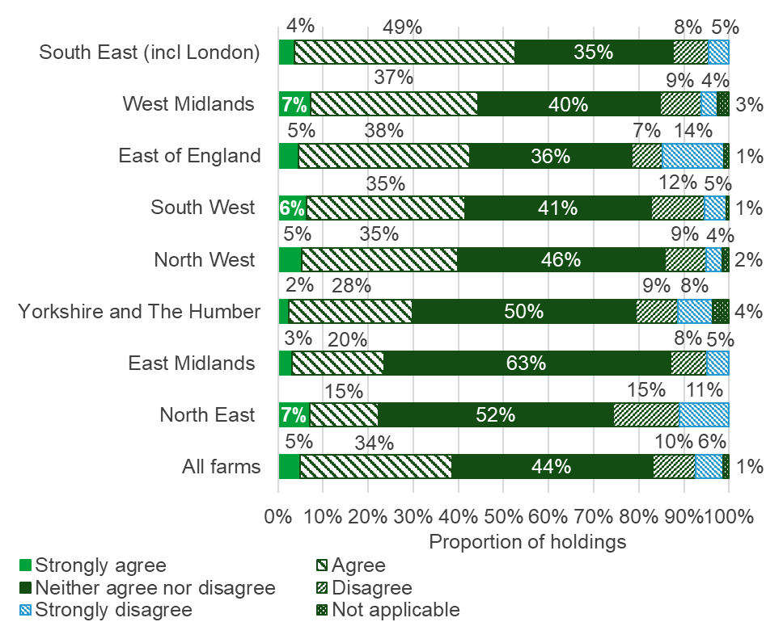

The future vision for farming involves farm businesses responding to both existing and new market demand for produce. Farmers on two thirds of holdings (66%) said that producing for the end market would currently be very important for their farm business with a further 24% indicating that it would be moderately important (see Figure 9).
Producing for the end market in the future was said to be very important by 72% of holdings and 19% indicated that it would be moderately important (see Figure 9). There was some variation across farm size as 66% of farmers on small holdings said producing for the end market would be very important to their businesses in the future, compared to 77% of medium holdings and 83% of large holdings.
Figure 9: Proportion of holdings that believe producing for the end market is important for their business
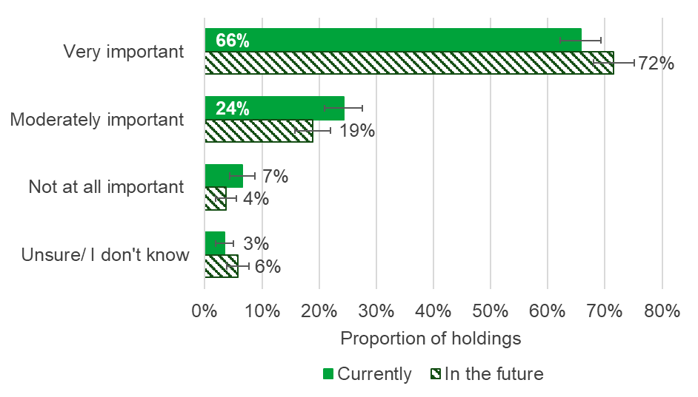

1.4 Environment
Defra's vision for farming involves providing environmental outcomes. Farmers on 81% of holdings said Defra paying for environmental outcomes was currently very (49%) or moderately (31%) important for their business (see Figure 10). Farmers on only 15% of holdings said this was not at all important. When asked how important it will be in the future for Defra to pay for environmental outcomes, farmers on 68% of holdings said it would be very important. A further 22% believed it would be moderately important and only 4% said that Defra paying for environmental outcomes in the future was not at all important (see Figure 10).
Figure 10: Proportion of holdings that believe Defra paying for environmental outcomes would be important for their business
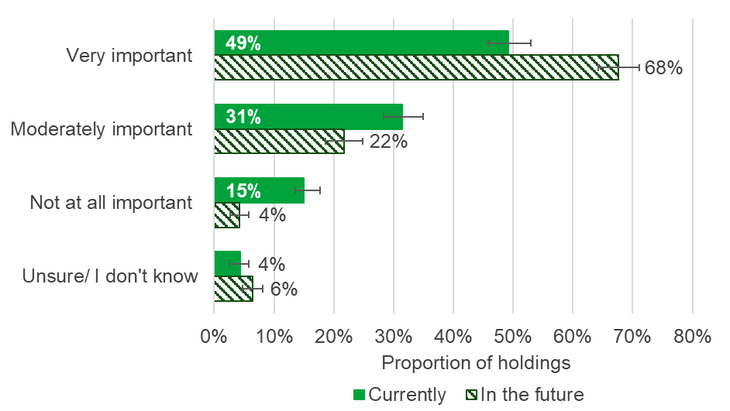
Environmental safeguards and standards in farming are maintained by both enforcing regulations and empowering individual responsibility. Approximately 43% of farmers on holdings agree (39%) or strongly agree (4%) that the current approach balances enforcement with individual responsibility (see Figure 11). This proportion varied across English regions, with 51% of holdings in the West Midlands agreeing to some extent with the statement, compared to 35% of holdings in the East Midlands. A further 35% of farmers on all holdings neither agree nor disagree that the current approach balances enforcement with individual responsibility.

Figure 11: Proportion of holdings that agree the current approach balances enforcement with individual responsibility
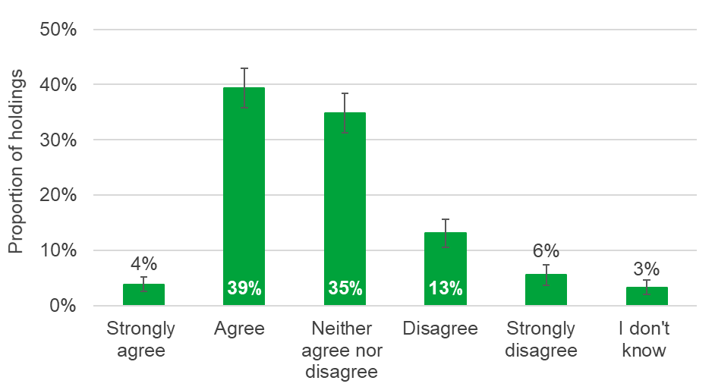

1.5 Relationships
Farmers were asked how they would best describe their current relationship with Defra, including Defra agencies such as the Rural Payments Agency (RPA), the Animal and Plant Health Agency (APHA), Natural England and the Environment Agency. Farmers on 39% of holdings described their relationship with Defra as an inspection and enforcement relationship, where Defra inspect and regulate their business (see Figure 12). This proportion varied across English regions, increasing to 49% of holdings in the East Midlands compared to 30% of holdings in the West Midlands. Just under a quarter (23%) of farmers on all holdings said they had a customer relationship, where Defra deliver services like payments and a further 16% indicated that they had a partnership relationship with Defra (see Figure 12). Only 9% of farmers on all holdings felt they had no relationship with Defra and other Defra agencies.
Figure 12: Farmer’s current relationship with Defra and Defra agencies
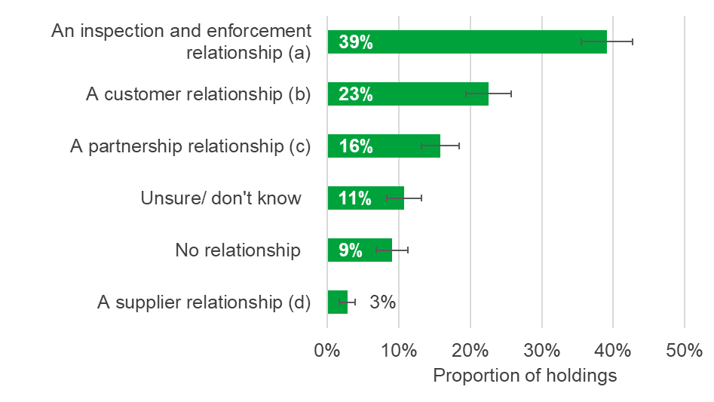
- where Defra inspect and regulate my business
- where Defra deliver services like payments to my business
- where Defra work with my business
- where Defra buy services (such as environmental goods) from my business

Farmers on 40% of holdings are either very (3%) or somewhat confident (37%) that their relationship with Defra and other Defra agencies will develop positively in the future (see Figure 13). A further 44% of farmers on holdings are not at all confident that their relationship with Defra will improve, which increased to just over half (52%) of farmers on cereal holdings compared 35% of lowland livestock grazing holdings. The remaining farmers on 16% of all holdings don’t know if their future relationship with Defra will be positive.
Figure 13: Proportion of holdings that believe their relationship with Defra and Defra agencies will develop positively in the future
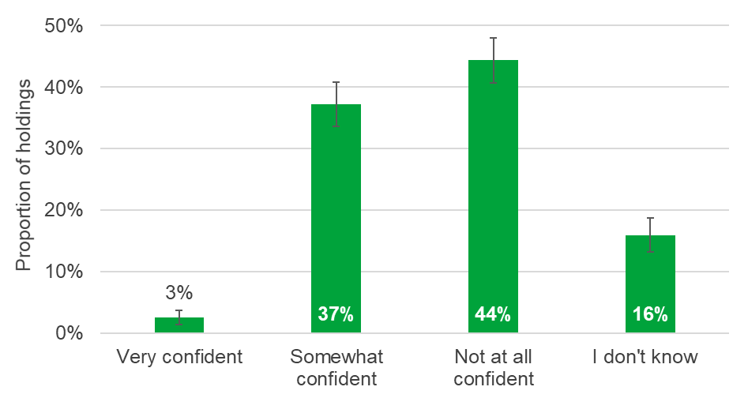
When asked how they feel about the future of farming, just over half (51%) of farmers on all holdings feel positive (8% very positive; 43% somewhat positive). This proportion varied across farm type, with approximately 32% of farmers on other crop holdings feeling positive about the future of farming compared to 64% of pigs and poultry holdings (see Figure 14). Farmers on 41% of all holdings are not at all positive and the remaining 9% said they don’t know how they feel about the future of farming.
Figure 14: Proportion of holdings that feel positive about the future of farming, by farm type
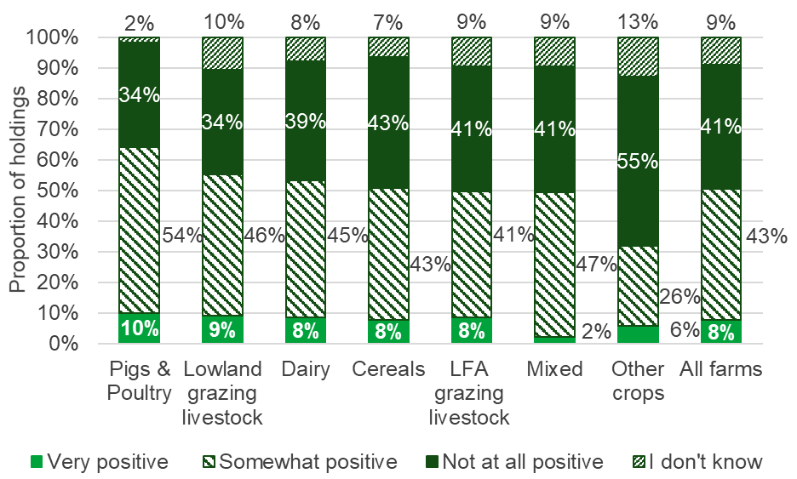

Section 2 – Open Text Comments
We offered farmers the opportunity to express opinions and their thoughts on farming i.e. what was on their mind at the time of filling in the survey. Below is a summary of their comments.

2.1 Markets and Future Trade

EU Exit, Trade Deal and Food Standards
Many respondents discussed future trade deals and what this means for food standards and prices. There was significant concern that lowering the standards of imports would have negative impacts for British farming and wider society. For example, making it harder for farmers to compete with international markets on price and quality, and exporting poor welfare and environmental damage. There were requests for a “level playing field”. Many comments were critical of the government’s approach to negotiating trade deals. Some respondents were concerned about the future of UK food production after EU Exit and wanted more support for domestic food production.

Supply Chains and Food Prices
Many comments revealed the opinion that market prices are too low. Farmers do not always receive a fair price for their products and prices don’t tend to reflect the hard work put into production. Concerns were identified regarding current supply chains which give farmers little control over prices and supply of products, with supermarkets having the power to drive prices down. Farmers are “price takers and not price makers”. This has caused fear of survival for many small farms who are unable to compete with larger organisations and international markets. Some farmers are unable to sell directly to customers as they do not have the resources or ability to compete with supermarket prices.

2.2 Environmental Management

Agri-Environmental Schemes (AES) – current experiences and thoughts about Environmental Land Management (E.L.M)
Detailed feedback was provided about experiences of existing AES, thoughts about the planned reduction in BPS payments and the introduction of E.L.M. There were mixed views with some respondents saying that they didn’t want to rely on subsidies, whereas many others would not make a profit or survive without BPS. There was consensus that Defra had not provided enough clarity and information about E.L.M and what they will be required to do and how much they will be paid. This was a particular issue for the long term planning required in farming and was making some farmers “fear for the future”. Some practical recommendations for how E.L.M should be delivered were provided, especially the need for simplicity, ease of access and certain payment levels which would all influence the level of uptake of new schemes.

Farming Objectives (Food Production and Environmental Outcomes)
There were strong views about the balance between food production and environmental work, and support for British farming. Some farmers wanted more focus and support for food growing, whereas others valued both food production and environmental work. Defra’s role in this debate was highlighted, especially the influence of conservation organisations on agricultural policy making and a perception that Defra is undervaluing food production. However, there was some positivity about collaboration, integrating different approaches and views, and the role of Government in leading this. There was widespread concern about the barriers to undertaking environmental work, whether these were financial and legal, or from the lack of policy clarity and issues from public access.

Environment
There were many comments which demonstrated farmers’ passion and care for the environment, including their role as custodians of the landscape. A few specific environmental issues were described such as public access creating problems around fly tipping, trespassing and theft. However, other farmers were enthusiastic about public access and the benefits of visiting. Pest and disease control were mentioned in a few cases, in particular the withdrawal of certain chemicals and the impacts on yields. There was also feedback about the positive role which farming can have in tackling climate change (including interest in carbon capture), as well as the weather, renewable energy, the importance of soil, conflicts with productivity, and planting the wrong type of trees. The need for support and financial incentives to protect the environment was demonstrated.

2.3 Relationships and Communications

Defra’s words and actions, including relationships with the farming community
Rich insights were revealed about Defra as an organisation; how we work, the decisions taken, our relationships with farmers, and how we communicate. There was some criticism about slow decision making and dissatisfaction about service delivery. In some cases, there was lack of confidence in Defra to implement the agricultural policy changes and doubt for the future of farming. This was partly linked to a belief that Defra is lacking the understanding about the practicalities of farming life and in turn was “out of touch” and not “farmer-friendly”. The vote in Parliament about food standards in the Agriculture Bill had really damaged the relationship between Defra and farmers, impacting trust and respect. There were references to the need for partnership working which supports farmers and takes a “human approach” to interactions. This was highlighted as important for the adoption of new schemes. Communication from Defra needs to be simple and meaningful for making decisions. The role of advisors and agents was also discussed.

2.4 Regulation and Enforcement

The RPA and experiences of inspections
There was specific feedback about regulation and enforcement and the role of the RPA. This included a damaged relationship due to failure to make payments on time and difficulty speaking to caseworkers. The burden of red tape and paperwork was highlighted, as well as different inspection experiences. There were suggestions for improvements and fairness, such as taking more of a “carrot” approach to regulation. There was a desire for smarter mapping and proportionate penalties. Some comments demonstrated the benefit of, and need for, a strong working relationship between the RPA and farmers moving forwards.

2.5 The Reality of Agricultural Policy ‘On The Ground’

Decision Making and Business Viability
The previous themes about the lack of certainty about future trade deals and payments for environmental work were impacting farmers’ ability to plan and make decisions. This included uncertainty about making investments in machinery or changing business activities. Some farmers were grappling with the possibility of exiting farming as they couldn’t see a viable future. Others were having to change succession plans as children were seeing the risk and difficulties associated with the business. Decision making was highlighted as specifically difficult for tenant farmers because paying rent is often linked to BPS payments which will be reducing.

Wellbeing
Many comments described a lack of hope and feeling nervous, doubtful and angry about the future. This was in relation to many different factors which create a cumulative impact, such as lack of policy clarity, uncertain trade deals, the reduction in BPS, late payments, future regulations, covid-19 and climate change. It is a complex situation which impacts farmers’ ability to make decisions and plan for the future. Working long hard hours, low supermarket prices, struggling to pay for extra labour and relationship breakdowns also contributed to the difficulty some farmers were going through. There was a clear role for both financial and social support to help farmers through these challenging times.

Specific Challenges for Different Farm Types
Small farms, family farms and tenanted farms were perceived to be most at risk from future changes, with assumptions that new schemes will not benefit them. Many small farms were worried about survival, fearing being pushed out of the industry by larger organisations who are more resilient, better able to adapt to the changes, and can be more competitive on price. Diversification as a method of building resilience was discussed, with positive and negative reactions. Some farmers were reliant on diversification to survive, whereas other, usually smaller, farms might not have the resources, flexibility or ability to diversify sufficiently. In certain areas diversification may not be possible, for example in greenbelt areas. Hill farmers were heavily reliant on BPS payments and were concerned about being disadvantaged by new schemes as they may not be able to improve environmental work further. The aging population in farming and the need to support new entrants and young farmers was also demonstrated in the comments.

2.6 Miscellaneous Themes

Survey Comments
There was some criticism and practical feedback about the content and aims of the survey. Issues included not being able to accurately answer questions due to lack of information about future schemes and deals, and some questions were not clear or related to a specific farm type. There was scepticism about a survey providing a full understanding of actual opinions and pre-empting answers in a tick box format. It would have been beneficial for the question about relationships with Defra to have been split into different agencies as relationships vary between them (e.g. APHA, RPA). Some comments around technical issues were also identified.

Section 3 – About these statistics

3.1 Methodology
The 2020 Farmer Opinion Tracker provides a snapshot of views and opinions towards Defra’s vision for farming as at October 2020. Farmers were asked questions about Defra’s vision for farming, business planning, relationships with farming organisations and Defra and the future of farming.
The results provided in this report are based on surveys sent to a representative sub-sample of the farming community in England, approximately 6,000 holdings. The survey was voluntary and 1,223 responses were received (including some partial responses), resulting in a response rate of 20%.
To be included in the main sample, holdings had to have at least 50 cattle, 100 sheep, 100 pigs, 1,000 poultry or 20 hectares of arable crops or orchards. Therefore, all results given in this statistical report reflect just over 60 thousand holdings that exceed these thresholds out of the total English population of almost 107 thousand commercial holdings.

3.2 Data analysis
Results have been analysed using a standard methodology for stratified random surveys to produce national estimates. With this method, all of the data are weighted according to the inverse sampling fraction.

3.3 Accuracy and reliability of the results
We show 95% confidence intervals against the results. These show the range of values that may apply to the figures. They mean that we are 95% confident that this range contains the true value. They are calculated as the standard errors (se) multiplied by 1.96 to give the 95% confidence interval (95% CI). The standard errors only give an indication of the sampling error. They do not reflect any other sources of survey errors, such as non-response bias.

3.4 Uses and Users
The survey was set up to collect farmer opinion on the future for farming in England prior to, and during, the Agricultural Transition. The aim is to be open and transparent about what we are hearing from the farming community and then acknowledge and respond to areas where we need to improve. The data collected via this survey will be used to create a baseline dataset of farmer opinion which can then be monitored over time to see how it is changing as we move through the agricultural transition period.

3.5 Definitions

Region
This refers to the NUTS1 regions in England, for the purposes of this analysis we have combined the South East with London.

Farm type
This refers to the ‘robust type’, which is a standardised farm classification system. Farms are split into Dairy, Grazing Livestock Less Favoured Areas (LFA), Grazing Livestock Lowland, Mixed, Other crops, Cereals and Pigs & Poultry (Specialist Pigs and Specialist Poultry combined).

Farm sizes
This is based on the estimated labour requirements for the holding, rather than its land area. The farm size bands used within the detailed results tables which accompany this publication are shown in the table below. Standard Labour Requirement (SLR) is defined as the theoretical number of workers required each year to run a holding, based on its cropping and livestock activities.
Farm size | Definition
Small | Less than 2 SLR
Medium | 2 to less than 3 SLR
Large | 3 or more SLR

Farm ownership
This is based on data from the June Survey of Agriculture and Horticulture. The types are split into:
- Owned - all area on the holding is owned
- Tenanted - All area on the holding is rented under a Full Agricultural Tenancy, Full Business Tenancy, Other agreement or is seasonally rented in (364 days or less)
- Mixed - area on the holding is a mixture of owned and tenanted

