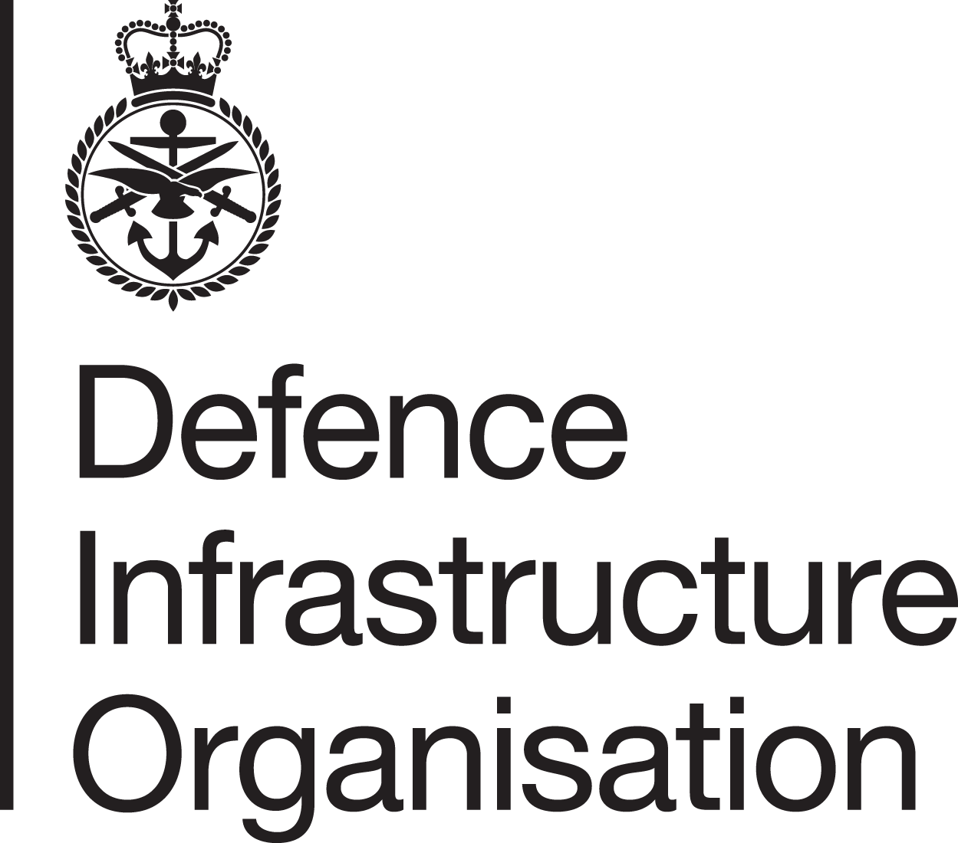


COVID-19 Guidance Notes for Substitute Service Family Accommodation
July 2021

Moves

The rental market has suffered the impact of Covid-19 among its workforce and reduced stock due to people opting to delay moves. This is continuing to make it more challenging to source properties. However, Mears and DIO will continue to do everything we can to provide a property by the required by date.

Move In Appointments

To continue to keep Service personnel and their families safe we will continue to exercise Covid-19 safety measures such as social distancing. Wherever possible our operatives will arrange for a check in inventory to be conducted without a service user in the same room at any time. They will also arrange a handover of keys without human contact. Our operatives will contact you to discuss specific arrangements, which will vary according to the property. All operatives have been issued with strict guidance to protect service users and operatives themselves - please see below.

In normal circumstances we ask occupants to sign documents at the end of the inventory appointment. To allow social distancing to continue we will now send you these documents prior to the appointment. Mears will send you a copy of the inventory along with your 14-day observation form, allowing you to record any issues that have not been covered. In the first instance please report repairs issues to us by calling us on 0800 032 4547 or by emailing repair.enquiry@mearsgroup.co.uk so we can resolve issues as soon as possible. The 14-day observation form is used in conjunction with the inventory at the end of occupation to assess any dilapidations.

Maintenance and repairs
Please continue to report any repair or maintenance issues in your Substitute Accommodation by emailing Mears at repair.enquiry@mearsgroup.co.uk or by calling on 0800 032 4547.

Returning to a property after a period away

In line with your Licence To Occupy, you should have informed Mears if you were going to be away from the property for more than 14 days. Where a property is going to be empty for more than 2 weeks Mears must either conduct Vacant Property Checks or inform the landlord of the absence as such an absence could invalidate the Landlord’s Insurance. In order to conduct checks on the property, keys will need to be made available to Mears or their representatives.

If your property has been vacant for an extended period of time, there is a risk of legionella build up in the water system. Please give us as much notice as possible that you are due to return to the property by emailing us at resident.enquiry@mearsgroup.co.uk. Mears will check with the landlord if there are any water tanks or other circumstances at the property that would require a legionella assessment to be conducted prior to your return. We will notify you when we have ascertained that it is safe for you to return to the property.
When you return to the property please ensure that you run all taps and showers for 5 minutes to flush out standing water. This will avoid the risk of legionella. Water from showers will form fine spray, which is a high risk if contaminated with legionella, so please flush your shower as close to the shower floor as possible, ventilate the room and try not to breath in any spray.
Once we have determined it is safe for you to return to your property, we will cancel any pre-booked vacant property checks. In some cases, to reduce the risk of flooding, Mears operatives may have turned off the water supply to your property. If they have done so, you should have received a vacant property check report with a photograph of the position of the stopcock. Please contact us if you have any trouble turning this back on.

Vacant Property Checks
Mears has an obligation to visit vacant properties to ensure they remain safe and secure. These are called Vacant Property Checks (VPC) and consist of a visual inspection to identify any hazards or issues that may invalidate a Landlord’s Home Insurance Policy. Depending on the circumstances we may turn off water at the stopcock to minimise the risk of leaks or flooding in your absence. Mears will compile a report, details of which include whether the heating is on/working during winter months, any alarm set and operational etc. A copy of the first VPC report will be sent to the occupant, and Mears will inform occupants of the frequency of ongoing visits. The details of the report would be shared with a third party in the event of any claim against Mears for breach of tenancy. VPC do not include checks of occupants’ personal belongings, which remain the responsibility of the occupant.

To gain access to conduct VPCs, in the first instance Mears will ask if you have left your keys with anyone and, if not, we will check whether the Letting Agent / landlord holds keys for the property. If we are able to locate the keys we will use these to gain access to the property. If we are unable to locate the keys we will inform the landlord and ask them to notify their insurance company.

Measures Mears is taking to protect service users
Even though the UK Government and devolved nations have eased Covid-19 restrictions, to continue to prevent the transmission of the virus, Mears continues to issue the following instructions:
- Operatives are to only carry out appointments if they or anyone else in their own household are not self-isolating or showing symptoms of COVID-19 with either a new, continuous cough, a high temperature in the past 10 days or a loss of taste or smell
- At the time of booking an appointment Mears will ask service users whether they or anyone in their current household is isolating. They will ask the same of current occupants for moves into sharing properties. If you have any particular concerns then please make your Mears Coordinator aware at the earliest opportunity
- Operatives are to ensure they maintain social distancing by keeping at least 2m away from any persons in the property at all times, as well as wearing a face covering.
We ask Mears Operatives, contractors and service users to reduce the risk of transmission at appointments by:
- Washing hands before entering, and where possible on arrival at the property. If handwashing facilities are not accessible, using alcohol-based hand sanitiser
- Cleaning & sanitising regularly touched objects and surfaces using your usual cleaning products (for current occupants)
- Wearing a face covering indoors
- Ensuring, as far as possible, that homes are well-ventilated
- Requesting (of current occupants) that all doors and required areas of access are open and kept clear to avoid contact with door handles and any other unnecessary items, fixtures or fittings
- Where possible, occupants should remain in a separate room from operatives
- Advising current occupants to clean down any touched surfaces post-access.
Our aim is to continue to provide you the service you require, whilst protecting you and our staff.

