Application Decision
by Richard Holland
Appointed by the Secretary of State for Environment, Food and Rural Affairs
Decision date: 14 July 2021

Application Ref: COM/3270255
Gwithian Common Towan, Hayle, Cornwall
Register Unit No: CL 109
Commons Registration Authority: Cornwall Council
- The application, dated 2 March 2021, is made under Section 38 of the Commons Act 2006 (the 2006 Act) for consent to carry out restricted works on common land.
- The application is made by South West Water.
- The works of approximately one month duration comprise i) diversion of a 96m long water main west and north west of 80 Gwithian Towans; and ii) temporary 2m high Heras fencing enclosing a works storage compound and working area of 1048 square metres for the duration of the works.

Decision
  - Consent is granted for the works in accordance with the application dated 2 March 2021 and submitted plans subject to the following conditions:
        - the works shall begin no later than 3 years from the date of this decision; and
        - all fencing shall be removed and the land shall be fully reinstated within one month from the completion of the works.
  - For the purposes of identification only, the location of the proposed works is shown in red and yellow on the attached plan.

Preliminary Matters
  - I have had regard to Defra’s Common Land Consents Policy in determining this application under section 38, which has been published for the guidance of both the Planning Inspectorate and applicants. However, every application will be considered on its merits and a determination will depart from the policy if it appears appropriate to do so. In such cases, the decision will explain why it has departed from the policy.

  - This application has been determined solely on the basis of written evidence. I have taken account of the representations made by the Open Spaces Society (OSS).

  - I am required by section 39 of the 2006 Act to have regard to the following in determining this application:-
- the interests of persons having rights in relation to, or occupying, the land (and in particular persons exercising rights of common over it);
- the interests of the neighbourhood;
- the public interest; and
- any other matter considered to be relevant.

Reasons

The interests of those occupying or having rights over the land
  - The land is owned by Ms Mary Angela Hutcheson, who was consulted about the application but did not comment. The commons register records two rights of common to graze eight and ten cattle respectively. One rights holder was consulted but did not comment. The other is deceased and the applicant was unable to contact relatives but has advised that neither right is ever exercised. There is no evidence before me to suggest that the proposals will harm the above interests.

The interests of the neighbourhood and protection of public rights of access
  - The applicant advises that a damaged water main must be diverted onto the common land as due to development works nearby there is nowhere else the main can be sited.
  - The interests of the neighbourhood test relates to whether the diversion works will unacceptably interfere with the way the common land is used by local people and is closely linked with the interests of public access. The applicant advises that the application land is close to the beach and is used by tourists.
  - The permanent works will be underground, with no new above surface features as existing valve covers will be used. The application land will be reinstated and all temporary fencing will be removed upon completion of the works, which is expected to be within approximately one month. Whilst the works will cause some short-term impediment to those using the common, I conclude that they will not have a significant or lasting impact on the interests of the neighbourhood or public rights of access.

Nature conservation and Landscape interests
  - The applicant advises that the land is near, but not within, a Site of Special Scientific Interest (SSSI), which would appear to be a reference to the Gwithian to Mexico Towans SSSI, some 200m away. NE advised that it had no comments to make on the application. The common has no specific landscape designation and the applicant confirms that it will be reinstated to its original condition, which can be required by attaching a suitable condition to the consent.
  - There is no evidence before me to suggest that the works will harm nature conservation interests or have a lasting impact on the landscape.

Archaeological remains and features of historic interest
  - There is no evidence before me that leads me to think the works will harm the above interests.

Other matters
  - Defra’s common land consents policy guidance advises that that works may be proposed which do not benefit the common but confer some wider benefit on the local community, such as minor works undertaken by a statutory undertaker where the works are of temporary duration (such as a worksite), where the works will be installed underground (such as a pipeline or pumping station) and where the proposals ensure the full restoration of the land affected and confer a public benefit. I am satisfied that the proposed works accord with this policy objective.

Conclusion
  - I conclude that the proposed works will not unacceptably harm the interests set out at paragraph 5 above and will confer a public benefit by ensuring the continued integrity of water supply to the local community. Consent is therefore granted for the works subject to the conditions set out in paragraph 1.

Richard Holland

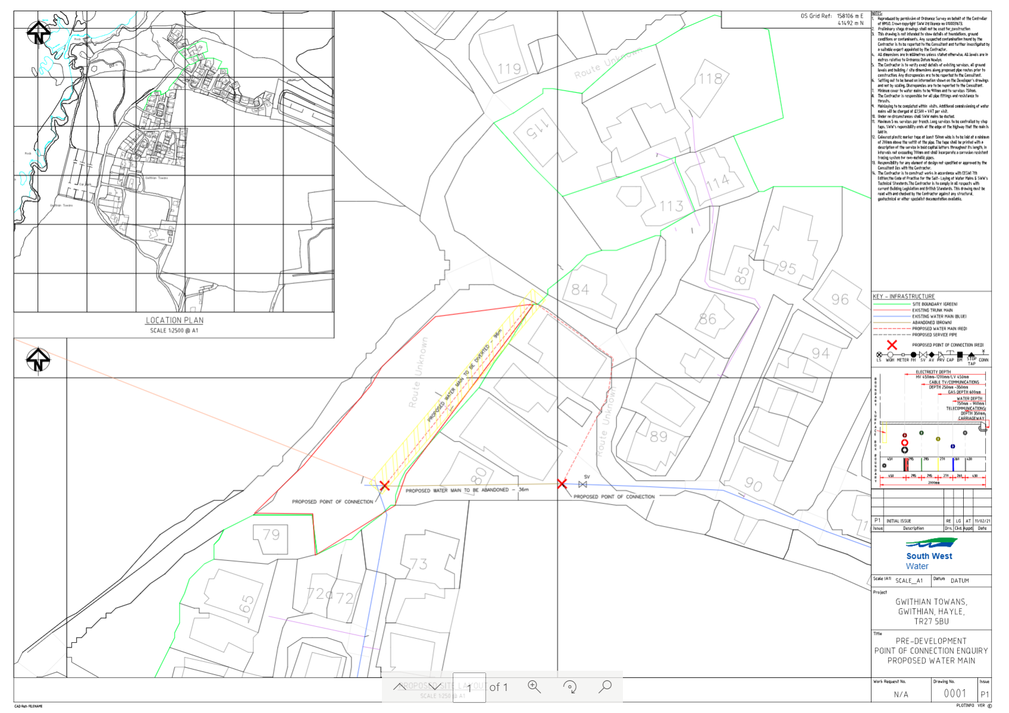

Common Land Consents Policy (Defra November 2015)
Section 39(2) of the 2006 Act provides that the public interest includes the public interest in; nature conservation; the conservation of the landscape; the protection of public rights of access to any area of land; and the protection of archaeological remains and features of historic interest.

