Logo

|  |
| --- |
| **Order Decision** |
| On papers on file |
| **by Sue M Arnott FIPROW** |
| **an Inspector appointed by the Secretary of State for Environment, Food and Rural Affairs** |
| **Decision date: 29 April 2021** |

|  |  |
| --- | --- |
| **Order Ref: ROW/3266889** | |
| * This Order is made under section 257 Of the Town and Country Planning Act 1990. It is known as the Amber Valley (Footpath No. 80 – Parish of Ripley) Public Path Diversion Order 2020. | |
| * The Order is dated 1 July 2020. It proposes to divert a section of public footpath at Bullbridge Hill, Ambergate in the Parish of Ripley, as shown on the Order map and described in the Order schedule. | |
| * There were no objections to the Order to require its submission to the Secretary of State for Environment, Food & Rural Affairs. | |
| **Summary of Decision:** | **The Order is confirmed subject to two minor modifications as set out in the Decision below.** |

**Preliminary Matters**

1. When this Order was advertised, no objections were received by the order-making authority, Amber Valley Borough Council (AVBC). However two minor errors were later discovered on the Order plan: in the title, the Order was wrongly referred to as affecting a bridleway, and the date of the Order was incorrectly stated to be 2019. As a consequence, AVBC forwarded the unopposed Order to the Secretary of State requesting that it be confirmed with modifications to correct these errors.
2. I am satisfied that the Order itself is otherwise perfectly clear in its intention and the likelihood of anyone being misled or prejudiced in any way by these simple mistakes is slight. I therefore propose to modify these details for the avoidance of doubt in future.
3. Although no objection has been made to the proposal, the relevant statutory tests must still be met if the Order is to be confirmed.

**The Main Issues**

1. Since the Order is made under section 257 of the Town and Country Planning Act 1990 (the 1990 Act), if I am to confirm it I must be satisfied that it is necessary to permanently divert the way in question (shown as B-A on the Order map) onto the alternative line (labelled B-C-D-E) to allow development to be carried out in accordance with a valid planning permission.

Reasons

1. Outline planning permission (reference AVA/2016/1030) was granted on 30 June 2017 by AVBC for mixed use development including residential and community uses, highway works and public open space on the site to the north west of Drovers Way. This was followed by the approval of reserved matters under reference AVA/2019/0252 on 26 November 2019 for phase 1 of the development comprising 21 residential dwellings, riverside open space and highway works.
2. Plans with references 2018-560-51 and 2018-560-143C identify the extent to which the definitive footpath (no 80) would be affected by the development. In essence, the diversion is required in order to conform to the highway requirements associated with the development and so that pedestrians will be safely accommodated on the proposed footway along a short section of Drovers Way which is to provide vehicular access into the new residential estate.
3. In determining an order of this kind it should not be assumed that because planning permission has been given necessitating diversion of a footpath that confirmation of the ensuing diversion order will automatically follow. Any disadvantages or loss likely to arise as a result of the diversion to members of the public, or to persons whose properties adjoin or are near to the existing highway, may be weighed against the advantages to be conferred by the diversion when determining the Order[1]. However no such issues have been raised in this case.
4. On the basis of the information provided, I am satisfied that the relevant statutory tests are met and I conclude that it would be expedient to confirm the Order with the modifications requested.

Conclusion

1. Having regard to the above and all other matters raised in the written representations, I conclude the Order should be confirmed subject to the two minor modifications referred to in paragraphs 1 and 2 above, neither of which require further advertisement.

Formal Decision

1. I confirm the Order subject to the following modifications:

* Amend the key to the Order plan by

(a) deleting the word “Bridleway” and substituting “Path”, and

(b) deleting “2019” and substituting “2020”.

Sue Arnott

**Inspector**

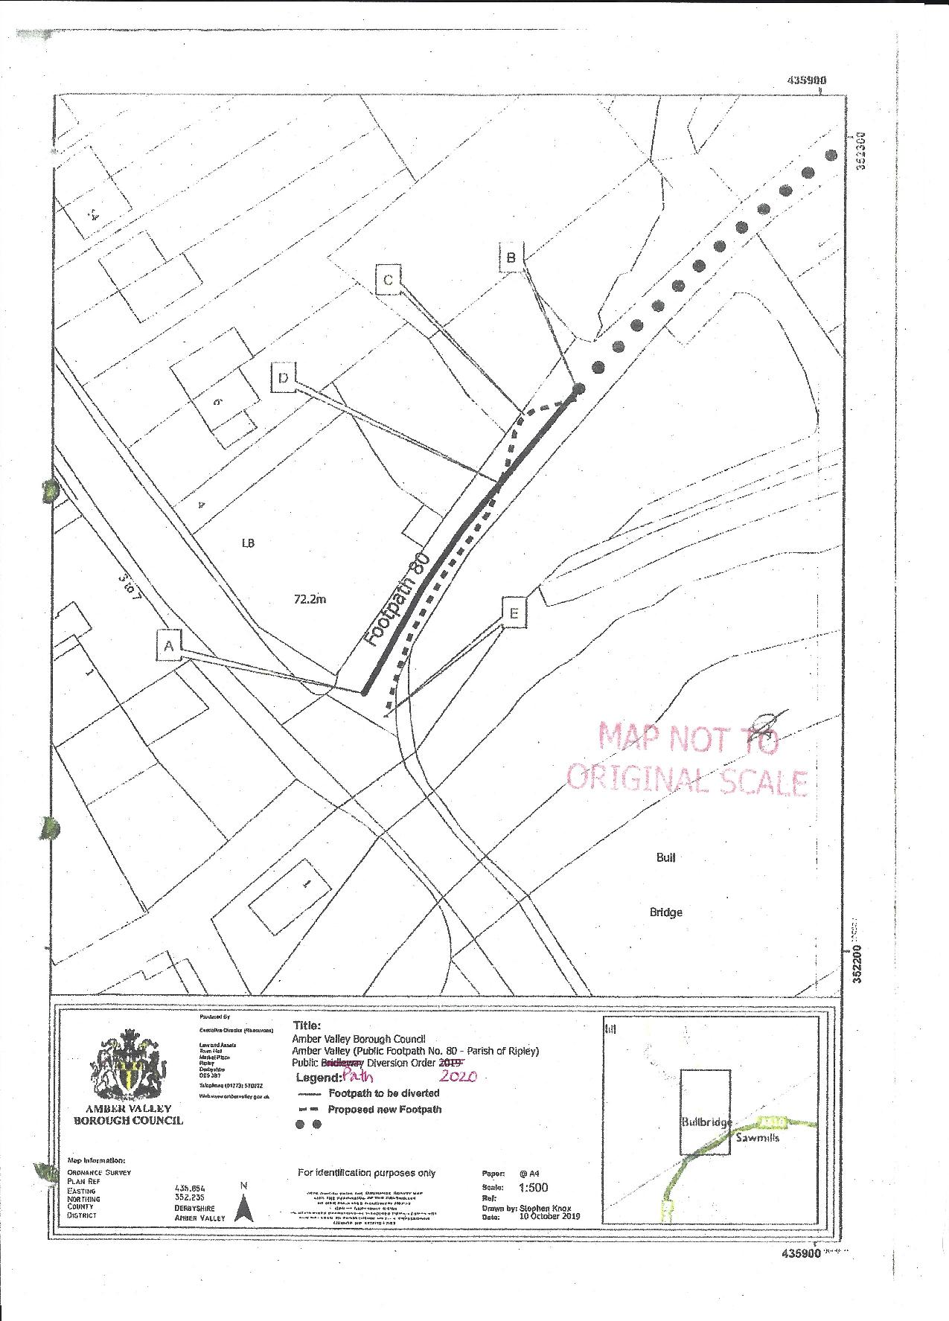

1. Government Circular 1/09 version 2 (Defra) refers