Order Decisions
Site visit made on 23 March 2021
by C Beeby BA (Hons) MIPROW
an Inspector appointed by the Secretary of State for Environment, Food and Rural Affairs
Decision date: 02 June 2021

Order A: ROW/3257874
- This Order is made under Section 257 of the Town and Country Planning Act 1990 and is known as the Brent Cross Cricklewood Regeneration Phase 1A North (Claremont Park) Stopping Up Order 2019.
- The Order is dated 28 November 2019 and proposes to extinguish the public rights of way shown on the Order plan and described in the Order Schedule.
- There were four objections outstanding when The London Borough of Barnet submitted the Order to the Secretary of State for Environment, Food and Rural Affairs for confirmation.
Summary of Decision: The Order is confirmed subject to modifications as
set out in the Decision below.

Order B: ROW/3247627
- This Order is made under Section 257 of the Town and Country Planning Act 1990 and is known as the Brent Cross Cricklewood Regeneration Phase 1A North (Plot 53 and Plot 54 Brent Terrace South) Stopping Up Order 2019.
- The Order is dated 11 September 2019 and proposes to extinguish the public rights of way shown on the Order plan and described in the Order Schedule.
- There were two objections outstanding when The London Borough of Barnet submitted the Order to the Secretary of State for Environment, Food and Rural Affairs for confirmation. One of these was subsequently withdrawn.
Summary of Decision: The Order is confirmed.

Procedural Matters
- Both Orders relate to the proposed stopping up of public footpaths in the vicinity of Claremont Open Space and Brent Terrace (south) in Barnet. One of the two footpaths to which Order B relates is physically linked to the footpaths which are the subject of Order A. Thus, taken together the Orders form a coherent package. Nevertheless, I must deal with each Order individually and on its own merits.
- The Schedule to Order A seeks at Point 2 to stop up public footpath A-O extending “to the junction with Claremont Way”. However, the termination of the path at Point O, as shown on the Order Map, does not meet Claremont Way. This corresponds with the edge of the planning application site. As a result, the planning permission to which the Order relates does not include land between Point O and Claremont Way. Accordingly, I have modified the Order Schedule by the deletion of the words “the junction with Claremont Way” from Point 2 and their replacement with an alternative description.
- Furthermore, although the presence of kissing gates is referred to in Points 1 and 2 of the Schedule to Order A, these were not present at the site. Thus, in the interests of accuracy, I have deleted the two references to kissing gates and replaced them with an alternative description.
- No-one requested an inquiry or hearing into the Orders. In arriving at my decisions I have taken into account all of the written representations.
- As I have found it convenient to refer to points along the existing and proposed routes as shown on each Order Map, I attach copies for reference purposes.

Main Issues
- Section 257(1) of the Town and Country Planning Act 1990 (the 1990 Act) provides for an Order to be made authorising the stopping up (or diversion) of a footpath if it is necessary to do so in order to enable development to be carried out in accordance with planning permission already granted under Part III of the same Act. In this case Order A seeks to stop up nine sections of public footpath crossing or adjacent to Claremont Park. Order B seeks to stop up two sections of public footpath which lie to the east of Brent Terrace.
- In considering whether or not to confirm an Order, the disadvantages or loss likely to arise as a result of the stopping up or diversion of the way to members of the public generally or to persons whose properties adjoin or are near the existing highway should be weighed against the advantages of the proposed order.
- In short there are two issues that must be considered here. These legal tests, as outlined above, have been described by the Courts as “the necessity test” and “the merits test”. Confirmation of an Order requires that both are satisfied.
- Whilst I must also have regard to any material provisions in any rights of way improvement plan for the area when determining these Orders, no issues have been raised in this respect. In addition, in reaching my conclusions I have considered the requirements of the Equality Act 2010 where appropriate.

Reasons

Order A

Background
- Planning permission (Permission 1) was granted on 18 March 2019 for the construction of highways infrastructure and associated public realm comprising road works required in association with part of the redevelopment of the Brent Cross Cricklewood regeneration area.
- Planning permission (Permission 2) was granted on 18 October 2019 for the provision of a new neighbourhood park (Claremont Park) comprising improvements and modifications to Claremont Way Open Space, changes to levels, hard and soft landscaping measures, the introduction of play equipment, park furniture, a pond, fencing, shared pedestrian and cycling routes and all associated enabling, incidental and temporary works.
- Consent for a non-material amendment of the second permission was granted on 14 July 2020. This added Condition 22 to the permission. This provides that the approved paths within the new park shall be kept open at all times for use by the public on foot, save for any temporary closures for the purpose of maintenance and/or repair.

Order A: Whether the stopping up of the paths is necessary to allow development to be carried out in accordance with planning permission
- I am satisfied that the relevant planning permissions are extant and directly relate to the land crossed by the Order routes.
- Nevertheless, Permission 1 relates to the construction of a highway over land crossed by the northern part of path section G-H. Rights of Way Circular 1/09 states that where planning permission is granted for constructing a highway and another highway crosses or enters the route of the highway, powers are available to enable the Secretary of State to stop up or divert such other highways. It further states that it is not appropriate to use section 257 of the 1990 Act to stop up ways for these purposes.
- As a result, the stopping up of the section of path G-H which is affected by Permission 1 is not necessary to allow development to be carried out in accordance with section 257 of the 1990 Act, because a separate statutory process exists which is the appropriate means by which to address the matter.
- Thus, I have modified the Order Map by the deletion of the northern section of path G-H, where it crosses the land to which Permission 1 relates.
- Permission 2 permits the remodelling of the existing park to allow for the construction of features including walls and a pond with an associated decking platform, which would obstruct the public footpaths at various points. Due to these permitted physical obstructions, the stopping up order is necessary to allow development to be carried out in accordance with the planning permission.

Order A: Disadvantages of the proposed Order
- The Ramblers’ Association objects to Order A on the partial basis that the network of paths which would cross the new park should not be taken into account in assessing the effect of the Order. The “Tyttenhanger Case” is referred to in support. This found that whilst creation agreements that are conditional and rely on the confirmation of an extinguishment order under section 118 of the Highways Act 1980 cannot be taken into account when determining section 118 orders, a sealed unconditional creation agreement already in force may be considered.
- Unlike the circumstances in Tyttenhanger, the stopping up order in this case is not linked to a creation agreement. The facts here are different because planning permission has already been granted to include provision for the new paths. Nevertheless, remarks within the Tyttenhanger judgment concerning the need to temper the weight attached to alternative access according to the likelihood of its provision have some applicability to my consideration of the Order.
- In this case, public rights of way would be stopped up and equivalent rights would not be secured. The new paths would not be available immediately, due to the need to construct the new park. A period of inconvenience to the public would arise from the necessity of using alternative and sometimes longer routes whilst works were carried out. I do not treat this inconvenience lightly, particularly with regard to those members of the public who may find a longer route significantly more onerous.
- However, this period would be temporary. The loss of public access to the land concerned would not be total as in due course it would revert to being a public park which would be owned and, ultimately, managed by the Council. It would contain a network of publicly accessible paths.
- Furthermore, Condition 22 to Permission 2 states that the new paths shall be kept open to the public at all times on foot, except where maintenance or repair is necessary. Failure to comply with the condition would form a breach of planning control enforceable by the local planning authority. Thus, a legal mechanism exists to protect access on foot to the paths at all times of day and night.
- Moreover, any future proposal for development of the land would follow a statutory procedure which requires consultation and a publicly available decision-making process in a similar manner to any proposal to stop up or divert a public right of way.
- Thus, as the new paths would not be recorded public rights of way but would be publicly accessible at all times and would have the legal protection of the planning condition and application process in the event of any proposed changes, the loss to the public would be partial, rather than total. This partial loss would be limited and must be weighed against any advantages which would be conferred by the Order.

Order A: Advantages of the proposed Order
- Two of the new paths would be shared use paths, so that access across the park by cycle would be available where it was not previously. Two matters reduce the weight which I am able to give to this new access as a consideration. These are the lack of public right of way status of the new cycle access, and the fact that the all-day access provided for by Condition 22 to Permission 2 would be for users on foot only. Uninterrupted access to the new paths by cycle is therefore less certain.
- Nevertheless, cycle access forms a benefit of the proposal which should not be discounted, due to the provision of access for an additional type of user. It would provide an off-road route for cyclists (which is intended to link to the proposed new railway station in due course), a matter which carries road safety benefits. As a result of these considerations, I give some weight to the provision of the additional access for cyclists.
- Accessibility features including suitable gradients, accessible play equipment, picnic tables and benches are proposed. The submission that the proposal would result in ecological enhancements is supported by the level of new planting which would be undertaken. Whilst full details of these matters are not before me, they are undisputed and are supported by the submitted evidence. As a result, I attach limited weight to them as a benefit.
- Whilst I acknowledge that some of the proposed facilities and equipment appear to have formerly been present in the adjoining Clarefield Park, the removal of that park had already occurred by the time of my visit and I am required to assess the effect of the permission and circumstances before me. Thus, a comparison between previous facilities and those proposed has not formed part of my assessment.
- Taken together, the benefits identified above form moderate advantages of the Order.

Order A: Whether development is substantially complete
- On the day of my site visit the area of land which is subject to Permission 2 was either part of a development site undergoing groundworks or formed the park itself, where no significant work had been undertaken. Thus, I am satisfied that development is not substantially complete.

Order A: Other Matters
- Access which is currently provided by the public footpaths between Brent Terrace and Clitterhouse Crescent, and between those two streets and the footpath off Claremont Way, would be retained on paths through the new park. Although development of the land to the new park’s north western side (i.e. the area surrounding Brent Terrace (north) is also planned, this would be independent of the stopping up orders before me. It is therefore not within the scope of this Decision to comment on the accessibility aspect of the wider regeneration proposals.
- Whilst I sympathise with other submissions, including those concerning opposition to the development, a suggested reduction in levels of open space in Brent Cross Town and the wider effect of temporary path closures, I must draw conclusions on the basis of the permission which has already been granted. Many of the issues raised will have been considered by the local planning authority when deciding whether or not to grant permission, and it is not my role to re-examine that decision. Thus, these matters have not had a bearing on my decision.
- I note concerns raised regarding the approach of the Council and of the Planning Inspectorate. Nevertheless, in making my determination I am restricted to a consideration of the stopping up orders before me. Separate procedures exist to address such concerns and hence I have not considered them further in this Decision.

Order A: Conclusion
- Whilst I find merit in the argument advanced by some of the objectors that other proposals rather than solely stopping up the public footpaths may have been preferable, provisions which allow for continuing public access to the land should not be discounted.
- I have found above that the Order would result in limited disadvantages to the public. I have identified advantages which together form moderate benefits of the Order. These advantages consequently outweigh the identified disadvantages.
- Thus, in view of the above considerations, I conclude that the Order should be confirmed subject to modifications.

Order B

Background
- Planning permission was granted on 23 July 2014 to develop land within the Brent Cross Cricklewood Regeneration Area without complying with conditions attached to a previous permission.
- Reserved Matters approval relating to various matters concerning the development of Plots 53 and 54 was granted on 9 June 2015.

Order B: Whether the stopping up of the paths is necessary to allow development to be carried out in accordance with planning permission
- I am satisfied that the relevant planning permissions are extant and directly relate to the land crossed by the Order routes.
- The public footpath at Plot 54 is a short section of route which leaves a path between Brent Terrace (south) and Clitterhouse Road to cross a grassed area before it terminates at an area of hardstanding which formerly held a small playground.
- The permitted terraced housing at Plot 54 would form a permanent physical obstruction to use of the public footpath. Thus, it is necessary for the public footpath to be removed from its present location to allow the development to be carried out.
- The public footpath at Plot 53 is a short section of surfaced path which leaves a junction with other rights of way in Claremont Open Space and a path to Clitterhouse Crescent, to cross a grassed area before it terminates at Brent Terrace.
- The permitted housing at Block A at Plot 53 would form a permanent physical obstruction of use of the public footpath. Thus, it is necessary for the public footpath to be removed from its present location to allow the development to be carried out.

Order B: Disadvantages of the proposed Order
- A significant proportion of the objection relating to this Order concerns opposition to the development and its Construction Traffic Management Plan, and to a suggested reduction in levels of open space in Brent Cross Town. These concerns relate to planning considerations and, as set out above, I must draw conclusions concerning the proposed stopping up order on the basis of the permission which has already been granted. Thus, these matters have not had a bearing on my decision.
- The public footpath on Plot 54 is a short section of route which terminates at a former playground. It does not provide a connecting route and my attention has not been drawn to any relevant submitted disadvantages concerning its proposed stopping up.
- The public footpath on Plot 53 provides a connection between Brent Terrace and other paths in the park, and to Clitterhouse Crescent. The loss of this connection during construction would be compensated for by the provision of a temporary alternative path along the boundary of Plot 53. Once construction of the Plot 53 development and the new park was complete, a similar connection would be formed by the new paths in the park.
- Thus, whilst some disadvantage may arise from the need for path users to walk to the northern end of Brent Terrace (south) before being able to access the park paths and the access to Clitterhouse Crescent, the inconvenience would be minor due to the short additional distance required.

Order B: Advantages of the proposed Order
- The Order would allow the permitted residential development at both plots to proceed. This would provide the “Whitefield Estate Replacement Units”, which would form homes for people currently living on Claremont Way who would need to move due to consented development there. Thus, the construction of the properties would contribute to the wider regeneration scheme to which the Brent Cross area is subject. As a result, I attach moderate weight to this advantage of the Order.
- Whilst I acknowledge the submission that doubts the delivery of the permission which would necessitate the new homes at Plots 53 and 54, I have minimal documentary or other evidence to support this concern. Thus, I attach only minimal weight to this submission.

Order B: Whether development is substantially complete
- On the day of my site visit no significant work had been undertaken at the two plots. Thus, I am satisfied that development is not substantially complete.

Order B: Conclusion
- The consented new access through the park allows for the retention of a connection between Brent Terrace and other paths in the park, and to Clitterhouse Crescent. The minor disadvantage that the short additional walk to access these connections would cause through inconvenience to the public would be outweighed by the moderate weight attached to the advantage I have identified above.
- Thus, I conclude that the Order should be confirmed.

Formal Decisions

Order A
- I confirm the Order subject to the following modifications:

Modifications to Order Schedule:
- By the deletion from Point 2 of the words “the junction with Claremont Way” and their replacement with the words “a point approximately 29 metres south of Claremont Way”,
- By the deletion of the words “kissing gates on” from Points 1 and 2 and their replacement with the words “junction with”,
- By typographical corrections to Points 6, 7 and 8, and
- Within Point 9, by the amendment of “54 metres” to “35 metres”, the transposition of “H” and “G”, and the deletion of the words “Claremont Way continuing south into Claremont Park” and their replacement with the words “the junction with path A-F continuing north to a point approximately 20 metres south west of Claremont Way”.

Modifications to Order Map:
- By the deletion of the northern section of path G-H (where it crosses the land to which Permission 1 relates) and a corresponding amendment to the location of Point H,
- By amendments to the descriptions/length of paths A-F, G-H and A-O within the tabular inset to reflect the above amendments to Points 1, 2 and 9 of the Order Schedule and to amend the grid references for route G-H.

Order B
- I confirm the Order.

C Beeby

INSPECTOR

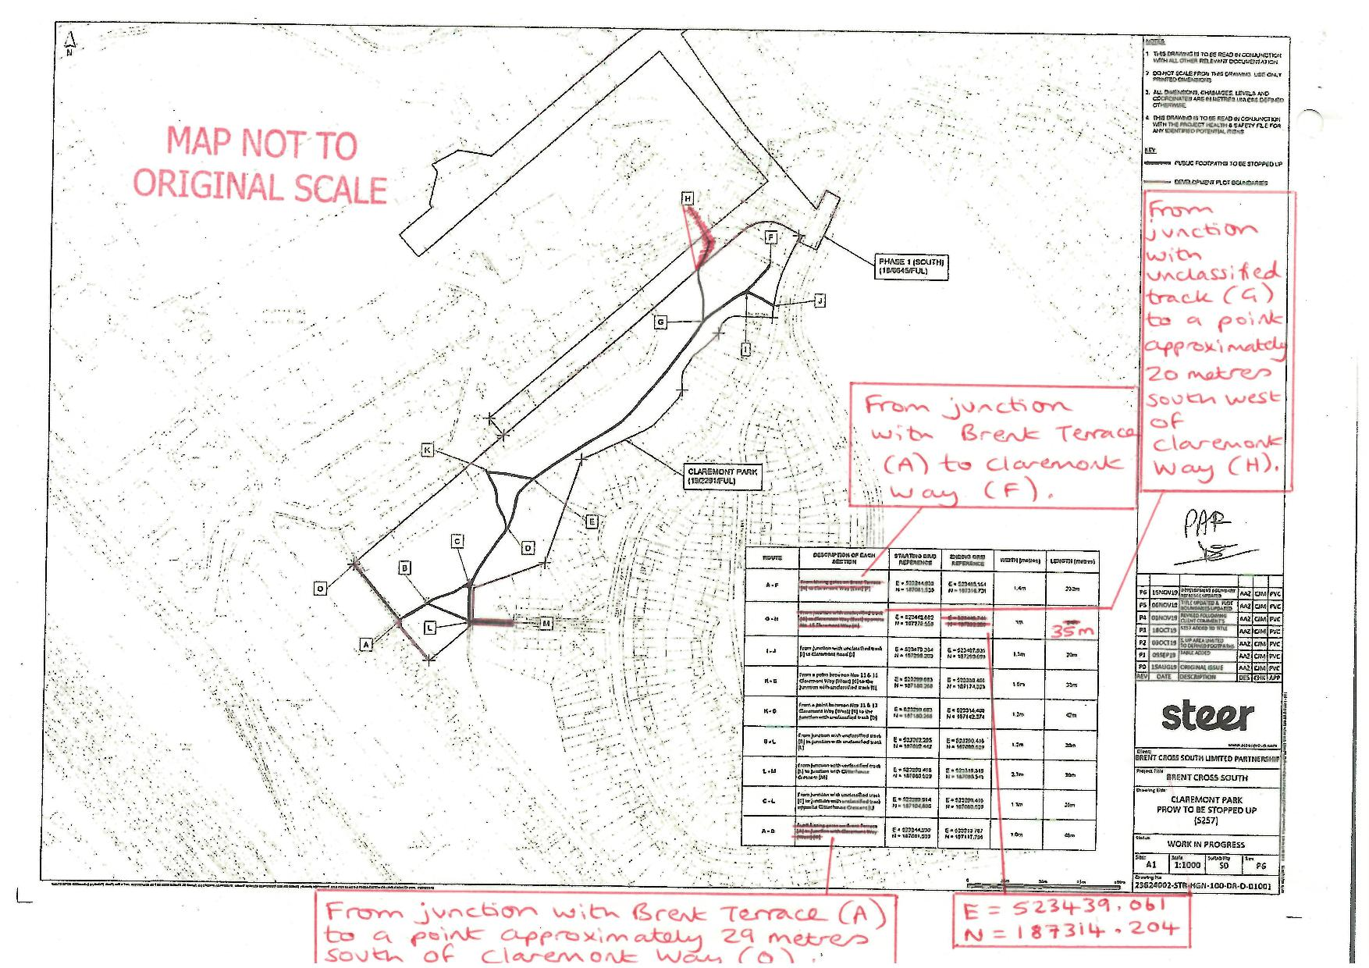

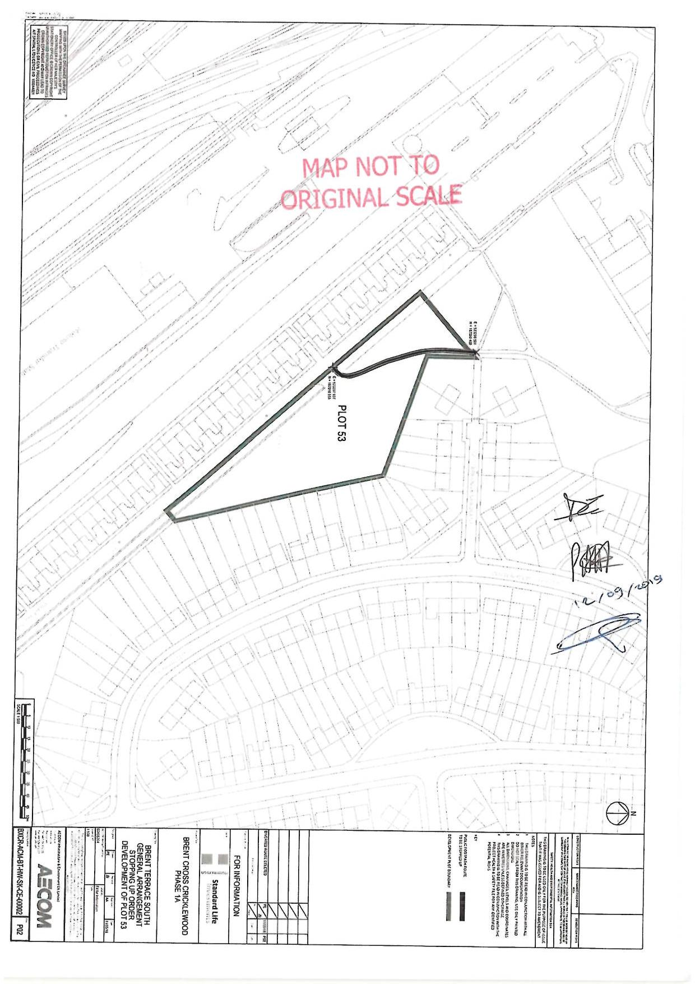

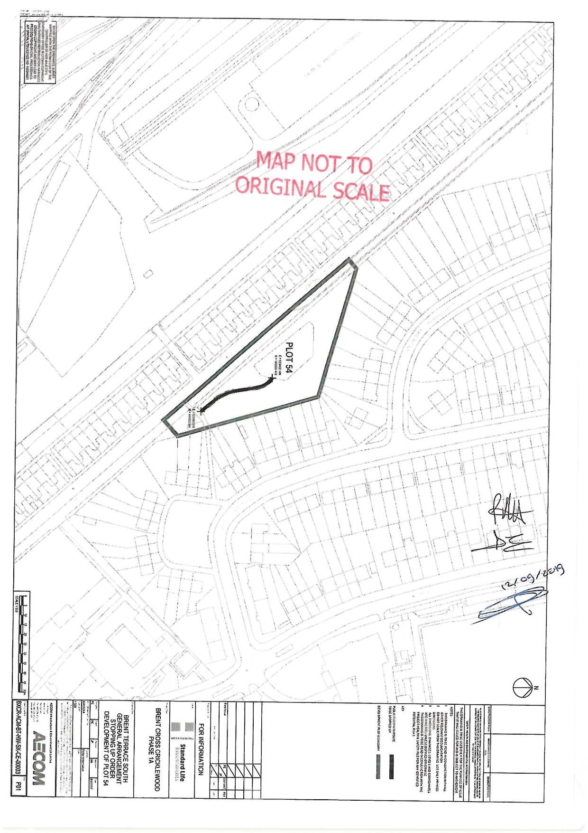

Local Planning Authority Reference: 18/6645/FUL
19/2291/FUL
20/2817/NMA
DEFRA, 2009
Hertfordshire County Council v SSEFRA (QBD) [2005] EWHC 2363 (Admin), (CA)[2006] EWCA Civ 1718
Local Planning Authority Reference: F/04687/13
C/17559/08
15/00720/RMA

