Order Decision
On the papers on file
by Susan Doran BA Hons MIPROW
an Inspector appointed by the Secretary of State for Environment, Food and Rural Affairs
Decision date: 24 May 2021

Order Ref: ROW/3245678
- This Order is made under Section 53(2)(b) of the Wildlife and Countryside Act 1981 and is known as The Northumberland County Council Definitive Map Modification Order (No. 16) 2018.
- The Order is dated 17 December 2018 and proposes to modify the Definitive Map and Statement for the area by upgrading lengths of footpath to bridleway, adding lengths of bridleway, and deleting lengths of footpath as shown in the Order plan and described in the Order Schedule.
- There were 2 objections outstanding when Northumberland County Council submitted the Order to the Secretary of State for Environment, Food and Rural Affairs for confirmation.
Summary of Decision: The Order is not confirmed

Procedural Matters
- This case was due to be determined following an unaccompanied site visit. However, in light of the Covid-19 pandemic, guidance in place at the time, and having regard to the circumstances of this case, no visit to the site was made. I therefore afforded the parties an opportunity to make further submissions on points of clarification in addition to those already provided during the written representations procedure. Submissions were received from the local British Horse Society (‘BHS’) representative (on behalf of the Applicant), and on behalf of the Objector. I take into account all the evidence, submissions and comments before me and am satisfied that I can reach my decision on the basis of the papers provided.

Background
- The case concerns the upgrading of parts of two existing footpaths (Lowick Footpath No. 29 and Kyloe Footpath No. 22) to bridleway, and the addition of lengths of bridleway, to provide a continuous route between the junction of the C18 road with the U1046 road west of Catton Ridge (point P on the Order plan), and the U34 road (point T) north-east of Blawearie (point R), passing through Kyloe Wood, comprising Lowick Bridleway No. 53 and Kyloe Bridleway No. 34. In addition, to delete Lowick Footpath No. 29 between points U and V, and Kyloe Footpath No. 22 between points R and S, as a consequence of these sections being upgraded to bridleway.
- The original application concerned the recording of a restricted byway over the Order route. However, on consideration of the evidence, Northumberland County Council (‘the Council’) concluded an Order should be made to record a public bridleway, following which two objections were received. One concerns the section R-S-T on the Order plan (recorded in part as Kyloe Footpath No. 22); and the other, the Order route as it passes through Kyloe Wood.

The Main Issues
- The criteria for confirmation of the Order are contained in the Wildlife and Countryside Act 1981 (‘the 1981 Act’), in this case subsections 53(3)(c)(i), 53(3)(c)(ii) and 53(3)(c)(iii). These require me to consider whether the evidence discovered shows that a bridleway should be recorded in the Definitive Map and Statement (‘DMS’) between points P-U-V-Q-R-S-T. For this to be the case, the evidence must show that those sections of the Order route not currently recorded in the DMS subsist and should be recorded with bridleway status, and those sections that are currently recorded as footpaths ought to be upgraded to bridleway status, and as a consequence those sections recorded as footpath be deleted from the DMS.
- As regards the documentary evidence adduced, section 32 of the Highways Act 1980 (‘the 1980 Act’) requires that I take into consideration any map, plan or history of the locality, or other relevant document provided, giving it such weight as is appropriate, before determining whether or not a way has been dedicated as a highway. Therefore, I must consider whether or not the documentary evidence available to me, when considered as a whole, shows that bridleway rights have existed historically over the Order route.
- My decision is reached on the balance of probability.

Reasons

County Maps
- It is suggested that the Order route forms a connection between the hamlets of Fenwick in the north and Holburn in the south (a distance of some 2 miles) that was available for use by the public in the 18th and 19th centuries, as shown on County maps. The earliest source, Armstrong’s Map of 1769, does not, in my view, depict the Order route, but it is shown (by a double pecked line suggesting it was not enclosed or fenced) on Fryer’s Map of 1820, with the exception of points S to T. Although no keys are provided for any of the County maps described, I understand of the categories of road shown here ‘Turnpike’ and ‘Other’, the Order route appears as ‘Other’.
- Similarly, Rule’s 1824 Map of Norham and Islandshire depicts it as enclosed, partly fenced or open between points T and roughly U, where the map’s extent appears to end. Cary’s Map, of 1827 (and/or 1820-32), shows the Order route from points S to P by a double pecked line identified as ‘Parochial Roads’ rather than ‘Parochial Carriage Roads’. Greenwood’s 1828 Map shows it partly enclosed and partly unenclosed from point T to around V before continuing south. It appears as a ‘Cross Road’, the other category of way being ‘Turnpike Roads’.
- Those purchasing the maps may have had an expectation the routes they showed were available for public use. However, the various terms used to describe them are not defined. A ‘parochial road’ may suggest one used on foot and horseback and not with carriages, but neither this nor a ‘cross-road’, or ‘other road’, automatically indicates public rights. Indeed, the maps may show both public and private ways. Both Fryer’s and Cary’s maps show almost all of the Order route, whilst Rule’s map does not cover the area beyond point U. Greenwood’s map, however, is inconsistent, depicting a route through Kyloe Wood continuing in a southerly direction rather than turning west.

Turnpike records
- An 1834 plan of roads intended to be included in the Ford & Lowick Turnpike shows the northern end of the Order route annotated ‘From Holburn’ as a spur leading to the turnpike. An annotation from a destination is suggestive of a highway of some description.
- Holburn lies to the south west of the Order route and Greenwood (1828) shows a route connecting to it which includes part of the Order route, but only as far as point V. Rule (1824) shows another route heading towards Holburn (although the coverage of the map does not extend that far), the current Kyloe Footpath No. 22 which also forms the northern end of the Order route. In other words, there are two possible routes that connected to the turnpike road – the Order route and Kyloe Footpath No. 22, both of which by reference to the County Maps could arguably be considered as routes from Holburn.

Tithe records
- Although the Council considers the entire length of the Order route appears on the Tithe Maps for Kyloe and Holburn, other evidence adduced indicates the middle section between points V and Q is absent. The Kyloe Tithe Award (1848) shows the Order route between points R and Q, and is annotated ‘From Kyloe’ at point R. The Holburn Tithe Award (1847) shows the Order route between points P and V, and is annotated ‘To Fenwick’ at point V. East and West Kyloe lie north of the Order route, and Fenwick to the north-north-east.
- It was not the purpose of tithe records to record public rights of way, but rather to identify titheable land that was capable of producing a crop. Nevertheless, as above, annotations to or from a destination suggest a highway of some description. A cumulative figure is recorded in the records for ‘Roads and Waste’, but it is not possible to attribute it to specific routes.

Ordnance Survey (‘OS’) records
- A series of OS maps available to me, dating between c1860 and the 1950s, show all or most of the Order route as a track represented for the most part by double pecked lines. The 1st Edition 25-inch map shows the section between S and a point south of R enclosed and numbered 91. The accompanying OS Book of Reference describes Plot 91 as ‘Public Road’. However, there is no consistent reference to a ‘road’ for the remaining plots through which the Order route passes, and where it does occur it is not further described. An OS Boundary Remarks Book is difficult to interpret and it is unclear how it relates to the Order route or with what significance, if any.
- It is suggested that some of the mapping shows a gap in the Order route south of Bogle Houses (point Q). Again, a small gap is apparent, this time at point V, in editions dated 1947 and c.1950. I do not consider this significant but rather indicative of what the surveyor saw on the ground, and/or a result of the scale of the mapping. In any event, a continuous feature had been mapped at these locations in many other examples of the OS mapping.
- Again, whilst no keys have been provided, I understand the 1897 1-inch map identifies the route as an ‘umetalled road’, and the 1903 1-inch map as an ‘unfenced and unmetalled road’. Some of the map extracts annotate routes as footpaths, ‘FP’, or as bridleways, ‘BR’. The east-west route now recorded as Lowick Footpath No. 29 (points U-V of the Order route) is marked with the letters FP, but there are no annotations on the remainder of the Order route.
- The OS maps record the physical features present at the time of the survey, and the existence of the Order route itself as a physical feature. However, since the late 19th Century, OS maps have carried a disclaimer that tracks and paths shown provide no evidence of the existence of a public right of way.

Finance Act records 1910
- The plans show part of the Order route leading to a point south-west of Blawearie excluded from coloured land parcels or hereditaments, suggesting it was a public highway of some sort, possibly though not necessarily a vehicular way. It forms part of the route now recorded as Kyloe Footpath No. 22. The remainder of the Order route falls within hereditaments or coloured land parcels. From roughly points R to Q the associated records refer to ‘an alleged public footpath’ and there is a deduction of £15 for public rights of way. It cannot be certain that this refers to the Order route as there are other routes marked on the OS base map including, as an Objector points out, a path annotated ‘FP’ leading to Bogle Houses, although in itself that would have been an unlikely destination for a public right of way. On the plan showing point Q to just south of V there is an alleged public footpath and £30 deduction for public rights of way. This may include part of what is now recorded as Lowick Footpath No. 29, but again there are other routes marked on the base map.
- The recording of public rights of way was not the primary purpose of this information gathering exercise. Whilst it is possible that parts of the Order route were the subject of deductions made, in this case for footpaths, it is not possible to reach a firm conclusion as they could concern other routes shown within the same hereditament.

Other records
- I understand that no references are made to the Order route in Norham & Islandshire highways records for the period 1867-82. This is not necessarily evidence that the way was not a highway but that, if it was, no expenditure was recorded and/or no issues regarding it arose during that period.
- Two documents provided by an Objector and owner of part of the Order route point towards a private rather than public status. A 1929 Requisitions on Title document includes a question as to whether the land between points V and Q was subject to any right of way, the answer given being ‘No’. A 1954 Deed of Grant provides a private right of way which includes point V on the Order route to a point west of U and with (amongst other things) horses, carts, motor, or other vehicles. This would not have been necessary were it a public highway for use by horses and so forth. Both documents were, however, produced for private purposes. It is asserted that between points R and Q the Order route formed a private road from Fenwick to Bogle Houses and beyond to the woodland planted between the late 19th and early 20th centuries.
- A letter from the late owner of Kyloe Wood, dated 15 December 2011, responds to correspondence about “creating bridleways through Kyloe”. In it, the late owner refers to “the idea being taken forward” but expressed that they did not want to “make new actual “rights of way” through the wood”. There is no reference to the route that is before me for consideration, and I do not regard this document as providing evidence that the (then) owner intended it be dedicated as a bridleway. A permit system has operated for several decades granting permissive access to local horse riders on application. This is not indicative of an intention of dedication of the Order route as a public bridleway by the landowner, or those acting on their behalf.
- There is nothing to suggest the Order route (as a whole) was considered for inclusion in the DMS under the National Parks and Access to the Countryside Act 1949, although sections of it came to be recorded as public footpaths.
- Although another Objector disputes ownership of the section R-T stating it is a permissive access on his land to Kyloe Wood, as stated in his deeds (a copy of which has not been submitted) and private access to parts of East Kyloe Farm, the Council notes it is recorded on their List of Streets as the U34 road, in other words a highway maintainable at public expense. The Objector asserts that the adoption of the Order route from R to T was at the request of the then owner of Kyloe Wood in the 1960s but that they did not own the route itself. Accordingly, it is suggested the adoption was without foundation. However, there has been no evidence produced by either this Objector to support these assertions, or by the Council to shed light on how part of the Order route here came to be claimed as a footpath or came to be adopted.

Consideration of the evidence
- The County Maps indicate that a way corresponding with the Order route, or the greater part of it, had come into existence certainly by the 1820s, although Greenwood’s Map only shows about two thirds before the alignment depicted changes direction. The inclusion on these maps of a route, or part of a route, is not in itself evidence of public status as a bridleway or even a carriageway. It is speculated, for instance, that the route arose (as mapped in 1820 by Fryer) to provide private access to Bogle Houses (roughly point Q), and conversely a public highway between settlements. The maps need to be considered alongside the other evidence adduced.
- Both the Turnpike and Tithe evidence include annotations to or from destinations which is suggestive of a public status for those sections so depicted, perhaps a carriageway. Noting the purpose for which Tithe documents were drawn up, there is no reference in the Apportionments to the sections of the Order route shown being public highways. Further, as regards the northern end of the Order route, two potential routes converge from the south at point R to connect with the turnpike road, these being the Order route and the continuation of what is now recorded as Kyloe Footpath No. 22. In my view, these considerations limit the weight that can be attached to these records as unambiguous evidence for the existence of a public bridleway, or carriageway, over the Order route.
- It is suggested the Order route declined in use when Kyloe Wood was planted from 1890. OS mapping confirms its existence as a physical feature throughout, though not its status. Other tracks were mapped as the landscape altered. The exclusion of its northern end on the Finance Act maps suggests a public highway of some description, though it could also indicate a private road. This evidence needs to be considered alongside the other evidence available. This section was described as a public road in the OS Book of Reference and is currently recorded on the Council’s List of Streets. There is no evidence before me to clarify how it came to be so recorded, or when. It is also in part currently recorded in the DMS as a public footpath. The Finance Act evidence for the remainder of the Order route is inconclusive. Had the route passing through hereditaments been considered a public bridleway the expectation is that this would have been reflected in the deductions claimed. However, there is no reference to bridleway rights, and deductions for a public footpath cannot be directly attributed to the Order route. Landowner documents point towards a private right of access having been granted over at least part of the Order route which would not have been necessary if public bridleway or vehicular rights existed.
- I find the evidence is conflicting with some hinting of a public status, some pointing towards private rights, and some neutral. However, considering the evidence together as a whole I find it is insufficient to reach the conclusion that the tests have been met such that those sections currently recorded as public footpaths ought to be upgraded, or that the remainder of the Order route subsists as a bridleway.

Other matters
- Concerns were raised in submissions about inconsiderate parking, should the Order be confirmed. However, these are not relevant to the issues I must take into account in reaching my decision, and it follows I have not done so.
- The Council provided a copy of a diversion order made under the 1980 Act for Lowick Bridleway No. 53. However, it is not relevant to my determination of the Order before me and I have placed no weight on it in reaching my decision.

Conclusions
- Having regard to these and all other matters raised in the written representations, I conclude that the Order should not be confirmed.

Formal Decision
- I do not confirm the Order.

S Doran

Inspector

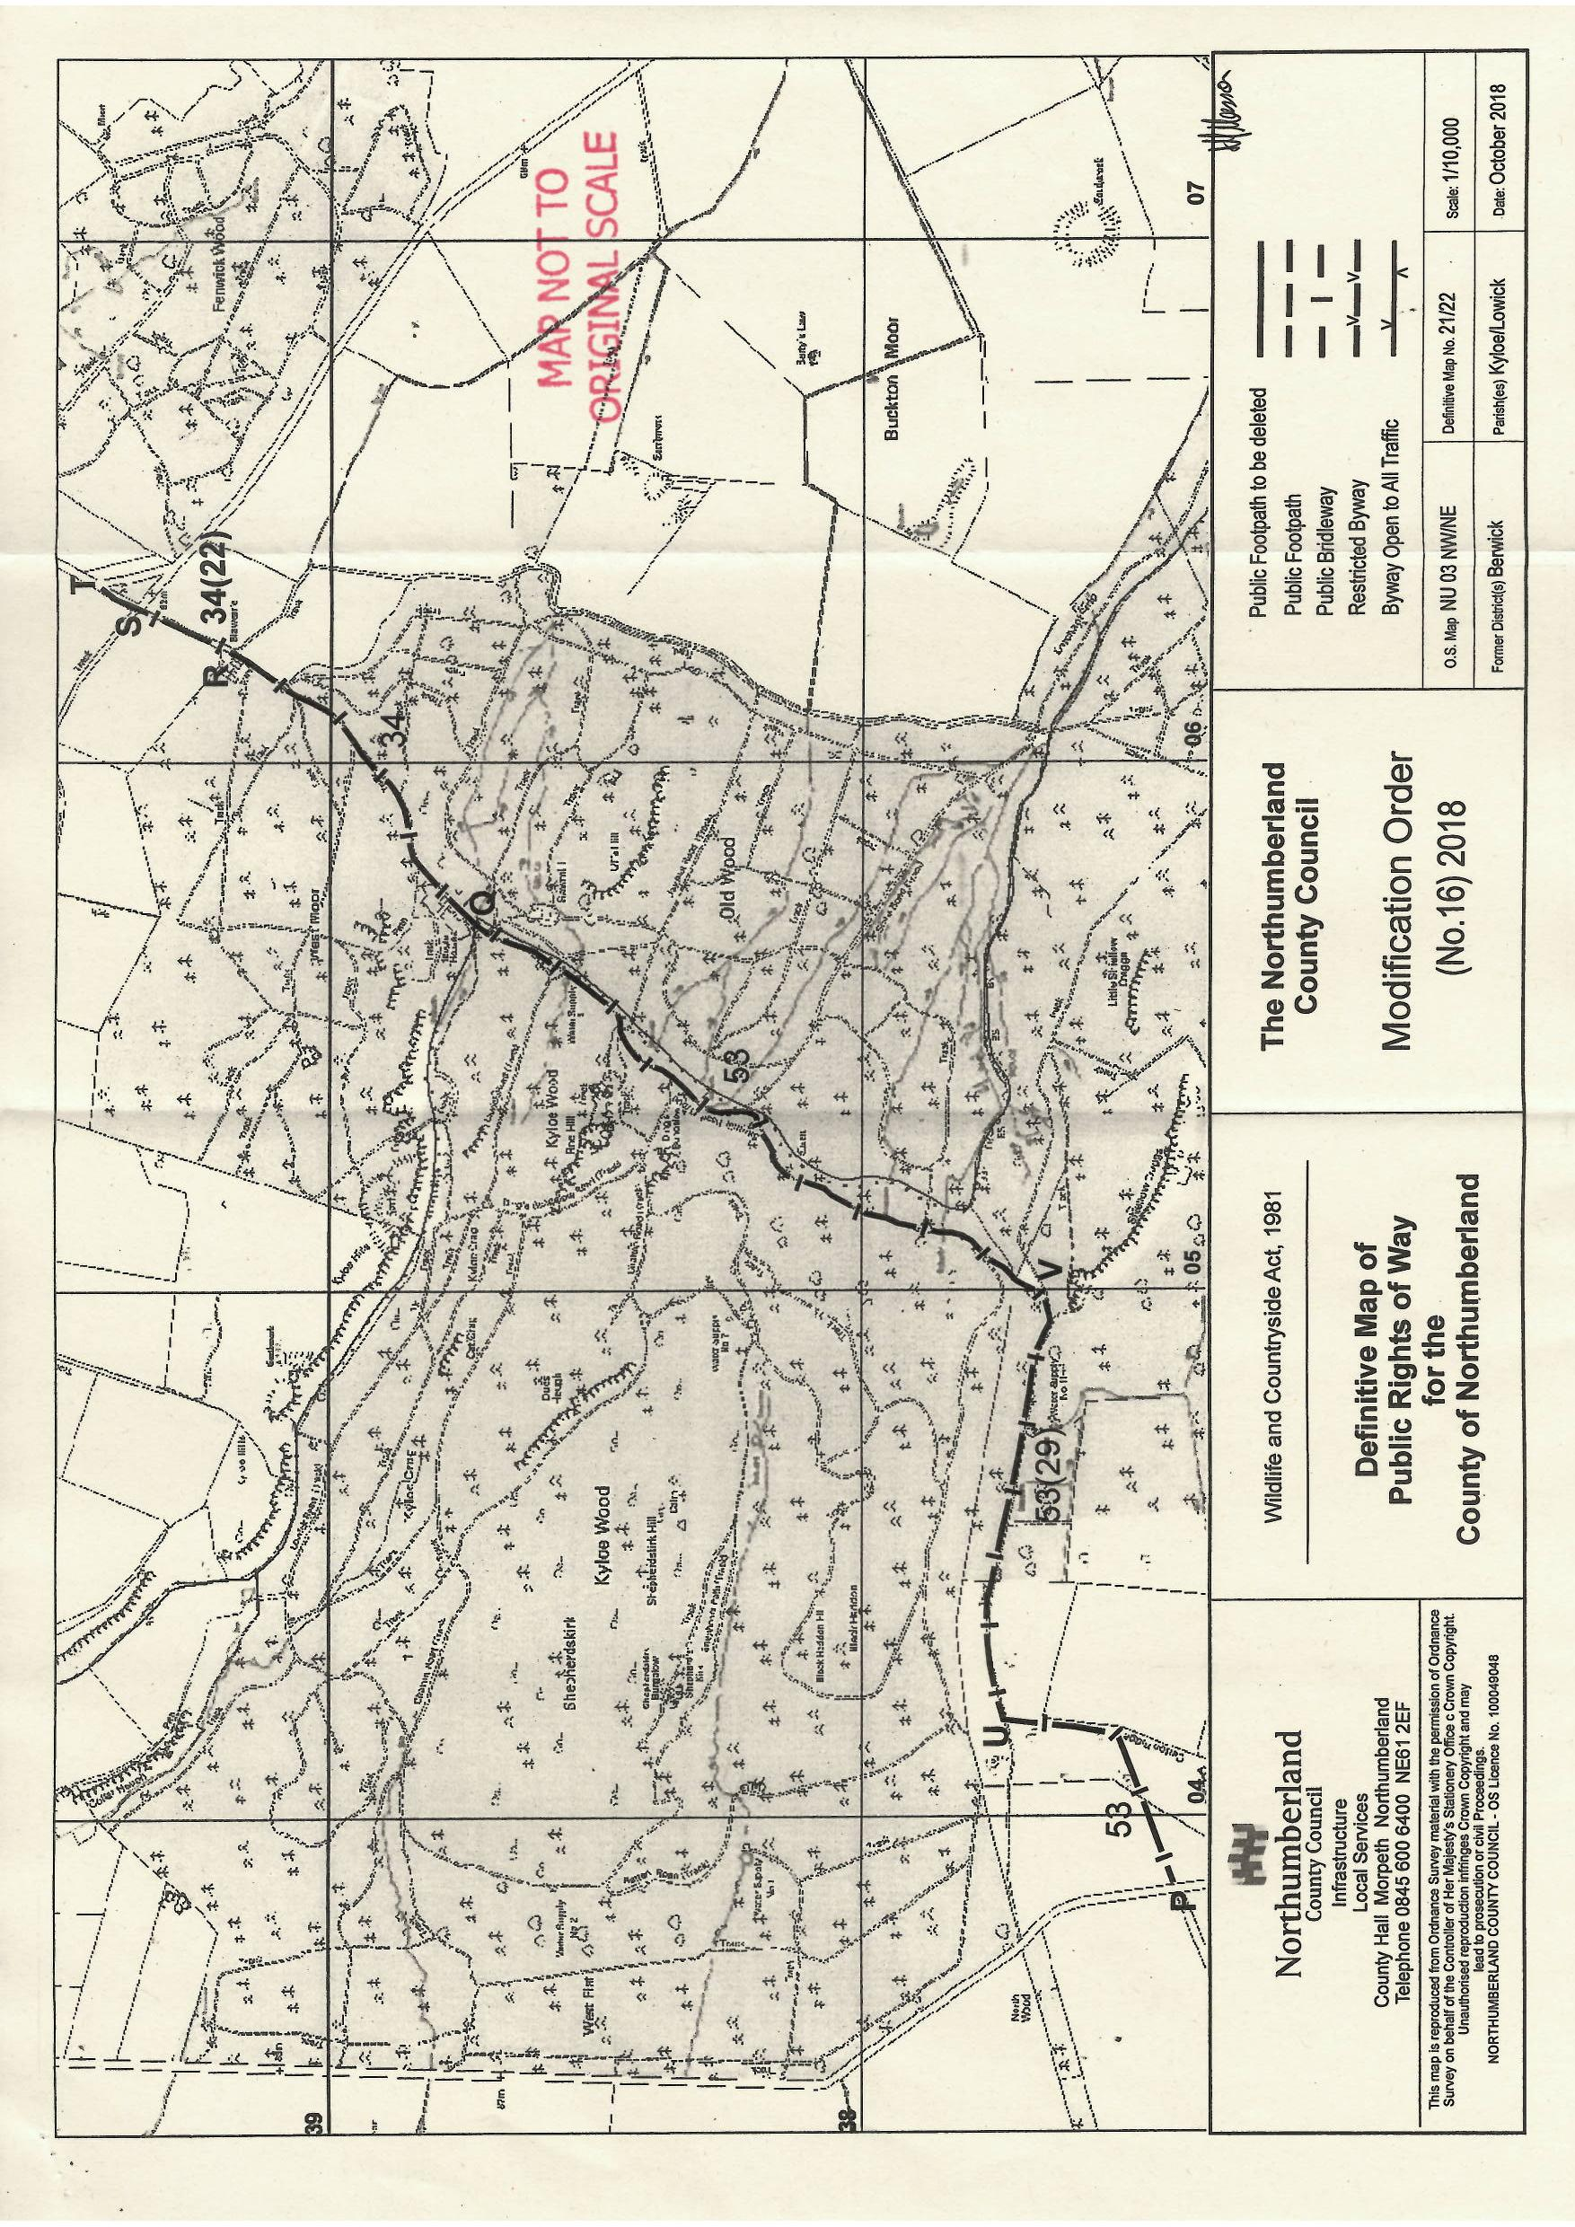

Based on documentary evidence
Also referred to as Kyloe Forest
As shown on the plan attached to the Order
In this case the particulars contained in the DMS requiring modification as a result of the upgrading, should the Order be confirmed
As described in the submission made opposing the Order on behalf of the owners of Kyloe Wood
A plan titled ‘Network Management Information System’ shows this coloured blue

