FCDO
Delivery Chain Mapping and Delivery Chain Risk Mapping Guidance for External Partners
Contents
Introduction 1
Delivery Chain Mapping (DCM) 1
Delivery Chain Risk Mapping (DCRM) 2
Application of the DCM and DCRM 3
Questions or Concerns 4
Annex A – Examples of a Delivery Chain Map 5
Annex B – Examples of a Delivery Chain Risk Map 6

Introduction
Delivery Chain Mapping (DCM) and Delivery Chain Risk Mapping (DCRM) are useful tools for programme risk management for the Foreign, Commonwealth and Development Office (FCDO). These tools play an important role in the due diligence and programme monitoring processes and improve understanding of how FCDO funding flows throughout a delivery chain, to ensure that our programmes achieve their objectives.

By better understanding our delivery chains FCDO can:

- Establish a comprehensive view of all partners in receipt of FCDO funding and the extent of those arrangements.
- Develop and strengthen future supplier bases.
- Understand a delivery partner’s role in achieving programme outcome(s) and opportunities for potential scale up.
- Capture and manage risks that could affect programme outcomes.
- Ensure risks are being managed by those best placed to do so.
- Strengthen our programme management capacity and programme delivery.
- Respond quickly and efficiently to requests for information about funding to specific organisations and provide greater transparency to the public.

Delivery Chain Mapping (DCM)
DCM is a process that identifies and captures, usually in visual form, the names of all partners involved in delivering a specific product, service or change, ideally down to the end beneficiary or recipient of FCDO funding.

The focus should be organisations with which FCDO’s implementing partners (i.e. signatories of a funding arrangement with FCDO) have formal funding arrangements involving FCDO funding, right down to the partners responsible for providing goods or services to the end beneficiaries/recipients. As a minimum, we would expect our partners to provide the names of their tier 1 partners (e.g. organisation to which they provide direct funding) and where possible the names of partners at lower tiers.

Delivery Chain Risk Mapping (DCRM)
DCRM is a visual depiction that builds on the DCM. It provides more information about the formal relationships, flow of funds from the initial source and the potential risks, ideally right down to the end beneficiaries/recipients.

Where DCM focusses on identifying all partners involved in delivering a specific product or service, the DCRM is about understanding, capturing, and managing the risks to the successful delivery of a programme, in relation to downstream delivery partners.

DCRM enables the FCDO to have focused discussions internally and with our partners about risk and risk management and supports improved risk escalating and reporting.

DCRM can help identify, highlight, or prompt the FCDO to consider areas such as:

- FCDO funds being distributed to each implementing (downstream or indirect) partner.
- Where capacity issues may exist with delivery partners (e.g. a partner’s capacity to manage a large number downstream / indirect partners).
- Vulnerable links or gaps where we have limited information (e.g. where knowledge and information about certain partners is limited).
- Key dependencies on downstream partners.
- Risks involved at each stage in the delivery chain (e.g. resources being diverted to terrorist groups) and associated controls.
- Where risk management is transferred or where there may be opportunities to transfer risk management and where accountability sits for the management of such risks.
- Administrative costs incurred throughout the delivery chain.

DCRM should, where possible, identify all partners (funding and non-funding e.g. legal/contributions in kind) involved in the delivery of a programme. Good practice includes details of:

- The name of all downstream delivery partners and their functions.
- Funding flows (e.g. amount, type) to each delivery partner.
- Risks involved in programme delivery, mitigating measures and associated controls.

DCRM should identify, to the extent possible, the fiduciary and other risks associated with the management of FCDO funds down the delivery chain. For example, how funding might be diverted, and where the FCDOs knowledge of the downstream partners may be incomplete. This should include consideration of potential fraud, bribery, or terrorist financing. It might also consider the dependency on key partners and the coherence and value for money (VFM) of the overall supply chain for the intervention.

FCDO delivery partners are responsible for mapping the complete delivery chain. Once the initial mapping is complete this will form the basis for a discussion with FCDO to identify the key risks and management of such risks.

A good delivery chain risk map will:

- Provide a clear understanding of all delivery partners involved in the delivery of a programme and the relationships between them.
- Identify key delivery risks, mitigating measures and associated controls throughout the delivery chain.
- Help ensure suitable risk management throughout the delivery chain.

DCRM remains important throughout the programme lifecycle. The map will be a live document which will support programme management and monitoring, helping all those involved in programme delivery remain alert to new and emerging risks.

Risk maps should be reviewed and updated periodically, in line with agreed programme monitoring processes and procedures e.g. during quarterly progress meetings. Any material changes to either the programme risk assessment or delivery chain should be recorded as soon as possible. It is the responsibility of the partner to notify the FCDO programme of any changes to risk within the delivery chain.

Application of the DCM and DCRM
DCM is a key mandatory component of FCDO’s Due Diligence Framework and Programme Operating Framework (PrOF) which assesses a potential delivery partner’s capacity and capability to deliver programmes and manage UK taxpayer’s funds. DCM/DCRMs are developed iteratively throughout the programme lifecycle. However, FCDO require a complete DCM/DCRM as soon as possible before funding is disbursed, as part of FCDOs due diligence process. DCRMs are currently considered as best practice by the FCDO within the Due Diligence Framework and PrOF.

Partners are required to maintain an up to date and accurate record of their delivery chain, detailing all downstream partners in receipt of FCDO funds and/or FCDO funded inventory or assets. FCDO programme teams work with partners and may request up to date DCM/DCRM information regularly throughout the implementation of any programme as part of ongoing programme monitoring. Partners must inform the FCDO programme teams of any changes to the partners in the delivery chain as and when any changes arise.

DCM and DCRM remains relevant throughout the programme lifecycle. These maps are a live programme management and monitoring tool to help FCDO programme teams remain alert to new and emerging risks.

Where the partner organisation is publishing this information to the International Aid Transparency Initiative (IATI) and effectively connecting downstream partner information so that a specific FCDO activity is traceable down the delivery chain, you can refer the programme team to the data available. For more information on publishing to IATI please find the IATI guidelines on gov.uk

Questions or Concerns
Please contact the Senior Responsible Owner or Programme Responsible Owner of the programme you are working on if you have any questions relating to this document.

The annexes below provide example formats for the DCM/DCRM but these are not presciptive. The partner and the programme team can discuss and agree what format works best for DCM and DRCM to provide/ obtain the information required.

Annex A – Examples of a Delivery Chain Map

Tier 1 partner name & funding amount
Tier 2 partner name & funding amount
Tier 3 partner name and funding amount
Tier 4 partner name and funding amount
Tier 4 partner name and funding amount
Tier 3 partner name and funding amount
Tier 4 partner name and funding amount
Tier 4 partner name and funding amount

Maps should include all tiers and all partners involved in delivering the programme to the beneficiary/recipient level

Annex B – Examples of a Delivery Chain Risk Map

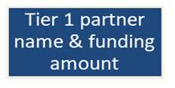
Tier 1 partner risks would be captured by FCDO through engagement and due diligence

Accountable Grant

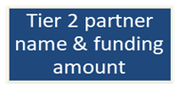
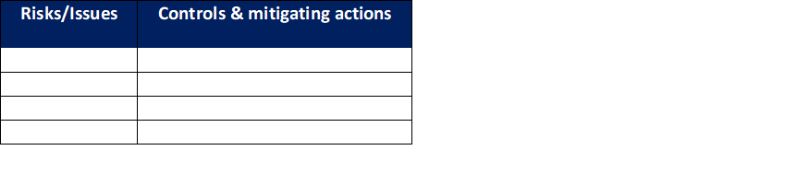

Accountable Grant
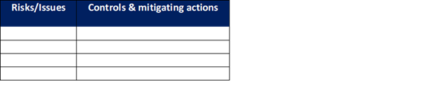
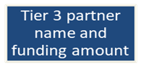

Accountable Grant

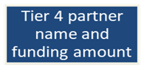
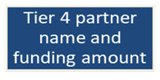

Maps should include all tiers and all partners involved in delivering the programme to the beneficiary/recipient level

